Jacob Moseley (2317034)
2317034@student.uwtsd.ac.uk

LEGO SPIKE PRIME PROJECT

L0 – Integrating Project

Module Code: ACHA4008

BSc Software Engineering (Foundation)

Contents

1. Introduction 3
2. Research 3
2.1 Researching the driving base. 3
2.2 Researching the line following technique. 3
2.3 Researching the maze solving problem. 3
3. Planning 4
3.1 Time management. 4
4. The Final Design 4
4.1 The hardware. 4
4.2 The software. 5
4.3 The final outcome. 7
5. Conclusion 7
6. References 8

1. Introduction

Robotics are beginning to play a larger role in people’s lives day by day, from self-driving hoovers to surgical robots. Robotics can be defined as a branch of engineering that involves the conception, design, manufacture and operation of robots. The objective in the field is to create intelligent machines that can assist humans in a variety of different ways [1]. The aim of this report is to explain the process involved in creating a functioning line following and maze solving robot using a Lego Spike Prime robotics kit and the provided code blocks.

2. Research

Within this section we shall be looking at all the different sources of information that were used to help aid in designing our robot from different line following techniques to distance sensor placement.

2.1 Researching the driving base.

The first step in our functioning robot was creating a good driving base. Some key features that needed to be included were making it narrow enough to be able to easily maneuver around corners. It also needed to be short enough to fit any sensors on the top while having some space below for any additional features. After looking around online we settled on Driving Base 1 from the Lego Spike Prime website [2] due to its small footprint and ability to be expanded.

2.2 Researching the line following technique.

Due to the fact that our robot is limited to one color sensor we had to find a solution that was able to follow a line based on the change of input from the color sensor. After looking around online we eventually came across a video on YouTube [3] that demonstrates a robot with a sensor facing the ground and based on the color it detects, rotates either left or right, stopping and changing direction based on the color it detects. These small changes in direction then push the robot forward until it has reached the end of its line. This was perfect as it only required one color sensor and was easy to program due to the simple logic required.

2.3 Researching the maze solving problem.

Once again limited by the number of sensors available within our Lego Spike Prime kit, we had to be creative as we needed to find values for the distance in front, to the left and to the right of our driving base. We started looking online and found an example of a robot that had the ability to turn its distance sensor from left to right [4]. This was optimal as it allowed the robot to know where it was in space, and we had the perfect motor available to rotate the distance sensing camera. After adding this we would simply have to write a program to turn the camera left and right by 90 degrees and we would have our distance values for all sides of the driving base.

3. Planning

Now that we understood how we were going to build our robot it was time to sort out a plan of how we aim to complete the robot in time for its final test. Within this section we shall be looking at how we chose to manage time as well as what we aimed to complete within our allocated time.

3.1 Time management.

As we only had access to the Lego Spike Prime kits on Fridays it was incredibly important we allocated our time wisely. Due to this limitation, we made sure we completed all our research in-between our time with the equipment so not a second was wasted. This allowed us to complete the main design of our robot and give it the ability to solve lines in just one session meaning we could focus on the harder maze solving problem for the remainder of our time which worked well.

4. The Final Design

After much planning and research, it was finally time to build the final design. Within this section we shall be looking at both the software and hardware that was used and how our robot fared in its final test.

4.1 The hardware.

The final design of the robot consists of a basic driving base with two wheels placed at the center of the bottom of the robot and a small rolling ball at the back to help with stability when moving. On the front of the robot facing down is a color and light reflectivity sensor that is used to make sure robot is following the line below it. This shall work by the robot making small movements left and right based on the color it is detecting, slowly pushing the robot forward towards the end of the line.
On top of the robot is a small motor that has the ability to spin 360 degrees. Placed on top of this motor is a distance sensor which shall be used during the maze. The sensor first faces forward and checks to see if the robot is too close to a wall meaning it has hit a dead end. In this event the motor below it spins 90 degrees left and then 180 degrees to right capturing the distance to the wall each turn, saving the values as variables. The software running the robot shall then check which side of the robot has more space and then decide which way to turn. If the robot lacks space on both sides, it will move a few centimeters backwards and try again to find an opening before turning and moving on. The color sensor shall also be used to check when the robot has reached the end of the maze. Below is an image of the final design of the robot with some annotations.

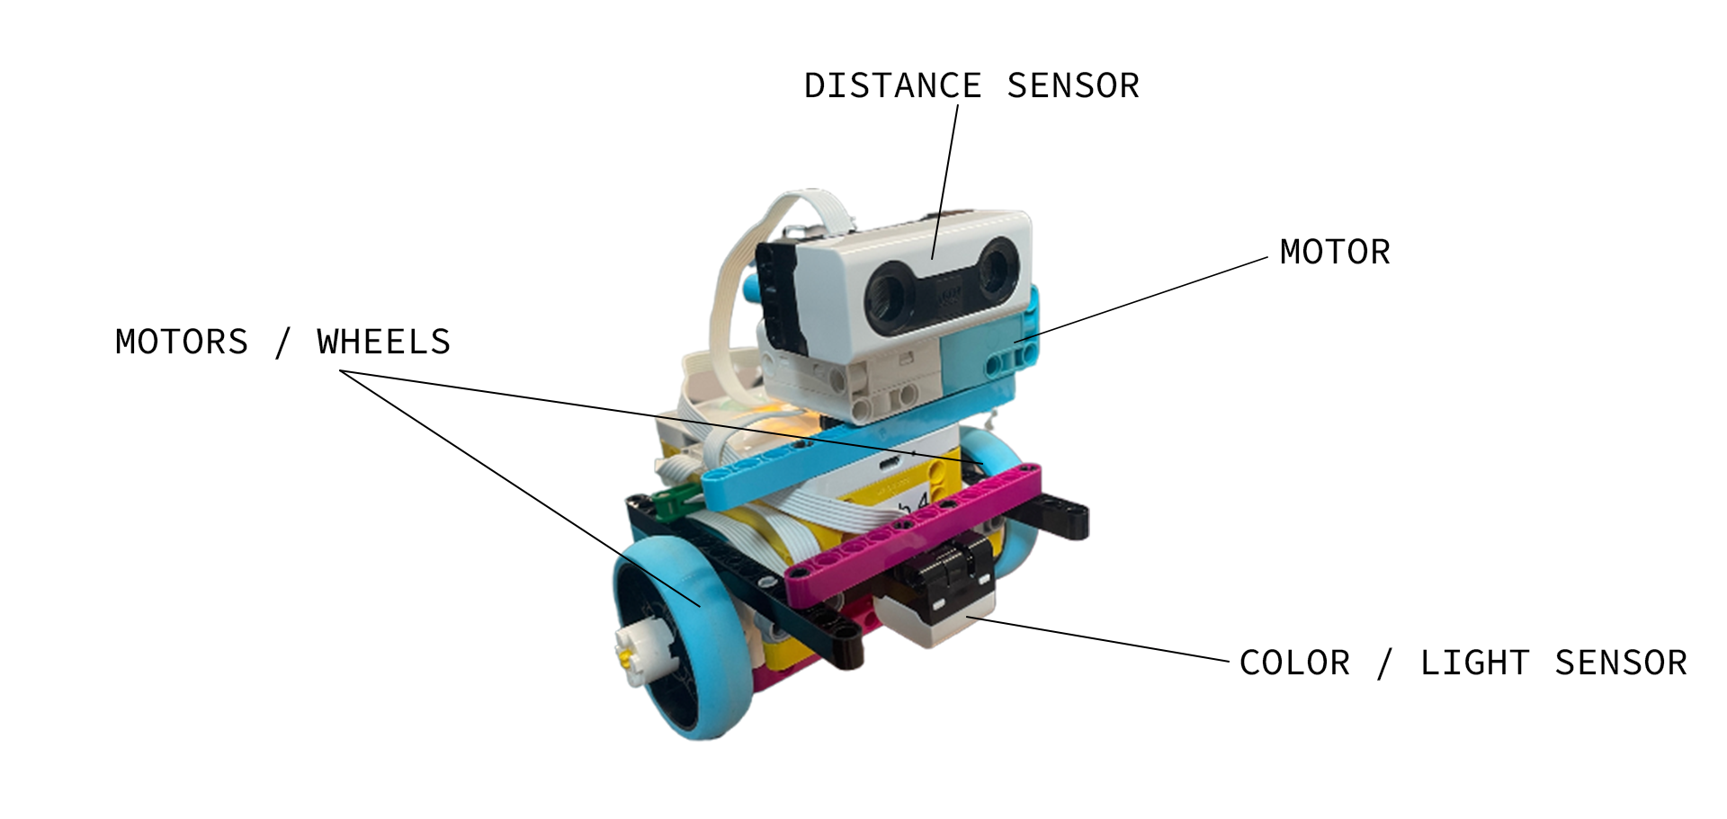

4.2 The software.

The software was the most important part of this project as without it the robot wouldn’t be going anywhere. We first started a simple line following program that can be seen below. The robot starts moving forward at a slow speed, if the color it detects is red it moves left slightly for two seconds, if the color is white, it moves right slowly for 2 seconds. This constant change in direction slowly pushes the robot forward along its path until it reaches the maze. We struggled to get both the maze program and the line following program to work within the same file as each program broke the other. If we were to ever recreate this robot, we would redesign the software from the ground up so that it can complete these two functions simultaneously.

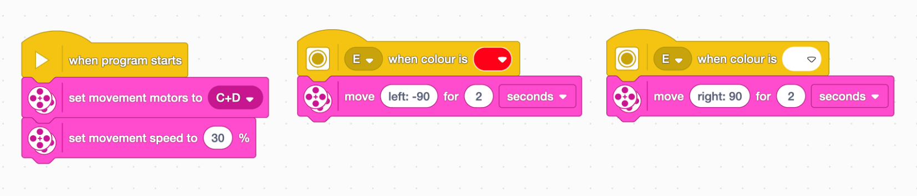

Creating the maze solving portion of the software was much more challenging as there were so many more variables at play. Below you can find the code we used to create the maze solving portion of our robot. It first slowly moves forwards until it gets too close to a wall. The sensor the spins left and right to see which side of the robot is open. If it finds an open side the robot turns and goes that direction and the cycle continues, otherwise the robot moves back and tries again to see if there is a new opening. This cycle continues until the robot finds a way out of the maze.

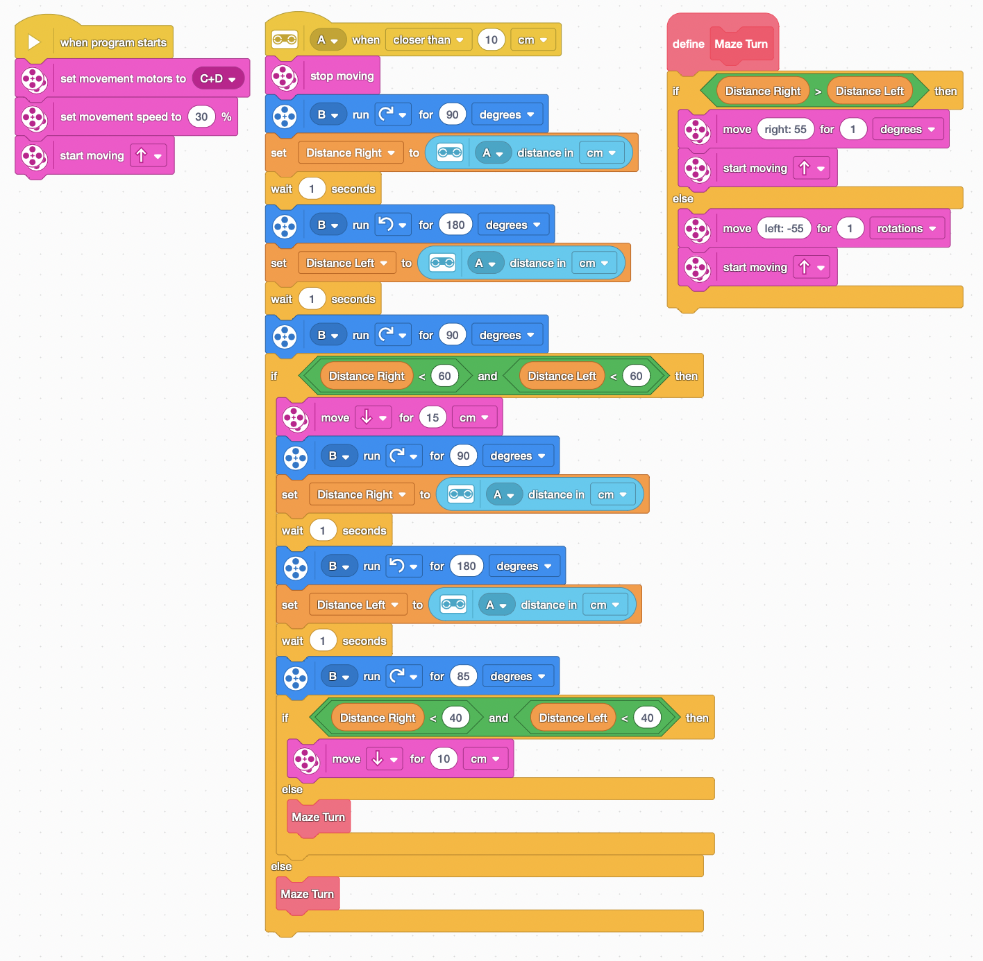

4.3 The Final Outcome.

Now that the robot had been built and the code had been written it was time to test the robot. The robot did very well following the line on the ground, however due to the robot constantly moving left and right to follow the line it was quite slow meaning in hindsight a better line following technique would have been good. The rotating distance sensor worked very well, however when hitting a dead end the robot struggled to move back the correct distance before stopping and turning. To improve this, it would probably be good to have the sensor constantly looking left and right for an opening to enter instead of guessing the distance to the next turn.

5. Conclusion

In conclusion I feel we tackled the problem well with the use of good time management and appropriate research. While there were some areas, I feel we could have improved on, such as the speed of the line following, I feel we successfully completed the task at hand in an efficient manner.

6. References

[1] Hanna, K.T (2023) What is robotics? [online] WhatIs.com Available at: https://www.techtarget.com/whatis/definition/robotics [Accessed: 26/04/24]
‌
[2] spike.legoeducation.com (n.d.) LEGO Education SPIKE. [online] Available at: https://spike.legoeducation.com/prime/models/bltc58e302d70cf6530 [Accessed: 26/04/24]

[3] www.youtube.com (n.d.) ‘Line Following Tips & Tricks For Your Mats’ [online] Available at: https://www.youtube.com/watch?v=0gRLxuvfILc [Accessed: 27/04/24]

‌[4] www.youtube.com (n.d.) Maze Solving Lego EV3 Robot. [online] Available at: https://www.youtube.com/watch?v=Ro7T3q14uDY [Accessed: 27/04/24]
‌

‌

