

Assessment 1 – Reading Task Template
Upload your photo of your A3 in-class notes here:
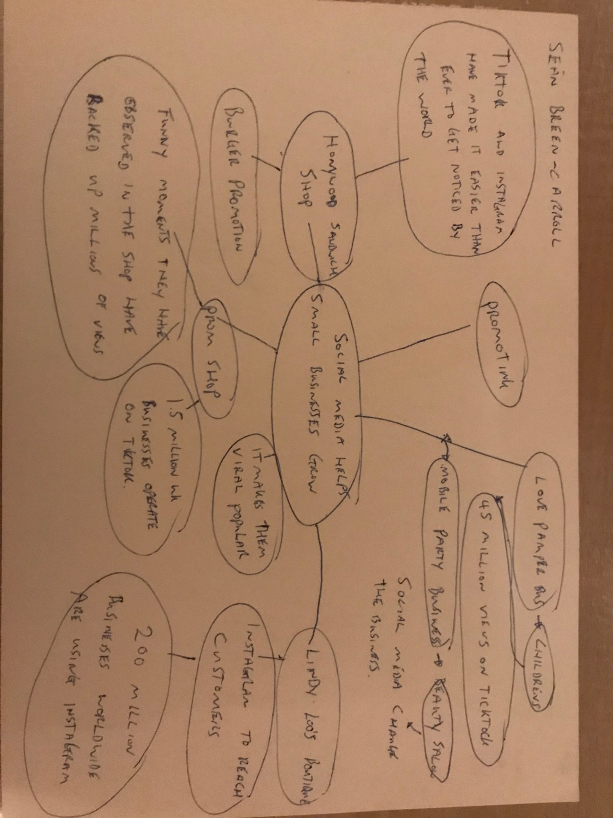

1. Answer these questions using the sentence starters below
a. What is the main idea of the text?
The main idea is that social media helps improve and get more customers to connect with your business, and how it has helped the businesses in the text.
b. What are two key points?
One key point is that social media such as tiktok is very useful in business, such as advertising as it can be accessed anywhere in the world
Another key point is that social media can make you go viral as a business and help you sell better as a business as a result.
c. What part of the text did you find most important? Why?
The most important part is that social media platforms such as tiktok and instagram have made it easier then ever to get noticed by the world.
d. Was anything unclear or difficult to understand?
I did not understand how social media can have such a large impact on certain business types as they don’t always seem the appropriate platform to promote on.

e. How did your group help you understand the text better?
My group helped me by explaining that they use social media similar to how it is explained in the text and that for small businesses going viral can significantly improve a businesses profits and customer base
2. One sentence reflection
Question: What did you find challenging about this task?
The hardest part was reading the quotes from certain busneesses in the text as I don’t know anything about some things like prom shops and they have never even been something I have thought of before reading this text.

