Assessment 1: Reading and Note- Taking
1)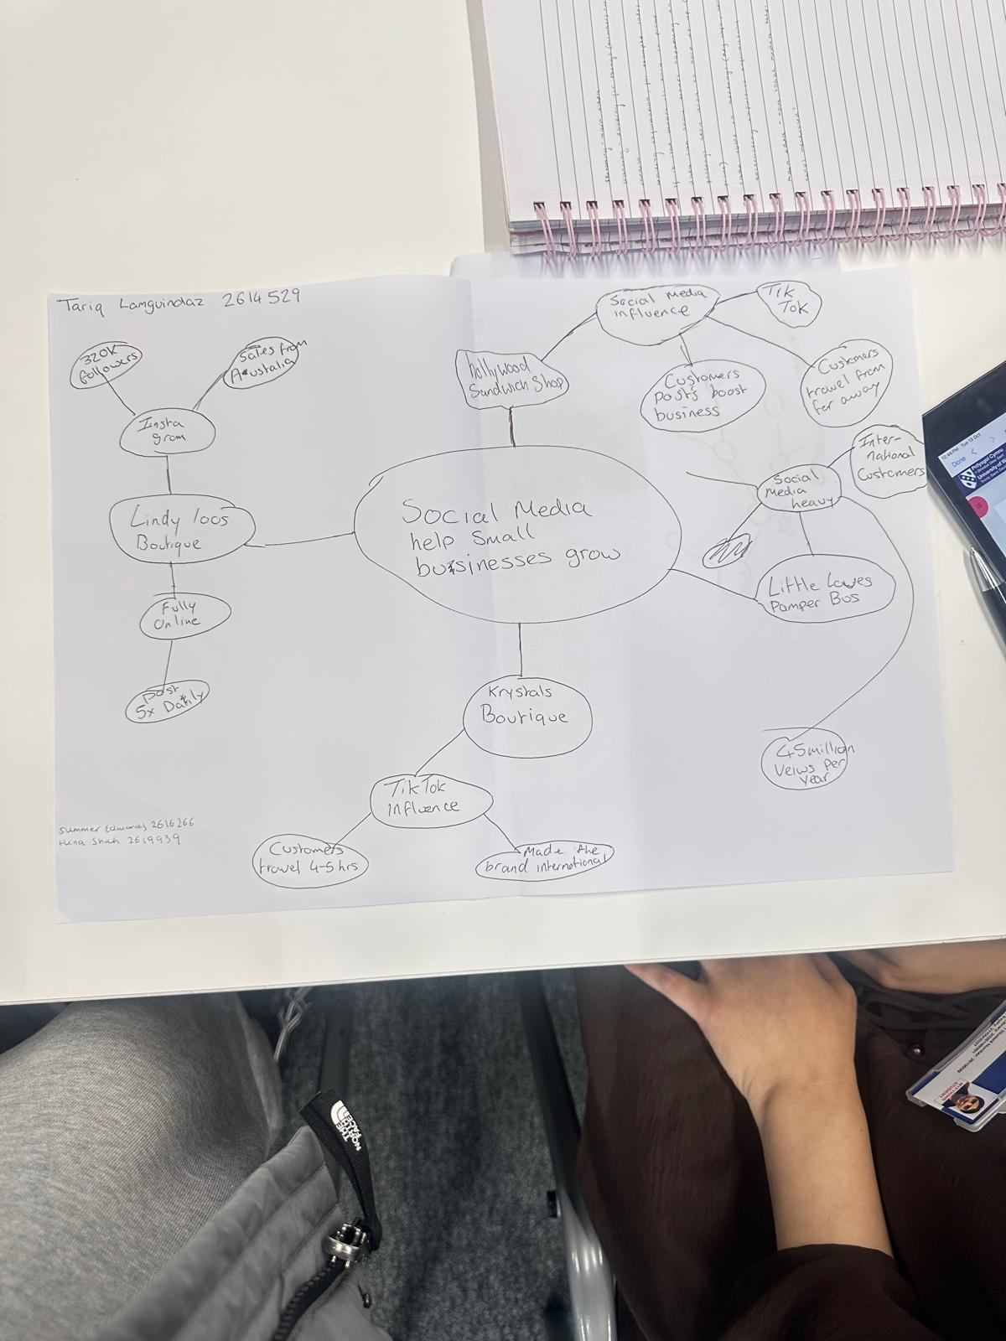
Part 2:
1)The Main Idea
The main idea of the text is that social media platforms such as Instagram and TikTok have transformed how small businesses market their trades. Without having to use the traditional marketing methods like newspaper or door knocking that will usually either very time consuming or at a high cost with potentially no

growth, local traders are able to achieve massive fame, turning online ‘likes’ into sustainable livelihoods.
2)Key Points and Supporting Evidence
The key point here is that going viral on social media can gain small businesses popularity overnight. The business revenue increases directly due to a higher number of customers. Social media fame allows a small local business to reach a nationwide audience from the comfort of their store.
The article features Ben Newman (Spudman) who runs a jacket potato stall in Tamworth. After his viral TikTok gained millions of views, customers travelled not just nationwide but also from the US, Malaysia and Australia, all just to try his potato.
3)Another Key Idea supporting the Main Idea
Another key aspect to this article supporting the main idea is that viral social media success democratises advertising, allowing ordinary people with no marketing knowledge to outcompete major competitors simply by being authentic.
An example of this is The Bingley Mega Chippy. On paper, it is your everyday neighbourhood fish and chip shop in Coventry. But it has become viral and sought after, all thanks to a catchy fan-made song about it and it started trending on TikTok. It became a global phenomenon simply through a user-generated content post. The video was organic and original from a local
customer, which has led the business to rapidly scale up their operations as now their clientele are international tourists, not just the couple locals at lunch.
4)The Most important Part and Why
The most important part of the text is the expert analysis section toward the closing comments of the article. The section that features consumer expert Sarah Green’s analysis. While having real life examples like Spudman and Chip Shop Diva bring the stories to life as they serve as an anecdote, the insight from Green explains the reason and link between social media and its growth. It explains why the phenomenon of how the current modern consumer drives for ‘real’ and ‘authentic reviews based on real customers, and less on over-polished corporate advert designs. I believe this section is the most significant as it proves that there is less random luck and that the virality is due to the shift in consumer behaviour. Most people nowadays go to social media for the next big thing based on reviews and viral thing as opposed to trusting things like Google Reviews or clicking the first sponsored link.

Reflection
5)When completing the mind map exercise, we had split the work between us.
Even though I had exciting ideas about a different section, I had to focus on something else. Our topic was similar, so we had to make sure even if our ideas overlapped, they were not repeated throughout. Similarly, with question 2 and 3, I found it hard to not repeat myself as the topic of the main idea was the same. 6)Before finishing our activity in class, we presented the three sections to each other, so this ensured all our points are shared and if the other people had something to add we quickly added our inputs into each other’s sections. This was all topics were covered and ideas we didn’t think of before were also shared. For my independent task at home, I used two different highlighters for each point and annotated in two different coloured ideas. This was I used examples from the text associated with one colour without repeating myself in the other.

