Environmental Impact Assessment of Mumbles Pier Restoration
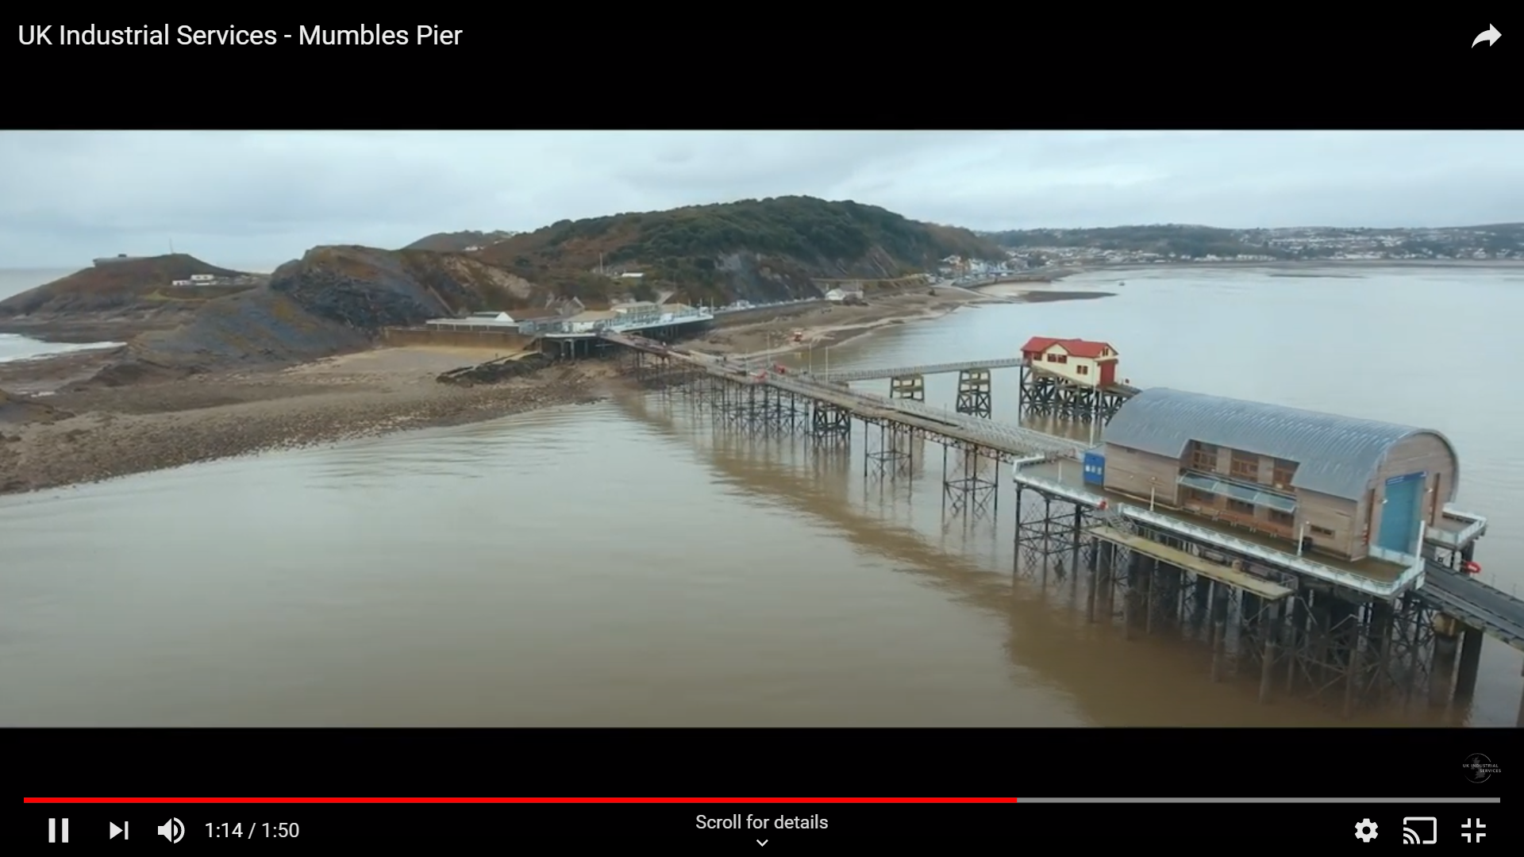
Photo Credit: (UK Industrial Services, 2020)
Module: Environmental Assessment

Module Code: M3X9629

Lecturer: Allan Nantel

By Shane Thomas
Table of Contents
1. Introduction 3
1.1 History 3
1.2 Aims & Objectives 4
2. Literature Review 5
2.1 What is an EIA 5
2.2 EIA Regulations Timeline 7
2.2.1 Criticisms of the EIA 8
2.2.2 Case Study – Seaham North Pier 9
2.3 Additional Assessments 10
2.3.1 Strategic Environmental Assessment (SEA) 10
2.3.2 Evaluation of a Health Impact Assessment (HIA) 12
2.3.3 Evaluation of a Habitats Regulations Assessment (HRA) 13
2.3.4 Landscape and Visual Impact Assessment (LVIA) 13
3. Regulations of the Development 15
3.1 The Conservation of Habitats and Species Regulations 16
3.2 Planning (Listed Buildings and Conservation Areas) Act (1990) 16
3.3 Town and Country Planning (Environmental Impact Assessment) (England and Wales) Regulations 16
3.4 EIA Regulations – The Town and Country Planning (Environmental Impact Assessment) Regulations 2017 17
4. Stakeholder Engagement 19
4.1 Opinion/Comment of Public & Professional Bodies 19
4.2 Consultation & use of Local Experts 20
5. Critical Evaluation of EIA 22
5.1 Recommendations 24
6. Conclusion 25
7. References: 27
8. Appendices 34

Table of Figures
Figure 1: This map was extracted from the Mumbles pier Environmental Statement and displays the pier and lifeboat station prior to restoration as well as highlighting the immediate study area considered within the EIA (Royal Haskoning, 2010b). 3
Figure 10: A workflow chart of the process of an EIA adapted from an example produced by the leading world academic on the topic John Glasson (Wilson et al, 2017). 6
Figure 2: The wider range of the Carmarthen Bay SPA (CBEEMS, 2020). 13
Figure 3: Carmarthen Bay & Estuaries SAC range (CBEEMS, 2020). 13
Figure 4: The range of the Burry Inlet SPA/Ramsar site (CBEEMS, 2020). 13
Figure 5: The new artificial ledges purposefully built and installed to the lifeboat house for use by the local breeding kittiwake (Rissa tridactyla) colony to mitigate for the temporary loss of roosting habitat (Crutchley, 2013). 20
Figure 6: The former ledges of the old pier structure that had been utilised by the kittiwake colony (Rissa tridactyla) (EDP, 2010a). 20
Figure 7: An example of honeycomb worm reef habitat (JNCC, 2014). 22
Table of Tables
Table 1: A step by step brief of the EIA process (Ministry of Housing, Communities & Local Government, 2020) – 5
Table 2: This table highlights how the Marine Works Regulations (2007) directly relate and influence the Mumbles pier development (IEMA, 2017). 15
Table 3: This highlights all the major changes to the amendment to the EIA regulations of 1999 (Burgess Salmon, 2017; Landscape Institute, 2017) – 18
Table 7: The list of all designations relating to the protection of Kittiwake (Rissa tridactyla) in the UK as well as internationally (EDP, 2010a; JNCC, 2018a) – 23
Table 4: The site was subject to the following national planning policy documents (Savills, 2010) – 34
Table 5: Local Planning Policy Documents (Savills, 2010) – 35
Table 6: The planning statement much like the EIA highlights the sensitive nature of the site throughout the document, particularly regarding the following (Savills, 2010) – 35

1. Introduction

1.1 History
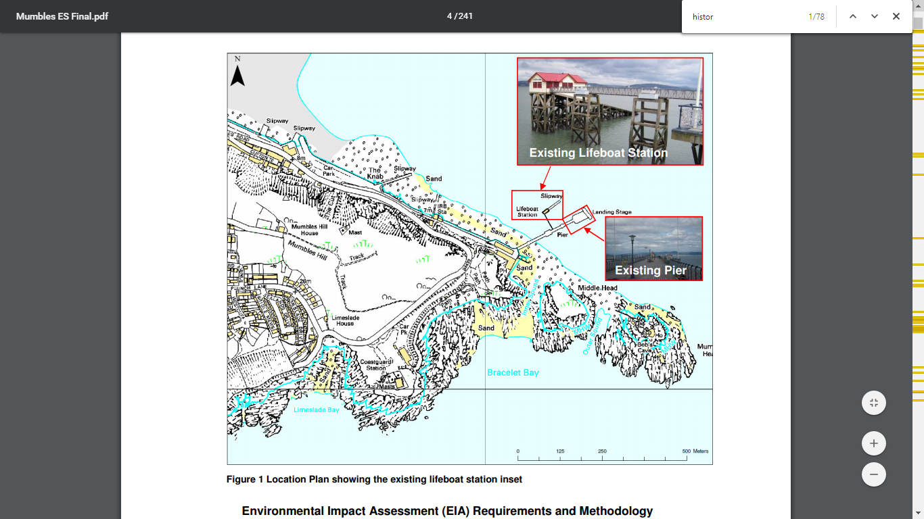
The Mumbles pier, situated on the western edge of Swansea Bay, first opened in 1898 serving as a final stopping point of the former Mumbles Railway (National Piers Society, 2020; Mumbles Pier Project, 2020). In 1992 the pier and attached lifeboat station were awarded Grade 2 Listed status (Royal Haskoning, 2010b). As a result of over a century of corrosion from the sea since its original construction, significant weaknesses had become apparent in the structure that required urgent restoration (Royal Haskoning, 2010b; National Piers Society, 2020).
Figure 1: This map was extracted from the Mumbles pier Environmental Statement and displays the pier and lifeboat station prior to restoration as well as highlighting the immediate study area considered within the EIA (Royal Haskoning, 2010b).

In response, pier owners AMECO held a public exhibition in 2010 on plans put forth for restoration. Following a year of uncertainty, planning consent was granted by Swansea City Burough Council in 2011, with the construction commencing in June 2012 (National Piers Society, 2020).

1.2 Aims & Objectives
This report aims to complete the following –
- To assess and critique the Environmental Impact Assessment of the re-development of Mumbles Pier.
- Scrutinise all available evidence to determine whether impacts and on the human and natural environment were appropriately mitigated against.
- Investigate legislation applicable to the development and in what way these were adhered to by the developer; and
- Emphasize variation in the environmental protection afforded at the time of development to that which it would be subject to in the present day.

2. Literature Review

2.1 What is an EIA
An early definition of a ‘Environmental Impact Assessment’ for many decades was in a paper published in 1979 by academic researcher Richard Munn in the acclaimed academic journal ‘Nature’ (Munn, 1979). It is stated that the purpose of an EIA is – “to identify and predict the impact on the environment and man’s health and wellbeing of legislative proposals, policies, programmes, projects and operational procedures, and to interpret and communicate information about the impacts” (Munn, 1979).
Adaptations from this definition have occurred in the decades since, with the Convention on Biological Diversity (CBD) also adding consideration of socio-economic and cultural impacts (SCBD, 2019). Additionally, the Brundtland Report (1987), which is seen to be a turning point in global sustainability thinking, makes reference to EIAs as being a useful tool in assisting the goal of achieving sustainable development (Glasson & Therivel, 2013; IISD, 2020).
An EIA can be divided in to 8 phases –
Table 1: A step by step brief of the EIA process (Ministry of Housing, Communities & Local Government, 2020) –
- Description of the impact
- Description of the environment
- Identification of effects
- Evaluation of effects
- Management and control of the environmental effects
- Presentation of the study
- Public Presentation (hearings)
- Formal decision making

There are five core themes that are shared among the most EIAs that contribute to success – Timing, Personnel, Scoping, Information & Monitoring (Kominkova, 2016). To start, the ‘timing’ at which the EIA process is incorporated into the planning process is of the upmost importance (Kominkova, 2016). The reasoning for this is that consideration of mitigation can often come too late or as an afterthought and so early integration of EIA in the planning process usually results in built-in mitigation that are of minimal negative and maximum positive impact (Kominkova, 2016).
Furthermore, there is ‘personnel’, this refers to employing individuals with the skills and experience that provide the ideal work profile for a specific project. Thorough scoping procedure allows for any significant environmental impacts attributed to the project to be identified at an early stage in planning (Cashmore, 2003). This allows for sufficient time to develop more appropriate alternative designs than that originally put forth.
Moving on from this, there is the importance of retrieving a sufficient quantity of reliable data. The lack of any baseline data for an ecological assessment for example is a common occurrence and would result in the practitioner having to start from the start (Wright et al, 2013). As such it is advised that practitioners work in collaboration with local universities and research institutes to aid in lessening this workload.
Lastly, monitoring has often been the least thorough phase in the process of an EIA. As it is a phase that occurs following the completion of a project, it therefore is often not viewed with the same level of importance to a developer (Cashmore et al, 2004). This is despite it being stipulated as a mandatory requirement in law (Noble, 2006).
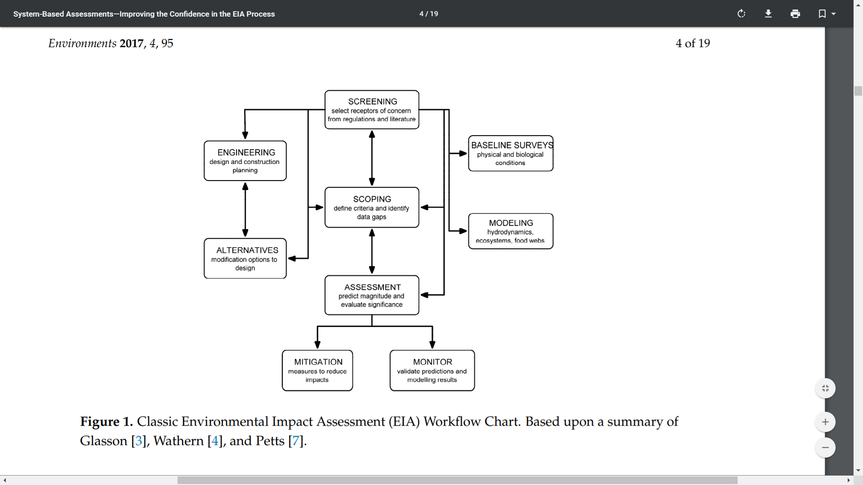
However, the monitoring phase, if carried out correctly, can prove to be worthwhile for a developer. The data collected overtime can highlight which impacts were or were not significant which in turn can result in an improved scoping phase for future projects (Kominkova, 2016).
Figure 10: A workflow chart of the process of an EIA adapted from an example produced by the leading world academic on the topic John Glasson (Wilson et al, 2017).

2.2 EIA Regulations Timeline
The concept of an EIA began rising in prominence during the 1960s with its inclusion within environmental policy in the US via the National Environmental Policy Act (NEPA) in 1969 (Caldwell, 1988; Wathern, 1988; Glasson & Therivel, 2013). This resulted in EIAs now being applicable to all significant government projects and programs in the US that posed a risk of having a detrimental impact human health (Wathern, 1988; IISD, 2020). As a result, the concept soon gained momentum with other nations adopting their own EIA models (Kominkova, 2016).
The first being Canada in 1973, a year after the UN Stockholm Convention that came to be known as a watershed moment in environmental politics (Beanlands & Duinker, 1983; UN, 2020). In Europe Germany and France in 1975/1976 each devised their own EIA respectively (IISD, 2020). In the mid-1980s the World Bank formally endorsed the international use of the EIA.
At a similar time, the United Nations Environment Programme (UNEP) implemented measures to promote EIA. Following on from this, the European Union implemented its own EIA Directive in 1985 (Kominkova, 2016; IISD, 2020). Several years later, in 1992, the UN went further once more by declaring EIAs as a national instrument (IISD, 2020).
Following on from the widespread adoption of EIA globally, the European Commission in 2001 adopted the SEA Directive to complement the existing EIA Directive. It operated on a wider-scale (i.e. plans/programmes) rather than just projects (University of Southampton, 2004). In subsequent years, amendments/provisions have been made to many different countries’ EIA system (Morris & Therivel, 2001).
A relatively recent example of such emerged from the UK in the form of the Town and Country Planning (Environmental Impact Assessment) Regulations 2017 which transposed the 2011 regulations (Ministry of Housing, Communities & Local Government, 2020).

2.2.1 Criticisms of the EIA
The EIA process has evolved over a period of five decades to date, although it is still not without criticism. A long-standing concern for developers, LPAs and other interested parties of a development is the lengthy time period of which it takes to complete an EIA.
For instance, in a study by Isaac & Garry Middle in 2010, it was found that the average time taken to complete an EIA is 567 days with the ‘environmental impact statement’ being the most time consuming phase (Middle & Middle, 2010). This was noted as accounting for between 45-65% of the workload, depending on the size of the EIA in question (Middle & Middle, 2010).
Furthermore, EIA methodologies the failings have been highlighted in a number of studies. One such study was carried out by Carter & Sadler in 1997, it was found that there is ambiguity as to what can be described as acceptable methods for surveying & Carter, 1997). This is especially true in ecological analysis, with it often being left at the discretion of the practitioner (i.e. the environmental consultant) (Carter & Sadler, 1997).
In turn, a conflict of interest arises in that the practitioner is employed by the developer to produce an EIA (Wathern, 1988). It would be in the interest of the developer that they receive an EIA which is cost-effective as a result of this, practitioners are often therefore pressured by the developer to rationalize a lower standard of surveying and analysis (Wathern, 1988).
Then there is the issue regarding the robustness of EIA theory, with funding of academic research in to the topic in the UK deemed to be lacking (Fischer et al, 2015). Despite this, around 25% of all publication in English language journals are by authors in the UK (Fischer et al, 2015). To add to this, there has been speculation by some authors of the role a scientific method approach could have in the decision-making process of EIAs (Morgan, 2012).
The aim of which would be in producing EIAs that would follow a logic-based approach backed by the latest scientific information (Jay et al, 2007; Morgan, 2012). The legal context and legislation is also a highly complicated matter in the UK with much jurisdiction having been handed to the devolved nations, resulting in variation (Glasson et al, 1999; Glasson et al, 2012).
The evaluation of ‘risk’ in EIAs is often inadequate (Glasson et al, 2012). It should be noted that one misconception is to view risks as static concepts, instead risks evolve as environments, technologies and the needs of societies change (Wilson et al, 2017).
The level of detail in a risk assessment analysis is now a large component in determining as to the amount of monetary funds a developer can lend from a bank (Gromley et al, 2011; Wilson et al, 2017). International lending institutions such as the World Bank or International Monetary fund now have a strong vested interest in understanding the environmental implications of approving such loans (Wilson et al, 2017).
Finally, the majority of EIAs due not consider risks that could cause an impact in the future. Although, EIAs largely incorporate a consideration of the impact of climate change if it is appropriate (Kasperson & Kasperson, 2013). However, the impacts of multiple factors are bundled in to the single all-encompassing term ‘climate change’. It often fails to cover other new risks such as acid rain and urban sprawl (Kasperson & Kasperson, 2013).

2.2.2 Case Study – Seaham North Pier
This case study of an EIA was chosen as it shares many similarities to that of the Mumbles Pier. The Seaham North Pier in 2016 was in need of urgent repairs with duties of oversight of the project being carried out by the Durham County Council LPA. The task of producing the screening, scoping and finally EIA on behalf of LPA was contracted to environmental consultancy firm AECOM Ltd.
Located within 2km of the site were three sites of European designation in the form of the Northumbria SPA/Ramsar site and Durham Coast SAC and nationally important Durham Coast SSSI. Matching the circumstances Mumbles Pier is the consideration needing to be provided to important bird species which in this instance was the ‘Purple Sandpiper’ (Calidris maritima) and ‘Turnstone’ (Arenaria interpres) (both ‘amber’ listed species of birds of conservation concern).
To mitigate for the disturbance caused to both species during construction through temporary loss of roosting habitat, the scheme has provided mitigation (AECOM, 2014). This mitigation will provide a long-term benefit in the creation of roosting ledges in much the same light as that chosen for the continued survival of the kittiwake colony of Mumbles Pier.
A concern shared between both case studies was in the handling of the impact of development to the water environment of each site. Unlike Mumbles Pier, the EIA for Seaham North pier predicted that construction operations would likely incur pollution incidents (AECOM, 2014). It was predicted that this would result in a minor negative impact to the bathing water quality of the surrounding environment which was of ‘good’ ‘Water Framework Directive’ status.
In the case of the former, the risk of machinery becoming embedded in the substrate during repairs to the pier were not noted as a possible risk. The result of which was an incident whereby a piece of machinery at the base of Mumbles Pier was engulfed by the incoming tide after sinking in to the sandy substrate. The lack of procedure in place for recovery of entrenched machinery resulted in oils and lubricants having leaked in to the marine environment.

2.3 Additional Assessments

2.3.1 Strategic Environmental Assessment (SEA)
The concept of a ‘Strategic Environmental Assessment was first formalised in 1996 by Sadler & Verheem (1996) who defined it as being –
“the formalized, systematic and comprehensive process of identifying and evaluating the environmental consequences of proposed policies, plans or programmes to ensure that they are fully included and appropriately addressed at the earliest possible stage of decision-making on a par with economic and social considerations” (SCBD, 2010).
There have since been many adaptations to this original definition, however, the fundamentals remain unaltered (Silva et al, 2014). In that it functions on a larger scale than an EIA, with it focusing on plans and programmes rather than projects, which is why Mumbles pier development was not subject to a SEA (Therivel, 1992; Therivel, 2004; Noble, 2006; Noble, 2019).
The SEA can be applied to an entire sector or a geographical area by examining the collective impact of several developments on a specified area (Bond et al, 2016). This is exemplified in Local Development Plans (LDPs) in the UK whereby a SEA is a mandatory requirement under the EU Directive 2001/42/EC (SEA Directive) (SCBD, 2010; European Commission, 2019; Swansea Council, 2019).
It will ensure early consultations with key stakeholders so that an environmental report highlighting any possible major environmental effects (positive/negative) due to a LDP are identified, assessed, mitigated and communicated to the policy maker. This is to facilitate accurate policy development and decision making (Roberts et al, 2012; Swansea Council, 2016).
The process of an SEA can be described as having six key steps that it broadly follows in any given scenario –
- Description of the plan/programme and the issue to be addressed.
- Administering a baseline study.
- Identification of the range of alternatives to the original plan/programme set out.
- Evaluating the impacts of these alternatives and its effect on separate plans/programmes.
- Deciding on the favoured approach for the progression or execution of the plan or programme.
- Implementing the preferred alternative and observing for any unforeseen environmental factors as well as whether plan/programme objectives set at the beginning are being attained.
(Noble, 2019)
The SEA process is however not without its criticisms. For instance, unlike an EIA process a SEA has often proven a difficult for a number of LAs to manage (Bond et al, 2016). This is evident in the LAs requirement to properly assess possible alternatives with inadequate scoping noted as also being a contributing factor to this (Bond et al, 2016). An example of which would be in the oversight of a large infrastructure development such as the HS2 link from London to Birmingham that involved plans having to be approved by Parliament.
Finally, consideration must be given to the fact the UK is at the time of writing (April 2020) in the transitional phase in its departure from the EU following the result of the 2016 referendum. As such, there is a plethora of rules and regulations that may or may not be transposed to UK law with SEA being one of these (Bond et al, 2016). It is anticipated that there will be discussion as to the limiting the scope, however it is highly unlikely that SEA will be ditched completely (Bond et al, 2016).
It is worth noting that as the UK negotiates its future relationship with the EU, the future of such environmental legislation could in large part be impacted by how amicable negotiations conclude. In the scenario that negotiations collapse and the UK takes the route of a no-deal exit then there is the real possibility of anti-EU sentiment developing and EU ‘red tape’ being slashed in response (Bond et al, 2016).

2.3.2 Evaluation of a Health Impact Assessment (HIA)
The principal purpose of a HIA is to assess the health impacts resulting from a proposed policy, plan or project (WHO, 2019). To tackle existing health inequalities and also avoid creation of new ones (Public Health Network Cymru, 2020). A widely credited definition of the HIA is that of the ‘European Centre for Health Policy Gothenburg Consensus (1999)’ that define it as being –
“A combination of procedures, methods and tools by which a policy, programme or project may be judged as to its potential effects on the health of a population, and the distribution of those effects within the population” (The European Centre for Health Policy Gothenburg Consensus, 1999). The Mumbles pier development was not subject to a Health Impact Assessment but the impact on human health was considered under the Marine Works Regulations (2007) (WHO, 2020).

2.3.3 Evaluation of a Habitats Regulations Assessment (HRA)
Functioning as a legislative tool for conserving wild habitats/species within the EU, the participation of the UK (up until 2016) as a member state meant that it was bound by the stipulations of the EU Habitats Directive (Planning Inspectorate, 2017; Natural England, 2017). This piece of legislation is transposed in to UK law to form the Habitats Regulations Assessment (Planning Inspectorate, 2017).
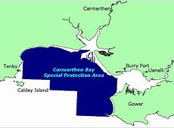
As a result, European sites of special protection such as SACs, SPAs and Ramsar sites are appointed stringent protection under the Conservation of Habitats and Species Regulations 2017, which is also more commonly known as the ‘Habitats Regulations’ whereby the HRA is derived (ECOSA, 2016; JNCC, 2018b).
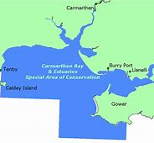
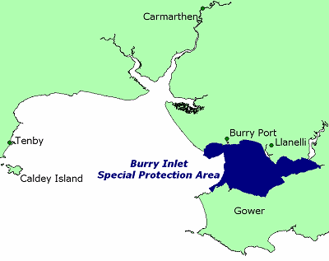
Figure 2: The wider range of the Carmarthen Bay SPA (CBEEMS, 2020).
Figure 3: Carmarthen Bay & Estuaries SAC range (CBEEMS, 2020).
Figure 4: The range of the Burry Inlet SPA/Ramsar site (CBEEMS, 2020).

Local authorities are legally obligated to evaluate potential impacts of any project which is determined to have a probable disadvantageous impact on a site of European designation. The process in which this is then assessed is referred to as a Habitats Regulations Assessment (HRA) (ECOSA, 2016; Scottish Natural Heritage, 2017). Any project that affects a European site of special protection, should be subject to HRA no matter the distance (Scottish Natural Heritage, 2017).

2.3.4 Landscape and Visual Impact Assessment (LVIA)
In a circumstance where development risks altering the aesthetics of a local landscape a LVIA will be included in the environmental assessment of the proposal (Watson, 2003; Scottish Natural Heritage, 2017). Aiming to avoid, reduce or offset the negative visual effect of a development on the landscape (Watson, 2003).
It is imperative to emphasize distinction between visual (human view/perception and landscape impacts which materialize regardless of whether or not it is viewed/perceived (2B Landscape Consultancy Ltd, 2020).
In the assessment of the site, a study area of a radius of 2km (4km linear distance) was sufficient in line with best practice guidelines for seascape assessment. Distances beyond this make the judgement of the scale of a feature difficult to interpret due to factors such as mist. Factors such as this can skew the ability of the human eye to discern objects from a distance (EDP, 2010b).
In the case of the Mumbles pier development, the main objections from residents were regarding alteration to the iconic view of Mumbles pier and its headland (National Piers Society, 2018). Additionally, there were concerns as to possible shading of property on the Oystermouth road due to the shadow cast from the new structure at certain periods of the day (EDP, 2010b).

3. Regulations of the Development
The timing from which the development was first formulated, approved and construction carried out occurred from 2010-2012. During this period, it was subject to the Marine Works Regulations of 2007 instead of the amended 2017 version (ITP Energised, 2018; MMO, 2018). These new regulations have seen significant changes being made in the EIA regime for developments requiring a marine licence (IEMA, 2017).
Required as part of the Marine Works Regulations (2007) is the stipulation that an EIA ‘screening & scoping’ process’ be included if any marine development application is to be approved (NRW, 2020). An example of this is the proposed Swansea bay tidal lagoon that is subject to this process prior to the issuing of a marine development licence.
Table 2: This table highlights how the Marine Works Regulations (2007) directly relate and influence the Mumbles pier development (IEMA, 2017).

Requirements of the Marine Works Regulations (2007) specific to the Mumbles Pier Development:
- A description of location of the project and the regulated activity.
- A description of the physical characteristics of the whole project and regulated activity, including requisite demolition (including nature and source of any materials and the working methods to be used).
- A description of the main characteristics of the operational phase of the project.
- An evaluation of the status of the local environment (i.e. the ‘baseline’) as well as the predicted evolution of that baseline if the development never occurred.
- The description in the ES should cover each of the following seven categories of effect – direct & indirect, secondary, cumulative, transboundary, short term – medium term – and long term, permanent/temporary and finally positive and negative effects.
(NRW, 2019)

3.1 The Conservation of Habitats and Species Regulations
Located less than 2 miles to the development is the Blackbill Site of Special Scientific Importance (SSSI), which is deemed to be of both regional and national importance for wading birds. The then Countryside Council for Wales (succeeded by Natural Rsources Wales) concluded that the development would not be subject to the provisions of the Conservation of Habitats and Species Regulations (2010). This was as a result of SSSIs not falling under the remit of said regulation.
European designations would be subject to consideration, however with the nearest sites - Carmarthen Bay and Estuaries SAC and Carmarthen Bay SPA - being >10km away the effect of said development was deemed neglibible to these sites (Royal Haskoning, 2010a).

3.2 Planning (Listed Buildings and Conservation Areas) Act (1990)
The listed status of Mumbles Pier and significant renovation needed resulted in it being subject to the said Act. An approval of such a development by the City and County of Swansea would in turn have to be in accordance to the Act (Royal Haskoning, 2010b). In particular section 7 of said Act which states that –
“Consent is normally needed for the listed building demolition, in whole or in part, and for any works of alteration or extension which would affect its character as a building of special architectural or historic interest”,

3.3 Town and Country Planning (Environmental Impact Assessment) (England and Wales) Regulations
The Town & Country Planning Act first emerged in 1932 following reforms to the rural planning system with it being greatly revised once more in 1947 during the post-war era. This was in order to facilitate the rebuilding of bombed towns/cities and to reorganise industry (House, 2018).
As of September 2002, Swansea Council requested a screening opinion by Swansea Council with a need for an EIA notified in October 2002. An EIA was a prerequistite due its scale and the environmental sensitivity of the site (Royal Haskoning, 2010b). In 2003, environmental consultancy firm, Royal Haskoning, were contracted with the task of producing a scoping report on behalf of the Swansea Council, to add to this it was also requested that a scoping opinion be produced (Royal Haskoning, 2010b).

3.4 EIA Regulations – The Town and Country Planning (Environmental Impact Assessment) Regulations 2017
of responsibility and burden that would result in turn added cost being passed on to the developer (Quad, 2017; The Landmark Practice, 2018). The purpose of these amended regulations was to simplify and harmonise the process of an EIA. The result of which would be that a larger portion take place at the start of the EIA process. It was thought that this could support the aim of decreasing the number of EIAs produced overall. This would lead to a focus instead on proportionate assessment. The LPA would be expected to foster a greater amount of the burden.
Table 3: This highlights all the major changes to the amendment to the EIA regulations of 1999 (Burgess Salmon, 2017; Landscape Institute, 2017) –

List of the changes to the new EIA Regulations –
- Developers must now hire competent experts to carry out EIAs with the ES (Environmental Statement) now including content detailing the expertise/qualifications of the persons that have carried out the EIA/ES (Landscape Institute, 2017).
- On a wider perspective, the new regulations now also force developers to consider the vulnerability of the project to climate change (Landscape Institute, 2017).
- The time-period of consultation for a project has now been extended from 21 days to 30 allowing the community a greater amount of time to learn of the project and share their thoughts/opinions (Burgess Salmon, 2017; Landscape Institute, 2017).
- The relevant authority can now ask for additional information if it is deemed to aid in helping reach a reasoned conclusion regarding the likely significant effects of the development in question (Burgess Salmon, 2017; Landscape Institute, 2017).
- Additionally, Local Planning Authority can request an extension of up to 90 days to adopt a screening opinion (Burgess Salmon, 2017; Landscape Institute, 2017).
- The LPAs decision to grant development should be supplemented by information regarding monitoring measures, meaning that any significant adverse effects a development would have on a site would have to be monitored (Landscape Institute, 2017).
- Not all changes in the regulations are at the detriment of the developer, in fact the developer can prove that an EIA is not required by providing a description of any measures that have will be put in place to avoid/prevent any possible adverse impacts occurring on the environment (Burgess Salmon, 2017; Landscape Institute, 2017).
- The developer now must compare the environmental effects of each alternative against one another when comparing alternatives to a proposed action on site (Burgess Salmon, 2017; Landscape Institute, 2017).
- The wording has been modernised, for example, human-being is now referred to as ‘population and human health’ also fauna and flora is now termed ‘biodiversity’ (Burgess Salmon, 2017; Landscape Institute, 2017).
- Previously it was considered good practice for a developments ES to comply with the scoping opinion and with the new regulations this is now mandatory (Burgess Salmon, 2017).
- Finally, the new regulations will transpose the European Union EIA Directive (2014) in to UK law following the events of Brexit (Burgess Salmon, 2017).

4. Stakeholder Engagement

4.1 Opinion/Comment of Public & Professional Bodies
As part of any EIA document, evidence must be shown that awareness of the impending development has been made to those near to the site or with vested interests (Ulibarri et al, 2019). At the time of this development first being proposed it attracted a great deal of proponents and opponents, making it a divisive topic among stakeholders and local residents. The proponents argued that the added revenue brought to the area by increased visitor numbers would have a large positive impact (National Piers Society, 2020). Whereas opponents argued against the adverse visual and ecological impact of the development.
One such concern was in the creation of a new apartment block that was said would assist the financing of the restoration. There was a supposed lack of attempt in promoting public awareness of the development according to a Mrs E J Parsons.
Additionally, given the close approximation of the development to the Gower AONB, concerns were raised as to whether the land being developed was actually located within the boundaries of the AONB. The claim was rebuked by the LPA as being false and so was not subject to separate planning jurisdiction afforded to AONBs in the UK (Swansea Council, 2018).
The Open Spaces Society, objected to the planning consent been granted for the demolition of the existing storage shed and construction of a site office for the pier. It was argued that this would suburbanise the coastal area and would be built upon registered common land. Another claim that was disputed by the LPA when challenged on the topic (Open Spaces Society, 2012).
Finally, a concerned member of the public by the name of Adam Tilt noted that the structure of the new ledges for the pier is breeding kittiwake (Rissa tridactyla) colony was very basic. To add to this, it was said that the design chosen had not been trialled previously to construction with no indication as to the suitability of ledge width and materials used (Tilt, 2011). Additionally, the justification of the ledge structure over that of other designs was seemingly lacking (Tilt, 2011).
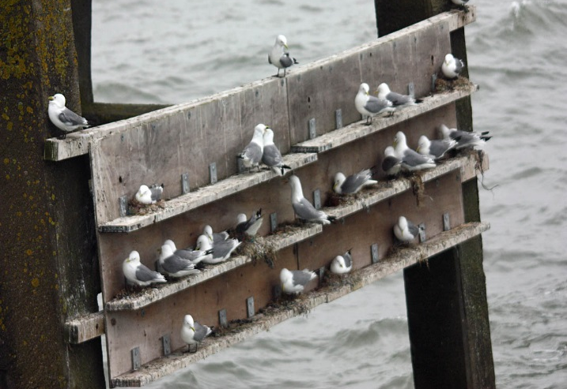
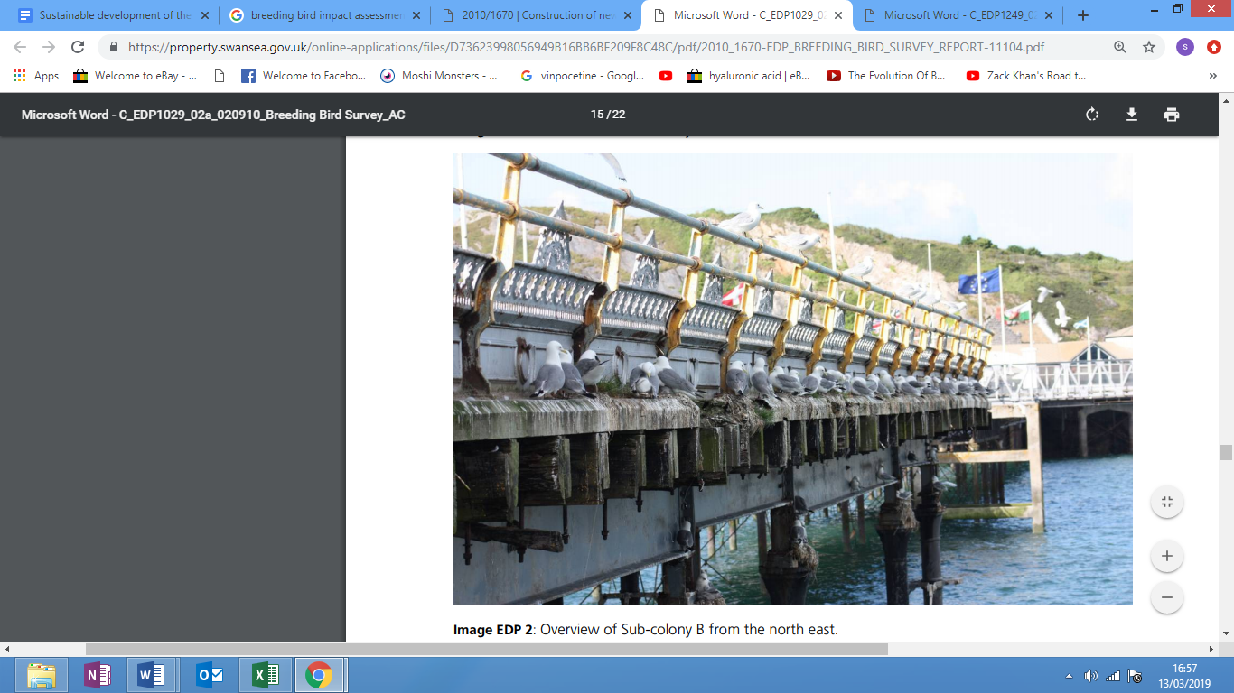
Figure 5: The new artificial ledges purposefully built and installed to the lifeboat house for use by the local breeding kittiwake (Rissa tridactyla) colony to mitigate for the temporary loss of roosting habitat (Crutchley, 2013).
Figure 6: The former ledges of the old pier structure that had been utilised by the kittiwake colony (Rissa tridactyla) (EDP, 2010a).

4.2 Consultation & use of Local Experts
The EIA comprised of 38 consultees ranging from businesses, clubs, trusts, societies, NGOs, government bodies, agencies and local authorities. Located at the entrance to the pier, Basstastic, the fishing shop, has been understanding to the disruption inflicted upon their business as a direct result of the renovation process. This is despite a decrease in annual income resulting from the loss of visiting anglers to the pier following temporary closure. Although unclear, the shop may have been given monetary compensation for this disruption through loss of trade and income.
A commercial oyster farming company, Deeplock Ltd, that operated adjacent to the pier structure had raised concerns regarding possible disruption to operations. Mitigation measures were then put in place in the form of a pledge that no construction material be left on the seabed following completion of the development (Royal Haskoning, 2010b).
Highlighted by the LPA in 2003 was the risk of a loss of sea view, which was subsequently addressed in 2010 via the creation of a LVIA (Royal Haskoning, 2010b). South West Wales Sea Fisheries Committee provided a platform for local commercial fishermen to voice concerns. Communication between the developer and fishermen was one such issue noted as needing improvement. It was requested that fishermen be informed in a more opportune manner of future renovation activities likely to cause further disruption (Royal Haskoning, 2010a).
It is also worth noting that recreational anglers were appropriately represented via the South West Wales Association of Sea Angling Clubs. It was this association that expressed the importance of retaining the existing lifeboat for its angling interests due to the subtidal and intertidal habitat present in and around the structure. It was argued, that these habitats provide an important food source for the feeding fish are the target of local anglers (Royal Haskoning, 2010b).
In regards to the inter/subtidal habitat previously mentioned, the Countryside Council for Wales raised concerns regarding its protection during development. In particular, Honeycomb worm (Sabelleria alveolata) and the reef habitat of the species create as well as native oyster that hold cultural importance to Swansea bay (Royal Haskoning, 2010b). Environment Agency (Wales) (currently Natural Resources Wales) made a suggestion that the risk of sea level rise and tidal flooding be confronted and incorporated within the design stage (Royal Haskoning, 2010b).
One of the key advocates for the protection of the resident kittiwake (Rissa tridactyla) colony was the Gower Ornithological Society. The society advised as to the optimal timing for piling activity so as not to disturb the colony during breeding season. In regards to local marine mammal species, the Gower Marine Mammals Project became a representative for the interests of protected species such as resident Harbour Porpoise (Phocoena phocoena).
All other consultees of the development not mentioned were generally pleased throughout and provided/raised no additional comment or concerns.

5. Critical Evaluation of EIA
Throughout the EIA, ambiguous wording is used - ‘negligible’, ‘anticipated’, ‘minor adverse’, ‘not likely’ - this wording makes it unclear as to the level of impact an activity could precipitate. For instance, interpretation of ‘negligible’ or ‘severe’ may vary. This is demonstrated in the EIA evaluation on the effect of the development on the site’ physical processes, stating that –
“long-term impacts on local hydrodynamics and seabed sediment movement are ‘anticipated’ to be of ‘negligible’ significance”.
The overall impact on the water and sediment quality was said to be of ‘minor adverse’ significance. Again, the method used to determine this is not provided in the text of the EIA and so is open to interpretation. Additionally, the drainage water that enters the sea from the boat cleaning activities of the lifeboat station are noted as ‘not likely’ to contain a considerable amount of chemicals which in this case highlights a lack of certainty as well as the possible effect.
The presence of important inter/subtidal species such as honeycomb worm (Sabellaria alveolata) is noted in the Environmental Statement as well as EIA, but despite this there is a statement which reads that “construction works may require access to the shoreline where areas of ‘honeycomb reef’ have been documented”, with it also being noted that the impact on this habitat is likely to be negligible.
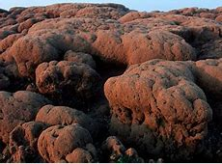
The honeycomb worm (Sabellaria alveolata) and the reefs that they then create are known to be fragile and easily damaged even from footfall (Oakley, 2017). As such, the assumption that construction works would have a negligible impact would seem to be incorrect and instead mitigation would need to be put in place to protect this UK BAP Priority Habitat (JNCC, 2014).

Figure 7: An example of honeycomb worm reef habitat (JNCC, 2014).
The kittiwake (Rissa tridactyla) colony on the Mumbles pier is the last major breeding colony on the South Wales coast. This is following the substantial decrease in breeding pair numbers at two other known breeding sites at Devil’s Tuck and Worms Head in Gower. Mitigation should aim to provide more space than previously facilitated on the old pier to support a growing number of breeding pairs to mitigate the loss of the other two breeding sites.
But instead, it was decided in the EIA that “at worst, a minor adverse impact will remain in the long-term through increased disturbance as a result of increased visitor numbers to the pier”. Given its protected status under numerous directives, protected species lists and legislation, added disturbance should not be tolerated.
Table 7: The list of all designations relating to the protection of Kittiwake (Rissa tridactyla) in the UK as well as internationally (EDP, 2010a; JNCC, 2018a) –
- OSPAR (JNCC, 2018a)
- Red Listed in Birds of Conservation Concern (JNCC, 2018a)
- EU Birds Directive (JNCC, 2018a)
- Wildlife and Countryside Act 1981 (as amended) (EDP, 2010a)
- Countryside and Rights of Way (CROW) Act 2000 (EDP, 2010a)

5.1 Recommendations
The following table contains recommendations based on the gaps identified between the EIA theory and the Mumbles pier environmental impact assessment –
- Consideration of a HIA (health impact assessment) for future proposed developments to the pier and foreshore.
- Greater transparency to the general public as to the running costs for the pier regarding continued maintenance/restoration.
- Depending on the success of the artificial ledge structure for the breeding kittiwake (Rissa trunctuata) colony there should be added provision of further ledges to accommodate a continued breeding population.
- A plan should be formulated for the recovery of machinery should an instance occur once more whereby a piece of machinery becomes stuck within the mud/sand composite.
- Fishermen using the pier should be informed regarding best practice guidelines for fishing activities on the pier i.e. barbless hooks, minimum retention sizes, use of drop nets as well as the rare species present that be encountered.

6. Conclusion
The report set out three aims/objectives, the first of which being to assess/critique the EIA of the Mumbles pier development. The first key finding was the ambiguous wording used throughout the EIA making it unclear in many cases as to the real level of impact an action would cause on the environment. The next major finding was in the poor protective measures and damaging actions that effected two such unique and protected species in the locality.
The first of which being the honeycomb worm (Sabellaria alveolata) as it was noted in the EIA that construction works may require access to the shoreline for necessary works to the pier structure and in the process may cause ‘negligible’ damage to the honeycomb reefs. It was highlighted in the report that the honeycomb reefs are known to be fragile and easily damaged by footfall which makes it highly likely that the assumption that this heavy machinery would cause ‘negligible’ damage to be false.
It was stated in the EIA that increased visitor numbers in the future would be expected to cause added disturbance to the breeding kittiwake (Rissa trunctula) colony in the long-term not just the short-term although this would be a ‘minor adverse impact’. The report highlighted that this assumption fails to recognise the importance of this colony on both a local as well as national and international level with numerous pieces of legislation, directives and protected species lists in place to protect this species.
The second aim in this report was to scrutinise the development by the examination of all archival evidence to determine whether both the human and natural environment were sufficiently protected. This was done by choosing to evaluate the following main areas – LVIA, HIA, HRA, professional and public opinion/comment, consultation process and the use of experts in the development.
Lastly, the report looked to determine under what regulations was the development subject to as well as any differences between the environmental protection afforded by old and current regulations highlighted. It was noted that the development was in accordance with the previous Town & Country Regulations (1999) rather than the amended 2016 version which had made many alterations to how these EIA regulations operate. For instance, the mandatory use of accredited professionals for ecological assessments as well as the need to consider a projects potential vulnerability to climate change.
There were some limitations also encountered. The main one of which was that there was no such document publicly available that was listed as ‘Project Development Document’ which meant that no comparison could be made between this and the EIA/ES.
Instead, following an informal discussion with Allan Nantel, it was decided that all documents closely resembling this missing document would be scrutinised instead and so it was the planning statement which proved to be of principal use in critiquing and comparing.
To conclude the pier owners and all consultancy firms hired during the development took due consideration for the majority of their actions with the many of the mistakes that had been made only having been spotted following intense scrutiny of all relevant archival material.
It should also be noted that given that at the time of writing (early 2019) many of the legislations/regulations that would have influenced the development have since been updated and as such it should be considered that given the current rules in place at the time of the development taking place, it was in fact at the time a very thorough and well-thought out assessment of the site as a whole in the consideration of the effect on both the human and natural environment.

7. References:
AECOM (2014) Seaham North Pier Environmental Impact Assessment: Non-Technical Summary. Altrincham: AECOM Ltd. Available at: https://www.iema.net/assets/nts/Aecom/Seaham_North_Pier_NTS_January_2014.pdf (Accessed: 12 April 2020).
Beanlands, E. G. & Duinker, N. P. (1983) An Ecological Framework for Environmental Impact Assessment in Canada. Halifax: Institute for Resource and Environmental Studies. Available at: https://www.researchgate.net/profile/Peter_Duinker/publication/236399538_An_Ecological_Framework_for_Environmental_Impact_Assessment_in_Canada/links/5919969d4585159b1a4b8060/An-Ecological-Framework-for-Environmental-Impact-Assessment-in-Canada.pdf (Accessed: 11 April 2020).
Bond, A.J., Fundingsland, M & Tromans, S. (2016) ‘Environmental impact assessment and strategic environmental assessment in the UK after leaving the European Union’, Impact Assessment and Project Appraisal, 34(3), pp. 271-274.
Burges Salmon, (2017) New Environmental Impact Assessment Regulations – what are the key changes Available at: https://www.burges-salmon.com/news-and-insight/legal-updates/environmental-impact-assessment-regulations/ (Accessed: 17 February 2020).
Caldwell, L.K., (1988) ‘Environmental impact analysis (EIA): origins, evolution, and future directions’, Impact Assessment 6(1), pp. 75–83. https://doi.org/10.1080/07349165.1988.9725648.
Carmarthen Bay & Estuaries European Marine Site, (2020) Carmarthen Bay SPA. Available at: http://english.cbeems.org/the-ems/carmarthen-bay-spa/ (Accessed: 1 April 2020).
Cashmore, M. (2003) ‘The role of science in environmental impact assessment: process and procedure versus purpose in the development of theory’, Environmental Impact Assessment Review’, 24(1), pp. 403-426.
Cashmore, M., Gwillam., R., Morgan, R., Cobb, D & Bond, A. (2004) ‘The interminable issue of effectiveness: substantive purposes, outcomes and research challenges in the advancement of environmental impact assessment theory’, Impact Assessment and Project Appraisal, 22(4), pp. 295-310, DOI:10.3152/147154604781765860
Ecological Survey & Assessment, (2016) Habitats Regulations Assessment (HRA) and Appropriate Assessment (AA). Available at: http://www.ecosa.co.uk/survey-and-assessment-services/habitats-regulations-assessment-hra/#.XH02RaL7TIU (Accessed: 4 March 2020).
Erikson, P.A. (2016) Environmental impact assessment. Principles and applications, New York: Academic Press, Inc.
European Commission (2019) Strategic Environmental Assessment – SEA. Available at: https://ec.europa.eu/environment/eia/sea-legalcontext.htm (Accessed: 10 April 2020).
Fischer, B.T., Jha-Thackur, U & Hayes, S. (2016) ‘Environmental Impact Assessment & Strategic Environmental Assessment Research in the UK’, Journal of Environmental Assessment Policy and Management, 17(1), pp. 1-12. DOI:10.1142/S1464333215500167
Friends of the Earth (2017) Environmental Impact Assessment: Campaigner’s Guide. Available at: https://cdn.friendsoftheearth.uk/sites/default/files/downloads/EIA%20campaigners%20guide.pdf (Accessed: 11 April 2020).
Glasson, J, Therivel, R. & Chadwick, A. (1999) Introduction to environmental impact assessment: principles and procedures, process, practice and prospects. London: UCL Press.
Glasson, J., Therivel, R & Chadwick A. (2012) Introduction to environmental impact assessment. London: Routledge.
Gromley, A., Pollard, S & Rocks, S. (2011) ‘Guidelines for Environmental Risk Assessment’, Bedford: Department for Environment, Food, and Rural Affairs. Available at: http://www.fwr.org/WQreg/Appendices/Green_Leaves_3_pb13670-green-leaves-iii-1111071.pdf (Accessed: 14 April 2020).
House, C, (2018) Conversation regarding the origins of the Town & Country Planning Regulations. Shane Thomas, 14 December.
IEMA, (2017) The Marine Works (Environmental Impact Assessment) (Amendment) Regulations 2017. Available at: https://transform.iema.net/article/marine-works-environmental-impact-assessment-amendment-regulations-2017 (Accessed: 27 February 2020).
International Institute for Sustainable Development, (2020) EIA Timeline. Available at: https://www.iisd.org/learning/eia/eia-essentials/timeline/ (Accessed: 27 February 2020).
International Union for Conservation of Nature (2020) General Principles of EIA. Available at: https://www.iucn.org/sites/dev/files/import/downloads/eia_principles.pdf (Accessed: 12 April 2020).
ITP Energised, (2018) EIA Directive 2014/52/EU Transposition into UK Law in 2017. Available at: http://www.itpenergised.com/eia-directive-20152eu-transposition-uk-law-2017/ (Accessed: 18 February 2019).
Jay, S., Jones, C., Slinn, P & Wood, C. (2007) ‘Environmental impact assessment: Retrospect and prospect’, Environmental Impact Assessment Review, 27(1), pp. 287–300.
Joint Nature Conservation Committee, (2014) Honeycomb worm (Sabellaria alveolata) reefs. Available at: http://jncc.defra.gov.uk/page-6019 (Accessed: 23 March 2019).
Joint Nature Conservation Committee, (2018a) Black-legged kittiwake (Rissa tridactyla). Available at: http://jncc.defra.gov.uk/page-2889 (Accessed: 23 March 2020)
Joint Nature Conservation Committee, (2018b) The Conservation of Habitats and Species Regulations 2017. Available at: http://jncc.defra.gov.uk/page-1379 (Accessed: 4 March 2020).
Kasperson, J.X & Kasperson, R.E. (2013) ‘Global Environmental Risk’, Routledge: New York.
Kassim, A.T & Simoneit, T.R.B. (2005) ‘Environmental Impact Assessment: Principles, Methodology and Conceptual Framework’, Water Pollution, pp. 1-57.
Kominkova, D. (2016) Environmental Impact Assessment and Application, Prague: Czech University of Life Sciences Prague.
Landscape Institute, (2017) New Environmental Impact Assessment Regulations expand scope. Available at: https://www.landscapeinstitute.org/news/eia-regulations-expand-scope/ (Accessed: 17 February 2020).
Marine Management Organisation, (2018) Marine Licensing: impact assessments. London: Marine Management Organisation. Available at: https://www.gov.uk/guidance/marine-licensing-impact-assessments (Accessed: 27 February 2020).
Middle, G & Middle, I (2010) ‘The inefficiency of environmental impact assessment: reality or myth?’, Impact Assessment and Project Appraisal, 28(2), pp. 159-168, DOI:10.3152/146155110X498825
Ministry of Housing, Communities & Local Government, (2020) Environmental Impact Assessment. Available at: https://www.gov.uk/guidance/environmental-impact-assessment (Accessed: 1 April 2020).
Morgan, R.K. (2012) ‘Environmental impact assessment: The state of the art’, Impact Assessment Project Appraisal, 30(1) pp. 5–14.
Morris, P. & Therivel, R. (2001) Methods of Environmental Impact Assessment. 2nd edn. London: Spon Press.
Mumbles Pier Project (2020) Timeline. Available at: http://www.mumblespierproject.com/timeline.php (Accessed: 5 April 2020).
Mumbles Pier Project, (2018) Mumbles Pier. (Facebook). 7 November. Available at: https://scontent-lhr3-1.xx.fbcdn.net/v/t1.0-9/48405235_285384592126738_8227716300298780672_n.jpg?_nc_cat=101&_nc_ht=scontent-lhr3-1.xx&oh=a0325d9d2e6da088d7da1e11916da744&oe=5CECE57A (Accessed: 1 February 2020).
Munn, R (1979) Environmental impact assessment: principles and procedures. Chichester: Wiley.
National Piers Society (2018) Mumbles Pier: History. Available at: https://piers.org.uk/pier/mumbles/ (Accessed: 15 February 2019).
Natural England (2017) Habitats Regulations Assessment (HRA) Standard. Available at: http://publications.naturalengland.org.uk/publication/8740045 (Accessed: 11 April 2020).
Noble, F.B. (2006) Introduction to Environmental Impact Assessment: A Guide to Principles & Practice, Toronto: Oxford University Press Canada.
Noble, F.B. (2019) ‘Strategic Environmental Assessment’. Canadian Encyclopedia. Toronto: Historica Canada.
Oakley, J, Stewart, B. & Jenkins, S. (2010) Visit Swansea Bay. [Online Poster]. Available at: file:///C:/Users/caine/Downloads/Swansea_Bay_-_wildlife_on_your_doorstep%20(3).pdf (Accessed: 28 February 2020).
Open Spaces Society (2012) Protect The Common Land at Mumbles Pier. Available at: https://www.oss.org.uk/protect-the-common-land-at-mumbles-pier/ (Accessed: 22 February 2020).
Public Health Network Cymru (2020) Health Impact Assessment. Available at: https://www.publichealthnetwork.cymru/en/topics/health-impact-assessment/ (Accessed: 4 March 2020).
Roberts, P. & Holmes, P (2012) Sustainability Appraisal and Strategic Environmental Assessment – Scoping Report. Swansea: Swansea Council.). Available at: https://www.swansea.gov.uk/ldpsasea (Accessed: 28 February 2020)
Royal Haskoning (2010a) Mumbles Pier Lifeboat Station: Marine Ecological Intertidal Survey. Exeter: Haskoning UK Ltd Environment. Available at: https://property.swansea.gov.uk/online-applications/files/0D1BC37B42D22858C472D8DD5A83FE34/pdf/2010_1670-MARINE_ECOLOGICAL_INTERTIDAL_SURVEY-12908.pdf (Accessed: 27 February 2020).
Royal Haskoning (2010b) RNLI Lifeboat Station and Pier Refurbishment Mumbles, Swansea Environmental Statement. Exeter: Haskoning UK Ltd Environment. Available at: file:///C:/Users/caine/Downloads/Mumbles%20ES%20Final%20(1).pdf (Accessed: 27 February 2020).
Savills (2010) Mumbles Pier and Foreshore Redevelopment: Planning Statement Cardiff: Savills https://property.swansea.gov.uk/online-applications/files/A258EF589F06215FF7FC4CB1E7EEA289/pdf/2010_1451-FINAL_PLANNING_STATEMENT-13052.pdf
Scottish Natural Heritage (2017) Habitats Regulations Appraisal (HRA). Available at: https://www.nature.scot/professional-advice/planning-and-development/environmental-assessment/habitats-regulations-appraisal-hra (Accessed: 4 March 2020).
Secretariat of the Convention on Biological Diversity (2019) What is Impact Assessment? Available at: https://www.cbd.int/impact/whatis.shtml (Accessed: 10 April 2020).
Silva, A., Selig, M.P., Leripio, A.A & Viegas, C. (2014) ‘Strategic environmental assessment: one concept, multiple definitions’, International Journal of Innovation and Sustainable Development, 8(1), pp. 53-76. DOI: 10.1504/IJISD.2014.059222
Swansea Council (2016) Swansea Local Development Plan. Swansea: Swansea Council – Strategic Planning Team. Available at: https://www.swansea.gov.uk/ldpsasea (Accessed: 27 February 2020).
Swansea Council (2019) LDP sustainability appraisal/strategic environmental assessment. Available at: https://www.swansea.gov.uk/ldpsasea (Accessed: 27 February 2020).
The Environmental Dimension Partnership (2010a) Breeding Bird Impact Assessment. Cirencester: The Environmental Dimension Partnership, Available at: https://property.swansea.gov.uk/online-applications/files/0420F66FD4CADC8E8B6B2780051A8C04/pdf/2010_1670-EDP_BREEDING_BIRD_IMPACT_ASSESSMENT-36236.pdf (Accessed: 28 February 2020).
The Environmental Dimension Partnership (2010b) Landscape and Visual Impact Assessment. Cirencester: The Environmental Dimension Partnership Ltd. Available at: https://property.swansea.gov.uk/online-applications/files/3A420DF65A631E189549F166A010A391/pdf/2010_1670-EDP_LVIA_REPORT-11105.pdf (Accessed: 28 February 2020).
The Landmark Practice (2018) 2017 EIA Regulations: where we stand in 2018. Available at: https://thelandmarkpractice.com/2017-eia-regulations/ (Accessed: 17 February 2020).
The Planning Inspectorate (2017) Habitats Regulations Assessment. Available at: https://infrastructure.planninginspectorate.gov.uk/wp-content/uploads/2015/06/Advice-note-10v4.pdf (Accessed: 11 April 2020).
The University of Southampton (2004) Origins and History of Environmental Assessment (EA). Available at: http://generic.wordpress.soton.ac.uk/gem/unit-2/2-1-origins-and-history-of-environmental-assessment-ea/ (Accessed: 26 March 2020)
Therivel, R. (1992) Strategic environmental assessment. London: Earthscan.
Therivel, R. (2004) Strategic environmental assessment in action. Sterling: Earthscan.
Tilt, A. (2011) Mumbles Pier Redevelopment. Available at: http://www.mylifeoutside.co.uk/2011/06/mumbles-pier-redevelopment.html (Accessed: 22 March 2020).
UK Industrial Services (2020) UK Industrial Services - Mumbles Pier [Video]. Available at: https://www.youtube.com/watch?v=GA0DmW7-P0w (Accessed: 10 April 2020).
Ulibarri, N., Scott, A.T. & Perez-Figueroa, O. (2019) ‘How does stakeholder involvement affect environmental impact assessment?’, Environmental Impact Assessment Review, 79(1).
United Nations (2020) United Nations Conference on the Human Environment (Stockholm Conference). Available at: https://sustainabledevelopment.un.org/milestones/humanenvironment (Accessed: 10 April 2020).
University of Nairobi Research Archive (2015) Environmental Impact Assessment. Available at: http://erepository.uonbi.ac.ke/handle/11295/55960 (Accessed: 4 April 2020).
Wathern, P. (1988) ‘Environmental Impact Assessment: Theory and Practice’, London: Allen & Undwin.
Watson, D. (2003) ‘Guidelines for Landscape and Visual Impact Assessment’, 3rd edn. London: Spon Press.
Wilson, J., Hinz, S., Coston-Guirani, J.,Mazille, C,. Guarini, J.M. (2017) ‘System-Based Assessments—Improving the Confidence in the EIA Process’ Environments, 4(4), pp. 95.
World Health Organisation (2020) Health Impact Assessment (HIA). Available at: https://www.who.int/hia/en/ (Accessed: 4 March 2020).
Wright, J.A., Dolman, J.S., Jasny, M & Parsons, M.C.E. (2013) ‘Myth and Momentum: A Critique of Environmental Impact Assessments’, Journal of Environmental Protection, 4(1) pp. 72-77.

8. Appendices
- Wales Spatial Plan (2004/2008)
- Planning Policy Wales (PPW)
- TAN 5, 8, 12, 13, 14, 15, 18 and 22 (TAN – Technical Advisory Notice)
Table 4: The site was subject to the following national planning policy documents (Savills, 2010) –

Table 5: Local Planning Policy Documents (Savills, 2010) –
- City & County of Swansea Unitary Development Plan (2008)
- Gower Management Plan (2006)
- Mumbles Pier & Foreshore Development Framework (April 2009)
- Swansea Bay Shoreline Management Plan (2001)
- Swansea Bay Strategy (2007)
- Swansea Environment Strategy (2006)
- Swansea Tourism Strategy (2006)
- Wales Coastal Tourism Strategy (2008)

Table 6: The planning statement much like the EIA highlights the sensitive nature of the site throughout the document, particularly regarding the following (Savills, 2010) –
- The proximity to the Blackpill & Bracelet Bay SSSIs
- The proximity of the Mumbles Hill Local Nature Reserve
- The adjacent Gower AONB; and
- The potential for marine and terrestrial biodiversity/habitat loss

