Analysing Academic in Employability Skills In Light Of Indented Career

Presented by Violeta Ilieva Kadieva
Student Number: 2030487

Lecturer: Joanna Walsh
Module Code: BMSW4001

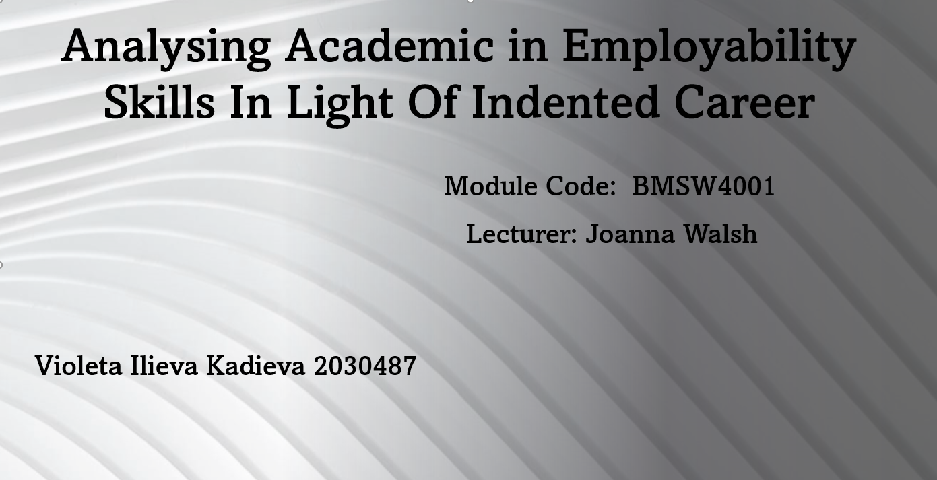

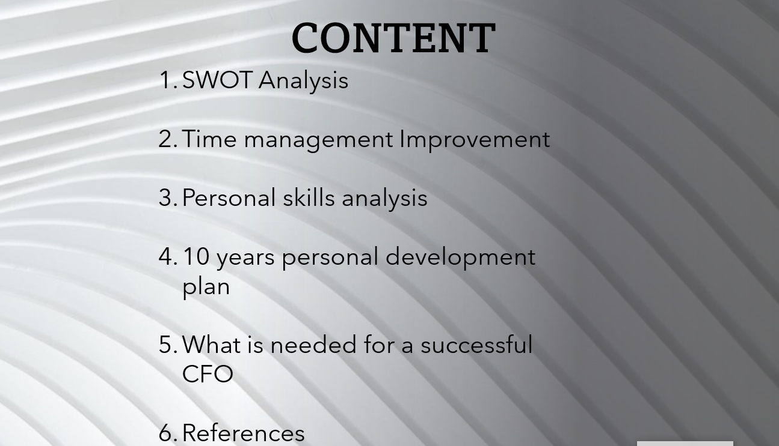

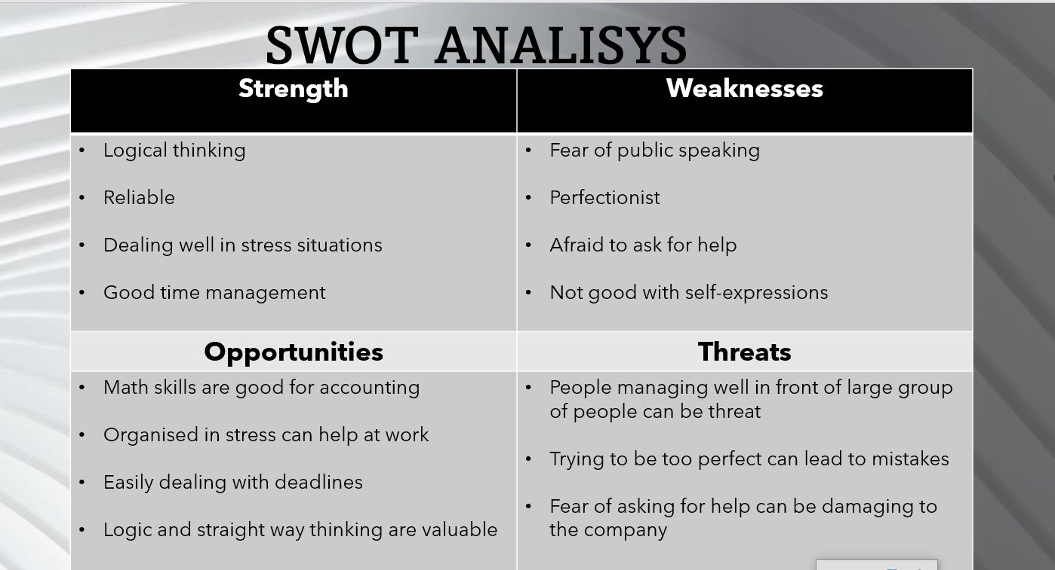

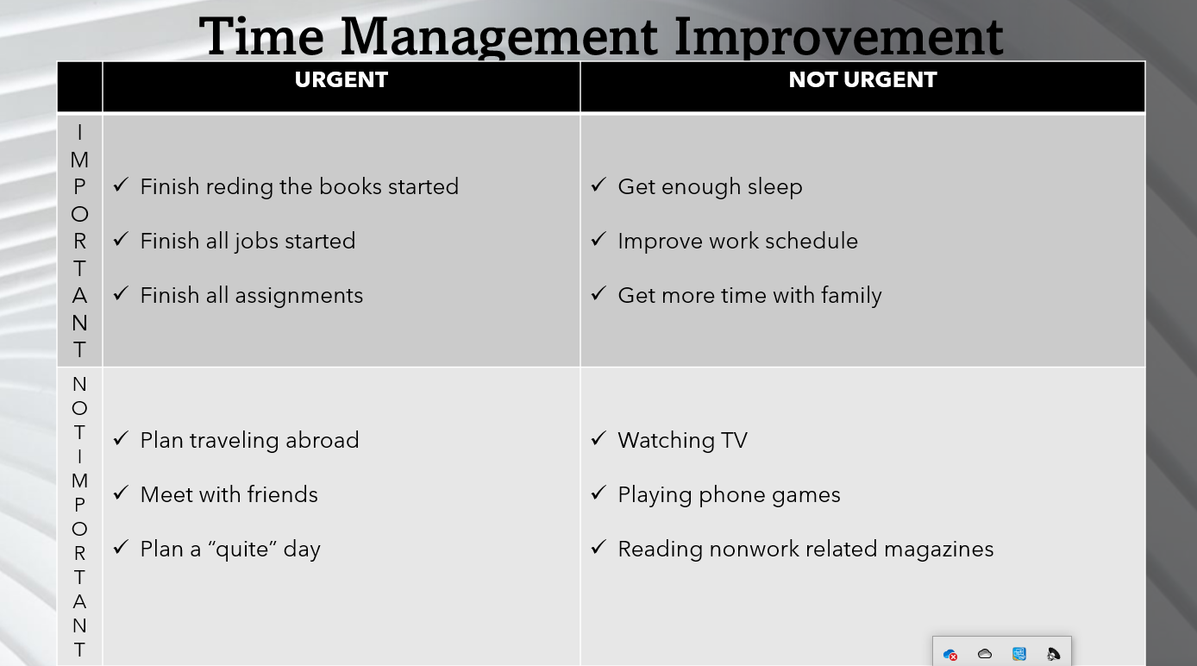

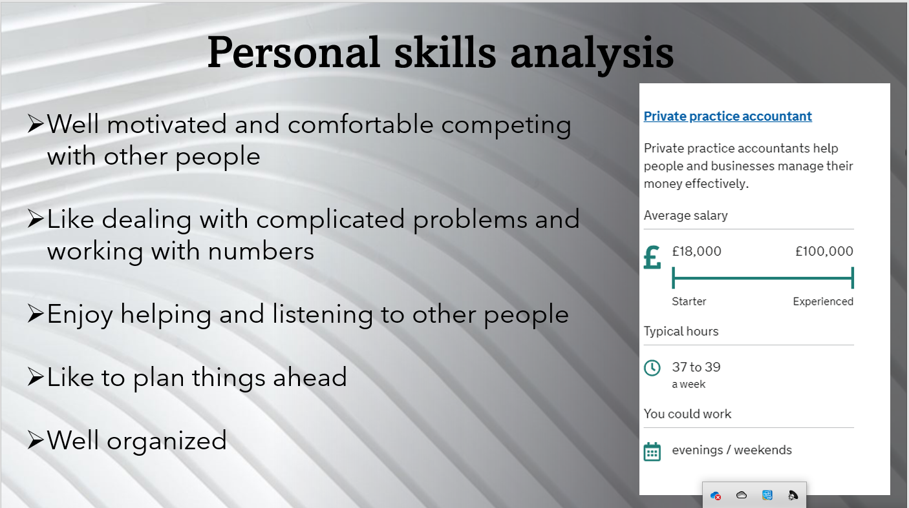

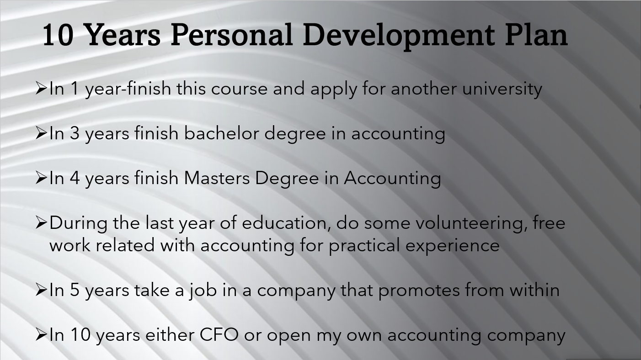

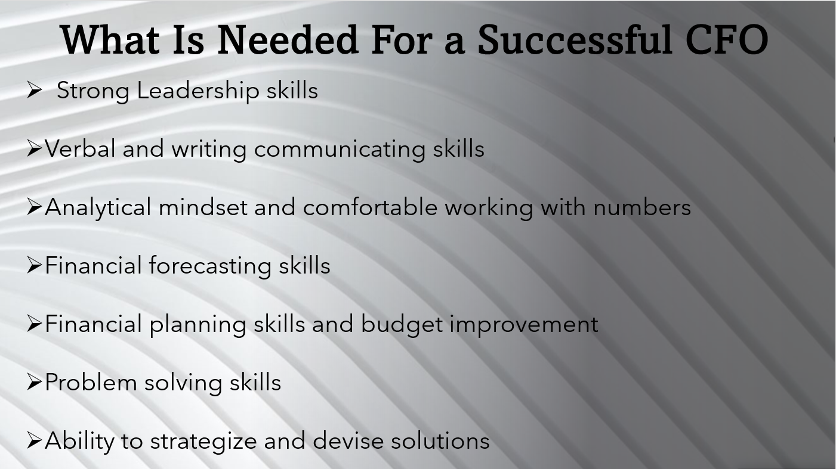

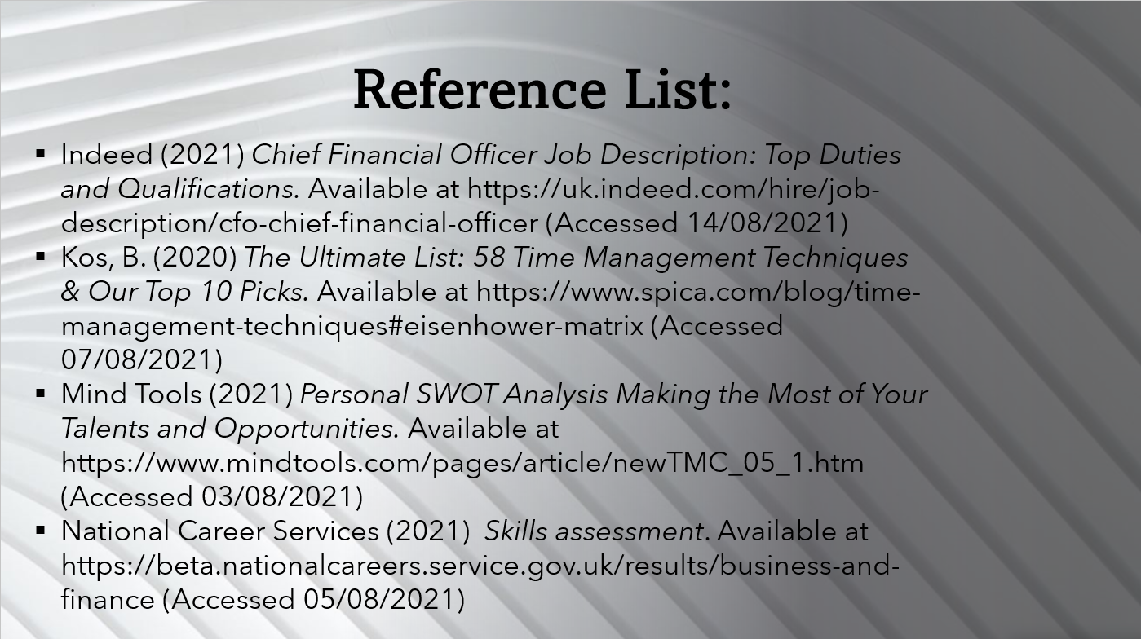

Reference List:
Indeed (2021) Chief Financial Officer Job Description: Top Duties and Qualifications. Available at https://uk.indeed.com/hire/job-description/cfo-chief-financial-officer (Accessed 14/08/2021)
Kos, B. (2020) The Ultimate List: 58 Time Management Techniques & Our Top 10 Picks. Available at https://www.spica.com/blog/time-management-techniques#eisenhower-matrix (Accessed 07/08/2021)
Mind Tools (2021) Personal SWOT Analysis Making the Most of Your Talents and Opportunities. Available at https://www.mindtools.com/pages/article/newTMC_05_1.htm (Accessed 03/08/2021)
National Career Services (2021) Skills assessment. Available at https://beta.nationalcareers.service.gov.uk/results/business-and-finance (Accessed 05/08/2021)

