Asthma Education Report for Adolescent Patients
Within our local GP surgery, there has been a growing concern among the clinical team about a noticeable increase in adolescent patients experiencing more frequent and severe asthma attacks. Many of these young people were initially diagnosed with asthma during childhood and had previously maintained relatively stable symptoms. However, recent appointments have highlighted a significant decline in their asthma control, prompting the practice nurse team and GP leads to collaborate and investigate potential causes. Their goal was to develop effective strategies to better support this vulnerable group.
Through multidisciplinary team meetings, it became clear that the lifestyle changes typical of adolescence play a major role in influencing respiratory health outcomes. As teenagers gain more independence in managing their health, they are also exposed to a range of environmental and behavioural risk factors. These include experimenting with smoking and vaping, inconsistent use of prescribed preventer medications, irregular sleep patterns, and frequenting crowded social venues such as bars, clubs, and parties, where exposure to smoke, vapor, and respiratory infections is heightened.
Further discussions during clinic consultations revealed a common theme: many adolescents have a limited understanding of how asthma affects their lungs and how their daily choices directly impact their breathing and symptom control. Several patients admitted to only using their inhalers when symptoms became severe, often unaware of early warning signs that indicate worsening airway inflammation. This lack of knowledge was identified as a significant barrier to effective engagement with personalized asthma management plans.
In response to these findings, the practice established a dedicated adolescent asthma clinic held every two weeks, jointly led by a GP and a practice nurse. The primary aim of this clinic is to provide targeted education, improve self-management skills, and encourage young people to take an active role in monitoring and managing their respiratory health. The clinic emphasizes clear explanations about how the respiratory system functions, including how oxygen and carbon dioxide are exchanged in the lungs, and the ways in which smoking, vaping, and infections contribute to airway inflammation. This educational approach is seen as essential for improving health outcomes in this age group.
This report has been developed as an educational resource to support adolescent patients attending the clinic. It is designed to help them better understand their condition and empower them to manage their asthma more safely and effectively. By providing accessible information and practical guidance, the resource aims to foster greater awareness and responsibility among young people, ultimately leading to improved asthma control and quality of life.
Asthma is a long-term inflammatory condition affecting the airways, causing repeated episodes of wheezing, shortness of breath, chest tightness, and coughing, especially during the night or early morning. This inflammation makes the bronchial tubes overly sensitive, leading them to narrow and restrict airflow. Although the exact cause is complex, asthma generally arises from a mix of genetic factors and environmental exposures. Important risk factors include having a family history of asthma or allergies, exposure to triggers like tobacco smoke, air pollution, and allergens such as dust mites or pollen, as well as a history of serious respiratory infections early in life. Offering patients clear and easy-to-understand information about how their respiratory system works and the risks it faces is essential for effective self-care.
Additionally, occupational exposures to chemicals or irritants and lifestyle factors such as obesity and stress may contribute to the severity and frequency of asthma attacks. Understanding these risk factors is essential for effective management and prevention strategies.
Asthma is a long-term inflammatory condition of the airways, marked by narrowing of the airways, increased mucus production, and heightened sensitivity of the bronchial tubes. These changes lead to symptoms like wheezing, difficulty breathing, chest tightness, and coughing, which can vary in how often and how severe they are.
In asthma, the airways react strongly to certain triggers, causing inflammation and tightening of the bronchial muscles, which restricts airflow to and from the lungs. While asthma often starts in childhood, symptoms can worsen during adolescence due to changes in lifestyle and environmental factors.
Factors that can increase the chances of asthma flare-ups include:
- Smoking and being around second-hand smoke
- Vaping or breathing in aerosolized chemicals
- Respiratory infections like colds and flu
- Exposure to air pollution and irritants in the environment
- Allergens such as dust mites, pollen, and pet dander
- Physical activity without using an inhaler properly
- Breathing in cold air
- Not following prescribed treatment plans consistently
Adolescents are especially at risk because as they become more independent, they might not stick to their medication routines and may be exposed to more triggers, like crowded social settings.
Gas exchange in the lungs:
Gas exchange takes place in the alveoli, which are tiny air sacs surrounded by a network of capillaries. When you breathe in, oxygen-rich air fills the alveoli. Oxygen then moves across the thin walls of the alveoli into the blood by diffusion, moving from an area of higher oxygen concentration in the alveoli to a lower concentration in the blood.
Once in the blood, oxygen binds to haemoglobin in red blood cells, which carries it throughout the body to be used by tissues and organs. At the same time, carbon dioxide, a waste product produced by cells, moves from the blood (where its concentration is higher) into the alveoli (where its concentration is lower) to be exhaled out of the body.
Finally, when you breathe out, the carbon dioxide is expelled from the lungs into the air outside. This continuous process of oxygen entering the blood and carbon dioxide leaving helps keep the body’s cells supplied with oxygen and removes waste efficiently.
this is essential for maintaining the body’s respiratory function and overall metabolism. In conditions like asthma, narrowed airways can affect airflow and gas exchange efficiency, especially during an attack.
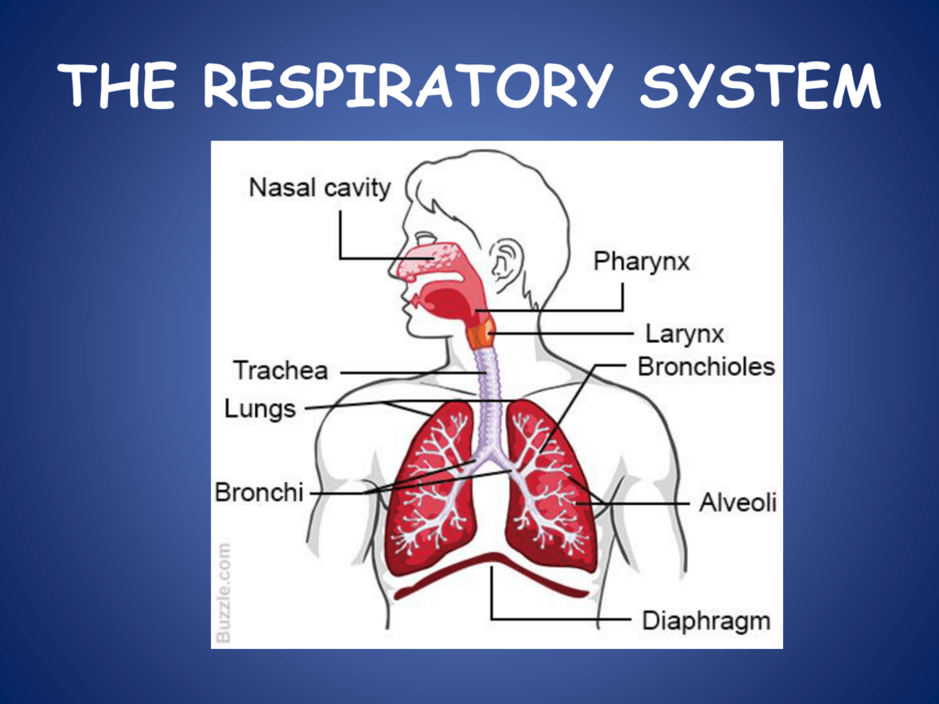

The respiratory system is made up of the upper and lower airways that let air enter the lungs and enable gas exchange.
The main parts include:
- Nose and nasal cavity – which filter, warm, and moisten the air
- Pharynx – a passage connecting the nose and mouth to the airway
- Larynx – holds the vocal cords and protects the airway
- Trachea – the windpipe that carries air to the lungs
- Bronchi – the main airways that enter each lung
- Bronchioles – smaller branches of the airways
- Alveoli – tiny air sacs where gas exchange happens
- Lungs – the organs that carry out respiration
- Diaphragm and intercostal muscles – muscles that control breathing
Mechanical respiration is the physical process of moving air in and out of the lungs.
During inhalation (breathing in):
- The diaphragm contracts and flattens
- The intercostal muscles lift the rib cage up and out
- The thoracic cavity gets bigger
- Pressure inside the lungs drops
- Air flows into the lungs
During exhalation (breathing out):
- The diaphragm relaxes and moves upward into a dome shape
- The rib cage moves down
- The lung volume decreases
- Pressure inside the lungs rises
- Air is pushed out
In asthma, the airways become narrowed, making it especially hard to breathe out. This causes air to get trapped in the lungs and leads to breathlessness.
When irritants like smoke, dust, or chemicals enter the respiratory system, they trigger the body’s immune response. The cells lining the airways detect these harmful particles and release chemicals called histamines and other inflammatory mediators. These chemicals cause the blood vessels in the lung tissue to widen and become more permeable, allowing immune cells and fluid to move into the tissue. This leads to swelling (inflammation) of the lung tissue and the lining of the airways.
This swelling narrows the airways, making it harder for air to pass through. It also causes increased mucus production, which can further block airflow. As a result, less oxygen reaches the alveoli (tiny air sacs where gas exchange happens), and carbon dioxide removal is reduced. This makes breathing more difficult, reduces oxygen supply to the body, and can cause symptoms like shortness of breath, wheezing, and coughing.
In summary, increased irritants cause inflammation and swelling in the lungs, which narrows airways and impairs efficient breathing and gas exchange.
Recording and tracking respiratory functions, such as peak flow readings, is very useful for individuals with asthma because it provides a clear, objective way to monitor lung function over time. Peak flow meters measure the maximum speed at which a person can exhale, which reflects how open or narrowed their airways are. By regularly measuring and recording these readings, people with asthma can identify changes or declines in their breathing capacity early, often before they notice any symptoms like coughing or shortness of breath.
This early detection allows them to take timely action, such as using their rescue inhaler, adjusting their medication as advised by their doctor, or avoiding known asthma triggers. It also helps healthcare providers understand how well the asthma is controlled and whether treatment plans need to be adjusted. Overall, tracking peak flow readings empowers individuals to manage their asthma more safely and effectively, reducing the risk of severe asthma attacks and improving their quality of life.
Lifestyle changes can play a significant role in improving asthma management, supported by strong evidence from medical research.
First, avoiding exposure to asthma triggers is crucial. Common triggers include tobacco smoke, dust mites, pet dander, Mold, pollen, and air pollution. Reducing contact with these can help prevent asthma attacks. For example, quitting smoking or avoiding smoky environments has been shown to improve lung function and reduce symptoms.
Second, engaging in regular physical activity can benefit lung health and overall fitness. Exercise helps strengthen respiratory muscles and improve cardiovascular health. However, it’s important to choose activities that are well-tolerated and to use preventive measures (like pre-exercise inhalers) if exercise-induced asthma is a concern.
Maintaining a healthy weight is also recommended because obesity is linked to increased asthma severity and poorer control. Losing excess weight through a balanced diet and exercise can reduce inflammation and improve breathing.
Stress management techniques, such as mindfulness, yoga, or relaxation exercises, have been shown to reduce asthma flare-ups. Stress can worsen asthma symptoms, so managing it can have a positive impact.
Finally, a diet rich in fruits, vegetables, and omega-3 fatty acids may help reduce airway inflammation. Some studies suggest that antioxidants and anti-inflammatory nutrients support better asthma control.
In summary, evidence-based lifestyle changes like avoiding triggers, exercising regularly, maintaining a healthy weight, managing stress, and eating a nutritious diet can all contribute to better asthma control and improved quality of life.
In conclusion, helping adolescents with asthma understand how their respiratory system works is key to improving their health outcomes. Explaining how oxygen is absorbed into the blood and carbon dioxide is expelled helps them appreciate the importance of keeping their lungs healthy. Smoking, vaping, and exposure to respiratory infections can damage the delicate airways, increase inflammation, and reduce lung function, leading to more frequent and severe asthma exacerbations.
Encouraging patients to avoid these harmful habits and environments is essential for preventing flare-ups and maintaining good respiratory health. Additionally, teaching them the importance of recording and tracking their respiratory data, such as peak flow measurements, empowers them to monitor their lung function regularly. This self-monitoring helps detect early signs of worsening asthma, allowing timely adjustments to treatment and avoiding emergency situations.
By engaging actively with their care plans and understanding the impact of lifestyle choices on their condition, adolescents can take greater control over their asthma. This knowledge fosters better communication with healthcare professionals and promotes adherence to medication and management strategies. Ultimately, combining education, lifestyle changes, and regular monitoring leads to improved asthma control, fewer hospital visits, and a better quality of life for these young patients. This approach supports their transition into adulthood with a strong foundation for managing their respiratory health safely and effectively.
In the asthma clinic, it’s important to educate adolescents about how their lungs work explaining that oxygen enters the blood through tiny air sacs called alveoli, while carbon dioxide is removed from the blood and breathed out. Smoking, vaping, and exposure to infections damage the lungs, making asthma worse by increasing inflammation and narrowing airways.
Helping patients understand this encourages them to avoid these harmful habits and environments. It’s also vital to teach them how to record and track their respiratory data, like peak flow readings, so they can monitor their lung function regularly. This helps catch early signs of worsening asthma, allowing timely action to prevent serious attacks and manage their condition better. Overall, this knowledge empowers adolescents to take control of their asthma and improve their respiratory health safely.

REFERANCES
Asthma, teenagers and young people | Asthma + Lung UK
Structure and function of the gas exchange system - Respiration and gas exchange - KS3 Biology - BBC Bitesize
Pulmonary Inflammation: Causes, Symptoms, and Treatment - Biology Insights
Peak flow test - NHS
NG245 Asthma: Evidence review M for pulmonary function monitoring in asthma
Lifestyle and wellbeing | Topic | NICE
Strategies to Help Patients Make Sustainable Lifestyle Changes | The Institute for Functional Medicine
13.2 Structure and Function of the Respiratory System – Human Biology

