DS 1 Template

My Screenshots/Photos
- Please add 4–6 screenshots or photos of your digital life.
- You can use your phone or laptop.
- For each screenshot, write one or two sentences explaining what it shows.

Screenshot/Photo 1
[Insert Photo/Screenshot below]
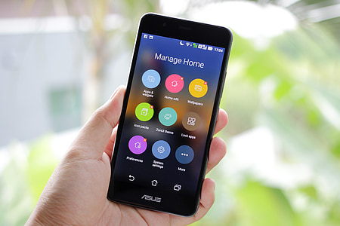
[Write what this shows of your digital life]
In last few years , my mobile phone started to became an important part of my life. I am using it for paying shopping by paying contactless everywhere , I am using it in place of GPS and maps for driving and traveling in places which are unknown , I am using it sometimes even for entertainment and I am using it also for communication with friends and relatives. I can use it in my life in so many ways that’s why became very important tool.

Screenshot/Photo 2
[Insert Photo/Screenshot below]
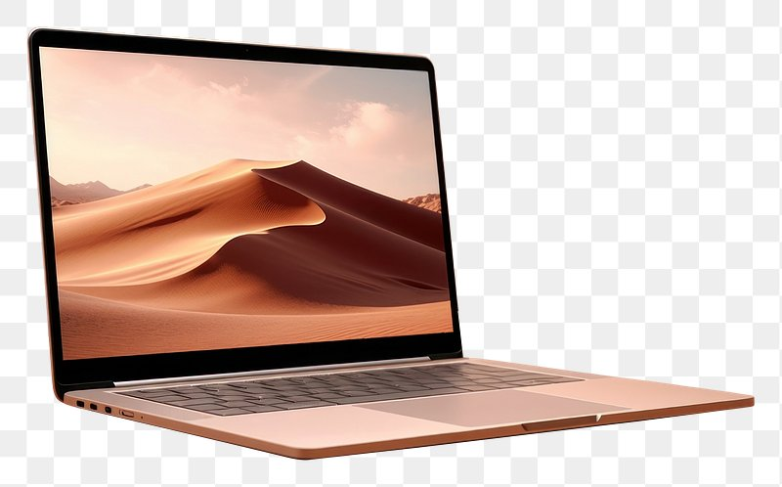
[Write what this shows of your digital life]
I am using my laptop in many ways for example for education , I get access to a lot of informations by using it like reading books , watching podcasts , completing assessments and tasks. I am using it also for entertainment ,I am playing games on it to have fun (counter-strike, my favourite game) , I am using it also for applies and requests from different institutions (NHS, DVLA ,etc)

Screenshot/Photo 3
[Insert Photo/Screenshot below]
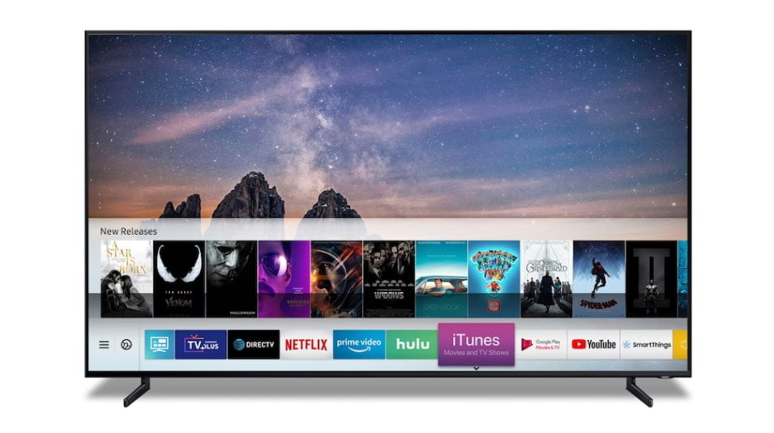
[Write what this shows of your digital life]
I am using my smart television most of the times for watching sports for example football games from champions league , fighting matches (box and ufc) . I am using it as a tool to relax myself in the evenings watching shows also on Netflix and movies.

Screenshot/Photo 4
[Insert Photo/Screenshot below]
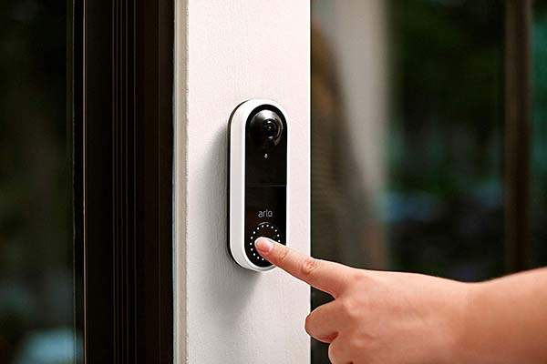
[Write what this shows of your digital life]
I am using the doorbell for protection of the house even when I am away. In this way I can see ,hear and speak to whoever is in front of my door without being physically at home. The doorbell with built-in camera gives you a direct feed , day or night , of what’s going on at home. As a downside about doorbell cameras is that they have limited coverage and the camera needs to be connected all the time at internet.

Screenshot/Photo 5
[Insert Photo/Screenshot below]
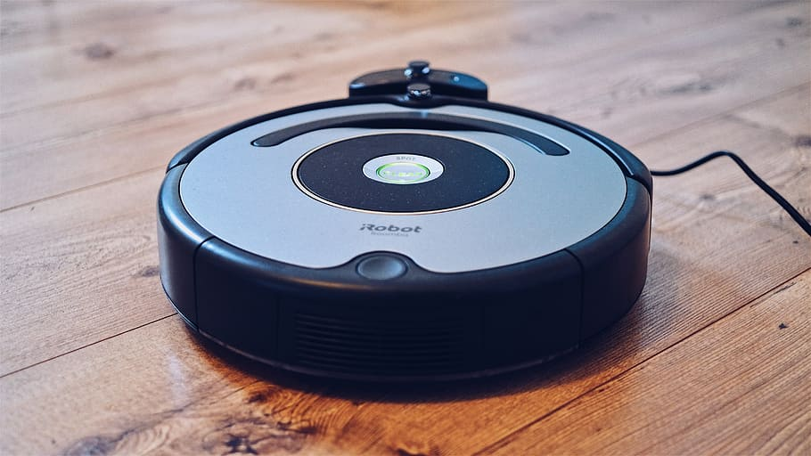
[Write what this shows of your digital life]
I am using the smart vacuum in my life for cleaning my house easier. A house cleaning robot gives me the freedom to clean without lifting a finger. He handles the daily messes for me.

Screenshot/Photo 6
[Insert Photo/Screenshot below]
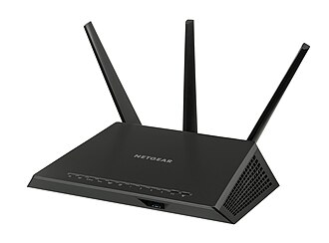
[Write what this shows of your digital life]
I have this in my house because is needed for connection to internet . Without it , I can’t use my smart tv , laptop and phone in the way I need . I need it to establish the internet connection in my house for all the devices.

My Short Reflection
- Write 5–8 simple sentences about your digital life.
- You can use the sentence starters below if helpful.
I use digital tools to make my life easier , to communicate , interact , share and connect with my friends , family and others for example social media , email or instant messaging. Digital tools enables faster communication , access to knowledge , online services, social interaction. I often use the phone and the laptop for daily actions and entertainment. I sometimes feel nervous about using the phone too much time daily , is feeling like you are getting addicted , and I am worried sometimes about personal security , having all the cards , banking details , passwords , personal conversations , everything in 1 little tool . I hope this module will help me to learn to use this digitals tools in a more productive way for learning and working also , not only in daily usage and entertainment.

Sentence starters
- I use digital tools to …
- I feel confident when I …
- I want to improve …
- I often use these tools: …
- I sometimes feel nervous about …
- I hope this module will help me …
- Digital skills are important for me because …
You can write more if you want.

Submission Checklist
Before you submit, please check:
​​​ ☒ I added 4–6 screenshots
☒ I wrote short sentences for each screenshot
☒ I wrote my short reflection
☒ My work is my own
☒ My file opens correctly
​​☒ My file opens correctly

