

EXAMINING THE IMPACT OF FLEXIBLE WORK ARRANGEMENTS ON JOB SATISFACTION AND PERFORMANCE OF SMEs IN THE UK RETAIL FOOD AND CONFECTIONARY INDUSTRY

(Swansea Business School)
Researcher: Soniya
Student id: 2230080
MA Leadership (2024)
Supervisor: Daniela Hellyer
Submitted: July 2024

Abstract
Research Question
What is the Impact of flexible work arrangements on job satisfaction and performance of SMEs (small and medium enterprises) in the UK retail food and confectionary industry?
The primary focus of the research has been on analysing flexible work arrangements and employee job satisfaction in UK confectionery companies. the availability of flexible work arrangements, including chances for remote working and shift rotation. The provision of flexible work arrangements is crucial in mitigating staff churn and fostering positive employee motivation. The main objective of the study was associated with analysing the positive impact of flexible working in SME confectionary industry of UK for better organisational performance. The study gathered primary quantitative data from 160 employees of confectionery companies located throughout the United Kingdom through a survey approach. The research question is also based on analysing the impact of the flexible work arrangement on the workers in the confectionary retail industry of UK. The study has sued the survey method of collecting 160 sample through the questionnaire and analysed through the T-test and correlation testing. The findings mostly indicate that small-scale confectionery enterprises primarily employ rotating shifts for work. In this particular context, having rotating shifts and flexible scheduling management is beneficial for positive motivation since it fosters better stress management techniques and promotes employee work-life balance. Additionally, it lowers stress levels and raises motivation as a means of fostering good job engagement and increased productivity.

Declaration
This work has not previously been accepted in substance for any degree and is not being concurrently submitted in candidature for any degree.

Signed: (candidate)

Date: 25/07/2024

STATEMENT 1

This work is the result of my own investigations, except where otherwise stated.

Other sources are acknowledged by footnotes giving explicit references. A bibliography is appended.

Signed:  (candidate)

Date: 25/07/2024

STATEMENT 2

I hereby give consent for my work, if accepted, to be available for photocopying and for inter-library loan, and for the title and summary to be made available to outside organisations.

Signed:(candidate)

Date: 25/07/2024

Table of Contents
Abstract 2
Declaration 3
Chapter 1: Introduction 7
1.1 Introduction 7
1.2 Research Background 8
1.3 Research rationale 11
1.4 Research Aim 14
1.5 Research Objectives 14
1.6 Research Questions 15
1.7 Research significant 15
1.8 Summary 16
Chapter 2: Literature Review 18
2.1 Introduction 18
2.2 Importance of flexible work arrangement in Small and Medium-sized Enterprises (SMEs) 18
2.3 Exploration of the type of flexible work arrangement in SMEs 21
2.4 Factors that influence the flexible working arrangement in the retail and confectionary industry 25
2.6 Challenges of Incorporating Flexible Work Arrangement in SMEs along with associated drawbacks of FWA 30
2.7 Mitigating strategies for resolving issues 33
2.8 Future scope of flexible work arrangement in SMEs 36
2.10 Literature gap 39
2.11 Conceptual Framework 39
2.12 Summary 41
Chapter 3: Methodology 42
3.1 Introduction 42
3.2 Research Onion 42
3.3 Research Philosophy 45
3.4 Research Approach 46
3.5 Research Design 47
3.6 Research Strategy 48
3.7 Data Sources 49
3.8 Data Type 51
3.9 Data sampling and tools 51
3.10 Data Analysis approach 52
3.11 Time horizon 53
3. 12 Pilot Test 53
3.13 Ethical Consideration 53
3.14 Summary 54
Chapter 4: Data Analysis 55
4.1 Introduction 55
4.2 Primary Quantitative Analysis 55
4.3 Limitations of Study 68
4.4 Key findings 68
4.5 Summary 69
Chapter 5: Discussion and conclusion 70
5.1 Unique findings and insights 70
5.2 Theoretical implications 72
5.3 Conclusion 73
5.4 Linking with Objectives and research questions 75
5.5 Recommendations 77
5.6 Study limitations 78
5.7 Future implications 79
Appendices 99
Appendix 1: Survey questions 99
Appendix 2: Statistical analysis 103

List of Figures
Figure 1.1: Revenue of Retail industry of UK 8
Figure 1.2: Value forecast of confectionary industry of UK 9
Figure 1.3: Job vacancy in the UK retail industry 12
Figure 2.1: Importance of FWA 19
Figure 2.2: Importance of FWA to motivate employees 21
Figure 2.3: Flexible working pattern 23
Figure 2.4: Connection between work-life balance and talent retention 26
Figure 2.5: Relationship between flexible work arrangement and innovative performance 28
Figure 2.6: The challenges encountered by SMEs to incorporate FWA 32
Figure 2.7: McClelland Theory 33
Figure 2.8: Importance of leveraging technology in SMEs 34
Figure 2.9: Implication of social exchange theory 38
Figure 2.10: Conceptual Framework 40
Figure 3.1: Research onion 43
Figure 4.1: Descriptive analysis 56
Figure 4.2: Correlation analysis age and the other variables 57
Figure 4.3: Correlation analysis gender and the other variables 60
Figure 4.4: Correlation between current experiences and the other variables 64

Chapter 1: Introduction

1.1 Introduction
Effective workplace management and flexible work arrangements can have a greater impact on the job satisfaction of retail workers. The increased job satisfaction can further help in the workers’ job engagement and performance improvement (Quek et al. 2021). In this regard, it has been observed that flexible work management has a significant contribution to the increased motivation of the employees and has encouraged them for better participation in the labour force. Especially after the pandemic situation, flexible work arrangements have become largely popular among retail workers. In flexible work arrangements, employees feel empowered as they get the opportunity to choose their working hours (Weideman and Hofmeyr, 2020). The UK retail food and confectionary industry is not the exception, where the workers prefer flexible work arrangements also.
In this context, the current research has investigated the impact of flexible work arrangements on the job satisfaction of employees and the performance of small and medium enterprises.
In this regard, that research has focused on the UK food and confectionary industry to observe the associated research facts and data. This particular chapter has introduced the readers to the research topic of the current research study and has provided a detailed background of the research scenario. In this context, this chapter has described the aim and objectives of the research and presented the research question. Therefore, this segment has explained the research rationale to provide the logical reason behind conducting this research study and highlight the research's significance.

1.2 Research Background
The UK retail food and confectionery industry is a major contributor to the national economy. It is a dynamic sector that is mainly dominated and regulated by small and medium enterprises. In 2024, the food market in the UK will generate revenue of 137.89 billion GBP. Moreover, the market volume is expected to become 32.2 billion kilograms by 2028 and it is expected to increase by 3.94% within 2028 (Statista, 2024). On the other hand, the annual revenue generation rate in the confectionary sector of the UK is showing continuous growth. It is also expected that this sector is going to generate revenue of 16.73 billion GBP by 2028 (Statista, 2024).
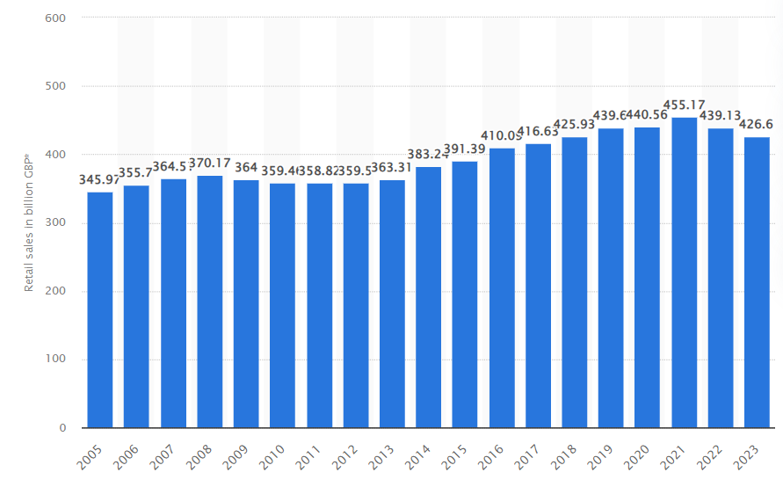

Figure 1.1: Revenue of Retail industry of UK
(Source: Statista, 2024)
The associated departments of this sector include chocolate confectionary, ice cream, sugar confectionary, preserved pastry, and cake. Therefore, it can be implied that this promising sector requires a large number of workers to maintain the seamless delivery of the products according to the market demand. The aforementioned data shows the positive performance of this sector that is none other than the contribution of skilled labour and their greater productivity. This can only be possible by encouraging the workers with a supportive and flexible work arrangement.
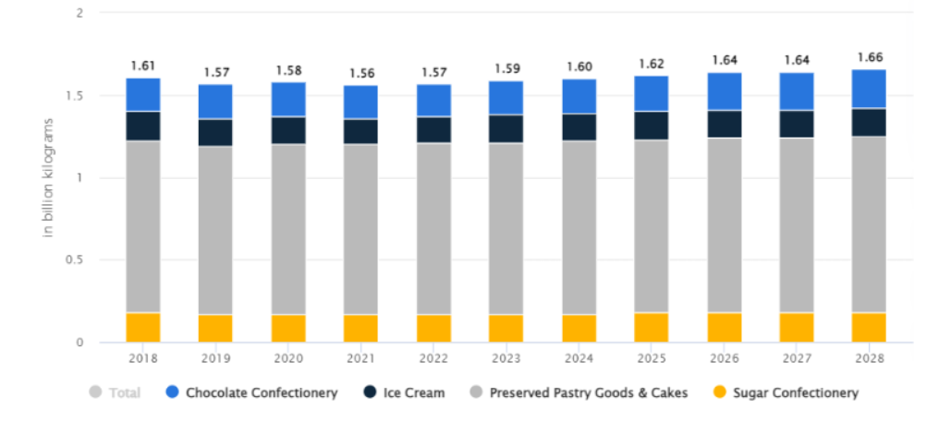

Figure 1.2: Value forecast of confectionary industry of UK
(Source: Statista, 2024)
Moreover, the revenue and volume forecast show the expected growth of this industry, which will require excellent performance of skilled workers and increased job engagement. According to the statistical observation and forecast, the industry is expected to get a volume of 1.66 billion kilograms in 2028 (Statista, 2024). In this situation, a restricted job schedule can hamper the performance of the workers due to their lower level of job satisfaction in the strict working arrangement. Therefore. It is highly important to maintain a flexible work arrangement to encourage the workers to maintain the large volume of the industry and the market operations. This is because these organisations are required to retain this large volume of workforce that needs to maintain sectoral revenue growth. In contrast, an increased number of employees leaving the companies will lead to the recruitment of new workers and their training process (Nguyen, 2020). The repetitive recruitment and training process can cause a large amount of expenditure that can reduce the profit margin of these enterprises.
Previous research studies have discovered that flexible working arrangements such as flexible work hours, remote working conditions, compressed work weeks, and part-time options can have a greater positive impact on the job satisfaction of the employees. The increased job satisfaction is directly related to the performance improvement of the workers (Dziuba et al. 2020). On the other hand, flexible working arrangements can contribute to better work-life balance and better well-being of the employees. It eventually improves the personal life of the workers and increases their job satisfaction. A better work-life balance helps to create a more engaged workforce and a healthier working culture. It will contribute to a greater employee retention rate that can be translated to higher organisational productivity and performance.
In contrast, the impact of flexible work arrangements may not have similar results in different industries (Chung and Van der Lippe, 2022). Due to this reason, further research observation is required to understand the impact of flexible working conditions on specific job types. In this regard, the current research has selected the employees of the UK retail food and confectionary industry to understand the impact of flexible working conditions on the employee's job satisfaction and the resultant performance of the associated small and medium-sized enterprises.

1.3 Research rationale
The huge market size of the UK retail food and confectionary industry offers a large amount of employment in the country. However, there is a significant increase in vacancies has been seen since 2020 in the UK retail sector (Statista, 2024). Although there is a sharp decline in number of vacancies from April to June, 2020 due to pandemic, after April 202, the number of vacancies has shown continuous increase (Statista, 2024). The lack of flexible working conditions is responsible for the high vacancy in the UK retail industry. In 2020, 1.2 million vacancies in the UK retail sector created a challenging issue of a lack of labour force in the UK retail sector (Statista, 2024). The retail food and confectionary industry is also a part of this sector that has also faced significant scarcity in the labour force. It has been observed that the strict working schedule and lack of flexibility within the working conditions have created the issue of higher vacancies remaining unfilled in this industry.
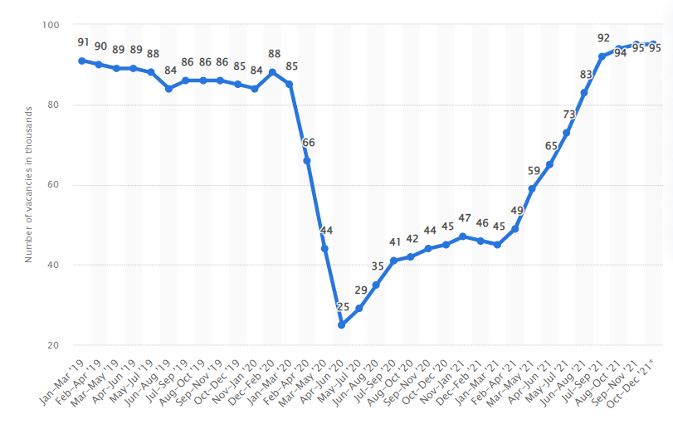

Figure 1.3: Job vacancy in the UK retail industry
(Source: Statista, 2024)
In addition, it is evident from the graph that the job vacancies in this industry drastically declined from Jan-Mar’20 due to the spread of Covid-19 pandemic situation. This sharp rate of reduction exhibits that the growth of the UK retail industry got hindered and many people who are associated with this sector had suffered job loss by almost 25k (Statista, 2024). Besides, some of these people were forced to quit their respective jobs. According to statistical data, around 60% of retail workers leave their jobs due to a lack of flexible work structure and the prevalence of traditional job environments (ONS, 2024). On the other hand, this sector is a significant part of the UK manufacturing industry where around 55% of the total staff has left their job within the last two years (Foodmanufcature.co.uk, 2024). The economic observations and analysis have determined that several factors including lack of flexible working conditions are responsible for the increasing staff turnover in the UK manufacturing sector.
However, the lack of these facilities can force the employees to turn to a different company that offers these benefits (Lange, 2021). In this regard, the previous research works have focused on the necessity of flexible work conditions for increasing employee retention rates. These research works have not established the relation between the flexible working conditions and the job satisfaction of the employees and their increased productivity. In this context, the current research has evaluated the relationship between flexible work arrangements, job satisfaction, and performance in small and medium-sized enterprises in the UK food and confectionary industry.
Moreover, A large portion of the UK retail food and confectionery industry is operated by small and medium-sized enterprises. There are around 22,830 small and medium-sized enterprises in the food and drink-manufacturing sector in the UK (Gov.UK, 2024). These business entities often have tight budgetary allocations that compel them to employ strict schedules to maintain maximum operation and a significant amount of profit. Therefore, it is important to identify the associated challenges that compel the companies to apply strict working conditions (Sims, 2020). It has been observed that the present issues and challenges create problems in the effective implementation of flexible working structures within the small and medium-sized enterprises of the retail food and confectionary sector in the UK.
Consequently, the resultant employee loss causes capital losses due to sudden scarcity in the labour force (Messabia et al. 2020). In addition, the new recruitment and workers’ training process leads to significant capital expenditure that further creates difficulties in achieving competitive advantages in the confectionary companies. On the other hand, previous research studies have not considered how the flexible working arrangement can be utilised to maintain a stable workforce. The application effective implementation of flexible working conditions may income few specified factors. Therefore, the working management authority needs to consider those factors and relevant techniques that can result in a robust establishment of flexible working arrangements (Sims, 2020).
In this regard, the current research has investigated the possible way through which the implementation of flexible work arrangements in small and medium-sized enterprises in the food and confectionary sector in the UK can boost the employee retention rate. It has also identified the potential impact of flexible working conditions and their utilisation on the improvement of organisational performance through accelerating employees’ job satisfaction and engagement (Lange, 2021).

1.4 Research Aim
The main aim of the research is associated with analysing the relationship between job satisfaction and flexible work arrangements within the SMEs of the retail and Confectionery industry.

1.5 Research Objectives
● To assess the prevalence and types of flexible work arrangements in small and medium-sized enterprises (SMEs in the food and confectionary sub-sector) in the UK.
● To examine the factors which influence the adoption of flexible work arrangements in the food and confectionary sub-sector UK.
● To analyse the relationship between flexible work arrangements, job satisfaction, and performance in SMEs, the food and confectionary sub-sector UK.
● To develop practical recommendations which can optimise the implementation of flexible work arrangements in SMEs, the food and confectionary sub-sector UK for an organisational performance boost.

1.6 Research Questions
What is the Impact of flexible work arrangements on job satisfaction and performance of SMEs in the UK retail food and confectionary industry?

1.7 Research significant
This research has investigated the influential impact of flexible work arrangements on employees' job satisfaction and the small and medium-sized enterprises’ performance in the UK retail food and confectionary sector. In this regard, this research has evaluated different types of flexible work arrangements in small and medium-sized enterprises of this industry and tried to understand the level of impact they have on organisational performance. Therefore, the observations and the present data will help the companies to select and apply the best-suited practices that can effectively increase the job satisfaction of the employees. The increased job satisfaction of the workers increases their job involvement and further increases individual productivity leading to improved business performance of the small and medium-sized enterprises (Wahjoedi, 2021). Hence, the valuable information provided in the research findings will help the companies in the betterment of their business performance.
On the other hand, the UK retail food and confectionary industry is a huge and dynamic industry that involves several interlinked departments and relevant factors (Statista, 2024). Therefore, it is highly important to investigate and explore those factors that influence the adoption of flexible work arrangements in this sector. This research has identified those factors that can help or hamper the easy and effective adoption of a flexible working culture within companies. Therefore, future companies will be able to consider these factors while adopting new and modified working structures that promote flexible work schedules and working nature. On the other hand, several challenges can create issues in implementing effective flexible working conditions. This is because different industrial sectors are associated with different job patterns and working structures (Regona et al. 2022). Therefore, a generalised way of implementation cannot work to maintain a stable and high-performing workforce. In this regard, this research has identified the relevant challenges and suggested the best recommendation that can help companies optimise their implementation of flexible work arrangements. Moreover, this research has analysed the relationship between job satisfaction, the performance of small and medium-sized enterprises, and the arrangements of flexible working facilities. The information regarding this relationship will keep the companies informed about the impact of a flexible work culture on employees' job engagement. It will help the companies to stay on track while following the recommended solutions in their workplace management.

1.8 Summary
This chapter has provided an introductory discussion about the research topic and the associated research scenario. In this regard, this chapter has explained the detailed background of the research topic and the present facts regarding the issues. This chapter has highlighted the greater vacancies present in the UK retail food and confectionary sector and the associated turnover issues. Moreover, it has demonstrated the importance of determining the relationship between flexible work conditions and employees’ job satisfaction and retention in the rationale section. Therefore, the aim of the research has been identified and presented with research objectives and research questions. Finally, the significance of this research and further advantages that future researchers and companies can get from the research results, have been logically explained.

Chapter 2: Literature Review

2.1 Introduction
The evaluation of different pieces of literature delineates the core idea, logical underpinnings and diversified theoretical understandings of a research topic. The findings of this chapter provide a clear idea about the loopholes too, which can be mitigated by the present investigation. Hence, the researcher has performed an observation of the peer-reviewed literature, which has helped to identify the main concepts of flexible work arrangement in Small and Medium-sized Enterprises (SMEs) with a special reference to the retail food and confectionery industry of the UK. Moreover, its relationship with job satisfaction, implementation procedures and probable challenges has also been highlighted here.

2.2 Importance of flexible work arrangement in Small and Medium-sized Enterprises (SMEs)
The term “flexible working arrangement (FWA)” is defined as the alteration schedule of work to enhance the satisfaction of the employees. Furthermore, this arrangement in the management of SMEs escalates the work-life balance by minimising the “stress, rate of absenteeism and employee turnover”. In this competitive and dynamic business environment, the implication of FWA is gradually increasing in the organisation to intensify the motivation of the employees. According to Jiang et al. (2023), it has been narrated that the continued adherence to fixed working cultures generates difficulty for employees to work under constant pressure, which leads to deterioration of physiological and psychological dimensions. Contrarily, on the other hand, FWA generates an ethical and pleasant working atmosphere, which squarely increases the productivity rate of the business. Thus, FWA also promotes an inclusive and relaxed organisational environment by down turning an excessive consumption of “psychological resources”. The implication of FWA in the management provides opportunities for the employees to communicate and learn by enhancing the coordination among the employees (Kalogiannidis, 2021). Hence, this strategy of the management will ameliorate the engagement rate of the employees, trigger the culture of innovation and facilitate the exchange of information and knowledge in the workplace. Thus, it will be beneficial for the employees to learn which will squarely allow the employees to generate creative ideas for the furtherance of business operations (Ali and Anwar, 2021).
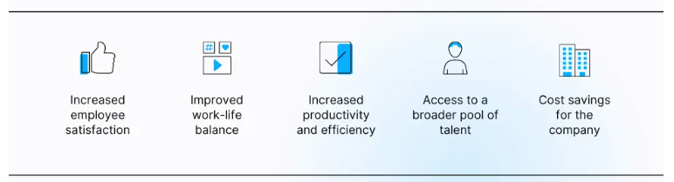

Figure 2.1: Importance of FWA
(Source: Weideman and Hofmeyr, 2020)
Simultaneously, FWA also promotes work flexibility of the employees. In this current corporate environment, the flexibility of the work enhances the job satisfaction of the employees by allowing the employees to work from home. It is evident from the findings of the article, which flexibility in the job escalates the satisfaction of the job to 62% and the changing of the schedule of work reduces the stress to 20% (Ray, and Pana-Cryan, 2021). Contrarily, it is also evident that this approach also increases the rate of stress of the employees. In the retail sector, the application of FWA promotes a “work-life balance” and reduces the overall cost of business operations by amplifying the commitment rate of the employees, which magnifies the productivity level. Thus, the types of FWA, which include “flexible schedules, teleworking and reduction of working hours”, ensure increasing the satisfaction of employees by assisting them to maintain a “work-life” balance, especially for highly skilled female employees after childbirth (Brega et al. 2023). This approach helps to improve the positive working environment by reducing stress and burnout in the workplace, which is beneficial for the retail sectors to maximise the rate of profit margin (Alsuwaidi et al., 2021). Furthermore, it can be stated that in this dynamic environment, the employees are accepting new jobs due to the presence of FWA in the management, which is one of the leading motivators for the employees to improve their efficiency, satisfaction and careers (McKinsey, 2023)

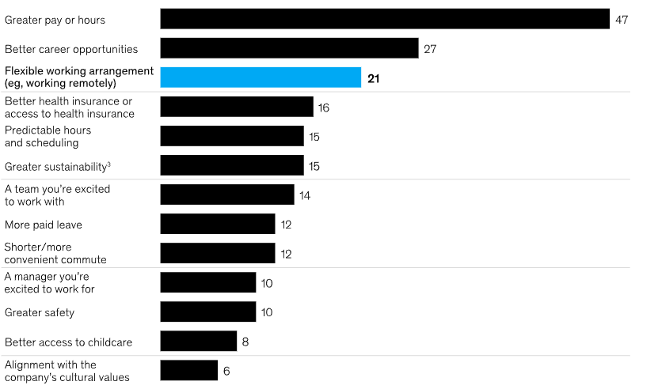

Figure 2.2: Importance of FWA to motivate employees
(Source: McKinsey, 2023)
The management of SMEs in the UK reveals that 55% of the SMEs are adopting FWA as per the trend of the working environment (SME Magazine, 2024). It is also stated that the embracement of “Artificial Intelligence (AI)” in management will trigger flexibility in the workplace to stay competitive in this global market. Furthermore, the adoption of the “Flexible Working Bill” by SMEs in the UK will play a predominant role in optimising the retention of employees, job satisfaction and collaboration. It is also evident that the implication of FWA in the management of SMEs reduces the churn rate in the business from 46% to 14% by maximising the productivity rate of the employees in the UK. The adoption rate of SMEs in the UK is 67%, which is much lower than large firms are which 81% is. Hence, the implication of the “flexible working bill” will escalate the flexibility of work in SMEs (Startup, 2024).

2.3 Exploration of the type of flexible work arrangement in SMEs
Flexible working condition refers to the ease of adjustment of working hours and the unprecedented conditions within the working area. Within SMEs, flexible arrangements can enhance job satisfaction and convenience of the employees, and ensure their retention (Forson et al., 2021). Moreover, greater productivity in the industry can be expected due to elevated trust and morale of the workers. Weideman and Hofmeyr, (2020) opined that the application of different types of flexible working arrangements has a positive effect on the well-being of the workers and different employee engagement strategies can improve the total outcome of the firm.
Different types of flexible working arrangements can be noticed in SMEs, which include “job sharing”, “remote working and work-from-home” facilities, “hybrid working”, “part-time and flexi-time working”, “compressed hours”, etc. Job sharing can be defined as the splitting of responsibilities between two or more employees to lessen workload. The collaboration between them can improve the quality of the work and seamless growth and time management can be ensured. On the other hand, Kotey and Koomson, (2021) delineated that providing “remote working” and “work from home” facilities can intensify the working intention of the employees. Due to the flexible position of working, the outcome of the workers magnifies, which adds value to the aim of the SME. Another type of flexible working system is “hybrid working”, which consists of “in-office”, remote and “on the way” jobs. In the post-COVID era, the concept of flexible working has become more popular, in this regard, Vyas, (2022) has stated that the application of the “hybrid working” concept should be designed wisely.
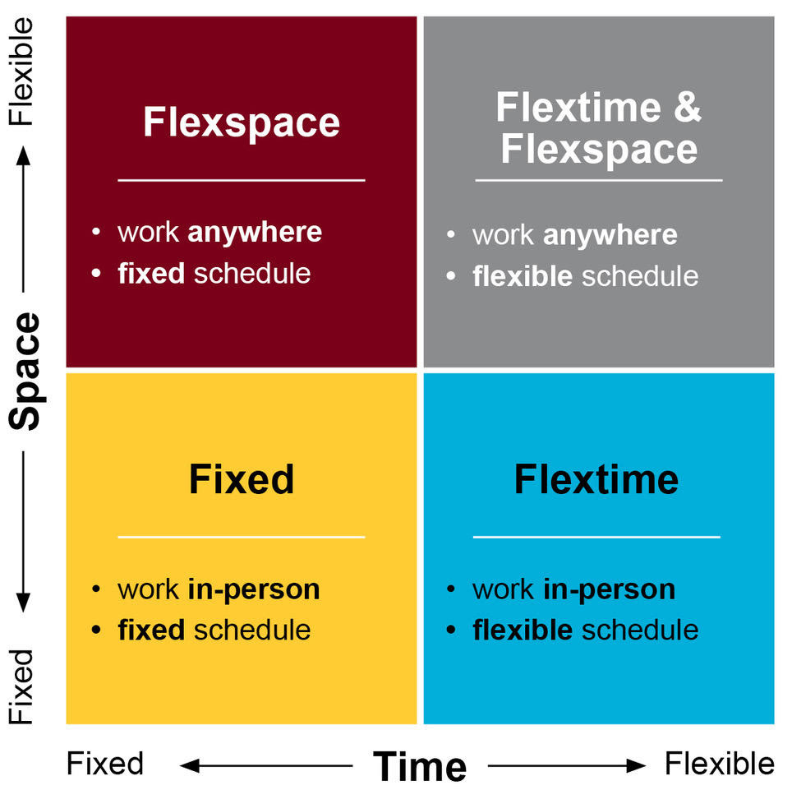

Figure 2.3: Flexible working pattern
(Source: UMN, 2021)
The concept of “flexi-time working” is also compatible with flexible working management systems in SMEs. The concept refers to the power of the employees to determine their working hours. On the other hand, “part-time” working helps the workers to bear less workload and maintain a work-life balance. In this type, the supervisors of the workplace play a different role, which can ensure the flexibility to choose the place of work and time, by which the employee can feel valued and the work efficiency can be magnified (Sekhar and Patwardhan, 2023). Another concept of flexi-time working is the choice of “compressed hours” by the workers. In this system, the employees can choose the preferable working hours and compile them into fewer hours than working through the entire week. According to the views of Nwekpa et al. (2020), a “compressed work week” can effectively reduce the workload of the employees and enhance their commitment to the organisation. Besides, flexible working hours are beneficial for managing both personal and professional life.
The emerging growth of the UK retail and confectionary industry is projected to be 3.31% by 2028 (Statista, 2024). Within this huge industry, grocery and confectionary stores in the United Kingdom have implemented flexible working patterns, which can meet the need of employees and their work-life balance can be regulated. The grocery stores of the nation are trying to incorporate this pattern to improve the outcome and job satisfaction of the employees (The Grocer, 2023). Besides, in recent studies, it has been found that the millennials and Gen-Z of the UK food industry are opting for “flexi-time working” and “adaptability”. The effect of the COVID-19 pandemic has played a significant role in this regard. It has shaped the industry and shown the owners the importance of flexible working management to ensure employee retention (Paais and Pattiruhu, 2020, Nguyen et al., 2020). Thus, it can be said that the application of different types of flexible working patterns can be effective in the SMEs and it can have positive effects on the job satisfaction of the employees of the UK food and confectionary industry (Tumi et al., 2022).

2.4 Factors that influence the flexible working arrangement in the retail and confectionary industry
Flexible working arrangements are crucial in industries to ensure a positive work environment and manage a good relationship with employees for the longer term. The retail and confectionery industry is also not immune from the process. The arrangement of flexibility and successful implementation of it in the workplace needs the support of both employers and employees (van Tuin et al., 2021).
The needs of employees are the foremost important factor, which can affect the establishment of a flexible working situation. The perks within the industry such as personal healthcare facilities, childcare equipment, and a true “work-life balance” are the basic needs, for which employees long for flexible working hours. According to the views of Shifrin and Michel, (2022), the implementation of flexible arrangements can mitigate the conflict between employees and improve their physical and mental health significantly. Along with this, the demand for the embracement of the talent of the employees is another need, which can affect the application of a flexible working environment. The skills and innovative ideas of the employees of the retail and confectionery industry can reduce the risk percentage of the sector (Rasheed et al., 2020, Ouakouak et al., 2020). The dynamic nature of this industry is the main cause of risks and continuously evolving customer needs. Hence, the accumulation of talent in this sector can aid the business owners to build a flexible environment and overall success can be achieved. Rodríguez-Sánchez et al. (2020) have disclosed the fact that perks and allowances after identifying employee needs can improve talent acquisition and management, and the resources can be engaged more easily.
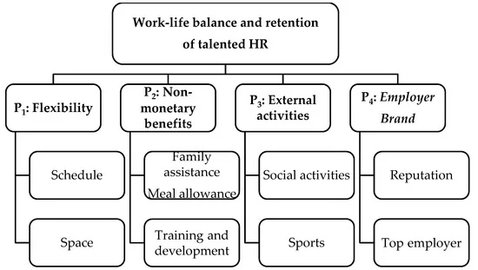

Figure 2.4: Connection between work-life balance and talent retention
(Source: Rodríguez-Sánchez et al. 2020)
The location of the workplace is one of the matters of utmost importance to the employees. Based on this, retail industrialists can plan the flexibility of work arrangements (Hajiali et al., 2022, Riyanto et al., 2021). Pliable locations of work are one of the primary demands of the employees, and its arrangements by the organisations can improve the engagement and retention of the employees. Austin-Egole et al. (2020) portrayed that the preference for geographical location of work is an important feature of the flexibility arrangements in the retail and confectionery industry. By implementing the location preference, a significant growth in outcome can also be observed. Another important factor is the style of working, which can affect the flexible working arrangements (Sitopu et al., 2021). It has been noticed that the working style is different for different industries and different workers. Hence, thriving within a flexible working environment depends on the adaptation power of the workers. However, Kotera and Correa Vione, (2020) opined that a newly adapted working style can increase the “work-related flow” and collaboration among the employees on one hand, and contrarily can blur the line between home and workplace.
Some organisational factors also influence the implementation of flexible working arrangements within retail and confectionery organisations. The adjustable working culture of an organisation can be suitable for the application of flexibility within a firm. Asatiani et al. (2021) have shown that up-to-date information about the organisational culture can be helpful for both internal and external stakeholders and flexibility can help the employees to provide the best outcome. On the other hand, the approach of the managers and leadership support can also impact the flexible working arrangement. The emotional understanding of the pain points of the employees and the incorporation of a reward system are the necessary management approaches, which can drive the application of flexible working environments in different organisations, including the retail sector (Hassan, 2022, Iis et al., 2022). Moreover, the technological infrastructure of an organisation can also affect flexible work management. In the present era, technological backup is important for “remote working” and “hybrid working” systems. Thus, without advanced technological support, the implication is not possible (Chatterjee et al. 2022). In different sectors of the UK, including the food and confectionery industry, the government has implemented necessary steps, which can ensure “one right to request flexible working”. It can improve the overall working conditions of the employees and retention of them in that sector (techUK, 2024).
2.5 Relationship between flexible work arrangement and job satisfaction and SME performances
A flexible work arrangement within the organisation can benefit it in diversified ways. The improvement of job satisfaction is closely intertangled with this aspect, which can positively enhance the performance of SMEs. Adjustable working hours in the workplace can improve the work-life balance of the employees and can reduce burnout. Hence, the morale of the employees can be boosted, which can elevate the overall SME performance. Quek et al. (2021) have explained that job satisfaction has a significant impact on the performances of employees, and thus, there is a positive relationship between employee performance, job satisfaction and SME performance.
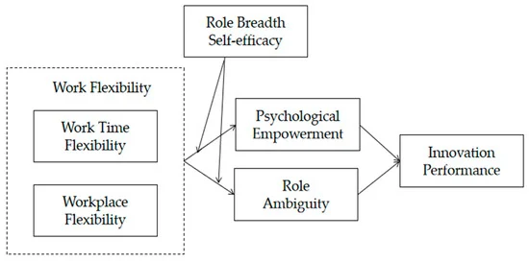

Figure 2.5: Relationship between flexible work arrangement and innovative performance
(Source: Wang and Xie, 2023)
Autonomy generation is a crucial component of flexible working arrangements, which can generate the trust of the employees. The feeling of control over the work schedule, place and collaborative approach can help to formulate trust towards the organisation, and this satisfaction level of the employees can elevate the organisational performance. Rahaman et al. (2021) supported this fact by saying that job satisfaction and autonomy can improve SME performance by boosting the morale of the workers. On the other hand, Kim and Cho, (2020) explained that about 60% of absences of workers are caused by job-related stress. The managers and leaders of SMEs have a significant role in providing autonomy to the workers. Appropriate interventions of the managers by implementing autonomy can steer a flexible working environment, which can reduce job stress and ensure job satisfaction (Saks, 2022, Pincus, 2023).
Flexible work arrangements also have a significant impact on the performance of SMEs. It has been noticed by the researchers that employee satisfaction is directly proportional to organisational performance. Job satisfaction always generates a feeling of satisfaction and commitment towards the organisation, which helps achieve the organisational goals. In this regard, Gorondutse et al. (2021) have stated that “strategic flexibility” along with sustainability measures is truly useful to magnify SME performance, including the retail sector. Thus, it can be said that different SMEs benefit by arranging flexible arrangements (Chandni and Rahman, 2020).
Along with this, research has proved that a flexible working environment can downturn the turnover ratio of employees and ensure talent retention within the firm, which can induce organisational performance. According to the views of Tirrel et al. (2021), alternative workspaces and flexibility in schedules accompanied by the support of the leaders can motivate employees, and the overall outcome of SMEs increases.
Different companies including the retail sector of the UK have embraced the “four days a week” concept for working as a part of a flexible working arrangement. This concept has induced job satisfaction in 71% of the employees of the country and reduced work-related stress (The Guardian, 2024). Hence, the organisations are enjoying better outcomes. Though the work frame is not feasible for emergency services, most organisations and SMEs have observed positive outcomes. Thus, the food and confectionery retailers of the UK should apply this strategy intensely to ensure employee retention. Hence, it can be said that flexible work arrangements can upgrade the working conditions, job satisfaction and overall satiety, which can improve the performance of the SME sector (Chanana, and Sangeeta, 2021).

2.6 Challenges of Incorporating Flexible Work Arrangement in SMEs along with associated drawbacks of FWA
SMEs experience diversified challenges to incorporate FWA in the management, which include “lack of investment in the technology and infrastructure, insufficient training to the staff to work in remote places and dearth of flexible planning of management”. It is analysed in the article that lack of investment and insufficient collaboration of the business leads to a downturn in the innovation rate of the SMEs and failure to adopt automated technologies (Indrawati, 2020).
Hence, the shortage of financial resources has become one of the challenging factors for SMEs to capture a competitive advantage in this emerging market. From this viewpoint, it can be reflected that the SMEs in the UK are also facing certain challenges like “economic uncertainty like fluctuations in inflation rate, high rate of interest, geopolitical conflict and others), lack of funding to expand or generate a comprehensive plan for the business, struggling to retain the skilled employees due to lack of FWA and digital technologies, the complex regulatory framework of the UK hiders the workforce, and gap in adopting the remote working arrangement” (EBR, 2023). These factors act as a hindering factor for SMEs in the landscape of the UK to embrace FWA in management.
According to Willetts et al. (2020), SMEs provide 60% of employment in the landscape of the UK. The dearth of skilled expertise due to insufficient implementation of training programs and insufficient resources resists the adoption of technology like “Big Data Analytics” which downturns the efficiency of business operations and “flexible working environments” in SMEs. The discussion of the resisting factors that reduce the magnitude of incorporating FWA in the management of SMEs reflects that the lack of flexibility in the workplace demotivates the employees and reduces their potential and credibility (Rasool et al., 2021). Thus, the insufficient supervision and strategies of the management is also another factor that downturns the FWA in the workplace. The dearth of effective approaches and poor decisions of both HR and Accountant management fail to implement FWA which leads to the decline of the performance of SMEs in the industry like retail and confectionary (Amirul and Mail, 2020).
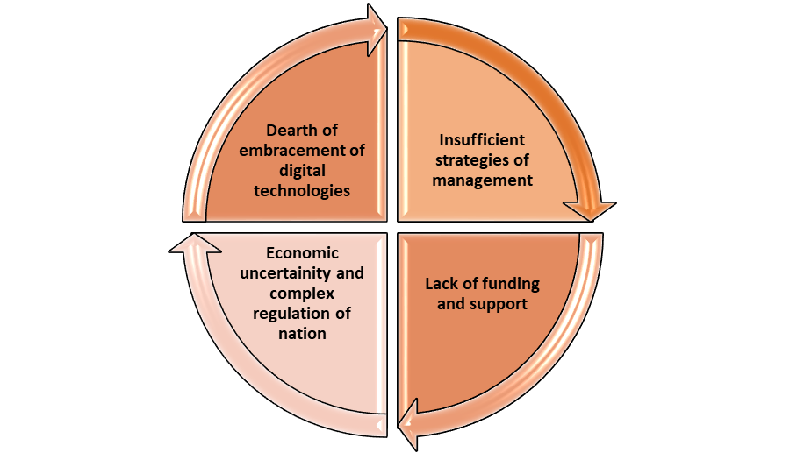

Figure 2.6: The challenges encountered by SMEs to incorporate FWA
(Source: inspired from EBR, 2023)
The FWA has certain drawbacks, which disrupt the efficiency of the employees for example, working from home escalates job stress by 22% (Ray and Pana-Cryan, 2021). Furthermore, working from home also leads to a reduction of social interaction due to low involvement with the team members. The “McClelland Need Theory” focuses on three motivators “achievement, power and affiliation” that signify the diversified drivers to motivate the employees to accomplish the task in the stipulated time frame (Nienaber and Martins, 2020). The motivator “affiliation” favours collaboration among the team members. The lack of this motivator creates a feeling of loneliness and reduces the social skills of the employees, which can lead to negative consequences on the mindset or persona of the employees (Tirrel et al. 2021).
Hence, the flexibility in the working also minimises the emotional bond of the employees with the value of the companies, which can downturn the loyalty of the staff. Therefore, the FWA can create isolation of the employees, which can generate an impact on the quality of the work (Barreiro and Treglown, 2020, Li et al., 2021, Lartey, 2021). Thus, following the “McClelland Need Theory” it can be narrated that the loss of collaboration among the staff in the retail and confectionary sector can generate a negative impact on the delivery of services to the customers (Verčič, 2021).
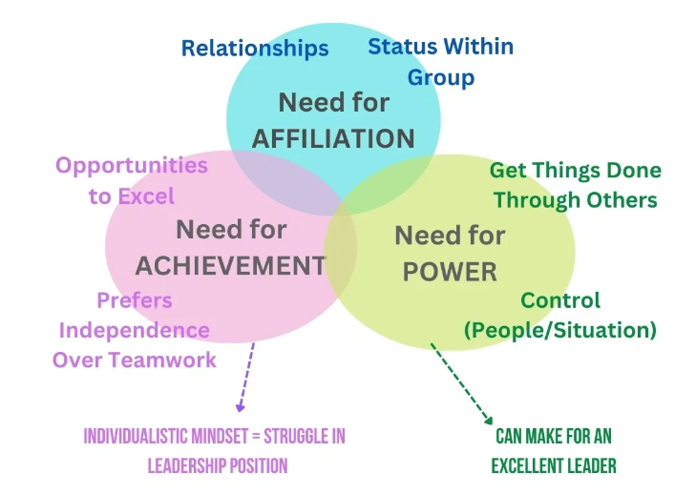

Figure 2.7: McClelland Theory
(Source: Tirrel et al. 2021)

2.7 Mitigating strategies for resolving issues
The mitigating strategies are required to enhance the implementation process of FWA in the business operations of SMEs. In this present business environment, 77% of SMEs reveal that “hybrid working” has maximised the profit margin (Employeebenefits, 2023). This type of FWA also assists in perpetuating the “work-life” balance and reducing employee turnover from the SMEs (Duque et al., 2020). Therefore, to implicate this type of FWA in the workplace, the management needs effective and constructive strategies to empower the employees to escalate their workforce. The implication of policy and investment by the SMEs to embrace digital technologies like “AI, Big Data Analytics, Information and Communication Technology ICT and other digital technologies” enhances remote work flexibility (Ababneh, 2021). In the pandemic situation, the outbreak of diseases has forced organisations like the retail industry to choose remote working for streamlined business operations. The adoption of digital technologies in management will also engage the employees, promoting continuous learning and enhancing flexibility by underpinning remote working (Chatterjee et al. 2022). Hence, SMEs need to embrace advanced technologies like “Big Data Analytics or ICT” to capture competitive advantages in this corporate landscape.
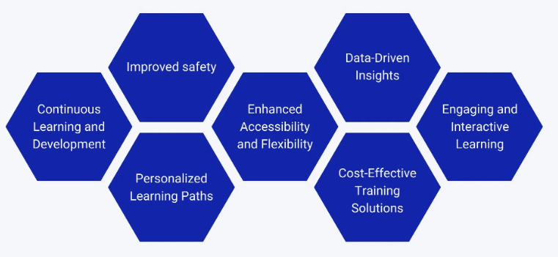

Figure 2.8: Importance of leveraging technology in SMEs
(Source: Chatterjee et al. 2022)
The support of the Government of the nation and the collaboration of the business is one of the mitigating strategies to address the issue of funding in the SMES. For example, the “Innovation Voucher” initiative by the UK government will grant £5000 for the growth and development of business operations of SMEs (Gov.UK, 2023). Furthermore, in a survey of 1000 HR Companies in the UK, 57% of the decisions favour flexible working. This helps the government in the application of “the flexible working bill” which will come into effect in the year 2024 for the rights of the workers of SMEs to request “flexible working” in the job from day one of the work (Cpid, 2024). Therefore, the support of the Governments of nations like the UK will boost the management of SMEs to adopt FWA in the process of capturing a sustainable advantage in this competitive landscape (Heslina and Syahruni, 2021).
The application of “lean Manufacturing” will enhance the performance, production process and flexibility of the management (Hernandez-Matias et al. 2020). Hence, the training of the employees to improve their skills and knowledge will assist in the acquisition of talent in the management, escalate the engagement of the employees in the process and focus on continuous innovation by increasing the flexibility of the workforce (Adisa et al., 2023). Moreover, the training of the employees with advanced technology and the hiring of skilled staff by the management of SMEs intensify the feasibility of the business process and assist in maintaining an ethical work culture (Albrecht et al., 2021). Furthermore, the utilisation of efficacious approaches like transparent communication, providing rewards and positive feedback by the management of the companies motivates the employees to enhance their commitment level and helps in perpetuating a flexible working culture. The proper scheduling of tasks by the management boosts the FWA (Clack, 2021). The alignment of the “Self-Determination theory” states that the factors “autonomy and competence” will be escalated in the employees due to the presence of FWA in the management (Austin-Egole et al. 2020).

2.8 Future scope of flexible work arrangement in SMEs
The idea of flexible working arrangements has become most popular during the time of the COVID-19 pandemic. The demand for it has risen due to its multifaceted benefits in the SME sector. In the United Kingdom, the application of this concept has already been initiated to reduce burnout and manage the work-life balance of the workers of diversified industries. The food and confectionery business is also not different from it. The future opportunities of this approach consist of improved employee productivity, which can recruit more Gen-Z candidates to work. Hence, the efficiency of the workforce and overall outcome can be enhanced (Hermawan et al., 2020). Furthermore, the retention of workers can reduce the input cost of the business, which can be invested in infrastructural development. The feeling of attachment to the organisation can cut the repeated labour recruitment cost of the industry (Mas and Pallais, 2020). The implication of advanced technologies for a flexible working environment can extend its surroundings, and the food and confectionery industry of the UK can benefit. Different cloud-based tools and AI for remote management of work can empower the workers to connect with a broader customer base and more profit can be earned from there. Along with this, technological help can reduce human error and flexible working conditions will not be affected in any way (MM, 2021).
The popularity of the “gig economy” has moulded the recent trend in the economy. Many individuals from the Gen-Z population are opting for flexible work arrangements and environments, as they are cautious about work-life balance (Liang et al. 2023). Job satisfaction and the talent pool of these individuals are fulfilling the requirements of the industries, including the food and confectionery retailers of the UK (Mulang, 2022).
2.9 Theoretical Framework
This structure supports the study of the research by utilising theories to provide consistency in the research process. The explication of two theories related to the topic is depicted below
Social exchange theory
This theory emphasises creating an environment in which the employees of the organisation or companies feel supported and valued. The offering of flexible working options to the employees like remote working provides an advantage for the employees to maintain a “work-life balance” (Nazir and Islam, 2020). The provision of appropriate arrangements and care by the management to the employees will result in the increment of the satisfaction level of the employees, motivate the staff and empower them. The result of the approaches will escalate the productivity and performance of the employees of the companies (Pham et al. 2023). Thus, the meeting needs of the employees will lead to positive outcomes in the work by escalating the efforts and efficiency of the employees and reducing the rate of absenteeism. Therefore, this theory focuses on the retention of skilled employees in SMEs like retail and Confectionary to deliver valuable services to the customers.
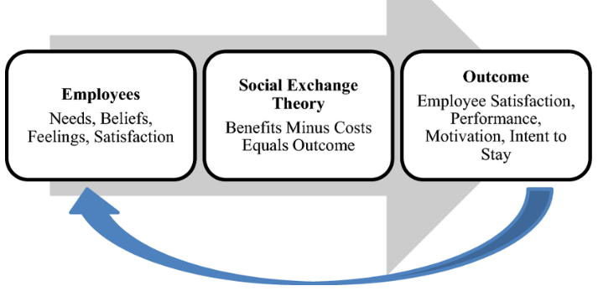

Figure 2.9: Implication of social exchange theory
(Source: Pham et al. 2023)
Enrichment theory of Work-life balance
This theory is also known as the “Enhancement theory”. This theory encapsulates the accumulation of “skills, abilities, satisfaction and values” from work or personal life, which creates positive influences in other domains of life (Submitter et al. 2020). It delineates that the skills gained from the workplace of companies like communication, problem solving and others are also beneficial to managing the tasks of the household (Men et al., 2020). Simultaneously, the competence gained from personal life like volunteering will provide an advantage in the workplace by promoting cooperation with the team members. Therefore, this theory supports the “work-life balance” by reducing the stress of managing strict schedules as well as focusing on personal activities by improving the relationship between personal and work life (Men et al., 2021). This theory also underpins the employees to enhance their creativity for positive outcomes of the business process.

2.10 Literature gap
Different literature has been reviewed in this chapter to identify the impact of flexible working arrangements on job satisfaction and the performance of employees in SMEs. The articles have elaborated on diversified theoretical knowledge and practical implications of this unique working approach. However, the articles are mostly focused on the SMEs and retail sector, while a special focus on the food and confectionery industry is limited, which has created a knowledge gap. Thus, the present research has intended to focus on this sector and fill this loophole.

2.11 Conceptual Framework
This framework provides a blueprint for the research study by illustrating the aspects of literature reviews in a logical and systematic pattern. The conceptual framework for this research is elucidated below-
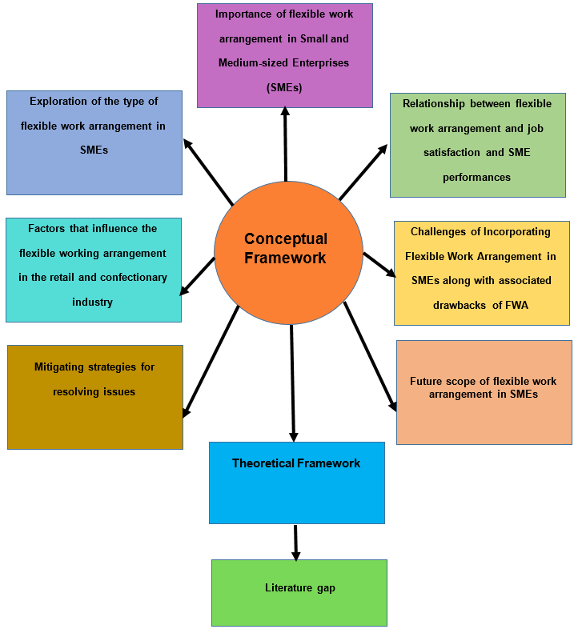

Figure 2.10: Conceptual Framework
(Source: Developed by the author of this dissertation)

2.12 Summary
This chapter encompasses the importance of FWA in SMEs by reflecting on the aspects of FWA on job satisfaction. The types of FAW are also explored which include “job sharing”, “remote working and work-from-home” facilities, “hybrid working”, “part-time and flexi-time working”, and “compressed hours” to apprehend their significance in the current scenario. Furthermore, influencing factors like “working style, organisational factors, preference for location and approaches of managers” that enhance FWA in the management to increase the engagement of employees are also explained. The explication of challenges that resist the incorporation of the FWA process with its associated drawbacks and remedial solution are also depicted by aligning McClelland Theory and “Self-Determination theory” respectively. The future scope of this study along with the literature gap is delineated for further study purposes. Hence, the elaboration of the social exchange theory and enrichment theory of work-life balance creates the foundation of this literature review.

Chapter 3: Methodology

3.1 Introduction
The chapter methodology has essential importance within the study as the chapter generally signifies the overall methods which are utilised in the overall study regarding collection of the data from the different resources and using the proper phenomenon that are analysed for reaching to the final conclusion regarding the methods of employees within the confectionery industry of UK. The chapter has also analysed the factors of creating the knowledge and the approaches of selecting the different phenomenon associated with the research context that helps to focus on formulating the proper perspectives regarding collection of the data and analysing the collected data for reaching to the final conclusion at the end of the study. The chapter also has analysed and evaluated the process of ethical considerations while collecting the primary data through the process of survey. Moreover, the different limitations associated with the method of the study are also analysed within the chapter which help in understanding and reaching to the final conclusion of the study and answering the research questions which are formulated already in the initial part of the research.

3.2 Research Onion
A method and process called "research onion" aids in the systematic handling of data collection from many sources. The research onion typically aids in developing the study's overall phenomenology, which concentrates on selecting the appropriate phenomenon within the larger research process and aids in concentrating on the appropriate elements of research phenomena and the data kinds related to the research context (Diago, 2022). Moreover, the research onion is also the essential framework that helps in demonstrating the process of the choice of the data resources and the data type throughout the research process that ultimately helps in considering the final conclusion at the end of the study (Saunders et al., 2009).
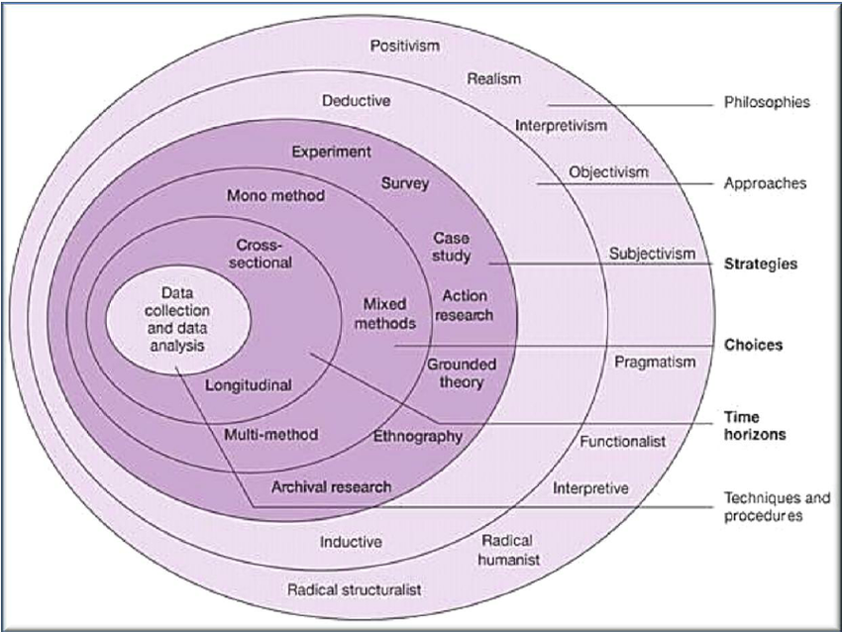

Figure 3.1: Research onion
(Source: Saunders et al., 2009)
In this research regarding the employee satisfaction of the employees in the confectionery industry of the UK the study has focused on utilising the onion approach for creating the remote regarding collection of the data. In terms of the first layer the study has focused on the epistemology of positivism and generally focuses on considering (Bell et al., 2022) the scientific structuring approach and finding the truth from the third-party perspective. The study has also focused on the approaches of deductive approach systems where the overall data and the large size of the data are deducted for finding the conclusion at the end (Al-Ababneh, 2020). Apart from that interns of the data resources the study have focused on the primary data from the quantitative data type method that indicates the utilisation of survey method of the participants.
Research Aim
The main aim of the research is associated with analysing the relationship between job satisfaction and flexible work arrangements within the SMEs of the retail and Confectionery industry.
Research Objectives
● To assess the prevalence and types of flexible work arrangements in small and medium-sized enterprises (SMEs in the food and confectionary sub-sector) in the UK.
● To examine the factors which influence the adoption of flexible work arrangements in the food and confectionary sub-sector UK.
● To analyse the relationship between flexible work arrangements, job satisfaction, and performance in SMEs, the food and confectionary sub-sector UK.
● To develop practical recommendations which can optimise the implementation of flexible work arrangements in SMEs, the food and confectionary sub-sector UK for an organisational performance boost.
Research Question
What is the Impact of flexible work arrangements on job satisfaction and performance of SMEs in the UK retail food and confectionary industry?

3.3 Research Philosophy
Research philosophy, also known as epistemology, is the broad term for the process of identifying a phenomenon, determining how to create the truth, or selecting the study's data sources. In order to demonstrate the appropriate conclusion that enables us to achieve the goals of the research created in the first part of the study, the philosophy of the research typically focuses on analysing and identifying the perspective of choosing the data as well as creating the perspective about finding the proper resources associated with the context of research (Pandey and Pandey, 2021).
In this respect the study has mainly chosen the philosophy of positivism that generally demonstrates the process of anticipating the data at first and structuring the data by focusing on anticipated conclusion at the end of the study. The philosophy of positivism generally indicates the top-down approach of the data analysis systems or the phenomenology systems that indicates the structured approach and the scientific method which are obtained from the third-party perspective (Budanov, 2020). The sociological factors associated with the job satisfaction regarding the employees in the confectionery industry have been mainly focused on in this research process that emphasises on the structured approach of the scheduling of the job shifts and remote working systems of the employees that helps in the positive motivation. The positivism philosophy is also important in this study and is most suitable as the factors of the positive consequences of the motivation and the job satisfaction approaches are already analysed in the literature review which are to be focused on and to be evaluated through the analysis of the viable data available in the primary data resources (Al-Ababneh, 2020). Moreover, it also has been helpful for maintaining the sociological considerations associated with the human participants while considering the different other modes of mediating variables that can also affect the context of overall research.

3.4 Research Approach
The research approach generally means the overall approaches of collecting the data and sorting the data that create the unit form of the oral data which shows the family and the indications of the overall collected data by selecting the proper sample out of the large size (Easterby-Smith et al., 2021). In terms of the research approach, the approach of oral study has mainly focussed on deductive systems which helps in the consideration of deducing large amounts of data into a small format that helps in reaching the conclusion and evaluating the existing theoretical considerations and frameworks effectively. The data approach generally also means focusing on the essential method in terms of collecting the data and using the proper phenomenon which is associated or related with the context of research.
In this respect the study has mainly chosen the deductive approach of the data analysis where the large amount of the data is reduced for creating the essential sample that indicates the factors of the overall collected data that align with the research context and the anticipated outcome of the study (Nayak and Singh, 2021). Due to the choice of positivism framework of philosophy the use of deductive approach in terms of the analysis of primary data helps in reducing the large size of data and choosing the proper sample by finding the essential phenomenon regarding the remote employment factors and its association with the job satisfaction among the employees within the confectionery industry of UK (Chang et al., 2020). The other approaches of research such as the inductive approach have not been used within the study and are avoided as the inductive approach is mainly associated with finding the subjective norms of the study by analysing the relation between the different context and the phenomenon associated with the topic of the research.

3.5 Research Design
Research design generally indicates the essential method of conducting the whole research through the analysis of the certain data associated with the research context and maintaining viability for reaching to the proper conclusion at the end of the study. The research design also essentially means the overall process of choosing the phenomenon of the research and finding the proper conclusion that enables it to maintain the vitality associated with the research philosophy and the approaches of the study (Diop and Liu, 2020). Choosing the proper research design is essential in the study as it relates to the viability of the overall research and maintaining the essential structure in terms of analysing the results in the overall study.
In the research about remote employment management and job satisfaction the study has mainly used the descriptive design among the different other research designs that are widely used in the research papers. The use of a descriptive approach is mainly associated with the description of the several factors associated with the current strategy of remote employment of employees in the confectionery industry of the UK. There are several other designs used in the different other papers such as experimental study, correlational study, exploratory study and explanatory designs (Mardikaningsih et al., 2022). The study has mainly chosen the descriptive design as it mainly focuses on the description of major factors and the variables of the study relating to the final conclusion in the research process. While the correlational and the experimental design also aligns with the survey method which are utilised in the study those are eliminated as the viability of the study have been mainly associated with the generalisation of the job satisfaction aspects and its association with the remote working facility in the confectionary industry of the UK (Ghauri et al., 2020). Choosing the descriptive design is also viable in the study as it has mainly focused on the analysis of participants' data by not segmenting the people into different groups which are generally done in the process of experimental designs of the study. Furthermore, the process of descriptive design is also viable for analysing the variables and their relations with the moderating and mediating variables such as motivations and employee engagement in the confectionary industry of the UK.

3.6 Research Strategy
In terms of the research strategy the study has mainly focussed on the use of primary quantitative analysis through the descriptive analysis method. Further the study also utilised the process of case study method where the case study about the remote employment and its effectiveness of the employees in the confectionary industry is analysed for maintaining the specificity of the overall approaches of the data analysis and data collection. Only the case of a specific industry in the specific area has been focussed in the study for maintaining the objectivity of the overall research (Eden et al., 2020).
The research strategy has also focussed on the primary quantitative analysis through the process of survey that relates to the recruitment of a large number of participants for collecting the numeric data that relates to the employee satisfaction in the confectionary industry of the UK due to the availability of the remote employment facilities (Gupta and Gupta, 2022). The statistical method of analysis is utilised in the study for relating to the data analysis and finding the viability of the existing framework of theory about remote employment and employee satisfaction management in the confectionary industry of the UK. The study has also focussed on the deductive method of approach that relates to the evaluation of the existing theory and framework by analysing the collected data through the perspective of top-down approach and the positivist approach (Verma et al., 2024).

3.7 Data Sources
In terms of the data resources the study have mainly focused on the analysis in the collection of the primary data collected from the different participants recruited in the study. There are generally two types of the data resources which are why they are used by the different research scholars in their papers that include secondary Research and the primary research data resources (Kumari et al., 2023). In that case the secondary data resources generated means available resources which are already published in the different platforms such as the general articles, magazines, websites and in the different other white papers that are published by the different organisations (Thomas, 2021). On the other hand, the primary data generally relates to collecting the data from the participants such as the human who are associated with the context of research in the different terms. The secondary data resources generally relate to analysis of the available data which are already analysed and aligns with the context of the research in the same way. However, the primary data resources generally relate to collecting the raw data from the participants for the first time that is focused on reaching the conclusion associated with the study that is being conducted (Zhang et al., 2023).
The secondary data generally helps in providing the available published data which are already analysed and are aligned with theoretical frameworks. On the other hand, the primary data have the major issues regarding the biases of the participants due to collecting the data or answering the questions of survey or interview from the personal intelligence. Yet in this process of the research, daddy has mainly focused on collection of the primary data from the participants such as the employees working in the confectionery industry of the UK who lie between the age group of 18 and 60.
The participants are engaged through the different advertisements in the social media as well as from the personal contacts. Then almost 200 participants are involved within the overall research process. However, at last only 160 samples of the data are chosen and through the process of random sampling for maintaining the viability of the research process. The survey questionnaires have been sent to the participants through emails by the process of using the tools such as Google forms. Only after collecting the return consent of the participants the data are collected from them and are utilised in the study. Moreover, the rights regarding withdrawing from the research have also been elaborated before collecting the data. The research survey questionnaire had almost 12 questions where 4 to 5 options are provided to them for selecting and to respond.
In this process only the employees who work as a staff in the confectionery companies of the UK are selected yet they have been anonymised within the overall research process due to maintaining the privacy considerations and the ethical concerns. A process of random sampling has also been utilised for maintaining the viability of the data by collecting 160 samples within the research process which helps in considering the final conclusion at the end of the study.

3.8 Data Type
Following the onion approach in the research the other two distinct types of the data resources or the data types in the study that include the mono method of collecting the data and the multi method of collecting the data. In this process the study has mainly focused on collecting the primary quantitative data through the mono method of study (Newman and Gough, 2020). Only the primary quantitative data are collected through the process of survey from the primary participants such as the employees or the staff associated with the confectionery industry of the UK.
While a multi method of collection of data is generally viable for understanding the different aspects of the research context such as the elaborate factors and the different small factors, mono method generally focuses on only one singular approach for reaching to the final conclusion (Nayak and Singh, 2021). However, the mono method generally indicates the clear approach of reaching to the final conclusion where the multi method can create essential deviation by analysing the different subjective factors of the study (Ocaña-Fernández and Fuster-Guillén, 2021). However, the choice of the mono method has been important in the study for collecting the primary quantitative data only through the process of survey and analysing those data in the statistical way for reaching to the final conclusion at the end and to reach the proper anticipated conclusion without any kind of deviation from the research context and the focus associated with the research objectives and the questions.

3.9 Data sampling and tools
In terms of the sampling approach the study utilised the simple random sampling for choosing the unit in the data resources that indicates the overall indication and the formulation of the conclusion at the end of the study. Choosing 160 samples of data from 200 participants have been important within the study for maintaining the essential consideration regarding finding the proper approaches for reaching the final conclusion at the end while analysing the impact of remote employment method for the job satisfaction among the employees in the confectionery industry of the UK.
The utilisation of tools such as Google form is provident in the study. Utilisation of the Google form for the survey process and for creating the statistical analysis have been important. However, the study has also utilised Microsoft Excel for creating the statistical analysis from the primary quantitative data. A research questionnaire is also utilised within the study with almost 12 questions that indicate the close ended questions with available 4 to 5 options for responding.

3.10 Data Analysis approach
Edit analysis approach of the statistical analysis is utilised within the research process. The data collected through the survey are utilised for the statistical analysis by evaluating the numeric data collected from the responses of the survey from 160 participants. Use of the Microsoft Excel has also been prominent in the study in terms of analysis of the primary quantitative data to reach the final conclusion at the end of the study and to relate which the existing theoretical framework analysed and identified in the literature review chapter of the study. The analysis of the overall research has mainly focused on the process of conceptual framework and evaluating the viability of the existing framework. For the better data analysis process the study has also implemented the 5-point Likert scale method for the analysis of the numeric quantitative data through the survey.

3.11 Time horizon
In terms of the time horizon the study has mainly focused on the cross-sectional method. The studies are collected from the participants for only one time through the process of survey for maintaining the viability of understanding remote employment and its effectiveness on the job satisfaction of the employees in the confectionery industry.

3. 12 Pilot Test
In terms of the pilot test, a smaller test can be done before implementing the questionnaire for the participants. In that case the family members and the friends for analysing the viability of the questionnaire and the Google forms that are used for the data gathering. However, in the final case the participants such as the managers and the employees associated with the construction projects of UK would be contacted through Facebook and LinkedIn advertises for anonymous survey. The two segments of the participants are sending the questionnaire through Google form for sample pilot testing before choosing the sample of data.

3.13 Ethical Consideration
The ethical considerations are maintained within the study in an effective way for relating to the privacy of the individual participants. The survey has ensured that no personal data regarding identification of the participants are collected within the process of survey. The participants are recruited as per their own wish and they also had the right of withdrawing themselves which had been already elaborated before collecting the data. Only after collecting the written consent through the email the survey paper has been shared with them. The data are also anonymised for reducing the issues of privacy considerations and the data are only used for academic purposes rather than commercial interest. The ethical considerations provided by the ethics committee of university are maintained and the data access is not shared to third parties which are protected with the personal id and password in the university library Microsoft 365 account. The data will be disposed of safely after conducting the overall research paper.

3.14 Summary
In summary, the overall process of the primary quantitative data has been important for reaching the final conclusion in objective manners by reducing the large amount of data. Moreover, the process of the data analysis through the statistical method is also used for evaluating the existing theoretical framework and region to the final conclusion by analysing the data in the next chapter.

Chapter 4: Data Analysis

4.1 Introduction
The chapter of data analysis has an essential importance as the chapter has focussed on the elaboration and the analysis of the data gathered from the respondents of the study such as the employees of the confectionary industry of the UK. Total sample of 160 responses were collected in the study for analysis of the impacts of flexible work arrangement on employee satisfaction and their work engagement within the confectionery industry. The chapter also focused on using the statistics through the analysis of the responses in Google form as well as using the tools such as MS Excel for visualising the overall data regarding the survey responses in the study.

4.2 Primary Quantitative Analysis
The study has collected the data regarding the demographic aspects of the respondents such as the age group of the respondents of the study. As a response it is found that almost 35% of respondents belong to the age group of 36-40 while there are also young workers such as 29% between the age group of 18 and 25, 24% almost of 26-35 years of age group. The survey also suggests that there are more than 11% of the respondents and the employees within the confectionery industry of the UK who generally belong to the age group of more than 41 years of age within the UK.
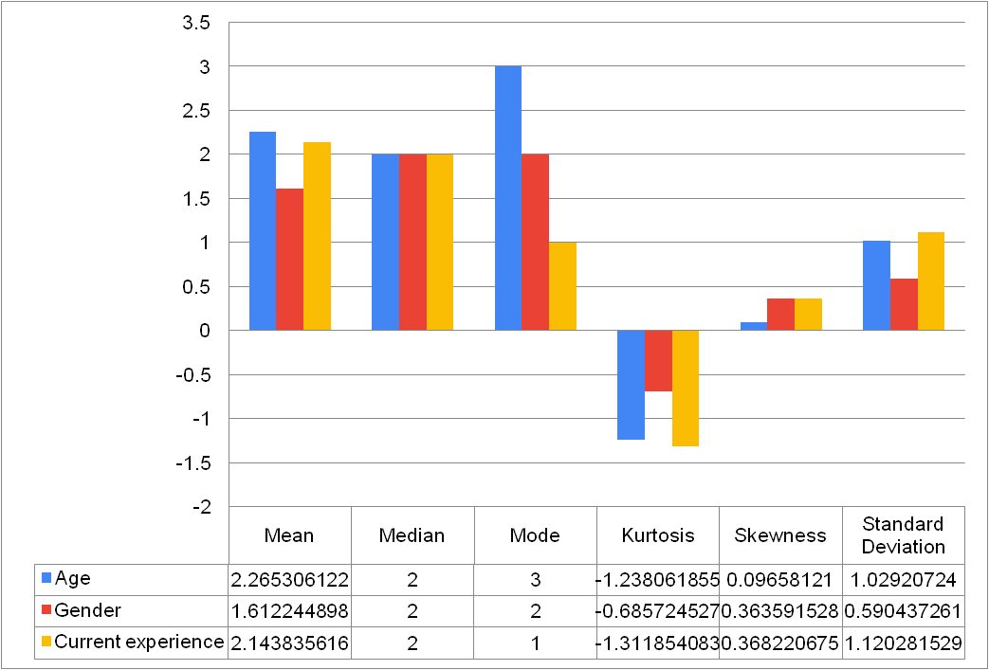

Figure 4.1: Descriptive analysis
The data shows an average age around 2.27 which recognised as the mean age of the participants are between the ages of 26 to 35 years. The descriptive statistics analysis shows that there is a distribution which has a slightly positive skewness and it means more respondents are likely in the younger age. The kurtosis indicates that a distribution is moderately peaked as well. Also, from the gender revelation from the analysis the mean of 1.612 suggests categorical variables where the numbers likely correspond with different gender categories. The mode is identified 2 which are most frequent and a slight positive skewness is identified and moderate kurtosis indicates a somewhat flat distribution among the male respondents.
Respondents’ experience in the UK retail food and confectionery sector averages around 2.14. This shows a range from less than 1 year of current professional experiences, which is being the most frequent response. The distribution is slightly positively skewed and moderately peaked.
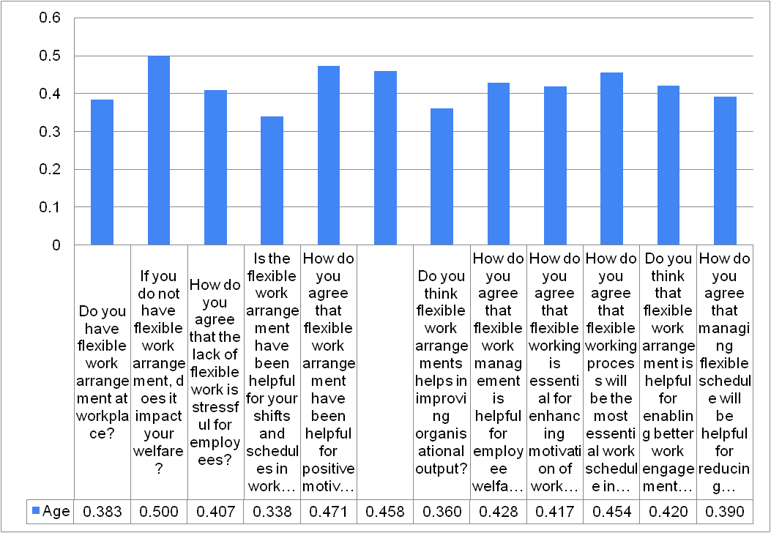

Figure 4.2: Correlation analysis age and the other variables
According to the correlation analysis between the age variables and the other variables identified in this study is depicted in the table. The average response suggests that about 38.3% of respondents have a flexible work arrangement at their workplace. There are certain considerations which follow that the process without the flexible work arrangements indicates an average impact in welfare of 0.500. This suggests a significant perceived impact on their wellbeing due to the lack of flexibility. There are respondents who have agreed with an average response at 0.408, which shows a lack of flexible work arrangements and is stressful for employees. There are also certain average respondents who found flexible work arrangements in certain helpful considerations. The analysis has suggested that there is a need to manage shifts and schedules at their current workplaces.
Flexible work arrangements are perceived to be moderately helpful with positive motivating employees. There are respondents who agree that flexible work arrangements are essential for fostering positive work relations and creativity. Also, according to the age there is a flexible work management that is seen as somewhat helpful which is for employee’s welfare in the workplace is average and moderate. The respondents are approached and agreed on the flexible working issues considerations which are essential for enhancing motivation in the confectionery industry. There is a moderate agreement with the age and flexible work arrangements enabled with a better work engagement and job satisfaction. Hence, there is a loss of consideration in having a flexible management schedule and is perceived at somewhat helpful and has an average response at 0.390 reducing employee’s attrition in the confectionary industry.
Overall, the response indicates a positive perception of flexible work arrangements with recognition of their potential benefit for employee welfare, motivation and creativity within the organisational outcomes. This is particularly in industries that are likely to proceed with confectionery where the operational flexibility is crucial. These findings suggest a strong support for implementing and improving flexible work policies to enhance workplace satisfaction and performance.
the majority of the respondents are younger with 53% under the age of 35 years which are likely to be more adaptable and open to flexible work arrangements. Conversely, the 36 to 40 years age groups represent a significant portion indicating that mid-career professionals are also a major part of the workforce. There are smaller representations of employees sieve 41 years suggests a potential need to tailored policies that accommodate the references and needs for older workers.
Within the survey the question was asked among the respondents about whether they believe the availability of flexible work and arrangement for the positive motivation of the workers in the confectionery industry of the UK. As a response it is understood that a vast majority of the workers believe on the factors of available to of the flexible work arrangement who have a positive impact on the management of positive motivation for the employees working in the industry.
The survey response suggested that almost 54.7% of the employees believe in the availability of working conditions and its association with the positive motivation of the workers. However, it is also a major factor that 19% and 10% of the workers do not agree on the view of the availability of flexible working conditions and its impact on the creation of positive motivation among the employees in the confectionery industry of the UK. Yet it is a major that availing the flexible work and rotating shift would be crucial for enhancing the motivation of the workers that relates to their greater engagement in the workplace and can also improve the overall productivity of the organisation.
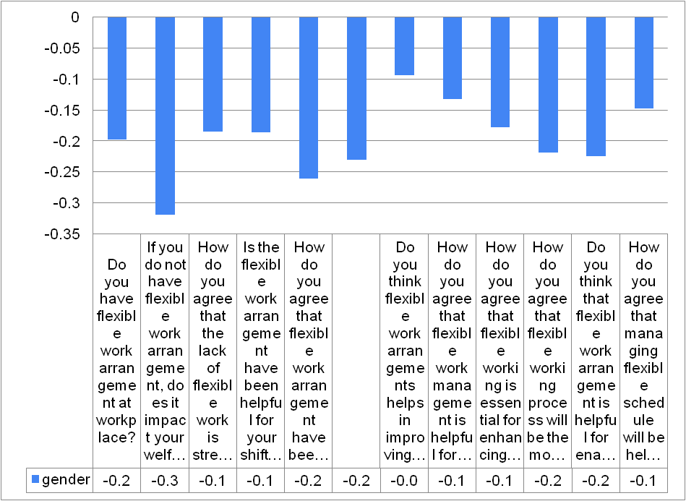

Figure 4.3: Correlation analysis gender and the other variables
The data collected suggests that lacking flexible work arrangements can lead to an increased stress among employees affecting their overall welfare negatively. Flexible work arrangements are perceived to be somewhat helpful for managing shifts and schedules which contribute to operational flexibility. There is a moderate agreement that flexible work arrangements positively influence motivation at the workplace. The analysis contributes to fostering positive work relations and creativity. While, the data has been considered which is considered to some of the agreement that flexible work arrangements improve organisational output? This sentiment is less pronounced compared to the other factors. There is a need to manage flexible work schedules that have been viewed as somewhat beneficial for employee welfare, better world engagement and job satisfaction, in this context of the confectionery industry. Flexible working is perceived as crucial for enhancing motivation. It is effective to being the most essential work schedule and reduces employee attrition.
Overall, the analysis interprets in the highlights those flexible work arrangements which are seen as an important approach for enhancing employee welfare, motivation and creativity with the jobs satisfaction across several industries. The data have analysed suggests that while tether are perceived benefits according to different genders there is a need to improve employee morale and reduce turnover. There are nuances in how flexible work arrangements impact organisational output indicating potential areas for further investigation and improvements. The gender distribution is fairly balanced with a slight majority. This balance is crucial for understanding the impact of flexible work arrangements in both the genders. Whereas, the responses can help identify the gender specific preferences or challenges related to flexible work arrangements. This significantly focused on the number of respondents who are relatively new to the industry which indicates a higher adaptability to new work arrangements. Thus, by understanding how flexible work arrangements impact those with more experiences which is crucial for retention strategies.
The response of the survey suggests that almost 49% of the respondents agree on the view that flexibility in the scheduling management of their employment helps in the management of the employee engagement and the positive motivations. Therefore, it reduces the attrition rate of the employees and rate of the changing of organisations in the industry. However, 19% of the participants also have indicated that flexibility in scheduling does not have any kind of importance and impact on the employee attrition rates in the confectionery industry of the UK.
The response of the survey indicates that almost 53% of respondents agreed on the matter that lack of the availability of the flexible working situations and rotating shifts of the employees have a major impact on increasing the stress factors of the employees in the workplace. On the other hand, 20% of the employees also have not agreed on the matter that availability of flexible work and management cannot reduce the stress of the employees within the workplace. Apart From that another 11.3% also have agreed on the same point that availability of the flexible work arrangement and conditions within the confectionery companies can essentially and positively impact the stress factors of the employees for reducing it and to improve the motivation and the employee welfare within the organisations. However, it is also a matter that almost 8% of the participants have strongly disagreed on the view that flexible work arrangement can reduce the stress factors of the employees working in the confectionery industry of the UK.
The survey emphasises not collecting the data regarding the impact of the flexible work arrangement on the personal work life balance of the employees. In that case the analysis of the survey responses suggests that the availability of the flexible work arrangement within the confectionery companies of the UK have a direct impact on the personal work life balance of the employees and their personal productivity approaches.
The response of the survey data suggests that 66.2% of the participants agreed on the view that the availability of the flexible work and event within the organisations in the confectionery industry can essentially and positively impact the work life balance of the employees within UK while 33.8% of the respondents within the confectionery industry in UK have also suggested that the available of the flexible do not have any kind of impact on the work life balance of the employees. However, the result of the survey prominently shows that availability of the flexible work arrangement can essentially and positively impact the factors of personal work life balance management of the employees in terms of their personal satisfaction.
In the response of the questions regarding the impact of the flexible work management on the positive motivations of the employees the data of the survey suggest that the availability of the flexible work arrangement and rotating scheduling management of employees in confectionery industry positivity impact the employee motivation regarding their engagement in the organisation.
The survey response suggests that almost 58.5% of the respondents agree on the view that availability of flexible work and management can essentially and positively impact the motivation of the employees regarding their workplace and can also improve their work engagement. However, within the data almost 20.8% of the participants also suggested a view that the factors of the availability of the flexible work schedule management do not have a positive impact on the motivation factor or avoided having any kind of impact on the motivation of employees for increasing their productivity and their work engagement within the workplace such as the confectionery companies that they are working in.
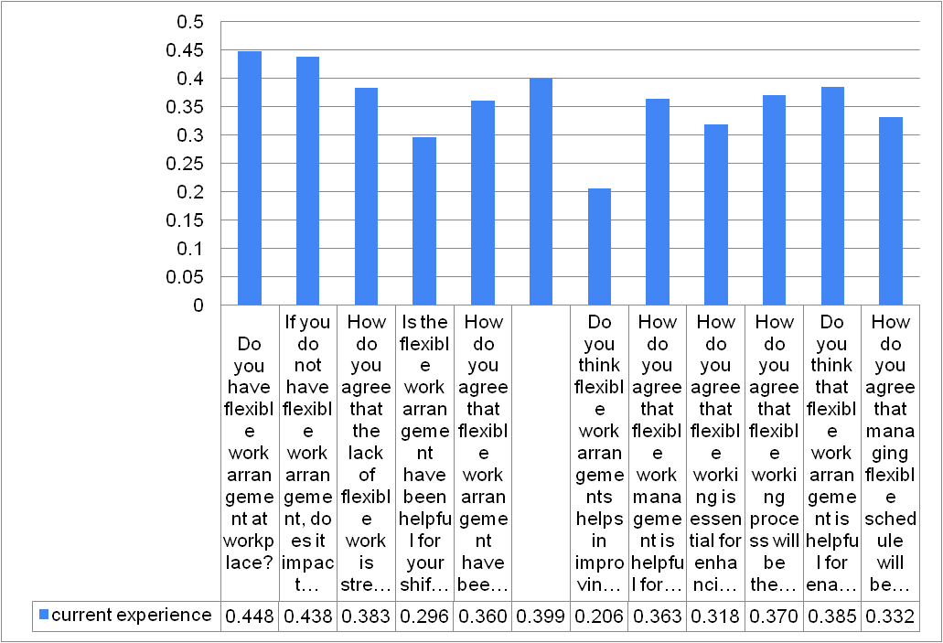

Figure 4.4: Correlation between current experiences and the other variables
Currently, employees identified that there is a perceived lack of flexible work arrangements negatively impacting their welfare. Therefore, the analysis interprets that lack of flexible work arrangements is seen as stressful for employees. Also, flexible work arrangements are perceived to be somewhat helpful for managing gifts and schedules to the workplaces. Flexible work arrangements are viewed as somewhat helpful for the positive motivation among employees. Therefore, flexible work arrangements are considered as helpful for employee welfare, and are viewed as somewhat established for enhancing motivation in the confectionary industry in the UK. The flexible working processes are perceived to be quite essential as work schedules in the confectionery industry in the UK. This is also processed with the flexible work arrangements seen as somewhat helpful for enabling better work engagement and job satisfaction. This tends to manage flexible schedules which are viewed as somewhat helpful for reducing employee attrition in the confectionery industry in the UK. The interpretation suggests that there is a generally positive perception of the benefits of flexible work arrangements. There is a degree of impact that varies across different aspects of workplace dynamics such as welfare, mitigation and creativity with the organisational output.
The survey has also collected the data regarding the gender and the sexual orientation of the respondents. In that case it is understood that the women's representation among the employees of the confectionery industry is high within the UK market. the data shows there are almost 50% of the respondents belongs to male while there are also 44.4% female within the confectionery industry of UK.
The current work experiences and flexible work arrangements tends to focus on flexible work arrangements as more beneficial for learning and adaptation to the workplace. These tend to consider a positive implication to flexible work policies which can be marketed as a benefit for new hires and enhances the onboarding process with early career developments. Also, more experienced employees are considered to offer a mix of flexible and fixed schedules to cater to experienced employees. This tends to maintain the productivity and satisfaction as well.
In terms of analysis of the impact of flexible work arrangement within the confectionery industry on the positive work relations management the employees at the respondents of the survey have suggested that availability of the flexible working conditions within the organisations can be a major factor for increasing the positive work relations within the organisation. The results suggest that the flexible working conditions create a positive motivation among the workers and the employees in the company that helps in building the positive relations among the employees as well as also help in the positive communication with the other stakeholders and the personal productivity within the organisation.
In a response almost 56.7% of the respondents agree on the view that availability of flexible working would be evident for increasing the positive work relations among the employees in the companies. On the other hand, 8.9% of the respondents have strongly disagreed on the view regarding the relations between the flexible working conditions and the positive work and further 19.6% of the survey respondents also have agreed on the view that there is no relation and the links between the positive work relations among the employees and the available of the flexible working conditions within their confectionery organisations in UK.
While the survey respondents were asked about their personal Idea regarding the relations between the flexible working conditions within the companies and its positive impact on the organisation output the 63.5% of the responders agree on the view that the flexible working conditions and its availability within the organisations can increase and improve in the organisation output in the confectionery companies. On the other hand, 22.6% of the employees have also suggested that there is no relation between the flexible working conditions and the organisation related outputs in terms of the productivity. As per their factors of the other aspect of management such as leadership and the collaboration as well as the product efficiency create the major impact on the product
In this case the study and the survey indicate that almost 57.2% of the participants agree on the view that availability of flexible working conditions is important for increasing employee welfare within the organisations of the confectionery industry of the UK. On the other hand, the survey also suggests that 19.5% of the respondents agree on the matter of the flexibility of the work arrangement in the confectionery organisations and its impact on the employee welfare management.
The survey has also focused on analysing the impact of flexible work arrangement on the scheduling process of the employees for mediating the best productivity within the organisation and maintaining the optimisation of the skills of human resources in the confectionery industry of the UK.
The response of the survey suggests that almost 52.8% of the participants agree on the view that availability of the flexible working schedule is important for maintaining the employee productivity and the essential scheduling process among the employees. The survey response also suggests that 22% of the overall participants have also designed the view that availability of the rotating schedules and the management of the flexible work arrangement helps in management of the ruling of the employees and maintaining the individual and the group level productivity within the organisations. However, the overall indications of the survey response generally suggest that the effective management of the flexibility in the job arrangement of the employees helps in the development of the individual level productivity of the employees as well as also develop and improves the group level productivity within the organisations.
The survey has collected essential data regarding the relations between the flexible work arrangement within the organisations of the confectionery industry of the UK and the management of the employee engagement within the workplace.
The response of the survey directly suggests that 50% of the participants of the survey have indicated that flexible work arrangement is important for enhancing the employee engagement within the workplace for the employees. However almost 40% of the employees and the respondents with the survey have also suggested that they do not have any kind of indication regarding the impact of flexible work arrangement on the improving employee engagement of the employees in the workplace. However, the overall data is suggestive of the factors that the management of the flexibility in the scheduling approaches and the work arrangement is a major factor for demonstrating the positive implications about the essential and positive work engagement of the employees in the workplace and improving the productivity in the organisations.

4.3 Limitations of Study
There has been essential barrier and challenges as well as the issues in the primary data collection process. In this way, the key components of the barrier to managing flexible work opportunities inside the work placement and raising employee engagement have not been fully understood. In that instance, using primary qualitative data obtained from employee interviews may have been more crucial for delving further into the variables influencing workers' motivation and job satisfaction.

4.4 Key findings
When analysing how flexible work arrangements affect the management of positive work relations in the confectionery industry, survey respondents' employees have indicated that having flexible work arrangements available within their organisations can play a significant role in fostering positive work relationships. The findings imply that flexible work arrangements foster a positive work environment and employee motivation, which in turn fosters good working relationships among staff members, facilitates positive stakeholder communication, and increases individual productivity within the company.

4.5 Summary
In summary, the overall responses of the survey have essentially confirmed the aspects of findings of the literature review and the conceptual framework within the study. The survey response suggests that implications of the flexibility in the scheduling approaches of the employees helps in the development of the employee engagement and their positive motivations within the organisations. In this way it helps in the demonstration of greater engagement and reduce the employee attrition rate within the organisations. The survey reports shows that flexible schedule management has been essential for workers in the confectionery sector to sustain job happiness and effectiveness. The provision of flexible scheduling has been essential for improving employee satisfaction, which in turn contributes to increased employee engagement and improved performance. The data suggests that managing flexibility in scheduling approaches and work arrangements plays a significant role in demonstrating the positive implications of essential and positive work engagement of employees in the workplace and enhancing organisational productivity.

Chapter 5: Discussion and conclusion

5.1 Unique findings and insights
The chapter has analysed the data of the responses of the respondents about the confectionary industry and their employee satisfaction on flexible work management. As the chapter has focussed on using the tools in google form to get the responses through MS Excel which helps to get the overall data of the survey and it is also easy to visualise the study. The data of the study has collected the demographic aspects regarding the responses of the respondents of the different age groups of the confectionary industry in the UK (Spurk and Straub, 2020). The workforce of the age demographics is analysed into diversity and in various age groups of the employees of the organisation which indicates the homogeneous nature to arrange the work flexible and contributes the fundamental information of the industry in the UK (Mughal and Iraqi, 2020).
Concerning the availability of flexible work arrangements in the confectionery business, wherein employees can work at their own pace and how they obtain employment possibilities inside the companies, the respondents' question was addressed. According to Austin-Egole et al. (2020), a significant proportion of confectionery companies offer their employees flexible work arrangements. This information is derived from the study. According to Spurk and Straub (2020), a small number of organisations are unable to offer their staff flexible work arrangements, which has an annual influence on their scheduling practices and lowers employee engagement and company motivation.
In that case of flexible working arrangement, the chapter denoted that an employees’ work availability depends on their designated time and makes it flexible to work in the organisations which impacts majorly on the employee welfare (Byrne, 2022).
Therefore, from the survey it has been known that if there is a lack of flexible work arrangement in the companies of the confectionery industry the employees are going through some difficult situations (Ngwenya and Pelser, 2020). As a result in this case, the confectionery industry has a large impact on the employees and increased the stress level of the employees in their workplace (Baqir et al., 2020). A majority of respondents agreed on the fact that lack of flexible work schedules and their working schedules have affected the employees within the workplace by increasing their stress about the difficult situations (Ray and Pana-Cryan, 2021). From the survey it is noted that some respondents have not agreed on the matter of availability of flexible work and the stress of the employees due to lack of flexible work management in the confectionery companies.
The influence of flexible work management and how it affects employees' personal work-life balance was examined in the survey. According to Putra et al. (2020), the survey findings indicate that a significant number of participants hold a consensus regarding the availability of flexible work inside the company. Encouraging employees to work in a sustainable environment through management systems contributes to their personal work-life balance in the United Kingdom. According to Sabuhari et al. (2020), the survey results pertaining to flexible work arrangements have a favourable impact on employees' positive motivations and their ability to work within planned work hours, hence improving their work engagement within the firm.
In the responses of the questions about the impact of flexible work management of the confectionery industry on the positive work relations of the employees within the organisations the survey has focussed that the flexible working management is a major issue for a positive work relation within the organisations (Park et al., 2022). Thus, the survey indicates the fact of increasing the positive work relations which leads to a positive motivation among the workers and makes the communication strong between the other organisations and the business stakeholders for producing more productivity in the business market in the UK (Tamssaouet et al., 2022). In this view of sustainable flexible working for positive work relations the survey has suggested that a large number of respondents have agreed the fact of flexible scheduling impacts on positive work culture among the employees in the organisations of the UK confectionery industry (Ray and Pana-Cryan, 2021).

5.2 Theoretical implications
The literature review in the evaluation and understanding of the social exchange theory has been mainly focusing on understanding the exchange regarding the work life balance and maintaining the psychological contract about employee welfare within the organisations that in exchange provides the greater employee engagement within the organisation that relates to improved productivity within the companies (Austin-Egole et al., 2020). In that case, availability of the scheduling approaches and flexibility in terms of the employment within the confectionery industries help in the employee motivation as well as it derives greater employee engagement (Spurk and Straub, 2020).
On the other hand, that theory of the enrichment regarding management of the work life balance had also been mainly focused on the enhancement of the skills and the capabilities as well as the satisfaction of the employees (Shifrin and Michel, 2022). In that case providing and creating the essential value in terms of managing employment are also the certain considerations that help in achieving the greater employee engagement as well as the greater motivation which relates to the effective productivity of the organisation (Hodzic et al., 2021). Therefore, when the data relates to the features that availability of the greater employee engagement and the greater welfare aspects help in gaining the better motivation of the employees as well as it also helps in management of the psychological Welfare of employees and increase productivity at the individual level (Li et al., 2022). The data also indicates that enhancing the Welfare and flexible work opportunities for the employees and the workers are also important for engaging within the workplace that reduce the employee turnover rate within organisations which also saves essential investment of the cost of organisations regarding hiring human resources and training about the daily operations (Austin-Egole et al., 2020).

5.3 Conclusion
The study regarding flexible work arrangement and its impact on the job satisfaction of the employees and the performance of the organisations in the confectionery industry have been important while collecting the primary quantitative data from the staff and the different other levels of the employees in the confectionery industry and small-scale organisations across the UK. The study has mainly focused on the impact of the flexible work arrangement on the motivation and the employee mental welfare of the participants such as the employees of the confectionery industry in UK. in that case the study has gathered the data that available at the flexible work arrangement has been mostly important for enhancing the mental Welfare of the employees and also help to reduce the respect that increase the individual level of the motivation and also helps in the development of the productivity in the organisations.
On the other hand, it is also understood that the lack of flexible work schedule available within the confectionery companies in the UK have a major impact on the stress factors of the employees and increase the rate of the employee turnover in the organisations as well as also reduce the individual levels of productivity in the companies. Furthermore, Collection of the primary quantitative data from the survey also indicates that the flexible work arrangement within the small-scale confectionery companies within the UK also have the essential impact on the positive motivation of the employees. The availability of the flexible work arrangement generator helps to generate the positive work life balance among the employees that helps in the generation of often personal level intrinsic motivation of the workers in the confectionery companies in the UK. The positive motivation also helps in developing the greater employee engagement within the workplace that reduces the employee attrition rate as well as help in the positive financial performances of the company in terms of the productivity level. The flexible worker arrangement also creates the positive relations between the different levels of the stakeholders in the hierarchy of the organisation that also helps in the development of the positive work relation and the positive organisation culture enhancing the personal level Innovation and the creativity of the employees.
Thus, when the data pertains to the attributes that are available to enhance employee engagement and welfare, it helps to improve employee motivation and also aids in managing employees' psychological well-being and boosting productivity on an individual basis. The data also suggests that improving worker welfare and flexible work arrangements are critical to fostering a work environment that lowers employee turnover rates within organisations and reduces the expenditures associated with hiring human resources and providing training on day-to-day operations.
The study also helps to understand that available to the different types of flexible employment includes the arrangement of the random shifting of the employees as well as available remote working opportunities for the employees who can maintain their operations from the remote performances. The study also focuses on the lack of flexible work arrangement and also increases the stress factor among the employees that can reduce the employee engagement and improvement of the personal level of productivity.

5.4 Linking with Objectives and research questions
Linking with Objective 1
The first objective of the study was mainly focused on analysing the different types of the flexible work arrangement within the confectionery companies in the UK. In that case it is understood that the different terms of the flexible worker generally include the shifting of the employees at the weekly basis such as the rotating shifting and the flexible shifting of the employees that helps in managing the daily operations of the employees as per their own wish (Öhrn et al., 2021). Moreover, Availability of remote working is also provided to the employee which also helps in the development of the individual level of the productivity of employees in the company. The different types of the flexible scheduling approach help in generating the motivation as well as the positive work engagement of the employees in terms of their individual performances and individual level of the productivity in their daily operation systems (Hodzic et al., 2021).
Linking with objective 2
The second objective of the study is mainly focused on the influences of the flexible work arrangement practices within the confectionery companies of UK. in that case it is understood that the lack of flexible work opportunities of the employees the decrease the personal level of the motivation for the work as well as increase the stress level of the employees that decrease their performance at the individual level (Jiang et al., 2023). In that case, maintaining the essential satisfaction and the motivation of the workers available in the flexible work arrangement is important to improve the job satisfaction of the employees as well as reducing the stress factor of the employees that helps in the better demonstration of productivity at the individual level (Tsen et al., 2021).
Linking with objective 3
The third objective of the study was mainly focused on analysing the positive impact of the flexible job opportunities on the job satisfaction of the employees and the motivation. In that it is understood that the flexible work arrangement opportunities improve the personal level motivation of the employees and also increase the job satisfaction that helps in development of the individual level of the performance of the employees and enhancing productivity (Jiang et al., 2023).
Linking with Objective 4
In terms of the future management, the implication of the availability of the skill development opportunities as well as use of the different technologies can be more important for enhancing the personal level of job satisfaction (Ray and Pana-Cryan, 2022). It is understood that the lack of teamwork management and the culture is the major barrier for the job satisfaction of the employees and increasing productivity (Sabuhari et al., 2024). Removing those barriers can be most important for the organisations to improve the job satisfaction of employees.

5.5 Recommendations
Skill development opportunities: Providing the skill development opportunities by learning the different aspects of the technology implications in terms of the production can be important for enhancing the motivation of the workers within the confectionery organisations of the UK (Öhrn et al., 2021). Moreover, providing the skill development opportunities can also be important for enhancing the job satisfaction and motivation of employees.
Use of technologies: The use of the technology such as the use of CRM systems and the different cutting-edge tools and devices for the production can also be important in this case for enhancing the productivity level and reducing the stress of the employees. Apart from that, the use of Technology systems such as HR analytics can also be important for analysing and evaluating the performance and dedication of the employees for providing promotional opportunities that can also increase job satisfaction (Jiang et al., 2023).
Shift rotation: the effective management of the shift rotation systems can also be effective in the case of the employees in the confectionary industry. The efficient shift rotation as per the weekly basis can be important in that case for the better management of the flexible timing approaches which can be evident for the better management of the managerial aspects of the employee motivation and positive employee engagement (Choi, 2020).
Future implication for Literature gap
The recent studies have not evaluated the factors of the relations of the employee well-being management and its relation with the flexible job management approaches. In that case the future studies can also focus on that matter for the better evaluation of the psychological aspects with flexible employment.

5.6 Study limitations
The study has certain limitations as the study has only collected the primary quantitative data through the survey method. In that way there has been a lack of understanding the crucial factors of the barrier regarding the flexible work opportunity management within the work placement and enhancement of the motivation of the workers. The use of primary qualitative data in that case through the interview process of the employees could have been more important for understanding deeper factors associated with the motivation of the employees and the job satisfaction.
The studies of the recent times and the data presented in the study lack a vital factor such as the lack of the analysis of the psychological aspects and focussing in the psychological welfare of the employees. The shift rotation and the practices of the flexible working has been essential for the better motivation and better productivity of the employees. However, the psychological considerations associated with the factors of the flexible working and productivity has not been drawn.

5.7 Future implications
In terms of the future implication the study can emphasise on collecting both of the primary qualitative and quantitative data through the survey and interview process. collecting both of the data would have been important for understanding the major factors of the motivation and flexible work arrangement in the confectionery organisations in the UK.

References
Ababneh, O.M.A., 2021. How do green HRM practices affect employees’ green behaviors? The role of employee engagement and personality attributes. Journal of Environmental Planning and Management, 64(7), pp.1204-1226.
Adisa, T.A., Ogbonnaya, C. and Adekoya, O.D., 2023. Remote working and employee engagement: a qualitative study of British workers during the pandemic. Information Technology & People, 36(5), pp.1835-1850.
Al-Ababneh, M., 2020. Linking ontology, epistemology and research methodology. Science & Philosophy, 8(1), pp.75-91.
Al-Ababneh, M., 2020. Linking ontology, epistemology and research methodology. Science & Philosophy, 8(1), pp.75-91.
Albrecht, S.L., Green, C.R. and Marty, A., 2021. Meaningful work, job resources, and employee engagement. Sustainability, 13(7), p.4045.
Ali, B.J. and Anwar, G., 2021. An empirical study of employees’ motivation and its influence job satisfaction. Ali, BJ, & Anwar, G. (2021). An Empirical Study of Employees’ Motivation and its Influence Job Satisfaction. International Journal of Engineering, Business and Management, 5(2), pp.21-30.
Alsuwaidi, M., Alshurideh, M., Al Kurdi, B. and Salloum, S.A., 2021. Performance appraisal on employees’ motivation: A comprehensive analysis. In Proceedings of the International Conference on Advanced Intelligent Systems and Informatics 2020 (pp. 681-693). Springer International Publishing.
Asatiani, A., Hämäläinen, J., Penttinen, E. and Rossi, M., 2021. Constructing continuity across the organisational culture boundary in a highly virtual work environment. Information systems journal, 31(1), pp.62-93.
Austin-Egole, I.S., Iheriohanma, E.B. and Nwokorie, C., 2020. Flexible working arrangements and organizational performance: An overview. IOSR Journal of Humanities and Social Science (IOSR-JHSS), 25(5), pp.50-59.
Austin-Egole, I.S., Iheriohanma, E.B. and Nwokorie, C., 2020. Flexible working arrangements and organizational performance: An overview. IOSR Journal of Humanities and Social Science (IOSR-JHSS), 25(5), pp.50-59.
Baqir, M., Hussain, S., Waseem, R. and Islam, K.A., 2020. Impact of reward and recognition, supervisor support on employee engagement. American International Journal of Business and Management Studies, 2(3), pp.8-21.
Barreiro, C.A. and Treglown, L., 2020. What makes an engaged employee? A facet-level approach to trait emotional intelligence as a predictor of employee engagement. Personality and Individual Differences, 159, p.109892.
Bell, E., Bryman, A. and Harley, B., 2022. Business research methods. Oxford university press.
Brega, C., Briones, S., Javornik, J., León, M. and Yerkes, M., 2023. Flexible work arrangements for work-life balance: a cross-national policy evaluation from a capabilities perspective. International Journal of Sociology and Social Policy, 43(13/14), pp.278-294.
Budianto, A., 2020. Legal research methodology repositions in research on social science. International Journal of Criminology and Sociology, 9(1), pp.1339-1346.
Byrne, Z.S., 2022. Understanding employee engagement: Theory, research, and practice. Routledge.
Chanana, N. and Sangeeta, 2021. Employee engagement practices during COVID‐19 lockdown. Journal of public affairs, 21(4), p.e2508.
Chandni, S. and Rahman, Z., 2020. Customer engagement and employee engagement: Systematic review and future directions. The Service Industries Journal, 40(13-14), pp.932-959.
Chang, S.J., Van Witteloostuijn, A. and Eden, L., 2020. Common method variance in international business research. Research methods in international business, pp.385-398.
Chatterjee, S., Chaudhuri, R. and Vrontis, D., 2022. Does remote work flexibility enhance organization performance? Moderating role of organization policy and top management support. Journal of Business Research, 139, pp.1501-1512.
Choi, S., 2020. Flexible work arrangements and employee retention: A longitudinal analysis of the federal workforces. Public Personnel Management, 49(3), pp.470-495.
Chung, H. and Van der Lippe, T., 2020. Flexible working, work–life balance, and gender equality: Introduction. Social indicators research, 151(2), pp.365-381.
Clack, L., 2021. Employee engagement: Keys to organizational success. The Palgrave handbook of workplace well-being, pp.1001-1028.
Cpid, 2024. Flexible Working Taskforce [Online]. Available at: https://www.cipd.org/en/about/public-policy/public-policy-partnerships/flexible-working-taskforce/#:~:text=The%20Employment%20Relations%20(Flexible%20Working,one%20of%20a%20new%20job. [Accessed on 12/04/24]
Diop, K.A.S. and Liu, E., 2020. Categorization of case in case study research method: New approach. Knowledge and Performance Management, 4(1), p.1.
Duque, L., Costa, R., Dias, Á., Pereira, L., Santos, J. and António, N., 2020. New ways of working and the physical environment to improve employee engagement. Sustainability, 12(17), p.6759.
Dziuba, S.T., Ingaldi, M. and Zhuravskaya, M., 2020. Employees’ job satisfaction and their work performance as elements influencing work safety. System Safety: Human-Technical Facility-Environment, 2(1), pp.18-25.
Dzwigol, H., 2022. Research methodology in management science: Triangulation. Virtual Economics, 5(1), pp.78-93.
Easterby-Smith, M., Jaspersen, L.J., Thorpe, R. and Valizade, D., 2021. Management and business research. Sage.
Eden, L., Nielsen, B.B. and Verbeke, A., 2020. Research methods in international business. Palgrave Macmillan.
Employeebenefits, 2023. 77% of SMEs say hybrid working has increased profitability [Online]. Available at: https://employeebenefits.co.uk/77-of-smes-say-hybrid-working-has-increased-profitability/ [Accessed on 12/04/24]
Foodmanufcature.co.uk, 2024. 55% of Food manufacturers Plan to Leave their current role. Available at: https://www.foodmanufacture.co.uk/Article/2023/08/22/uk-and-irish-food-manufacturing-struggles-to-retain-staff [Accessed on 12/04/2024]
Foodmanufcature.co.uk, 2024. Six Factors Increasing Staff Turnover and How to Avoid Them. Available at:https://www.foodmanufacture.co.uk/Article/2022/11/23/six-factors-increasing-staff-turnover-and-how-to-avoid-them [Accessed on 12/04/2024]
Forson, J.A., Ofosu-Dwamena, E., Opoku, R.A. and Adjavon, S.E., 2021. Employee motivation and job performance: a study of basic school teachers in Ghana. Future Business Journal, 7(1), p.30.
Ghauri, P., Grønhaug, K. and Strange, R., 2020. Research methods in business studies. Cambridge University Press.
Gorondutse, A.H., Arshad, D. and Alshuaibi, A.S., 2021. Driving sustainability in SMEs’ performance: The effect of strategic flexibility. Journal of Strategy and Management, 14(1), pp.64-81.
Gov.Uk, 2023. Business Support for SMEs [Online]. Available at: https://assets.publishing.service.gov.uk/media/5a7e1162e5274a2e87daf55b/business-support.pdf [Accessed on 12/04/24]
Gov.UK, 2024. Food Statistics in Your Pocket. Available at: https://www.gov.uk/government/statistics/food-statistics-pocketbook/food-statistics-in-your-pocket. [Accessed on 12/04/2024]
Gupta, A. and Gupta, N., 2022. Research methodology. SBPD Publications.
Hajiali, I., Kessi, A.M.F., Budiandriani, B., Prihatin, E. and Sufri, M.M., 2022. Determination of work motivation, leadership style, employee competence on job satisfaction and employee performance. Golden Ratio of Human Resource Management, 2(1), pp.57-69.
Hassan, Z., 2022. Employee retention through effective human resource management practices in Maldives: Mediation effects of compensation and rewards system. Journal of Entrepreneurship, Management and Innovation, 18(2), pp.137-174.
Hermawan, H., Thamrin, H.M. and Susilo, P., 2020. Organizational citizenship behavior and performance: the role of employee engagement. The Journal of Asian Finance, Economics and Business, 7(12), pp.1089-1097.
Hernandez-Matias, J.C., Ocampo, J.R., Hidalgo, A. and Vizan, A., 2020. Lean manufacturing and operational performance: Interrelationships between human-related lean practices. Journal of Manufacturing Technology Management, 31(2), pp.217-235.
Heslina, H. and Syahruni, A., 2021. The influence of information technology, human resources competency and employee engagement on performance of employees. Golden Ratio of Human Resource Management, 1(1), pp.01-12.
Hodzic, S., Kubicek, B., Uhlig, L. and Korunka, C., 2021. Activity-based flexible offices: effects on work-related outcomes in a longitudinal study. Ergonomics, 64(4), pp.455-473.
Iis, E.Y., Wahyuddin, W., Thoyib, A., Ilham, R.N. and Sinta, I., 2022. The effect of career development and work environment on employee performance with work motivation as intervening variable at the office of agriculture and livestock in Aceh. International Journal of Economic, Business, Accounting, Agriculture Management and Sharia Administration (IJEBAS), 2(2), pp.227-236.
Indrawati, H., 2020. Barriers to technological innovations of SMEs: how to solve them.? International Journal of Innovation Science, 12(5), pp.545-564.
Jiang, L., Pan, Z., Luo, Y., Guo, Z. and Kou, D., 2023. More flexible and more innovative: the impact of flexible work arrangements on the innovation behavior of knowledge employees. Frontiers in Psychology, 14, p.1053242.
Jiang, L., Pan, Z., Luo, Y., Guo, Z. and Kou, D., 2023. More flexible and more innovative: the impact of flexible work arrangements on the innovation behavior of knowledge employees. Frontiers in Psychology, 14, p.1053242.
Kalogiannidis, S., 2021. Impact of employee motivation on organizational performance. A scoping review paper for public sector. The Strategic Journal of Business & Change Management, 8 (3), 984, 996(3).
Kaur, P. and Mittal, A., 2020. Meaningfulness of work and employee engagement: The role of affective commitment. The Open Psychology Journal, 13(1).
Kim, K.W. and Cho, Y.H., 2020. The moderating effect of managerial roles on job stress and satisfaction by employees’ employment type. International Journal of Environmental Research and Public Health, 17(21), p.8259.
Kotera, Y. and Correa Vione, K., 2020. Psychological impacts of the new ways of working (NWW): A systematic review. International journal of environmental research and public health, 17(14), p.5080.
Kotey, B. and Koomson, I., 2021. Firm size differences in financial returns from flexible work arrangements (FWAs). Small Business Economics, 56(1), pp.65-81.
Kumari, S.K.V., Lavanya, K., Vidhya, V., Premila, G.A.D.J.S. and Lawrence, B., 2023. Research methodology (Vol. 1). Darshan Publishers.
Lange, T., 2021. Job satisfaction and implications for organizational sustainability: a resource efficiency perspective. Sustainability, 13(7), p.3794.
Lartey, F.M., 2021. Impact of career Planning, employee autonomy, and manager recognition on employee engagement. Journal of Human Resource and Sustainability Studies, 9(02), p.135.
Li, H., Wang, X. and Peng, J., 2022. A hybrid differential evolution algorithm for flexible job shop scheduling with outsourcing operations and job priority constraints. Expert Systems with Applications, 201, p.117182.
Li, P., Sun, J.M., Taris, T.W., Xing, L. and Peeters, M.C., 2021. Country differences in the relationship between leadership and employee engagement: A meta-analysis. The Leadership Quarterly, 32(1), p.101458.
Liang, C., Peng, J., Hong, Y. and Gu, B., 2023. The hidden costs and benefits of monitoring in the gig economy. Information Systems Research, 34(1), pp.297-318.
Mardikaningsih, R., Azizah, E.I., Putri, N.N., Alfan, M.N. and Rudiansyah, M.M.D.H., 2022. Business Survival: Competence of Micro, Small and Medium Enterprises. Journal of Social Science Studies (JOS3), 2(1), pp.1-4.
Mas, A. and Pallais, A., 2020. Alternative work arrangements. Annual Review of Economics, 12, pp.631-658.
McKinsey, 2023. About [Online]. Available at: https://www.mckinsey.com/industries/real-estate/our-people [Accessed on 12/04/24]
Men, L.R., O’Neil, J. and Ewing, M., 2020. Examining the effects of internal social media usage on employee engagement. Public Relations Review, 46(2), p.101880.
Messabia, N., Fomi, P.R. and Kooli, C., 2022. Managing restaurants during the COVID-19 crisis: Innovating to survive and prosper. Journal of Innovation & Knowledge, 7(4), p.100234.
MM, S., 2021. Influence of empowerment, psychological contract and employee engagement on voluntary turnover intentions. International Journal of Productivity and Performance Management, 70(2), pp.325-349.
Mughal, M.U. and Iraqi, K.M., 2020. The impact of leadership, teamwork and employee engagement on employee performances. Saudi Journal of Business and Management Studies, 5(3), pp.233-244.
Mulang, H., 2022. Analysis of the effect of organizational justice, worklife balance on employee engagement and turnover intention. Golden Ratio of Human Resource Management, 2(2), pp.86-97.
Nayak, J.K. and Singh, P., 2021. Fundamentals of research methodology problems and prospects. SSDN Publishers & Distributors.
Nayak, J.K. and Singh, P., 2021. Fundamentals of research methodology problems and prospects. SSDN Publishers & Distributors.
Nazir, O. and Islam, J.U., 2020. Effect of CSR activities on meaningfulness, compassion, and employee engagement: A sense-making theoretical approach. International Journal of Hospitality Management, 90, p.102630.
Newman, M. and Gough, D., 2020. Systematic reviews in educational research: Methodology, perspectives and application. Systematic reviews in educational research: Methodology, perspectives and application, pp.3-22.
Nguyen, C., 2020. The impact of training and development, job satisfaction and job performance on young employee retention. Job Satisfaction and Job Performance on Young Employee Retention (May 1, 2020).
Nguyen, H.N., Le, Q.H., Tran, Q.B., Tran, T.H.M., Nguyen, T.H.Y. and Nguyen, T.T.Q., 2020. The impact of organizational commitment on employee motivation: A study in Vietnamese enterprises. The Journal of Asian Finance, Economics and Business, 7(6), pp.439-447.
Ngwenya, B. and Pelser, T., 2020. Impact of psychological capital on employee engagement, job satisfaction and employee performance in the manufacturing sector in Zimbabwe. SA Journal of Industrial Psychology, 46(1), pp.1-12.
Nienaber, H. and Martins, N., 2020. Exploratory study: Determine which dimensions enhance the levels of employee engagement to improve organisational effectiveness. The TQM Journal, 32(3), pp.475-495.
Nwekpa, K.C., Offor, P.G. and Ezezue, B.O., 2020. Work schedule flexibility and employee commitment: A study of Nigerian Breweries, Ama, Enugu, Nigeria. International Journal of Development and Management Review, 15(1), pp.1-16.
Ocaña-Fernández, Y. and Fuster-Guillén, D., 2021. The bibliographical review as a research methodology. Revista Tempos e Espaços em Educação, 14(33), pp.e15614-e15614.
Öhrn, M., Wahlström, V., Harder, M.S., Nordin, M., Pettersson-Strömbäck, A., Bodin Danielsson, C., Olsson, D., Andersson, M. and Slunga Järvholm, L., 2021. Productivity, satisfaction, work environment and health after relocation to an activity-based flex office—the active office design study. International journal of environmental research and public health, 18(14), p.7640.
Ouakouak, M.L., Zaitouni, M.G. and Arya, B., 2020. Ethical leadership, emotional leadership, and quitting intentions in public organizations: does employee motivation play a role? Leadership & organization development journal, 41(2), pp.257-279.
Paais, M. and Pattiruhu, J.R., 2020. Effect of motivation, leadership, and organizational culture on satisfaction and employee performance. The journal of asian finance, economics and business, 7(8), pp.577-588.
Pandey, P. and Pandey, M.M., 2021. Research methodology tools and techniques. Bridge Center.
Park, J., Han, S.J., Kim, J. and Kim, W., 2022. Structural relationships among transformational leadership, affective organizational commitment, and job performance: the mediating role of employee engagement. European Journal of Training and Development, 46(9), pp.920-936.
Parliament.uk, 2024. Retail sector in the UK, Available at: https://researchbriefings.files.parliament.uk/documents/SN06186/SN06186.pdf[Accessed on 12/04/2024]
Pham, H.M., Le, T.T.H., Dang, L.H. and Nguyen, L.T., 2023. The impact of reward system on talented employees’ performance in Vietnamese commercial banks: mediating role of job satisfaction. Journal of Financial Services Marketing, pp.1-16.
Pincus, J.D., 2023. Employee Engagement as Human Motivation: Implications for theory, methods, and practice. Integrative Psychological and Behavioral Science, 57(4), pp.1223-1255.
Putra, K.C., Pratama, T.A., Linggautama, R.A. and Prasetyaningtyas, S.W., 2020. The impact of flexible working hours, remote working, and work life balance to employee satisfaction in banking industry during covid-19 pandemic period. Journal of Business and Management Review, 1(5), pp.341-353.
Quek, S.J., Thomson, L., Houghton, R., Bramley, L., Davis, S. and Cooper, J., 2021. Distributed leadership as a predictor of employee engagement, job satisfaction and turnover intention in UK nursing staff. Journal of Nursing Management, 29(6), pp.1544-1553.
Rahaman, M.A., Gupta, A., Ali, A.I., Ali, M.J. and Taru, R.D., 2021. Identification of determining factors of employee performance of SME business. Academy of Entrepreneurship Journal, 27(6), pp.1-5.
Rasheed, M.I., Jamad, W.N., Pitafi, A.H. and Iqbal, S.M.J., 2020. Perceived compensation fairness, job design, and employee motivation: The mediating role of working environment. South Asian Journal of Management, 14(2), pp.229-246.
Rasool, S.F., Wang, M., Tang, M., Saeed, A. and Iqbal, J., 2021. How a toxic workplace environment effects the employee engagement: The mediating role of organizational support and employee wellbeing. International journal of environmental research and public health, 18(5), p.2294.
Ray, T.K. and Pana-Cryan, R., 2021. Work flexibility and work-related well-being. International journal of environmental research and public health, 18(6), p.3254.
Ray, T.K. and Pana-Cryan, R., 2021. Work flexibility and work-related well-being. International journal of environmental research and public health, 18(6), p.3254.
Ray, T.K. and Pana-Cryan, R., 2021. Work flexibility and work-related well-being. International journal of environmental research and public health, 18(6), p.3254.
Raza, A., Farrukh, M., Iqbal, M.K., Farhan, M. and Wu, Y., 2021. Corporate social responsibility and employees' voluntary pro‐environmental behavior: The role of organizational pride and employee engagement. Corporate Social Responsibility and Environmental Management, 28(3), pp.1104-1116.
Regona, M., Yigitcanlar, T., Xia, B., and Li, R.Y.M., 2022. Opportunities and adoption challenges of AI in the construction industry: A PRISMA review. Journal of open innovation: technology, market, and complexity, 8(1), p.45.
Riyanto, S., Endri, E. and Herlisha, N., 2021. Effect of work motivation and job satisfaction on employee performance: Mediating role of employee engagement. Problems and Perspectives in Management, 19(3), p.162.
Riyanto, S., Endri, E. and Herlisha, N., 2021. Effect of work motivation and job satisfaction on employee performance: Mediating role of employee engagement. Problems and Perspectives in Management, 19(3), p.162.
Rodríguez-Sánchez, J.L., González-Torres, T., Montero-Navarro, A. and Gallego-Losada, R., 2020. Investing time and resources for work–life balance: The effect on talent retention. International journal of environmental research and public health, 17(6), p.1920.
Sabuhari, R., Sudiro, A., Irawanto, D. and Rahayu, M., 2020. The effects of human resource flexibility, employee competency, organizational culture adaptation and job satisfaction on employee performance. Management Science Letters, 10(8), pp.1775-1786.
Saks, A.M., 2022. Caring human resources management and employee engagement. Human resource management review, 32(3), p.100835.
Saunders, M., Lewis, P. and Thornhill, A., 2009. Research methods for business students. Pearson education.
Sekhar, C. and Patwardhan, M., 2023. Flexible working arrangement and job performance: the mediating role of supervisor support. International Journal of Productivity and Performance Management, 72(5), pp.1221-1238.
Shifrin, N.V. and Michel, J.S., 2022. Flexible work arrangements and employee health: A meta-analytic review. Work & Stress, 36(1), pp.60-85.
Shifrin, N.V. and Michel, J.S., 2022. Flexible work arrangements and employee health: A meta-analytic review. Work & Stress, 36(1), pp.60-85.
Sims, S., 2020. Modelling the relationships between teacher working conditions, job satisfaction and workplace mobility. British Educational Research Journal, 46(2), pp.301-320.
Sitopu, Y.B., Sitinjak, K.A. and Marpaung, F.K., 2021. The influence of motivation, work discipline, and compensation on employee performance. Golden Ratio of Human Resource Management, 1(2), pp.72-83.
SME Magazine, 2024. How the Flexible Working Bill could affect you [Online]. Available at: https://www.smeweb.com/how-the-flexible-working-bill-could-affect-you/#:~:text=The%20Flexible%20Working%20Bill%20signifies,a%20year%2C%20instead%20of%20once. [Accessed on 12/04/24]
Spurk, D. and Straub, C., 2020. Flexible employment relationships and careers in times of the COVID-19 pandemic. Journal of vocational behavior, 119, p.103435.
Startup, 2024. Millions of employees will request flexible hours under law change [Online]. Available at: https://startups.co.uk/news/flexible-working-bill-becomes-law/ [Accessed on 12/04/24]
Statista, 2024. Confectionary- United Kingdom. Available at: https://www.statista.com/outlook/cmo/food/confectionery-snacks/confectionery/united-kingdom#revenue [Accessed on 12/04/2024]
Statista, 2024. Confectionary-United Kingdom [Online]. Available at: https://www.statista.com/outlook/cmo/food/confectionery-snacks/confectionery/united-kingdom [Accessed on 12/04/24]
Statista, 2024. Food- United Kingdom. Available at: https://www.statista.com/outlook/cmo/food/united-kingdom [Accessed on 12/04/2024]
Statista, 2024. Number of job vacancies in the retail industry in the United Kingdom from 2019 to 2021. Available at: https://www.statista.com/statistics/1291334/job-vacancies-retail-industry-united-kingdom/ [Accessed on 12/04/2024]
Tamssaouet, K., Dauzère-Pérès, S., Knopp, S., Bitar, A. and Yugma, C., 2022. Multiobjective optimization for complex flexible job-shop scheduling problems. European Journal of Operational Research, 296(1), pp.87-100.
TechUK, 2024. techUK win: Making flexible working the default [Online]. Available at:
The European Business Review (EBR), 2023. The Biggest Challenges Facing Small Businesses In The UK Right Now [Online]. Available at: https://www.europeanbusinessreview.com/the-biggest-challenges-facing-small-businesses-in-the-uk-right-now/ [Accessed on 12/04/24]
The Grocers, 2023. Frontline grocery staff deserve more flexible working [Online]. Available at: https://www.thegrocer.co.uk/people/frontline-grocery-staff-deserve-more-flexible-working/682618.article
The Guardian, 2024. Four-day week made permanent for most UK firms in world’s biggest trial [Online]. Available at: https://www.theguardian.com/money/2024/feb/21/four-day-week-made-permanent-for-most-uk-firms-in-worlds-biggest-trial [Accessed on 12/04/24]
Thomas, C.G., 2021. Research methodology and scientific writing. Thrissur: Springer.
Tirrel, H., Kaufmann, H.R. and Winnen, L., 2021. Why not to work in flexible workplaces? A Systematic Literature Review and development of a conceptual framework for SMEs. International Review of Entrepreneurship, 19(4), pp.555-584.
Tsen, M.K., Gu, M., Tan, C.M. and Goh, S.K., 2021. Effect of flexible work arrangements on turnover intention: does job independence matter?. International Journal of Sociology, 51(6), pp.451-472.
Tumi, N.S., Hasan, A.N. and Khalid, J., 2022. Impact of compensation, job enrichment and enlargement, and training on employee motivation. Business Perspectives and Research, 10(1), pp.121-139.
University of Minnesota (UMN), 2021. Adapting to a Culture of Flexible Work [Online]. Available at: https://supervising.umn.edu/adapting-culture-flexible-work [Accessed on 12/04/24]
van Tuin, L., Schaufeli, W.B., Van den Broeck, A. and van Rhenen, W., 2020. A corporate purpose as an antecedent to employee motivation and work engagement. Frontiers in Psychology, 11, p.572343.
Verčič, A.T., 2021. The impact of employee engagement, organisational support and employer branding on internal communication satisfaction. Public Relations Review, 47(1), p.102009.
Verma, R., Verma, S. and Abhishek, K., 2024. Research Methodology. Booksclinic Publishing.
Vyas, L., 2022. “New normal” at work in a post-COVID world: work–life balance and labor markets. Policy and Society, 41(1), pp.155-167.
Wahjoedi, T., 2021. The effect of organizational culture on employee performance mediated by job satisfaction and work motivation: Evident from SMEs in Indonesia. Management Science Letters, 11(7), pp.2053-2060.
Wang, L. and Xie, T., 2023. Double-Edged Sword Effect of Flexible Work Arrangements on Employee Innovation Performance: From the Demands–Resources–Individual Effects Perspective. Sustainability, 15(13), p.10159.
Weideman, M. and Hofmeyr, K.B., 2020. The influence of flexible work arrangements on employee engagement: An exploratory study. SA Journal of Human Resource Management, 18(1), pp.1-18.
Wels, J., 2021. The Contribution of Labour Unions in Fostering Access to Flexible Work Arrangements in Britain. METICES Discuss Pap. Ser, 1, p.23.
Willetts, M., Atkins, A.S. and Stanier, C., 2020, October. Barriers to SMEs adoption of big data analytics for competitive advantage. In 2020 Fourth International Conference On Intelligent Computing in Data Sciences (ICDS) (pp. 1-8). IEEE.
Zhang, C., Gong, Y. and Brown, S., 2023. Research methodology. Contributions to Management Science.

Appendices

Appendix 1: Survey questions
What is your Age?
- 18 to 25
- 26 to 35
- 36 to 40
- 41 and above
What is your gender?
- Male
- Female
- Others
What is your current experience level in the UK retail food and confectionary sector?
- Less than 1 year
- 1-3 years
- 4-5 years
- More than 5 years.
Do you have flexible work arrangement at workplace?
- Yes
- No
If you do not have flexible work arrangement, does it impact your welfare?
- Strongly agree
- Agree
- Neutral
- Disagree
- Strongly disagree
How do you agree that the lack of flexible work is stressful for employees?
- Strongly agree
- Agree
- Neutral
- Disagree
- Strongly disagree
Is the flexible work arrangement have being helpful for your shifts and schedules in workplace?
- Yes
- No
How do you agree that flexible work arrangement have been helpful for positive motivation at your workplace?
- Strongly agree
- Agree
- Neutral
- Disagree
- Strongly disagree
Do you think flexible work arrangement is essential for positive work relations and creativity in workplace?
- Strongly agree
- Agree
- Neutral
- Disagree
- Strongly disagree
Do you think flexible work arrangements helps in improving organisational output?
- Yes
- No
- Not sure
How do you agree that flexible work management is helpful for employee welfare in workplace?
- Strongly agree
- Agree
- Neutral
- Disagree
- Strongly disagree
How do you agree that flexible working is essential for enhancing motivation of workers in confectionary industry of UK?
- Strongly agree
- Agree
- Neutral
- Disagree
- Strongly disagree
How do you agree that flexible working process will be the most essential work schedule in confectionary industry of UK?
- Strongly agree
- Agree
- Neutral
- Disagree
- Strongly disagree
Do you think that flexible work arrangement is helpful for enabling better work engagement and job satisfaction?
- Strongly agree
- Agree
- Neutral
- Disagree
- Strongly disagree
How do you agree that managing flexible schedule will be helpful for reducing employee attrition in confectionary industry of UK?
- Strongly agree
- Agree
- Neutral
- Disagree
- Strongly disagree

Appendix 2: Statistical analysis
What is your Age? |  | What is your gender? |  | What is your current experience level in the UK retail food and confectionary sector?
Mean | 2.265306122 | Mean | 1.612244898 | Mean | 2.143835616
Standard Error | 0.084887582 | Standard Error | 0.048698444 | Standard Error | 0.092715159
Median | 2 | Median | 2 | Median | 2
Mode | 3 | Mode | 2 | Mode | 1
Standard Deviation | 1.02920724 | Standard Deviation | 0.590437261 | Standard Deviation | 1.120281529
Sample Variance | 1.059267543 | Sample Variance | 0.348616159 | Sample Variance | 1.255030704
Kurtosis | -1.238061855 | Kurtosis | -0.685724527 | Kurtosis | -1.311854083
Skewness | 0.09658121 | Skewness | 0.363591528 | Skewness | 0.368220675
Range | 3 | Range | 2 | Range | 3
Minimum | 1 | Minimum | 1 | Minimum | 1
Maximum | 4 | Maximum | 3 | Maximum | 4
Sum | 333 | Sum | 237 | Sum | 313
Count | 147 | Count | 147 | Count | 146

 | Age
Do you have flexible work arrangement at workplace? | 0.383101486
If you do not have flexible work arrangement, does it impact your welfare? | 0.50011617
How do you agree that the lack of flexible work is stressful for employees? | 0.407892542
Is the flexible work arrangement have being helpful for your shifts and schedules in workplace? | 0.338646266
How do you agree that flexible work arrangement have been helpful for positive motivation at your workplace? | 0.471307696
Do you think flexible work arrangement is essential for positive work relations and creativity in workplace? | 0.458506645
Do you think flexible work arrangements helps in improving organisational output? | 0.360179102
How do you agree that flexible work management is helpful for employee welfare in workplace? | 0.428493195
How do you agree that flexible working is essential for enhancing motivation of workers in confectionary industry of UK? | 0.41779235
How do you agree that flexible working process will be the most essential work schedule in confectionary industry of UK? | 0.454381091
Do you think that flexible work arrangement is helpful for enabling better work engagement and job satisfaction? | 0.420558332
How do you agree that managing flexible schedule will be helpful for reducing employee attrition in confectionary industry of UK? | 0.390465695

 | gender
Do you have flexible work arrangement at workplace? | -0.19661
If you do not have flexible work arrangement, does it impact your welfare? | -0.31846
How do you agree that the lack of flexible work is stressful for employees? | -0.18448
Is the flexible work arrangement have been helpful for your shifts and schedules in workplace? | -0.18537
How do you agree that flexible work arrangement have been helpful for positive motivation at your workplace? | -0.26007
Do you think flexible work arrangement is essential for positive work relations and creativity in workplace? | -0.22986
Do you think flexible work arrangements helps in improving organisational output? | -0.09368
How do you agree that flexible work management is helpful for employee welfare in workplace? | -0.13216
How do you agree that flexible working is essential for enhancing motivation of workers in confectionary industry of UK? | -0.17739
How do you agree that flexible working process will be the most essential work schedule in confectionary industry of UK? | -0.21803
Do you think that flexible work arrangement is helpful for enabling better work engagement and job satisfaction? | -0.22432
How do you agree that managing flexible schedule will be helpful for reducing employee attrition in confectionary industry of UK? | -0.14727

 | current experience
Do you have flexible work arrangement at workplace? | 0.448668
If you do not have flexible work arrangement, does it impact your welfare? | 0.438135
How do you agree that the lack of flexible work is stressful for employees? | 0.38348
Is the flexible work arrangement have being helpful for your shifts and schedules in workplace? | 0.296581
How do you agree that flexible work arrangement have been helpful for positive motivation at your workplace? | 0.360748
Do you think flexible work arrangement is essential for positive work relations and creativity in workplace? | 0.39994
Do you think flexible work arrangements helps in improving organisational output? | 0.20612
How do you agree that flexible work management is helpful for employee welfare in workplace? | 0.363493
How do you agree that flexible working is essential for enhancing motivation of workers in confectionary industry of UK? | 0.318246
How do you agree that flexible working process will be the most essential work schedule in confectionary industry of UK? | 0.370173
Do you think that flexible work arrangement is helpful for enabling better work engagement and job satisfaction? | 0.38533
How do you agree that managing flexible schedule will be helpful for reducing employee attrition in confectionary industry of UK? | 0.332121

