Module: Leading and Implementing Change (LCLM6003_BIRM)

Lecture name: Ivan Rodriguez Hernandez

A Strategic Change Plan

Student name: Aleksandar Zdravkov

Student number: 2242990

Table of Contents
Introduction 3
Evaluation of the External and Internal Environment 4
PESTLE Analysis 4
SWOT Analysis 6
Impact of Digital Disruption, Online Shopping, and AI 6
Assessment of Models for Change Management and Their Use in Hobbycraft 7
Lewin’s Three-Step Model 7
Kotter’s Eight-Step Model 8
The ADKAR Model 10
Comparative Analysis and Use in Hobbycraft 11
Organisational Culture and Leadership in Change Management 12
Leadership and Change Management 12
Leadership Challenges and Resistance to Change 13
Organisational Culture and Change 13
Integrating Leadership and Culture in Change Management 14
Change Management Plan Suggestion 14
Objectives of the Change 14
Financial Strategy 15
Communication Plan 16
Plan for Assessment and Monitoring 17
Conclusion and Suggestions 18
Reference: 19

Strategic Change Management for Hobbycraft: Growing from a Small to a Large Retail Store

Introduction
With more than 124 stores and approximately 2400 employees around the country and a growing online presence, Hobbycraft is the top arts and crafts retailer in the UK. The firm was founded in 1995 with the goal of "inspiring and supporting every crafter." It offers more than 25,000 goods in categories such baking, knitting, art supplies, and home décor (Hobbycraft, 2024). Its business strategy combines online and physical retail stores to provide both professional artists and casual hobbyists a multichannel experience.
The market for Hobbycraft has increased significantly over the past ten years due to growing interest in DIY culture, creative wellbeing, and customised gifts. However, this expansion has put strain on the business's current operational infrastructure, especially its capacity for transportation and warehousing. Now, Hobbycraft works out of a very small distribution warehouse that is full, which restricts the effectiveness of stock management, scalability, and online order fulfilment speed.
The company is preparing a strategic move from its small distribution center to a larger located in Burton upon Tren, more technologically equipped retail warehouse to continue long-term growth and its competitive edge in the UK artisan retail sector. This action is intended to help both in-store and online order fulfilment, improve inventory control, and optimise supply chain efficiency.
The suggested modification is in line with Hobbycraft's strategic goals of enhancing customer satisfaction, operational effectiveness, and sustainability performance. The expansion is a strategic shift towards a more robust and digitally connected company model, not only a logistical improvement.
The dynamic retail environment, where digital disruption, e-commerce growth, and changing customer expectations have changed traditional retail operations, further emphasises the need for transformation (Kotler et al., 2021). To guarantee that Hobbycraft successfully moves to its new warehouse while preserving employee engagement, reducing opposition, and accomplishing its operational objectives, effective change management becomes crucial in this situation.
As a result, a strategic change plan is created in this report for Hobbycraft's warehouse relocation. It assesses suitable change management and leadership models, examines the causes and forces of change in its internal and external surroundings, and suggests a workable strategy that is in line with the organization's long-term goals and vision.

Evaluation of the External and Internal Environment
A thorough grasp of the internal and external elements affecting an organization's operations and competitiveness is necessary for strategic change management . Hobbycraft's decision to relocate to a larger warehouse is a reaction to changing customer tastes, technological disruption, and changing market dynamics in the UK retail environment rather than a singular operational choice. The PESTLE and SWOT frameworks are used in the study that follows to evaluate these factors.

PESTLE Analysis
- Political factors
The UK's political stability creates an atmosphere that is typically conducive to retail growth. However, supply chain efficiency has been affected by post-Brexit trade laws, which have raised import costs for components imported from the EU (Bailey & De Propris, 2017). To control inventory risks and lessen reliance on just-in-time logistics, Hobbycraft has sought to increase storage capacity. Hobbycraft's sustainability objectives are also in line with UK government incentives for green logistics and sustainable warehousing practices, such as energy-efficient facilities and lower carbon footprints (Morris, 2025).
- Economic Factors
The retail industry in the UK is still vulnerable to changes in consumer purchasing power and inflation. Hobbycraft saw a spike in at-home crafts during the COVID-19 epidemic as people looked for creative outlets and well-being amid lockdowns (Statista, 2023). However, consumer discretionary spending has been impacted by inflationary pressures, making it difficult for Hobbycraft to maximise operating costs through economies of scale and warehouse efficiency (Covar, 2025). Increasing the size of the facility facilitates cost control, better stock management, and bulk purchasing.
- Social Factors
The arts and crafts industry are heavily favoured by social trends. Consumer interest in handcrafted items, sustainability, and individual inventiveness is rising. Hobbycraft's clientele has grown across all age groups because of the growth of the "craft for mindfulness" movement. Current warehouse capacity is insufficient to meet the demands of these developments, which call for a greater selection of products and quicker fulfilment. Moving to a bigger location would improve the capacity to supply a variety of product lines and satisfy consumer demand.
- Technological Factors
The retail supply chain has changed because of technological disruption. Modern warehouse operations today heavily rely on automation, data analytics, and artificial intelligence (AI) (Wamba et al., 2017). Since its introduction in 2014, Hobbycraft's online retail division has grown to account for a sizeable share of overall sales, necessitating reliable digital inventory management systems and delivery procedures. The new warehouse's operational accuracy and efficiency will be improved by integrating robotic picking technologies, AI-enabled forecasting, and warehouse management software (WMS). Organisations that embrace digital transformation are better positioned to maintain a competitive edge in the era of automation, according to Brynjolfsson and McAfee (2017).
- Legal Factors
Hobbycraft must abide by employment standards, data protection laws (GDPR), and UK health and safety requirements (Gov.uk, 2023). Employee training on new technology and adherence to workplace safety regulations will be necessary for the move to a larger warehouse. Furthermore, the design of the new facility must incorporate responsible waste management and carbon reduction as required by environmental regulations (Zandieh et al., 2024).
- Environmental Factors
Regulators and consumers alike are placing a greater emphasis on sustainability. Reducing packaging waste and using eco-friendly materials are part of Hobbycraft's corporate responsibility plan (Hobbycraft, 2024). In keeping with the company's larger ESG goals, moving to a more energy-efficient warehouse with renewable energy systems promotes environmental sustainability (Smith, 2025).

SWOT Analysis
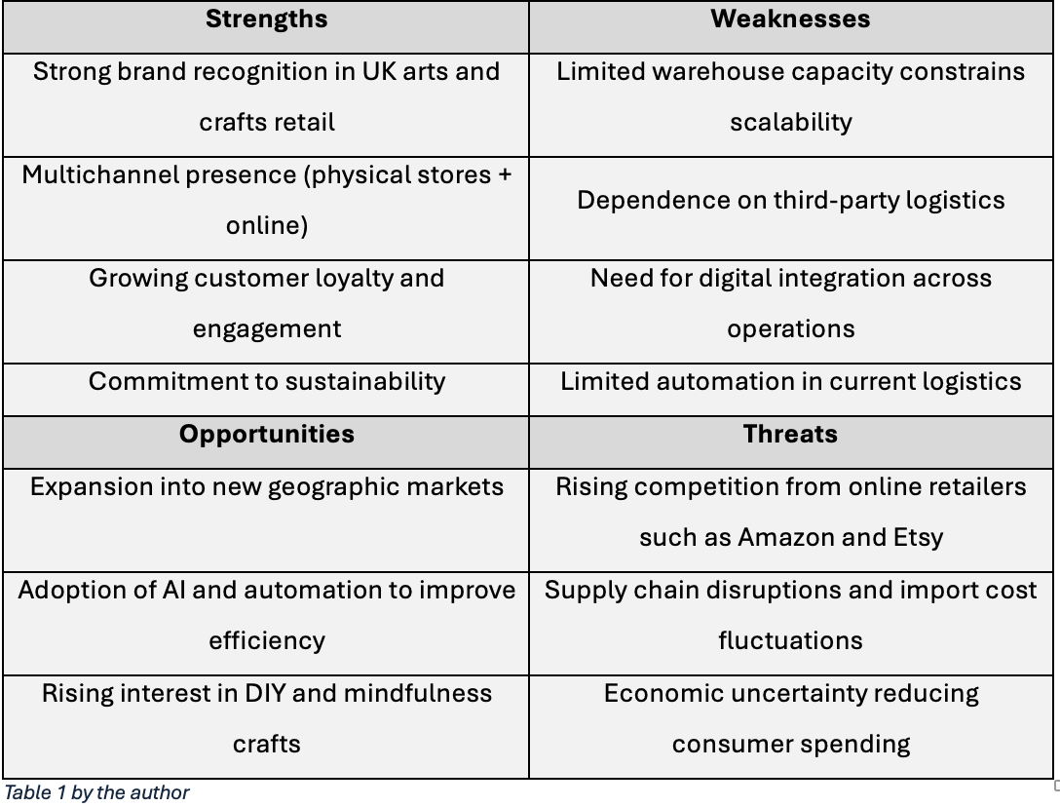
Hobbycraft's internal strengths, especially its brand equity, online growth, and environmental activities, may be utilised through the projected expansion, according to the SWOT analysis. However, warehouse modernisation is crucial due to operational flaws and external concerns including technology lag and competitive pressure.

Impact of Digital Disruption, Online Shopping, and AI
In the UK retail industry, digital disruption has drastically changed customer expectations. Demand for quicker, more dependable fulfilment has increased due to the surge in online buying, especially after the COVID-19 pandemic. Lockdowns caused Hobbycraft's online sales to rise by more than 200%, exposing the company's obsolete logistical infrastructure and storage capacity restrictions (Bradbury et al., 2021).
Demand forecasting, inventory control, and delivery scheduling may now be improved by AI technologies and predictive analytics, cutting down on waste and operational bottlenecks (Wamba et al., 2017). Hobbycraft may enhance customer happiness, boost profitability, and obtain real-time stock level insight by implementing AI-enabled warehouse management tools.
The use of digital tools is consistent with Hobbycraft's overarching plan to create an omnichannel retail experience that combines digital and physical consumer journeys. According to Porter and Heppelmann (2014), data-driven decision-making and customisation made possible by smart, connected technologies redefine industrial rivalry. Moving to a more sophisticated, larger warehouse is therefore strategically necessary for Hobbycraft, both to support physical expansion and to integrate digital transformation into the core operations of the business.
In conclusion, the examination of the internal and external environments shows that Hobbycraft works in a complex, rapidly changing retail market that is influenced by sustainability, digitisation, and shifting customer values.
In addition to being a calculated reaction to environmental challenges, the company's choice to move to a bigger, digitally connected warehouse presents a chance to improve its long-term competitiveness.

Assessment of Models for Change Management and Their Use in Hobbycraft
Models of change management offer methodical ways to successfully execute organisational transformation while reducing opposition and disturbance (Cameron & Green, 2020). Moving to a bigger, more technologically sophisticated warehouse is a strategic shift for Hobbycraft that calls for careful planning, effective communication, and leadership alignment. From manual methods to digital automation, from small-scale logistics to a data-driven supply chain, and from localised processes to integrated, nationwide distribution, the process entails both operational and cultural changes.
About Hobbycraft's change initiative, this section assesses three important change management frameworks: Lewin's Three-Step Model, Kotter's Eight-Step Model, and ADKAR.

Lewin’s Three-Step Model
According to Kurt Lewin's (1951) paradigm, change occurs in three stages: unfreezing, changing, and refreezing. According to the concept, for change to be effective, current behaviours must be disrupted (referred to as "unfreezing"), new procedures or techniques must be implemented (referred to as "changing"), and these must be incorporated into the organization's culture (referred to as "refreezing").
The unfreezing phase for Hobbycraft include informing management and staff about the need for increased productivity, scalability, and customer happiness to get them ready for the relocation to a bigger warehouse. Effective communication at this point minimises resistance and ambiguity, according to research (Burnes, 2017).
New processes, technologies, and operational procedures must be implemented during the transformation phase. This can entail reorganising logistics teams, implement automation, and educate warehouse employees about modern Warehouse Management Systems (WMS). To address obstacles in real time, the transition phase needs constant leadership support, resource allocation, and feedback loops (Cummings et al., 2016).
Lastly, institutionalising the new habits is the main goal of the refreezing step. For Hobbycraft, this would entail incorporating new digital procedures into everyday activities, appreciating employee flexibility, and strengthening the new culture via ongoing development initiatives.
Critics contend that Lewin's model oversimplifies intricate, iterative transformation processes despite its basic nature (Todnem By, 2005). Change is frequently continuous rather than linear in quickly changing digital environments, like AI-enabled logistics. However, the model's strength is its clarity and emphasis on staff preparation, which is crucial for Hobbycraft's warehouse transformation, where successful workforce adaption will be crucial.

Kotter’s Eight-Step Model
Lewin's theory is expanded upon by John Kotter's (1996) Eight-Step Model, which offers a more thorough, methodical framework for handling strategic change. The model includes:
- Establishing a sense of urgency
- Forming a powerful guiding coalition
- Creating a vision for change
- Communicating the vision
- Empowering employees for action
- Generating short-term wins
- Consolidating gains and producing more change
- Anchoring new approaches in the culture

Kotter's approach provides a thorough plan for carrying out the warehouse move when applied to Hobbycraft.
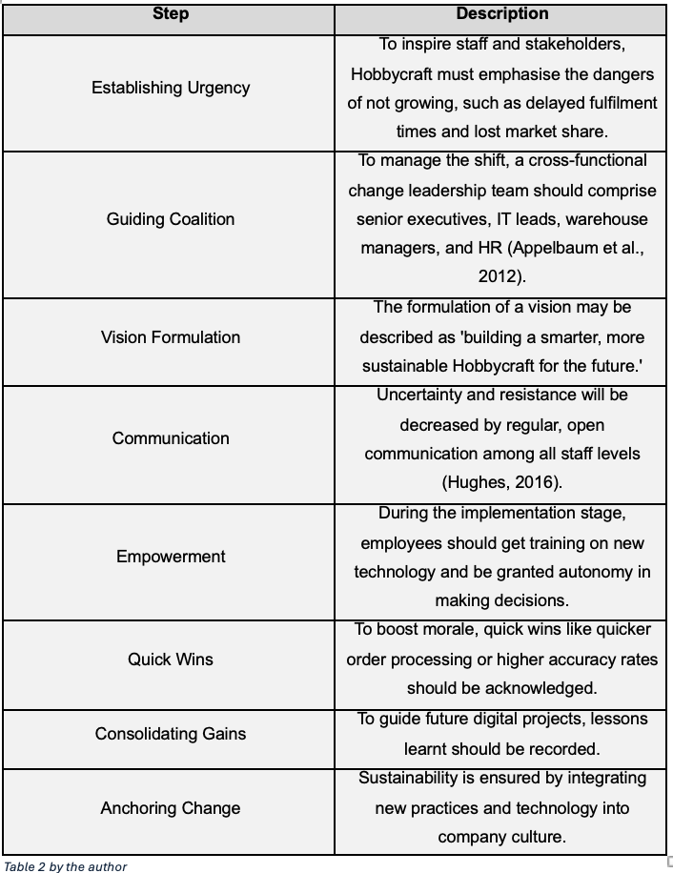
Kotter's model is strong because it emphasises communication and leadership, two things that are essential to Hobbycraft's success. Nevertheless, it could not adequately address the iterative nature of digital transformation and can be time-consuming (Pollack & Pollack, 2015). The best approach for Hobbycraft would be to interpret Kotter's phases in a way that is adaptable and fluid, allowing for modifications as implementation moves forward.

The ADKAR Model
Prosci (Hiatt, 2006) created the ADKAR model, which emphasises individual transformation as the cornerstone of organisational success. Awareness, Desire, Knowledge, Ability, and Reinforcement are its five main components.
Since employee acceptability and competence are essential to successful change adoption, this model is especially pertinent to Hobbycraft's warehouse move.
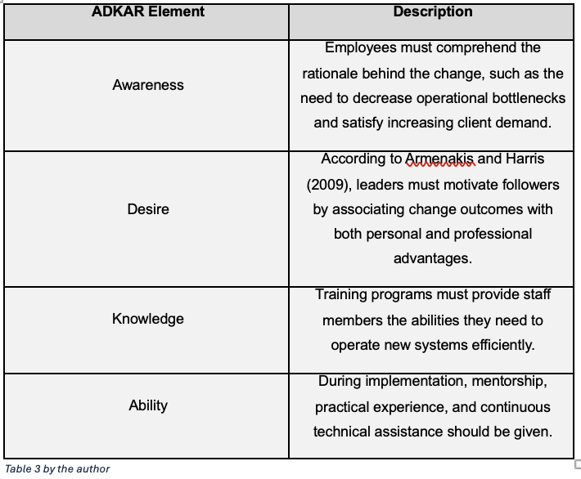
The benefit of the ADKAR model is its human-centred approach, which guarantees that change is ingrained at the person level (Hiatt, 2006). A tailored and compassionate strategy will be essential for attaining long-lasting change in Hobbycraft, where many staff may be non-technical or long-serving.
Nevertheless, the concept has been challenged for having a weak strategic component and being unduly individualistic (Hornstein, 2015). To balance individual and organisational demands, it should be incorporated with more comprehensive frameworks like Kotter's model.

Comparative Analysis and Use in Hobbycraft
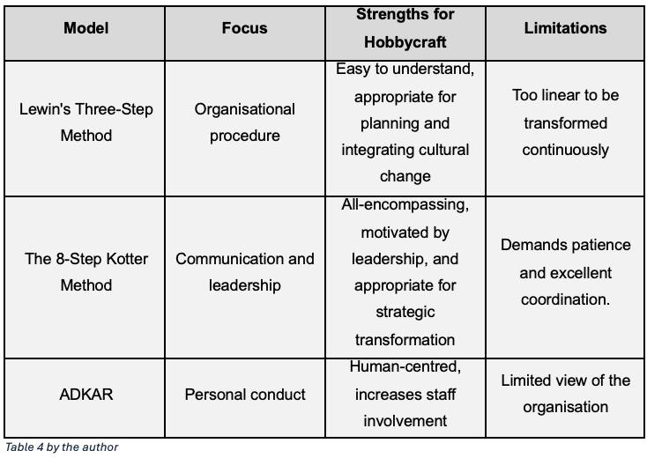
The most reliable strategy for Hobbycraft's warehouse expansion is to combine Kotter's and ADKAR frameworks. The integration of these models links strategic leadership with change preparedness at the employee level, as Table 4 illustrates. While ADKAR focusses on employee engagement and skill development, Kotter's approach guarantees strategic alignment and leadership structure.
When combined, they guarantee the accomplishment of strategic goals while considering the human elements that are essential to their successful execution (Cameron & Green, 2020).
In conclusion, a mixed change approach that incorporates Kotter's structured leadership process, Lewin's emphasis on cultural anchoring, and ADKAR's emphasis on employee involvement is necessary for the successful management of Hobbycraft's warehouse move. Hobbycraft will be able to handle both the technical and human aspects of change thanks to our hybrid strategy, guaranteeing that the shift is both operationally effective and culturally durable.

Organisational Culture and Leadership in Change Management

The decision-making culture of Hobbycraft is manager-led and top-down. Senior staff members make most of the choices, with little involvement from the workforce. Floor employees have minimal autonomy and adhere to predetermined responsibilities and procedures. Particularly in workshops, a little amount of creativity and teamwork is permitted. Daily work is heavily influenced by targets, such as loyalty sign-ups. Employee participation is often low and decision-making is structured.
Successful organisational transformation requires both organisational culture and leadership (Schein, 2010). The success of the transformation program in Hobbycraft's move from a smaller to a larger, technologically advanced warehouse will depend on the leadership's efficacy and the organisational culture's flexibility. To match staff motivation with strategic objectives, leaders must inspire as well as guide (Northouse, 2025). This synopsis critically looks at how organisational culture and leadership interact to affect change management at Hobbycraft.

Leadership and Change Management
Setting a clear vision, inspiring staff, communicating clearly, and empowering individuals are all part of leadership throughout organisational transition (Gill, 2002). Transformational leadership, a style that encourages dedication and creativity while building trust and involvement, is necessary for Hobbycraft's relocation effort. Four components make up transformative leadership, according to Bass and Avolio (1994): idealised influence, intellectual stimulation, inspiring drive, and personalised concern.
Senior executives at Hobbycraft may create and convey a cohesive vision, such building a "smarter, more sustainable supply chain for the future," by implementing transformational leadership. Employee resistance and doubt can be decreased by communicating this goal with passion and consistency (Kotter, 1996). To foster creativity and adaptation, transformational leaders also employ intellectual stimulation, particularly when Hobbycraft integrates automation and AI-driven technology into warehouse operations. According to Eisenbach et al. (1999), this learning-oriented strategy necessitates the provision of training materials and the development of problem-solving abilities.
Employees may worry about being laid off or having to adjust to new technology, thus individualised attention is equally important. Such anxieties are lessened by leaders who show empathy and provide opportunities for professional growth. Empathetic leadership dramatically boosts employee engagement throughout change processes, according to Al-Haddad and Kotnour (2015). All things considered, transformational leadership works effectively for Hobbycraft's warehouse development because it strikes a balance between strategic direction and emotional intelligence, guaranteeing that organisational goals and worker welfare are given priority.

Leadership Challenges and Resistance to Change
Leaders must successfully handle the inevitable organisational response of resistance to change (Piderit, 2000). Uncertainty about new procedures, worries about job security, or technological disruption might all lead to resistance at Hobbycraft. Through open communication, involvement, and empowerment, leaders play a crucial part in resolving these issues.
According to Kotter and Schlesinger (1989), employee participation in decision-making and concise justifications for changes increase ownership and acceptability. Regular staff briefings, town hall meetings, and open digital communication channels are realistic measures that Hobbycraft may use to ensure openness during the warehouse transfer.
Putting in place efficient feedback systems is also crucial. Employees may voice problems and offer solutions through two-way communication channels, fostering a collaborative atmosphere that fosters trust (Lines, 2004). Employees who feel heard are more likely to participate favourably in change projects, according to research (Imran et al., 2023). Therefore, managers need to create a welcoming environment where staff members may positively adjust to changes in procedures and technology.

Organisational Culture and Change
A key factor in deciding how change occurs is organisational culture, which is described as the common values, attitudes, and behaviours that influence relationships at work (Schein, 2010). For Hobbycraft to successfully relocate and integrate technology, cultural alignment with new strategic goals is essential. Schein (2010) divides culture into three levels: fundamental assumptions (deeply ingrained norms), avowed ideals (stated tactics and philosophies), and artefacts (visible behaviours and symbols). For cultural components to support the new path, effective change management necessitates alignment across various layers.
In keeping with its retail brand and interaction with hobbyist clients, Hobbycraft's current organisational culture is customer-centric, innovative, and community-oriented. However, shifting to a logistics-orientated, data-driven paradigm creates new cultural demands that are focused on accuracy, efficiency, and technology adoption. Alvesson and Sveningsson (2024) state that when employees perceive a clash between long-standing organisational ideals and new operational rules, this might lead to internal stress.
Leaders must stress that the company's creative spirit is enhanced by digital transformation rather than replaced to solve this. Automation and data analytics, for example, might be positioned as instruments that improve customer happiness by facilitating quicker, more dependable deliveries—thereby supporting Hobbycraft's objective to foster creativity and community involvement. Employees will view the shift as significant and in line with the organisation's character thanks to this synergy between cultural values and technology innovation.

Integrating Leadership and Culture in Change Management
In the end, the results of transformation are shaped by both culture and leadership. As cultural architects, transformational leaders model desirable behaviours and instil new values through symbolic acts and constant communication. During the relocation process, Hobbycraft's leaders may guarantee cultural coherence by cultivating an open atmosphere and reiterating a common goal.
According to Schein (2010) and Northouse (2025), both strong leadership and cultural flexibility are necessary for long-term organisational development. To ensure that change is viewed as evolution rather than disruption, leaders must strike a balance between implementing new practices and upholding basic beliefs. To establish an operational culture that is both technologically sophisticated and values-driven and promotes long-term strategic success, Hobbycraft will need this combination.

Change Management Plan Suggestion
To make sure that changes are in line with stakeholder expectations and organisational goals, strategic change management entails organised preparation, execution, and monitoring (McCabe, 2020). In response to increasing challenges, technological upheaval, and consumer demand for quicker delivery and wider product availability, Hobbycraft has strategically moved to a bigger retail warehouse.
The roadmap for this transformation program is outlined in the following strategy, which guarantees alignment with Hobbycraft's long-term goal of being the most creative, customer-focused, and sustainable arts and crafts retailer in the UK.

Objectives of the Change
Any change project's effectiveness depends on having specific, quantifiable goals (Johnson et al., 2017). Hobbycraft's warehouse relocation goals are organised according to the SMART framework, which stands for Specific, Measurable, Achievable, Relevant, and Time-bound (Doran, 1981).
Purpose | Description | Target Achievement
Effectiveness of Operations | To increase warehousing capacity by 60% and improve order fulfilment speed by 30% through automation and process redesign. | Within 12 months of relocation
Digital Incorporation | To put in place a new Warehouse Management System (WMS) with data analytics and AI forecasting features | In less than nine months
Personnel Preparedness | 100% of logistics and warehouse employees should receive training on new technology and safety protocols. | Before the go-live date
Sustainability | To reduce waste and energy use by 20% by using renewable energy sources and green infrastructure. | During the first year of operation
Satisfaction of customers | To boost Net Promoter Score (NPS) by 15% and shorten delivery lead times. | Six months after the changeover
Table 5 by the author
These goals are in line with Hobbycraft's overarching strategy aims of sustainability, digital innovation, and operational excellence (Hobbycraft, 2024).

Financial Strategy
A strong financial strategy guarantees the sustainability and accountability of transformation projects. Hobbycraft's warehouse move calls for operational budgeting, capital investment, and backup plans.
An estimated breakdown of the budget
Category of Cost | Cost Estimate (£) | Specifics
Purchasing or leasing property | £3000000 | Acquisition or long-term rental of a bigger storage facility
Setting up and renovating a facility | £1000000 | Energy-efficient lighting, shelving, refitting, and safety compliance
Automation and technology | £2000000 | WMS, robots, AI systems, and IT infrastructure implementation
Development and training | £300000 | Workshops, outside consultants, and employee training
Change management and communication | £100000 | Campaigns for internal communication and stakeholder involvement
Emergency fund | £600000 | Risk reduction for unanticipated expenses
Total Projected Investment | £7000000
Table 6 by the author
The move and digital transformation are intended to yield long-term benefits through operational efficiency, cheaper shipping costs, and enhanced client retention. Covar (2025) forecasts that automation in warehousing may cut operating expenses by 20–30% yearly. For Hobbycraft, improved capacity and fewer order mistakes are predicted to generate payback within 3–5 years, boosting profitability and scalability.
Funding sources will include retained revenues and prospective green investment incentives under UK government sustainability initiatives.

Communication Plan
Effective communication is critical for successful change management, since it helps employees grasp the objective of change and decreases misunderstanding and resistance ( (Clampitt et al., 2000). For Hobbycraft’s relocation, a multi-channel communication strategy based on Kotter’s (1996) and ADKAR (Hiatt, 2006) concepts will promote clarity, transparency, and involvement throughout the process.
The major objectives are to explain the rationale for the shift, preserve transparency, reduce opposition, and develop confidence among all stakeholders. Different groups want different information: employees need updates on training and job security; senior management requires progress and performance statistics; suppliers need operational timetables; and consumers require assurances about continuous service.
These requirements will be addressed by targeted communication channels such as emails, town halls, reports, formal letters, and digital updates given at suitable intervals.
Across all messages, the tone will remain clear and inclusive, focused on shared goals. Feedback mechanisms, including surveys and Q&A sessions, will assist evaluate understanding and sentiment, allowing Hobbycraft to modify communication as needed (Cornelissen, 2020). Overall, this strategic approach enables a smoother transition and builds stakeholder trust during the transfer.

Plan for Assessment and Monitoring
Evaluating change progress and results supports accountability and continual development (Hughes, 2010). Hobbycraft’s assessment approach will include Key Performance Indicators (KPIs), feedback channels, and organised review phases.
Key Performance Indicators (KPIs) offer crucial information on how well a company is accomplishing its objectives. These indicators assist executives in monitoring progress and making well-informed decisions in several crucial areas, including operations, finance, employee engagement, customer happiness, and sustainability.
To guarantee seamless and effective operations, operational KPIs like order fulfilment time and stock correctness are assessed on a regular basis. To evaluate the results of strategic expenditures, financial metrics such as ROI and cost reductions are examined on a regular basis. The organization's dedication to workforce development and well-being is demonstrated by the bi-monthly monitoring of employee engagement through training completion rates and staff satisfaction scores.
Delivery accuracy and Net Promoter Score are two examples of quarterly customer satisfaction measures that show how successfully a company meets customer expectations and fosters loyalty. Lastly, trash reduction and energy consumption per unit supplied are two sustainability KPIs that are assessed every two years to monitor the advancement of ecologically friendly activities.
When combined, these KPIs provide a clear and impartial picture of an organization's performance, promoting long-term success and ongoing development.

Conclusion and Suggestions
Moving from a smaller warehouse to a larger, digitally integrated facility is Hobbycraft's suggested strategic transformation, which is a revolutionary move towards operational excellence and long-term competitiveness. Significant challenges from digital disruption, the expansion of online shopping, and changing customer expectations were found in the examination of Hobbycraft's internal and external environment, requiring more capacity, automation, and sustainability. The shift is strategic as well as logistical, putting Hobbycraft in a position to improve consumer satisfaction and fortify its omnichannel retail strategy (Kotter, 1996).
The application of Lewin's, Kotter's, and ADKAR models showed that both individual involvement and strategic leadership are necessary for effective transformation. ADKAR guarantees staff preparedness and behavioural reinforcement, whereas Kotter's structured eight-step framework offers a transformation road map (Hiatt, 2006). Therefore, culture must change from a conventional retail attitude to one that welcomes technological agility, and leadership must be transformative, inspiring trust, articulating vision, and promoting innovation (Bass & Riggio, 2006; Schein, 2017).
With increased productivity, automation, and environmental measures, the move is a financially sound long-term investment. However, ongoing communication, performance reviews, and stakeholder alignment are necessary for this shift to be successful.
Hobbycraft will be able to attain both organisational alignment and individual change preparedness through a hybrid change management strategy that combines Kotter's methodical, strategic approach with ADKAR's human-centred focus.
The company's digital progress and cultural development will be further supported by bolstering transformational leadership throughout management. New methods of working will be easier to integrate if a learning-oriented environment is maintained through ongoing training, innovation workshops, and recognition programs.
To guarantee continuous improvement and accountability, post-implementation performance should be tracked using the PDCA cycle. Furthermore, including sustainability objectives into every aspect of warehouse operations would strengthen Hobbycraft's larger dedication to social and environmental responsibility. In conclusion, Hobbycraft can effectively complete its warehouse expansion and improve operational resilience, employee engagement, and long-term development in an increasingly digital retail environment with a clear vision, flexible leadership, and a collaborative culture.

Reference:

Al-Haddad, S. and Kotnour, T. (2015) ‘Integrating the organizational change literature: A model for successful change’, Journal of Organizational Change Management, 28(2), pp. 234–262. .Available at: https://www.studeersnel.nl/nl/document/breda-university-of-applied-sciences/change-management/integrating-the-organizational-change-literature-a-model-for-succesfull-change/6091263
Alvesson, M. and Sveningsson, S. (2024) Changing organizational culture: Cultural change work in progress. Routledge.Available at: https://knowledgehub.ghamfin.org/wp-content/uploads/2024/06/Changing-Organizational-Culture_-Cultural-Change-Work-in-Progress.pdf
Appelbaum, S.H., Habashy, S., Malo, J.L. and Shafiq, H. (2012) ‘Back to the future: Revisiting Kotter’s 1996 change model’, Journal of Management Development, 31(8), pp. 764–782..Available at: https://d1wqtxts1xzle7.cloudfront.net/88598514/BacktotheFutureRevisitingKottersChangeModel-libre.pdf?1657837509=&response-content-disposition=inline%3B+filename=Back_to_the_future_revisiting_Kotters_19.pdf&Expires=1762601391&Signature=BcJC9rh6qwptOtTkFbF2RPc53~gGcZNGQkm8mp36yVQjgX2sA~3GfH49CtpcRGRBZ5QePn5kzG-ozNLBZoBkV7U63rWWsSy85-P3qCH0i1oG3rAblMk64AYYWYq23QhXPbY6fmnPHOqZHwCTWWuslP5d-EA6oMhfoQQ3XaS0AvsuE0BfmKAqf3SCWS2SYLMyxLTe9DuCNjzYU16zuiVZD9yazSleHSIh7bhT5ZxjK~i-IxDLUilcaeKlq6clEd~zipQdyMSjV9XBMBDMraL7uJHPupBHH51CVnPhuK3U4ZiB690xiti-WeWJMdp0h6anRokgk29mXeY2ZSq9twSoVA__&Key-Pair-Id=APKAJLOHF5GGSLRBV4ZA
Armenakis, A.A. and Harris, S.G. (2009) ‘Reflections: Our journey in organizational change research and practice’, Journal of Change Management, 9(2), pp. 127–142.Avaioable at: https://www.tandfonline.com/doi/pdf/10.1080/14697010902879079
Bailey, D. and De Propris, L. (2017) ‘Brexit and the UK automotive industry’, National Institute Economic Review, 242(1), pp. R51–R59.Available at: https://pure-oai.bham.ac.uk/ws/portalfiles/portal/48240078/Bailey_De_Propris_NIER_authors_version.pdf
Bass, B.M. and Riggio, R.E., 2006. Transformational leadership. Psychology press. Available at:https://scholar.google.com/citations?user=Y8_Qqy0AAAAJ&hl=en&oi=sra
Bradbury, A., Warran, K., Mak, H. and Fancourt, D. (2021) The role of the arts during the COVID-19 pandemic. Available at: https://discovery.ucl.ac.uk/id/eprint/10159116/1/Arts during covid-19 ACE report.pdf
Burnes, B. (2007) ‘Kurt Lewin and the Harwood studies: The foundations of OD’, The Journal of Applied Behavioral Science, 43(2), pp. 213–231..Available at:https://journals.sagepub.com/doi/abs/10.1177/0021886306297004
Cameron, E. and Green, M. (2019) Making sense of change management: A complete guide to the models, tools and techniques of organizational change. Kogan Page.Publishers. Available at: http://edl.emi.gov.et/jspui/bitstream/123456789/286/1/Making Sense of Change Management A Complete Guide to the Models, Tools and Techniques of Organizational Change by Esther Cameron, Mike Green %28z-lib.org%29-1.pdf
Clampitt, P.G., DeKoch, R.J. and Cashman, T. (2000) ‘A strategy for communicating about uncertainty’, Academy of Management Perspectives, 14(4), pp. 41–57.Available at: https://d1wqtxts1xzle7.cloudfront.net/55081114/Artikel_1_sesi_ke-1128-5-017_Communication_Strategy-libre.pdf?1511359869=&response-content-disposition=inline%3B+filename=Academy_of_Management_is_collaborating_w.pdf&Expires=1763549357&Signature=ddeH~Vxjcko1EN~IBo4M9QTPr~SyAHFaF2XEZAW0QAz2fV537fFs8P5O8PNwD~zVHmpUlKnZZDL~6NKADlZ9FKZKESwgaIXRnDjMIdzWrdsdCqw0GgGl9mvEHnsnZaBBMbwSJxdcSCkN1~NO71gTdMAdFFvDCub2BJIUa~0fykvcVw2eodu02pFSvMw11xtsy7k-JEIlkDMkfKdX2S7JHE81h6T9cW~1QC4WyqqbsECHngGnP0iq0jBVL-e4OvoMI-0GK0Dw7YoPTvi05UgJD3rtgf5u637ec3GW6d-65Tn8tbakVeAbDjD5u1WhJmXiv4ylfAkBow7k1IgVh62EFw__&Key-Pair-Id=APKAJLOHF5GGSLRBV4ZA
Cornelissen, J.P. (2023) Corporate communication: A guide to theory and practice.Available: https://d1wqtxts1xzle7.cloudfront.net/34336929/S13.Professor_Joep_Cornelissen_Corporate_Communications_Theory_and_Practice____2004-libre.pdf?1406879062=&response-content-disposition=inline%3B+filename=S13_Professor_Joep_Cornelissen_Corporate.pdf&Expires=1763549463&Signature=UF-FDpN1gjmaTMF4UaBLjAUCciR-IiLMXtvQDKNAir5CZcs2XPr9EKl9jPq7JC8aaeEyVffYTOO5VGKyp20WEH1AcbAkHBkWQ1KOt1S-~lmNkeHgsoixgbk8qCpTOIwgV~HJHGBe~NAXe0J0gmyYpWGa7xJzztBX66aS5ghSdFaXzGodNzbKmQGL3MeIBTBwVZWnM9Amr8ookze~sT07~i-zCAeSt9QCt1mQFsC2lj0BveER9pjnqO-o2vl5sculIUtwFLKs~i5o2bMlKx8UBnQY7O2aWBT7eOzs1KONVk97-YgioWmO6PyK7iXFnp80JVAH6j~rWbDhd6l2WxHbjA__&Key-Pair-Id=APKAJLOHF5GGSLRBV4ZA
Covar, E., 2025. Resilience and Rebound: A Financial Analysis of Czech's Big Four Accounting Firms Post-COVID-19 Recovery. Available at : https://mpra.ub.uni-muenchen.de/124351/1/2nd paper.pdf
Cummings, S., Bridgman, T. and Brown, K.G. (2016) ‘Unfreezing change as three steps: Rethinking Kurt Lewin’s legacy for change management’, Human Relations, 69(1), pp. 33–60.Avaible at: https://www.researchgate.net/profile/Stephen-Cummings-3/publication/282330663_Unfreezing_change_as_three_steps_Rethinking_Kurt_Lewin%27s_legacy_for_change_management_Human_Relations_2015/links/560c687908aed543358d34de/Unfreezing-change-as-three-steps-Rethinking-Kurt-Lewins-legacy-for-change-management-Human-Relations-2015.pdf
Doran, G.T. (1981) ‘There’s a SMART way to write management’s goals and objectives’, Management Review, 70(11). Available at: https://openurl.ebsco.com/EPDB%3Agcd%3A3%3A2979171/detailv2?sid=ebsco%3Aplink%3Ascholar&id=ebsco%3Agcd%3A6043491&crl=c&link_origin=scholar.google.com
Eisenbach, R., Watson, K. and Pillai, R. (1999) ‘Transformational leadership in the context of organizational change’, Journal of Organizational Change Management, 12(2), pp. 80–89. Available at: https://www.emerald.com/jocm/article-abstract/12/2/80/243119/Transformational-leadership-in-the-context-of?redirectedFrom=fulltext
Gill, R., 2002. Change management--or change leadership?. Journal of change management, 3(4), pp.307-318. Available at:https://spartan.ac.brocku.ca/~bwright/4P93/Reading 2_Gill_change l Kotter, J.P. and Schlesinger, L.A., 1989. Choosing strategies for change. In Readings in strategic management (pp. 294-306). London: Macmillan Education UK. eadership.pdf
Gov.uk. (2023). Health and Safety Regulations in the Workplace. Available at: https://www.gov.uk/browse/employing-people/health-safety
Hiatt, J. (2006) ADKAR: A model for change in business, government, and our community. Prosci. Available at: https://books.google.co.uk/books?hl=en&lr=&id=Te_cHbWv-ZgC&oi=fnd&pg=PA1&dq=Hiatt,+J.+(2006).+ADKAR:+A+Model+for+Change+in+Business,+Government+and+Our+Community.+Prosci+Research.&ots=1tjKl7r2KO&sig=NQ5Qc_8VBXDXUMxgdjVR9WTXMrk&redir_esc=y - v=onepage&q&f=false
Hobbycraft. (2024). About Us. Available at: https://www.hobbycraft.co.uk
Hobbycraft. (2024). Corporate Responsibility and Sustainability Report. Available:https://www.hobbycraft.co.uk/
Hobbycraft. (2024). Sustainability and Corporate Responsibility Report. Available at:https://www.hobbycraft.co.uk/on/demandware.static/-/Library-Sites-hobbycraft-uk-content/default/dwe633da49/images/static-pages/corporate-and-press/further-information/social-responsibility/Hobbycraft_ESG_Deck_Master-2024.pdf
Hornstein, H.A. (2015) ‘The integration of project management and organizational change management is now a necessity’, International Journal of Project Management, 33(2), pp. 291–298.Available : https://www.sciencedirect.com/science/article/abs/pii/S0263786314001331
Hughes, M. (2010) Managing change: A critical perspective. Kogan Page. Available at :https://books.google.co.uk/books?hl=en&lr=&id=ZtslDwAAQBAJ&oi=fnd&pg=PP1&dq=Hughes,+M.+(2019).+Managing+Change:+A+Critical+Perspective+(3rd+ed.).+Kogan+Page.&ots=0zicBCLk-M&sig=ukCH01LcYGCI2Hlx7E0FtxLdWcM&redir_esc=y - v=onepage&q&f=false
Hughes, M. (2016) ‘Leading changes: Why transformation explanations fail’, Leadership, 12(4), pp. 449–469. Available at: https://woodlanddecay.com/wp-content/uploads/2019/06/hughes2015onlinefirst.pdf
Imran, M.K., Sarwar, A., Fatima, T. and Iqbal, S.M.J. (2023) ‘I value ethics, do you? An employee-oriented perspective on ethical leadership and organizational change’, Evidence-based HRM: A Global Forum for Empirical Scholarship, 11(4), pp. 577–593.Available at : https://www.emerald.com/ebhrm/article-abstract/11/4/577/33139/I-value-ethics-do-you-An-employee-oriented?redirectedFrom=fulltext
Kotter, J.P. and Schlesinger, L.A. (1989) ‘Choosing strategies for change’, in Asch, D. and Bowman, C. (eds) Readings in strategic management. London: Macmillan Education UK, pp. 294–306. Available at:https://tashfeen.pbworks.com/f/S1.pdf
Kotter, J.P., 1996. Leading Change, harvard business review.
Lines, R. (2004) ‘Influence of participation in strategic change: Resistance, organizational commitment and change goal achievement’, Journal of Change Management, 4(3), pp. 193–215.Available at: https://www.researchgate.net/profile/Rune-Lines/publication/211390260_Influence_of_participation_in_strategic_change_Resistance_organizational_commitment_and_change_goal_achievement/links/5f97eb5da6fdccfd7b827290/Influence-of-participation-in-strategic-change-Resistance-organizational-commitment-and-change-goal-achievement.pdf
McAfee, A. and Brynjolfsson, E. (2017) Machine, platform, crowd: Harnessing our digital future. W.W. Norton & Company. Available at: https://www.mintur.gob.es/Publicaciones/Publicacionesperiodicas/EconomiaIndustrial/RevistaEconomiaIndustrial/409/SEGUNDA CRÍTICA DE LIBROS.pdf
McCabe, D. (2020) Changing change management: Strategy, power and resistance. Routledge. Available at:https://www.taylorfrancis.com/books/mono/10.4324/9780429029981/changing-change-management-darren-mccabe
Morris, M. (2025) Towards a UK trade strategy. Institute for Public Policy Research (IPPR). Available at:: https://ippr-org.files.svdcdn.com/production/Downloads/UK_trade_strategy_Jan25_2025-01-16-123929_eqer.pdf
Northouse, P.G. (2025) Leadership: Theory and practice. Sage Publications. Available at:https://books.google.co.uk/books?hl=en&lr=&id=V6AwEQAAQBAJ&oi=fnd&pg=PT16&dq=Northouse,+P.+G.+(2021).+Leadership:+Theory+and+Practice+(9th+ed.).+Sage.&ots=qN_FAlaSlL&sig=RVp64M1fPUuEB7KBp1NXEpVVpOE&redir_esc=y - v=onepage&q&f=false
Piderit, S.K. (2000) ‘Rethinking resistance and recognizing ambivalence: A multidimensional view of attitudes toward an organizational change’, Academy of Management Review, 25(4), pp. 783–794. Available at:https://goal-lab.psych.umn.edu/orgpsych/readings/18. Organizational Change and Development/Piderit (2000).pdf
Porter, M.E. and Heppelmann, J.E. (2014) ‘How smart, connected products are transforming competition’, Harvard Business Review, 92(11), pp. 64–88. Available at:https://moodle2.units.it/pluginfile.php/727297/mod_resource/content/1/How-smart-connected-products-are-transforming-competition.pdf
Project Management Institute (2021) A guide to the project management body of knowledge (PMBOK® Guide) – Seventh edition and the standard for project management. Project Management Institute. Available at: https://books.google.co.uk/books?https://books.google.co.uk/books?hl=en&lr=&id=lKsxEAAAQBAJ&oi=fnd&pg=PT31&dq=PMI.+(2021).+A+Guide+to+the+Project+Management+Body+of+Knowledge+(PMBOK®+Guide)+(7th+ed.).+Project+Management+Institute.&ots=wTupnChc3z&sig=rSuMXW7EwxdNLbztZ3GODrWAXFo&redir_esc=y - v=onepage&q=PMI. (2021). A Guide to the Project Management Body of Knowledge (PMBOK® Guide) (7th ed.). Project Management Institute.&f=false
Schein, E.H. (2010) Organizational culture and leadership. John Wiley & Sons. Available at:http://library.megu.edu.ua:8180/jspui/bitstream/123456789/4900/1/2010.pdf
Smith, A.D. (2025) ‘Sustainability and technology aspects of inventory management and trucking: A case study approach’, International Journal of Process Management and Benchmarking, 20(3), pp. 327–365. Available at:https://www.inderscienceonline.com/doi/epdf/10.1504/IJPMB.2025.146714
Statista (2023) Arts and crafts market in the United Kingdom 2020–2023. Available at:https://www.statista.com/search/?q=Arts+and+Crafts+Market+in+the+United+Kingdom+2020–2023&p=1
Todnem By, R. (2005) ‘Organisational change management: A critical review’, Journal of Change Management, 5(4), pp. 369–380. Available at:https://www.avannistelrooij.nl/wp/wp-content/uploads/2017/06/Todnem-BY-2005-JoCM.pdf
Wamba, S.F., Gunasekaran, A., Akter, S., Ren, S.J.F., Dubey, R. and Childe, S.J. (2017) ‘Big data analytics and firm performance: Effects of dynamic capabilities’, Journal of Business Research, 70, pp. 356–365. Available at:https://d1wqtxts1xzle7.cloudfront.net/97622074/JBR1-FINAL_20VERSION-MAY_2023-SA-libre.pdf?1674350317=&response-content-disposition=inline%3B+filename=Big_data_analytics_and_firm_performance.pdf&Expires=1762552248&Signature=Ml3crcdzZVC5lHGGRkJEV5NgdEXoOZ3dPGpfV~-4I5K4lsz0FkNaHXNFq9DkvlHhnjNc36JqBiYPO1ytXhv-Z~OwNE9Dl0zvh~u6tpdv1BAoHDeEmzYjiBKDakcDlyOc0lbmkMh2BWdiL0KVrIraP~XhI6FViwdGv5K8SFy5wgXQNejpCSw9yh2XXk4qsTrv8iIiqbvcBYTY0s35jjg3GTEkzq08sBoBIH~B3u5v6mm0sexoXGt0b~WAi6sTdwDCbQJUehGJCqdA1UdrezNAdZ6e1FlUAj~UA4~-ZtInHxBtF~1MXALgpgAgyYlTM1TbS~x7lbR-Nd4W6wlbotiTkw__&Key-Pair-Id=APKAJLOHF5GGSLRBV4ZA
Zandieh, Z., Thornley, P. and Chong, K. (2024) ‘Progress of waste management in achieving UK’s net-zero goal’, Journal of Material Cycles and Waste Management, 26(5), pp. 2601–2619. Available at:https://link.springer.com/content/pdf/10.1007/s10163-024-02003-8.pdf

