Research in context
Student Name: Rosie Banks
Student Number: 2103263
Programme of Study: BA Hons Illustration
Module: ADAD5003
Tutor: Chris Harrendence
Total Word Count: -2250
Analyse the work of illustrators and, particularly, author illustrators who tackle difficult, sensitive
and sometimes shocking themes.

Sensitive subjects like mental health, abuse and grief are all an imperative themes that children should be taught from a young age as trying to figure out these subjects alone is challenging. This theory is supported by the idea that,
‘progressing and continuing development aspects, unique to children and young people, for offering early help and support so that lifelong outcomes can be improved.’ (Howard, Burton and Levermore, 2020).
The fact that these are taboo and uncomfortable subjects magnifies the importance of teaching children about them as it can possibly help to reduce these issues later on in life. Giving children these lessons can also allow them to understand these themes better if they do occur in their life and help to control their trauma from them.
Although they are difficult and awkward to talk about, tackling these subjects with the use of illustration and children’s books can be very effective as ‘seeing comes before words. The child looks and recognises’ (Berger, 1972) Visual learning in early development allows the child to have a broad understanding of the world around them. ‘Visual stimuli do not necessarily have to represent a rearrangement of the verbal idea but can be an idea of their own.’ This implies that unlike verbal communication and reading, visual concepts allow the child to think more about the subject and interpret it in their own way in order to get a better understanding of a challenging matter.
This essay will look into the theme of abuse and how illustrators have used different techniques to portray these uncomfortable situations in a way that children can understand and absorb. As ’90 percent’ of children in domestic violent homes ‘are in the same or adjacent room when the violence occurs’, the importance of getting children to talk about it and process the trauma is essential. ‘Children are often the silent victims of domestic violence’ meaning that many cases are left, unseen and not reported.
Illustrated children’s book like these, that tackle sensitive subjects such as abuse, are useful tools for psychiatrists, in that they allow children to comprehend previous actions they’ve seen or experienced. The combination of both text and image is powerful as ‘the reader turns from verbal to visual and back again, in an ever-expanding concatenation of understanding’ (Nikolajeva, Scott 2006) meaning that every aspect of their ability to grasp information is being used.

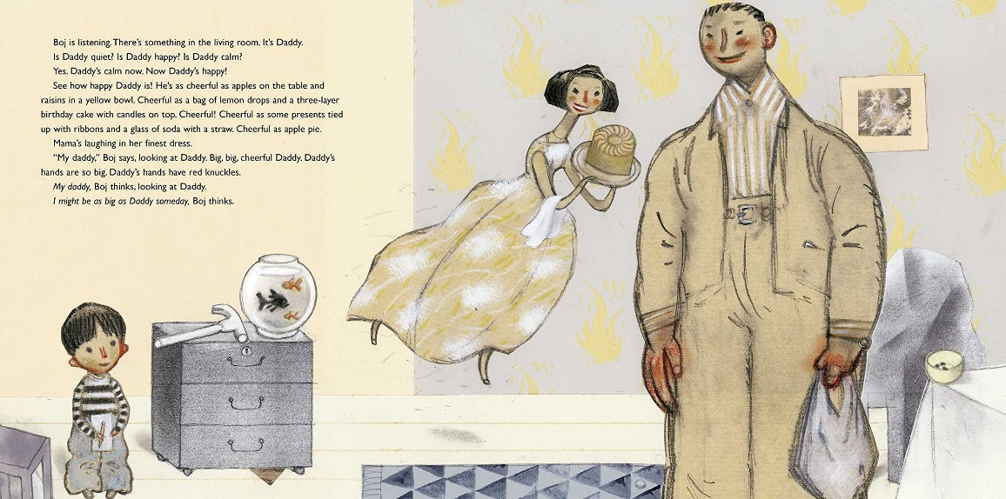

Figure 1, Angry Man by Gro Dahle (2005)

‘Angry Man’ by Gro Dahle (2019) is a perfect example of illustrators using visual language to tackle difficult and unsettling themes. The book depicts a family home of a mother, father and their son with the mother and son suffering the wrath the abusive father in manic episodes of rage. The colour palette is simple consisting of mostly yellow and grey muted tones which, on this specific page infers a calm atmosphere with a contrasting detail of a bright red in small aspects of the image. This indicates to there being conflict beneath the surface as red ‘is a colour seemingly meant by nature to stand out’ (Fine, 2021) and has been purposely used to show the contrast of the father’s demeanour and characteristics, to the mother and son who are depicted in the muted yellows and greys. The composition is fairly plain with the main focus of each page being the characters - the family. The focus on the family allows the reader to not get distracted by other aspects of the page, which is an important aspect when the target reader is young children. But Dahle does use texture and symbolism to hint at certain themes and feelings being portrayed on the page.The style in which the characters have been drawn is simple and identifiable to a young audience. Salisbury and Styles said that ‘the subtle relationship between artistic vision and the means by which we articulate it’ (2012) is greatly important. By illustrating the characters in this style which is sweet and a cartoon like manor it keeps the child interested whilst the story is being read to them.
Another aspect to the picture above is the way in which the characters are situated on the page. The father is in the foreground and appears to be much larger than the other characters, with is hands out by his side and having a much broader body making him the dominant figure in the drawing, while the mother is floating in the back and is very dainty and slim implying that her character is possibly more complicit and weaker. The son is in the bottom left corner and is very small with his arms in front of him, almost cowering indicating to his lack of power or perhaps presence in the house. Dahle has shown their status in the household by using shape, size and position on the page, doing this rather than obviously saying the hierarchy of the household allows the child to decide and figure out for themselves. The use of a
‘Symbolic medium they understand can help young children figure out a different, unfamiliar medium that they would otherwise not understand.’ (DeLoache 1991)
By having the mother floating implies that she is away or not present in the room. Almost like she is in a dream and is brushing the situation under the carpet. Dahles addition of these small details allow for talking points, such as the mother floating and the hammer balancing on the draws, a child would point them out and ask questions. All these key aspects make for an ease into conversation with a young child who has experienced situations like this and can help a therapist to engage with the child to help them comprehend it.

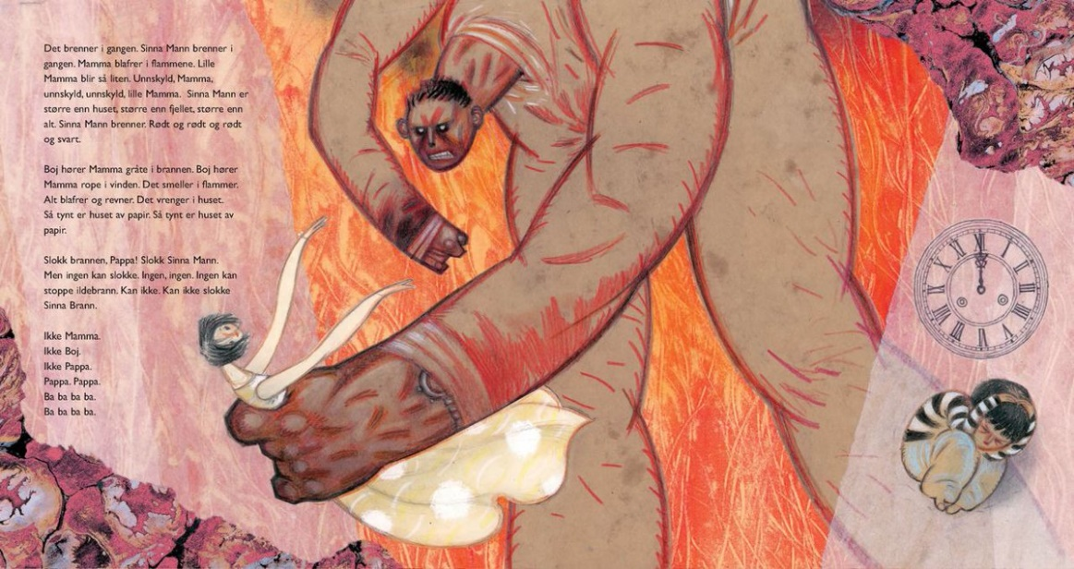

Figure 2, Angry Man by Gro Dahle (2005)

Later on, as the story progresses the father character gets bigger and bigger and the colour palette changes from predominantly consisting of the calm yellows and greys to being almost entirely the angry orange and red composition shown above. This is implying to the conflict and abuse the father is now inflicting onto his family in an episode of pure anger and violence. Dahle portraying him with the huge, hunched stature and blood red markings all over his body is quite a disturbing image but then the subject of domestic abuse is disturbing. The red on his hands is symbolic of his guilt in the situations as he’s ‘red-handed’ and in some way know what he is doing is wrong but still does it anyway. The overpowering orange and reds give the image a sense of pure rage and fury as ‘Red is a very hot colour. It’s associated with fire, violence, and warfare.’ This indicates that there is a constant battle going on in that the father is consumed with a haze of bloody red rage compared to the beginning of the book where he is in the calm beige and the mother remains unchanged in her yellow polka dot dress. The way Dale uses texture also indicates to the characters personality, by having the mother in a soft polka dot dress it implies an innocence to her and the idea that that innocence is her demise as it doesn’t change throughout the story, she is compliant as she doesn’t want her child to get caught is the crossfire of the father’s anger. Flicker, Van Schooneveld and Richins said that ‘as art has emerged as a tool of expression, communication and imagination’ it means that the use of simple shapes to indicate the characters nature is possibly more effective than just saying it transparently through the text or drawing it out in an obvious way. It does however show the ‘light’ of the story as the mother protects the son from the violence from the father. The colour ‘inspires hope, enthusiasm, yellow fosters positive way of thinking’ which shows the young reader that there is always and light in the dark tunnel. Dahle does include text in the book, but it doesn’t obviously day what is happening, and has it from the son’s point of view. This makes it easier for the young reader to understand and learn as the vocabulary used is simple.
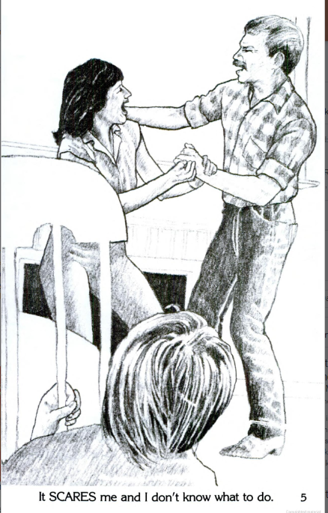

Figure 3, Something is wrong at my house by Diane Davies (1984)
Something is wrong at my house by Diane Davies is used to help children in situations where parents are fighting constantly and sometimes end up in violent occurrences. The image above is just in black and white and is in a traditional style of illustration. The absence of colour ‘which chromatic relations to favour to obtain a dramatic effect, to soothe, or to evoke primal emotional response’ (2021) indicates to there being no joy in this family dynamic and in this situation any colour would suggest a sense of happiness of relief from the torment the young boy is experiencing. The way in which the child is situated in the foreground watching his parents fight, with his back being the only part of his body on show implies the boys lack of power and inability to help his mother. Similar to ‘Angry man’, the father, who is the abuser in this scenario too, I larger and dominant in the image. As the reader not seeing the boy’s face makes it that more upsetting as you are unsure to what he is feeling, fear? Sorrow? Worry? Guilt? The lack of detail in the background also highlights the situation as it doesn’t distract from what is going on. Even though it is upsetting for a child to see this, having it in a book may help them to not feel alone and realize the dangers of domestic abuse.

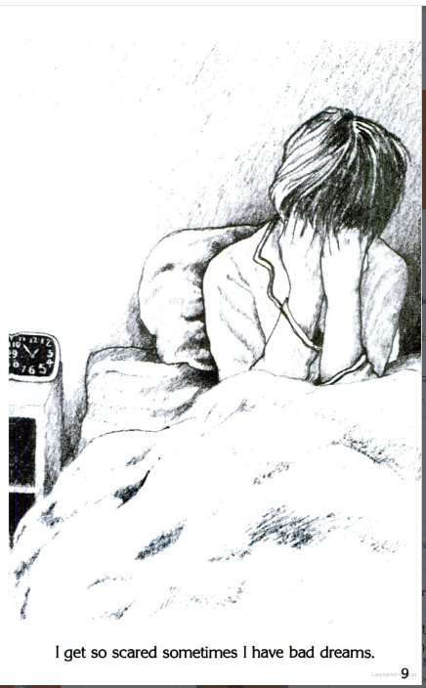

Figure 4, Something is wrong at my house by Diane Davies (1984)

The little text used in the book adds to the effect of the illustrations as spoken communication is important but ’65 percent’ (Ephratt 2022) of interaction and understanding is conveyed ‘nonverbally’ (Ephratt 2022) this means that the images used to show the emotion of the boy is more effective than phrasing it, but the addition of text does amplify the emotions being felt and helps the story to flow. The use of Chiaroscuro around the boy in the image above highlights his feelings as well as adding depth to the image and a ‘mastery of tone allows the artist to create impactful pieces that evoke strong emotions.’(Rise art) The reader can see how he is almost collapsing in on himself and the fear that he has is causing these bad dreams. The fact that we cannot see the boys face again adds to the powerful empathetic feeling the reader gets when seeing the image. The pose in which the boy is drawn in, having his hands over his face and being hunched over really conveys how he is feeling and if it’s understood that ‘understanding emotion should look beyond the frameworks provided’ (Hjort 1997) the reader should interpret his feelings in their own way, in that the boy is feeling scared but can be interpreted as feeling so many other emotions too and the reader can sympathise and relate to that.

To conclude all the above, both books have allowed the reader to use every ability to grasp and absorb information and have handled the unsettling theme appropriately and effectively with their use of different illustrative skills. Although they each approached the way to tackle the theme of domestic abuse very differently. Dahle has a symbolic approach in that he uses shape and colour to show emotion and to show a hidden conflict between characters by having contrasting colours. As well as subliminal messages with the floating mother and details of objects balancing on the edge of tables or draws, inferring to the father’s temper and how his emotion imbalance could tip and erupt at any time. The style that Dahle has used also has a symbolic meaning with the different textures used to show the characters demeanours. Dahle also has quite a bit of text in their book, which adds to the story structure, because of the symbolic approach they have taken, the narrative aspect to the book helps to convey the message of the story. Compared to Dahles approach in tackling domestic abuse and how to convey it across in a way children will understand, Davies has used a different style where they have illustrated the situation literally and in a more realistic composition. With the emphasis being on the characters, there is little to no detail in the background nor on the characters themselves, like clothing or texture. They is however a clever use of tone to add depth highlight the deep and difficult themes and emotions being felt in the book. Davies lack of colour also contrasts Dahles approach with their monochromatic colour scheme. But this is effective in that the lack of colour highlighted the dark theme of abuse and added the empathic theme. As well the realistic style used made it relatable to the target reader who would be a victim of abuse. As the books are used by therapists to help children who have experienced abuse, the ability to communicate across and teach children about abuse is very important. As well as ensuring that the next generation know that domestic violence is such a damaging subject and hopefully help to wither the numbers of domestic abuse cases.

Bibliography
Berger, J. (1972) Ways of seeing. London: BBC and Penguin.
Howard, C., Burton, M. and Levermore, D. (2020) Children's mental health and emotional well-being in primary schools. London: Learning Matters, an imprint of SAGE Publications Ltd.
David Mike Moore and Dwyer, F.M. (1994). Visual literacy: a spectrum of visual learning.
Available at: https://www.researchgate.net/profile/Kathleen-Baird-3/publication/272711853_Identifying_domestic_abuse_against_women_and_children/links/5d08b8d3a6fdcc35c155eb26/Identifying-domestic-abuse-against-women-and-children.pdf?origin=journalDetail (Accessed: December 5, 2022).
Nikolajeva, M. (2015). How picture books work.
Fine, A. (2022). Color theory: a critical introduction.
Salisbury, M. and Styles, M. (2012). Children’s Picture books: the art of visual storytelling.
Chapman, C., Magazine. Available at: https://www.smashingmagazine.com/2010/01/color-theory-for-designers-part-1-the-meaning-of-color/#:~:text=Red%20(Primary%20Color)%20%23&amp;text=It's%20associated%20with%20fire%2C%20violence,blood%20pressure%20and%20respiration%20rates. (Accessed: December 5, 2022).
Braam, H.van (2022) The color psychology of yellow, symbolism &amp; meaning, Color Psychology. Available at: https://www.colorpsychology.org/yellow/ (Accessed: December 5, 2022).
Flicker, F., G., V.S.J. and Richins, J. (2020) Creating art for all ages: Industry and imagination in ancient and modern civilizations. Lanham: Rowman &amp; Littlefield.
Absence of colors: Three symbolic examples of black and white artworks Perfect Picture Lights. Available at: https://perfectpicturelights.com/blog/the-absence-of-color-symbolism-of-black-and-white (Accessed: December 6, 2022).
Ephratt, M. (2022) Silence as language: Verbal silence as a means of expression. Cambridge: Cambridge University Press.
Rise Art. (n.d.). What is Tone in Art? [online] Available at: https://www.riseart.com/guide/2420/what-is-tone-in-art.
Mette Hjort and Laver, S. (1997). Emotion and the arts.
List of figures
Figure 1: ‘Angry man’ by Gro Dahle, 2005
Figure 2: ‘Angry man’ by Gro Dahle, 2005
Figure 3: ‘Something is wrong at my house’ by Diane Davies, 1984
Figure 4: ‘Something is wrong at my house’ by Diane Davies, 1984

