Rina Salique
1806203
Hossain

WORKPLACE CULTURE AND ITS IMPACT ON ORGANISATIONAL EFFICIENCY

Executive summary
The sharing values and attitudes along with a belief system as well as the behaviour of people working in an organization are referred to as workplace culture. This report has evaluated the rolesof organisational culture on its efficiency as well as sustainability. Different factors have been evaluated in this context to analyse the organisational culture which includes different socio-cultural aspects such as individualism, masculinity and power distance. External factors such as policy of government or economy of the nation are also influential in this context that determined the organisational culture. This study has evaluated the internal as well as external cultural environment of Debenhams to identify its impact on organisational performance and its efficiency. Organisational culture also includes the inter-relationship between different functions as well as its peoples. Another aspect of organisational culture includes communication channels that determine the communication process as well as sharing of information which supports organisational performance and productivity.This study also highlights the barriers of functioning in terms of organisational efficiency.

Table of content

Introduction 4
Workplace culture assessment 4
Hofstede analysis of UK 4
Debenhams’s culture 5
Corporate social and environmental responsibility 6
Organizational ethics and values 7
Broader environment 8
PESTLE analysis 8
SWOT analysis 12
Relationships between departments and employees 14
Communication channels 15
Cultural and ethical behaviour present in Debenhams and other 16
Barriers to effectual functioning and solution 16
Conclusion 18
Reference 19
Appendices 22

Introduction
The sharing values and attitudes along with a belief system as well as the behaviour of people working in an organization are referred to as workplace culture. This report is going to evaluate the organizational culture and the effect on the efficiency of the workplace with its efficiency. In this context, it will assess the culture of the workplace of the retail company Debenhams in the UK by the culture; it will discuss the corporate social as well as environmental responsibility policy of it and also the ethical and values of the concerned company. Here, the evaluation of Debenhams with its broader environment along with the communication channels and relationships between employees and departments of the concerned company will be assessed. This report is also going to discuss the challenges that will arise during the functioning of the company. In this scenario, it will provide a recommendation on the possible ways for overcoming the issues.

Workplace culture assessment

Hofstede analysis of UK
Power Distance
This dimension used to deal with the culture of inequalities present within us. The UK has scored low as 35 in this dimension that states the society of this nation has a belief that inequalities should get reduced that present within them.
Individualism
This dimension used to state the level of interdependence that should be maintained by members of society. In this section, UK has a high scored of 89 that represents individualism among people of the country.
Masculinity
The score in this dimension used to indicate that the society used to get driven by success and achievement as well as competition. 66 are the UK score in this that represents a contradictory situation.
Uncertainty avoidance
This is the dimension in which there is a culture feels to be threatened by the situations that are unknown. UK has scored low with 35 representing the thinking of being happy by not knowing the future.
Long term orientation
This dimension states the culture believing in having a link with past experiences in order to deal with the future possible challenges. UK has scored an intermediate of 51.
Indulgence
This dimension used to represent the level of a try by people for controlling desires as well as impulses. Here, UK has a high score of 69 that shows people of UK used to be indulgent.
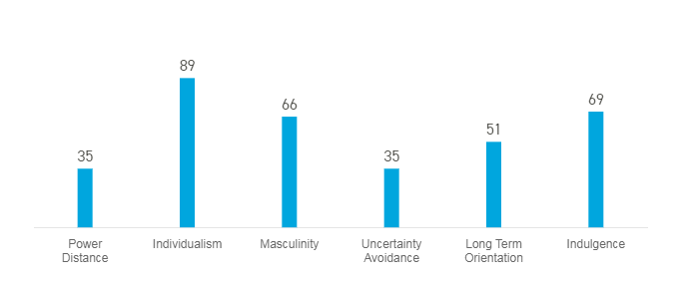
Figure 1: Hofstede analysis
(Source: Hofstede, 2019)

Debenhams’s culture
Organizational culture is used to represent the policies used by an organization for guiding the employees and also to provide the direction sense in the place of working. There are several kinds of cultures that represent the practice and nature of characteristics for working used to take place. Debenhams used to follow the clan culture of an organization in which it used to belief in team working and communication. As per the views of Cai et al (2016), clan culture used to enhances the thinking of collaboration and also facilitates in making team for working efficiency. In this context, Debenhams used in maintaining the culture of engagement of colleagues and provide equal opportunities. It used to follow the culture of providing empowerment to women and other communities of society. In the long-term orientation, Debenhams used to create pipeline of management for an efficient and productive future. It used to make alignment of culture to their goals and target of the organization.

Corporate social and environmental responsibility
Corporate social responsibility (CSR) automated model of business facilitates an organization in socially comprehensible with stakeholders and itself as well as with the public. As per the views of Unit et al. (2015), having CSR and procedures will help a company in integrating socially and ethically as well as environmentally. Debenhams also has a CSR policy in its organizational culture that helps in increasing their ethical values. It has a policy towards community betterment and targeting for £1 million of annual fundraising (Debenhams, 2019). It has raised £1.5 million for its partner of charity Look Good Feel Better, Breast Cancer Now and Children in need. It used to generate funds by donating profits from the selling of products that are exclusive as well as from the annual partner and supplier of the business.
It has also CSR policy regarding tackling emergency services named Disaster Emergency Committee that used to help people in providing shelter and food as well as clean water and also clothes and blankets in case of emergency situations (Debenhams, 2019). It has also CSR policy for promoting equality among its workforces and also for diversity. Debenhams used to follow and maintain the policies of international human rights being a part of the code of conduct of suppliers. It used to organize diversity campaigns. In 2013, it has organized such campaign in which various kinds of models with different kinds of age and sized and colour were used for promoting fashion collection (Debenhams, 2019). Debenhams is also involved with various Programs of Ethical Trade with an aim for reducing the practice of inequalities in its supply chain globally. By this, it used to make focus on the life skills that will help in empowering women as well as their communities.
In the year of 2015, Debenhams has made a partnership with Swati which is an international centre of human resource. As mentioned by El Ghoul et al. (2018), corporate environmental responsibility (CER) is a process by which an organization is used to incorporate issues of the environment in their organizational operation with the aim for elimination of wastes. By having CER, an organization is able for maximizing its efficiency as well as productivity. In this context, Debenhams has its CER and created five areas to focus on ensuring the reduction of its impact on the energy and emission and sustain as well as water along with the waste.
It used to maintain the policy of Environmental and chemical for maintenance of safety and the highest level of standards of its products. It used to maintain the limit of chemicals as per the permission mentioned in Regulation EC No 1907/2006 (REACH) in their products (Debenhams, 2019). It has also an organization of Animal Testing and Animal Welfare for ensuring the deriving materials are used to source from the good practice farms of animal husbandry for protecting the ethical as well as fair therapy of animals. It also used to arrange recycling programs for reducing wastes and various emission-reducing programs.

Figure 2: Corporate social and environmental responsibility
(Source: Debenhams, 2019)

Organizational ethics and values
As suggested by Lefkowitz, (2017), principles, as well as standards of operation of a business, are referred to the organizational ethics and it is essential in maintaining the basic needs of humans. In an organization, ethical behaviour is generally represented by honesty and fairness as well as interpersonal fairness. Debenhams used to maintain the ethical standards for maintaining its culture of the place. It used to enhance the ethics of respect among employees by maintaining an integrity working environment. Also, it used to spread the honour of its workforces irrespective of any sense of inequality.
It maintains the policy of diversity and inclusion for making an environment of working where everyone is used to get the right attention and care. Integrity is well maintained by the concerned company and it used to follow the ethical program of trading for the entire chain of supply. It also used to maintain the ethics of focusing on the customer in which the service provided to consumers and maintain the satisfaction and needs of people is its first priority. As per the views of Shin et al. (2015), organizational values are the concept used in providing guidance of thinking for a company and its actions. Values are important for an organization as it used to determine the method in which people are treated in the company and that are used for shaping the basic ethics of work.
Debenhams used to maintain the organizational value that oriented for the welfare of both customers as well as the company. Maintaining organizational values is necessary for an organization in order to understand as well as to motivate employees and entire workforces for its purpose of influence. Values in an organization used to make influences the behaviour as well as attitudes of the people. Values help in developing and growing an organization and for creating a future of productivity. Maintaining the values Debenhams used to get benefits to the working culture of integrating without any compromise. This has been achieved by the concerned company by adhering to its ethical code as well as strict values of morals.
The company also has succeeded in building communal leadership in their organizational culture. This leadership helps in making inspire to all employees and members of the company for flourishing in the success of goals driven by the goals as well as opportunities for development continuously. Organizational values have also helped the concerned company in achieving consistent as well as clear strategies and decision-making processes.
These strategies, as well as decision-making methods, have facilitated the concerned company in making products that possess reliable outputs and benefit for the shareholders as well as its consumers. By maintaining the values of diversity, Debenhams used to maintain the trust and communication system among employees. It also used to build honest relationships among the company and consumers. These values used to provide the opportunity of maintaining communication at every level.

Broader environment

PESTLE analysis
Components | Factors | Impact
Political | - Politically stable nation  - Policy for trade is open as well as free  - Brexit decision has impact | Impact is positive and negative as well
Economy | - Further reduction in the inflation rate to 1.5% (Tradingeconomics, 2019) (Refer to Appendix 3)  - Reduction from 1.8% in 2017 to 1.4% in the year 2018 of annual GDP rate (Tradingeconomics, 2019) (Refer to Appendix 4)  - Constant rate of tax in 41.6% (gov.uk 2019) | Both positively and negatively impact
Social | - Reduction in the percentage of unemployment from 3.9% to 3.8% (tradingeconomics, 2019)  - Reduction to 8.6% in the rate of gender inequality (ons.gov.uk, 2019)  - There is 99% of the rate of literacy (UNA-UK, 2019) | Positively impact
Technology | - Investment of £1 billion for improving artificial intelligence (gov.uk, 2019)  - Government has invested £153 million aiming in improving quantum computing (Computing, 2019)  - Mobile POS Systems  - Beacons (nn4m, 2019)  - In-store Kiosks (nn4m, 2019)  - Electronic Price Tags | Positively impact
Legal | - Consumer rights act 2015 (legislation.gov.uk, 2019)  - Data Protection Act 1998 (legislation.gov.uk, 2019)  - Privacy and electronic communications regulations 2003 (legislation.gov.uk, 2019)  - Sale of Goods Act 1979 (legislation.gov.uk, 2019) | Both positively and negatively impact
Environment | - JNCC Environmental Policy (Jncc, 2019)  - Policy of recycling  - Environmental Protection Act 1990 (legislation.gov.uk, 2019) | Both positively and negatively impact
Table 1: PESTLE analysis
(Source: Rastogi and Trivedi, 2016)
There are various factors in the exogenous environment that has influence in the performance of a retail industry. In this context, Debenhams is also subjected to these factors and politically it is getting positive impact for making long-term policies due to having stable political condition in the UK. Also, the trading policies will facilitate it in expanding its business. However, there is one negative effect persists for the concerned company in terms of additional tariffs and taxes due to the decision of government on Brexit.
On the other hand the improving economic condition of the country including the reducing inflation rate and stable tax rate will increase people's purchasing power. Also, socially the decreasing rate of unemployment with the gender inequality and increasing literacy rate will facilitate Debenhams in getting skilled and both male and female workforce. Investment by the government for improvement of technology will also facilitate the company in improving its updating business operation. However, there are certain legislations that are needed to be maintained by Debenhams in order to smooth functioning and avoid any lawsuits. 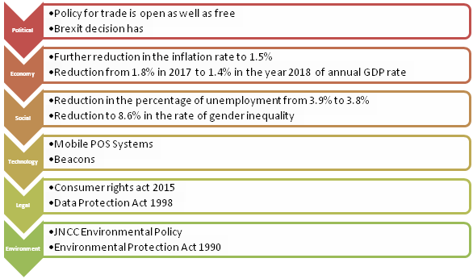
Figure 3: PESTLE analysis
(Source: Rastogi and Trivedi, 2016)

SWOT analysis
Strength | Opportunity
- Over 165 stores in the UK and 87 stores across the world  - Innovative products  - Successful in market penetration  - A strong network of distribution  - Strong customer service  - Increasing revenue  - The third position in the fashion market share in the UK (Statista, 2019) (Refer to Appendix 2) | - Opportunity to invest in R&D to apply new trends  - A chance for moving in other segments of product  - Option for entering in the untapped markets  - Opportunity to implement new strategies for handling risks
Weakness | Threat
- Lacking in handing challenges arising by the new market entrants  - Investment in the process of research and development is slow  - Limitation in maintaining an effective market segment  - High rate of employee turnover  - Restriction in moving out to any new segments of product | - Potential competitors and rival companies  - John & Lewis, Marks & Spencer are the tough competitors  - Fluctuation of currency in various countries
Table 2: SWOT analysis
(Source: Phadermrod et al. 2019)
There are various strengths that of the Debenhams that provide the concerned company more opportunities for increasing its efficiency in performance. Revenue of Debenhams is increasing and in the year 2017 was £2,335.0 that has increased to £2,277.0 in 2018 (Debenhams, 2019). (Refer to Appendix 1) It is also over 165 stores with 87 franchisees over the world that provides the opportunity in entering many untapped markets across the world. Also, it has the strength of having a strong network of distributors that will provide the opportunity in maintaining performance over various countries. Also, it is sharing the market of the UK in the fashion departmental stores in the third position.
However, there are some weak areas that will pose a serious threat in its performance. The main challenge of Debenhams is the slow investment in the process of research and development that will pose threat in lacking of competitive advantage. It can overcome the challenge by investing in the R&D. High turnover rate of employees is also a weakness of Debenhams and in order to mitigate this issues motivational strategies are needed to implement. The threats due to this weakness are the increasing potentiality of its tough competitors including John & Lewis, Marks & Spencer. Also, fluctuation in the economy of various countries poses a serious threat for the company. 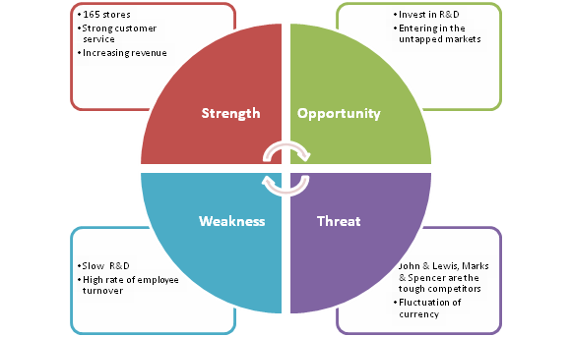
Figure 4: SWOT analysis
(Source: Phadermrod et al. 2019)

Relationships between departments and employees
There are formal and informal relationships among people of an organization and this generally forms in order to accomplish the targets and goals of the firm. As per the views of Manuti et al. (2015), for fulfilling the needed objectives the formal relationships are built by official authority. On the other hand, on the basis of interests and attitudes as well as liking, unofficial relationships used to get built. Formal structure in an organization helps in the systematic working process and also in a smooth functioning that will help in achieving the organizational goals. The relation of formal between various departments and employees of an organization used to be maintained by the effective communication channel.
Formal relationships in an organization helps in building coordinated network in the various activities of different departments of an organization. This also facilitates in smooth and coordinated working process of employees in various departments. It helps the concerned company in avoiding overlapping of work because of systematically delegation. However, focusing only on the formal relationship often used to make ignorance about the social requirements of employees of a company and this in turn can lead to demotivation of them. On the other hand, informal relationships between people in an organization helps in maintaining satisfaction psychologically by providing free space of communication.
As suggested by White et al. (2016), informal relationship among people helps in fulfilling social needs that in turn facilitates in motivating employees. However, there are some cons of informal relationship as it often promotes the spreading of rumours in an organization. These rumours have the capability in misleading employees and also capable enough for hindering smooth and systematic process of working. By building more informal relationship in organization can hamper the focus on the organizational goals and emphasis only on an individual. It also has the capability in braking policies and regulation of working and changes will be difficult for implementing by the management of an organization.

Communication channels
In an internal environment of an organization, communication channel in order to share useful information is a key for maintaining good professional relations. As per the views of Dwyer and Hopwood (2019), an appropriate tool for interaction generally needs to identify the audience and the message as well as the main goals of the message. Debenhams used to maintain various kinds of communication system in its operation system including Intranet Software. This tool is extremely useful channel for interaction in an organization by serving as a hub for the people and employees as it provides a particular space in which corporate information including news and policies can be spread. As mentioned by Sillitoe, (2015), Debenhams has started the communication channel named shopper feedback system for interaction with its consumers.
By this communication system, consumers after purchasing any product will be provided by a URL in which they can be able in giving feedback about the product. Another form of communication channel is the internal blogs and info graphics that used to provide an open area for discussion. Apart from these, Meeting Management software is another form of tool for interaction that helps in building relationships among employees by effective way of communication. As stated by Dwyer and Hopwood (2019), by this software, action for pre-planning and meeting as well as post-meeting will be easily arranged.
This helps the concerned company in making schedules and setting goals as well as its distribution among the management and employees. Internal discussion forum is another important form of communication channel that provides an evolutionary basement of information that can be utilized by employees in order to resolve issues as well as share information. Apart from these tools and methods, face to face meetings and emailing are important for verbal and non-verbal communication that facilitates the concerned company in discussing relevant information and data with management and employees.

Figure 5: Communication channels
(Source: Dwyer and Hopwoodm, 2019)

Cultural and ethical behaviour present in Debenhams and other

Barriers to effectual functioning and solution
The rules along with boundaries that are set by an organization which are needed to follow by employees and all members are referred to culture. As per the views of Shin et al. (2015), the ethics included principles as well as standards for operating the business used in enhancing the ethical behaviour of an organization. Generally, there are symbols as well as signs that are mainly actions and practices which are used to enhance the sustainability of an organization culture. Debenhams in this scenario also used to well maintain its culture by regulating its policies according to the legislation of the country.
Debenhams used to maintain all legislation as the privacy policy that helps it maintaining privacy by using personal information of its consumers and employees connecting to their websites and stores (Debenhams, 2019). On the other hand, its competitor Marks & Spencer used to maintain a code of ethics and behaviour and that are needed to be adhered to by its employees. It used to promote the practice of integrity for all its members. It also maintains the payment security policy that is 3-D Secure and Payment Authentication.
It also maintains the policy of transaction Group Expenditure and Commitment Approval Policy and Invoice Authorisation Controls as well as Non-Merchandise Contracts Approval Process and provides expenses by Business Travel and Expenses Policy. Debenhams also used to emphasize equality among its employees and used to enhance fair trading and promote its equal opportunities policy. By this Debenhams used to promote the hiring and recruitment o its employees o the basis of skills as well as talent. It also believes in ethical behaviour and promotes against corruption and anti-bribery (Debenhams, 2019).
Its Anti-Bribery policy demarcates the standards of ethical behaviour and also layout guidance to employees of exchanging of gifts as well as hospitality. It used to maintain the policy of human rights and promote the prohibition of modern slavery by its modern slavery policy. It used to maintain the culture of the company by establishing the norms of behaviour by top management that are to be adopted by the organization. The same thing is followed by the M&S by maintaining the agreement policy for payment with suppliers by sticking to its Anti-Bribery policy.
Beyond this M&S also has Group Fraud Policy that states any member or employees deliberately promote fraud working activity will be declared as performing criminal activities and for that actions will be taken (Marksandspencer, 2019). M&S also maintains the confidentiality of internal information and for this; it nurtures Share Dealing Code that restricts any leaking out of information outside of the company.
However, there are various barriers arise that used to make restriction in the maintenance of ethical behaviour and practice of an organization. According to El Ghoul et al. (2018), ethical practices can be affected by the structure of an organization and this can be enhanced due to lack of motivation in the organization and also in moral values. In order to eradicate this barrier, it is necessary for the management of an organization to incorporate the practice of motivation providing activities to employees. Cognitive theory can be incorporated in this situation by an organization with the use of tools and methods to make employees learned and motivated about them. Another barrier for an organization to ethical behaviour is to adopt it.
Adoption of standards of ethical culture and practice is too much costly. However, it is important for maintaining a proper and effective budget for incorporating ethical codes and legislation. As by not having an efficacious ethical practice and codes will lead to make more costly than having them. Several strategies for ethics and actions including empowering the employees and creation of sense of goals and mission of the organization as well as to provide rewarding are helpful in providing improvement in the commitment of employees. It will also help in enhancing productivity and also in avoiding punishments regarding monetary and other aspects. Another barrier that comes for maintaining ethical practice is the failure in making regulatory compliance.
Compliances of regulations are important as it makes adherence to legislation as well as guidelines stating the process of business. The failure in the maintenance of it will lead to a violation of regulatory compliance regulations and this, in turn, will result in the legal punishment comprising of federal lines. Misuse of the code of ethics is results in the rising of barriers in the practice of ethical and cultural behaviour. This kind of violation can result in the use of unprofessional language as well as inappropriate attitude and behaviour with clients. Also, abuses of resources in the workplace and kind of damage to any resources lead to the violation of ethical code. Harassment to any member of a workplace including physical and sexual harassment and destroying any assets of a workplace is included in the violation of code of ethics.

Conclusion
Thusit can be concluded that ethical behaviourin organisation culture is an important practice that is needed to maintain the efficiency and discipline of an organization. This report has evaluated the organizational culture and behaviouralethics and the impact of it on the efficiency of the workplace. Regarding this scenario, it has assessed the culture of the workplace of the retail company, Debenhams in the UK.It has discussed the corporate social as well as environmental responsibility policy of it and also the ethical and values of the concerned company. Here, the evaluation of Debenhams with its broader environment along with the communication channels and relationships between employees and departments of the concerned company has been assessed. This report has also discussed the challenges that will arise during the functioning of the company. In this scenario, it has provided a recommendation on the possible ways for overcoming the issues. It has also make a comparison in the ethical and cultural practices with proper legislation and policies of Debenhams and its competitors.

Reference
Alvesson, M. and Sveningsson, S., (2015). Changing organizational culture: Cultural change work in progress. Routledge: Abingdon
Cai, L., Cui, J. and Jo, H., (2016). Corporate environmental responsibility and firm risk. Journal of Business Ethics, 139(3), pp.563-594.
Computing (2019) Government launches £153m programme to commercialise quantum tech. Available at: https://www.computing.co.uk/ctg/news/3077401/government-quantum-funding-gbp153m [accessed on: 30.11.2019]
Debenhams (2019) About Debenhams. Available at: https://www.debenhams.com/ [accessed on: 30.11.2019]
Debenhams (2019) CORPORATE SOCIAL RESPONSIBILITY. Available at: http://sustainability.debenhamsplc.com/community/ [accessed on: 30.11.2019]
Debenhams (2019) Debenhams Privacy policy. Available at: https://www.debenhams.com/wcsstore/DebenhamsUKSite/faq/legal_information/privacy_policy.html [accessed on: 3.11.2019]
Driskill, G.W., (2018). Organizational culture in action: A cultural analysis workbook. Routledge: Abingdon.
Dwyer, J. and Hopwood, N., (2019). The business communication handbook. Cengage AU.
El Ghoul, S., Guedhami, O., Kim, H. and Park, K., (2018). Corporate environmental responsibility and the cost of capital: International evidence. Journal of Business Ethics, 149(2), pp.335-361.
gov.uk (2019) AI Sector Deal. Available at: https://www.gov.uk/government/publications/artificial-intelligence-sector-deal/ai-sector-deal [accessed on: 30.11.2019]
gov.uk (2019) Income Tax: Personal Allowance and basic rate limit from 2019-20. Available at: https://www.gov.uk/government/publications/income-tax-personal-allowance-and-basic-rate-limit-from-2019-to-2020/income-tax-personal-allowance-and-basic-rate-limit-from-2019-20 [accessed on: 30.11.2019]
Jncc (2019) Managing our environmental impact. Available at: https://jncc.gov.uk/about-jncc/corporate-information/managing-our-environmental-impact/ [accessed on: 30.11.2019]
Lefkowitz, J., (2017). Ethics and values in industrial-organizational psychology. Routledge: Abingdon.
legislation.gov.uk (2019) Consumer Rights Act 2015. Available at: http://www.legislation.gov.uk/ukpga/2015/15/contents/enacted [accessed on: 30.11.2019]
legislation.gov.uk (2019) Sale of Goods Act 1979. Available at: http://www.legislation.gov.uk/ukpga/1979/54 [accessed on: 30.11.2019]
Manuti, A., Pastore, S., Scardigno, A.F., Giancaspro, M.L. and Morciano, D., (2015). Formal and informal learning in the workplace: a research review. International journal of training and development, 19(1), pp.1-17.
Marksandspencer (2019) Code of Ethics and Behaviours. Available at: https://corporate.marksandspencer.com/documents/policy-documents/archived-documents/2_code-of-ethics.pdf [accessed on: 3.11.2019]
nn4m (2019) 10 Examples of Digital Technology in Retail Stores - NN4M. Available at: https://www.nn4m.co.uk/10-examples-of-digital-technology-in-retail-stores/ [accessed on: 30.11.2019]
ons.gov.uk (2019) Gender pay gap in the UK: 2019. Available at:https://www.ons.gov.uk/employmentandlabourmarket/peopleinwork/earningsandworkinghours/bulletins/genderpaygapintheuk/2019 [accessed on: 30.11.2019]
Phadermrod, B., Crowder, R.M. and Wills, G.B., (2019). Importance-performance analysis based SWOT analysis. International Journal of Information Management, 44, pp.194-203.
Rastogi, N.I.T.A.N.K. and Trivedi, M.K., (2016). PESTLE technique–a tool to identify external risks in construction projects. International Research Journal of Engineering and Technology (IRJET), 3(1), pp.384-388.
Shin, Y., Sung, S.Y., Choi, J.N. and Kim, M.S., (2015). Top management ethical leadership and firm performance: Mediating role of ethical and procedural justice climate. Journal of Business Ethics, 129(1), pp.43-57.
Sillitoe. B., (2015) Debenhams opens up communication channels. Available at: https://www.essentialretail.com/news/560162818ac79-debenhams-opens-up-communication-channels/ [accessed on: 30.11.2019]
Statista (2019) Gross domestic product (GDP) year-on-year growth in the United Kingdom (UK) from 2000 to 2018. Available at: https://www.statista.com/statistics/281734/gdp-growth-in-the-united-kingdom-uk/ [accessed on: 30.11.2019]
Statista (2019) Leading department stores in the United Kingdom (UK) in 2012 and 2017, by share of the market. Available at: https://www.statista.com/statistics/784771/department-store-retailers-market-share-united-kingdom-uk/ [accessed on: 30.11.2019]
tradingeconomics (2019) United Kingdom Inflation Rate. Available at:https://tradingeconomics.com/united-kingdom/inflation-cpi [accessed on: 3.11.2019]
tradingeconomics (2019) United Kingdom Unemployment Rate. Available at: https://tradingeconomics.com/united-kingdom/unemployment-rate [accessed on: 30.11.2019]
UNA-UK (2019) INTERNATIONAL LITERACY DAY. Available at: https://www.una.org.uk/international-literacy-day-factsheet [accessed on: 30.11.2019]
Unit, B., Star, E. and SmartWay, E.P.A., (2015). Corporate social responsibility.Environmental Stewardship Policy.2 (1). pp. 1-7
White, L., Currie, G. and Lockett, A., (2016). Pluralized leadership in complex organizations: Exploring the cross network effects between formal and informal leadership relations. The Leadership Quarterly, 27(2), pp.280-297.

Appendices
Appendix 1: Revenue of Debenhams
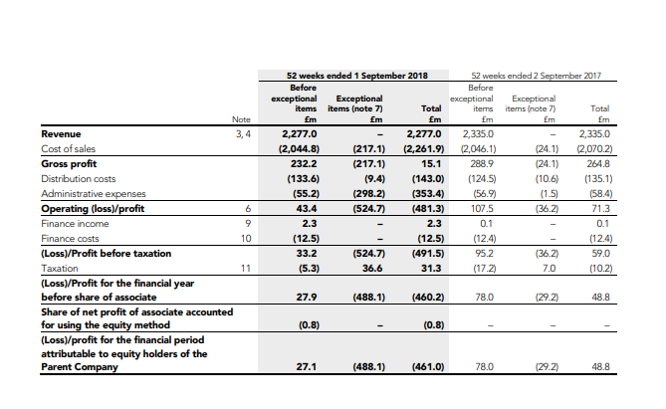
(Source: https://ir.debenhams.com/static-files/32bcca3d-8332-4a15-bfbe-08398fc595f1)

Appendix 2: Market share of Debenhams
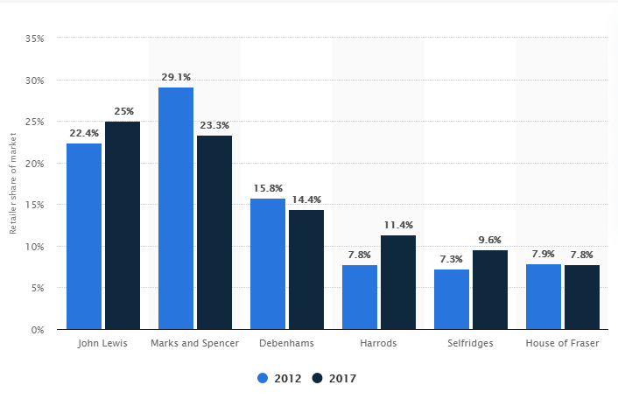
(Source: https://www.statista.com/statistics/784771/department-store-retailers-market-share-united-kingdom-uk/)

Appendix 3: Inflation rate of UK
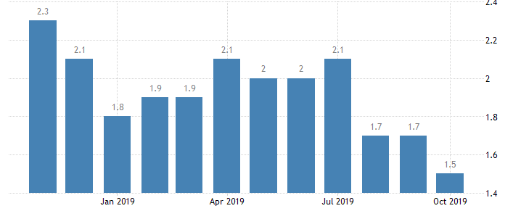
(Source: https://tradingeconomics.com/united-kingdom/inflation-cpi)

Appendix 4: GDP of UK
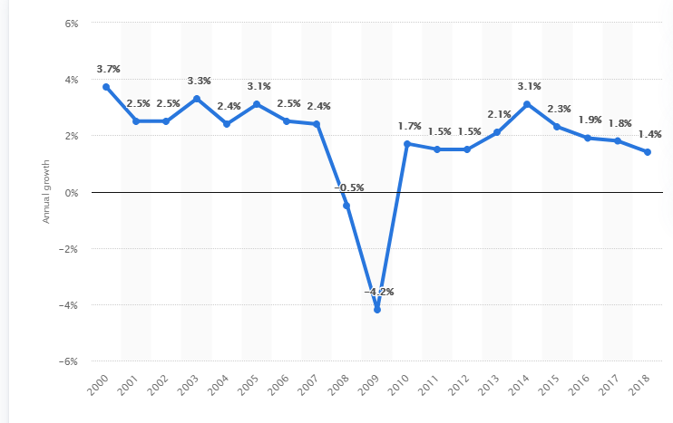
(Source: https://www.statista.com/statistics/281734/gdp-growth-in-the-united-kingdom-uk/)

