
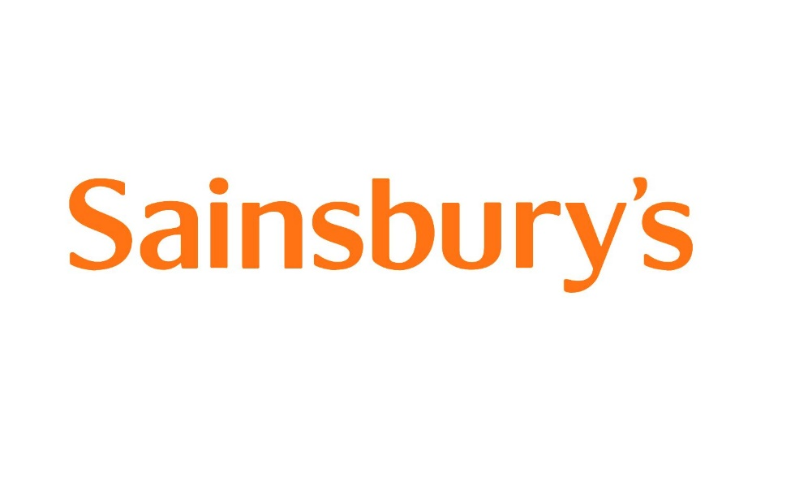

University of Wales Trinity Saint David
Module Number: LCB4003
Module Name: Introducing to the Modern Workplace
Module Tutor: Uju Ugochukwu
Student name and ID:
Constantin-Alexandru Frunza: 2008383
Ioana-Theodora Popescu: 1922523
Ionela-Filip Datcu: 1922490
Oana-Florentina Bolocan: 2009953

Introduction

In a workplace, the leadership is explained as the process through which an individual mainly gets manipulated as well as encouraged in order to meet all the objectives of the company. Apart from that, with the help of leadership, an organization could be guided both in the cohesive and coherent way. Moreover, in a modern workplace, the leadership is very essential as it helps to motivate the employees for better performance with the help of strong and efficient bonding. It also increases the overall efficiency of the organization along with the achievement of goals (economicsdiscussion.net, 2020).
The modern workplace is very essential as it mainly demonstrates the growth of the employees as well as their prosperity. On the other hand, this type of upgraded workplace helps to minimize the associative investments with proper retaining talent. It is essential for protecting the competitive advantage of the organization. Additionally, these amenities are not installed and implemented at random. It must have some significant use and must possess some features that make the work easier and fun. The main purpose of this study is to understand the aspects of modern workplace and for that one retail organization; Sainsbury has been considered (sainsburys.co.uk, 2020).

Background of the Organization

For this project, our organization of choice is Sainsbury, which is a retail company and possesses a chain of supermarkets all around the United Kingdom. Now, Sainsbury has 3 parts, Sainsbury retail, Sainsbury bank and Sainsbury Argos. In 1869, John James Sainsbury and Mary Ann, his wife, opened a retail store in partnership. Instantly, Sainsbury became popular around the neighbourhood, for providing its customers with good quality food products at a lower rate than the outside market. The neighbourhood was a poor one, and they preferred Sainsbury over the other stores. At first, it was opened to sell milk, and after that, they started to sell fresh foods and packaged grocery items at cheaper prices. They used the generated revenue in buying items for the next day to sell. During time, Sainsbury became a major chain of supermarkets in the entire United Kingdom (sainsburys.co.uk, 2020).
In 1888, they started to sell products with their own brand name and used to maintain a good relationship with the customers and the suppliers. They stuck on to their motto of providing good products at a cheaper price, and that helped them grow their business many folds. They cared for the children’s and joined hands with the suppliers to lower the number of additives added in the children’s products. They were the pioneer company to sell soft drinks free of any additives with their own brand name, and they also employed female shopkeepers first in the business. They were visionary. They were the first company to use computers in stores to run and monitor the operations of the store, accepted cards, and with their good brand name and brand value, they started to generate more and more revenues (sainsburys.co.uk, 2020).
That led them to expand their horizon of operations, by expanding the area of the stores, number of the stores and many more. Moreover, they expanded their business in many sectors, and did not only stuck to the grocery business. With time, they introduced their own petrol pump, bank, bakeries, coffee shops, fresh fish counters, flower stores and nurseries, book shops, restaurants, bike shops, clothing brands, music stores, finance systems, and electronic and electrical businesses. Among all, they stick to their motto of providing good quality at a lower price, and that made them one of the biggest Supermarket chains in the United Kingdom (sainsburys.co.uk, 2020).

The main two strategies of Sainsbury’s

Sainsbury's main mission is to deliver excellent quality services at an affordable price to a wide range of customers by working quicker and easier together, making food the first choice. By balancing profit growth and reducing costs and increasing marginal profits, Sainsbury expects the brand to expand and is committed to generating business margins in a complex, marketplace and global and delivering a strong total of needs. profitable to increase the company's program from year to year (Sarah Fatricia, 2016).

- Our reasonable need is to expand on our solid image legacy and notoriety for quality, reach, and advancement and offer steadier an incentive to clients while making shopping more advantageous. This is the thing that we mean by returning food at the core of Sainsbury's. We will convey delightful, extraordinary worth food any place and anyway clients need to shop with us. We will pull together the part of our portfolio brands to guarantee that they contribute emphatically in their own right, effectively uphold our desire in food and don't weaken returns or redirect center and assets from the center. Argos, Territory, Tu, Nectar, and Sainsbury's Bank will convey for their clients and drive solid, feasible, product development to help our center food business. We will convey a stage change in effectiveness by changing our way to deal with costs, streamlining our association, and conveying an auxiliary decrease in our working cost base. We are quickening our cost sparing designs to open new open doors to finance the improvement of our food offer and to guarantee we can meet the development in clients shopping over a wide scope of channels. Sainsbury's mission is to deliver quality goods and services at a reasonable price by working quicker easier, together and making it the first choice for food. By balancing revenue growth, reducing cost and rising margins, Sainsbury expects expansion to continue. The company is committed to generating business margins in a complex, global marketplace and to delivering a strong total number of necessary profit growth every year of its business programmed. (Sainsbury, 2020).

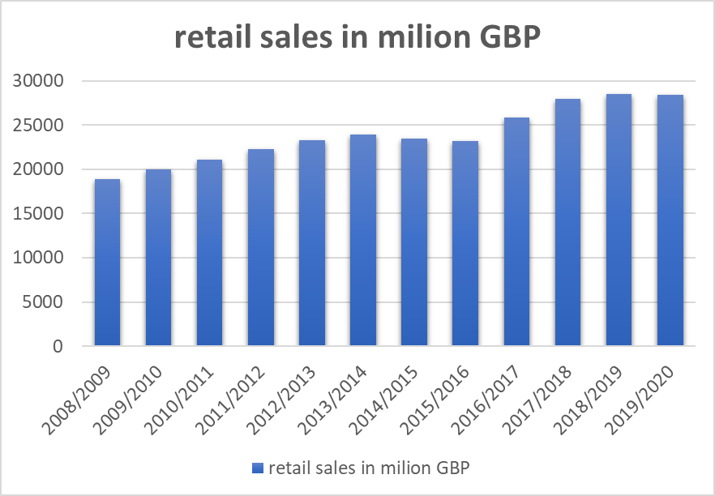

- After Tesco, Sainsbury’s is the second largest supermarket in the UK and has lost market share with competitors, Tesco and Asda, which have a market share of over 17%. To increase market share, Sainsbury's has adapted its strategy to implement the Nectar Loyalty Program. This program is a crucial part of the great Sainsbury's brand. The retailer was convinced that it is a strategy to attract attention by giving rewards programs that help to improve the current marketing position. The biggest advantage of using Nectar Card is based on easily reaching rewards, collecting points of purchase. One year after bringing this product to market, Nectar Club has surpassed the advantage card of its rival, Tesco. This concept is based on customer information in parallel with daily needs. Sainsbury's uses this information to decide what stock of products will be supplied in stores, and this concept helps the brand to become better and more efficient in reaching its target customers. Nectar program is based on the partnership with numerous sponsors and many advantages for a loyalty program. Of course, Sainsbury's is the largest sponsor that benefits from the flow of customers, retention, up selling and acquisition (Sarah Fatricia, 2016).

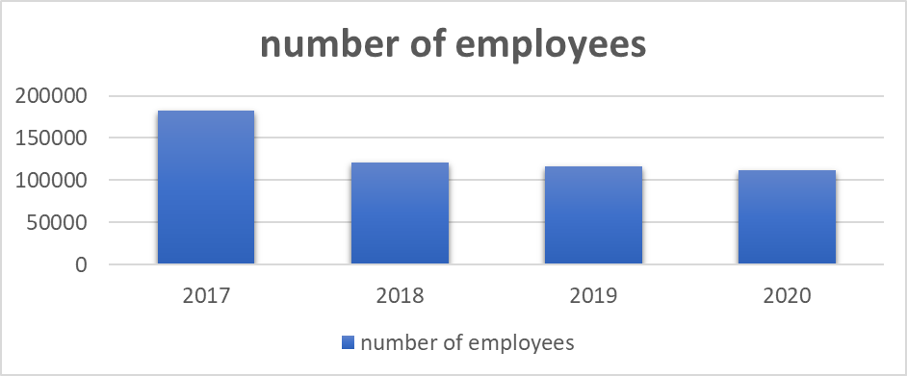

Analyse the relationship between structure, culture, people, and organizational performance
There is an intricate relationship between the structure, culture, people and the organisational performance, because those are parts of organization performance which depends collectively on these factors. (Alosani and Al-Dhaafri, 2020, p. 23).
Sainsbury’s structure:
- Sainsbury’s SUPERMARKETS- The first Sainsbury's supermarket was opened in 1869 and is the oldest brand selling food in the UK (Jaoua, 2018, p. 476).
- Sainsbury’s ONLINE- The delivery service is available for approximately 90% of households in the UK and delivers over 100,000 orders weekly (Odor, 2018, p. 15).
- Sainsbury’s PROPERTY- Sainsbury's has more than 43 properties under the risk agreements and 297 freehold and long-term leased properties (Jaoua, 2018, p. 476).
- Sainsbury’s BANK- Sainsbury's Bank offers a wide range of quality products, including savings, loans, credit cards and insurance and is an HBOS company, part of Lloyds Banking (Odor, 2018, p. 15).

According to Al-Dhaafri (2020) ‘’The five main stores of Sainsbury are structured as:
- Regular Sainsbury’s stores;
- Sainsbury’s Local;
- Sainsbury’s Central;
- Sainsbury’s ‘Main Plus’;
- Save centre.’’

Relationship between the structure and the culture of the organisation and organisational performance
In a functional organisational structure, the organisation plays an important role in determining the performance of the business, employees are grouped on the basis of their expertise in the field, and that helps in organising the work management very well, because the employees know what to do and what not, thus making the communication among the same group of employees very clear and it also saves time (Oyewobi et al. 2016, p. 25).
- The Divisional structure of the organisation ensures that a team of specialised employees tackle a specialised function, and the employees in this manner can generate maximum output of work with a higher efficiency (Alosani and Al-Dhaafri, 2020, p. 23).
- The Matrix structure of the organisation further ensures that the employee’s specialisation is optimum, and the employees can generate maximum business without wasting much time (Jaoua, 2018, p. 476).
- The flat organisational structure ensures that the employees can use their imagination and unique ideas in dealing with the customers, and without hesitation can share their ideas with the organisational hierarchy (Alosani and Al-Dhaafri, 2020, p. 23).
The culture of the organisation and the culture of the country also creates an impact on the performance of the organisation. If an organisation has a culture of providing good products at a cheaper price, in future also, they must maintain that culture in order to be the customer’s favourite, because the organisation itself and must perform according to the expectation of the loyal customers of that organisation, meanwhile the customers expect from the standpoint of the globalisation, whereas the organisation operates from the standpoint of the culture of its country or of its own. (Yuliansyah et al. 2017, p. 10).
In order to mitigate the gap in the expectation of the customers, the organisation may plan and implement some countermeasures from time to time (Patyal and Koilakuntla, 2016, p. 319).

Relationship between the people of the organisation and organisational performance

Whatever plan the management, or the company makes, the employees are the people who make it a reality. If the people of the organisation are not motivated or enthusiastic enough, the plans which are made for the betterment of the organisation, cannot do anything in order to increase the performance of the organisation. This is the main reason for looking for self-motivated and self-enthusiast candidates for the company (Odor, 2018, p. 15).
The employees are the people who will give shape to the plan and programs made by the managerial authorities, and if they are not enthusiastic and motivated enough, the performance of the organization will be lowered, also, if the people of the organization do not take their job seriously, and act casually and callously, that also hampers the performance of the organisation and drags down the entire effort of the team fighting to achieve the maximum performance out of the company becoming a burden for the entire company. (Alosani and Al-Dhaafri, 2020, p. 23).

Identify the essential nature of managerial works and Communicate the role of leadership

- Responsible for any type of constructive jobs in an organisation (Foster et al. 2019, p. 473).
- To look after the well beings of the employees (Foster et al. 2019, p.473).
- To look after the financial conditions of the organisation (Willmott, 2019, p. 305).
- Totally out the profit and loss factors of the company (Willmott, 2019, p. 305).
- Regulate the line of action accordingly by checking the flow of money (Willmott, 2019, p. 305).
- Gets to know about any type of politics being played on any of the employees (Willmott, 2019, p. 305).
According to Alefari (2017), ‘’ In an organisation, there is an immediate hierarchy for an employee, to whom he reports. A leader is the person who, along with the employees, do the same task to help them achieve it in time. He makes the employees comfortable enough to share their thoughts, ideas, problems and solutions with him, and make an understanding of equality. Factors that make a man a leader:
- The leader’s qualifications: The leader should be qualified enough to tackle the job he is appointed to. He should also be experienced and qualified enough to tackle his subordinates working below him. He should be able to understand the depth and the vastness of the job and should be able to brief his subordinates about every aspect of the job. Moreover, he should be able to foresee the consequences of the job, if something goes wrong and should be prepared accordingly to tackle the situation immediately.
- The culture of improvement: The leader should improve himself constantly in the field of the designated job or in any other field, coming from the culture of improvement, so he can adapt to any situation. He could upgrade and improve himself in every manner by reading books, journals, searching the internet about various topics, or by talking with the professionals of the field. A leader must be a dynamic form or entity, so that he can be a good example to his subordinates and the individual should always be craving knowledge and wisdom.
- The development of the policy: A leader should be a flexible person who adapts to the changes in the business plans easily and does not stick to the backdated version of the business policies. He should be knowledgeable and open minded enough to easily accept the changes, which will then benefit his leadership.’’

The four characteristics of leadership have been illustrated below-
- Effective skill of solving issues;
- With the help of strong orientation of outcomes, the leaders are operated;
- Always look for different and productive viewpoints (economicsdiscussion.net, 2020);
- Always support the subordinates.

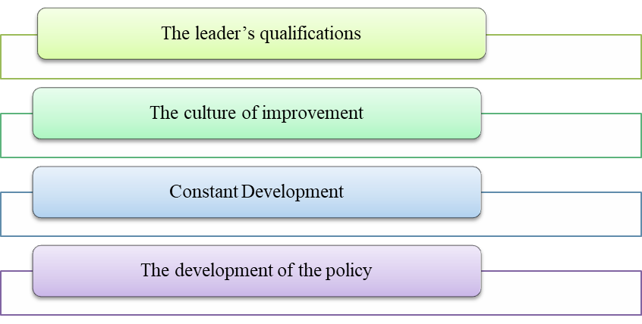
Figure 1: Role of Leadership
(Source: Alefari et al. 2017, p. 756)

Explain the variables that determine effective management and leadership

Several factors determining the quality of a leader in a company are the following:
- Sense of urgency- A leader should have the quality of managing time precisely, otherwise he will be left behind in the long run of the time. The higher authority should be aware about the deadlines of the projects and should set the pace of the job according to the deadline, should also motivate his subordinates to do the job at the same pace as him (Sedighiet al. 2017, p. 308).
- Powerful guiding quality- A leader should be a powerful guide and should know the positive and negative outcomes of an action and must be able to guide his workers, as well as himself, through the good and the bad situations. The individual should be powerful enough to take decisions on his own and need to have the power to deal with the consequences afterwards (Kumar et al. 2020, p. 104818).
- Great quality of vision- A leader should have a great foresight, to have the capability to foresee and anticipate the consequences of a decision taken and it would allow him to take decisions that are in the favour of the company and would stop him from taking decisions that may go against the company. The leader must have the ability to visualize the decisions of the others as well (Alefari et al. 2017, p. 756).
- Keeping up to the vision- A leader has a strong vision and has enough confidence in himself, he should stick to the decision he made about the project, no matter how negative it seems looking from the other’s perspectives. A leader should have the power to believe in himself and to do things the other way, where it seems he is doing something wrong (Kumar et al. 2020, p. 104818).
- Power to remove the obstacles coming in the path of success- A leader should be powerful enough to tackle the adverse situations coming his ways and must take the responsibilities of his mistakes and should have strong proof to defend himself. He should be smart and clever enough to remove the obstacles coming on to his path of work either by destroying it, or by working around it (Alefari et al. 2017, p. 756).
- Creating short progress in the path of a long run- The leader should be a tactical worker. In order to tackle a project, to divide the entire one-piece project into several smaller subparts, and should achieve one part after the other, being able to track progress along with the completion of each subpart. In this manner, the entire project will not look like a big one, rather, will look like many smaller projects, and the task will not be laborious anymore (Kumar et al. 2020, p. 104818).
- Not getting satisfied by little wins- While achieving the smaller sub parts of a big project, if the leader gets over satisfied over the small achievements, he will lose the main objective of the task. (Alefari et al. 2017, p. 756).
- Responding to the changes of the business policy- Flexible enough in order to adapt the changes of the business policy and business system. However, the individual should not stick to the backdated business processes and must upgrade himself with newer knowledge, newer tactics and newer business strategies. Being adamant to sticking to a specific business or working style will do no help and will degrade his own performance (Kumar et al. 2020, p. 104818).

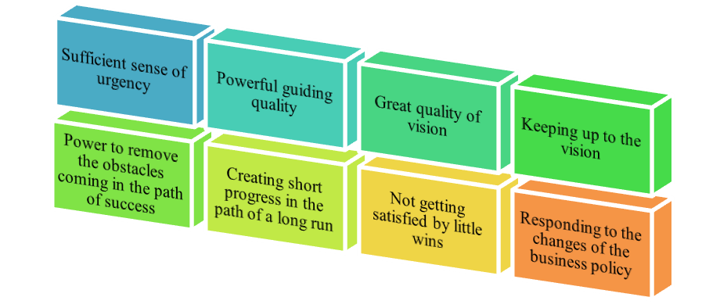
Figure 2: Different Determining Variables
(Source: Sedighiet al. 2017, p. 308)

Factors that evaluate the behavioural approach to management
Various management conditions could not explain individual worker’s behaviour and the development management policies in classical times were simply not effective in dealing with this situation. Workers’ motivation and behaviour are ignored by classical theory (Kumar et al. 2020, p. 104818).
According to the Sainsbury organization method assumes that the worker wants to work and will follow productivity if the manager provides the right environment. The workers of children are involved in behaviour management and the day-care is offered by the company. The innovative idea is that if workers know that their children are close and well cared for, the work may be a little less interrupted. It is an example of the belief that work is necessary for workers and gives a suitable environment for workers that do not work in contrast to family life (Sedighiet al. 2017, p. 308).
The Sainsbury organization keep hold of the workers and increase the reputation of the organization as a better workplace by encouraging their ideas making them comfortable with suitable schedules (Yu et al. 2017, p. 196).
Management styles that rely on a mix of personal leadership to engage employees and the leaders can be more open-minded than any other style, there is a general tendency to listen to employees' input and consider alternative perspectives in certain types of management approaches (Shahi et al. 2020, p. 117).
According to Maslow law’s, ‘’there are five crucial points that must be followed by the workers as illustrated below-
- Physiology- Food and drink are necessary is the most important part of a human being. Once the need is satisfied, it is no longer motivating.
- Safety purpose- The basic safety concepts are protection, stability, protection, and freedom from fear.
- Intrinsic needs of love- The initial motivating concept is love. It is important to bond with all workers and managers. This suitable relationship establishes a meaningful workplace.
- Respect- A person must increase self-confidence and gain dignity, fame, notoriety, and glory and it is important that we always respect each other (Shahi et al. 2020, p. 117).
- Self-implementation- Assuming that all the previous necessities of the classification are satisfied, a person feels the need to find himself.’’
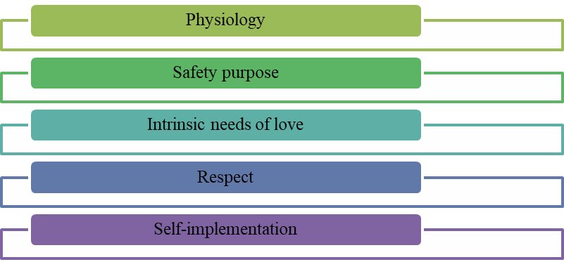
Figure: Five Crucial points of Maslow
(Source: Shahi et al. 2020, p. 117)

Using these five points and features of the behavioural approach we can evaluate and app the workers’ performance to make a good organization and it can be developed by their workers. This procedure can observe different parameters like employee satisfaction, turnover rate, control span, and many more. Moreover, the conflict of interest, control, and reward these all are mixed with performance with goal achievement (Yu et al. 2017, p. 196).

In Sainsbury, the management of the organization believes in democratic style of leadership. However, this leadership style is followed by the organization because it helps in the proper involvement of employees and due to this reason; the employees of this organization are highly motivated (Patyal and Koilakuntla, 2016, p. 319).

CEO of Sainsbury

Simon Robert, CEO of Sainsbury's, allowed in 2018 the digitization and restructuring of warehousing operations in his company's industry. This restructuring offers increased customer satisfaction, additional investments to ensure and maintain customer satisfaction, market productivity and investments to enhance the company's customers.
Recently, he took responsibility for sales operations by joining Argos as part of the brand's ongoing integration. Simon is a determined, enthusiastic person and a champion dedicated to his clients and colleagues. He is also a champion of inclusion and diversity allowing for significant leadership and capacity transformation throughout Operation Sainsbury's. The personality of Simon Roberts is unique as he helps to make a clear linkage between all the retail and the digital terms of Sainsbury in order to make the retail business much more consumer oriented (Jahshan, E., 2020).
Elizabeth Newman is a self-persuaded, characteristic pioneer, equipped for working in forced conditions, very efficient, driving and moving groups to convey extended targets and complex tasks. Her 20 years' experience has given her introduction to senior key partners the executives in complex huge scope associations, P&L duty to convey multi-billion incomes and cost the board, and complete proprietorship and execution of the business and client system. She reliably manufactures high performing and faithful groups and is knowledgeable about overseeing huge cross-useful inner and outer groups. Her broad experience and attributes, including being solid scientifically and with amazing correspondence and introduction abilities, is borne from running the business, class, and knowledge activities for the absolute most notable media brands and UK retailers (Newman E., 2020).

In accordance with Newman (2020),
- ‘’A monetarily determined pioneer with solid business discernment;
- Exceptionally versatile with involvement with driving business change and development;
- Proficient at making a communitarian culture to convey high performing and roused groups;
- A compelling pioneer with a definitive character, an incredible colleague with imaginative pizazz;
- Open correspondence style for compelling partner the executives and moving initiative;
- A superb history of executing greater picture business and client systems;
- Involvement with enormous associations and complex inside and outside partner the executives;
- The vital level administrator with solid money related and expository abilities;
- Graduate of Sainsbury's Initiative Advancement Program in 2014.’’

Conclusion

This study mainly concludes the modern workplace of the organization, Sainsbury. Automation means all works depend on various types of machines and nowadays survive in times of instability, complexity, and change and that is where it is. The next decade sees the way to work, learn and explore, amid technological advances, redefining careers and unbalancing personal lives for work.
The nature of work is increasingly dynamic even in the ever-changing government environment. During team-based collaboration in virtual environments, projects are multifaceted and interdisciplinary as needed. The transition is not just of generation: most people are growing more complex and fast in a world that is more interconnected and dependent than ever before, and their hope has changed. In order to increase the modern technology, the workplace of Sainsbury's becomes more modern than the earlier workplace. This study also concludes the democratic leadership style and the autocratic management style of Sainsbury along with the analysis of the personality of their leader, Simon Roberts and Elizabeth Newman.

References

Alefari, M., Salonitis, K. and Xu, Y., 2017. The role of leadership in implementing lean manufacturing. Procedia CIRP, 63, pp.756-761.

Alosani, M.S. and Al-Dhaafri, H.S., 2020. An empirical examination of the relationship between benchmarking, innovation culture and organisational performance using structural equation modelling. The TQM Journal.
economicsdiscussion.net, 2020. Leadership. Available at: https://www.economicsdiscussion.net/management/leadership/what-is-leadership/32116 [Accessed on 20th October 2020]

Foster, W.M., Hassard, J.S., Morris, J. and Wolfram Cox, J., 2019. The changing nature of managerial work: The effects of corporate restructuring on management jobs and careers. Human Relations, 72(3), pp.473-504.

Jahshan, E., 2020. Sainsbury's New CEO Simon Roberts Announces 2 Key Senior Appointments. [online] Retail Gazette. Available at: <https://www.retailgazette.co.uk/blog/2020/06/sainsburys-new-ceo-simon-roberts-announces-2-key-senior-appointments/> [Accessed 23 November 2020].

Jaoua, F., 2018. Impact of strategic roles of middle managers on the relationship between successful strategy implementation and organisational performance. International Journal of Business Performance Management, 19(4), pp.476-499.

Kumar, A., Moktadir, M.A., Khan, S.A.R., Garza-Reyes, J.A., Tyagi, M. and Kazançoğlu, Y., 2020. Behavioral factors on the adoption of sustainable supply chain practices. Resources, Conservation and Recycling, 158, p.104818.

Newman, E., 2020. Elizabeth Newman. [online] LinkedIn. Available at: <https://uk.linkedin.com/in/elizabethhnnewman> [Accessed 23 November 2020].

Odor, H.O., 2018. Organisational culture and dynamics. Global Journal of Management and Business Research.

Oyewobi, L.O., Windapo, A.O., Rotimi, J.O.B. and Jimoh, R.A., 2016. Relationship between competitive strategy and construction organization performance. Management Decision.

Patyal, V.S. and Koilakuntla, M., 2016. Relationship between organisational culture, quality practices and performance: conceptual framework. International Journal of Productivity and Quality Management, 19(3), pp.319-344. sainsburys.co.uk, 2020. About.
Available at: https://about.sainsburys.co.uk/?_ga=2.31110204.261143590.1603870269-48385226.1601292090 [Accessed on 16th October 2020]

Sharah Fatricia R. (2016). SWOT ANALYSIS OF SAINSBURY’S SUPERMARKET. Jurnal Manajemen Terapan Dan Keuangan, 5(1), 19 - 35. https://doi.org/10.22437/jmk.v5i1.3232

Sainsbury. 2020. Our Business Strategy. [online] Available at: <https://www.about.sainsburys.co.uk/about-us/our-business-strategy> [Accessed 23 November 2020].

Sedighi, M., van Splunter, S., Zand, F. and Brazier, F., 2017. Evaluating critical success factors model of knowledge management: An analytic hierarchy process (AHP) approach. In Organizational Culture and Behavior: Concepts, Methodologies, Tools, and Applications (pp. 308-326). IGI Global.

Shahi, T., Farrokhsheresht, B. and Aghajani, H.A., 2020. Behavioral Factors Affecting Talent Management: Meta-Synthesis Technique. Iranian Journal of Management Studies, 13(1), pp.117-137.

Willmott, H., 2019. STUDYING MANAGERIAL WORK: A CRITIQUE AND APROPOSAL. Managerial Work, 24(3), p.305.

Yu, T.K., Lin, M.L. and Liao, Y.K., 2017. Understanding factors influencing information communication technology adoption behavior: The moderators of information literacy and digital skills. Computers in Human Behavior, 71, pp.196-208.

Yuliansyah, Y., Gurd, B. and Mohamed, N., 2017. The significant of business strategy in improving organizational performance. Humanomics.

