Material sciences
Lighting layout and Acoustics measurement
By Al David Ikete
Student number:1902411
BSc Building Surveying (Hons)

Table of Contents
Introduction......3
Task A (calculate RI (Room index) and UF (Utilisation factor) ....4
Task A (number of lights needed and Smax) ....5
Task B sound calculations....6,7
Task B part 2....8,9
Appendix A....10,11
Reference page....12

Introduction

This presentation aims to demonstrate the two methods used by designers in order to come up with adequate installations solutions for buildings whether that’s in the direction of sound or lighting layout. The first method will calculate the Room Index, the Utilisation factor using a utilisation factor table which shows the reflectance factor for incandescent and florescent lighting and from this the number of lamps required can figured out, in order to create a layout plan for a factory. Once the number of lamps is figured out, a suitable layout (S Value) can be determined for the lamp fittings. The second method explorers sound the effects of sound frequency on different building fabrics.

Task A
Question 1: To calculate the following:

- The Room Index forms part of the utilisation factor.
Room index (RI) best described as the room proportions, the nearest figure to those on the Utilisation factor table will be used to work out the utilisation factor, however they must adhere to the correct fittings.

Method:

$RI=\frac{\left(L×W\right)}{\left(Hm\left(L+W\right)\right)}$

Key:
$L$ = Length of the room
$W$ = Width of the room
$Hm$ = Height of the lamp measured

$$RI=\frac{(60 x 24)}{\left(7m\left(60+24\right)\right)}=2.448m$$

The working above shows the calculation used in order to find out the RI for the question above.

- The Utilisation Factor (from tables)
the utilisation factor is the ratio of total flux reaching the working plane (factory work bench) compared to the total flux output of lamps. Using tables provided by manufactures to determine the utilisation factor of different light fixtures.

Method:
In order to find the utilisation factor, use the room index and find the figure on the table closest to the room index factor and the slide to the reflectance’s factor and this gives us the UF (utilisation factor).

For the question above the reflectance’s figure is between 0.5/0.3
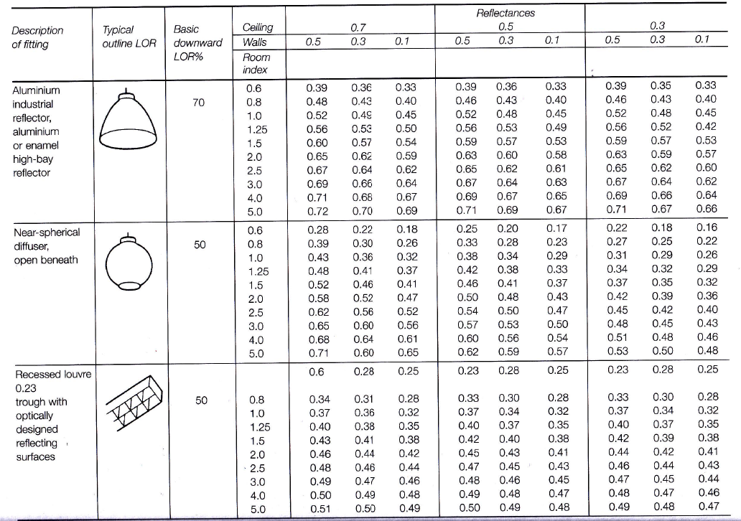

- The number of lamps required

Method:

$$N=\frac{E x A}{F x UF x LLF}$$

$N =$ Number of lamps required
$E =$Illuminance level required$(lux)$
$A =$ Area at working plane height $(m2)$
$F =$ Average luminous flux from each lamp $(1m)$
$UF =$Utilisation factor

Lux level given in the question $= 200LUX$
$Area =60m ×24m=1440$m²
Output of lumens is required is $18000 lumens$
Utilisation factor from the table$= 0.45$
Lighting loss factor given in the question $= 0.7$

$N= \frac{200 × 1440}{18000 x×0.45 x 0.75}=47.407$lamps

There for the number of lights needed for the factory floor of this size is 48 lamps.

The workings out above show work out the number of lights required to luminate the factory floor.

- S_{max} (It allows for the maximum amount of spacing between each light fitting)
The S_{max} is split into two calculations, for the two different types of lighting one for fluorescent lighting and incandescent lighting below I have shown the equations.

Fluorescent tubes in diffusing luminaires $Smax = 1.5 × Hm$

Filament lamps in direct luminaires $Smax = 1.0 ×Hm$

Key:
$Smax$= Maximum spacing between fittings.
H_{m} = Height of the lamp measured from the working plane (work top)

The maximum spacing between each lamp for the factory floor is as follows:

$$1.5 x 7 = 10.5m$$
Smax = 10.5m
(figure shows lighting layout)

Task B (Section 1)

Sound reduction index of the wall

- This section tackles how’s to solve the overall sound reduction index of the entire wall.

Method:

$SRI = 10 x$ $(log$ ₁₀ ($1/T))$

T₀ = $\frac{\left( T1 x A1\right)+(T2 x A2)}{A1+A2}$

Below are the SRI calculations

Brick Window
$SRI=10 x (log10\left(1÷T\right)$ $SRI=10 x(log{10 \left(1÷T\right)}$
$50=10 x (log10 (1 ÷T1$ $10=10 x (\log{10 ( 1 ÷T2)}$
$5=log10 x (1÷T1$) $1=\log{10 x ( 1 ÷T2)}$
$1÷T1=$ 10^{5§} $1 ÷T2=10$¹
T1 = 10⁻⁵ T2 = 10⁻¹
= 0.000010 = 0.10

$$\frac{\left(16 {× 10}^{-5}\right)+({10}^{-1} × 4)}{16+4}=0.020008$$

Overall sound reduction index for given wall:

$10×log10\left(1÷0.02008\right)=16.97dB$
(*The answer must be rounded up, for this instance it would be 17dB)

Task B Section 2

This section aims to analyse the implications of frequency and wavelength in internal sound management, also looking at the construction techniques and take a look at various insulation choice.

Frequency and wavelengths internal sound management

Vibrating objects radiate sound waves outwards in various directions, until it hits a surface where depending on the material fabric properties it could either be reflected or absorbed. Sound waves have peaks and valleys, similar to waves in water. The distance between each peak of one wave to another wave peak is referred to as a wavelength. Wavelengths of sounds we can hear vary between 15.25 meters (50ft) for lower pitches to 25mm (1in) for high pitch noises. The way in which sound is perceived is referred as the frequency.

Insulation Choice and partition wall types:

This section analyses the different insulation choices, as well as physical measures that can be taken in order to reduce the effects of frequency and sound waves. When designing acoustic installations designers look to building regulations part E in order to produce adequate installations.
- E1 looks at protection from noise from adjoining buildings (flats, terraces, semis)
- E2 deals with sound transmission within the home itself.
Reference (ISBN 978 1 85946 616 2(Resistance to the passage of sound 2010))

Partition walls are distinguished as load bearing which are mainly constructed from materials such as bricks, blocks of clay or in-situ concrete and have the design advantage of being high sound insulation. Non-load bearing partition walls, cheaper to construct and offer a wide range of methods of construction given below are a few categories.
1) Masonry partitions
2) Timber stud partition
3) Demountable partitions

Building designers promote the use of sold materials as the outer skin of partition walls and of building envelope as at solid ridged materials reflect sound waves and dissipate it into the surroundings these refer to materials such as building blocks and plaster board, whereas porous materials such as fibre wool absorbs energy from the frequency waves and transforms the energy into other forms of energy such kinetic or thermal.

Porous materials are preferable when attempting to create a quite ambient atmosphere. As the materials absorb the frequencies and dissipated into the multiple pores where these frequencies are met with resistance from entrapped air in the pores. Slowing down the speed of the sound waves and transforming the sound frequencies to different energy forms, kinetic energy being the main as sound frequencies produce vibrations when they make contact with surfaces. However soft porous materials absorb the vibrations. See Appendix A for further explanation on how absorbent materials work and how various materials respond to sound waves and frequencies.

Attenuation of sound by material:
Plaster board of 12mm (1inch) will act as the first sound barrier as it is has a sound attenuation of 15dB at 125Hz to 35dB at 4k Hz however if the thickness of the material is doubled its sound attenuation capabilities are increased therefore stating that the thicker the material the more likely it is to stop sound from getting through as the sound waves are broken down or reflected as (figure 3) shows. An increase in airspace In between walls cavities will result in a reduction in sound waves traveling through the wall as the air apace acts as a gas barrier in which sound waves are broken down.

(figure 3, (http://education.lenardaudio.com/en/04_acoustics_3.html)

Appendix A
Sound insulation and absorption:
In order to understand how insulations provides acoustic comfort to inhabitants of a building we must understand how sound waves behaves.
When a sound waves reaches one surface, part of its energy (incident energy E_{i}) is reflected toward the same direction in which it came from (reflected energy E_{r}). According to Snell’s law, the angles of E_{i} and E_{r.} are equal to the surface of incidence.
Non-reflected energy is usually expressed as the sum of two terms: transmitted energy E_{t} and absorbed energy E_{a}. transmitted energy E_{t} refers to the energy that is passed through the surface of the wall. Also generating another acoustic wave at the other side of the wall; the second part is the incident energy that is dissipated at the surface of the wall (figure1).

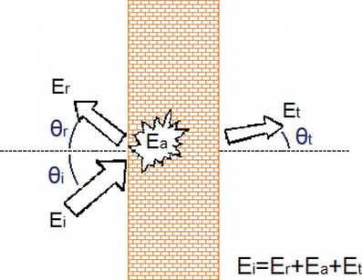

Figure 1.
Potential destination of the acoustic energy that’s reaches a surface at any chosen moment.
“Let α be the absorption coefficient (α = $Ea/Ei)$ and τ the transmission coefficient (τ = $Et/Ei).$ The part of the incident energy that is not reflected should accomplish:
$$Ei-Er=αEi+τEi=(α+τ)EiEi-Er=αEi+τEi=α+τEi E3"$$

(Figure 1) (https://www.intechopen.com/books/acoustics-of-materials/how-do-acoustic-materials-work-)

The greater the amount of energy is absorbed; the less energy is transmitted and vice versa. A good insulating material should be bad for acoustic absorption, as a high value of $a$ is related to a low value $τ$.
If a material is more porous is a material, the less insulates, the more resistance to air flow in a material presents as a better insulation performance. The Elizabeth, Alice publication goes on further to state that the thicker the material the better it is at insulating.

The absorption of sound:
acoustic absorption refers to the transformation of acoustic wave energy into other forms of energy such as thermal, mechanical (kinetic) or its deformation. Elizabeth describes it as “the acoustic absorption is, then, an energy dissipation phenomenon.”
“The acoustic absorption coefficient α of a surface is defined as the relation between the acoustic energy that it can absorb and the incident energy that affects it. It is dimensionless:
E4
Then, the absorbed energy turns out to be Ea = α Ei.” (Elizabeth, Gonzalez, Alice,2019, How Do
Acoustic Materials Work)

There three types of absorbent materials, which perform well according to different phenomena” porous or fibrous materials, membrane absorbers, and resonators. Each one has its best performance in different frequency ranges, shown in (figure 4).
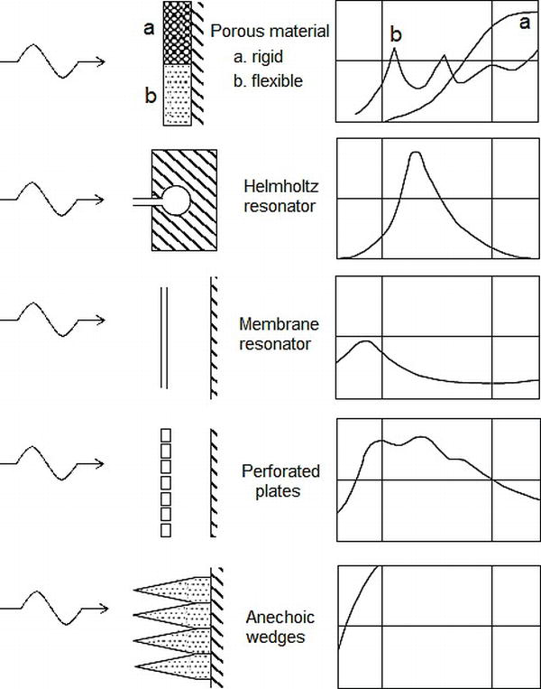 (Acoustic absorbers and their performance curves. Figure 4)
Building designers will use (building regulations Part E) and will also promote the use of sold materials as the outer skin of partition walls and of building envelope as at solid ridged materials reflect sound waves and dissipate it into the surroundings these refer to materials such as building blocks and plaster board, whereas porous material such as glass fibre wool absorb sound waves.

There are two ways they absorb acoustic energy via two mechanisms:

- They absorb acoustic energy due to the deformation that occurs when the sound wave makes contact with them.
- Porous materials absorb by the vibration of air contained in the pores, which loses energy by friction against their edges.
the absorbent properties of the absorbers improve the smaller the length of incident wave in relation to the incident wave in relation to the dimensions of irregularities of their surfaces. Therefore, performance is improved with an increase in frequency. However, its main weakness is conversational frequencies as a result of its high air content.

Sound insulation:

Airborne sound propagation is usually due to the elastic vibration of the air due to the sound waves that make contact with a materials surface exciting it. It also occurs more easily discontinuities (openings) or weakness such as cracks, weakly sealed passages in the construction or in any electrocortical or plumbing insulations, ventilation ducts.
The acoustic insulation of a material refers to the materials ability to oppose and, consequently, to minimise the flow of acoustic energy the passes through. Good insulating materials reduce the acoustic energy that is received on the other side of it, affecting the amplitude of the wave but not through dissipative phenomena, as the acoustic absorbers do.

Reference page
Citation: (Alice, 2019) (Chudley, 2016) (RIBA, 2010)

Bibliography
Alice, E. G., 2019. How Do Acoustic Materials Work?. s.l.:s.n.
Chudley, R., 2016. Building Construction handbook. 11th Edition ed. s.l.:Routeledge.
RIBA, 2010. Buildiung regulation. [Online]
Available at: https://assets.publishing.service.gov.uk/government/uploads/system/uploads/attachment_data/file/468870/ADE_LOCKED.pdf
[Accessed 4 April 2020].
http://education.lenardaudio.com/en/04_acoustics_3.html)

