BMIH6002 Level 6 Hotel Placement
Managing Food and Beverage Operations

Student Name: Md Zahirul Haque
Student ID: 2109025
Lecturer: Natalie Brailsford

Table of Contents
Introduction 4
Objectives 4
Section 1: Reflection on Experience and Personal Development 5
Gibbs reflective cycle 5
Section 2: Analysis of Work-Based Skills and Technical Knowledge 6
Section 3: Reflection on Organisational Issues 7
Section 4: Action Plan for future 8
Conclusion 8
References 9

Welcome to Hotel Holiday Inn Sunderland, Keel Square

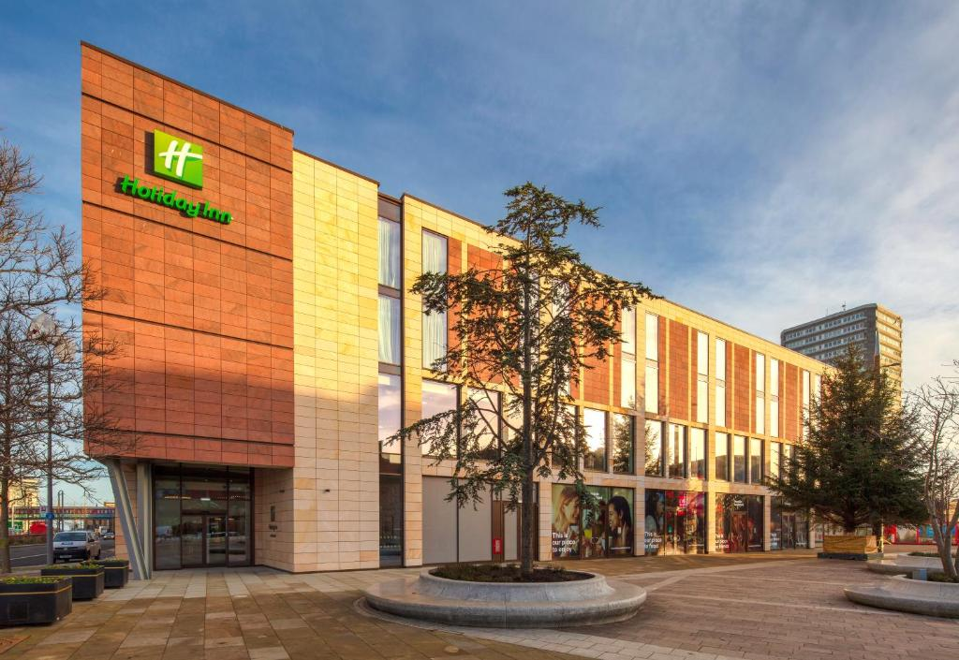
“Stay smart, Stay at Holiday Inn Express”

Introduction
Holiday Inn Sunderland is one of the most famous hotels in the UK (INN et al., 2017). If offers one of the most standard food and beverage service in the England. For example, it has on-site restaurants that cater to various tastes and preferences based on customers (Yeoman, 2022). Culture, caste, and religion play a critical role in food preferences in human life, Holiday Inn Sunderland always tries to maintain it. There room services are excellent which include meals and snacks in their bedrooms (Hu et al., 2022). It offers various range of foods, so that different cultures can be introduced. For enhancing customer experience, it offers a complimentary breakfast to the guests with different options (Kimes, 2016). It takes catering orders for meetings, events or conferences. Customization is available. In addition, healthy foods, organic foods, vegan, veg and non-veg food items are always available for guests.

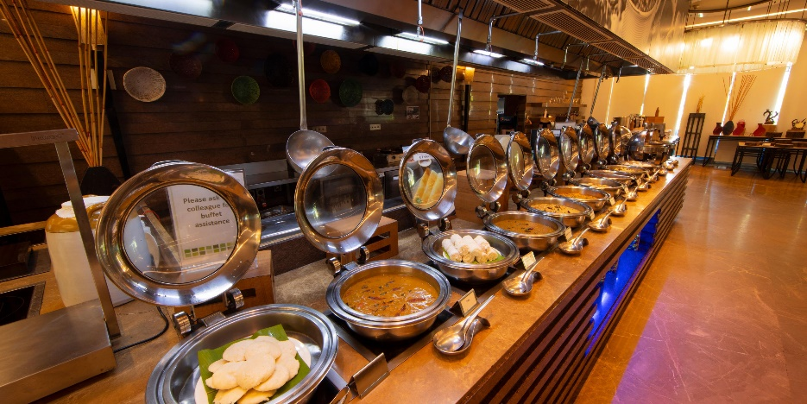

Objectives
The learning objectives for my position within the department are to strengthen my understanding of the value of personal skills, collaboration, interaction, and handling duties. After completing the placement, I gained the ability to provide courteous service to customers in the food and beverage area.

Section 1: Reflection on Experience and Personal Development

Gibbs reflective cycle

Figure 1: Gibbs reflective cycle
Source: Adeani, Febriani, and Syafryadin (2020)
Description: I am the supervisor of Holiday Inn Sunderland’s food and beverage department. England is a country of great heritage and culture, every year a large number of tourists come here to visit and as Holiday Inn has international recognition so we receive huge customers ((Đorđević, and Janković, 2016). I believe food and beverage is one of the most important sectors to satisfy the customers, which is why this hotel has always focused on maintaining good taste, quality, hygiene and cleanliness in the food. According to many customers, our food price is high, it is because we never compromise with our high standard. Different country has different types of food tastes, which is why we offer various options so that each customer gets something to consume without any hesitation (Lin, 2016). While working here I have improved my communication and teamwork skills. In the beginning, I faced many problems in managing my workforce, but later I understood how to manage tasks and the entire chain effectively.
Feelings: In this position, I felt that I have improved my leadership skills, I always wanted to be a transformational leader because I think I have good skills to influence people to achieve organizational goals. But sometimes it is difficult to ensure 100% communication and show empathy for mistakes while working in the food and beverage department. I need to improve my self-control and resilience.
Evaluation: There are many positive and negative things that have happened to me during work. My positive impact would be I have understood my mistakes and improved my skills as a leader. I have increased my knowledge about different cultures, which would create a positive impact on my career. Some negative things are, that many of my followers misunderstood me, and sometimes l cannot control my anger because of silly excuses and mistakes for employees.
Analysis: I think I have improved my leadership, communication, teamwork, task and time management because I have focused on these things and made proper plans every day before working. But sometimes because of distance and many other reasons, some employees do not listen to instructions, which creates big problems.
Conclusion: I think mistakes are common, I need to emphases more attention to communication and need to improve my empathy skills.
Action Plan: I will call for a meeting every day before starting work, I will share my strategies with my team members and will take their feedback.

Section 2: Analysis of Work-Based Skills and Technical Knowledge
My work-based skills have helped me to be successful in my career and ensure a better future. Real life application of knowledge: Before working here I could not apply my entire academic knowledge practically. Normally food and beverage department in a hotel always faces rush and work pressure. Sunderland is one of the most tourist attractions places so we receive huge tourists from different countries and cultures. I have observed that culturally diverse knowledge and diverse teams help to enhance customer service. I have always observed my people, it has helped me to understand their emotions and working capabilities.
Effective communication: It has also improved my effective communication management capabilities. Sometimes from employees, I learnt how to enhance work efficiency some of the chefs suggest adopting lean management to reduce waste. In this process, I have reduced the extra movement of employees and products.
Inventory management skill: Inventory management, is an important thing, in the food & beverage department we need to estimate everything; this work has improved my inventory management skills.

Section 3: Reflection on Organisational Issues
As a supervisor, I have tried to maintain a standard in food quality and taste to satisfy the guests. I tried to arrange training programs for better efficiency in the work. Most of my trainings are related to communication and team management.
Sometimes we face service delays because our entire work is based on a chain, when an employee is delayed then the entire work is delayed to deliver. Many times we face this late issue, which reduces the image of the Hotel. The company is still suffering from
Turnover in this department is high, which is another reason for our delay in work; the recruitment process is not difficult but a new employee needs time to understand the working style and environment to be productive. I am trying to be more empathic and resilient to understand employees' problems which will help to know the actual cause of turnover.
Holiday Inn always maintain a high level of hygiene and sanitation. After COVID-19 it has become more conscious about cleanliness (Residata et al., 2023). All the chefs and workers in my department maintain a high level of hygiene to satisfy the guests.
However, we faced communication breakdowns between kitchen and serving staff many times, which leads incorrect orders and delays. Now the number of meetings has increased to reduce this issue.
This department produces a huge amount of waste, which increases the operational cost, one of my employees from Japan has introduced Toyota’s system, which is known as Lean management. This process helps to manage inventory and reduce waste production (Bertagnolli, 2018).

Section 4: Action Plan for future
- In future, we have decided to provide smartphone and free internet facilities to the employees. It will help to reduce miscommunication issues.
- I have decided to recruit more employees in this department, but I will recruit skilled employees who are interested in building careers in the Hospitality industry.
- I have decided to provide more training programs related to personal improvement because it will attract them. Fresher and new graduates are always attracted to those organizations that offer career development opportunities (Boštjančič and Slana, 2018). Then I will try to improve my personal skills to be friendlier with my employees.

Conclusion
The food and beverage department plays a critical role in maintaining the reputation of an organization. In every branch of the Holiday Inn including Sunderland, authorities have strictly told us to maintain a high standard. During COVID and intense market competition, it has become difficult for the company to gain revenue like before, which is why I have tried my best to manage everything. I had some negative experiences but I believe, those changes I made, will create a long-term effect in this hotel.

References
Adeani, I.S., Febriani, R.B. and Syafryadin, S., 2020. Using GIBBS’reflective cycle in making reflections of literary analysis. Indonesian EFL Journal, 6(2), pp.139-148.
Bertagnolli, F., 2018. Lean management. Springer Fachmedien Wiesbaden.
Boštjančič, E. and Slana, Z., 2018. The role of talent management comparing medium-sized and large companies–major challenges in attracting and retaining talented employees. Frontiers in psychology, 9, p.1750.
Đorđević, D.Ž. and Janković, M., 2016. Modern distribution and development of hotel industry in the world. Ekonomika, 61(3), pp.99-110.
Hu, F., Kong, W., Innes, J.L., Wu, W., Sunderland, T. and Wang, G., 2022. Residents’ Perceptions toward Tourism Development: A Case Study from Grand Canyon National Park, USA. Sustainability, 14(20), p.13128.
INN, C., ALPENA, O., BILTMORE, A., Ridge, C.I.R., West, C.I., SUITES, C., LODGE, B., MARRIOTT, C.B., ASHEVILLE, C.P.R., DOWNTOWN, F.P.B.S.A. and PARK, H.A.B., 2017. North Carolina, USA.
Kimes, S.E., 2016. How product quality drives profitability: The experience at Holiday Inn. Cornell Hotel and Restaurant Administration Quarterly, 42(3), pp.25-28.
Lin, X., 2016. Strategy analysis of a boutique and lifestyle hotel: a SWOT analysis.
Rafahat, M., 2022. Service Strategy of Hotel Holiday Inn (Doctoral dissertation, Sonargaon University (SU).
Residata, W., Ningrum, N.F.K., Rahmi, S.N.A., Dylan, M.A., Nurcahyo, R., Wibowo, N., Kristiningrum, E. and Setyoko, A.T., 2023. Comparative Analysis for Strategy Implementation in Indonesia's Hotel Business Sector During Covid-19. In E3S Web of Conferences (Vol. 465, p. 02015). EDP Sciences.
Yeoman, I., 2022. Q. What can we learn from Sunderland AFC about the future of tourism? A. Absolutely everything. Journal of Tourism Futures, 8(1), pp.2-6.

