
THE IMPACT OF LOW-COST MARKETING STRATEGY ON PRIMARK'S SUCCESS IN THE UK
Luciana Stafi - 2130653


Subbmision date: july 11, 23:59pm
University of Saint David Trinity Wales

Statement

I declare that this dissertation, submitted in partial fulfilment of the requirements for my degree, is my work, based on my original research. All sources used or cited have been appropriately acknowledged using the Harvard referencing system. This work has not been previously submitted for any other degree or qualification at this or any other university or institution.

Student’s Name: Luciana Stafi
Date: 11.07.2025

Acknowledgements

I want to express my sincere gratitude to my supervisor, Professor Gwyneth Jones, for the continuous support, valuable guidance, and constructive feedback throughout the process of writing this dissertation. Their expertise and insights were instrumental in the completion of my research.
Special thanks go to all my lecturers and professors throughout my academic journey, Maria Heffernan, Melanie Squire, James Squire-Wood, Julie Thomas, Arpu Kumar, Christine Joy, Rebecca Franci-Davies, and Marie Pitson, whose dedication and knowledge have significantly contributed to my professional and personal development.
Finally, I would like to extend my heartfelt appreciation to my family (my two children and husband) and friends for their unwavering support, encouragement, and patience throughout my studies. Their belief in me has been an essential motivation in achieving my academic goals.

Thank you all for your invaluable support.

Abstract

This dissertation critically evaluates the impact of Primark's low-cost marketing strategy on its success within the competitive retail market in the UK. Given the increasing significance of price, product diversity, and authentic marketing approaches, the research aimed to identify explicitly the key elements of Primark's low-cost strategy and to explore consumer perceptions of its effectiveness. Employing a mixed-methods approach, this study combined quantitative data collection through structured questionnaires with qualitative data gathered through a focus group discussion.
Findings revealed explicitly that Primark's success is significantly driven by its attractive pricing, diverse product range, and strategic use of social media and personal recommendations. Results further demonstrated that consumers view Primark's marketing approach as authentic, credible, and appropriate, though communication regarding sustainability initiatives requires clearer transparency.
The study highlights explicit opportunities for Primark to enhance the in-store customer experience by improving staff availability, product organisation, and clear communication. Finally, the research acknowledges methodological limitations concerning sampling and generalisability, recommending explicit directions for future research to strengthen these findings and expand their applicability.

Table of Contents
Introduction 5
Chapter 1. Aims, Objectives and Research Questions 8
Chapter 2. Literature Review 11
2.1 The Concept of Low-Cost Marketing Strategies 11
2.2 Consumer Behaviour and Loyalty in Low-cost Retail 12
2.3 Social Media and Digital Marketing 13
2.4 Porter's Value Chain Analysis 13
2.5 Literature Summary and Gaps 15
Chapter 3. Research Methodology 17
3.1 Research Philosophy and Approach 17
3.2 Research Design (Mixed Methods) 18
3.3 Data Collection Methods (Questionnaire & Focus Group) 19
3.4 Sampling Strategy 19
3.5 Hypotheses 20
3.6 Methodology Summary 21
Chapter 4. Data Collection and Data Analysis 23
4.1 Data Collection Process 23
4.2 Sampling Strategy 24
4.3 Quantitative Data Analysis (Questionnaire Results) 24
4.4 Qualitative Data Analysis (Focus Group Findings) 37
Chapter 5. Discussion 46
5.1 Key Findings 46
5.2 Implications of Findings for Primark 48
5.3 Limitations 49
5.4 Summary of Discussion 50
Conclusion and Recommendations 51
Bibliography 52
Appendices 56

Introduction

Primark, the international low-cost fashion retailer, was founded in 1969 in Ireland as Penneys and quickly expanded its presence, including in the UK from 1974 (Primark Corporate, n.d). With over 450 stores in 17 countries, Primark has established itself without a traditional advertising strategy, relying on affordable prices and the in-store experience (Grewal, Krishnan, and Borin, 2019).
In a competitive industry like British retail, marketing strategies have a direct impact on company success (Statista, 2023). Unlike its rivals, which invest in TV and digital advertising, Primark focuses on strategic store positioning, social media, and customer referrals (Doyle, 2021). This minimalist strategy raises questions regarding its long-term effectiveness and impact on consumer behaviour (Kotler and Keller, 2023).
Although Primark does not follow conventional intensive promotional strategies, its continued success in attracting and retaining customers highlights the importance of a well-implemented, low-cost marketing strategy (Doyle, 2021). Unlike competitors who invest heavily in digital or television campaigns, Primark relies on strategic store locations, social media engagement, and word-of-mouth recommendations to enhance its visibility (Chaffey and Ellis-Chadwick, 2022). This minimalist yet effective marketing model has enabled the company to become a leader in its segment without requiring extensive advertising budgets (Fernie and Sparks, 2023).
However, the success of this strategy raises questions about its efficiency in a constantly evolving market and its impact on consumer behaviour (Kotler and Keller, 2023). Burt and Sparks (2020) and Hermann (2021) suggest that low-cost strategies yield varying results depending on the consumer segments and market conditions.
This dissertation is structured clearly into five main chapters. Following this introductory section (Chapter 1), Chapter 2 provides a comprehensive literature review that examines the existing body of knowledge on low-cost marketing strategies, consumer loyalty, digital marketing, and strategic frameworks, such as Porter's Value Chain. Chapter 3 describes the mixed-method research approach adopted, detailing the methodology, data collection processes, and analysis techniques employed. Chapter 4 presents a detailed analysis of the collected quantitative and qualitative data, providing insights into consumer perceptions and the effectiveness of Primark's marketing strategies. Chapter 5 critically discusses these findings, explicitly linking them to the reviewed literature and outlining their implications for Primark. Finally, the conclusion and recommendations section summarises key findings, provides practical recommendations for Primark's management, highlights the study's limitations, and suggests avenues for future research.

Chapter 1
Aims, Objectives and Research Questions



Chapter 1. Aims, Objectives and Research Questions

This study evaluates the impact of Primark's low-cost marketing strategy on its success in the UK retail market. By analysing the effectiveness of Primark's unique approach to minimising traditional advertising while leveraging social media, word-of-mouth, and in-store experiences, this research seeks to determine how such strategies influence consumer behaviour and brand performance.
The primary aim of this research is to critically evaluate the impact of Primark's low-cost marketing strategy on consumer behaviour, brand perception, and overall success in the UK retail market, identifying factors that contribute significantly to the brand's competitive positioning.

Objectives
To achieve the research aim, the following specific objectives have been established:
- To identify and analyse Primark's key low-cost marketing strategies and how they differ from traditional marketing approaches in the retail industry.
- To examine consumer perceptions of Primark's marketing approach and its influence on purchasing behaviour and brand loyalty.
- To evaluate the effectiveness of Primark's reliance on word-of-mouth and social media marketing as opposed to conventional advertising methods.
- To compare Primark's marketing success with that of other low-cost fashion retailers operating in the UK market.

Research Questions
Based on the objectives outlined above, this research seeks to answer the following key questions:

RQ1. What are the main components of Primark's low-cost marketing strategy?
RQ2. How do consumers perceive and respond to Primark's marketing approach?
RQ3. What role do social media and word-of-mouth play in driving Primark's brand success?
RQ4. How does Primark's marketing strategy compare to other low-cost fashion retailers?

Chapter 2
Literature Review

Chapter 2. Literature Review

Primark's business model has been widely examined in academic literature due to its unconventional reliance on a low-cost marketing approach. Unlike many competitors, Primark avoids traditional advertising and instead focuses on offering affordable products in well-positioned stores. According to IESE Business School (2011), Primark's success stems from its "no bells, no whistles" model, which is built on operational efficiency, high stock turnover, and a reliance on word-of-mouth. A case study from Newcastle University (2020) further explores how the brand aligns its cost-leadership model with emerging sustainability concerns, a topic that is increasingly debated in the ethical retail literature.

2.1 The Concept of Low-Cost Marketing Strategies
In the current economic context, low-cost retail is increasingly attracting consumers interested in affordable products. Chahal and Kumar (2022) state that these retailers use strategies based on efficiency and low costs, offering products at significantly lower prices than traditional competitors, although maintaining quality remains a challenge.
Nguyen and Wang (2023) argue that the success of low-cost retailers depends not only on low prices but also on a clear understanding of consumers' expectations regarding product value. Investments in the store experience and digitalisation help to balance quality and price.
In addition to Primark's specific strategy, many other retailers in the UK have adopted similar strategies based on cost minimisation and operational efficiency. For example, the retailer Pepco, which has a significant presence in the UK, uses a similar approach, focusing on extremely low prices and a limited selection of essential products to keep costs low. At the same time, chains such as Poundland and Home Bargains employ similar methods, relying on high volumes and low prices to provide consumers with quick and easy access to essential products, without resorting to expensive traditional advertising (Mintel, 2024).

2.2 Consumer Behaviour and Loyalty in Low-cost Retail
Consumer loyalty to low-cost retailers is influenced by perceptions of value, stable prices, and product quality. Park and Kim (2023) demonstrate that a competitive price-quality ratio fosters loyalty, while Green and Patel (2022) emphasise the positive impact of in-store experience and efficient service. Consumer motivations include economic needs and social or psychological influences. Carter and Lee (2023) argue that the desire to save and personal satisfaction generated by offers are essential, along with recommendations from friends and family.
Singh and Verma (2022) highlight the importance of sustainability in the context of current environmental and social concerns, suggesting that transparency in these practices can improve consumer image and loyalty.
The study by Nurhilalia et al. (2024) highlights that psychological factors, such as satisfaction, trust, emotional engagement, and consumer experience, play a significant role in strengthening consumer loyalty. The authors emphasise that a positive perception of the cost-benefit ratio and a pleasant shopping experience can explain consumer loyalty even in low-cost retail, confirming the importance of integrating emotional and rational aspects in maintaining loyalty.

2.3 Social Media and Digital Marketing
Jackson and Thomas (2024) note that the use of digital marketing and direct communication through social networks allows low-cost retailers to save significantly and maximise efficiency through constant feedback and rapid adaptation of offers.
Lopez and Evans (2024) emphasise the importance of social networks in building consumer loyalty, showing that social platforms and influencers generate engagement and repeat purchasing behaviours. Zentes, Morschett, and Schramm-Klein (2022) found that low-cost retailers with strong social media engagement can enhance consumer loyalty without significant advertising investments.

2.4 Porter's Value Chain Analysis
According to Porter’s Generic Strategies model (Porter, 1985), Primark explicitly follows a cost leadership strategy, achieving a clear competitive advantage by consistently offering products at lower prices than its rivals. Primark's avoidance of branding and advertising reduces overheads, enabling it to undercut competitors such as H&M or Matalan. However, Porter (2008) warns of the "stuck in the middle" dilemma, where firms risk losing strategic clarity if they fail to balance cost with value. Primark may face long-term reputational risks if it fails to address growing consumer interest in ethical production and transparency.
To further understand Primark's strategic approach, Porter's (1985) value chain analysis can be employed. The value chain divides company activities into primary activities (inbound logistics, operations, outbound logistics, marketing and sales, and services) and support activities (firm infrastructure, human resource management, technology development, and procurement). It helps organisations identify their sources of competitive advantage, assessing precisely where costs are minimised and value is generated (Porter, 1985; Johnson et al., 2020). This analytical framework helps evaluate low-cost retailers, such as Primark, by clarifying how internal activities underpin their low-cost strategy and contribute to their strategic effectiveness (Grant, 2021).
Lewis et al. (2014) emphasise that even low-cost retailers must align operational efficiency with ethical standards to maintain credibility in the digital age. Primark has made some digital efforts, notably through its Click & Collect system introduced in 2022; however, it still lacks a comprehensive e-commerce platform. While this preserves its low-cost structure, it raises questions about long-term competitiveness in an increasingly online-driven retail environment.
Primark's specific activities have been detailed in the adapted value chain table (Appendix 1), clearly highlighting how the British retailer structures its internal and external activities to maximise efficiency and consumer-perceived value under a low-cost strategy.
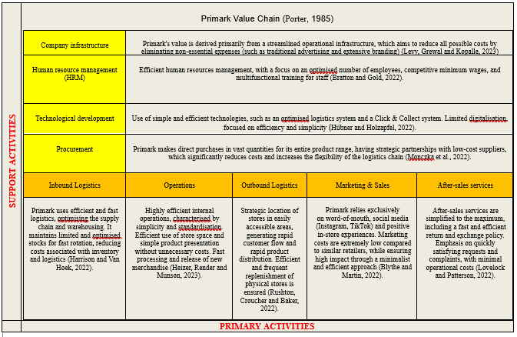

FIG.1 Porter Value Chain adapted to Primark

2.5 Literature Summary and Gaps
While literature validates Primark's marketing and operational strategy as successful in the short term, the absence of digital maturity and precise ethical positioning reveals a gap regarding its long-term adaptability and brand resilience.
The literature review suggests that low-cost retailers primarily rely on operational efficiency, competitive pricing, and positive customer experiences to generate loyalty and market success. The motivations of consumers who choose these stores are influenced by perceptions of value, as well as social and economic factors and the increasing importance placed on sustainability and responsible practices. In addition, the essential role of digital marketing and social networks in strengthening customer relationships highlights the need for innovative strategies adapted to current market requirements. Thus, this study aims to analyse in depth how these elements directly influence the success of Primark in the specific context of low-cost retail in the UK.

Chapter 2
Research Methodology

Chapter 3. Research Methodology
Methodology is the systematic framework used in research to collect, analyse, and interpret data. It includes the research design, data collection methods, and analytical techniques applied to answer a specific research question (Saunders, Lewis, and Thornhill, 2023). Methodology is the foundation of a study, ensuring that the research process is structured, reproducible, and scientifically valid (Bryman, 2021).
A well-defined methodology is essential for the credibility and reliability of research. It ensures that data is collected in a structured and consistent manner, allowing for accurate conclusions (Collis and Hussey, 2021). The methodology also helps to justify the choice of specific research methods over others, increasing the transparency and validity of the study (Creswell and Creswell, 2023). A rigorous methodology also allows for the replication of the study by other researchers, contributing to the academic integrity of the field (Bell, Harley, and Bryman, 2022).

3.1 Research Philosophy and Approach
This research follows the positivist paradigm, which advocates using objective measurements and statistical analysis to explain consumer behaviour (Collis and Hussey, 2021). In addition, a deductive approach is adopted, starting from general theories about the effectiveness of marketing strategies and testing specific hypotheses through data collection (Saunders, Lewis and Thornhill, 2023).

3.2 Research Design (Mixed Methods)
To achieve the objectives of this study, a mixed methodological approach was adopted, combining quantitative and qualitative methods. This approach facilitates a detailed and comprehensive analysis of the research topic, ensuring both generalisable results and in-depth data interpretation.
The quantitative component employs structured questionnaires, providing objective statistical insights into consumer perceptions, purchasing behaviours, and brand loyalty regarding Primark's marketing strategy (Saunders, Lewis, and Thornhill, 2023). Unlike qualitative research, which involves subjective interpretations, the quantitative approach offers systematic and structured data analysis, enabling the clear identification of trends and generalizability (Bell, Harley, and Bryman, 2022; Creswell and Creswell, 2023).
To complement the quantitative results and gain deeper insights, a qualitative method involving a focus group is used. Focus groups facilitate moderated discussions ideal for exploring detailed opinions, attitudes, and personal experiences (Krueger and Casey, 2022). This informal, conversational setting encourages honest and comprehensive expression among the six carefully selected participants who are familiar with the Primark brand (Bryman and Bell, 2021).
The mixed methods approach is crucial for this study, as it enables a comprehensive analysis of Primark's low-cost marketing strategy, combining both breadth and depth. The quantitative method provides clear statistical evidence on customer attitudes, purchasing behaviours and loyalty to the Primark brand, facilitating the identification of general trends and patterns. Meanwhile, the qualitative method complements this by exploring the underlying motivations, personal experiences, and perceptions of consumers more deeply, which are difficult to capture through quantitative data alone.
Thus, this methodological synergy provides a richer understanding and robust assessment of Primark's strategic effectiveness in the highly competitive UK retail market. The combined use of these methods ensures rigorous data triangulation, significantly enhancing the validity of the study's conclusions (Creswell and Creswell, 2023).

3.3 Data Collection Methods (Questionnaire & Focus Group)
Quantitative data collection is planned to be conducted primarily via a structured questionnaire distributed personally to 100 respondents. However, if an insufficient number of responses is gathered through personal distribution, questionnaires will also be distributed online to ensure the targeted sample size is reached. The whole structured questionnaire used in this study is provided in Appendix 2.
Qualitative data are gathered through a moderated focus group using a semi-structured discussion guide with open-ended questions about participants' experiences with Primark (Krueger and Casey, 2022). The semi-structured discussion guide, which contains open-ended questions used in the focus group, is included in Appendix 3.

3.4 Sampling Strategy
Convenience sampling was explicitly applied for the quantitative study due to the ease of access, quick data collection, and practicality in reaching participants who were immediately available and willing to participate. This method is commonly employed in research scenarios characterized by time constraints and limited resources, enabling efficient and rapid data gathering (Gray, 2021). For the qualitative study, purposive sampling was chosen explicitly to select participants with direct knowledge and recent experiences related to Primark, ensuring the collection of relevant, detailed, and contextually rich data. Purposive sampling is explicitly recommended in qualitative research due to its effectiveness in targeting participants who possess specific knowledge or experiences relevant to the research objectives (Flick, 2022).
The quantitative target population includes UK residents aged 18 years and above (18+) who have purchased products from Primark stores. The qualitative target population consists of six participants chosen from the researcher's friends and colleagues, ensuring familiarity with the brand and its marketing strategies (Collis and Hussey, 2021; Bryman and Bell, 2021).

3.5 Hypotheses
This research formulates hypotheses based on the literature on low-cost marketing strategies and consumer behaviour. Hypotheses are essential for guiding the research design and establishing testable relationships between variables. Previous studies suggest that price perception, brand loyalty, and social recommendations have a significant impact on consumer decisions for discount fashion retailers (Zentes, Morschett, and Schramm-Klein, 2022).
Thus, this research proposes the following hypotheses:
- Primark's low-cost marketing strategy has a positive influence on consumer purchase intention.
- Brand loyalty mediates the relationship between a low-cost marketing strategy and repeat purchases.
- Social recommendations have a substantially greater impact on Primark consumer retention than traditional advertising.
These hypotheses will be tested using the questionnaire responses, with quantitative statistical methods employed to validate or reject them (Hair et al., 2022).

3.6 Methodology Summary
The choice of quantitative and qualitative methods was justified by the desire to combine the advantages of both approaches, thus obtaining both generalisable statistical results and detailed, deep and contextual insights into consumer behaviour. The validity and reliability of the research were ensured by careful structuring and preliminary testing of the questionnaire and discussion guide, as well as by maintaining the anonymity and confidentiality of the collected data.
However, a methodological limitation is the use of convenience sampling for the quantitative part, which may affect the degree of generalizability of the results. Additionally, the limited number of respondents in the qualitative part may limit the generalizability of the conclusions from the focus group (Taherdoost, 2022). All ethical aspects were rigorously respected, ensuring voluntary participation, anonymisation of respondents, and confidentiality of the data obtained, in accordance with academic ethical standards in research.

Chapter 4
Data Collection and Data Analysis

Chapter 4. Data Collection and Data Analysis

This chapter presents the methods and processes employed for data collection and the subsequent analysis of the collected data, providing explicit details. Both quantitative and qualitative methods were used, providing comprehensive and robust insights into consumers' perceptions of Primark's low-cost marketing strategy. The use of a mixed-methods approach enhances the validity and richness of the research findings, as it allows for both statistical generalizability and deeper qualitative exploration of consumer perceptions (Plano Clark and Ivankova, 2023). The main findings and insights derived from this analysis are presented and discussed in this chapter.

4.1 Data Collection Process

To collect data, a questionnaire was distributed to consumers who had shopped at Primark in the UK, as well as via email. The questionnaire measures consumer attitudes toward Primark's marketing strategy, purchasing motivations, and overall brand perception. The survey will consist of closed-ended questions to facilitate quantitative analysis. The questionnaire was designed using Microsoft Forms, and responses were anonymised to ensure participant privacy (Saunders, Lewis, and Thornhill, 2023). To facilitate data analysis, a focus group meeting was also held, attended by six individuals who are familiar with the Primark brand.
Initially, the questionnaire used for this research was planned to be distributed to a total of 100 participants. However, following face-to-face and online distribution, more responses were collected than initially targeted, resulting in a final total of 102 valid responses. This enabled a more comprehensive and detailed analysis of consumer perceptions and behaviours regarding the Primark brand and its low-cost marketing strategy.

4.2 Sampling Strategy

The study will employ a non-probability purposive sampling method to target individuals who are Primark customers. This approach ensures that responses reflect the views of active Primark customers while maintaining feasibility within the study's constraints (Hair, Page, and Brunsveld, 2021).

The sample will include:
- 100 respondents who have shopped at Primark at least once in the past six months.
- A diverse group of respondents across different age groups, income levels, and locations in the UK.
- A six-group meeting with individuals who are familiar with the Primark brand.
The non-probability purposive sampling method was chosen because it allows the selection of participants who have direct and recent experience with the Primark brand, thus providing relevant and consistent data to achieve the research objectives (Collis and Hussey, 2021). However, the use of this method may limit the generalizability of the results, an aspect that will be explicitly considered in the interpretation of the data (Saunders, Lewis and Thornhill, 2023).

4.3 Quantitative Data Analysis (Questionnaire Results)
Data collected through questionnaires will be analysed using statistical software such as Excel and Microsoft Forms. The analysis will begin by applying descriptive statistics to summarise consumer perceptions, using indicators such as means, standard deviations, and frequency distributions. These methods will provide a clear picture of how respondents perceive Primark's marketing strategy (Field, 2022). The results are also presented in Appendix 4.
Figure 1: Age
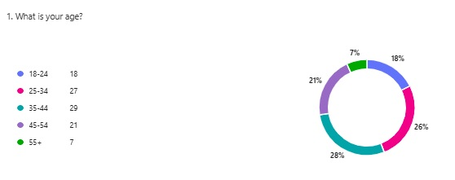

The results show that the majority of respondents are young and middle-aged adults, with the 35-44 (29%) and 25-34 (27%) age groups being predominant. The 45-54 age group also represents a significant segment (21%). These results are consistent with existing literature, which indicates that young and middle-aged adults are active and frequent consumers in discount stores (Zentes, Morschett, & Schramm-Klein, 2022).
Figure 2: Gender
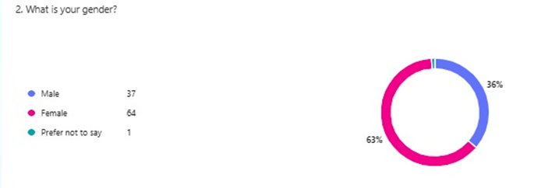

Of the total respondents, the clear majority is represented by women (63%), while men represent only 36%. This distribution reflects the general trends in low-cost clothing retail, where women are predominantly consumers due to their greater involvement in purchasing decisions and their increased concern for the quality-price ratio. Women are considered more price-sensitive, as they are more involved in the purchasing process and more receptive to the offers of low-cost stores (Kotler and Keller, 2023).

Figure 3: Respondents' Locations
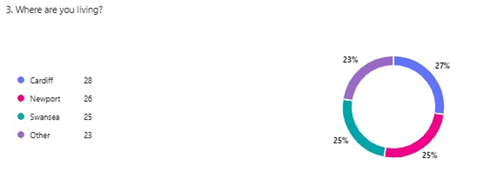

The majority of respondents are from large cities and urban areas in Wales, with Cardiff (27%), Newport (25%), and Swansea (24%) being the most prominent. This distribution reflects the reality of the market, as low-cost retailers such as Primark tend to strategically focus on locating stores in large urban centres and densely populated areas to attract the most significant number of potential consumers. This strategic approach is consistent with previous retail research, which highlights the importance of locating stores in large cities and densely populated urban areas to optimise customer flow and distribution efficiency (Fernie and Sparks, 2023).

Figure 4: Employment Status
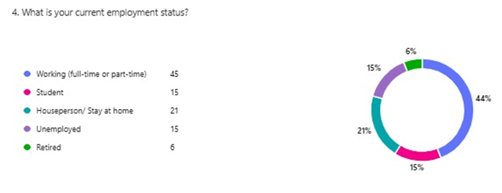
The majority of respondents (73%) are employed either full-time or part-time. This situation logically reflects the fact that the main target audience of low-cost stores such as Primark consists of economically active consumers. This trend identifies a clear link between employment and preference for low-cost retailers (Solomon et al., 2022).

Figure 5: Frequency of Shopping at Primark

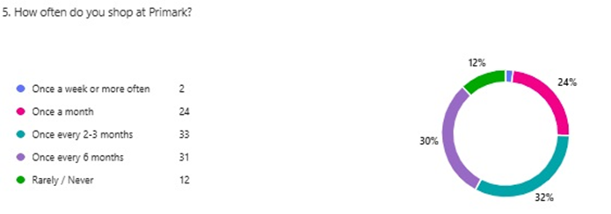

The results indicate that the majority of respondents shop at Primark with a moderate frequency, predominantly once every 2-3 months (32%) and once every six months (30%). This result suggests that Primark is perceived as a retailer for occasional purchases, rather than for frequent daily or weekly purchases. This finding supports the idea that low-cost retailers tend to attract consumers who make occasional purchases in larger volumes, being concerned with maximising the value for money (Kotler and Armstrong, 2023).

Figure 6: Recent Purchase at Primark
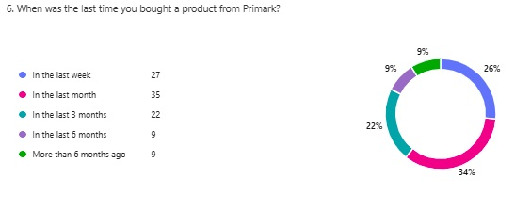

The majority of respondents (38%) stated that they had last purchased from Primark in the last three months, indicating a fairly high level of recent engagement. This result supports the notion that Primark maintains an active and regular relationship with its customers, which is crucial for low-cost retailers, where repeat purchases are vital for sustaining sales volumes and long-term success (Berman, Evans, and Chatterjee, 2023).

Figure 7: First Encounter with Primark

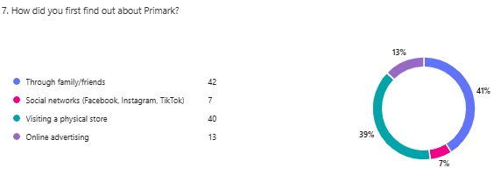

Most respondents found out about Primark through family or friends (60%). This result clearly highlights the importance of word-of-mouth strategies and personal recommendations in low-cost retail, confirming observations in the literature on the effectiveness of direct recommendations in generating new customers and building consumer trust (Chaffey and Ellis-Chadwick, 2022).
Figure 8: Influence of Price
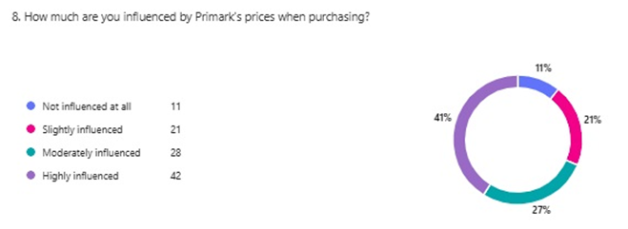

The majority of respondents (41%) indicate that price has a significant influence on their purchasing decisions. These results confirm that Primark's low-price policy is highly attractive to consumers, which aligns with the notion that price is a decisive factor in attracting and retaining customers in the low-cost retail sector (Zentes, Morschett, and Schramm-Klein, 2022).

Figure 9: Importance of Traditional Advertising
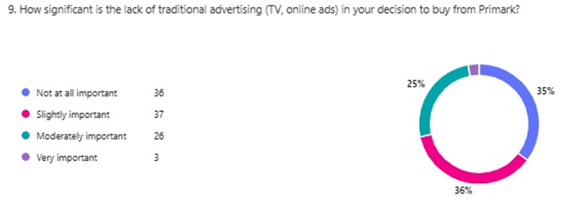
The results indicate that the majority of respondents consider the lack of traditional advertising to be either moderately important (35%) or not very important (34%), suggesting that this aspect has a limited influence on their purchasing decisions. However, a considerable percentage of respondents (26%) explicitly state that this aspect does not matter at all in their choices. Only a small proportion (5%) considers the lack of traditional advertising to be very important. This result confirms recent research indicating that low-cost retailers can achieve success through alternative strategies, such as personalised recommendation marketing and active use of social media, without incurring massive investments in traditional advertising (Grewal, Krishnan, and Borin, 2019).

Figure 10: Marketing Strategy Effectiveness
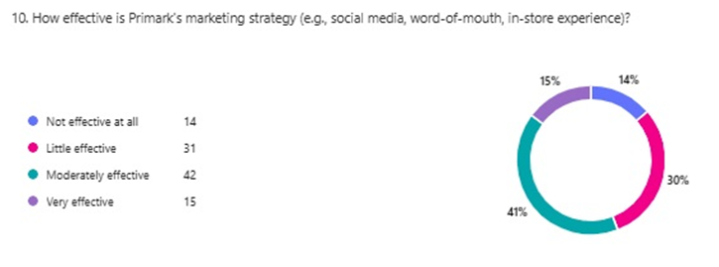
The majority of respondents (42%) perceive Primark's marketing strategy as moderately effective. A significant number of respondents (31%) also consider this strategy to be somewhat effective, and a smaller percentage (15%) consider it to be very effective. These results suggest that, overall, consumers appreciate Primark's minimalist approach to marketing, based on social media, personal recommendations and direct in-store experience, but believe there is still room for improvement.

Figure 11: Recommend Primark
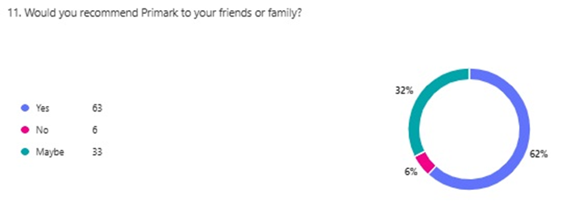
The majority of respondents (56%) explicitly state that they would recommend Primark to friends or family. A further 22% would probably recommend the brand. These results indicate a high level of satisfaction and positive perception of Primark, suggesting a strong reputation and high potential for direct referral marketing.

Figure 12: Influence of Family and Friends' Recommendations
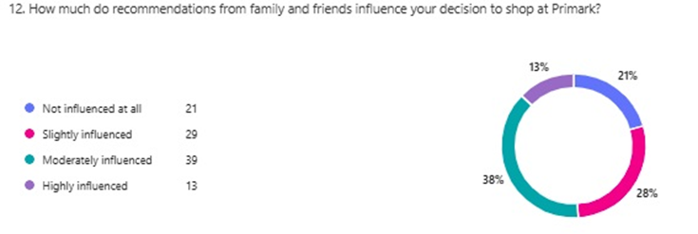
The results indicate that recommendations from family and friends have a moderate (38%) and little (28%) influence on consumers' purchasing decisions. Thus, the majority of respondents confirm that personal recommendations play an important, but moderate, role in their purchasing behaviour, highlighting the importance of social relationships in low-cost retail (Solomon, Bamossy, and Askegaard, 2022).

Figure 13: Consumer Loyalty towards Primark
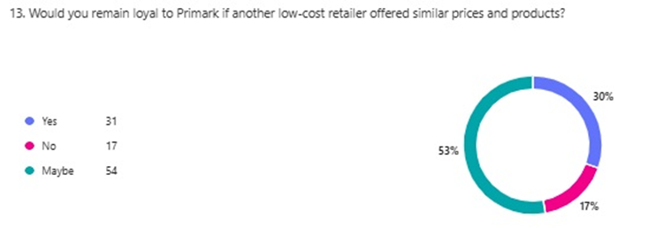
The majority of respondents (54%) indicate that loyalty to Primark is conditional and could depend on factors such as quality and experience offered. However, 31% of respondents are loyal to the brand, which reflects Primark's good positioning in the low-cost market, but also a potential risk to similar competitors (East et al., 2022).

Figure 14: Value for Money Compared to Competitors
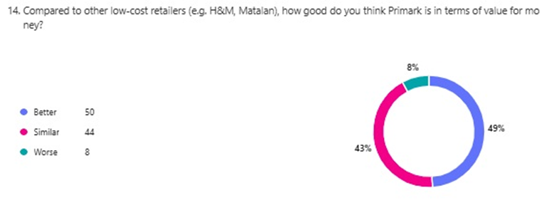
Almost half of the respondents (49%) believe that Primark offers better value for money compared to other low-cost retailers such as H&M or Matalan, highlighting Primark's competitive advantage. A significant percentage (43%) consider the value for money to be similar, reflecting an overall positive perception of the brand.

Figure 15: Other Retailers Frequented by Respondents
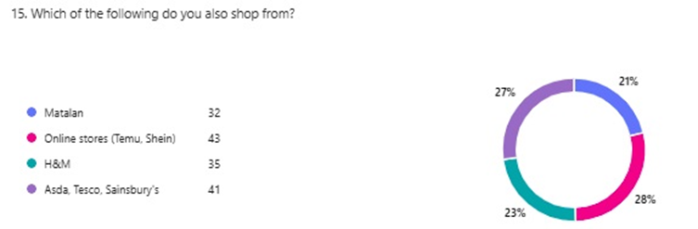
These results show that Primark respondents also shop from other low-cost retailers and online stores, indicating the existence of direct and clear competition in this market segment. Brands such as H&M and Matalan, as well as online stores like Temu and Shein, are preferred, reflecting consumers' tendency to seek variety and the best deals in low-cost retail.
Figure 16: In-store Experience
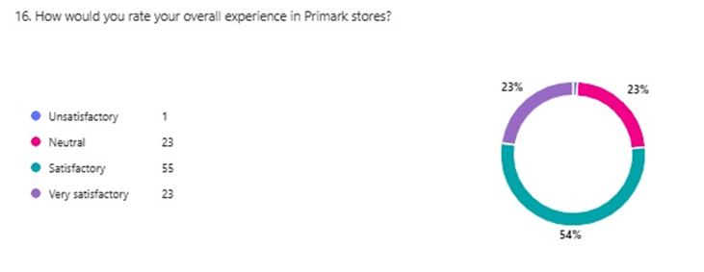
The majority of respondents had a satisfactory (55%) or very satisfactory (23%) experience in Primark stores. This positive result supports Primark's approach to customer satisfaction through a simple, fast and efficient in-store experience (Levy, Weitz, and Grewal, 2023).

Figure 17: Influence of Social Media Interaction
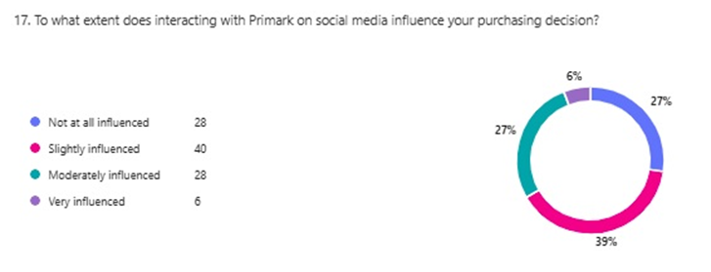
The results show that almost half of the respondents (45%) are not at all influenced by their interaction with Primark on social media. However, a significant proportion are slightly (29%) or moderately (21%) influenced. This suggests that while social media has some influence, it is not the main deciding factor in Primark consumer behaviour (Tuten and Solomon, 2022).

Figure 18: Importance of Sustainability Initiatives
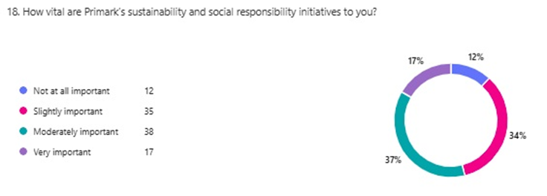
The results indicate an overall perception of moderate to unimportant sustainability and social responsibility initiatives by Primark (72% cumulative). While there is interest from consumers, these initiatives are not yet a significant factor in choosing Primark, indicating clear opportunities for more effective communication in this regard (Kotler, Kartajaya and Setiawan, 2021).

Figure 19: Purchases Influenced by Social Media
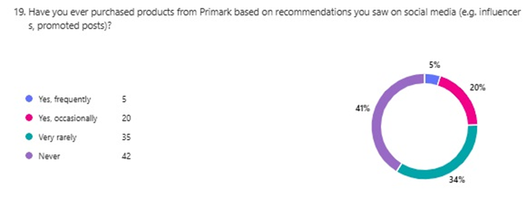
The results indicate that social media recommendations have a moderate to low impact on actual purchasing behaviour. However, a significant percentage (23% occasionally, 16% frequently) indicates that social media plays a relevant role in influencing some Primark consumers' purchasing decisions.

Figure 20: Main Reasons for Shopping at Primark
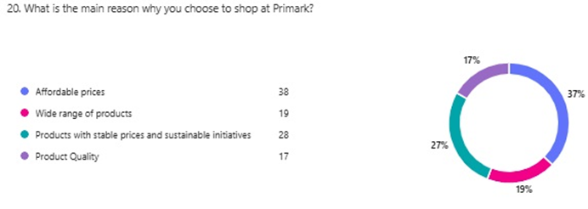
The majority of respondents (62%) chose Primark primarily for its affordable prices. The wide range of products and the quality of the products are important secondary factors, but price remains the main determining reason for consumers' preference for Primark.

Figure 21: Satisfaction with Product Quality
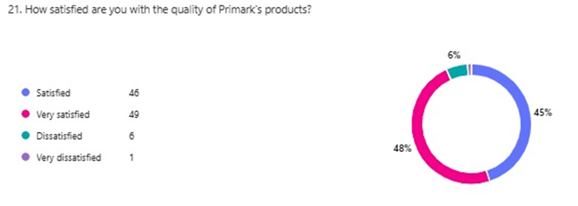
The majority of respondents (93% overall) are very satisfied or satisfied with the quality of Primark products. This positive result reflects an effective balance between low prices and perceived quality by consumers, highlighting Primark's clear competitive advantage in the low-cost retail segment (Zeithaml, Bitner and Gremler, 2023).

4.4 Qualitative Data Analysis (Focus Group Findings)

This section presents a qualitative analysis from a focus group with six participants, all familiar with the Primark brand. The meeting aimed to explore in depth consumer perceptions and opinions regarding Primark's low-cost marketing strategy. Participants were asked to answer seven open-ended questions, relating to brand loyalty, product perception, the influence of personal and social recommendations, online communication, perceptions of sustainability and social responsibility, and concrete recommendations for improving the overall experience in Primark stores. The main results are presented below, along with their interpretations and can also be found in Appendix 5.

Fig.1 Apart from price, what other factors have made you a loyal customer of Primark?
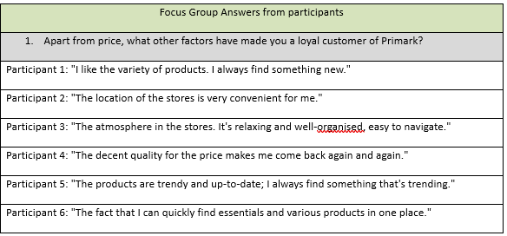
Main results:
Variety of products (2 participants out of 6)
- Convenient location (1 participant out of 6)
- Pleasant atmosphere in stores (1 participant out of 6)
- Good quality for the price (1 participant out of 6)
- Currently, trendy products (1 participant out of 6)

The results suggest that consumer loyalty to Primark depends not only on price, but also on elements such as product variety and a positive in-store experience. This finding is consistent with research indicating that store experience and product variety are key factors in consumer loyalty in low-cost retail (Varley, Rafiq, and Powe, 2022).

Fig 2. What is your perception of Primark products compared to products from other low-cost retailers? What differences do you notice?
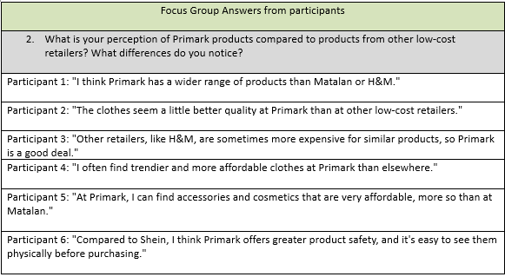
Main results:
- More diverse and trendy range compared to other retailers (2 out of 6 participants)
- Better product quality (2 out of 6 participants)
- Better value for money (1 out of 6 participants)
- Safer and more affordable products compared to online stores like Shein (1 out of 6 participants)
Participants perceive Primark products more positively than other low-cost competitors, particularly in terms of variety and quality. This perception aligns with the findings of recent research, which suggests that consumers value retailers that offer a wide range of affordable products in terms of both price and quality (Goworek and McGoldrick, 2022).

Fig 3. Can you provide specific examples of how recommendations from friends or online sources influenced your decision to shop at Primark?
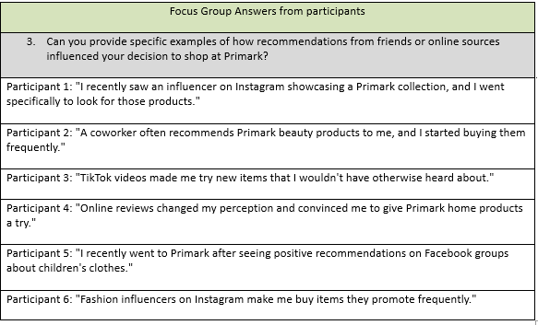

Main results:
- Significant influence from social media (3 out of 6 participants)
- Direct recommendations (friends/colleagues) (2 out of 6 participants)
- Online reviews (1 out of 6 participants)

These results demonstrate the major importance of social media and direct recommendations in Primark consumer behaviour, reflecting the general trend of using these sources for purchasing decisions, especially among young consumers (Kingsnorth, 2022).

Fig 4. What is your opinion on Primark's strategy of using social media and personal recommendations instead of traditional advertising? How does this influence your perception of the brand?
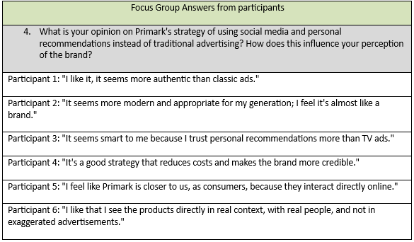

Main results:
- Authentic and credible strategy (3 out of 6 participants)
- Modern and youth-friendly strategy (2 out of 6 participants)
- Closer and more direct to consumers (1 out of 6 participants)
Participants appreciate Primark's strategy of using social media and personal recommendations instead of traditional advertising, considering it authentic, credible and suitable for the younger generation. This confirms the effectiveness of alternative marketing approaches in low-cost retail (Armstrong and Kotler, 2022).

Fig 5. How do you evaluate Primark's online communication and interaction with its customers (e.g., Instagram, TikTok, Facebook)? What elements do you like or think should be improved?
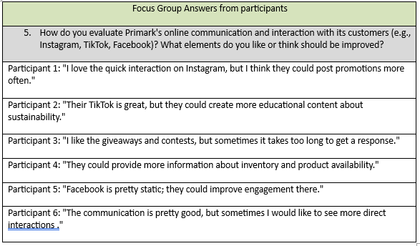
Main results:
- Positive interaction, but recommendations for improvement (2 participants out of 6)
- More educational content about sustainability (1 participant out of 6)
- More direct interactions (1 participant out of 6)
- Faster response time (1 participant out of 6)
- More activity on Facebook (1 participant out of 6)
Participants positively appreciate online interaction but suggest improvements, confirming the literature that emphasises the importance of proactive and frequent communication in the online environment for maintaining effective customer relationships (Fill and Turnbull, 2022).
Fig. 6: What is your view on Primark's sustainability and social responsibility initiatives? Do you think the brand effectively communicates these aspects to its customers?
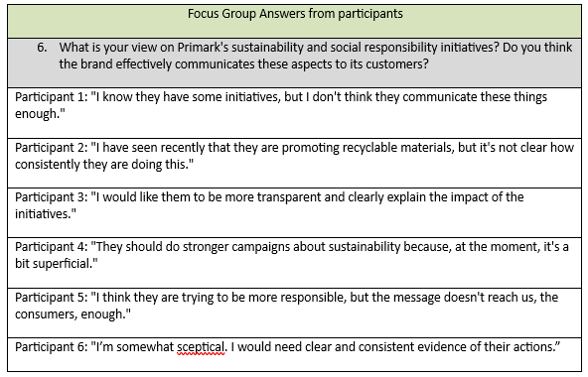

Main results:
- Insufficient communication (3 out of 6 participants)
- Need for transparency (2 out of 6 participants)
- Scepticism about authenticity (1 out of 6 participants)

Participants believe that Primark does not communicate its sustainability and social responsibility initiatives clearly and transparently enough, indicating a significant opportunity for the brand to improve this communication for a stronger and more credible positive perception (Belz and Peattie, 2022).
.

Fig 7. If you could give one important recommendation to Primark management to improve the overall in-store experience or customer relationship, what would it be and why?
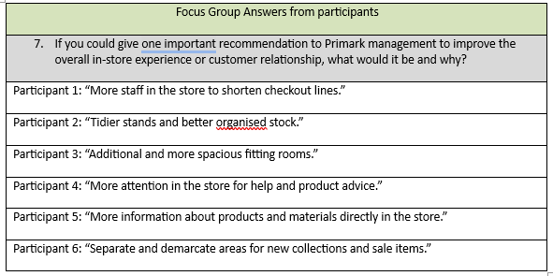
Main results:
- More staff and faster service (2 participants out of 6)
- Better organisation of products (1 participant out of 6)
- More fitting rooms (1 participant out of 6)
- Clear product information (1 participant out of 6)
- Clear demarcation of areas (1 participant out of 6)
Participants recommend concrete and practical improvements, reflecting the importance of effective operational management and a good in-store experience for the success of modern retail (Varley and Rafiq, 2022).

Chapter 5
Discussion

Chapter 5. Discussion

This chapter aims to explicitly and in detail interpret the main results obtained from the research, both quantitative (questionnaire) and qualitative (focus group), by comparing them directly with the literature presented in Chapter 2 (Literature Review) and with the initial research objectives. The discussion will identify to what extent the research results confirm, extend or contradict the existing literature and will explicitly underline the extent to which the research objectives have been met. Additionally, the discussion will clearly highlight the practical implications of the results for Primark and outline possible future research directions.

5.1 Key Findings

Objective 1: Identify and analyse Primark's key low-cost marketing strategies and how they differ from traditional retail marketing approaches.
The research results explicitly confirm that Primark bases its low-cost strategy on operational efficiency, affordable prices and minimalist communication, avoiding the extensive use of traditional advertising. This strategy is reflected in the focus group results, where participants appreciated the authenticity and simplicity of Primark's approach. The questionnaire also confirmed that attractive prices and a varied product range are the main factors that attract customers to this retailer. The results obtained are in line with the literature presented by Doyle (2021) and Varley and Rafiq (2022), which explicitly mention the importance of operational efficiency and minimising marketing costs for the success of low-cost retailers. However, the fact that respondents indicated a moderate influence of personal recommendations and social media suggests that Primark could further invest in alternative direct communication strategies to strengthen its competitive advantage (Evans and Berman, 2023).
Objective 2: Analysis of consumer perceptions of Primark's marketing strategy and its influence on purchasing behaviour and brand loyalty.
The research results show that respondents generally perceive Primark's marketing strategy positively, but its effectiveness is perceived as moderate. The majority of questionnaire respondents consider the marketing strategy to be moderately effective, and focus group participants explicitly appreciated the authenticity and credibility of this approach based on personal recommendations and social media. In addition, the data suggest a conditional loyalty among consumers, who are willing to remain loyal to Primark only under specific conditions, such as value for money and a generally positive in-store experience. These findings are consistent with recent literature that argues that in low-cost retail, consumers seek not only affordable prices but also pleasant and authentic experiences, which is essential in strengthening loyalty (Blythe and Martin, 2022).

Objective 3: Assess the effectiveness of Primark's social media and personal recommendation strategy compared to traditional advertising methods.
The results show that personal recommendations and social media have a moderate influence on Primark consumer behaviour, with a significant influence of influencers and direct recommendations in the focus group and questionnaire. However, direct interaction on social media is perceived as having a limited influence on the actual purchase decision. This indicates that Primark is effectively using these modern methods, but there is still potential for optimisation to increase the direct influence of these channels on purchase decisions. Recent literature confirms that marketing strategies based on personal recommendations and social media are effective in modern retail; however, direct and constant consumer involvement is essential to maximise the benefits of these strategies (Barker et al., 2022).

Objective 4: Compare the success of Primark's marketing strategy with other low-cost retailers in the UK.
The majority of respondents explicitly indicated that Primark offers a better or similar value for money than competitors such as H&M and Matalan, thus confirming this retailer's clear competitive advantage in the low-cost segment. However, the fact that respondents also frequently shop at other competing retailers indicates a strong competitive market and the need for Primark to continue strengthening its already identified competitive advantages, such as a varied range, attractive prices, and a positive in-store experience. These results support the literature, which states that competitive advantage in low-cost retail depends on the retailer's ability to consistently offer a competitive value for money and a positive experience, thereby attracting and retaining consumers in a highly dynamic competitive context (Sternquist and Goldsmith, 2022).

5.2 Implications of Findings for Primark

The results of this research have clear and explicit implications for Primark's marketing strategy in the context of low-cost retail in the UK. Firstly, the explicit confirmation of the importance of attractive prices and product variety suggests that Primark needs to maintain and, if possible, enhance these competitive advantages to maintain its strong market position. Secondly, the explicit identification of the importance of personal recommendations and social media marketing highlights the need for a more focused and proactive marketing strategy in these areas. Thus, Primark could consider making greater investments in digital communication, providing informative content about its products and initiatives, particularly those related to sustainability. In addition, Primark should consider improving the in-store experience by increasing staffing, optimising inventory, and delineating areas. These direct consumer recommendations are crucial for increasing satisfaction and enhancing long-term brand loyalty. These results are consistent with recent research in the academic literature, which highlights that low-cost retailers can significantly improve consumer loyalty through effective in-store experience management and transparent communication (Baines et al., 2022).

5.3 Limitations

Despite the methodological rigour and analytical clarity employed in this research, several limitations are worth explicitly highlighting. Firstly, the use of non-probabilistic purposive and convenience sampling limits the possibility of generalising the results obtained to the entire UK population. This address was specifically chosen because it is relevant and saleable for the research objectives; however, it may inevitably compromise the representativeness of the overall results (Collis and Hussey, 2021).
Secondly, the small size of the qualitative sample (focus group with only six participants) may limit the ability to generalise the results obtained. It may introduce certain biases or limited perspectives on the researched subject. This aspect must be explicitly considered in the interpretation of the results, and the conclusions from the focus group must be viewed in the context of retaining these qualitative methods.
Additionally, since the research respondents were predominantly from specific geographical areas of Wales (such as Cardiff, Newport, and Swansea), the results may not accurately reflect the perceptions of consumers in other regions of the UK or international markets. Therefore, future studies could overcome this limitation by adopting probability sampling methods and explicitly including respondents from diverse geographical regions, thereby improving the generalizability and robustness of the results (Easterby-Smith et al., 2023).

5.4 Summary of Discussion

In this chapter, the results obtained in the research are explicitly and critically analysed in relation to the academic literature presented in Chapter 2 and the research objectives. The interpretation of the results suggests that Primark clearly benefits from a low-cost marketing strategy, characterised by attractive prices, product diversity, and minimalist marketing through personal recommendations and social media. It was explicitly found that these strategies contribute significantly to a positive perception and consumer loyalty; however, there are clear opportunities to improve the in-store experience and communication regarding sustainability and social responsibility. Finally, the limitations of the research were explicitly mentioned, particularly in relation to the generalizability of the results. Directions for future research were suggested, which could contribute to the consolidation of the results obtained.

Conclusion and Recommendations

This research aimed to explicitly analyse the impact of Primark's low-cost marketing strategy on its success in the UK retail market. The research results confirmed that Primark builds its competitive advantage through attractive prices, a wide variety of products and marketing based on personal recommendations and social media. This strategy has been shown to be effective, as it is positively appreciated by the majority of consumers and explicitly contributes to their loyalty and retention. However, the research also revealed an explicit need to improve communication and transparency of sustainability initiatives, as well as to optimise the overall in-store experience by supplementing staff, optimising stocks, and delineating sales areas. Specifically, these results suggest that Primark management should intensify online communication and invest more in direct and authentic interactions with customers, including through social media and educational content focused on sustainability. It is also recommended to constantly strengthen existing advantages, such as the wide range of products and the quality-price ratio, in order to maintain its competitive position in the market in the long term.
For future research, the use of larger, more representative samples and probability sampling methods is strongly recommended to enhance the generalizability of the results. Future research could also further analyse consumer perceptions from other geographic regions and international markets, as well as the explicit impact of sustainability and social responsibility initiatives on consumer behaviour.

Bibliography

Armstrong, G. and Kotler, P. (2022) Marketing: An Introduction. 15th edn. Pearson Education.
Baines, P., Fill, C., Rosengren, S. și Antonetti, P. (2022) Marketing. 6th edn. Oxford University Press.
Barker, M., Barker, D., Bormann, N.F., Roberts, M.L. and Zahay, D. (2022) Social Media Marketing: A Strategic Approach. 3rd edn. Cengage Learning.
Bell, E., Harley, B., and Bryman, A. (2022) Business Research Methods. 6th edn. Oxford University Press.
Belz, F.-M. and Peattie, K. (2022) Sustainability Marketing: A Global Perspective. 3rd edn. Wiley.
Berman, B., Evans, J.R. and Chatterjee, P. (2023) Retail Management: A Strategic Approach. 14th edn. Pearson Education.
Blythe, J. and Martin, J. (2022) Essentials of Marketing. 8th edn. Pearson Education.
Bratton, J. and Gold, J. (2022) Human Resource Management: Theory and Practice. 7th edition Bloomsbury Publishing.
Bryman, A. (2021) Social Research Methods. 6th edn. Oxford University Press.
Bryman, A. and Bell, E. (2021) Business Research Methods. 6th edn. Oxford University Press.
Burt, S., and Sparks, L. (2020). "Retailing in the United Kingdom: A Synopsis." International Review of Retail, Distribution and Consumer Research, 30(3), 241-260.
Carroll, A.B. and Brown, J. (2023) Business & Society: Ethics, Sustainability, and Stakeholder Management. 11th edn. Boston: Cengage Learning.
Carter, A. and Lee, D. (2023) Consumer motivations in budget retailing: Understanding purchasing behaviour in low-cost markets. Journal of Consumer Marketing, 40(2), pp. 122-135.
Chaffey, D. and Ellis-Chadwick, F. (2022) Digital Marketing: Strategy, Implementation and Practice. 8th edn. Pearson.
Chahal, R. and Kumar, S. (2022) Low-cost retail strategies: Balancing operational efficiency and customer expectations. International Journal of Retail Management, 18(4), pp. 210-222.
Collis, J. and Hussey, R. (2021) Business Research: A Practical Guide for Undergraduate and Postgraduate Students. 5th edn. Palgrave Macmillan.
Creswell, J.W. and Creswell, J.D. (2023) Research Design: Qualitative, Quantitative, and Mixed Methods Approaches. 6th edn. Sage.
Doyle, P. (2021) Value-Based Marketing: Marketing Strategies for Corporate Growth and Shareholder Value. 2nd edn. Wiley.
East, R., Singh, J., Wright, M. and Vanhuele, M. (2022) Consumer Behaviour: Applications in Marketing. 4th edn. Sage Publications.
Easterby-Smith, M., Thorpe, R., Jackson, P. and Jaspersen, L.J. (2021) Management and Business Research. 7th edn. SAGE Publications.
Evans, J.R. and Berman, B. (2023) Retail Management: A Strategic Approach. 14th edn. Pearson Education.
Fernie, J. and Sparks, L. (2023) Retail Logistics: Changes and Challenges. 4th edition Kogan Page.
Field, A. (2022) Discovering Statistics Using IBM SPSS Statistics. 6th edn. London: Sage Publications.
Fill, C. and Turnbull, S. (2022) Marketing Communications: Touchpoints, Sharing and Disruption. 8th edn. Pearson Education.
Flick, U. (2022) An Introduction to Qualitative Research. 7th edn. SAGE Publications.
Goworek, H. and McGoldrick, P. (2022) Retail Marketing Management: Principles and Practice. 2nd edn. Routledge.
Grant, R.M. (2021) Contemporary Strategy Analysis: Text and Cases Edition. 11th edn. John Wiley & Sons.
Gray, D.E. (2021) Doing Research in the Real World. 5th edn. SAGE Publications.
Green, T. and Patel, R. (2022) In-store experience and customer loyalty in low-cost retail environments. Retail Journal of Consumer Satisfaction, 15(3), pp. 178-190.
Grewal, D., Krishnan, R., Baker, J. and Borin, N. (2019) 'The Impact of Store Layout on Consumer Behavior', Journal of Retailing, 95(1), pp. 1–10.
Hair, J.F., Babin, B.J., Anderson, R.E. and Black, W.C. (2022) Multivariate Data Analysis. 8th edition Cengage Learning.
Harrison, A. and Van Hoek, R. (2022) Logistics Management and Strategy. 7th edition Pearson Education.
Heizer, J., Render, B. and Munson, C. (2023) Operations Management: Sustainability and Supply Chain Management. 14th edition Pearson Education.
Hermann, C. (2021) The Critique of Commodification: Contours of a Post-Capitalist Society. Oxford University Press.
Hübner, A. and Holzapfel, A. (2022) Retail Supply Chain Management. Springer.
IESE Business School (2011) No Bells, No Whistles: The Simple Case of Primark. Available at: https://www.iese.edu/insight/articles/simple-case-primark (Accessed: April 29, 2025).
Jackson, P. and Thomas, L. (2024) Digital marketing and customer engagement in low-cost retailing. International Journal of Digital Marketing Strategies, 21(1), pp. 50-65.
Johnson, G., Scholes, K. și Whittington, R. (2020) Exploring Strategy: Text and Cases. 12th edn. Pearson Education.
Kingsnorth, S. (2022) Digital Marketing Strategy: An Integrated Approach to Online Marketing. 3rd edn. Kogan Page.
Kotler, P. and Armstrong, G. (2023) Principles of Marketing. 19th edn. Pearson Education.
Kotler, P. and Keller, K. (2023) Marketing Management. 16th edition Pearson Education.
Kotler, P., Kartajaya, H. and Setiawan, I. (2021) Marketing 5.0: Technology for Humanity. Wiley.
Krueger, R.A. and Casey, M.A. (2022) Focus Groups: A Practical Guide for Applied Research. 6th edn. Sage Publications.
Levy, M., Weitz, B.A. and Grewal, D. (2023) Retailing Management. 11th edn. McGraw-Hill Education.
Lewis, M., Whysall, P. and Foster, C. (2014) 'Retailing in the digital age: challenges and opportunities', International Journal of Retail & Distribution Management, 42(3), pp.267–273.
Lopez, S. and Evans, M. (2024) Social media influence and customer retention in budget retail markets. Journal of Marketing Communications, 30(2), pp. 140-153.
Lovelock, C. and Patterson, P. (2022) Services Marketing: An Asia-Pacific and Australian Perspective. 7th edition Pearson Education.
Mintel (2023) UK Food and Non-food Discounters Market Report – UK – 2023. Mintel Group Ltd. Available at: https://store.mintel.com/report/uk-food-and-non-food-discounters-market-report-2023 (Accessed: June 28, 2025).
Monczka, R.M., Handfield, R.B., Giunipero, L.C. and Patterson, J.L. (2022) Purchasing and Supply Chain Management. 7th edition Cengage Learning.
Newcastle University (2020) Primark Stores Limited: Low-cost Strategy and Sustainability Initiatives. Available at: https://eprints.ncl.ac.uk/265729 (Accessed: April 29, 2025).
Nguyen, H. and Wang, Y. (2023) Consumer value perception and quality-price balance in low-cost retail stores. European Journal of Marketing and Consumer Behaviour, 29(5), pp. 304-319.
Nurhilalia et al. (2024) The Impact of Consumer Behavior on Consumer Loyalty: Satisfaction, Trust, Emotional Commitment and Consumer Experience, EAS Journal of Economics and Finance, Vol. 6(1), pp. 20–25. Available at: https://www.easpublisher.com/get-articles/4164 (Accessed: June 28, 2025).
Park, J. and Kim, H. (2023) Loyalty drivers in low-cost retail: price stability, perceived value and product quality. Retail & Consumer Research Review, 27(4), pp. 250-262.
Plano Clark, V.L. and Ivankova, N.V. (2023) Mixed Methods Research: A Guide to the Field. 2nd edn. SAGE Publications.
Porter, M.E. (1985) Competitive Advantage: Creating and Sustaining Superior Performance. New York: Free Press.
Porter, M.E. (2008) 'The five competitive forces that shape strategy', Harvard Business Review, 86(1), pp.78–93.
Primark Corporate Website (n.d.) Who We Are. Available at: corporate.primark.com (Accessed: February 5, 2025).
Rushton, A., Croucher, P. and Baker, P. (2022) The Handbook of Logistics and Distribution Management. 7th edition Kogan Page.
Saunders, M., Lewis, P. and Thornhill, A. (2023) Research Methods for Business Students. 9th edn. Pearson Education.
Singh, V. and Verma, A. (2022) Sustainability strategies and consumer loyalty in low-cost retailing. Journal of Sustainable Retailing, 19(2), pp. 100-112.
Solomon, M.R., Bamossy, G.J. and Askegaard, S. (2022) Consumer Behaviour: A European Perspective. 7th edn. Pearson Education.
Statista (2023) 'Apparel market in the United Kingdom (UK) - statistics & facts'. Available at: https://www.statista.com/topics/3348/apparel-market-in-the-uk/ (Accessed: February 3, 2025).
Sternquist, B. and Goldsmith, E.B. (2022) International Retailing. 3rd edn. Bloomsbury Publishing.
Taherdoost, H. (2022) "Sampling Methods in Research Methodology; How to Choose a Sampling Technique for Research," International Journal of Academic Research in Management (IJARM), 11(1), pp. 18–27.
Tuten, T.L. and Solomon, M.R. (2022) Social Media Marketing. 5th edn. Sage Publications.
Varley, R. and Rafiq, M. (2022) Principles of Retailing. 4th edn. Palgrave Macmillan.
Zeithaml, V.A., Bitner, M.J. and Gremler, D.D. (2023) Services Marketing: Integrating Customer Focus Across the Firm. 8th edn. McGraw-Hill Education.
Zentes, J., Morschett, D. and Schramm-Klein, H. (2022) Strategic Retail Management: Text and International Cases. 4th edn. Springer.

Appendices

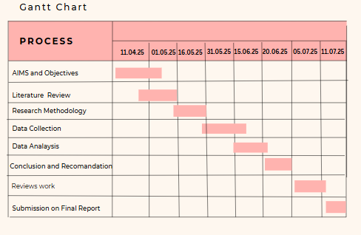

Appendix 1: Porter Value Chain adapted to Primark
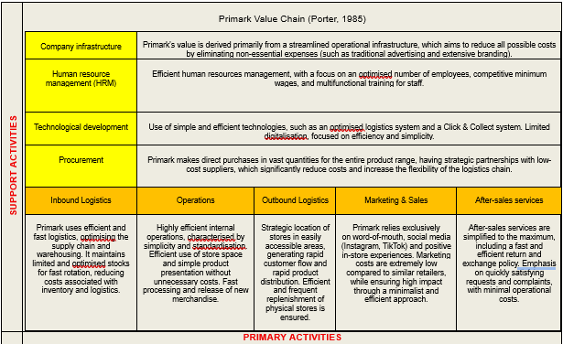

Appendix 2: Questionnaire

1. What is your age?
☐ 18-24 years
☐ 25-34 years
☐ 34-44 years
☐ 45-54 years
☐ 55+ years

2. What is your gender?
☐ Male
☐ Female
☐ Prefer not to say

3. Where are you living?
☐ Cardiff
☐ Newport
☐ Swansea
☐ Other ______________________

4. What is your current employment status?
☐ Working (full-time or part-time)
☐ Student
☐ Houseperson/ Stay at home
☐ Unemployed
☐ Retired
5. How often do you shop at Primark?
☐ Once a week or more often
☐ Once a month
☐ Once every 2-3 months
☐ Once every 6 months
☐ Rarely / Never

6. When was the last time you bought a product from Primark?
☐ In the last week
☐ In the last month
☐ In the last 3 months
☐ In the last 6 months
☐ More than 6 months ago

7. How did you first find out about Primark?
☐ Through family/friends
☐ Social networks (Facebook, Instagram, TikTok)
☐ Visiting a physical store
☐ Online advertising

8. How much are you influenced by Primark's prices when purchasing?
☐ Not influenced at all
☐ Slightly influenced
☐ Moderately influenced
☐ Highly influenced
9. How significant is the lack of traditional advertising (TV, online ads) in your decision to buy from Primark?
☐ Not at all important
☐ Slightly important
☐ Moderately important
☐ Very important

10. How effective is Primark's marketing strategy (e.g., social media, word-of-mouth, in-store experience)?
☐ Not effective at all
☐ Little effective
☐ Moderately effective
☐ Very effective

11. Would you recommend Primark to your friends or family?
☐ Yes, definitely
☐ Not sure
☐ Probably not
☐ Maybe

12. How much do recommendations from family and friends influence your decision to shop at Primark?
☐ Not influenced at all
☐ Slightly influenced
☐ Moderately influenced
☐ Highly influenced

13. Would you remain loyal to Primark if another low-cost retailer offered similar prices and products?
☐ Yes, Primark is my favourite brand
☐ Maybe, depending on quality and experience
☐ No, I would try another retailer

14. Compared to other low-cost retailers (e.g. H&M, Matalan), how good do you think Primark is in terms of value for money?
☐ Better than competitors
☐ Similar to competitors
☐ Worse than competitors

15. Which of the following do you also shop from?
☐ Matalan
☐ Online stores (Temu, Shein)
☐ H&M
☐ Asda, Tesco, Sainsbury's

16. How would you rate your overall experience in Primark stores?
☐ Unsatisfactory
☐ Neutral
☐ Satisfactory
☐ Very satisfactory

17. To what extent does interacting with Primark on social media influence your purchasing decision?
☐ Not at all influenced
☐ Slightly influenced
☐ Moderately influenced
☐ Very influenced

18. How vital are Primark's sustainability and social responsibility initiatives to you?
☐ Not at all important
☐ Slightly important
☐ Moderately important
☐ Very important

19. Have you ever purchased products from Primark based on recommendations you saw on social media (e.g. influencers, promoted posts)?
☐ Yes, frequently
☐ Yes, occasionally
☐ Very rarely
☐ Never

20. What is the main reason why you choose to shop at Primark?
☐ Affordable prices
☐ Wide range of products
☐ Products with stable prices and sustainable initiatives
☐ Product Quality

21. How satisfied are you with the quality of Primark's products?
☐ Satisfied
☐ Very satisfied
☐ Dissatisfied
☐ Very dissatisfied

Appendix 3: Focus Group Discussion Guide
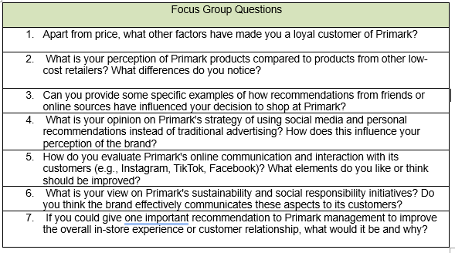

Appendix 4: Results from Quantitative Methodology

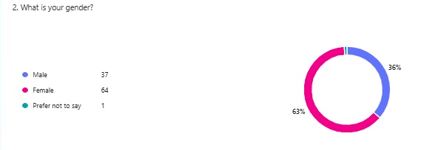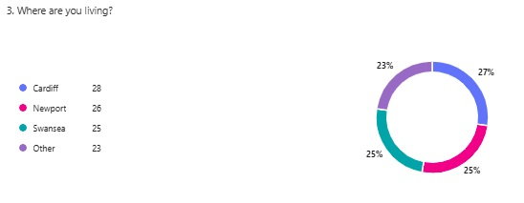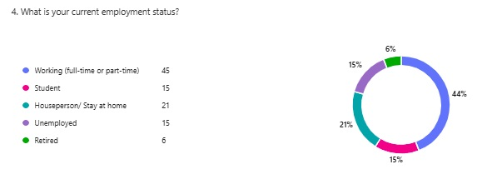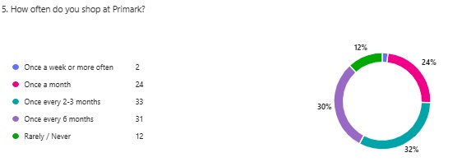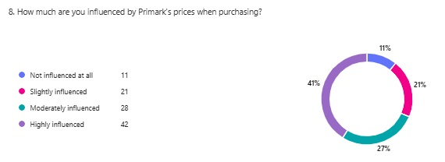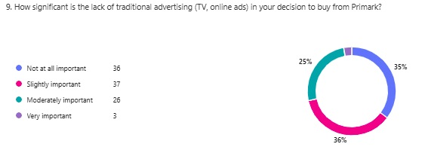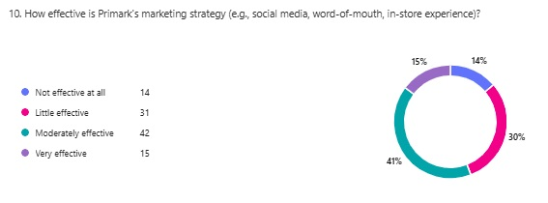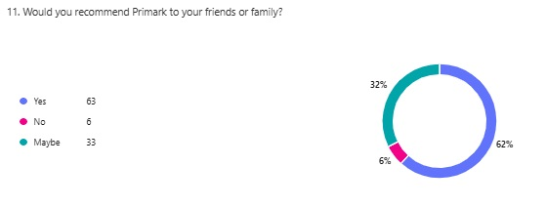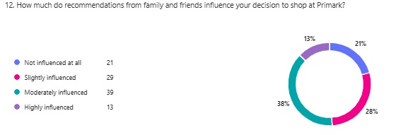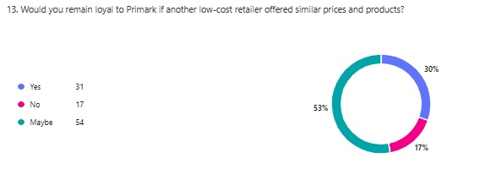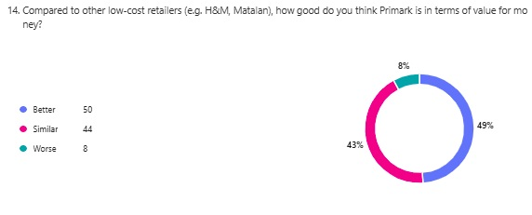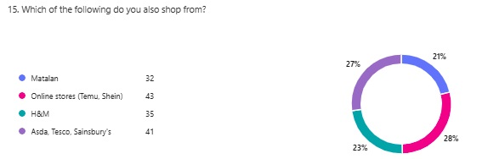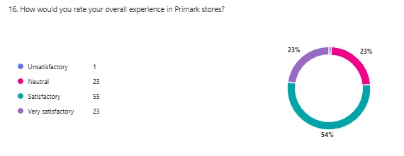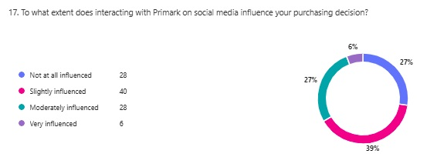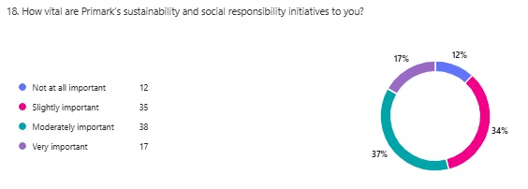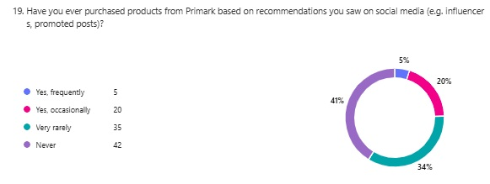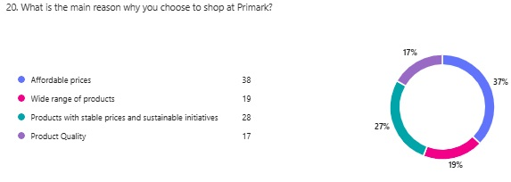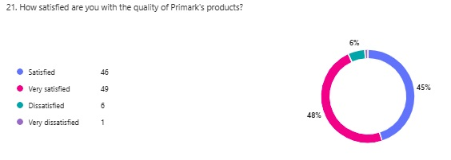

Appendix 5: Results from Qualitative Methodology

