Exploring Maslow’s Hierarchy of Needs

AI Cover sheet
I confirm that I did not use AI

Contents Page
- Infographic exploring Maslow’s Hierarchy of Needs.
- Exploring the concept of holistic child development – with links to Maslow’s model and other developmental theories.
- Exploring Maslow’s significance in understanding child development – with links to Transitions.

- Infographic exploring Maslow’s Hierarchy of Needs.
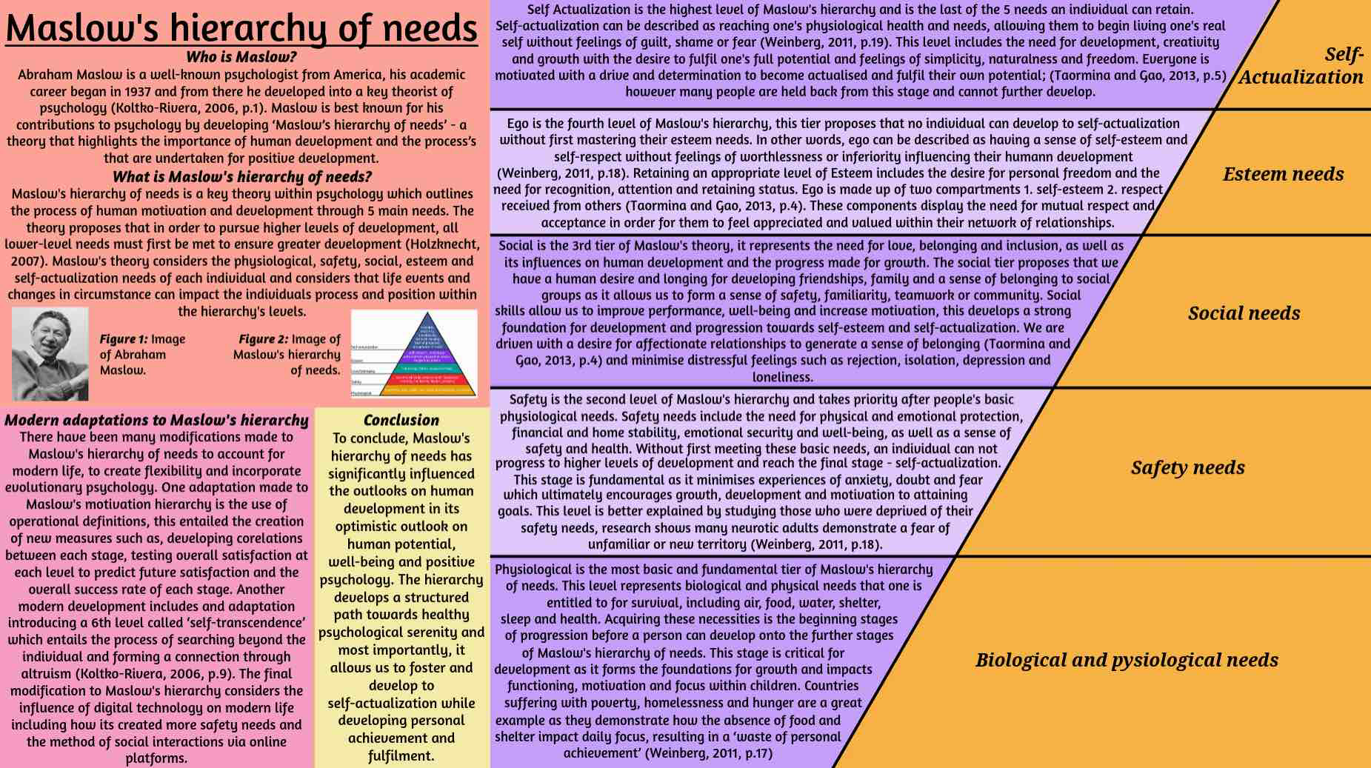
Reference list
- Factoryjoe, (2009) depiction of Maslow’s hierarchy of needs. Available at: https://commons.wikimedia.org/wiki/File:Mazlow%27s_Hierarchy_of_Needs.svg (Accessed: 20th November 2025) (Date viewed: 20thNovember 2025)
- Holzknecht, J. (2007) Maslow’s hierarchy of needs. Available at: https://video.alexanderstreet.com/watch/maslow-s-hierarchy-of-needs (Accessed: 20th November 2025)
- Koltko-Rivera, M. (2006) Rediscovering the Later Version of Maslow’s Hierarchy of Needs: Self-Transcendence and Opportunities for Theory, Research, and Unification. Washington, DC: Educational Publishing Foundation.
- Taormina, R.J. and Gao, J.H. (2013) Maslow and the Motivation Hierarchy: Measuring Satisfaction of the Needs. Champaign, IL: University of Illinois Press.
- Weinberg, D (2011) Montessori, Maslow and Self-Actualization. New York: American Montessori Society.
- William, C. (1971) Photo of Abraham Harold Maslow by William Carter. Available at: https://en.wikipedia.org/wiki/Abraham_Maslow (Accessed: 20th November 2025)

- Exploring the concept of holistic child development – with links to Maslow’s model and other developmental theories.
What is Holistic child development?
Holistic child development is the overall learning, growth and development of a child. This theory focuses on developing and understanding the child as a whole and not just their academic status. Overall growth of a child includes their physical, cognitive, emotional, moral and social skills during their first few years of life. All areas of development and learning are intricately intertwined and are interdependent and concurrent stages. Through holistic development children are able to gain the skills and competence needed to thrive and grow in the real world (Brodie, 2028, p.13).
Why is Holistic child development important and how is it implemented into education?
Holistic development is a key theory for overall child development as is acts as a foundation for effective future learning, it allows children to develop a sense of confidence, happiness and independence which ultimately supports their behaviour and motivation (Malindi, 2023, p.17). The holistic approach prepares children to embrace their uniqueness and differences as they grow and develop into young people in the real world.
Educators often use the holistic approach to support children as individuals with the overall goal of developing the child as a whole. This is implemented into education by taking necessary adaptations to suit each individuals learning styles, incorporate diverse activities, generating a positive environment and supporting their social and emotional growth. By adopting these adaptations into everyday learning, educators create well rounded development for the children, create inclusive learning and a positive learning environment rather than creating a sole focus for academic levels.
Play
Play is a integral part of school's curriculum and holistic development, this offers direct experiences where children can be observed reinforcing their learning by developing awareness of themself and the world around them. Play is a primary way children can develop their physical, social, emotional, cognitive and spiritual well-being in their own creative and amusing way creating a fun and positive learning environment (Keung and Cheung, 2019, p.628). Holistic development is supported by play as it allows children to explore their personal interests, make decisions and learn with a hands on experience. This ultimately fosters their intellectual curiosity, problem solving skills and motivates them for effective learning (Brodie, 2028, p.110).
Relationships
Relationships within holistic development is systemic, children are complex, integrated individuals whose growth and development must be supported and nurtured across all dimensions of learning to achieve overall wellbeing and attain their full potential. Children form their own relationships through learning and interaction, one example is mutual influence. This involves the development of social skills through interaction with peers, children socialise with other children on a daily basis which allows them to learn from each other through reciprocal practise and aids their development of problem solving and emotional management by feelings of frustration or risk taking. Another example includes emotional and social wellbeing, this entails learning through secure and nurturing relationships to form essential foundations for cognitive learning – without feelings of safety and security, children cannot flourish and thrive into effective learning, demonstrating the absolute importance of relationships for holistic development. (Kingston and Blackmore, 2020, p.259-264)
Connection to Maslow’s hierarchy of needs
The holistic development approach is tightly connected to Maslow's hierarchy of needs as it is the fundamental foundation for the concept of gaining overall holistic development. Maslow’s hierarchy is also formally known as the Holistic Dynamic Theory due to its significant influence and connection to the Holistic approach. Maslow’s hierarchy emphasizes the importance of prioritizing all human needs to foster complete and healthy individuals who have fulfilled their potential (Weinberg, 2011, p.17). The connection between these theories lies in the core beliefs that children can increase their motivation to grow and reach their full potential only when all fundamental foundation needs are met across all dimensions to allow further development beyond self-actualization (Duncan, 2025).
Connection to Bronfenbrenner (PPCT)
Bronfenbrenner has a great connection and influence on the holistic development approach as it provides a structure and language that conceptualises development through comprehension. Bronfenbrenner’s theory of Process, Person, Context, Time (PPCT) model influences the holistic approach as it acts as a fundamental framework for the understanding of development in children. This theory is holistic as it does not focus on just one factor, its theory demonstrates that regular interactions within a child's immediate environment is crucial for their development (Bronfenbrenner, 1979, p.18), how both personal and societal influences impact development and acknowledges everyone's unique characteristics (Bronfenbrenner, 1979, p.110). Overall Bronfenbrenner promotes a more comprehensive understanding of child development by exploring all elements that are involved in shaping an individual.
Connection to Vygotsky
Vygotsky has had a significant impact on the holistic approach, he believed that psychological theories should focus on the child as a whole and rather than as isolated parts. His work is central to the holistic theory as he advocated for holistic learning through activities that are relevant and embedded into real life scenarios (Salas and Larrain, 2024, p.1189), argued that a persona cognitive development is influenced by their social and cultural environment (Salas and Larrain, 2024, p.1191), his view on the systemic approach to the mind and his work on integrated emotions by examining their evolutionary and neurophysiological bases.
Conclusion
To conclude, the holistic approach is a key theory for the development of children, it greatly influences their overall development and is essential for preparing young minds for the future. By acknowledging that all aspects of a person are interconnected, we are provided with a deep understanding of lifelong learning, personal growth and the ability we gain to navigate the real world all whilst ensuring that children positively develop their intellectual, emotional, physical and social skills. This approach ultimately guides children to fulfilling their potential and contributes to a healthier society that is knowledgeable, compassionate and adaptive.

Reference list
- Brodie, K. (2018) The holistic care and development of children from birth to three: an essential guide for students and practitioners. Routledge: Taylor & Francis Group.
- Bronfenbrenner, U. (1979) The ecology of human development: experiments by nature and design. Cambridge, MA: Harvard University Press.
- Duncan, B.A. (2025) Discovering holistic dynamic needs beneath a rigid pyramid. Available at: https://www.synthegrate.com/index.php/knowledge-areas/human-development/human-organism/66-discovering-holistic-dynamic-needs-beneath-a-rigid-pyramid?showall=1#:~:text=313)%20by%20including%20in%20contemporary,Table%201.&text=Seeks%20to%20further%20a%20cause,the%20self%20through%20peak%20experience.&text=Seeks%20fulfillment%20of%20personal%20potential.&text=Seeks%20esteem%20through%20recognition%20or%20achievement.&text=Seeks%20affiliation%20with%20a%20group.&text=Seeks%20security%20through%20order%20and%20law.&text=Seeks%20to%20obtain%20the%20basic,did%20not%20seem%20to%20use.(Accessed: 23rd November 2025)
- Keung, C.P.C. and Cheung, A.C.K. (2019) Towards Holistic Supporting of Play-Based Learning Implementation in Kindergartens: A Mixed Method Study. Dordrecht: Springer Netherlands.
- Kingston, A. and Blackmore, K. (2020) Developing social and learning relationships in primary schools. First edition. England: Bloomsbury Academic.
- Malindi, M.J. (2023) Towards a holistic approach to support learners at risk of interrupted development: Midst- and post-COVID-19 interventions. Capetown: AOSIS.
- Salas, M.H. and Larrain, A. (2024) A Holistic theorization of the developmental potential of peer dialogue: revisiting Vygotsky. Dordrecht: Springer Netherlands.
- Weinberg, D (2011) Montessori, Maslow and Self-Actualization. New York: American Montessori Society.

- Exploring Maslow’s significance in understanding child development – with links to Transitions.
Introduction
In this section, I will bring focus to the importance of Maslow's hierarchy of needs within the early year's settings, highlighting its significance for child development and motivation with the aim of developing a greater understanding of its importance. I will use relevant examples, articles and websites to support my research.
Example 1
‘A pupil who is a victim of neglect regularly comes to school feeling tired, hungry and nervous. The school supports this pupil by providing necessary measures such as consistent meals (e.g. breakfast club, fruit snacks and free school meals) as well as regular nap times, time for the pupil to relax and regenerate, and a structured class setting with the same staff present each day to create a predictable and well structured environment. The child eventually settles well into the school and becomes familiar with their surroundings and routine; the pupil has begun developing a sense of belonging and is creating friendships with their peers. Staff are frequently acknowledging the pupils work, fuelling their feelings of pride and confidence. From here the pupil can begin to comfortably explore their potential and find their curiosity.’
This example displays the process of Maslow’s hierarchy of needs and each stage of the pupil's development. Due to the settings structured routine and its use of Maslow’s hierarchy of needs, the school has provided the child with a stable and healthy environment that encourages a sense of security and predictability as well as supporting their physiological health by providing food, drinks and nourishment, fulfilling their psychological and safety needs. This ultimately allowed the pupils to continue their development and allowed them to flourish and develop their sense of belonging, build their confidence, and finally feel secure enough to explore and learn (Taomina and Geo, 2013, p.5). These measures allow the children to continue their progression to the next stages of the hierarchy and develop a sense of familiarity and safety.
Example 2
‘A pupil in year 2 has recently moved to a new school. The pupil’s physiological and safety needs have already been met, however the pupil must regain their sense of love and belonging in their new environment. Teachers have worked hard to develop secure relationships with the pupil and their parents, having frequent meetings to discuss progress, given them tours of the school and introduced them to each member of staff in order to generate a feeling of familiarity and comfort. Educators have assigned a buddy to ease the process of transition and have provided pupils with opportunities to bond and welcome the new pupil(Meehan, C. and Howells, K., 2019, p.1379). This pupil has now been able to create new friendships with their peers and has developed a strong sense of belonging to the school. Their parents are confident and compliant with the school which has aided the transition and has given them a sense of belonging and relief. The pupil is now thriving in their new setting with strong feelings of accomplishment and pride as well as the confidence to explore further and attain their full potential.’
This example also exhibits the strong structure provided by Maslow's hierarchy and displays the theory's fluidity and flexibility to personalize and adapt the levels to each individual's circumstances to generate effective progress. Thanks to the school's consistent efforts and ability to follow Maslow's hierarchy and knowledge of transitions, the pupil has been able to further progress through each stage of development, minimizing their feelings of anxiety and has successfully transitioned into their new setting with comfort and ease. Since the transition of schools, the pupil has been positively challenged, praised, encouraged and recognized by both the staff and their peers, generating positive feelings of accomplishment and the confidence to try new activities and find their potential. This example also supports the connection between Maslow’s hierarchy and transitions, displaying its flexibility to support and work alongside changing circumstances that impact a child's development and growth, its ability to be personalized to each individual and their experiences.
Example 3
‘This year 4 pupil has been flourishing and thriving throughout their first years of school, meeting all stages of development with confidence and great motivation. However, a recent change of circumstances has begun to severely impact their sense of self-esteem. A new teacher has been appointed to their classroom, the educator has not been acknowledging, praising or giving positive reinforcement to the pupils creating a big change in routine and removing their sense of familiarity. This has begun diminishing the individuals sense of self-worth, confidence and accomplishment. This disruptive change has also begun to impact the pupils sense of belonging to their class, they no longer feel happy in their setting and are overwhelmed with feelings of insecurity. This development has had a fatal impact on their emotional wellbeing, social connections, confidence, work ethic and instead replacing them with fears of distress and the unknown.’
This example shows the significant change that takes place when Maslow's hierarchy of needs is not implemented correctly and displays the unfortunate impact it has on children's confidence and feelings of safety and security (Taomina and Geo, 2013, p.8). This pupil, who was once thriving and developing positively, has now been diminished and has moved back down to lower levels of Maslow's hierarchy of needs. As educators, we are required to meet the needs and expectations of our students and encourage growth and improvement from each pupil (Taomina and Geo, 2013, p.4). This educator could have included a transition process to familiarise the pupils with themself and to ease the changes that have occurred creating a more welcoming environment (Fisher, J., 2011, p.32).
Conclusion
To conclude, Maslow’s hierarchy of needs is a critical theory that provides an important structure to the educational system, without it educators could unfortunately miss signs of distress or slow development. The hierarchy is a useful framework that educates teachers on the importance of understanding the needs of their students and the process of their development, they must have their basic physiological and safety needs met before they can effectively learn and develop to their full potential.

Reference list
- Birth to 5 Matters (2021) Transitions. Available at: https://birthto5matters.org.uk/transitions/ (Accessed: 26th November 2025)
- Fisher, J. (2011) Building on the Early Years Foundation Stage: developing good practice for transition into Key Stage 1. Abington: Routledge.
- Meehan, C. and Howells, K. (2019) In search of the feeling of “belonging” in higher education: undergraduate students transition into higher education. Abingdon: Routledge.
- Taomina, R.J. and Geo, J.H (2013) Maslow and the motivation hierarchy: measuring satisfaction of the needs. Champaign. IL: University of Illinois Press.

