ASSIGNMENT 1

ACCOUNTING FUNDAMENTALS

Desislava Hristova

ID:1813113

Tutor: Gazi Arif

Module code: LCBB4001

Table of contents
Introduction……………………………………………………………………3
TASK1……………………………………………………………………………………….3
a) Preparation of ledger accounts for accounting transactions of Maxim……………………3
b) Trial balance of above entries…………………………………………………………….6
c) Preparation of profit and loss statement of financial position statement of Maxim……….7
TASK 2……………………………………………………………………………………….8
a) Preparation of ledger accounts of following transactions of Pendo ………………………8
b) Preparation of Trial balance at 31st January of Pendo…………………………………….12
c) Formation of profit and loss statement and financial position statement of Pendo……….12
TASK 3………………………………………………………………………………………14
a) Preparation of Ledger accounts of Mafuta………………………………………………...14
b) Trial balance at 31st January of Mafuta…………………………………………………...16
Profit and loss statement and financial position statement at 31st January of Mafuta……….16
TASK 4………………………………………………………………………………………17
Ledger accounts and recording of transactions………………………………………………17
TASK 5………………………………………………………………………………………23
Demonstrate the difference between revenue and capital expenditure with reference to International accounting standard……………………………………………………………23
CONCLUSION………………………………………………………………………………24
REFRENCES………………………………………………………………………………...25

INTRODUCTION
Financial fundamental emphasise on recording all the financial transaction of business that affects the functioning of business (Hilton and Platt, 2013). Financial department record, summarize and finally present the business report for the interested stakeholders of the company. Thus, company follows appropriate accounting standard such as IAS, IFRS and so on to make the better comparison among various competitors. This report covers topics like practical application of financial transaction, ledger account, trial balance, preparation of profit and loss account that depict the actual position of business and demonstrate the difference between revenue and capital expenditure with reference to International accounting standard (Wright, 2017).
TASK 1
a) Preparation of ledger accounts for accounting transactions of Maxim

Date | Particular |  |  | Debit amount | Credit amount
05/04/18 | Cash a/c |  |  | 300
 |  | To capital |  |  | 300
07/04/18 | Purchase a/c |  |  | 200
 |  | To cash a/c |  |  | 200
08/04/18 | Cash a/c |  |  | 250
 |  | To loan form Tatiana |  |  | 250
15/04/18 | Motor car a/c |  |  | 150
 |  | To van a/c |  |  | 150
20/04/18 | Cash a/c |  |  | 350
 |  | To sales |  |  | 350
28/04/18 | rent a/c |  |  | 50
 |  | To cash a/c |  |  | 50
29/04/18 | Loan a/c |  |  | 200
 |  | To cash a/c |  |  | 200
30/04/18 | Drawing a/c |  |  | 60
 |  | To cash a/c |  |  | 60

Cash a/c
Date | Particular | Amount | Date | Particular | Amount
05/04/18 | To capital a/c | 300 | 07/04/18 | By purchase | 200
08/04/18 | To loan form Tatiana | 250 | 15/04/18 | By Motor van | 150
20/04/18 | To sales | 350 | 28/04/18 | By rent | 50
 |  |  | 29/04/18 | By loan paid | 200
 |  |  | 30/04/18 | by Drawing | 60
 |  |  | 30/04/18 | By closing balance | 240
 |  | 900 |  |  | 900

Capital a/c
Date | Particular | Amount | Date | Particular | Amount
30/04/18 | To drawing | 60 | 05/04/18 | By cash | 300
30/04/18 | To closing balance | 240
 |  | 300 |  |  | 300
Purchase a/c
Date | Particular | Amount | Date | Particular | Amount
07/04/18 | To cash | 200 | 30/04/18 | By trading a/c | 200
 |  | 200 |  |  | 200
Loan a/c
Date | Particular | Amount | Date | Particular | Amount
29/04/18 | To cash | 200 | 08/04/18 | By cash | 250
30/04/18 | To closing balance | 50
 |  | 250 |  |  | 250
Motor van
Date | Particular | Amount | Date | Particular | Amount
15/04/16 | To cash | 150 | 30/04/16 | By closing balance | 150
 |  | 150 |  |  | 150
Sales a/c
Date | Particular | Amount | Date | Particular | Amount
30/04/16 | To Trading a/c | 350 | 20/04/18 | By cash | 350
 |  | 350 |  |  | 350

Rent a/c
Date | Particular | Amount | Date | Particular | Amount
28/04/18 | To cash | 50 | 20/04/18 | By P&l ac | 50
 |  | 50 |  |  | 50
Drawing a/c
Date | Particular | Amount | Date | Particular | Amount
30/04/18 | To cash a/c | 60 | 30/04/18 | By capital a/c | 60
 |  | 60 |  |  | 60

b) Trial balance of above entries
Trial balance
S.N. | Particulars |  | Debit amount | Credit amount
1 | Cash |  | 240 | -
2 | Capital |  | - | 240
3 | Purchase |  | 200 | -
4 | Loan a/c |  | - | 50
5 | Motor Van |  | 150 | -
6 | Sales |  | - | 350
7 | Rent |  | 50 | -
 | Total |  | 640 | 640

c) Preparation of profit and loss statement of financial position statement of Maxim
Trading and P&L a/c Statement
Particular | Amount
Sales | 350
Less: Cost of sales | -100
(Purchase-closing stock)
Gross profit | 250
Rent paid | 50
Net profit | 200
Financial position statement
Assets
Non-Current assets
Motor van | 150
Current assets
Cash | 240
Closing stock | 100
Total assets | 490
Liabilities
Capital 240
add profit 200 | 440
Loan | 50
Total liabilities | 490

TASK 2
a) Preparation of ledger accounts of following transactions of Pendo
Journal entries
Date | Particulars |  | Amount (£) | Amount (£)
01/01/18 | Cash a/c |  | 5000
 |  | To capital a/c |  | 5000
 | (Being capital introduced)
02/01/18 | Motor van |  | 600
 |  | To cash a/c |  | 600
 | (Being Motor van acquired)
03/01/18 | Purchase a/c |  | 1300
 |  | To cash a/c |  | 1300
 | (Being purchase made)
04/01/18 | Cash a/c |  | 1000
 |  | To loan form Sergei a/c |  | 1000
 | (Loan received from Sergie)
10/01/18 | Motor expenses |  | 200
 |  | To cash a/c |  | 200
 | (Being motor expenses paid)
13/01/18 | Cash a/c |  | 300
 |  | To sales |  | 300
 | (Sales made)
20/01/18 | Cash a/c |  | 500
 |  | To sales |  | 500
 | (Being sales made)
24/01/18 | Storage Expenses a/c |  | 150
 |  | To cash a/c |  | 150
 | (Being expenses made)
27/01/18 | Loan a/c |  | 350
 |  | To cash a/c |  | 350
 | (Repayment of loan)
30/01/18 | Drawing a/c |  | 175
 |  | Cash |  | 175
 | (Drawings made)
Ledger accounts
Cash a/c
Date | Particular | Amount (£) | Date | Particular | Amount (£)
01/01/18 | To capital a/c | 5000 | 02/01/18 | By motor van | 600
04/01/18 | To loan form sergri | 1000 | 03/01/18 | By Purchase | 1300
13/01/18 | To sales | 300 | 10/01/18 | By motor expenses | 200
20/01/18 | To sales | 500 | 24/01/18 | By storage expenses | 150
 |  |  | 27/01/18 | By repayment of loan | 350
 |  |  | 30/01/18 | By drawing | 175
 |  |  | 31/01/18 | By closing balance | 4025
 |  | 6800 |  |  | 6800

Motor van a/c
Date | Particular | Amount (£) | Date | Particular | Amount (£)
02/01/18 | To Cash | 600 | 31/01/18 | By closing balance | 600
 |  | 600 |  |  | 600

Purchase a/c
Date | Particular | Amount (£) | Date | Particular | Amount (£)
03/01/18 | To Cash | 1300 | 31/01/18 | By trading a/c | 1300
 |  | 1300 |  |  | 1300

Loan form Sergie a/c
Date | Particular | Amount (£) | Date | Particular | Amount (£)
27/01/18 | To Cash | 350 | 04/01/18 | By cash | 1000
31/01/18 | To balance c/d | 650
 |  | 1000 |  |  | 1000
Sales a/c
Date | Particular | Amount (£) | Date | Particular | Amount (£)
31/01/18 | To trading a/c | 800 | 13/01/18 | By cash | 300
 |  |  | 20/01/18 | By cash | 500
 |  | 800 |  |  | 800

Storage expenses
Date | Particular | Amount (£) | Date | Particular | Amount (£)
24/01/18 | To Cash | 150 | 31/01/18 | By P&L a/c | 150
 |  | 150 |  |  | 150

Drawing a/c
Date | Particular | Amount (£) | Date | Particular | Amount (£)
30/01/18 | To Cash | 175 | 31/01/18 | By Capital a/c | 175
 |  | 175 |  |  | 175

Capital a/c
Date | Particular | Amount (£) | Date | Particular | Amount (£)
31/01/18 | To Drawing | 175 | 01/01/18 | By cash | 5000
31/01/18 | To balance c/d | 4825
 |  | 5000 |  |  | 5000

Motor expenses
Date | Particular | Amount (£) | Date | Particular | Amount (£)
10/01/18 | To Cash | 200 | 31/01/18 | By P&L a/c | 200
 |  | 200 |  |  | 200

b) Preparation of Trial balance at 31st January of Pendo
Trial balance
S.N. | Particulars |  | Debit Amount (£) | Credit Amount (£)
1 | Cash |  | 4025 | -
2 | Motor Van |  | 600 | -
3 | Purchase |  | 1300 | -
4 | Loan a/c |  | - | 650
5 | Sales a/c |  | - | 800
6 | Storage expenses |  | 150 | -
7 | Capital |  | - | 4825
8 | Motor expenses |  | 200 | -
 | Total |  | 6275 | 6275

c) Formation of profit and loss statement and financial position statement of Pendo
Profit and loss statement
 | Particulates | Amount (£)
 | Sales | 800
Less: | Cost of sales | 500
 | (Purchase-closing stock)
 | Gross profit | 300
Less: | expenses
 | Storage expenses | 150
 | Motor expenses | 200
 | Net loss | -50

Financial position statement
 | Non-current assert | Amount (£)
 | Motor van | 600
 | Current assets
 | cash | 4025
 | Stock | 800
 | Total assets | 5425
 | Equity
 | Capital 4825
 | Less: Net loss -50 | 4775
 | Current liability
 | Loan form Sergei | 650
 | Total liabilities | 5425

TASK 3
a) Preparation of Ledger accounts of Mafuta
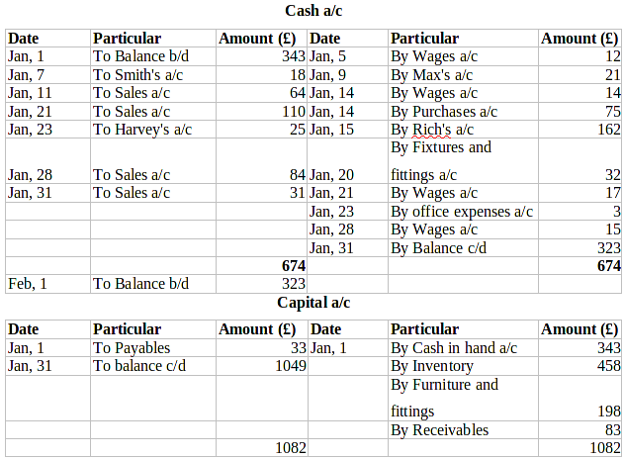
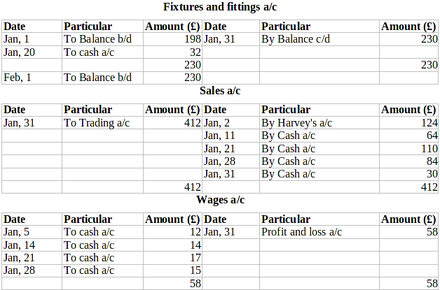
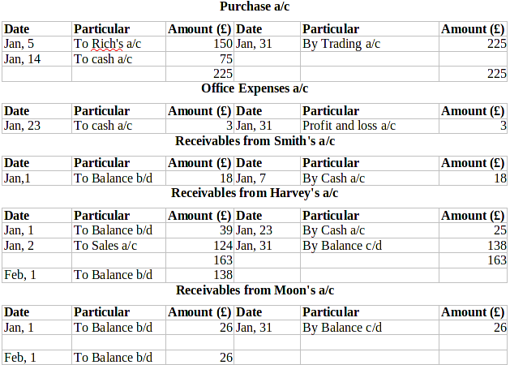
Payable to Max's a/c
Date | Particular | Amount (£) | Date | Particular | Amount (£)
Jan, 9 | To cash a/c | 21 | Jan 1 | By Balance b/d | 21
Payable to Rich's a/c
Date | Particular | Amount (£) | Date | Particular | Amount (£)
Jan, 15 | To cash a/c | 162 | Jan 1 | By Balance b/d | 12
 |  |  | Jan, 5 | By purchase a/c | 150
 |  | 162 |  |  | 162
Inventory a/c
Date | Particular | Amount (£) | Date | Particular | Amount (£)
Jan 1 | To Balance b/d | 458 | Jan, 31 | By Trading a/c | 458
Jan, 31 | To Trading a/c | 374 | Jan, 31 | By Balance c/d | 374
Feb, 1 | To Balance b/d | 374

b) Trial balance at 31st January of Mafuta
Trial Balance at 31 January
Particulars | Debit (£) | Credit (£)
Cash in hand a/c | 323 | -
Capital a/c | - | 1049
Fixtures and fittings a/c | 230 | -
Sales a/c | - | 412
Wages a/c | 58 | -
Purchase a/c | 225 | -
Office expenses a/c | 3 | -
Receivables a/c | - | -
Harvey | 138 | -
Moon | 26 | -
Inventory a/c | 458 | -
 | 1461 | 1461
Profit and loss statement and financial position statement at 31st January of Mafuta
Statement of Profit and Loss
For the month ended 31 January
Particulars |  | Amount (£)
Sales |  | 412
Less- Cost of goods sold |  | 309
Gross profit |  | 103
Less – Expenses
Wages | 58
Office Expenses | 3 | 61
Net Profit |  | 42
Statement of Financial position at 31 January
Particulars |  | Amount (£)
Non-current assets
Fixtures and fittings |  | 230
Current assets
Inventory | 374
Trade receivables (138+26) | 164
Cash | 323 | 861
Total Assets |  | 1091
Capital account | 1049
Add – Net Profit | 42 | 1091
Total Liabilities |  | 1091
Working Note:
Cost sale = Purchase + Opening inventories – Closing stock
= 458 + 225 – 374 = 309
TASK 4
Ledger accounts and recording of transactions

Date | Particular |  | Debit amount | Credit amount
02/06/18 | Claire a/c |  | 8500
 |  | To sales a/c |  | 8500
 | (Being sales are made)
13/06/18 | Purchase a/c |  | 12000
 |  | To Georgina |  | 12000
 | (Being purchase are made)
14/06/18 | Hywel a/c |  | 8550
 |  | To sales a/c |  | 8550
 | (Being sales are made)
20/06/18 | Cash a/c |  | 6000
 |  | To sales a/c |  | 6000
 | (being sales are made)
21/06/18 | Purchase a/c |  | 4500
 |  | To Andrew |  | 4500
 | (Being purchase are made)
22/06/18 | Sales return a/c |  | 1000
 |  | to Claire a/c |  | 1000
 | (Being sales return are made)
24/06/18 | Mandy a/c |  | 5000
 |  | To sales a/c |  | 5000
 | (Being sales are made)
24/06/18 | Cash a/c |  | 7125
 | Discount allowed a/c |  | 375
 |  | to Claire a/c |  | 7500
 | (Payment made by Claire)
25/06/18 | Cash a/c |  | 8550
 |  | To Hywel a/c |  | 8550
 | (Payment made to Hywel a/c)
 | Georgina |  | 12000
 |  | To Cash |  | 11160
 |  | To discount received |  | 840
 | (Payment made to Georgina)
27/06/18 | Andrew a/c |  | 4500
 |  | To discount received |  | 90
 |  | To cash |  | 4410
Ledger accounts
Sales a/c
Date | Particular | Amount (£) | Date | Particular | Amount (£)
30/06/18 | To Trading a/c | 28050 | 02/06/18 | By Claire | 8500
 |  |  | 14/06/18 | By Hywel | 8550
 |  |  | 20/06/18 | By cash | 6000
 |  |  | 24/06/18 | By Mandy | 5000
 |  | 28050 |  |  | 28050

Purchase a/c
Date | Particular | Amount (£) | Date | Particular | Amount (£)
13/06/18 | To Georgina | 12000 | 30/06/18 | By Trading a/c | 16500
21/06/18 | To Andrew | 4500
 |  | 16500 |  |  | 16500

Claire a/c
Date | Particular | Amount | Particular | Amount
02/06/18 | To sale | 8500 | By Cash | 7125
 |  |  | By discount allowed | 375
 |  | 8500 |  | 8500

Georgina a/c
Date | Particular | Amount (£) | Date | Particular | Amount (£)
25/06/18 | To Cash | 11160 | 13/06/16 | By Purchase | 12000
 | To Discount received | 840
 |  | 12000 |  |  | 12000
Hywel a/c
Date | Particular | Amount (£) | Date | Particular | Amount (£)
14/06/18 | To sales | 8550 | 25/06/18 | By cash a/c | 8550
 |  | 8550 |  |  | 8550
Andrew a/c
Date | Particular | Amount (£) | Date | Particular | Amount (£)
27/06/18 | To Cash | 4410 | 21/06/18 | By Purchase a/c | 4500
 | To Discount received | 90
 |  | 4500 |  |  | 4500
Cash a/c
Date | Particular | Amount (£) | Date | Particular | Amount (£)
20/06/18 | To sales | 6000 | 25/06/18 | By Georgian | 11160
14/06/18 | To Hywel | 8550 | 27/06/18 | By Andrew | 4410
24/06/18 | To claire a/c | 7125 | 30/06/18 | By Balance c/d | 6105
 |  | 21675 |  |  | 21675

Sales return a/c
Date | Particular | Amount (£) | Date | Particular | Amount (£)
22/06/18 | To claire a/c | 1000 | 30/06/18 | By Trading a/c | 1000
 |  | 1000 |  |  | 1000
Mandy a/c
Date | Particular | Amount (£) | Date | Particular | Amount (£)
24/06/18 | To sales | 5000 | 30/06/18 | By Balance c/d | 5000
 |  | 5000 |  |  | 5000

Discount allowed a/c
Date | Particular | Amount (£) | Date | Particular | Amount (£)
24/06/18 | To Claire | 375 | 30/06/18 | By P&L a/c | 375
 |  | 375 |  |  | 375
Discount Received account
Date | Particular | Amount (£) | Date | Particular | Amount (£)
30/06/18 | To P&L | 930 | 25/06/18 | By Georgina | 840
 |  |  | 27/06/18 | By Andrew | 90
 |  | 930 |  |  | 930

Trial balance
Particular | Debit amount | Credit amount
Sales |  | 28050
Purchase | 16500
Cash a/c | 6105
Discount received |  | 930
Discount allowed | 375
Sales return | 1000
Mandy | 5000
Total | 28980 | 28980

TASK 5
Demonstrate the difference between revenue and capital expenditure with reference to International accounting standard
Revenue expenditure: Revenue expenditure are those expenditure which are incurred on continuous or regular basis. In simple words, it includes those transaction which are incurred by business firm in its day to day activities such as printing, postage, stationery, wages and so on. These expenditures are incurred for short duration due to which the company gets its profit within a financial year (Dosamantes, 2013).
Capital expenditure: Unlike revenue expenditure, capital expenditure is made on the long-term basis. Within this business makes huge expenditure like installation of new machinery to enhance the capacity of production. These expenditures are simply made to enhance the profitability as well as productivity of the firm.
International Accounting Standard (IAS): International Accounting Standard Board that is IASB has issued International Accounting Standard (Brealey, Myers and Marcus, 2012). Their aim is to maintain transparency, make better comparison among various companies and enhance the trust of external parties such as creditor, government, investor, customer and so on to perform their business operations effectively. Universally applicable accounting standard such as IAS helps the company in lowering down their cost and improve the allocation of cash with the help of stakeholder of company such as investor.
Difference between Revenue expenditure as well as Capital expenditure based on International Accounting Standard

Basis of difference | Revenue expenditure | Capital expenditure
Objective | The primary objective of revenue expenditure is to carry on day to day activities of business smoothly. Due to which business incur this expenditure on daily basis so that the growth of business does not gets hampered. | The primary objective behind incurring long term expenditure is that company can expand their business, widen its reach and increase its productivity (Toms and Fleischman, 2015).
International accounting standard | Revenue expenditure must abide the criteria of international accounting standard of 18 and 39. | Capital expenditure must fulfil the criteria of accounting standard that is IAS 16.
Nature of respective international accounting standard | As per IAS 18 and 39 states that all the expenditure apart from capital expenditure comes under this category (Altma, Cizel and Rijken, 2014). Therefore, it includes only those expenditure which provide benefit in the current financial year as these expenditures are incurred for short duration. | As per IAS 16 the asset must provide economic benefit and the cost of respective asset must be calculated reliably. For instance, if business purchase an asset with the motive to resale it cannot be considered as capital expenditure. Similarly, if an asset requires repair work or maintenance work then these things cannot enhance the life of asset due to as per IAS 16 this repair or maintenance done on asset are again not part of capital expenditure.
Time period | These expenditures are made for specific period which is less than one year (Hoyle, Schaefer and Doupnik, 2018). This is done for running day to day production and sales process. | Within capital expenditure the expenditure is made for more than one year to capitalise the business. As business gets long term profit out of it.
Financial statement | Revenue expenditure are further posted in trading and profit or loss account (Bushman, 2016). | These types of expenditure are posted in balance sheet (Pilato and Ulrich, 2014).
Example | Expenditure incurred on rent, carriage, commission, insurance, printing charges etc. | Purchase of new building or plant, land, machinery, furniture and fixture (Kieso, Weygandt and Warfield, 2016). Apart from it also include expenditure made on intangible asset such as licence or patent.
CONCLUSION
From the above report its has been concluded that financial accounting is the significant part of organisation which is vital not only for external party but for internal party as well. The role of financial or accounting manager is to record all the monetary entries which are finally used for the preparation of balance sheet as well as income statement. To prepare these statement business follows appropriate accounting standard. Furthermore, it includes capital and revenue expenditure to produce long term as well as short term objective.

REFRENCES
Books and Journal
Hilton, R. W. and Platt, D. E., 2013. Managerial accounting: creating value in a dynamic business environment. McGraw-Hill Education.
Wright, C. J., 2017. Fundamentals of oil & gas accounting. PennWell Books.
Dosamantes, C. A. D., 2013. The relevance of using accounting fundamentals in the Mexican stock market. Journal of Economics Finance and Administrative Science. 18. pp.2-10.
Brealey, R. A., Myers, S. C. and Marcus, A. J., 2012. Fundamentals of corporate finance. McGraw-Hill/Irwin,.
Toms, S. and Fleischman, R. K., 2015. Accounting fundamentals and accounting change: Boulton & Watt and the Springfield Armory. Accounting, organizations and Society. 41. pp.1-20.
Altman, E. I., Cizel, J. and Rijken, H. A., 2014. Anatomy of bank distress: the information content of accounting fundamentals within and across countries.
Hoyle, J. B., Schaefer, T. F. and Doupnik, T. S., 2018. Fundamentals of advanced accounting. McGraw-Hill Education.
Kieso, D. E., Weygandt, J. J. and Warfield, T. D., 2016. Intermediate Accounting, Binder Ready Version. John Wiley & Sons.
Pilato, B. and Ulrich, M. M., 2014. Is the Case Study Method an Effective Pedagogical Method for Students to Learn the Fundamentals of Financial Accounting? ASBBS Proceedings. 21(1). p.541.
Bushman, R. M., 2016. Transparency, accounting discretion, and bank stability. Economic Policy Review, Issue Aug, pp.129-149.

