STUDENT NAME: Sunitha Peeter
STUDENT NUMBER: 2421161
LECTURER NAME: Tsivani Kumalo
MODULE TITLE: PRINCIPLES OF HEALTH AND SOCIAL CARE PRACTICE
COMPONENT 1: WRITTEN ASSIGNMENT (REFLECTIVE REPORT)
MODULE CODE: BMHP5016

Table of Contents
Component 1 3
Introduction 3
Task 1: Reflection on Importance of Principles 3
Task 2: Practical examples of concepts 6
Task 3: Reflection on experience 7
Conclusion 9
References 10

Component 1

Introduction
Core principles of healthcare practices consists of ensuring person-centred care along with implementation of ethical standards. The purpose of the report is to highlight key components of healthcare using real-life case studies which has applied medical ethics and partnership working. It will explore the necessity of applying people or person-centred care, partnership or collaborative working, and ethics in real-life practice, with a focus on the case study of John. Additionally, the report analyses the ways principles of health and social care influence quality along with person-centred care. The report has conducted a case study analysis on Joan, a patient with Chronic Obstructive Pulmonary Disease (COPD) which affects her day-to-day activities. Assessing the case study, the report explores the importance of factors such as partnership working and person-centred care across the UK healthcare sector.

Task 1: Reflection on Importance of Principles
1. Defining principles
A person-centred approach is a collaborative, respectful approach that aims at increasing healthcare outcomes and boosting patients’ satisfaction. A person-centred approach helps to develop a foundation of effective partnership working to develop coordinated care (Schick-Makaroff et al. 2025). Person-centred care approaches put stress on fostering indisputable communication among professionals to deliver quality and personalised treatment facilities to care seekers. On the other hand, Person-centred care (PPC) is a healthcare approach in which each individual is treated as equal partners, tailoring services according to the unique values, preferences, and needs rather than providing generalised treatment (Lee et al. 2022). Partnership working refers to the strategy of integrating the potential of team members to achieve success in managing ethics. The principle of person-centred care provides an opportunity to manage ethical aspects (Furmenti et al. 2025). According to Andersson et al. (2022), ethics plays an important role in health and social care, as neglecting ethical values leads to causing moral harm and injury to patients. Therefore, complying with ethical principles are crucial to drive person-centred care and partnership working
2. Explain the significance to health and social care
Maslow and Bronfenbrenner's theory provide guidelines to develop a holistic framework of support with an understanding of the impact of external factors. Individual care in health and social care helps to maintain collaboration in the team and creates a scope for ethical decision-making. Based on Carroll et al. (2025), Maslow’s Hierarchy of Needs has proposed that building motivation depends on needs such as “physiological”, “safety”, “a sense of belonging”, “esteem” and “self-actualisation”. Linking the theory with partnership working, driving motivation for collaboration and coordination involves providing job security to healthcare professionals and meeting needs related to burnout and fatigue. On the other hand, Amali et al. (2023) highlighted that Bronfenbrenner ecological systems theory emphasises on microsystem, macrosystem, mesosystem, exosystem, and macrosystem. Aligning the principles of the theory with patient-centred care, healthcare professionals are required to interact with the adjacent environment of Joan that is part of the microsystem. The Care Act 2014 provides regulatory support to ensure consistency in care and promote well-being (Legislation.gov.uk, 2024). The currency of the information is recent, creating an opportunity to improve healthcare outcomes and to understand the healthcare support system in the study.
The concept of Maslow’s Hierarchy of Needs can be meaningful in diagnosing and getting to know the precise needs of John that were diagnosed with Chronic Obstructive Pulmonary Disease (COPD). In this case, the needs of John can be considered to be dealing with breathlessness and fatigue (physiological needs), safety by taking medication and checking breathlessness attacks (safety needs), social interaction despite the limited activities (love and belonging) and supporting his well-being and quality of life (self-actualisation). Considering the observations of Giuffrida and Davila (2024), a Maslow framework allows healthcare providers to identify the gaps in care, reduce risks, and increase patient safety by systematically fulfilling these layer needs. Thus, the implementation of the hierarchy as suggested by Maslow is likely to inform the efficient provision of the person-centred care (PCC) to John so that his physical, psychological, and social needs are fulfilled in an integrated manner.
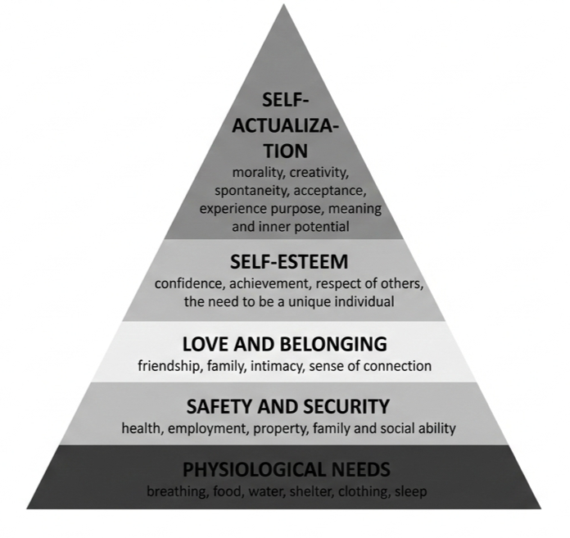
Figure 1: Key dimensions of Maslow’s Hierarchy of Needs Framework
(Source: Influenced by Giuffrida and Davila, 2024)
3. Benefits and challenges
Benefits
A key benefit of implementing person-centred care involves improving patient outcomes such as higher adherence to treatment along with better quality-of-life. The benefits of implementing person-centred care are an increase in quality of life, a reduction of depression, and an enhancement of the morale of staff (Sakharanget al. 2025). Ethical provisions help in increasing the authenticity of decision-making, and implication is found in reaching the desired success.
Challenges
Resource limitations are one of the key challenges that threatens effective integration of person-centred care, as it leads to staff shortages and inadequate training. Challenges observed in terms of principles of “person-centred care”, partnership working, and ethics are resource and staff shortage, and structural barriers (Nieuwenhuis et al. 2025). In the UK, focus is given on increasing feedback mechanisms and providing an opportunity to achieve success in quality of care.

Task 2: Practical examples of concepts
1. Real-world case study
These aspects, person-centred care, partnership working and ethical practise are effectively used in the case study of John with Chronic Obstructive Pulmonary Disease (COPD). The respiratory specialist who was put under the care of John recommended that regular care support would aid the patient to meet the demands of a community environment. The Care Quality Commission has applied the NICE Guidelines that focus on nine mandates to achieve high-quality health services (Cqc.org.uk, 2022). The relevance of the guideline lies in the determination of quality in the person-centred care approach. Assessing the case study, an instance that highlights application of partnership working involves collaboration between therapy team and General Practitioner. NICE Guidelines that are applied by the Care Quality Commission focus on nine mandates that should be achieved to attain high-quality health services (Cqc.org.uk, 2022).
2. Explaining the impact of the three principles
Three principles are used in person-centred care to transform care and achieve better healthcare outcomes, increase patients’ satisfaction, and foster trust in the care system (Bäckman et al. 2025). Authority of the information determines the benefits of implementing a person-centred approach in health and social care. A key impact of the partnership working on service users involves improved quality care due to collaboration between different healthcare professionals. Based on Khatri et al. (2023), continuity of care is a key aspect that depends on coordination between healthcare professionals. Additionally, partnership working drives influence healthcare professionals by increasing shared responsibility and knowledge to tackle complex challenges of patients. On a similar note, Jeyaraman et al. (2023) mentioned that adoption of ethics has strengthened with the integration of AI across healthcare. In this regard, ethics influence service users by protecting rights and autonomy, while it also increases trust in healthcare professionals. For instance, the Health and Care Act 2022 prioritise collaboration over competition, especially to deliver joint-care (UK Legislation, 2022). As a result, complying with the Act, healthcare professionals deliver collaborative person-centred care to Joan, which reduces medical errors and improves quality-of-life.
3. Challenges
Staff shortage, time constraint, and high rate of turnover are three major barriers observed in the implementation of “person-centred care in the UK setting”. The “Health and Care Act 2022” focus on integrating relevant practical measures to determine a better quality of treatment (Legislation.gov.uk, 2022). The accuracy of the legislation provides guidelines to ensure alignment with healthcare support planning. Management of patients’ autonomy is the purpose behind the identification of healthcare challenges. Despite the benefits, multiple challenges are observed due to time constraints, infrastructural gaps, and a lack of human resources.
Strategy to overcome
It is recommended to work on the issue of staff shortage and increase investment in infrastructure to get better healthcare outcomes, along with understanding patients’ autonomy. Implementation of ethical principles provides an opportunity to deal with the constraints and achieve desired success (Damant et al. 2026). The purpose of the strategy is to increase the quality of support in alignment with NICE Guidelines to achieve success in healthcare support.

Task 3: Reflection on experience
Gibbs Reflection
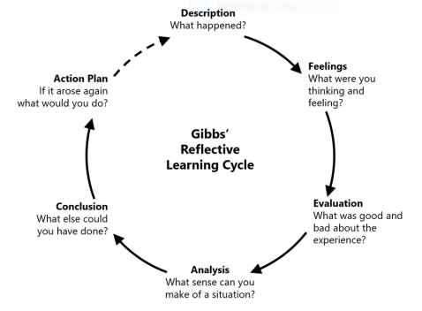
Figure 1: Gibbs Reflective Cycle
(Source: Beldar, 2025)
Description
A key experience regarding my role as a healthcare professional involves addressing patient’s needs, supervising teams and collaborating with different practitioners. In this context, I have applied ethical principles of respecting patient autonomy along with focusing on beneficence to provide maximum support to the patient. Practical application of strategic measures is necessary to address the challenges observed in maintaining responsibility (Furmenti et al. 2025). I observed that I lack coordination and time management skills that eventually disrupt the entire process.
Feeling
Reflecting on the practical experience in partnership working, I found myself less confident due to my skill gap in teamwork and time management. Managing ethics in practice depends upon the level of coordination observed among team members (Witte et al. 2025). I have often experienced negative emotions due to challenges faced while managing team-based conflicts and difficulties applying ethical principles during moral dilemmas. Lastly, I have also faced positive feelings during partnership working in healthcare due to clear and respectful communication with team members.
S-Strengths  - Open communication  - Ability to deliver care to patients | W-Weaknesses  - Poor teamwork skills  - Low time management competencies
O-Opportunities  - Focus on enhancing interpersonal relationships with patients  - Minutely understanding patients’ needs | T-Threats  - Conflicts with team members  - Delays in task completion
Table 1: Personal SWOT
(Source: Developed by Author)
Evaluation
In reference to my experience as a health and social care professional, I have found it difficult to manage ethics and coordination in partnership working. For example, practical skill development is associated with the strategy of collaboration, and consequences are observed in reaching the desired goal (Hagendijk et al. 2025). In this context, I can mention that my limitations in ethical management and coordination have affected my partnership working abilities, especially on wider and diverse groups. According to Topp et al. (2022), gaining patients’ confidence in healthcare systems involves adopting different communication mechanisms to create a sense of belonging. As a result, assessing positive emotions, I have found my ability to openly communicate and interact with users that assists in trust-building.
Analysis
I have found strength in terms of understanding guidelines and the authentic strategy of policy implementation in person-centred care. As per McLaney et al. (2022), interprofessional collaboration in healthcare supports person-centred care and reduces medical errors. In this regard, a lack of collaboration skills is negatively influenced by the ability to deliver effective partnership working or address patients’ needs. Assessing my strengths, I can further mention that apart from complying with guidelines, I have potential to interact with patients and be part of a diverse community.
Conclusion
Reflecting on my strengths and weaknesses, I believe building coordination and time management skills is crucial to enable partnership working and person-centred care. Lastly, I aim to strengthen my knowledge and application of ethical guidelines by building critical thinking skills.
Action plan
Areas of improvement | Strategy to improve | Timeframe
Coordination skill | Clear delegation of responsibility, taking assistance of technological tools. | 3 months
Time management skill | Divide the task into small segments and set a deadline for each task | 2 months
Critical thinking skill | Building open-mindedness and reading diverse perspectives to strengthen evidence-based reasoning | 3 months
Table 2: Action Plan
(Source: Self-developed)

Conclusion
It can be concluded from the above evaluation that the quality of care is linked with the adoption of an authentic strategy of professional development. Three principles, such as person-centred care, partnership working, and ethics, create an opportunity to achieve success in fulfilling the desired objectives. Partnership working supports quality care by improving patients' ability to receive continuous care and strengthening mutual collaboration between team members. Additionally, person-centred care effectively addresses complex needs of patients and enables trust among healthcare professionals. Lastly, compliance with ethics ensures that use of AI and other healthcare tools follows guidelines such as data privacy while healthcare professionals are focusing on maintaining patients’ autonomy. Thus, adhering to ethics and building skills such as collaboration enables improved engagement and meeting different needs of patients.

References
Component 1
Amali, N.A.K., Ridsuan, M.U.M., Rahmat, N.H., Seng, H.S. and Mustafa, N.C., (2023). Exploring learning environment through Bronfenbrenner’s ecological systems theory. Journal of Academic Research in Progressive Education and Development, 12(2), pp.144-162.
Andersson, H., Svensson, A., Frank, C., Rantala, A., Holmberg, M. and Bremer, A., (2022). Ethics education to support ethical competence learning in healthcare: an integrative systematic review. BMC medical ethics, 23(1), p.29.
Bäckman, H., Lindkvist, M., Niklasson, J. and Backman, A., (2025). ‘Health and Quality of Life in Nursing Homes: A Repeated Cross‐Sectional Study on the Impact of Leadership and Person‐Centred Care’. Nursing Open, 12(7), p.e70283.
Beldar, P.R., (2025). ‘Case Study: Enhancing Learning in C Programming Through Gibbs Reflective Cycle’. Journal of Engineering Education Transformations, pp.61-68.
Carroll, A., Collins, C. and McKensie, J., (2025). Physician wellbeing in a national rehabilitation hospital, a qualitative study utilising Maslow’s hierarchy of needs as a framework for analysis. BMC Health Services Research, 25(1), p.175.
Cqc.org.uk (2022) Person-centred Care. Available at:https://www.cqc.org.uk/publications/themed-work/inpatient-coronavirus-experience-care(Accessed: 31 January 2026)
Damant, J., Hamashima, Y., Toma, M., Smith, N., Taylor, J., Caprioli, T., Jasim, S., Prato, L., Mcleod, H., Giebel, C. and Peters, M., (2026). ‘Investigating Person‐Centred Care Planning in Care Homes Across England: An Exploratory Study of Practices and Contextual Factors’. Journal of Advanced Nursing, 82(1), pp.617-631.
Furmenti, M.F., Bertarelli, G. and Ferrè, F., (2025). ‘Person-centred care in oncological home services: a scoping review of patients’ and caregivers’ experience and needs’. BMC health services research, 25(1), p.232.
Furmenti, M.F., Bertarelli, G. and Ferrè, F., (2025). ‘Person-centred care in oncological home services: a scoping review of patients’ and caregivers’ experience and needs’. BMC health services research, 25(1), p.232.
Hagendijk, M.E., Sipfel, N., Melles, M., van der Wees, P.J., Hulshof, C.T., Çölkesen, E.B., Hoving, J.L. and van der Burg-Vermeulen, S.J., (2025). ‘Towards person-centred work-focused healthcare for people with cardiovascular disease: a qualitative exploration of patients’ experiences and needs’. Disability and Rehabilitation, 47(1), pp.194-206.
Jeyaraman, M., Balaji, S., Jeyaraman, N. and Yadav, S., (2023). Unraveling the ethical enigma: artificial intelligence in healthcare. Cureus, 15(8).
Khatri, R., Endalamaw, A., Erku, D., Wolka, E., Nigatu, F., Sewdie, A. and Assefa, Y., 2023. Continuity and care coordination of primary health care: a scoping review. BMC Health Services Research, 23(1), p.750.
Legislation.gov.uk (2022) Health and Care Act 2022. Available at: https://www.legislation.gov.uk/id/ukpga/2022/31 (Accessed: 31 January 2026)
Legislation.gov.uk (2024) Care Act 2014. Available at: https://www.legislation.gov.uk/ukpga/2014/23/contents (Accessed: 31 January 2026)
McLaney, E., Morassaei, S., Hughes, L., Davies, R., Campbell, M. and Di Prospero, L., 2022, March. A framework for interprofessional team collaboration in a hospital setting: Advancing team competencies and behaviours. In Healthcare management forum (Vol. 35, No. 2, pp. 112-117). Sage CA: Los Angeles, CA: SAGE Publications.
Nieuwenhuis, S., Nijs, S. and Maes, B., (2025). ‘Person-Centred Care for People with Profound Intellectual and Multiple Disabilities: A Rapid Review’. Journal of Long-Term Care, 2025, pp.110-126.
Sakharang, W., Ellis-Smith, C., Senanarong, V., Aworinde, T., Chen, L. and Evans, C., (2025). ‘90 Implementation of person-centred outcome measures (PCOMS) to support assessment and care for people with dementia: a mixed-method systematic review’. BMJ Supportive & Palliative Care, 15(Suppl 2), pp.A42-A42.
Schick-Makaroff, K., Berendonk, C., Salum, M., Yoeun, P., Wichart, J., Armstrong, M., Thompson, S., Elliott, M., Lee, L., Smith, T. and Reintjes, F., (2025). ‘Developing and tailoring a person-centred pathway for mental health care for people receiving dialysis’. Nephron, 149(7), pp.392-410.
Topp, S.M., Tully, J., Cummins, R., Graham, V., Yashadhana, A., Elliott, L. and Taylor, S., (2022). Building patient trust in health systems: A qualitative study of facework in the context of the Aboriginal and Torres Strait Islander Health Worker role in Queensland, Australia. Social Science & Medicine, 302, p.114984.
Witte, L.E., van Diepen, C. and Cramm, J.M., (2025). ‘Beyond BRCA: A scoping review of person-centred care for women diagnosed with a BRCA gene mutation’. BMJ open, 15(3), p.e094416.
Lee, K.H., Lee, J.Y. and Kim, B., (2022) ‘Person-centered care in persons living with dementia: A systematic review and meta-analysis’. The Gerontologist, 62(4), pp.e253-e264.
Giuffrida, P. and Davila, S., (2024). Addressing nursing shortages and patient safety using Maslow's hierarchy of needs. Nursing2025, 54(1), pp.35-40.

