Gabriella Harris
University of Wales Trinity Saint David
Secondary PGCE Religion, Values and Ethics
Student Number: 2205862

How a school develops one aspect of its SDP: a report that critically reflects on the actions, impact and evidence base.

Word count: 2732

Personal Targets

Target | What have I done in this assignment?
‘Please ensure you revise your referencing so that you are not including page numbers when they are not required.’ | I have studied the Harvard Referencing Guide in order to ensure my referencing is accurate throughout.

Introduction

This assignment will be looking at a departmental School Development Plan (SDP) from School X and analysing how the school developed a particular action point from an objective. The objective that will be the focus of discussion will be ‘objective 2: raise aspirations and improve outcomes for boys at GCSE Religious Studies’ specifically looking at action point one ‘develop the KS3 and KS4 scheme of work to include topics and activities which boys may engage with’ (Appendix 1). Throughout, the ethical guidelines outlined by the British Educational Research Association (BERA) will be adhered to (BERA, 2018). The school, its staff and its students will be anonymised throughout. The school will be referred to as ‘School X’ and staff will be referred to as ‘Teacher X’ and ‘Headteacher X.’ The relevant section of School X’s SDP can be found in the appendices at the end of the assignment (Appendix 1). School X is a 3-16 school situated in a deprived area of South Wales where 1400 pupils are on roll. In the secondary sector, 26.8% of students are eligible for free school meals which is above average for the local authority (23.1%) and Wales’ national average (20.4) (Estyn, 2022).

School Development Plans

In 2014, the Welsh Government produced a document called School Development Plans which provides guidance on what the purpose of a SDP is and the stages involved in producing an effective SDP (Welsh Government, 2014). However, in 2022 the Welsh Government replaced this guidance with a new document called School Improvement Guidance. This new document was produced in line with the introduction of the Curriculum for Wales, specifically the importance it places on pupil progression and well-being (Welsh Government, 2022). Although the two documents have their distinctions, the steps for producing an effective SDP remain almost identical. Both documents outline the importance of self-evaluation, data analysis, stake-holders, strategies and measuring impact (Welsh Government, 2014) (Welsh Government, 2022). It could be said that due to this, both documents are still relevant for the discussion of developing an SDP’s.

In their 2014 SDP guidance, the Welsh Government described an SDP as being a ‘school’s strategic plan for improvement’ (Welsh Government, 2014 p.3). An SDP is produced through a self-evaluation process where the school considers its strengths and areas it may need to improve on. This self-evaluation process leads to the school determining improvement priorities which will include strategies on how the school will reach its objectives. This usually includes information regarding the time scale of each target and the costs associated with them. Once these priorities have been established, the school must consider how it is going to measure the impact, such as who is in charge of reviewing the SDP, how often will it be reviewed and how they will establish its effectiveness (Welsh Government, 2014; Welsh Government, 2022). The purpose of an SDP is for the school to share its vision to its stakeholders and what it intends on doing to make that vision a reality (Fernandez, 2011).

The creation of a SDP has links to schools as learning organisations. On the podcast Education Wales, headteacher Jenny Scott (2019) discusses how all staff at her school completed questionnaires regarding staff perceptions of the school. The school also included other stakeholders such as parents, pupils and community and all of this data informed the school’s vision for improvement. Jenny Scott believed that by including stakeholders, everyone became invested in the vision and were more aware on how the school will improve (Bubbins and Scott, 2019). Schools as learning organisations means it supports schools to adapt to change which allows schools to continually self-assess and therefore improve (OECD, 2018).

Raising Aspirations and Improve Outcomes for Boys

‘Develop the KS3 and KS4 scheme of work to include topics and activities which boys may engage with’

As stated in the introduction, the objective from School X’s Religious Studies departmental SDP that will be the focus of the assignment is ‘raise aspirations and improve outcomes for boys at GCSE Religious Studies’ specifically looking at the action point ‘develop the KS3 and KS4 scheme of work to include topics and activities which boys may engage with’ (Appendix 1).

Since the 1990’s, the academic attainment of boys in education has been a major concern in countries around the world, including the United Kingdom (Skelton, 2001). In the UK, girls are continuing to receive better GCSE results than boys confirming an achievement gap between the genders (Paton, 2013). There has been much debate over the best ways to raise aspirations and improve outcomes for boys. One suggestion has been for schools to change the curriculum to include topics and themes that may appeal to boys. There are positives and negatives to using this approach which will be discussed throughout.

It has been suggested that boys will perform better if they are interested in the topic they are studying (Taylor, 2004). Students who are interested are actively involved in the class work and will feel confident and knowledgeable. Interest is an imperative aspect of teaching and learning as it allows students to practice an enhanced level of attention and concentration (Mazer, 2013). As there are benefits to students being interested in the topic they study, it is vital that interests are addressed so a positive learning environment can be established. Brozo (2001), suggests if teachers want to grab the attention of boys then teachers should focus on topics with ‘traditional male appeal’ such as sport (Brozo, 2001 p.323).

However, this has been criticised as every child should be treated as an individual with a unique personality and set of interests. It could be stereotypical to determine that all boys would be interested in a subject if it covered topics such as sport. In order for teachers to target the interests of their students to enhance their aspirations and improve their outcomes, they must know their students on a personal level (Heyder & Kessels, 2013). It has also been proposed that students are given a choice of topics to work on so they are given control over the work they are completing. When students have ownership over their learning it promote positivity and enhance achievement (Chan et al., 2014).

Although there is evidence to suggest that being interested in a topic has strong links to a heightened level of attention which may result in greater levels of attainment, Mills and Keddie (2007) argue that by appealing to only their interests will limit their exposure to other ideas. This is especially the case when teaching working class students as it does not allow them to build cultural capital. Sociologist Pierre Bourdieu (1987) argued that cultural capital is built through having access to particular skills, knowledge and behaviours that are highly esteemed in society. Bourdieu (1987) states that the wealthier your parents are the more likely you are to have cultural capital, and therefore working class children are more disadvantaged. Students need to be exposed to topics and ideas outside of their scope in order to build cultural capital, so teaching them topics they are already familiar with or are interested in may result in having unintended negative consequences (Pinkett and Roberts, 2019).

In conclusion, implementing students interests into the classroom does have its benefits, including improving the attention and engagement of pupils which can lead to higher attainment levels. However, teachers must be careful not to group boys together as one by reinforcing masculine stereotypes. This could be achieved by knowing students on a personal level and by giving boys the option over what topics they would like to study. Although this can be a positive teaching technique, all students deserve to be exposed to a multitude of topics and themes in order to build their cultural capital. This is especially important for working class students who may already be disadvantaged in this area due to the socioeconomic background of their parents.

Developing an Action Point

The SDP guidance produced by the Welsh Government (2014) outlined how schools should produce an SDP effectively. The guidance suggests that schools should follow a step-by-step process which is displayed in the form of a cycle (see Figure 1).
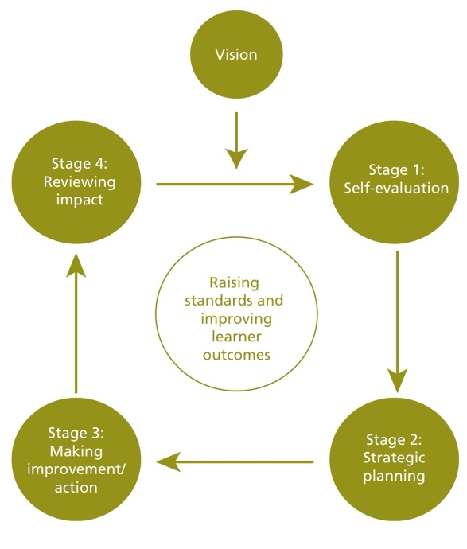

Figure 1: School Development Planning Cycle (Welsh Government, 2014)

As discussed previously, this document is still relevant and many schools may still use it for advice on effective development planning. School X follows the cycle established by the Welsh Government (2014) for their whole school development plan and their departmental development plans (Headteacher X, 2023). The topic of this section will be the departmental development plan from the religious studies department at School X. The information was provided through personal correspondence with Teacher X (2023) who is head of the religious studies department at School X.

Stage 1: Self-Evaluation

The first step refers to how School X identified this objective and action point. The quantitative data showed that even though there are 329 male students across year 9, 10 and 11 and only 301 female students, the number of girls choosing to study religious studies at GCSE was substantially more than the boys. Only 10% of the religious studies GCSE cohort were boys, and of that 10% the majority of which were working below their target grade. Teacher X also explained that she used qualitative data from pupil voice as she had experience boys making comments such as ‘religious studies is pointless because I am not religious’ on a regular basis from some students in all year groups (Teacher X, 2023). Even though Teacher X involved staff and pupils in order to make a decision, it may have been even more beneficial to involve other stakeholders such as parents and the community. The Welsh Government (2021) suggest that the self-evaluation process is most effective when the school involves as many stakeholders as possible (Welsh Government, 2021).

Stage 2: Strategic Planning

From the data, Teacher X determined that one of her objectives for her departmental development plan would be ‘raising aspirations and improve outcomes for boys’, and one of the ways they would achieve this is to ‘develop the KS3 and KS4 scheme of work to include topics and activities which boys may engage with’ (Appendix 1) (Teacher X, 2023). Teacher X explained that she then needed to start strategically planning how the action point was going to be achieved. Teacher X and other staff members from the department, decided on four strategies that would allow them to achieve their action point (see Appendix 1). The development plan outlines which member of staff is responsible for which strategy as Teacher X believed that if the work is divided up throughout the department, each strategy becomes more manageable and achievable (Teacher X, 2023). Although there will be some financial costs in implementing the strategies, most of the costs will revolve around time. By implementing these strategies effectively, the department have concluded that there will be two intended outcomes: ‘higher proportion of male students opting for GCSE Religious Studies’ and a ‘higher proportion of male students achieving their target grade at GCSE’ (Appendix 1).

Stage 3: Making Improvement/Action
The development plan has two progress reviews, one of which has been completed. So far the year 7 and year 8 pupils have completed a Microsoft Forms questionnaire regarding the religious studies curriculum and fed back their views on how they best learn and the topics that they would and would not like to study in the subject. As stakeholders, it is important for the students voices to be heard and regarded as important (Welsh Government, 2021). The department has begun to include more competition in the KS3 and KS4 lessons through the use of Kahoot quizzes. The year 8 curriculum is in the process of being updated and it is intended that further competition will be introduced by the next progress review. They have also begun to implement a wider range of independent learning and problem solving activities in KS4 which is ongoing. However, they have addressed that Teacher X needs to speak with heads of other humanities subjects to develop strategies to improve the performance of boys at GCSE level (Teacher X, 2023). Teacher X and her department have clearly reflected on the work they have done so far and have established what still needs to be done in order to achieve their action point.

Stage 4: Reviewing Impact

As the action point is addressing issues regarding boys attainment levels at GCSE and the number of boys opting for GCSE religious studies, the majority of the data can only be reviewed at particular points throughout the year. In the development plan, it states that they will review the impact of their action point and strategies during GCSE data drops and departmental meetings but the most effective data will come from GCSE results and GCSE option choices. They will know that their development plan has been effective if boys are meeting or exceeding their target grades at GCSE level and a higher percentage of boys choose religious studies as one of their GCSE options. This data has not been collected yet due to the time of year, however, it will be collected at the end of the academic year after their second progress review (Teacher X, 2023). By having progress reviews in place, it shows that School X is aware of the importance of a SDP being a live document that is continually being reviewed in order to have the best possible outcomes.

Reflection and Evaluation

By following the structure and cycle outlined by the Welsh Government (2014), it shows that School X understands that SDP’s require a step by step process and careful planning on order to be effective. However, after a conversation with both Headteacher X and Teacher X, it is believed that the majority of their planning came from the 2014 Welsh Government guidance (Headteacher X, 2023; Teacher X, 2023). It may be valuable for School X to engage more with the Welsh Governments new guidance released in 2022 to ensure their SDP is in line with the Curriculum for Wales. For example, the guidance outlines eight factors that schools should be aware of which support reform and which, where absent, are expected to act as obstacles to improvement (Welsh Government, 2022).

The objectives and action points decided by School X were determined after substantial self-evaluation and data analysis, and their action point will have a positive impact according to particular literature. It states that if students are interested then they are more likely to be engaged, and engagement will likely result in achievement (Mazer, 2013). However, there is literature that may criticise the action point. For example, in their book Boys Don’t Try Pinkett and Roberts (2019) believe that limiting the curriculum for it to appeal to boys may be doing more harm than good as it enables their cultural capital to grow (Pinkett and Roberts, 2019). It is unsure whether School X is aware of this possible limitation but it may be useful to engage with such literature in order to inform their future practice.

It is clear to see that School X recognises the importance of a SDP being a live document. This means that the document is continually being reviewed and evaluated. There are two formal progression reviews regarding the whole document during the year, but they have also included individual reviews for each strategy at pivotal points throughout the year such as after data drops and option selections. Alongside this, all staff in the department have contributed to the document and have a personal responsibility for at least one of the strategies. Teacher X decided to do this as she believes that it makes each strategy more achievable (Teacher X, 2023).

Conclusion

To conclude, this assignment has discussed what an SDP is and the processes behind how it is developed effectively. It has analysed how School X has developed one aspect of its religious studies development plan which critically reflected on the actions, impact and evidence base. The literature review has given me a deeper understanding of SDP’s and the topic of underachieving boys. By undertaking the literature review I am now aware of how important it is to research particular topics in order to make informed decisions in my future practice. Through my research I have been able to examine the government documents regarding development planning which will positively impact me professionally in the future. This assignment has also brought to my attention how important it is to be aware of SDP’s and to be actively involved in the document in order for it to have the greatest positive impact on the students and the school. In future research, I would like to look further into the new eight factors outlined in the 2022 Welsh Government guidance in order to ensure SDP’s are in line with the Curriculum for Wales (Welsh Government, 2022).

Reference List

Bourdieu, P., (1987). Distinction: A social critique of the judgement of taste. Harvard university press.

Brozo, W.G. (2002). To be a boy, to be a reader. Newark, DE: International Reading Association

British Educational Research Association [BERA] (2018) Ethical Guidelines for Educational Research, fourth edition, London.

Bubbins, M., & Scott, J., (2019) Exploring Schools as Learning Organisations. Education Wales. Available at: https://www.spreaker.com/user/bengomedia/acew-slo-english-edit-2 [Accessed on April 1st 2023]

Chan, P.E., Graham-Day, K.J., Ressa, V.A., Peters, M.T. and Konrad, M., (2014). Beyond involvement: Promoting student ownership of learning in classrooms. Intervention in School and Clinic, 50(2), pp.105-113.
Estyn (2022). Anonymity.. https://www.estyn.gov.wales/system/files/2022-11/Inspection%20report%20
Estyn (2020). Including all staff in the self-evaluation process. Available at: https://www.estyn.gov.wales/effective-practice/including-all-staff-self-evaluation-process [Accessed on April 10th 2023]
Fernandez, K.E., (2011). Evaluating school improvement plans and their affect on academic performance. Educational Policy, 25(2), pp.338-367.

Heyder, A. and Kessels, U., (2013). Is school feminine? Implicit gender stereotyping of school as a predictor of academic achievement. Sex Roles, 69(11-12), pp.605-617.

Headteacher X (2023). Conversation with Gabriella Harris, March 24th

Joseph P. Mazer (2013) Validity of the Student Interest and Engagement Scales: Associations with Student Learning Outcomes, Communication Studies, 64:2, 125-140
Mills, M. & keddie, A. (2007) ‘Teaching boys and gender justice’, International Journal of Inclusive Education, 11:3, pp. 335–354.

OECD (2018). Developing Schools as Learning Organisations in Wales, Implementing Education Policies, OECD Publishing Paris

Paton, G. (2012): “Girls stretch to record lead over boys.” Available at: https://www.telegraph.co.uk/education/educationnews/10260163/GCSE-results-2013-girls-%20stretch-to-record-lead-over-boys.html

Pinkett, M. and Roberts, M., (2019). Boys Don't Try? Rethinking Masculinity in Schools. Routledge.

Skelton, C., (2001). Schooling the boys (pp. 199-217). Buckingham: Open University Press.

Taylor, D.L., (2004). “Not just boring stories”: Reconsidering the gender gap for boys. Journal of Adolescent & Adult Literacy, 48(4), pp.290-298.

Teacher X (2023). Conversation with Gabriella Harris, March 24th

Welsh Government (2014). School Development Plans. Available at: https://www.gov.wales/sites/default/files/publications/2018-03/school-development-plans.pdf [Accessed April 5th 2023]

Welsh Government (2021). Engaging with Stakeholders. Available at: https://hwb.gov.wales/evaluation-improvement-and-accountability/the-national-resource-evaluation-and-improvement/evaluation-and-improvement-principles/engaging-with-stakeholders/ [Accessed on April 1st 2023]

Welsh Government (2022). School improvement guidance: framework for evaluation, improvement and accountability. Available at: https://hwb.gov.wales/evaluation-improvement-and-accountability/school-improvement-guidance-framework-for-evaluation-improvement-and-accountability [Accessed April 5th 2023]

Appendices

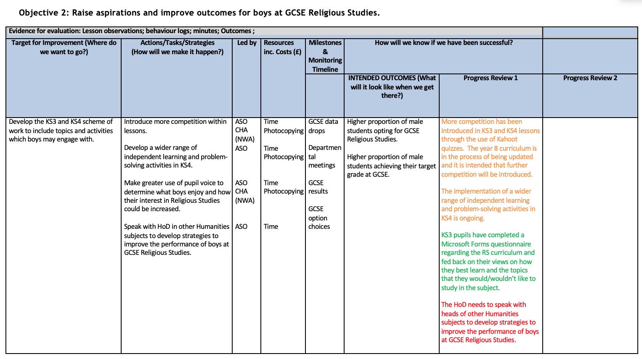
Appendix 1: An extract from School X’s Religious Studies Departmental Development Plan

