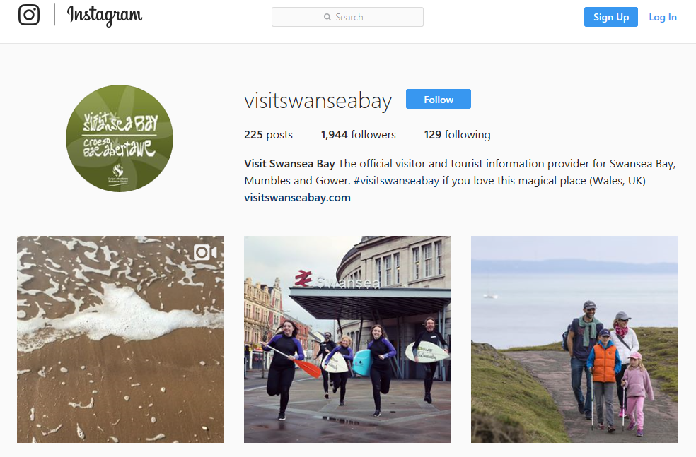

Consultancy Project Visit Swansea Bay
Instagram
Report

An investigation focusing on how to get Visit Swansea Bay more active on Instagram

Jessica Harrison | P140704 | 2nd May 2018
Lucy Vincent, Geraldine Williams | Confidential | Tourism & Marketing Officers | @swansea.gov.uk

- Acknowledgements

This will be dedicated to the thanks of Swansea Council, Tourism and Marketing team at the Guildhall, for passing on any information that was needed and for letting the researcher do this project for them in order for them to potentially gain more followers and become more active on Instagram, there was a wide range of help given from taking the Survey that was sent to the team to giving me information to finalise my research, the main thanks goes to Lucy Vincent and Geraldine Williams for helping with anything that was needed and for listening to any thoughts.

- Executive summary

Throughout this report it shows the information of the project that was taken place for Visit Swansea bay and basing it on their Instagram and how to get it more active. It shows a detailed summary of the findings, along with and introduction, the method used, discussions, surveys, a conclusion of the overall project, and recommendations for Visit Swansea Bay, sampling taken place, pages of the appendices and to finalise with references. It shows that through the detailed evidence that was from Survey Monkey and answered by the local people in the area of Swansea, have visited Swansea, Lived in Swansea, the tourism team of the council and then the tourism team’s partners of Visit Swansea Bay, this helped to investigate the problem and to see if the public actually thought there was a problem that needed to be fixed on behalf of the tourism team and how they are able to do that with recommendations. The questions shown, and answer show you a percentage of each one and who mainly answered them depending on age and location and if they were partners or not. By having the evidence, it has also helped to conclude it from many perspectives such as the investigators conclusion, the conclusion of the public, tourism team and the Visit Swansea Bay’s Partners so it shows a detailed conclusion of how they recommend togo about fixing any problems or if they need to and what they would like to see on the account.

Contents

- Acknowledgements………………………………………………………………………..2
- Executive Summary.……………………………………………………………………….2
- Introduction…………………………………………………………………………………4
- Work Place……………………………………………………………………………………………4
- Aims and Objectives………………………………………………………………………5
- Links & Partners…………………………………………………………………………………….5
- Research Methods…………………………………………………………………………6
  - Primary Research……………………………………………………………………………6
  - Secondary Research………………………………………………………………………...6
- Marketing Plan……………...………………………………………………………………7
  - Current Marketing Situation…………………………………………………………………7
  - Issues…………………………………………………………………….……………………7
  - Target Market…………………………………………………………………………………7
  - Financial Plans……………………………………………………………………….………8
- Findings……………………………………………………………………………………...9
  - Survey Monkey Answers and Charts…………………………………………………….10
- Comparisons………………………………………………………………………………20
- Client Insight………………………………………………………………………………20
12.0 Conclusion…………………………………………………………………………………21
13.0 Recommendations………………………………………………………………………..23
- Sampling……………………………………………………………………………………24
15.0 Appendices……………………………………………………………………………...…25
16.0 References.………………………………………………………………………………...38

- Introduction

This report shows the investigation taken out to find how Visit Swansea Bay can get their Instagram more active and how to gain more followers. To help with this investigation it shows a SWOT and PESTLE analysis along with a Survey Monkey questionnaire that was sent out via social media in order to get a wide range of answers from many locations. They have also stated recommendations to help Visit Swansea Bay achieve the goal or becoming more known via the social media account. The investigation covers some ideas that could be done that everyone mostly thinks would work for them and to find out what they are doing well and what they are doing badly. Within the report there are a few changes that have been made since the PID, the changes that had been made were that instead of working with just Lucy, Geraldine and the tourism team had stepped in to help with anything that had been asked to them.

- Work Place

The Swansea council Tourism team, support and work with businesses involved in tourism in Swansea Bay, Mumbles and Gower.
Swansea Council – Tourism Team
The Welsh Government's priority is to have robust destination management plans in place, developed and implemented at local level, and therefore recommends that each authority in Wales develop their own Destination Management Plan (DMP). Future funding allocation will be determined from priorities highlighted in local authorities' plans. (GOSS iCM, 24th July 2017)

'Destination Swansea Bay 2017-2020' addresses the vital role tourism plays in the economy and set a strategic direction for Swansea Bay as a visitor destination. Produced in consultation with major tourism stakeholders, it is regarded as a shared statement of intent between the public, private and third sectors on how to manage, develop and promote Swansea Bay. (GOSS iCM, 16th August 2017)

- Aims and Objectives

- The aim of this investigation is to help Visit Swansea Bay by doing all the research in advance for them to find out where they are going wrong on their Instagram, to find out what they are doing well, but most importantly how they can improve their Instagram.

- The objectives are this is going to be managed by looking at what the Swansea Council Tourism and Marketing team think of the Instagram, to then put it against what some of their partners think and what visitors and people in the area think of the Instagram.

This will be done mainly by a Survey Monkey questionnaire as it would not work as well by using interviews, by using a questionnaire it can be put into graphs and compare the argument from three sides along with a lot of data.

- Links & Partners – Visit Swansea Bay have a lot of partners due to their three guides and Year of the sea magazine and other work that they do within the Tourism and Marketing board, so this can help boost activity by the organisations joining in to and by the recommendations from the partners they are happy to help them be more active if they take the time to repost some of their posts and what’s on in the area. The partners of Visit Swansea Bay that got involved with the investigation are; Bay Bistro, Morgans Hotel, Verdis, Down to Earth, Monksland, Dulais Valley Quads, Three Cliffs Bay Holiday Park, LC Swansea, The Swigg, Glynn Vivian Art Gallery, Café Play Mumbles, Gower Coast Adventures, Gower Kite Riders, Greenways of Gower, Plantasia and Mumbles Pier.

- Research Methods Used
  - Primary Research
To do the investigation the focus has mainly been put on Primary Research as it’s looking at things now and, in the future, and having to find out what people think. There is not much Secondary Research that can be focused on due to the scope of the project. The actual research has been focused on seeing what the public in the area and people that have stayed or visited Swansea think of the Instagram page and if they knew about it. It followed on with the questionnaires to see what they think could be improved to get them known and to attract to them as well as everyone else.
  - Secondary Research

The secondary research would have only been used for researching subjects rather than searching into Visit Swansea Bay’s Instagram as everything is relatively to do with now and the future so there is not much secondary research that can be focused on during this investigation.

- Marketing Plan

  - Current Marketing Situation

The current marketing situation that Visit Swansea Bay are in, is that they mainly market daily on other social media and instead of finding a way to put it onto the Instagram they leave it, There are so many new ways that they can market the destination along with what’s on offer and who their partners are via Instagram but this is not being done.

  - Issues

The issues that they are facing is being able to get the audience to engage with them and to follow the account, the issue is there simply because people do not know that the account exists and if they did they would more than likely start engaging and follow the account, but if they fall down and don’t post regularly things that would interest their target market they will then unfollow the account.

  - Target Market

The main target is for people and partners within the Swansea area to engage more with Visit Swansea Bay’s Instagram and when they have met a goal to broaden it out of the area more to get outbound tourism rather than sticking to developing the inbound tourism on their Instagram. If they firstly focus on the inbound though this will help them get a platform and then by word of mouth will start to broaden out of the area. As Visit Swansea Bay covers Swansea, Gower, Mumbles Rural Swansea and Neath they need to focus more on these areas and market them through their Instagram

  - Financial Plans

This would be free for the client with no costs attached to it, if they choose to follow the recommendations and plan in the future again it would be no costs just managing their own time to fulfil the tasks that would need to be done to make sure that the problems are solved.

Usually if they would like a certain type of post that is boosted and seen by more people they pay around £50 to do that, which they have not done for any of their Instagram posts but have done for their Facebook and Twitter, so maybe they could look at certain things that would attract to people but to pay for a boost once to see if it makes any changes as this would be classed as sampling an idea which could work in favour for the account.

- Findings

See Appendices for Survey Monkey Link

For the findings, the questionnaire has been sent via a link on social media such as Facebook, Twitter, Instagram, Snap Chat, Text and Email.
The ones sent via email have been sent to the Swansea Council Tourism and Marketing team, the reason why it has been sent to them is to see what they think on the inside as they are involved with it and then to compare their answers along with people that live out of Swansea and from people in the area.
Normally the people working with the Instagram in Swansea Council on the Tourism and Marketing team will be quite biased so by asking a range of people it shows exactly how it looks and wat needs to be improved from different points of views and to see if the people working on it thinks there are changes that need to be done and if so are they thinking along the lines of the visitors or people that have looked at the Instagram and how they have decided to rate the Instagram itself compared to what other people think of the account.

9.1 Survey Monkey Answers and Charts

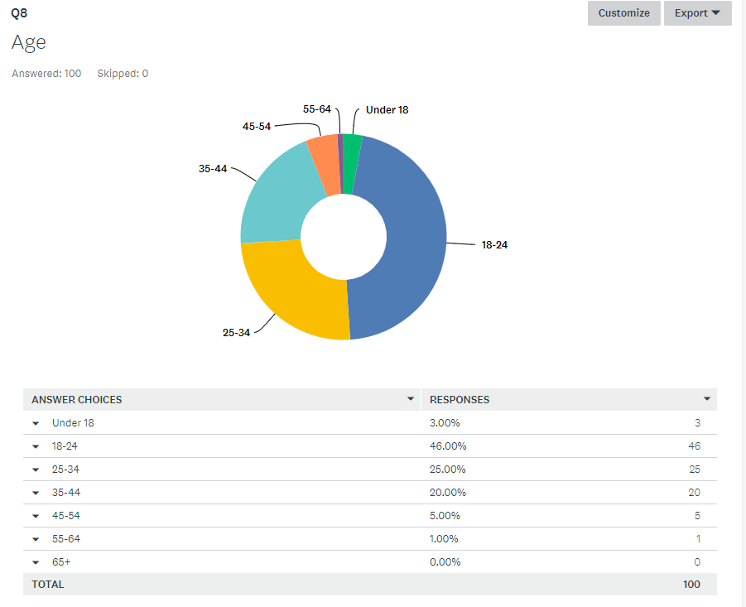

The chart shows that 3% were under 18, 46% were 18 – 24, this is the age range of mainly the students that have answered. 25% were aged 25 – 34 and most of them come from the area or work within the Tourism Team in the council, 20% were aged 35 – 44 again from the council or Visit Swansea Bay Stakeholders, 5% were aged 45 – 54 and 1% were aged at 55 – 64.

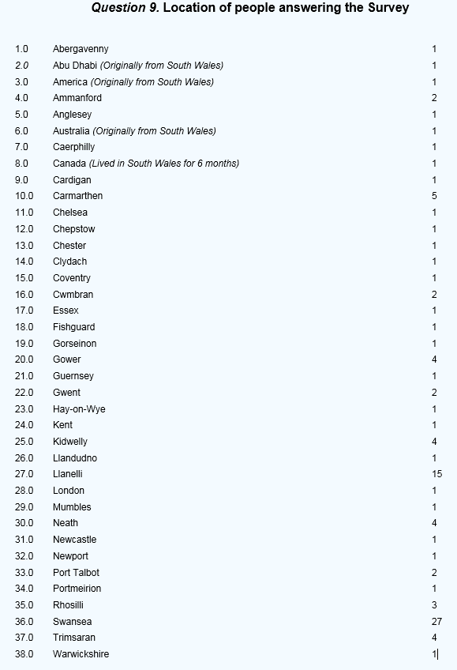

This shows that most people were located within the Swansea location that answered the survey including all the partners, anyone with a location outside of Swansea has either visited or lived in Swansea before.

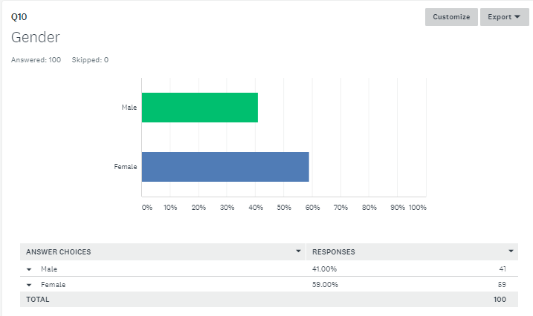

The chart is showing that out of 100 people that had answered the survey 41% was male and 59% was female so it was roughly close enough to even.

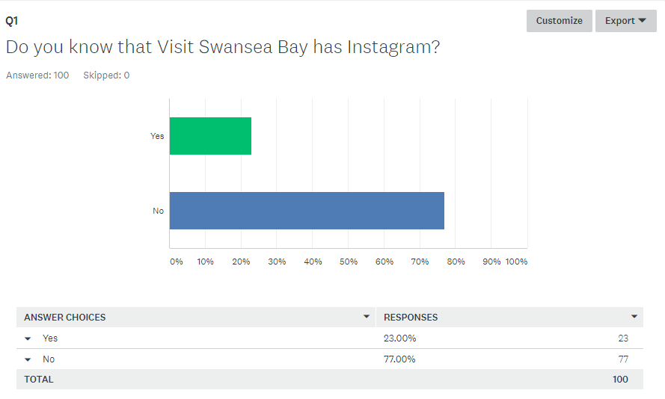

With the research taken it shows that not many people knew about Visit Swansea Bay having Instagram as only 23% knew which would have been some of their partners and the Tourism Team, where as the rest of the public did not know estimating to 77%.

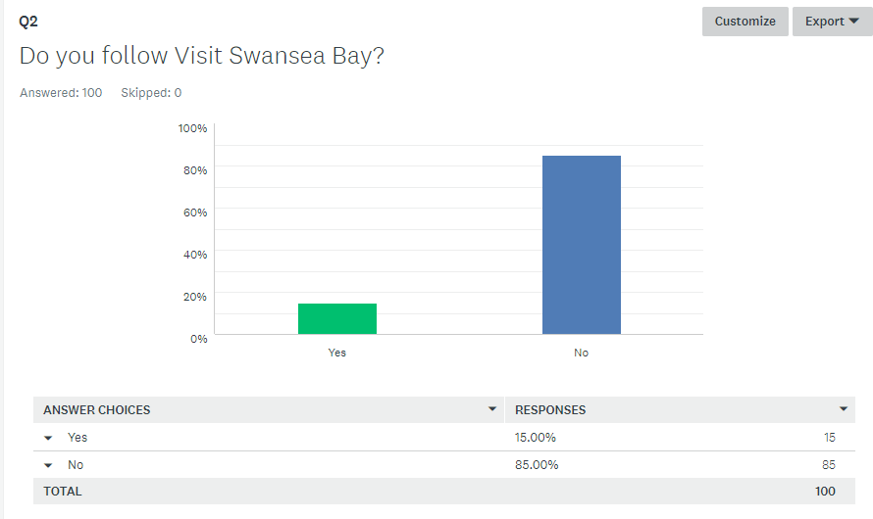

This chart shows that Visit Swansea Bay does not have a big follower base from the people that are located in Swansea, have Visited Swansea or that have lived here, the 15% that said yes are mainly the people that are part of the Tourism Team, where as 85% do not follow Visit Swansea Bay mainly because they did not know the account existed.

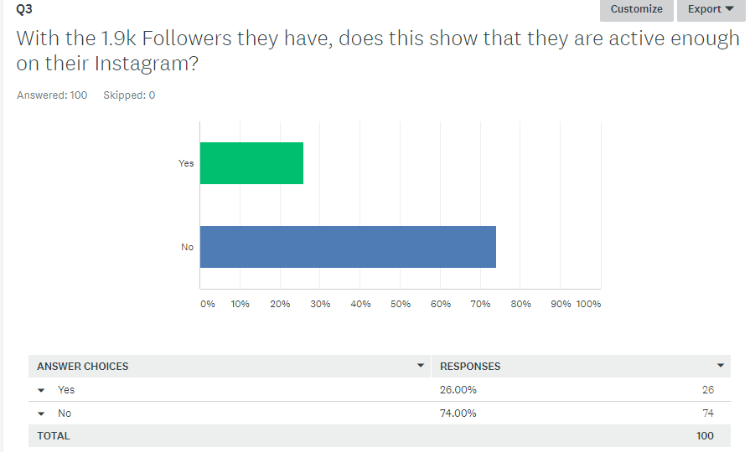
This chart shows that 26% of the 100 answered that they think by Visit Swansea Bay having 1.9k that they are active enough, but the people that answered that have Instagram but do not really use it by researching into the comments they left for the reason. 74% said that they think Visit Swansea Bay are not active enough on their Instagram and find that 1.9k is not enough for a destination account.

The main reasons followed up that were mainly spoken for are;

- “They need to aim for 5k plus to influence people to follow.” (Respondent 33)
- “There should be more than 1.9k followers with the population that Swansea has.” (Respondent 3)
- “1.9k followers show they are not active enough.” (Respondent 7)
- “They need to promote their Instagram on their other social media.” (Respondent 6)

Q4. Open question – How do you think Visit Swansea Bay could improve their account?

With 100 responses on this open question, the evidence show that the main improvements are as followed;

- “Need to repost more, engage with visitors.” (Respondent 90)
- “They need to feature more posts, the area and availability.” (Respondent 65)
- “To do more competitions, market the area more and not just the beaches.” (Respondent 51)
- “To make the account more visually appealing to get potential followers.” (Respondent 11)

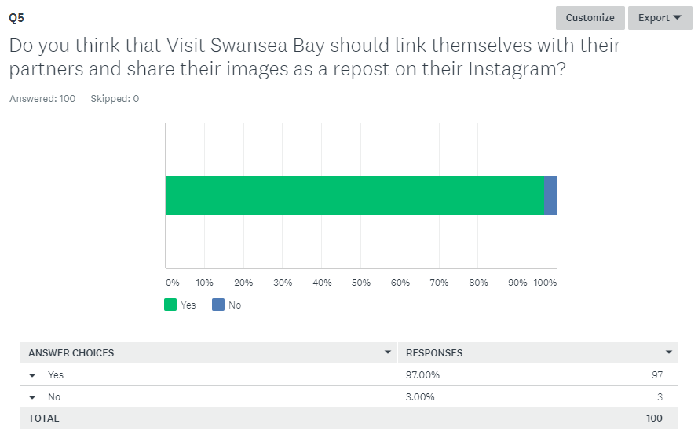

This chart shows that 97% of the people answered said yes to Swansea Bay linking themselves with their partners to share more content and this will help keep them active and a small number of 3% said no to this and was all in the older generation category as they don’t understand Instagram as much.

The 100 respondents stated their reasons for this and the main ones shown are;
- “It would definitely make partners feel as if they ARE a partner.” (Respondent 28)
- “Yes 100%! More coverage and will reach more people on the platform.” (Respondent 21)
- “It will help gain more followers and more visitors will be made and more people will be aware of Swansea Bay” (Respondent 3)
- “They need to grow in followers, it’s an easy way to do it because it takes little effort.” (Respondent 10)

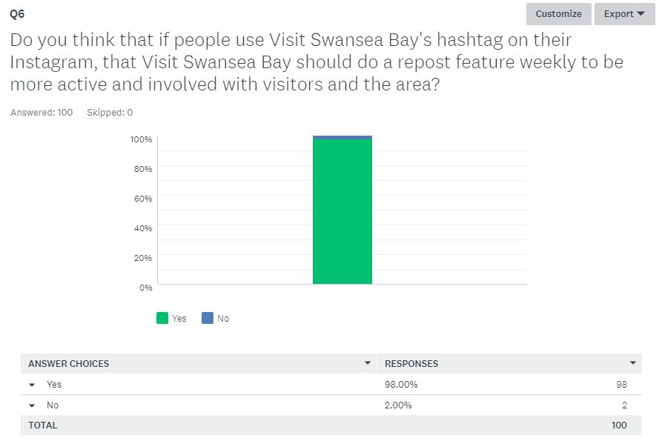
This chart shows that 98% think that it’s a good idea for Visit Swansea Bay to do feature posts of people that have visited the area and taken a picture that they could share to keep themselves active and would have plenty of pictures to show that finding pictures themselves, 2% said no to this and was based in the older generation as they do not understand what Instagram does fully.

The reasons that people think it is a good idea from the comments stated are;

- “Yes, because this way visitors are wanting to interact with Visit Swansea Bay to be able to be featured and show their images off, this also helps with word of mouth being used and people’s views on the place to bring more people into the area. It will make people want to be involved with Visit Swansea Bay’s account just to be featured.” (Respondent 1)
- “It’s easy promotion of Visit Swansea Bay and it’ll save them making their own content.” (Respondent 8)
- “It increases activity and engagement with tourists and the local community.” (Respondent 5)
- “It shows appreciation towards the local and people visiting.” (Respondent 13)

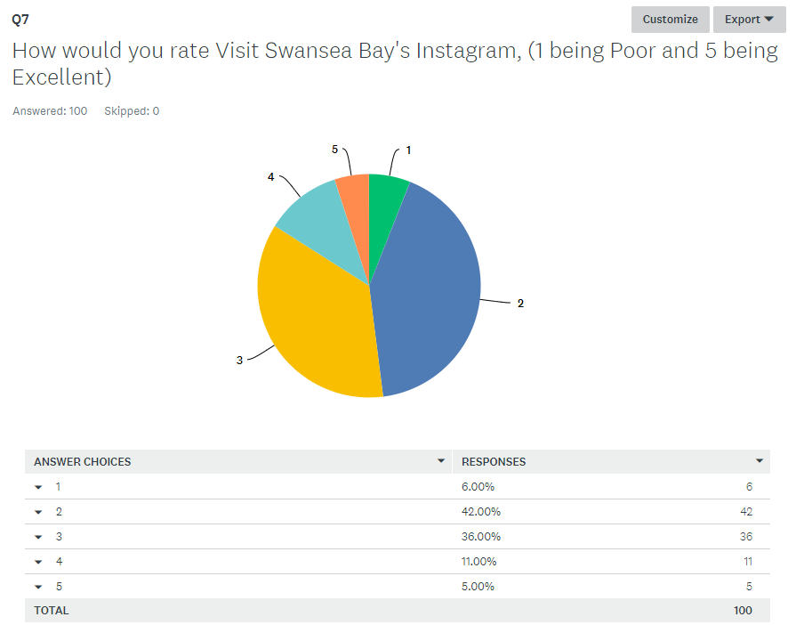

This pie chart shows that out of the 100 people that had answered 6% had rated Visit Swansea Bay’s Instagram account with a 1 being Poor, 42% rated it with a 2, 36% rated it with an average score of 3, 11% rated it with a 4 and a small amount of 5% rated it with an excellent and they were the people that work with the Tourism Team. Over all it shows that most people think the Visit Swansea Bay’s Instagram account is quite poor.

The main reasons for the ratings are;

- “They are not using Instagram to its full potential.” (Respondent 11)
- “Good use of images, but not enough of a variety to catch attention.”
(Respondent 12)
- “The account has room to grow and develop in 2018.” (Respondent 21)

- Comparison

By comparing Visit Swansea Bay as a destination to other destination locations that have the same sort of account as Visit Swansea Bay they are all doing much better than them and posting much more such as Visit Cardiff with over 2K, Visit Wales with 80.3K, Go Visit Britain with 57.7K, this shows a range of different activity and a different following base which Visit Swansea Bay should be reaching as a goal.

- Client Insight

While the first meeting went ahead on the 19th February with Lucy and Tonia in the Tourism and Marketing team in the Swansea Council we discussed my idea which both were happy enough for me to go ahead with doing on helping them with their Instagram account, while the meeting went ahead it was discussed that finding out what they can do and any recommendations would be very grateful as they are doing well on their other accounts but they feel that there is only so much that can be done on their Instagram. During the past few months they had listened to some recommendations given along with answering the survey for the Instagram account, they are very intrigued to see what they can do to be more known and to be more active and have been very helpful regarding answering questions and keeping in contact with the investigator,

- Conclusion

Overall by looking through all the research that has been considered it shows that Visit Swansea has so much potential to grow, people from 38 locations have been helpful enough to answer the survey that had been put out to get the answers that were needed for this project. It shows that they have so much they need to mainly focus on to be able to improve on their following account along with being more active with the audience and potential audience. It shows that there are changes to be made as even the Tourism and Marketing manager had answered the survey and put down recommendations that could be made for them to grow and to be more known via social media. By having all the recommendations from the Tourism Team, Partners and from everyone else that has been to Swansea or know of Swansea has answered the survey have picked out some really valid points to be changed such as joining in with their partners sharing their posts as a repost and advertising what’s in the area , by them helping their partners out with what’s in the area this also helps Visit Swansea Bay for themselves and also the partners are willing to work with them and share their content and Instagram page to get more people involved and to know that the account does exist.
It shows that Visit Swansea Bay does have a problem that needs to be fixed by looking at the evidence and research that was taken place, recommendations from people in the area of Swansea, Visited Swansea or use to live in Swansea have stated that Visit Swansea Bay needs to post more images and videos, promote themselves more with their other social media accounts, advertise surrounding tourist attractions they are linked with, promote what the bay has to offer, post competitions, show what offers are of the week/month, post more exciting and cultural posts, more events need to be shown along with promotions, other posts of the area not just focusing on the beach, be more involved with visitors, engage with their stakeholders on the account, welsh rugby players involved as they have a strong following base and are active with their fans, use hashtags that people use daily as more people will see the images or videos posted, market the account better to make people want to be active and follow.

It was then shown that from the client’s team itself that they had a few recommendations to put forward for the account to improve which were to encourage more people to use the hashtags, do feature posts, run competitions, link marketing partners and offers, to cross promote on the other social media channels, incentives with a prize, increase the frequency and relevance of a post to the intended audience and to share positive bloggers content.

The next one that was taken place for the research was to ask the Partners of Visit Swansea Bay such as Bay Bistro, Morgans Hotel, Verdis, Down to Earth, Monksland, Dulais Valley Quads, Three Cliffs Bay Holiday Park, LC Swansea, The Swigg, Glynn Vivian Art Gallery, Café Play Mumbles, Gower Coast Adventures, Gower Kite Riders, Greenways of Gower, Plantasia and Mumbles Pier the research shows that they also think Visit Swansea Bay has a problem that they can improve on by Showing more availability of what’s available in the area, engage more with the public, promote special events, be more involved with local businesses, share their partners events, post more frequently, post more of the cultural organisations and venues and to support promoting events and exhibitions in the area.

Overall it shows that with all the research taken and given that there is a problem with Visit Swansea’s Instagram and that there have been 3 aspects taken in to consideration to make it fair on the data taken it to find everything out. To be able to improve the client needs to take onboard the recommendations given and concluded to be able to be successful with their social media.

- Recommendations

- To link themselves more with their partners do reposts of their partners posts as this will get more people engaging that follow the partners and then will go on to follow Visit Swansea Bay.
- For anyone that uses Visit Swansea Bay’s hashtag that they put on a feature of an image that got hash tagged every week as this will get more people engaging with Visit Swansea Bays Instagram and this will build up their following account very quickly as people love being featured in a well-known Instagram and they will normally share that they have been featured so by word of mouth it will get even more people engaging.
- Any new developments that are going to happen in the upcoming years should be featured on the Instagram as it keeps people keen to see what’s happening, when, where how, why?, people will share and engage more if they find it interesting such as the new area coming in 2020, which is to be built on the National Waterfront Museum Car Park if they share this content on Instagram it will get more people engaging and wanting to come into Swansea to see the development and what is going to happen with everything else.

- Sampling

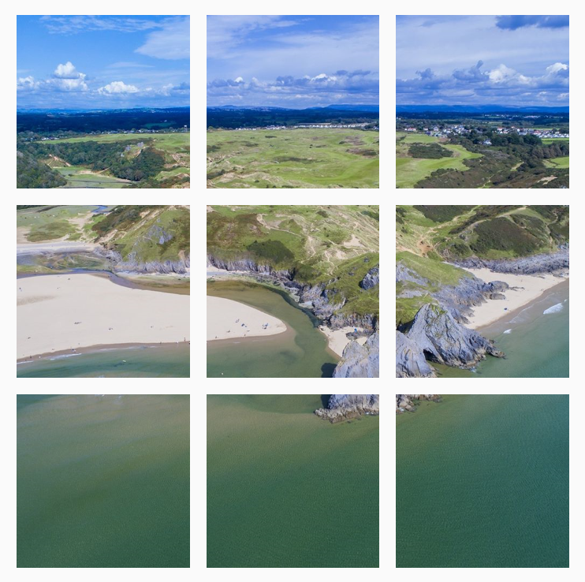

(L. Vincent, Visit Swansea Bay Instagram image (10th April, 2018)

Some sampling of the investigation has taken place the past few weeks, where Visit Swansea Bay has been posting much more on their Instagram page. On the 9th April 9 images got posted as you can see in the image above that’s how one image was posted into 9 small images, because they have done they when they then want to post again they are having to post 3 images at a time or soon after they have posted one image as it will show the 9 image all muddled up. On the 11 April they then posted 3 different images, they posted another 3 on the 12th April and then another 3 on the 17th April, so this shows they are now posting every week and by doing that they have gained more followers and people are engaging with them and the page more. This shows that the recommendations that have been given from people are paying off and have listened to new ideas and suggestions to get them more known through images and videos and are not too far away from reaching 2K followers.

- Appendices

'Destination Swansea Bay 2017-2020' is the official Destination Management Plan for Swansea. (January 2018)

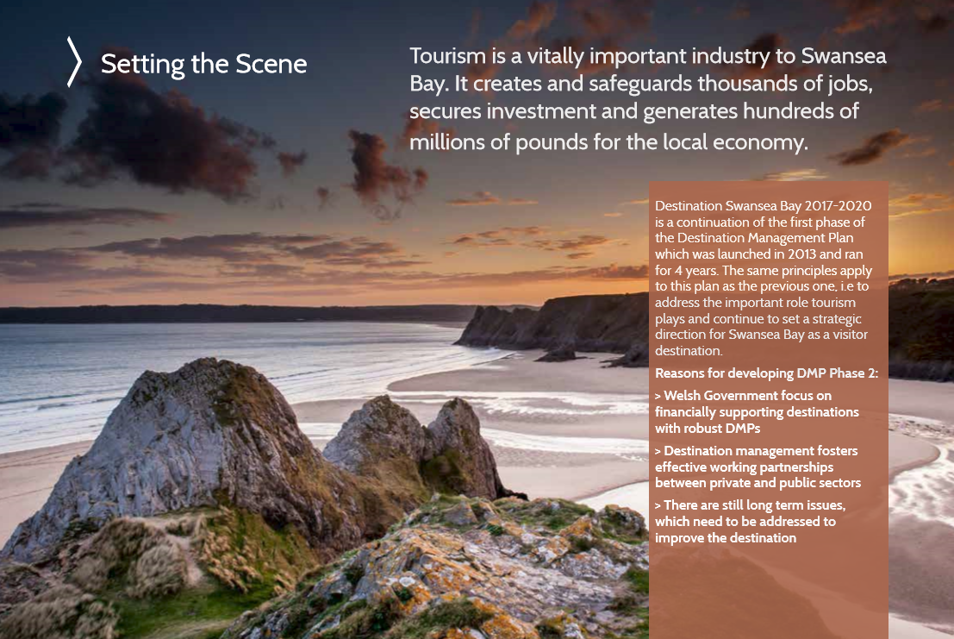

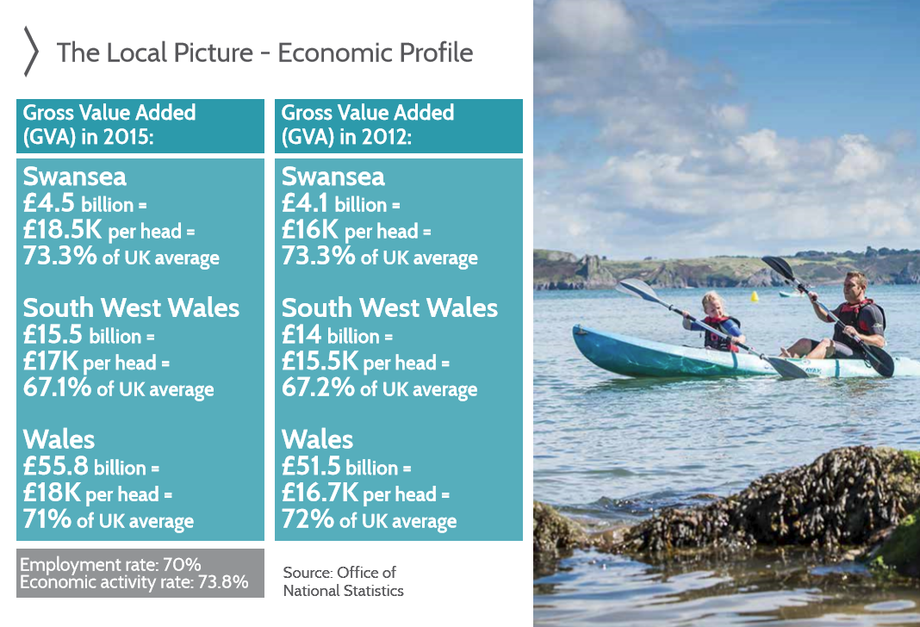
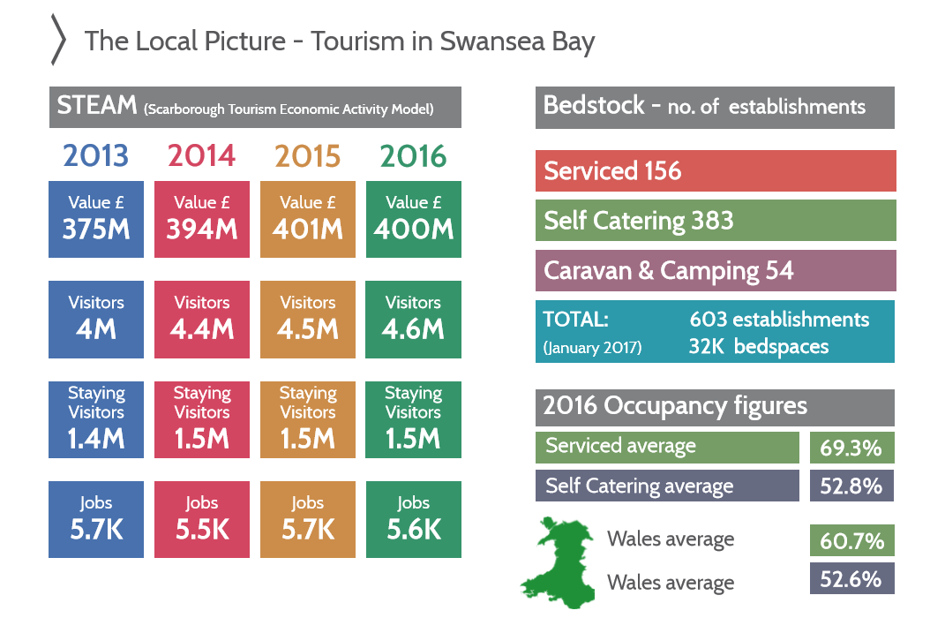
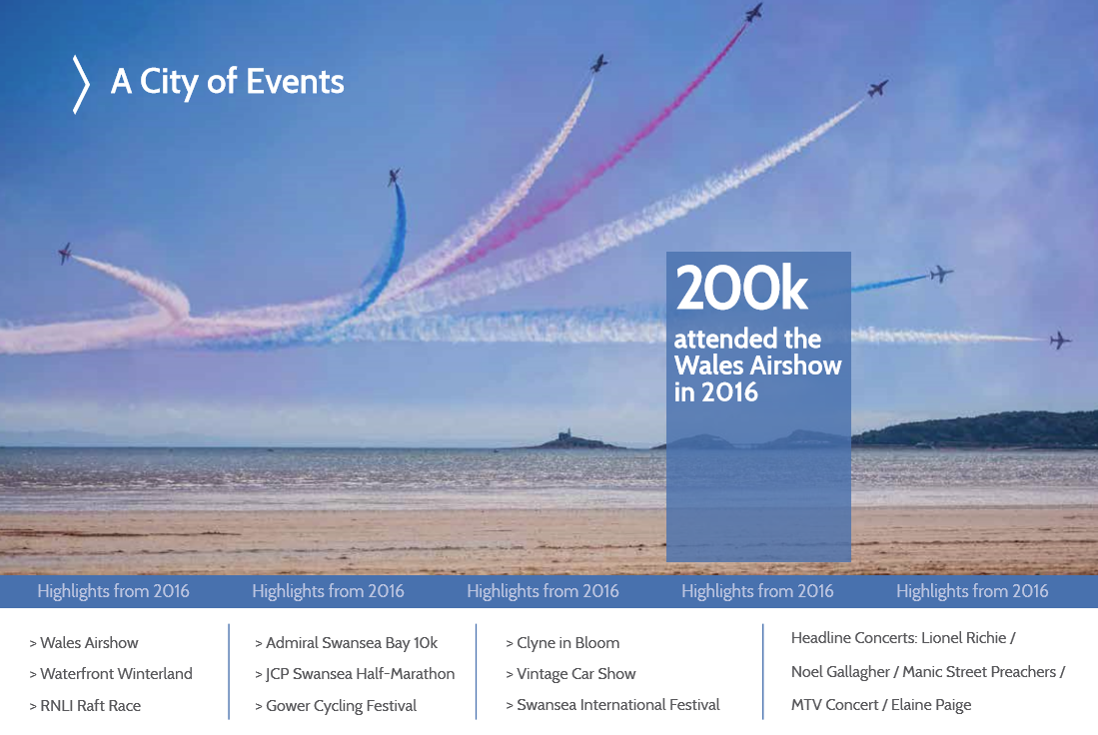
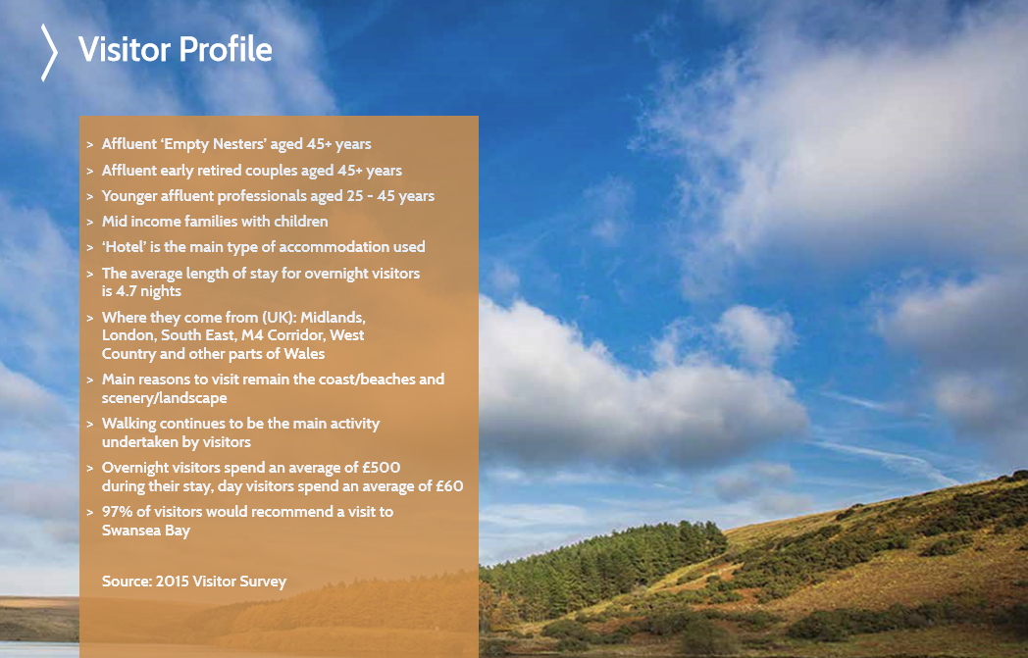

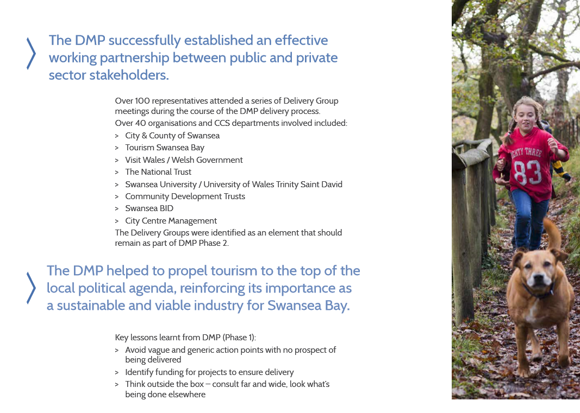
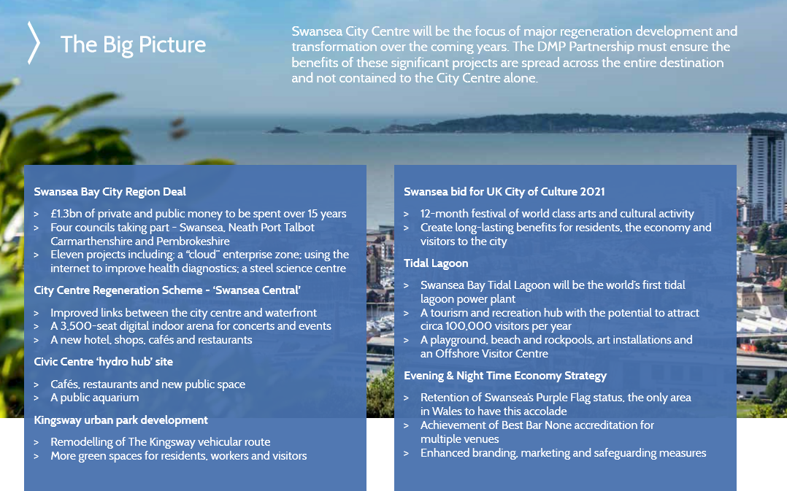
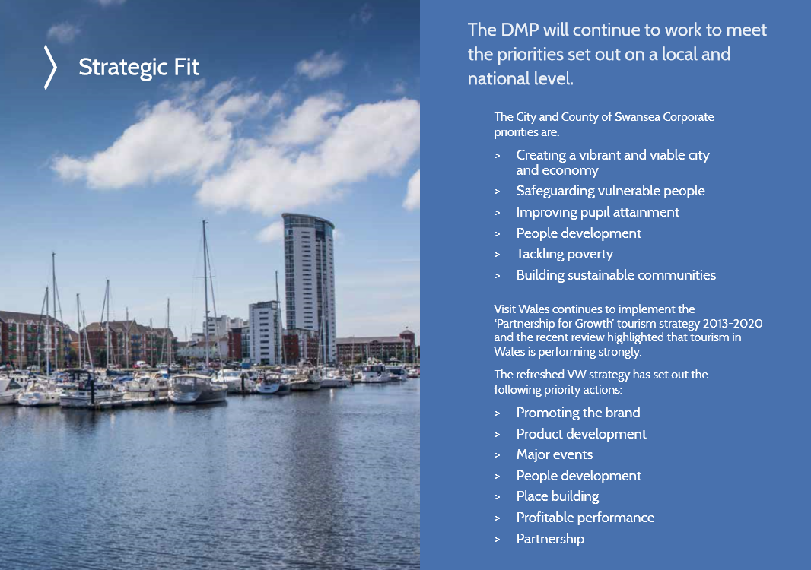
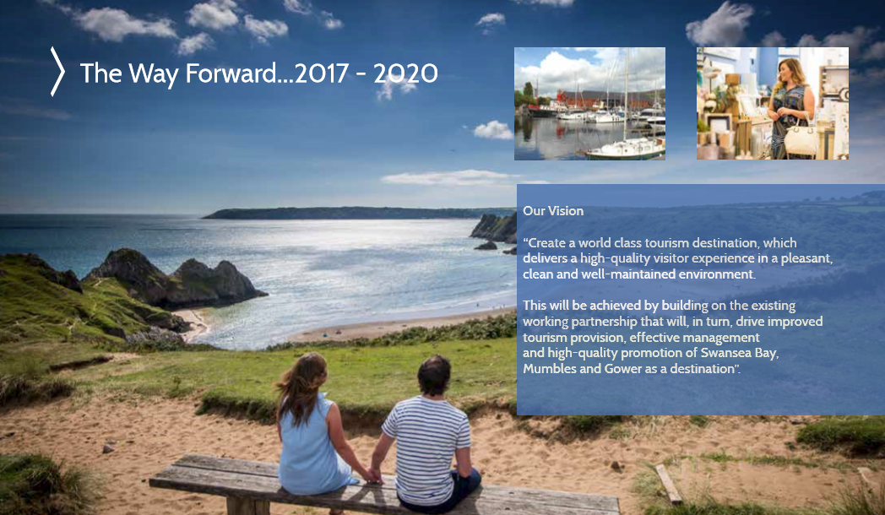

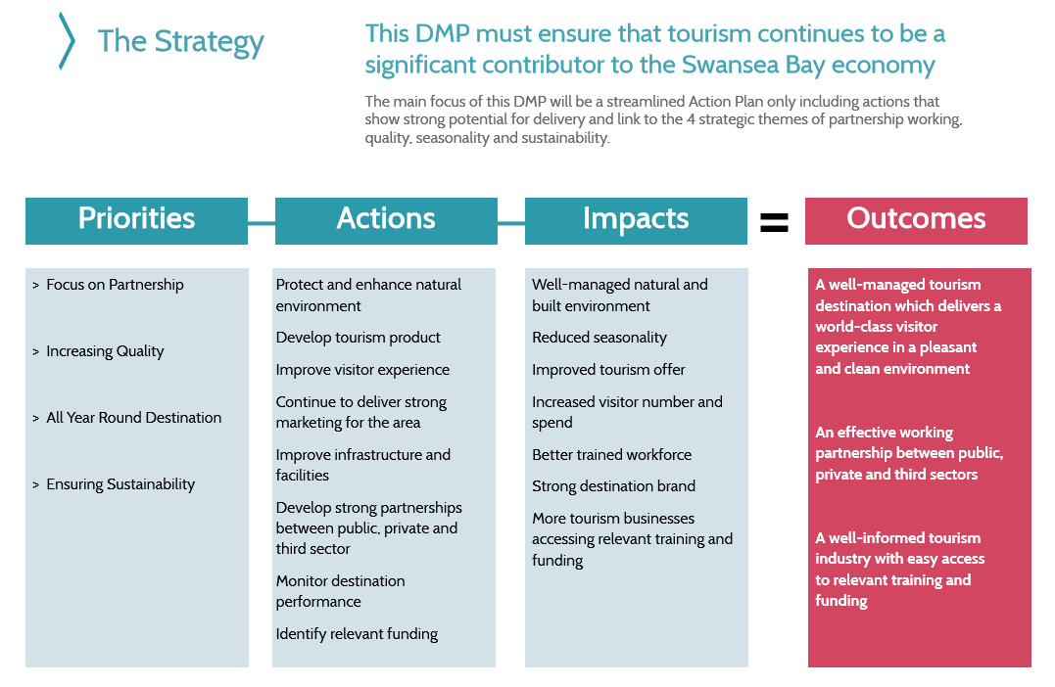
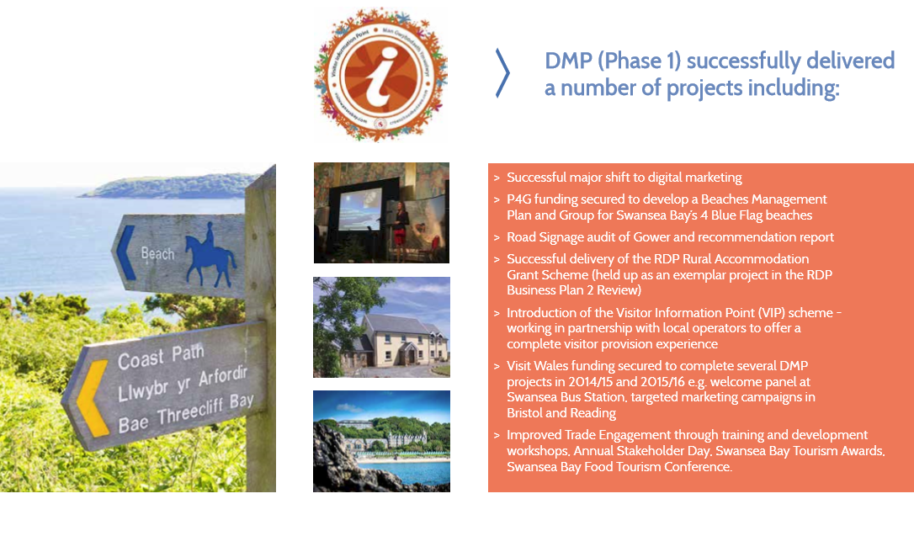

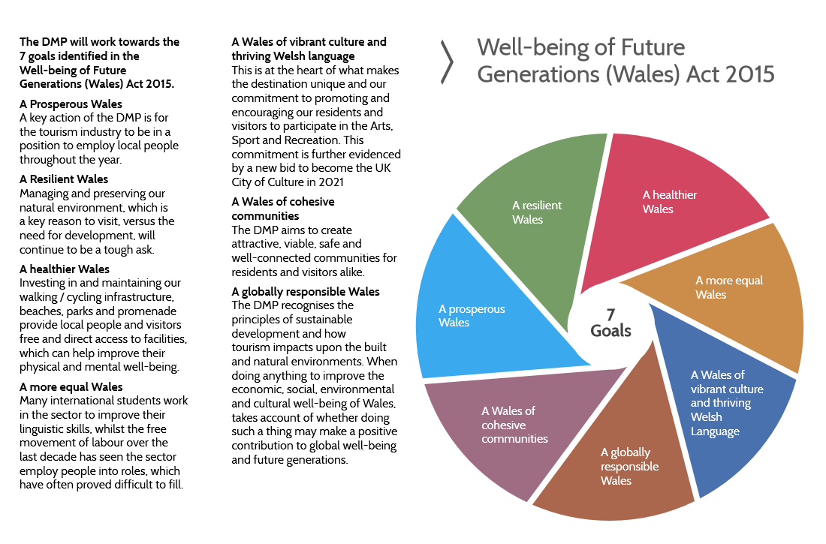
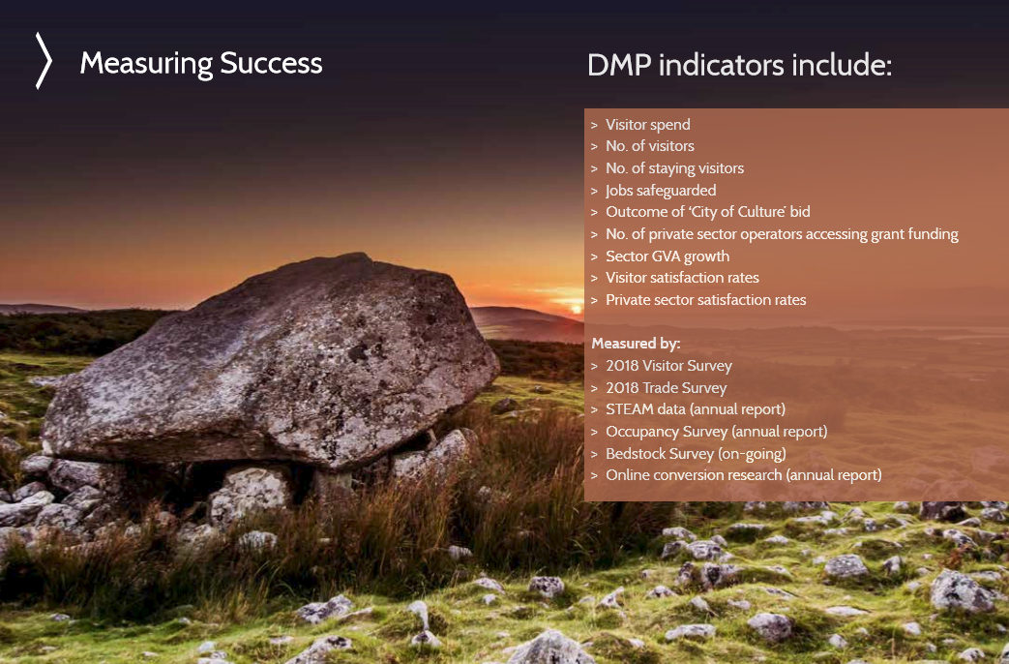

Minutes of Meetings
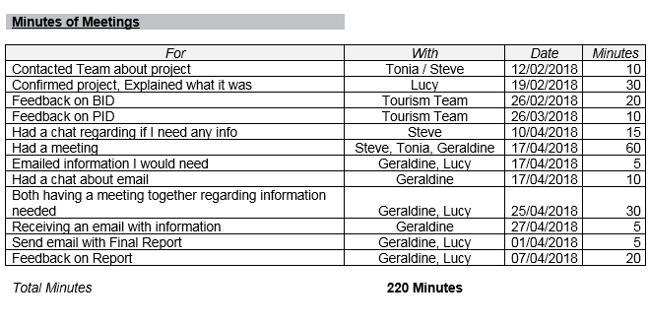

Survey Monkey Link - https://www.surveymonkey.co.uk/r/C7MNQYX
(4th April 2018)

Survey Monkey Questionnaire
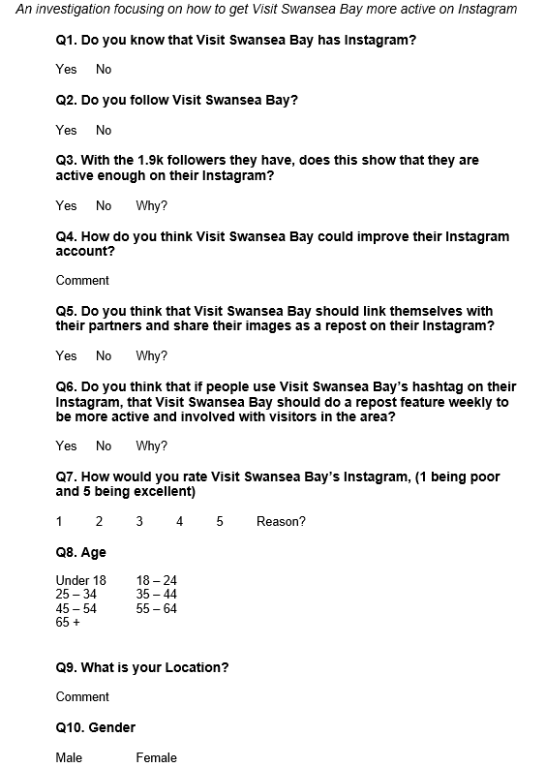

Team Structure – Project Management - Stakeholders

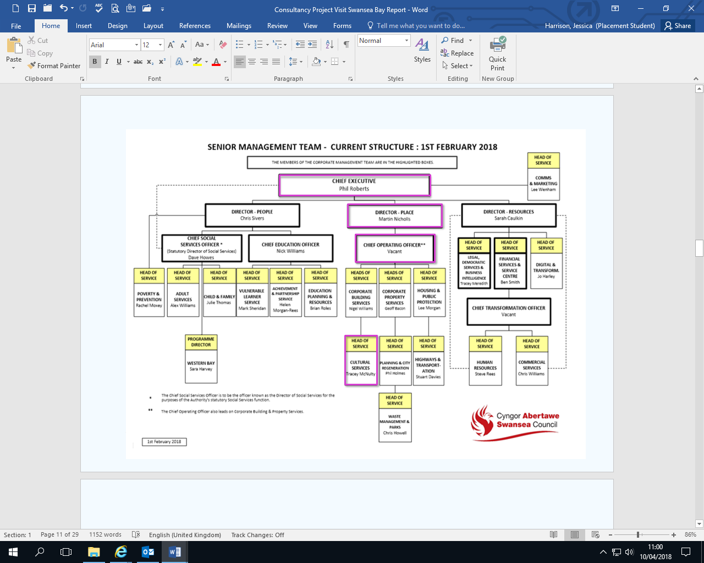

Senior Management Team Structure (February 2018)

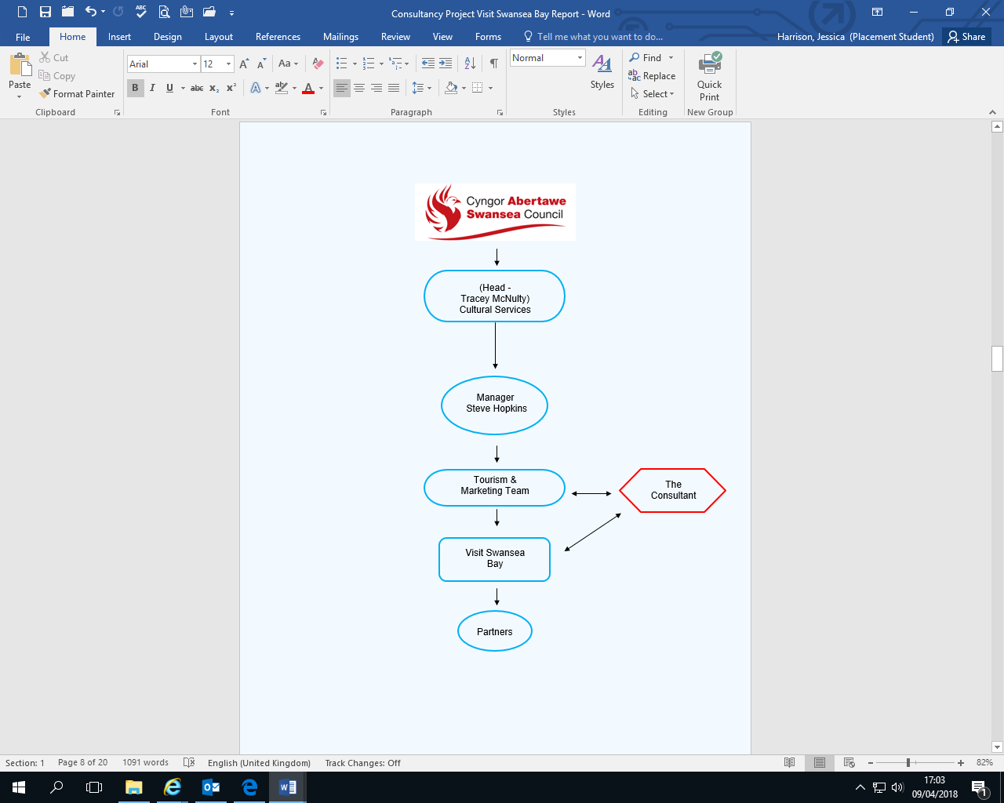

Members Guide to Officers and Functions (January 2018)

PESTLE Analysis

Political

Politically they are on the part of using bloggers to get their voices heard and get the political surroundings involved, but the political aspects does not really concern the Instagram account, the political part would play more on the team itself and the destination.

Economic

Visit Swansea Bay need to be more involved with the Economic side of things due to needing to be able to engage with the public, the partners, the area and themselves to be successful. They need to be able to appeal to new partners to build a profit for the Swansea Council and to get Visit Swansea Bay known in more areas as by doing so if the new partners have an Instagram account they will then follow Visit Swansea Bay on Instagram and this way it builds up a bigger profile for Visit Swansea Bay to get more known in areas and by other people that go to these places.

Sociological

On a social matter Visit Swansea Bay are not meeting the needs of their Instagram account where as they are on their Twitter and Facebook. They post a lot on other social media but not need to broaden themselves to be more social on the Instagram and to post about their Instagram on their other social media to get more people engaging with them and for people to know that they do have a Instagram account as by looking at the results from survey monkey not many people know that it exists.

Technological

Visit Swansea Bay have the technology to keep posting and featuring images on the account, it is mainly the time management that they have to work around with other tasks that hold them up from posting much. They have many different soft wares to use via the computers and phones that they use to post the images or videos onto Instagram.

Legal

There are a lot of legal actions that Visit Swansea Bay have to consider regarding the images and reposts that they use, due to copy rights. They would have to confirm with partners before they are able to repost and if they look at featuring images from people that have used their hashtag they would have to let them know beforehand.

Environmental

The Instagram itself will not have an effect on the environment, but by posting certain images and announcements, they could help the environment and state things that are on their actual website onto their Instagram such as dog friendly places and where to go for a walk or cycle, small things like that get a huge audience to follow as it interests them more and like to see what the area has to offer.

SWOT Analysis

Strengths

- The strengths that have been shown are that they are starting to be more active online, posting more pictures and gaining more followers.
- Visit Swansea Bay have a lot of partners and a huge audience that they can engage with.

Weaknesses

- The weaknesses that are shown are that most the time Visit Swansea Bay are not active enough, they are not focusing on the area as well as themselves and their partners.
- Not reaching out to visitors
- Not sharing enough social media
- Just focusing on the beach
- Not marketing themselves as they should
- Focusing on Swansea only not the other areas they should be promoting such as Gower, Mumbles, and Rural Swansea and Neath.

Opportunities

- Can work with the partners they have this year
- Gain more followers
- Get known in more locations
- Get the Instagram known
- To be involved more with events
- To use feature posts so that they do not have to go looking for images
- Competitions

Threats

- So many partners to deal with
- Other well-known Instagram accounts such as Visit Wales
- Some partners may not agree and will think it’s too much work for them to do it back for Visit Swansea Bay’s Instagram.

- References

- @visitswanseabay, (March 2018), Visit Swansea Bay Twitter [ONLINE]. Available at: https://twitter.com/visitswanseabay/ [Accessed 9 March 2018].
- A. Griffiths & S. Wall, Economics for business and management, Harlow : Financial Times Prentice Hall, 2011 [Accessed: 16th April 2018]
- Destination Swansea Bay, The destination management plan for Swansea Bay, Mumbles and Gower, Phase 2: 2017 – 2020, (January 2018) file:///C:/Users/Jessica.Harrison/AppData/Local/Microsoft/Windows/INetCache/IE/VKR44Y1D/DMP_Jan_2018.pdf [Accessed: 3rd April 2018]
- GOSS iCM, Swansea Council, Destination Management Plan, (24th July 2017) https://www.swansea.gov.uk/dmp [Accessed: 3rd April 2018]
- GOSS iCM, Swansea Council, Tourism Trade, (16th August 2017) https://www.swansea.gov.uk/tourismtrade [Accessed: 3rd April 2018]
- K. Systrom & M. Krieger, About us, Instagram, (2018), https://www.instagram.com/about/us/ [Accessed: 10th April 2018]
- L. Vincent, Meeting, Swansea Council, (19th February 2018)
- L. Vincent, Visit Swansea Bay Instagram image, (9th April 2018), https://www.instagram.com/p/BhWmkNkBX2P/?taken-by=visitswanseabay [Accessed: 10th April 2018]
- Members Guide to Officers and Functions, Swansea Council, PDF, (January 2018) [Accessed: 9th April 2018]
- Respondent 1, Question 6, Survey Monkey, do you think that if people use Visit Swansea Bay's hashtag on their Instagram, that Visit Swansea Bay should do a repost feature weekly to be more active and involved with visitors and the area? (April 2018) [Accessed: 27th April 2018]
- Respondent 10, Question 5, Survey Monkey, do you think that Visit Swansea Bay should link themselves with their partners and share their images as a repost on their Instagram? (April 2018) [Accessed: 27th April 2018]
- Respondent 11, Question 4, Survey Monkey, how do you think Visit Swansea Bay could improve their Instagram account? (April 2018) [Accessed: 27th April 2018]
- Respondent 11, Question 7, Survey Monkey, how would you rate Visit Swansea Bay's Instagram, (1 being Poor and 5 being Excellent) (April 2018) [Accessed: 27th April 2018]
- Respondent 12, Question 7, Survey Monkey, how would you rate Visit Swansea Bay's Instagram, (1 being Poor and 5 being Excellent) (April 2018) [Accessed: 27th April 2018]
- Respondent 13, Question 6, Survey Monkey, do you think that if people use Visit Swansea Bay's hashtag on their Instagram, that Visit Swansea Bay should do a repost feature weekly to be more active and involved with visitors and the area? (April 2018) [Accessed: 27th April 2018]
- Respondent 21, Question 5, Survey Monkey, do you think that Visit Swansea Bay should link themselves with their partners and share their images as a repost on their Instagram? (April 2018) [Accessed: 27th April 2018]
- Respondent 21, Question 7, Survey Monkey, how would you rate Visit Swansea Bay's Instagram, (1 being Poor and 5 being Excellent) (April 2018) [Accessed: 27th April 2018]
- Respondent 28, Question 5, Survey Monkey, do you think that Visit Swansea Bay should link themselves with their partners and share their images as a repost on their Instagram? (April 2018) [Accessed: 27th April 2018]
- Respondent 3, Question 3, Survey Monkey, With the 1.9k Followers they have, does this show that they are active enough on their Instagram? (April 2018) [Accessed: 27th April 2018]
- Respondent 3, Question 5, Survey Monkey, do you think that Visit Swansea Bay should link themselves with their partners and share their images as a repost on their Instagram? (April 2018) [Accessed: 27th April 2018]
- Respondent 33, Question 3, Survey Monkey, With the 1.9k Followers they have, does this show that they are active enough on their Instagram? (April 2018) [Accessed: 27th April 2018]
- Respondent 5, Question 6, Survey Monkey, do you think that if people use Visit Swansea Bay's hashtag on their Instagram, that Visit Swansea Bay should do a repost feature weekly to be more active and involved with visitors and the area? (April 2018) [Accessed: 27th April 2018]
- Respondent 51, Question 4, Survey Monkey, how do you think Visit Swansea Bay could improve their Instagram account? (April 2018) [Accessed: 27th April 2018]
- Respondent 6, Question 3, Survey Monkey, With the 1.9k Followers they have, does this show that they are active enough on their Instagram? (April 2018) [Accessed: 27th April 2018]
- Respondent 65, Question 4, Survey Monkey, how do you think Visit Swansea Bay could improve their Instagram account? (April 2018) [Accessed: 27th April 2018]
- Respondent 7, Question 3, Survey Monkey, With the 1.9k Followers they have, does this show that they are active enough on their Instagram? (April 2018) [Accessed: 27th April 2018]
- Respondent 8, Question 6, Survey Monkey, do you think that if people use Visit Swansea Bay's hashtag on their Instagram, that Visit Swansea Bay should do a repost feature weekly to be more active and involved with visitors and the area? (April 2018) [Accessed: 27th April 2018]
- Respondent 90, Question 4, Survey Monkey, how do you think Visit Swansea Bay could improve their Instagram account? (April 2018) [Accessed: 27th April 2018]
- Senior Management Team Structure, Swansea Council, Word Document, (February 2018) [Accessed: 9th April 2018]
- Survey Monkey Link, Jessica Harrison, An investigation focusing on how to get Visit Swansea Bay more active on Instagram, (4th April 2018), https://www.surveymonkey.co.uk/r/C7MNQYX [Accessed: 4th April 2018]
- Survey Monkey, (4th April /2018) www.surveymonkey.com [Accessed: 4th April 2018]
- Tourism and Marketing feedback, meeting, Swansea Council, (26th February 2018)
- Visit Swansea Bay, Google +, (April 2018) Available at: https://plus.google.com/+Visitswanseabay [Accessed: 4th April 2018]
- Visit Swansea Bay, Mumbles and Gower, @visitswanseabay, (2018), Visit Swansea Bay Facebook [ONLINE]. Available at: https://www.facebook.com/visitswanseabay [Accessed 9 March 2018].
- Visit Swansea Bay, Pinterest, (2017) Available at: https://www.pinterest.co.uk/visitswanseabay [Accessed: 4th April 2018]
- Visit Swansea Bay, YouTube, (March 2018) Available at: https://www.youtube.com/user/visitswanseabay [Accessed: 4th April 2018]
- Visitswanseabay, Facebook, (April 2018) Available at: https://www.facebook.com/visitswanseabay [Accessed: 4th April 2018]

