Design for Industry 4.0 Review
In today’s fast paced world of business, design and manufacturing use a myriad of software applications and rapid prototype methods that have been developed and introduced to enable them achieve goals and objectives to keep up with demands that customers impose along with sales and their requirements. Getting products to market on time to satisfy the customer and/or sales division ahead of competition to gain or maintain market leadership.

MSc Industry 4.0 and Advanced Manufacturing

Nic Goddard

20th January 2023

Email: 2117167@student.uwtsd.ac.uk

Design for Industry 4.0 ACPA7001
Assignment 2 Essay
Supervisor: Andrew Killen
MADE Industry 4 Wales (I4W)

Contents

Design for Industry 4.0 Review 1
Contents 2
Introduction 4
Evolution of Design within Industry 4.0 5
CAD/CAM Early Beginnings 5
The New Era (Design, Rapid Prototyping and Pre-production Manufacture) 5
Historical Design 6
Product Development 6
Generative Design 7
Advantages of Generative Design 7
Disadvantages of Generative Design 8
Prototyping 8
Additive Manufacture 8
Conclusion 10
Modern Design in Industry 4.0 10
Workforce Factors 10
Greener Manufacturing 11
Appendix 12
Appendix 1. 3D Generative Design Model and Data example 12
Figure 1. 3D Model 12
Figure 2. Generative Design Overlay 12
Figure 3. Case Study Outcome 13
Appendix 2. 3D Typical and Generative Design Models 13
Figure 4. Traditional Design Process 13
Figure 5. Generative Design Process 14
Appendix 3. Rapid Prototyping 14
Figure 6. Prototyping Cycle 14
Appendix 7. Greener Manufacturing 15
Figure 7. Carbon Footprint 15
Figure 8. Carbon Neutral 15
Figure 9. Net Zero Emissions 16
Figure 10. Circular Economy 16
Figure 11. 7 Wastes of Lean 17
Figure 12. 7 Wastes of Green 17
Works Cited 18
Acronyms 20

Introduction
The importance of maintaining or extending market leadership cannot be over emphasised. It is commonly known that design, test and development can be a money pit, potentially it still can in the future. It has done so in the past many times over and often resulted in lost projects, been the demise of a business or even closure. This review of design for industry 4.0, firstly gives a broad overview of what is becoming increasingly commonly found within design offices. There are many applications available in the marketplace that designers and engineers can have in their armoury to help better the workflow rate, to get things right first time, from conception to development and ultimately, production of a component, assembly or more. It will identify and outline the acceleration Generative Design can provide to businesses. Highlighting the links with new recent technological developments, the improvements and significant benefits that can be provided, through removal of un-necessary wastes such as, lost time due to design failure the potential for reduced material usage and testing, all resulting in lowering costs and adding to profit.

Evolution of Design within Industry 4.0

CAD/CAM Early Beginnings
CAD (Computer Aided Design) software was basic and simplistic. It consisted of plotting points, that would be joined by lines, arcs, or circles. The early years go back further than people think. Way back to 1957 in fact when Patrick Hanratty also known as the father of CAD/CAM developed PRONTO (Program for Numerical Tooling Operations), it is estimated the around 70% of all current 3D CAD/CAM software can be linked back to this original code. In 1963 SKETCHPAD, enabled drawing with a light-pen, Ivan Sutherland of MIT used this as part of his thesis. By 1972 CAD software was being used commercially. In 1977 CATIA (Computer Aided Three-Dimensional Interactive Application) breaking new ground was launched into the world, it was adopted by many industries such as Aerospace and Defence, Architecture, Construction Engineering, Marine and Offshore, Transport and Motor Sport, as the standard go to application for 3D design and is still widely used today (Bethany, Scan2CAD, 2019).
In this community of software applications there is an array of choices. Some have focused on 3D CAD such as CATIA, TurboCAD and Solidworks. Which are used to create graphical models of components. While others have followed the route of CAM for example EdgeCAM, GibbsCAM and MasterCAM. Which can import the model data generated in 3D CAD, which in turn is used to produce NC (numerical code) data used by CNC programmers that can be translated via post processors macros to convert into CNC languages used by machine control systems such as, Fanuc, Heidenhain or Siemens.
In addition to design and manufacture, sitting in between is an important aspect that considers, calculates and analyses the physical features of a component or assemblies for example, the materials selected, the application and load bearing forces of the component’s structural properties, and then finally manufacture. Here software solutions such as Dlubal have been developed to rapidly analyse the integrity of the materials choice, loads and stress along with failure mode effect analysis to determine if the design is fit for purpose.

The New Era (Design, Rapid Prototyping and Pre-production Manufacture)
Many technology breakthroughs have features such as: IoT & IIoT, Pocket AI, Mobile Communication, Interconnection, and Cloud Storage that are now commonplace enablers to access a multitude of resources. The processing power that the vast majority carry around in our pockets is phenomenal. Yet it would be fair to say that it is very underutilised and its main use is for texting, talking, taking photos, social media and online banking.
Development with design and manufacturing continues, today there are many to choose from. Many of the applications found in the marketplace have varying degrees of functionality, it is common to find combinations of some of the aspects, features of the software applications identified. Pictorial examples of a practical application of Fusion 360 can be found in the appendix 1.
Autodesk with AutoCAD have been around since 1982 and over the years has made a number of acquisitions to strengthen its product and market position (Luke, Scan2CAD, 2020). Indeed over the last decade, have significantly change the dynamics when it launched Fusion 360 in 2013 which was the first and only cloud based system at the time, integrating CAD, CAM, CAE (with the inclusion ANSYS) software package (AutoDesk, 2022).

Historical Design
Aside from the design process itself, (new methods of which are covered further on) for which there are many processes and events before you get a physical part or product, it has to be manufactured at some point in time during the process of design for, research, test and development. However as yet there is no part or product, but the costs are mounting up and potentially could run into thousands of pounds, even a hundred thousand or more. The cost of manufacture will result in additional expenditure, then there is another cost adding to the bill for testing. This is typical of Traditional design methodology. Many times-over during the past the results of these endeavours have resulted in FAILURE! Just to create more expenditure and rising costs through the necessity of RE-STARTING!

Product Development
Every product starts life as a concept, beginning as artistic impression, interpretation, or graphics representations. It then goes to a construction design phase where the core assemblies and requirements are identified, then individual components are identified, a proportion of which will need to be designed, manufactured, prototyped, tested, analysed and developed. This demonstrates there are many key steps from concept to design. It is more commonplace today that the Traditional more time-consuming initial design, design analysis, prototyping, trail and testing route gives way to Generative design.

Generative Design
There are many benefits from the utilisation of generative design. The first of these is the potential accelerated time conception to market release, significantly reduced wastes within development through the elimination of excessive material usage, manufacturing process, testing, evaluation and validation all requirements under the Tradition Route, should a failure occur at any stage following this method, the result is ‘back to the drawing board’, more delays and added frustration (pictorial examples can be found in the appendix 2).
The processes involved in design start with human interaction through creation of a graphical 3D model that has the key features required for the component, part, sub-assembly, full assembly or whatever is required. The designer then has direct controlling influences as to what data is included for design creation, such as: direction of forces and/or loads, constraints, limitations and goals. Through AI and the algorithms applied to provide multiple options to choose an appropriate design that is validated, optimised that best meets the requirements. Modifications can easily be made and the process re-run if the results are not useable (Skidmore, 2018).

Advantages of Generative Design
- As a result of these powerful cloud computerised processes, businesses find themselves having potentially hundreds of solutions and in the position of being ready to begin trial production of fully functional components and even sub-assemblies that nowadays is a pre-requisite feature that is required for the prototypes (Skidmore, 2018).
- Prototype production of one or more variants can be manufactured as a scaled down version for examination and testing (Skidmore, 2018).
- Significant savings can be made both in time and subsequently financially during the design phase alone, proven use demonstrates increased productivity, allows for use of collaborative cloud-based computing power that enables designers and engineers to explore very many scenarios (even simultaneously) (Ewald Egel, AutoDesk, 2019).
- All the main attributes required for testing are in built in the software, AI runs all the testing and analysis, which is determined from the human inputs setting the criteria of the data to be used (AutoDesk, 2022).
- Within the realms of the computer world, software, AI and use of algorithms means that errors are more than likely to be discovered exceedingly early on during the initial stages analysis with no major catastrophes or expensive costs and easily rectified with nothing more than a few clicks of a mouse and taps on a keyboard.

Disadvantages of Generative Design
- Human Error. This unfortunately is impossible to factor out. However sometimes quite incidentally events can result in new discoveries.
- Greater, sometimes over ambitious expectations from hierarchy.
- Sometimes too many solutions can be created by the software.

Prototyping
As mentioned at the very beginning of this review it is important for businesses to maintain or extend its market position. Product design and development is not a cheap exercise to conduct, therefore it is prudent for businesses to find economic solutions. Traditional methods of prototyping in the past have proven extremely expensive, especially when there is failure of the design, it may well have been precisely executed, but nevertheless proven to be not fit for purpose. On the other hand, as stated in the previous section, there is Generative Design that sits in front of prototyping which is a key aspect of ‘Rapid Prototyping’ which has three stages a trio of enablers. Before manufacturing commences analysis of the major factors are already proven within the results of the design phase, whereby suitable alternative materials and structures can be identified for prototype manufacture, that are adequate for trials and mock ups (which could be functional), less likely to fail, require lower finances to produce. Rapid prototyping is a means of creating solution, proving design concept and purpose fitness (Nick Babich, Adobe, 2019). The final enabler in this trio is Additive Manufacturing.

Additive Manufacture
This is not a new concept. In fact, it is the opposite, there is evidence that molds from clay and bees wax were used as far back as the copper age (Industrail metal castings, 2010). However, with the developments with additive manufacturing introduced for rapid prototyping during the 1980’s there was one drawback at this time, which was that they were not normally functional (Rebecca Lake, MIT Sloan, 2017). Through continuous development and the immergence new materials, has enabled what is now a common method with additive manufacturing technologies often referred to as 3D printing. Although not technically completely 100% correct. Modern additive manufacturing is a process of building up layers of material one at a time that is fused together through heat transfer from one source or another, whereby the process results in functional designs are manufactured, with little to no material waste, over processing and far lower raw material requirements. New processes have come to being through technical research, the development of process, types of materials and equipment which enable a multitude of modern applications to maximise unique manufacturing capabilities and exceptional properties that enable more often than not far more usable a test pieces, sometimes quicker, cheaper and in many cases immediate manufacture of designed components can begin without any pre-production processes such manufacturing jigs, fixtures, work holding or specialised tooling.

Conclusion

Modern Design in Industry 4.0
Modern; technology, software, cloud computing, AI, use of complex algorithms, analysis can all be used to advantage, by providing calculated, analysed, trustworthy, multiple design solutions, with computed data results to aid decision making on a manufacturable prototype which could and should potentially produce significant cost saving. All these potential waste savings already and as yet there has been no mention of the potential costs saving from using modern manufacturing processes, it is part of value stream mapping and continual improvement processes. Not forgetting greater probability of RIGHT FIRST TIME! Cost savings.
The developments in additive manufacturing through putting down layer upon layer of material through methods such as SLA giving high detail, tight tolerance and quality surface finishes and commonly used for medical parts by using liquid thermoset resin and UV light for curing. powder bed fusion methods like, SLS selective laser sintering melts together nylon-based powders producing functional parts but generally have rough surface finishes, EBM melts metal power in a vacuum chamber and DMSL direct metal sintering produce parts similar in density to traditional metal removal manufacturing of parts. These are some of the common methods employed today, with proven cost benefits due to reduced material and energy usage, these methods are not always quick process especially when it comes to larger or extremely complex parts (Applied Engineering, 2021; Matt Ahart, Protolabs, 2019). Nevertheless, modern design and additive manufacturing process certainly address the seven wastes identified through lean principles by minimising and or eliminating non-value-added waste. What is achievable and quite practical is the combined ability of generative design, prototyping and additive manufacturing today is that they sit quite nicely in the lean methodologies when you consider the ability to produce scaled down functional components, these are all still developing and more efficiently effective than subtractive manufacturing where material is removed and as the modern techniques further develop and improve so the expenses are likely to reduce compared to today (Nagle Kristine, Evocon, 2022).

Workforce Factors
Just like many other areas within businesses, design is no different when the fear factor introduces itself without invitation, ‘That’s it the beginning of the end,’ ‘We are all being replaced by robots and computers’ are just a couple phrases that have been repeated time after time. What is apparent is that the opposite is truer. The introductions of innovative technologies, is allowing businesses to become more competitive, have greater diversity and higher demands. Businesses know that skillsets retention is important, as is development and training. As Industry 4.0 continues to gain traction, it means that new skillsets are required and need to be learned, in order to complement existing valued skillsets. Gaining new skills along with modern technology, processes, methods and applications all contribute towards productivity increases, high quality, and greater revenue. Consequently, these combined are resulting in job creation, promotion opportunities, a greater feeling of job security and satisfaction, the evidence shows also that there are significant craft trade shortage on a large scale meaning great training opportunities for up-and-coming generations. The take-off and appetite for Industry 4.0 has hugely impacted on global economy, and the potential for expansion appears boundless, it cannot happen overnight, a weekend, a week, or a month, but the pace is fast (Lugovsky Vladimir, Forbes, 2021).

Greener Manufacturing
Carbon Footprint Reduction, Carbon Neutral, Net Zero Emissions, Circular Economies. These highly topical discussions and goals cast out on global scales. ‘Lean and Green’ (see appendix 7, figures 11 and 12). Lean is now quite well established with its aims to remove non-value-adding waste. Green which has been making great in roads over the las few years is addressing waste from and environmental perspective. Both ideologies apart from being good practices, enable savings along with sustainability, through re-use and reductions of raw material usage resulting in lower costs, which allow investment in power initiative thereby reducing energy consumption, energy costs, emissions and pollution. Sustainability is not a touchy-feely fad. Venturing down the greener route, means looking for better ways, newer technologies, increased OEE, using less resources to produce, greater productivity output, shorter lead times, greater capacity, being more innovative and are all achievable by businesses engaging with greener manufacture are also benefiting through recognition of increased responsibility, trust and reputation. This engagement with green manufacturing practices provides opportunities for improved profit margins that can become significant within a three-to-five-year period, but also adding to the shareholder value (Nagle Kristine, Evocon, 2022). Mostly importantly, better for the environment, wildlife and human habitation and a healthier more sustainable planet for future generations.

Appendix

Appendix 1. 3D Generative Design Model and Data example

Figure 1. 3D Model
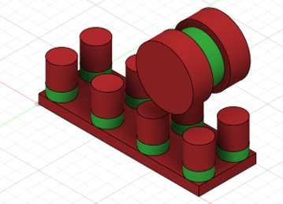

Figure 2. Generative Design Overlay
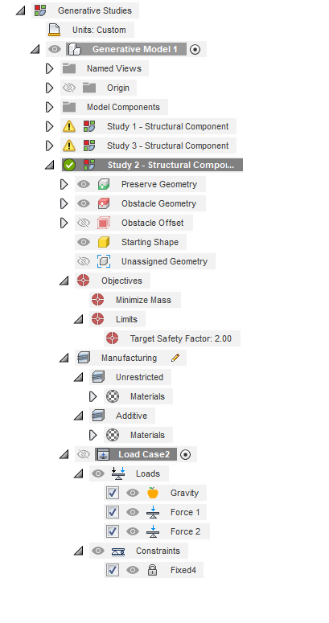
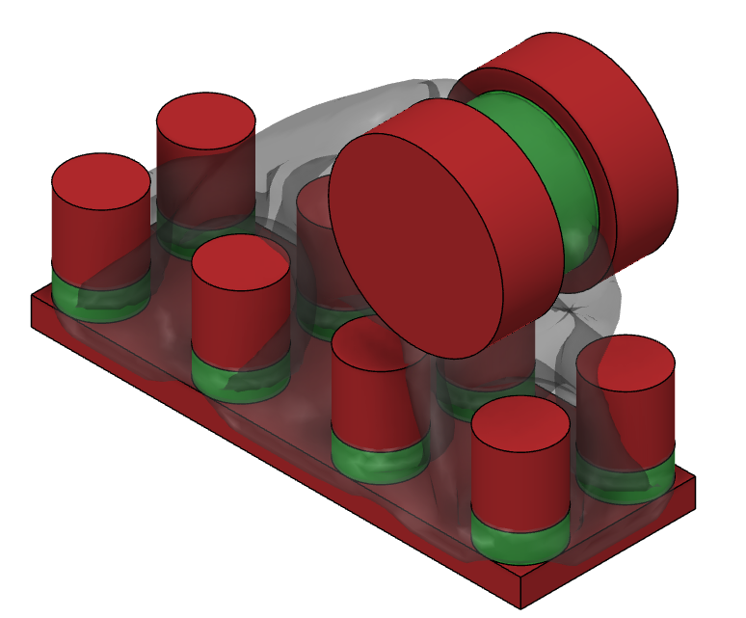

Figure 3. Case Study Outcome
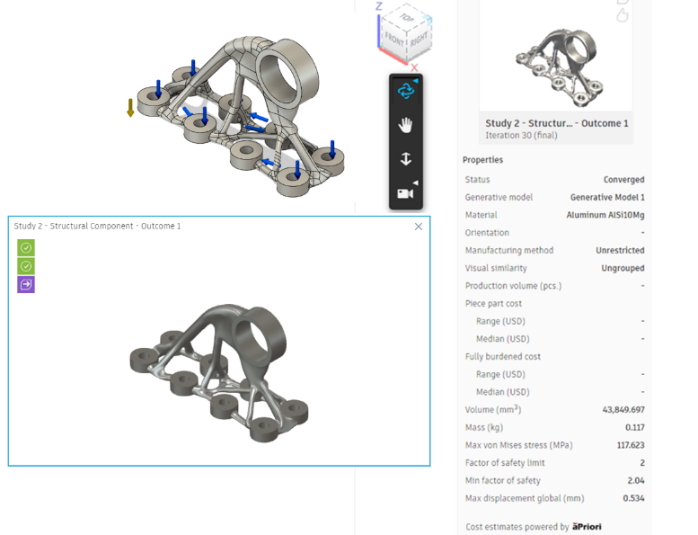

Appendix 2. 3D Typical and Generative Design Models

Figure 4. Traditional Design Process
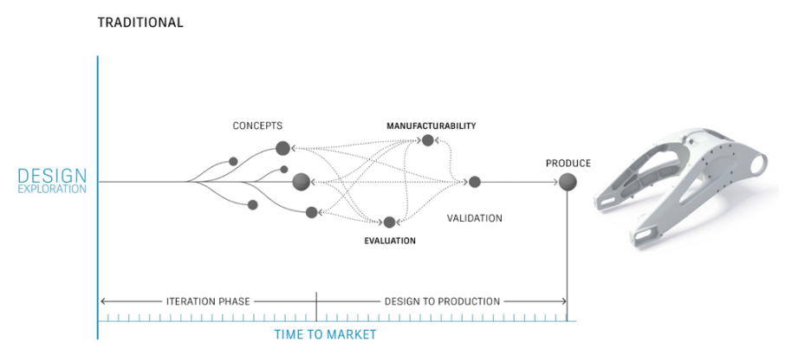
(Ewald Egel, AutoDesk, 2019)

Figure 5. Generative Design Process
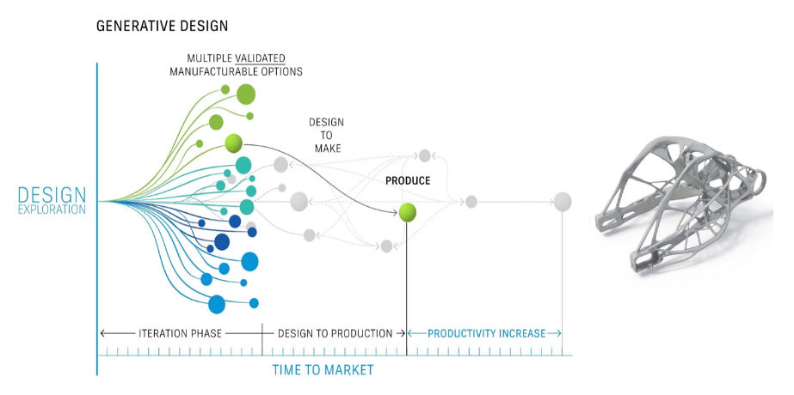
(Ewald Egel, AutoDesk, 2019)

Appendix 3. Rapid Prototyping

Figure 6. Prototyping Cycle
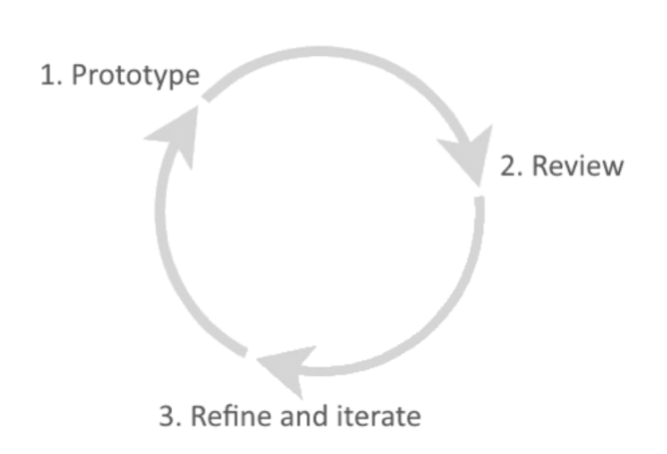
(Nick Babich, Adobe, 2019).

Appendix 7. Greener Manufacturing

Figure 7. Carbon Footprint
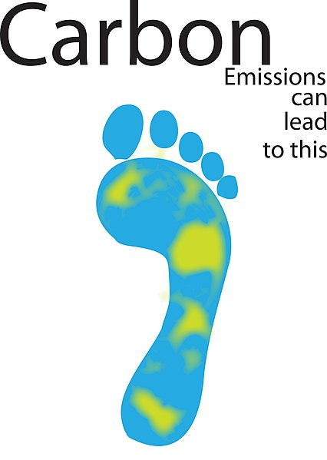
(Beaumont Patracia, 2013)

Figure 8. Carbon Neutral
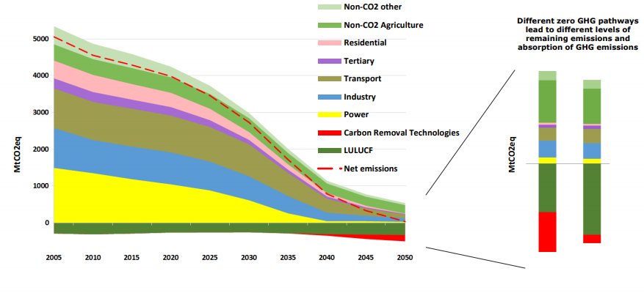
(World Economic Fourm, 2018)

Figure 9. Net Zero Emissions
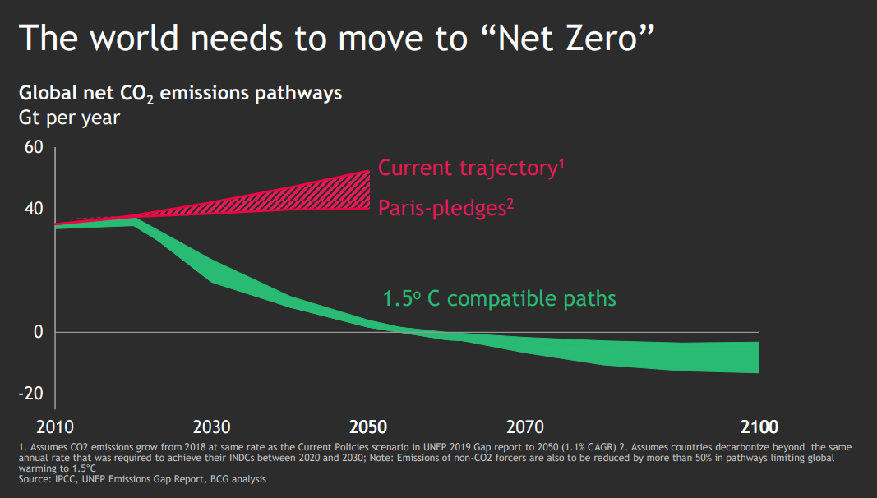
(World Economic Forum, 2019)

Figure 10. Circular Economy
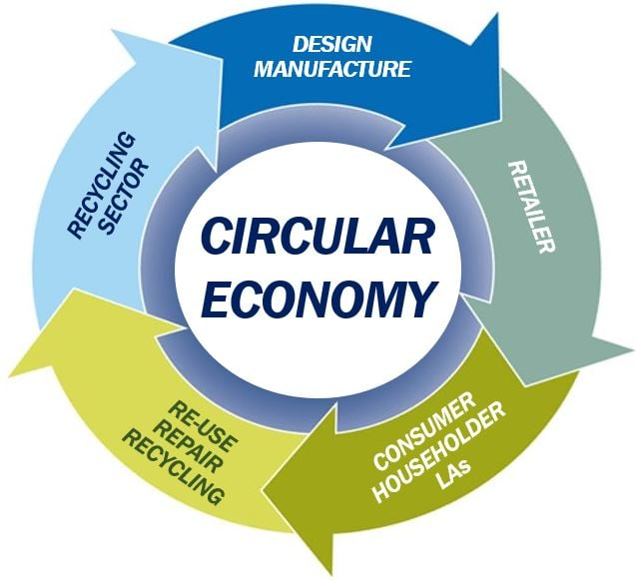
(Market Business News, 2023)

Figure 11. 7 Wastes of Lean
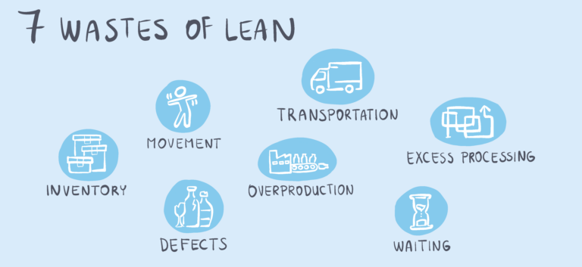
(Nagle Kristine, Evocon, 2022)

Figure 12. 7 Wastes of Green
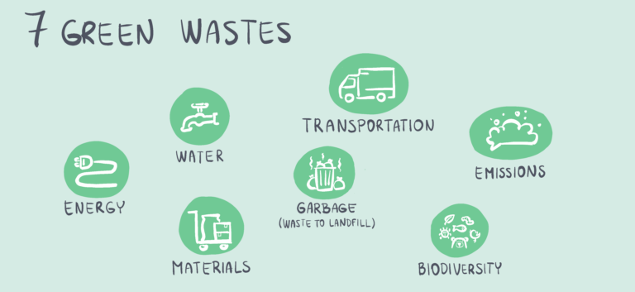
(Nagle Kristine, Evocon, 2022)

Works Cited
Applied Engineering, 2021. 7 Types of Additive Manufacturing. [Online]
Available at: https://www.appliedengineering.com/blog/2021/1/22/7-types-of-additive-manufacturing
[Accessed 23 Januart 2023].
AutoDesk, 2022. Fusion 360. [Online]
Available at: https://www.autodesk.co.uk/products/fusion-360/overview?term=1-YEAR&tab=subscription&plc=F360
[Accessed 18 Jaunary 2023].
Beaumont Patracia, 2013. The Green dandelion. [Online]
Available at: https://blogs.rochester.edu/thegreendandelion/2013/01/what-is-a-carbon-footprint/
[Accessed 25 January 2023].
Bethany, Scan2CAD, 2019. How CAD Has Evolved Since 1982. [Online]
Available at: https://www.scan2cad.com/blog/cad/cad-evolved-since-1982/
[Accessed 16 January 2023].
Ewald Egel, AutoDesk, 2019. Desiign & Manufacture. [Online]
Available at: https://knowledge.autodesk.com/support/fusion-360/getting-started/caas/simplecontent/content/generative-design-fusion-360-offers-new-ways-to-create-and-design-products.html#:~:text=Generative%20design%20is%20a%20design%20exploration%20technology%20availab
[Accessed 19 January 2023].
Industrail metal castings, 2010. History of casting. [Online]
Available at: http://www.industrialmetalcastings.com/history.html
[Accessed 22 January 2023].
Lugovsky Vladimir, Forbes, 2021. Industry 4.0: The Beneficial Trends And Challenges For SMEs. [Online]
Available at: https://www.forbes.com/sites/forbesbusinesscouncil/2021/09/03/industry-40-the-beneficial-trends-and-challenges-for-smes/?sh=71d39f3f293c
[Accessed 24 January 2023].
Luke, Scan2CAD, 2020. AutoDesk History. [Online]
Available at: https://www.scan2cad.com/blog/tips/autocad-brief-history/
[Accessed 17 January 2023].
Market Business News, 2023. What is a circular economy? Definition and examples. [Online]
Available at: https://marketbusinessnews.com/financial-glossary/circular-economy-definition/
[Accessed 26 January 2023].
Matt Ahart, Protolabs, 2019. Types of 3D Printing Technology. [Online]
Available at: https://www.protolabs.com/resources/blog/types-of-3d-printing/#:~:text=There%20are%20several%20types%20of%203D%20printing%2C%20which,Laser%20Sintering%20%28DMLS%29%208%20Electron%20Beam%20Melting%20%28EBM%29
[Accessed 25 January 2023].
Nagle Kristine, Evocon, 2022. What is Green MAnufacturing, and Why Does It Matter?. [Online]
Available at: https://evocon.com/articles/what-is-green-manufacturing-and-why-does-it-matter/
[Accessed 29 January 2023].
Nick Babich, Adobe, 2019. What is Rapid Prpototyping?. [Online]
Available at: https://xd.adobe.com/ideas/process/prototyping/rapid-prototyping-efficient-way-communicate-ideas/#:~:text=Rapid%20Prototype%20Definition%20The%20definition%20of%20rapid%20prototyping,group%20of%20users%2C%20stakeholders%2C%20developers%2C%20and%20other%20
[Accessed 19 Januray 2023].
Rebecca Lake, MIT Sloan, 2017. Additive manufacturing explained. [Online]
Available at: https://mitsloan.mit.edu/ideas-made-to-matter/additive-manufacturing-explained
[Accessed 22 January 2023].
Skidmore, P., 2018. Cad Cowd. [Online]
Available at: https://www.cadcrowd.com/blog/what-is-generative-design-and-why-its-important-for-your-company/#:~:text=Advantages%20of%20Generative%20Design%201%20Reduced%20Time%20to,...%204%20Enables%20Creation%20of%20the%20Impossible%20
[Accessed 23 January 2023].
World Economic Forum, 2019. Who's promised net zero carbon emissions, and who looks likely to get there?. [Online]
Available at: https://www.weforum.org/agenda/2019/12/countries-companies-net-zero-carbon-emissions/
[Accessed 24 January 2023].
World Economic Fourm, 2018. The EU wants to be carbon neutral by 2050. [Online]
Available at: https://www.weforum.org/agenda/2018/12/european-union-aims-to-be-first-carbon-neutral-major-economy-by-2050
[Accessed 24 January 2023].

Acronyms
AI - Artificial Intelligence
AM - Additive Manufacturing
CAD - Computer Aided Design
CAM - Computer Aided Manufacturing
CAE - Computer Aided Engineering
CNC - Computer Numerical Control
EBM - Electron Beam Melting
DMSL - Direct Metal Laser Sintering
IoT - Internet of Things
IIoT - Industrial Internet of Things
NC - Numerical Code.
OEE - Overall Equipment Effectiveness
SLA - Stereolithography
SLM - Selective Laser Melting
SLS - Selective Laser Sintering
SMES - Small to Medium Enterprises

