DIGITAL SKILLS AND RESEARCH METHODS: The Impact of Virtual Learning Environment Module code: BMSW4003
Student: sERGEY KAMBUROV (2133450)

module leader: Suneth fernando

UWTSD

2022

Introduction……………………………………………………………………………2

Background of eLearning…………………………………………………………….3

Features and Benefits………………………………………………………………...3

Positive and negative impact of VLE………………………………………………..5

How to improve online learning………………………………………………………6

Methods…………………………………………………………………………………7

Conclusion……………………………………….…………………...…….…………..8

References ………………………………………………………………….…………9

Introduction.

As there is an excellent modification in technology, the need for innovative ways of delivering education is rising, leading to changes in learning and teaching methods. Distance education, which is so dissimilar from traditional education, consists of learning from home, where students and teachers are physically remote. At the same time, classroom learning is the type of education in which the learners and the teachers work in the same venue. Electronic means are used to keep students in touch with lecturers, provide access to contact between students, and distribute educational material via distance learning programs. Both learning systems have their benefits and weaknesses. Choosing between these two methods highly relies on learners’ requirements. In this article, the researcher aims to discuss the history and theories of distance learning, review the literature on distant learning, state the advantages and disadvantages of distance learning, define the study's implications for learners and teachers, and finally mention suggestions for improving suggestions distance learning. (Sadeghi, 2019)

Background of eLearning

There has been a rapid evolution in the range of software since the beginning of the 21st century to support learning in universities. The range of software available can be used in teaching/learning during disasters. ‘Online education is established, growing, and here to stay.
When disasters and crises, both manufactured and natural, occur, resilient higher education institutions adapt to continue teaching and research. Define organisational stability as ‘the ability of an organisation to endure trouble and succeed in a world of indecision. It also refers to how organisations improve their ability to respond to, and quickly recover from, crisis events such as natural disasters. Such events can interrupt the activity of an academic institution. The University of Canterbury (UC) was affected by seismic events, which resulted in the closure of the University for two weeks at the start of the 2011 academic year.
There has been little analysis into the evolution of e-learning in a university that has been subjected to a disaster such as a series of earthquakes. This case study research provides an illustration of how e-learning assisted a College in staying open and even improving learning and teaching as it recovered from three seismic events in two years. (Ayebi-Arthur, 2017)

Features and Benefits

- The Moodle platform can be accessed from anywhere.
- The tools within Moodle provide the ability to:
  - Supply additional help, including reading materials and links to outside resources in libraries and on the Internet
  - Set and obtain course assignments
  - Provide review on assignments, particularly of those assignments that can be marked automatically, such as numerous choice examinations
  - Supply Interactive online group talks on course subjects with communication support, including e-mail, threaded discussions and chat rooms, with or without a moderator
  - Act as a contact channel between students and staff
  - Set self-assessment examinations and questionnaires, which can be achieved automatically

Virtual learning environments (VLE's) are now well proved in educational institutions as a means to structure, organise and provide learning activities and content. They are recognised as containing stability in student tracking and managing online assessments.
These integrated tools may be one creation (eg, Blackboard, Moodle) or an integrated group of individual, perhaps open-source, tools with additional roles such as e-portfolios.
Advantages
These centrally controlled systems support both campus-based and online courses and have the benefit of:
Technical support
Potential to deliver a constant experience for students and staff
Ability to offer classes to a large number of students.
They include communication tools to help students dialogue with staff and peers within courses through email and publication board discussions. They can also show shared workspaces to support collaboration.
Curriculum design
One benefit of using VLEs is that organisations can prepare all staff to create the most of their system. However, VLEs have been criticised for not encouraging innovative curriculum design or delivering flexible ways for students to engage with content.
Staff can be tempted to upload all their existing content rather than consider how they could use technology to change the structure of the curriculum.
Inclusivity
In addition to providing content in a range of configurations, students can also present coursework operating VLEs, including assessment and feedback through multiple selection questionnaires. But institutional license and control of these platforms can make it difficult to include participants from exceeding the institution, and they may not relate well with social networking or other outer technologies and services.
Staff may not efficiently be able to share their practice beyond the institution if it needs authentication, so VLEs can hamper open practice by making publicly funded content available.
Some content creation instruments (for example, Xerte toolkits) get around this issue by sitting outside the VLE and including inbuilt export feeds for both public and private sharing options.
Personal learning environments
The concept of personal learning environments (PLE) has been around since the early VLE systems (the first documented use of the term was at the Cetis conference in 2004). The idea acknowledges that learners need to make their learning environment and let them control it.
This idea is specifically relevant for online learning, where students may decide which technologies and services are most relevant to them; this may include an institutional VLE. (jisc.ac.uk, 2016)

Positive and negative impact of VLE.

Known positive impacts of VLEs
A study in the UK supports the positive impacts of the use of VLEs on student learning. Students operated a software collaboration tool allowing students and teachers to communicate online to improve their understanding and analytical skills. Students achieved significantly better on standardised tests in reading, language and vocabulary and on measures of depth of knowledge, multiple perspectives and independent thinking than students who did not use the software. The study concluded that VLEs maximise student reflection and encourage progressive thought and independent review.
Reasons why using a VLE might be motivating for students:
• Control over learning - students can limit the tasks and activities they wish to engage in, they take responsibility for their learning.
• Ownership - boosted access to technologies has encouraged widening participation. The chance to learn informally at a time, place and pace to fit is highly motivating.
• Fun - learning online can be associated with fun.
• Communication - communication and cooperative learning, such as the use of platforms, chat and email for discussion and feedback.
• Learning-in-context – the chance to access resources and information in the appropriate context with the ability to share it with others.

General negative impacts of VLEs
Web-based instruction does not allow for the social and emotional interaction that takes place in traditional classrooms. Using a longitudinal experimental design, classes taught using VLEs with traditional teacher-led classes. They found no significant differences in learning performance between the environments. However, the participants in the VLE group reported being less satisfied with the learning process. Students in an online learning environment lack the opportunity and benefits of structured dialogue and the sense of community created in a traditional on-site classroom environment.

How to improve online learning.

Regardless of how a student learns—in a traditional setting or online—a significant first step to improve online classes is learning results. A learning result is a statement that defines what knowledge, skills and values learners should have obtained by the end of a lecture or course.
Identifying the desired learning results and related activities and inspections can help students and instructors comprehend the objectives of whatever they are learning. How they commune to the last lecture’s learning, the program they are following and the general goal.
Note that the focus is on the student instead of the teacher. Be specific about the results of the course. What will the student need to show to be thriving in the lesson or program? Students more likely to fund themselves in it and see the online lecture through to its realisation.
Students should be capable to efficiently navigate online classes or Learning Management System (LMS) to find lecture materials, discussions, assessments, and records. Everything they need should be exactly where they would innately look for it.
Creating accessible content means reducing obstacles to comprehension and ensuring that content is available to everyone, including those with disabilities who speak languages other than English.
It was discovered by research when an online lecture included an online community element, students were five times more involved and 16 times more potential to finish the course.
When an online class requires community participation, students have more options to connect with tutors and fellow students to discuss their work, help each other, and share thoughts. Discussion boards are another excellent place for further discussions as they allow participants to reproduce the types of discussion they would expect to see in a face-to-face classroom environment.
Each online lesson should consist of a piece of information and a student action. These actions could include:
Participating in an online forum
Providing real life examples or scenarios
Having a conversation (online or offline) with fellow students
Answering instructor-led questions
Solving a problem
Reviewing what’s been learned in notes or journaling

Methods

Every way of conducting market analysis falls into one of these types, and it is crucial to understand the contrast between the two.
The critical difference between these two kinds of research is that primary research is collected first-hand whilst secondary research is gathered from pre-existing analyses.
Primary research is also directed as field research. It applies original research, which is taken out first-hand, often for an exact purpose. It can be achieved through various methods, including secondary research, also called desk research. This kind of research depends on pre-existing databases such as business websites and market research reports. It is naturally brought out at a desk, either offline (via books, research documents, etc.) or online (via websites, pdf reports, etc.).
Most market analyses will typically begin with secondary market research. This is usually triggered by typing a question into a search engine and is used as a knowledge basis from which conduct further analyses. Once it is specified what data already exists, the researcher can then decide whether to proceed with primary research or to delve more in-depth into secondary research.
Primary research is usually noticed as being more valuable than secondary research as it responds to a specific question instead of depending on second-hand data, which was originally collected for a different purpose. This indicates that primary research is commonly more definitive than secondary research. However, it takes more time to complete this type of research and is, therefore, more pricey. (Anon., 2022)

Results
Here is results I have collected from the respondents in my questionnaire. In this reserch we can see that our students are expereianced in VLE, they are not prefered VLE to classic learning. Most of them had proper trainig for using VLE. Student are prefere to continue to use VLE and contacting with lecturer and friends via VLE. Mostly had an online learning impact on their academic studies and ready to do studies in VLE. The University e-learning platform does provided support to compleet our assigments. Most of students are find required recources in VLE.

Questions | Yes | No
Do you have an expereriance in relation to the usage of virtual Learning Envirment. | 15 | 4
Do you prefer to use VLE for your higher Studies | 0 | 19
Did you have proper training to use University VLE to your studies | 12 | 7
Would you like to see that the University conltinue to use VLE platform after pandemic as well? | 13 | 6
Do you prefere to communicate with your lacturers and your friends via VLE? | 15 | 4
Please rate the inpact of the online learning platform on your academic studies during pandemic. | 9 | 10
Please rate your preference to do your studies in VLE. | 11 | 8
Does University e-learning platform provide appropriate support to complete your assigments? | 15 | 4
Do you find required and appropriate resources in VLE for each module which you study? | 15 | 4
Since lockdown, how satisfied are you in relation to the support which you received from lecturers, university admin and management through VLE towards you studies? | 7 | 5

Conclusion
In conclusion, the main objective of this analysis was to research and explore the current status of virtual learning environments at UWTSD, as well as to explore the problems that UWTSD face in implementing virtual learning circumstances in teaching and learning practice, and to implement a virtual learning environment with suggested additional elements that can help to minimize the teaching and learning practices issues in this. As a result of the research, VLE implementation was found to be entirely supported. To summarize, the research questions was achieved one of the researches aims, and it does have an impact on students' VLE implementation.

References
Anon., 2022. smartsurvey.co.uk. [Online]
Available at: https://www.smartsurvey.co.uk/articles/primary-research-methods
[Accessed 10 august 2022].
Ayebi-Arthur, K., 2017. journals.sagepub.com. [Online]
Available at: https://journals.sagepub.com/doi/10.1177/2042753017751712
[Accessed 09 august 2022].
jisc.ac.uk, 2016. jisc.ac.uk. [Online]
Available at: https://www.jisc.ac.uk/guides/technology-and-tools-for-online-learning/virtual-learning-environments
[Accessed 09 august 2022].
Sadeghi, M., 2019. ijreeonline.com. [Online]
Available at: http://ijreeonline.com/browse.php?a_id=132&sid=1&slc_lang=fa
[Accessed 4 august 2022].

Appendix

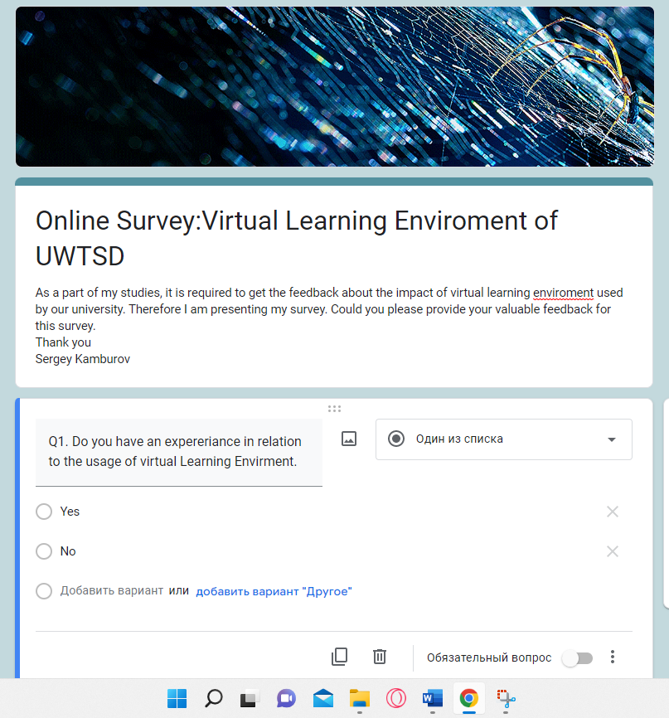

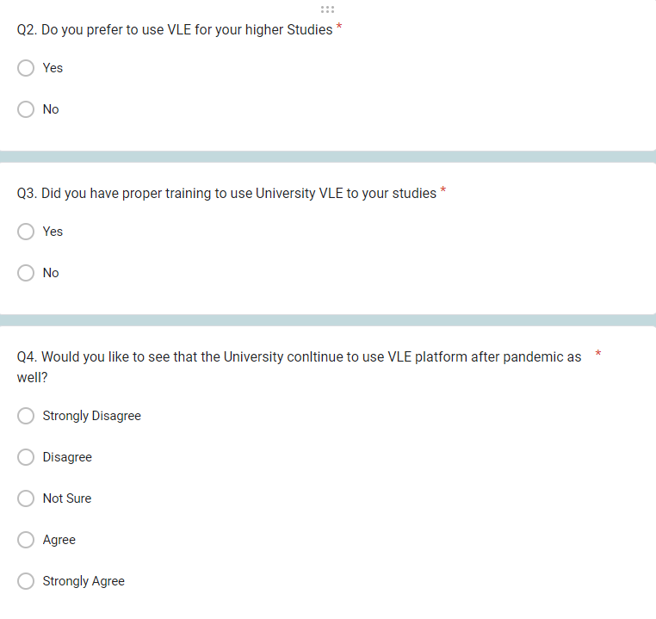
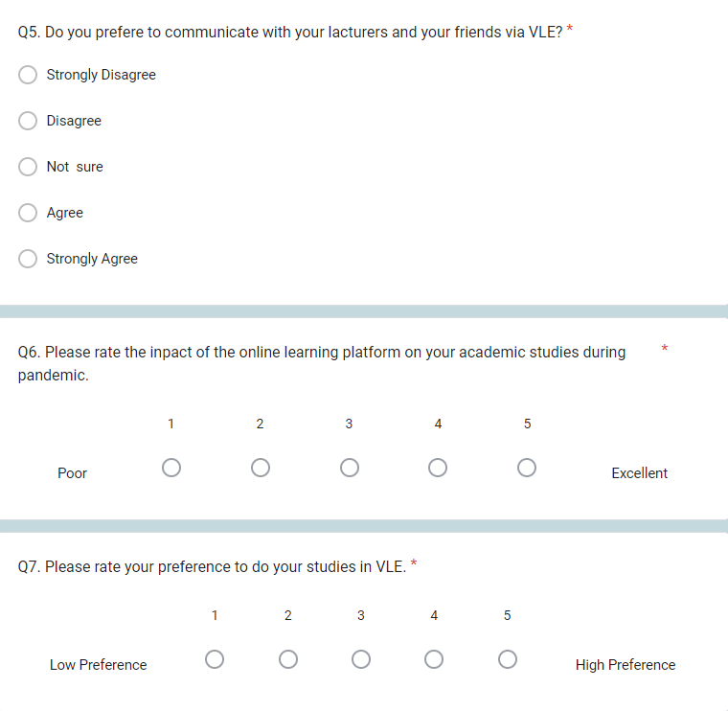

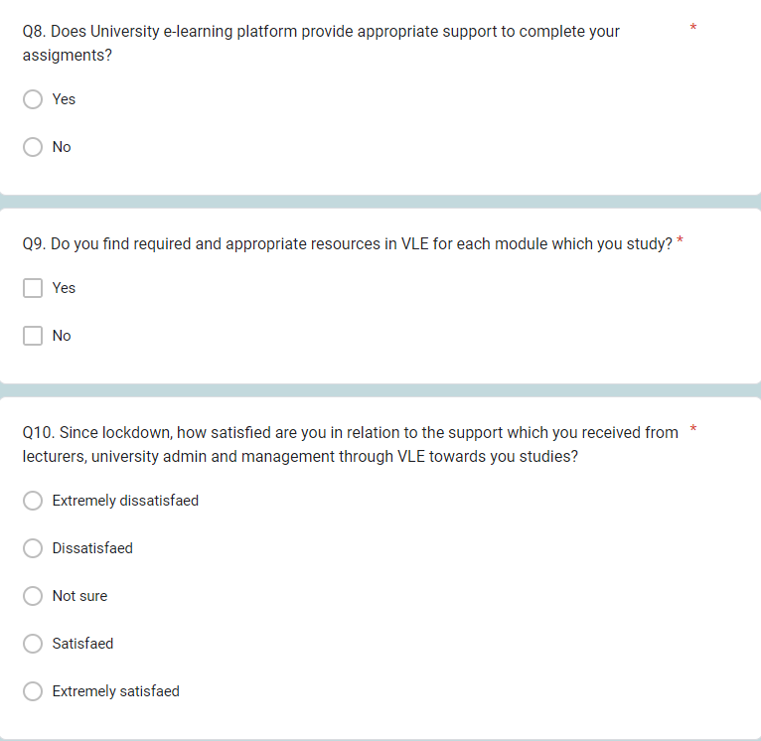

Results


