

Assessment 1
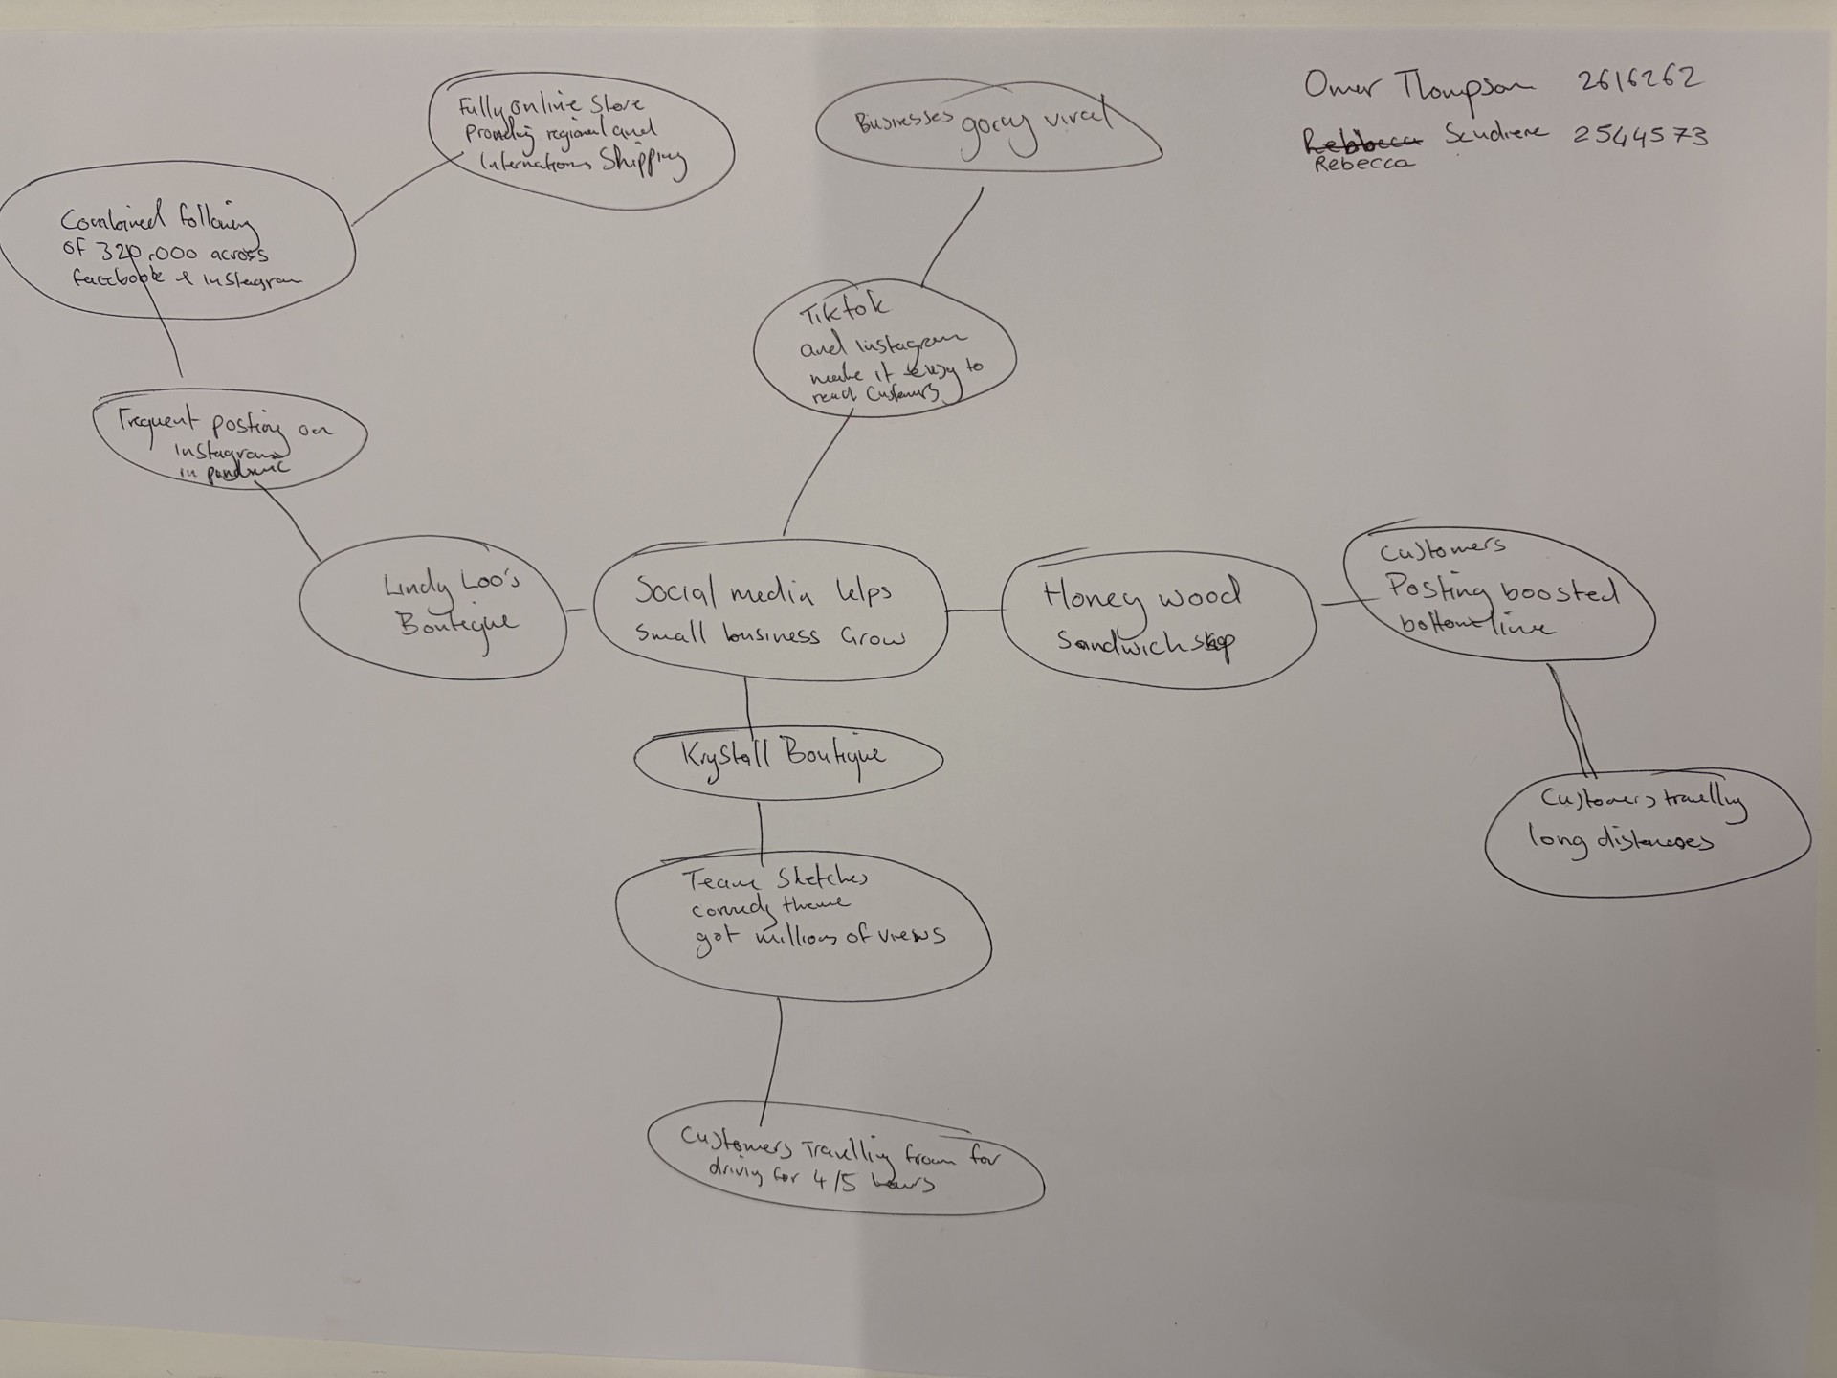

- What is the main idea of the whole text?
The main idea of the text focus on how social media help small businesses grow.

- What is one key point that supports the main idea, and which specific example from the text shows this?
The key point that support the main idea is viral video content.

- What is a different key point that supports the main idea, and which specific example from the text shows this?
Honey wood sandwich shop use customers review, also kybalt boutique use social media to share updates.

- Which part of the text do you think is most important, and why?
Choosing the right platform is the important part, TikTok is a good tool to grow a family business.

Reflection:
- What did you find difficult in this task (including in-class components), and why was it difficult?
In this task was hard to connect different businesses together, because every shop have different social media plan. Put them all together was difficult

- What helped you with this difficulty, and how did it help you?
Working with my classmate help me. We share opinion and this helped us to find links between the shops

