

EXAMINATION PAPER
MARKS AND COMMENTS SHEET

PROGRAMME | OME Degree Apprenticeship
LEVEL | 4
MODULE | ACDB4011 Chemistry
STUDENT I.D. | 2430694
EXAMINER | Ewa Kazimierska | INTERNAL VERIFIER
Once completed marks only should be transferred onto the front of the examination paper (no comments other than ticks or crosses on the examination paper)

Question  Number | Comments | Marks available | Marks awarded | 2nd marker (sample) | 3rd marker (where necessary)
1 | 7/10 True/False answers correct. Good overall understanding of core principles; minor errors in orbital and intermolecular force concepts. | 15 | 10.5
2 | Bohr model and charge identification were correct. However, Lewis structure was incorrect, and bond comparison answer was inaccurate. | 11 | 5
3 | All parts well attempted. Photon energy calculated correctly, and explanations related to electron configuration and emission were accurate. | 10 | 10
4 | Combustion equation incorrect, and follow-up calculations contained errors or were missing. Only gas volume was properly solved using correct method. | 15 | 4
5 | Partial attempt at oxygen balance with minimal detail. Remaining parts not attempted. | 16 | 0
6 | Energy profile drawn well, though enthalpy change was not calculated. Reaction type correctly identified as endo-/exothermic. | 7 | 5
7 | Heating curve drawn correctly but phases not labelled. Mixed performance in phase diagram analysis; some key points (e.g., name, pressure) missing. | 11 | 6.5
8 | No attempt made on either titration calculation or ionic equation. | 5 | 0
9 | General understanding of calorimetry evident; ΔT correctly calculated, but full calculation not completed. | 5 | 3
10 | Redox processes and changes were correctly identified. No response to agent classificatio | 5 | 1.5
 |  |  | 45.5

1st Marker Name | Ewa Kazimierska | 1st Marker Signature | 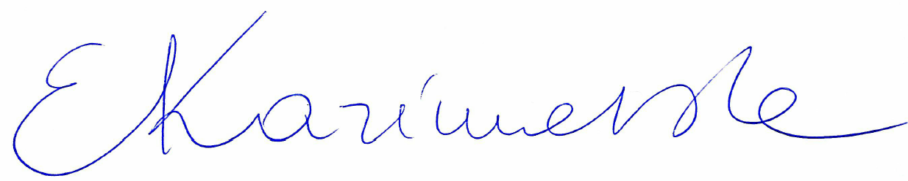
2nd Marker Name |  | 2nd Marker Signature
3rd Marker Name |  | 3rd Marker Signature
Reasons for awarding the final mark where there is more than one marker
Notes:
- The 3rd marker may be used where there is more than a 10 percentage point difference (in the TOTAL mark) between markers 1 and 2 OR when it is not possible to get agreement between markers 1 and 2. Reasons must be given where an agreed mark is given.
- This form is for internal use only and is NOT to be returned to the student. The final agreed marks must be transferred to the student feedback sheet in the assignment specification.
- The external examiner MUST be shown this form.

