

Scripting and Programming Concept, ASSignment
ACCA5036

23 July 2026
waheeb salem, id:2407868
LECTURER: DR. MOBOLANLE BELLO
UNIVERSITY OF WALES, BIRMINGHAM
Smart Device Manager link:
https://github.com/Waheeb26/Waheeb-Salem-Scripting-And-Programming-Module/tree/main

Contents
1.0 Introduction 2
2.0 Requirement Analysis 2
MoSCoW Table features of Smart Device Manager 3
Structured Diagram 4
3.0 Software Design and Development 4
Importance of Design and Development in Software Solutions 4
3.1 Design 5
3.1.1 Flowchart 5
Flowchart logic – step by step representation: 6
3.1.2 Pseudocode 7
Device Manager Pseudocode: 8
Purpose of Pseudocode in Smart Device Manager Design 11
Logic Behind the Pseudocode and Translation to Code 12
3.2 Implementation Decision 15
3.2.1 Data Structures: 15
3.2.2 Programming Constructs: 16
3.2.3 Python Modules and Libraries 18
4.0 Testing and Debugging 19
4.1 Role of Testing in Software Environment 19
4.2 Type of Errors in Programming 19
4.3 Example of Test Cases 29
5.0 Evaluation 31
Reflective Summary, Challenges and How they were Addressed 31
Project Overview 31
Future Improvements 32
Self-Reflection 33
References 34

1.0 Introduction
Bright Minds Academy required a simple system to manage classroom devices. Staff were finding it difficult to track which devices were connected, their locations, and their status. This project aimed to develop a Smart Device Manager program to address these issues.
The program was built using Python and stores device information using a dictionary. It allows staff to add devices, update room locations, view all devices, and search for specific devices. The MoSCoW method was used to prioritise features, ensuring that essential functions were developed first.
This report documents the complete development process. The Analysis stage identifies user requirements. The Design stage presents pseudocode, a flowchart, and the system logic. The Implementation stage shows the Python code and explains the data structures and programming constructs used. The Testing stage describes the test cases and debugging process. Finally, the Documentation stage reflects on the project and suggests future improvements.

2.0 Requirement Analysis
Bright Minds Academy required a simple system to manage classroom devices. Staff were finding it difficult to track devices and their locations. The main problem was that there was no central system to record and view device information.
The software must allow staff to add new devices and room locations. For example, a staff member can add ‘Device 1’ to ‘Room 11’. They must also be able to view all devices, update room location and search for specific devices.

How features were selected and why
Must have features were included because the academy's core problem involves tracking devices and their locations. Without these functions, the system fails its primary purpose [2].
Should have features (device type menu and auto-naming) were added to make data entry faster and more consistent for staff members.
Could have feature (last used tracking) was included as an extra benefit to help staff identify when devices were last active.
Won't have features were excluded because they require complex hardware or cloud systems, which falls outside the project scope of using only a dictionary for data storage.

MoSCoW Table features of Smart Device Manager
Using the MoSCoW method, features were prioritised for the prototype [1]:
Priority | Meaning | Features Selected | Device Example
Must have | Essential for system to work | Add device, View all, Update status, Search | Device 1, Device 2
Should have | Important but not critical | Device type menu, Auto-naming | Device 3, Device 4
Could have | Nice to have if time permits | Last used tracking | Device 5
Won’t have | Save for future | Remove device, Auto-detect, Reports, Cloud backup | _
Table 1: MoSCoW Analysis for Smart Device Manager

Structured Diagram

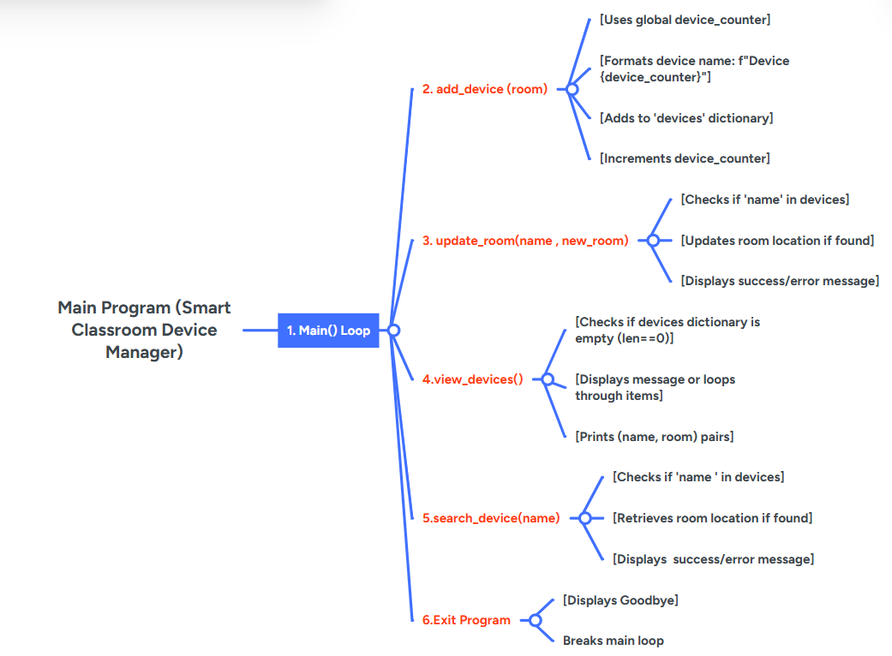
Figure 1: Structure Diagram for Smart Device Manager

3.0 Software Design and Development

Importance of Design and Development in Software Solutions
Design and development are essential steps in building software. A good design acts like a blueprint. Without it, software becomes confusing and full of mistakes [3].
The design stage involves planning data structures, functions, and the user menu. Good design saves time and reduces errors [3]. Development is where the design becomes code. This project uses Python with dictionaries to store device information.
When design and development work together, the software is easy to use and fix. Usability is a key quality attribute that determines user acceptance [4]. Skipping design leads to messy code and project failure.

3.1 Design

3.1.1 Flowchart
A flowchart is a visual diagram that represents the steps of a program or process. It uses standard shapes to show different types of actions [ 5]. An oval represents the start or end of a program. A rectangle shows a process or action being performed. A parallelogram indicates input (user types something) or output (screen displays something). A diamond represents a decision point where the program asks a yes/no question and chooses a path based on the answer.
Flowcharts are valuable tools in software design because they help developers plan logic before writing code. By drawing a flowchart first, problems can be identified early, saving time during implementation. Flowcharts also make the program's logic clear for other developers who may need to understand or modify the code later [6].

Flowchart for Smart Device Manager
The following flowchart shows the complete logic of the Smart Device Manager program. The user starts at the menu, makes a choice (1-5), and the program follows the path for that choice. After completing any action except Exit, the program returns to the menu.
The flowchart visually maps the logic of the Smart Device Manager. It shows each step from menu display to user input, decision-making, and program exit. The program helps identify potential errors before coding begins. It also serves as a communication tool, making the program’s structure clear for developers and stakeholders. The flowchart ensures all required features including add, update, view, search and exit are properly sequenced.

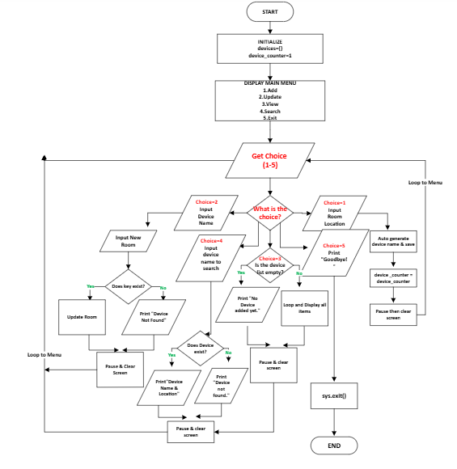
Figure 2: Smart Device Management System Flowchart

Flowchart logic – step by step representation:
The flowchart begins when the program starts and displays a main menu with five options. When the user selects option one, the system asks for a room name, generates a unique device identifier such as "Device 1", and stores both the device name and room location in a dictionary. A success message is then displayed to confirm the addition.
For option two, the user provides a device name and a new room location. The system searches the dictionary for the specified device. If found, the room is updated and a confirmation message appears. If not found, an error message is shown.
Option three allows the user to view all stored devices. The system checks if the dictionary is empty. If empty, it displays a message indicating no devices have been added. If devices exist, the system displays a complete list of device names and their corresponding room locations. When option four is selected, the user enters a device name to search. The system looks for the name in the dictionary. If found, it displays the device name and room. If not found, a "not found" message appears.
Finally, option five exits the program. A goodbye message is displayed and the program terminates. After each action except exit, the system returns to the main menu.
User Action | Input | Process | Output
Add Device | Room name | Generate Device X, save to dictionary | Success message
Update Room | Device name, new room | Search dictionary, update if found | Confirmation or “Not Found”
View All | None | Check if empty, loop through dictionary | Device list or “No devices”
Search | Device name | Search dictionary | Device details or “Not Found”
Exit | None | End Program | “Goodbye” message
Table 2: IPO Function Summary Table

3.1.2 Pseudocode
Pseudocode is a simplified, human-readable description of a program's logic [ 7]. It uses plain language and common programming structures like loops and decisions but avoids the strict syntax rules of actual programming languages. Pseudocode helps developers plan and communicate their ideas before writing real code.
Pseudocode is easy to read and understand. It also helps find mistakes in the program’s logic before any code is written [8]. Different styles can be used when writing pseudocode. Some writers use camel case for variable names, like deviceCounter or newRoom. Others prefer Pascal-style structures such as AddDevice and ViewDevices. Some formats use indentation to show blocks of code, while others use keywords like IF, ELSE and UNTIL [8]

Device Manager Pseudocode:
START

PROGRAM SmartDeviceManager;
VAR
devices : DICTIONARY OF STRING;
counter : INTEGER;
choice : STRING;
room, name, new_room : STRING;
// 1. Function to add a new device
AddDevice(room : STRING):
name ← "Device " + ToString(counter)
devices[name] ← room
Display(name + ' added to ' + room)
counter ← counter + 1
Display('Press Enter to continue...')
Input(room)
END AddDevice
// 2. Function to update an existing device’s room
UpdateRoom(name : STRING; new_room : STRING):
IF KeyExists(devices, name) THEN
devices[name] ← new_room
Display(name + ' moved to ' + new_room)
ELSE
Display(name + ' not found.')
ENDIF
Display('Press Enter to continue...')
Input(room)
END UpdateRoom
// 3.Function to view all devices
ViewDevices:
IF IsEmpty(devices) THEN
Display('No devices added yet.')
ELSE
Display('--- All Devices ---')
FOR EACH name, room IN devices DO
Display('- ' + name + ' is in ' + room)
ENDFOR
ENDIF
Display('Press Enter to continue...')
Input(room)
END ViewDevices
// 4. Function to search for a specific device
SearchDevice(name : STRING):
IF KeyExists(devices, name) THEN
Display('Found! ' + name + ' is in ' + devices[name])
ELSE
Display(name + ' not found.')
ENDIF
Display('Press Enter to continue...')
Input(room)
END SearchDevice
// 5. Function to clear the screen
ClearScreen:
← Clears the terminal screen
END ClearScreen
//6. Function to display the user menu
ShowMenu:
Display(' Bright Minds Academy Device Manager ')
Display('1. Add a new device')
Display('2. Update device room')
Display('3. View all devices')
Display('4. Search for a device')
Display('5. Exit')
END ShowMenu

BEGIN ← Main program starts here
devices ← EMPTY DICTIONARY
counter ← 1

REPEAT
ShowMenu
Display('Choose an option (1-5): ')
Input(choice)

IF choice = '1' THEN
Display('Enter room location: ')
Input(room)
AddDevice(room)
ClearScreen
ELSE IF choice = '2' THEN
Display('Device name to update: ')
Input(name)
Display('Enter new room location: ')
Input(new_room)
UpdateRoom(name, new_room)
ClearScreen
ELSE IF choice = '3' THEN
ViewDevices
ClearScreen
ELSE IF choice = '4' THEN
Display('Device name to search: ')
Input(name)
SearchDevice(name)
ClearScreen
ELSE IF choice = '5' THEN
Display('Goodbye!')
ELSE
Display('Invalid option. Try again.')
Display('Press Enter to try again...')
Input(room)
ClearScreen
ENDIF

UNTIL choice = '5'
END.

Purpose of Pseudocode in Smart Device Manager Design
Pseudocode serves as a planning tool for the Smart Device Manager program. It allows the developer to outline the logic of the system before writing actual Python code. By writing pseudocode first, the structure of the program becomes clear, and any potential errors can be identified early.
The pseudocode shows how the system initialises variables, displays menu, processes user choices, and handles device management functions such as adding, updating, viewing, and searching for devices. It demonstrates using a dictionary to store device information [8]. Pseudocode makes implementation faster and acts as a guide [8].

Logic Behind the Pseudocode and Translation to Code
The pseudocode for the Smart Device Manager follows a Pascal style structure, which uses clear block markers and indentation to show the flow of the program [8]. This method was chosen because it is easy to read and understand, making it ideal for planning program logic before coding begins.
The pseudocode for the Smart Device Manager follows a clear and logical structure. It begins by declaring variables, including a dictionary called devices to store device names and room locations, and a counter to generate unique device identifiers such as "Device 1" and "Device 2". This structure directly matches the Python implementation where a dictionary is used for data storage [8].
The main logic revolves around a loop that continuously displays a menu until the user chooses to exit. Each menu option corresponds to a specific procedure. For example, the AddDevice procedure takes a room as input, generates a device name, and stores it in the dictionary. This translates directly into a Python function with the same logic. Similarly, UpdateRoom checks if a device exists before updating its room, which becomes an if statement in Python. The ViewDevices procedure iterates through the dictionary, which becomes a for loop in Python.
The pseudocode also shows how user input is captured and how decisions are made. Each IF statement in the pseudocode represents a branch in the program flow, such as choosing between different menu options. The REPEAT …UNTIL loop ensures the program runs until the user selects the exit option.
By writing the pseudocode first, the translation to Python becomes straightforward. Each line of pseudocode maps to a corresponding line or block of Python code. The variables and logic remain the same, only the syntax changes. This makes the coding process faster and reduces the chance of errors [8].
How the Pseudocode Translates into an actual code
Pseudocode acts as a bridge between design and implementation. Each pseudocode statement maps to a corresponding Python command [8]. For example, Display becomes print(), Input becomes input(), and IF becomes if. The logic remains the same, only the syntax changes.
- AddDevice Function
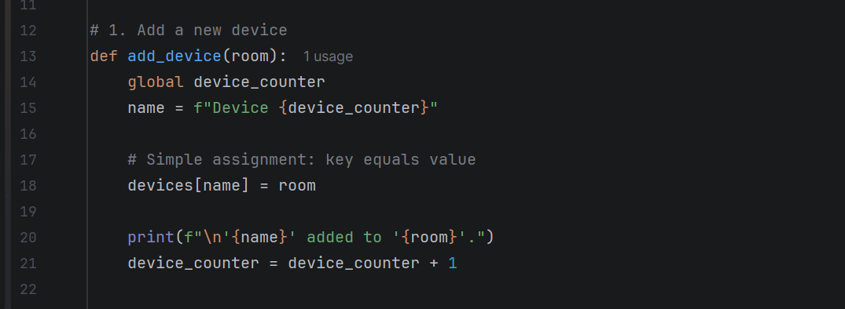
Figure 3: Adding a new device to the dictionary
This function in the image above (Figure :3) creates a new device name using the counter. It then stores the device name as the key and the room as the value in the dictionary using devices[name] = room. This is how new data is added to the dictionary [9].
- UpdateRoom Function
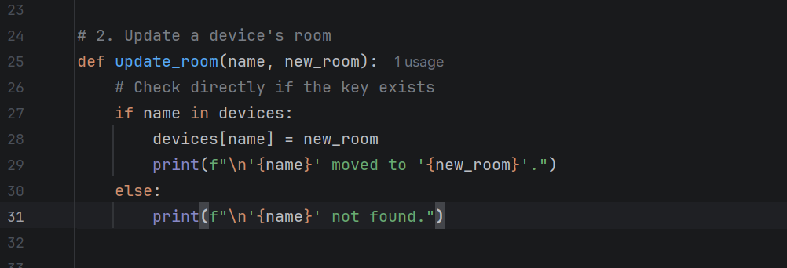
Figure 4: Updating a device room in the dictionary
In Figure 4 above, the UpdateRoom function checks if a device name exists in the dictionary using if name in devices. If found, it updates the room by assigning a new value to the existing key. If not found, it shows an error message. This shows how the dictionary supports fast lookups and updates [9].

- ViewDevices Function
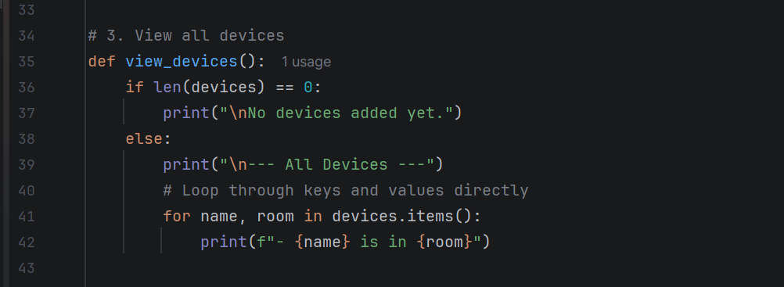
Figure 5: Viewing all devices stored in the dictionary
In Figure 5 above, the ViewDevices function checks if the dictionary is empty using len(devices). If devices exist, it loops through the dictionary using devices.items() and displays each device name and its room. This shows how to iterate through all key-value pairs in a dictionary [9].
- SearchDevice Function
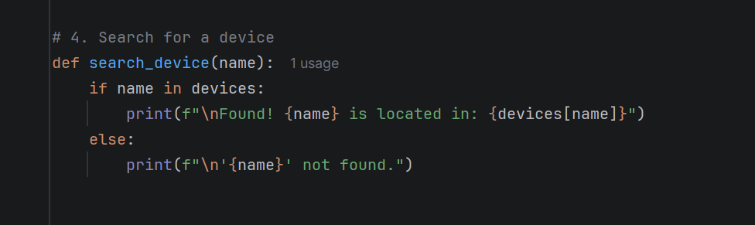
Figure 6: Searching for a device in the dictionary
In Figure 6 above, the SearchDevice function searches for a device by checking if the name exists as a key in the dictionary using if name in devices. If found, it retrieves the room using devices[name]. If not found, it shows an error message [9]. This shows how dictionaries provide fast data retrieval.

3.2 Implementation Decision

3.2.1 Data Structures:
A data structure is a way of organising and storing data in a computer so that it can be accessed and used efficiently [9]. Different types of data structures are designed for different purposes. Some common examples include lists, arrays, stacks, queues, and dictionaries. The choice of data structure affects how fast and how easily a program can perform its tasks.

Data Structure Used in Smart Device Manager
The Smart Device Manager relies on a dictionary for its primary data structure. This structure holds data as a key-value pairs, associating each unique key with a specific value [9]. In this system, the device name is used as the key, and the room location is stored as the value. This allows the program to quickly find, add, update, or delete device information without searching through the entire collection [9].
Justification for Using a Dictionary
A dictionary was chosen as the main data structure for the Smart Device Manager because it provides fast lookups, simple updates, and clear organisation of device data [18]. Dictionaries use a technique called hashing, which allows the program to find a device almost instantly, even if the system contains hundreds of devices. Without a dictionary, the program would need to search through a list item by item, which is slower and less efficient. This makes the program efficient for staff who need to find devices quickly [9], [18].
The dictionary also perfectly matches the problem domain. Each device has a unique name, and each name corresponds to one room. This is a natural key-value relationship. Using a dictionary makes the code more readable and maintainable because the data structure reflects how staff think about devices. For example, in the search_device function, the program uses if name in devices to check if a device exists and then retrieves the room using devices[name]. This direct lookup is fast and simple. Without a dictionary, the program would need to loop through all devices to find a match, which is slower and requires more code. A dictionary keeps the program simple, lightweight, and easy for other developers to understand [18].

Variables Used in Smart Device Manager Program
The program uses several variables to store data and control the flow of the program. Each variable serves a specific purpose as described below and shown in table 2.
Variable | Data Type | Purpose
Devices | Dictionary | Stores all devices as key-value pairs (device name - room)
device_counter | Integer | Generates unique device numbers (Device 1, Device 2, etc)
Choice | String | Stores the user’s menu option (1-5)
Room | String | Stores the room location entered by the user
Name | String | Stores the device name entered by the user
new_room | String | Stores the new room location when updating a device
Table 3: Description of Each Variable used in the Smart Device Manager Program

3.2.2 Programming Constructs:
Programming constructs are basic elements controlling program logic and flow. Key types include sequences, selections, and iterations, enabling complex software through simple logic [10].
Sequences run instructions step-by-step in order. Selection statements, like IF, enable decision-making based on conditions, whereas iteration constructs, including FOR and REPEAT…UNTIL loops, repeat code blocks multiple times [11].

Programming Constructs Used in Smart Device Manager
Smart Device Manager project uses several programming constructs, including loops, functions and error handling.
Loops are used in two ways. A REPEAT…UNTIL loop keeps the main menu looping until the user chooses to exit [11], [18]. A FOR loop is used in the ViewDevices function to iterate through all devices stored in the dictionary and display each one.
Functions are used to organise the code into reusable blocks. Each function performs a specific task, such as AddDevice, UpdateRoom, ViewDevices, and SearchDevice. This makes the code cleaner, easier to read and simpler to maintain. The main() function directs the program’s overall execution flow and calls other functions as needed.
Error handling is implemented to manage invalid user inputs. For example, when the user is asked to choose an option from the menu, the program checks if the input is valid. If the user enters an invalid choice, an error message is displayed, and the user is prompted to try again [15].
These constructs work together to create a functional and user-friendly program. They also make the code easier to read, test, and maintain.

Justification of Programming Constructs Used
The programming constructs chosen for the Smart Device Manager were selected to make the program efficient, easy to read, and easy to maintain. The two main constructs used are selection and iteration.
Selection is used through IF...THEN...ELSE statements. These allow the program to make decisions based on user input. For example, when the user chooses option 1, the program calls the AddDevice function. If the user chooses option 5, the program exits. This construct is essential for creating interactive programs that respond to different user actions [10].
Iteration is used through REPEAT…UNTIL and FOR loops. The REPEAT…UNTIL loop keeps the menu running until the user decides to exit. This provides a continuous user experience. The FOR loop is used in the ViewDevices function to iterate through all devices stored in the dictionary. This allows the program to display each device without writing repetitive code [10].
These constructs were chosen because they are fundamental to structured programming. They make the code clearer and reduce the chance of errors [12]. By using these constructs, the program becomes more reliable and easier for developers to understand and modify.

3.2.3 Python Modules and Libraries
A Python module is a file containing Python code that including function, class and variable definitions. Modules are designed to be imported and used in other programs, helping to organise code into reusable units [13]. While a library refers to a collection of related modules and packages that provide functionality for specific tasks. The Python Standard Library, for instance, contains numerous modules for common tasks such as file handling, data processing, and network communication [14].
Modules used in Smart Device Manager
The Smart Device Manager uses two built-in Python modules: os and sys. The os module is used to clear the terminal screen. This improves the user experience by keeping the interface clean after each action [18]. The sys module is used to exit the program cleanly when the user selects the exit option.
These modules were chosen because they are part of the Python Standard Library, meaning they are built into Python and do not require installation. This keeps the program lightweight and ensures it can run on any system with Python installed [18].
Justification for not using external Libraries
The Smart Device Manager does not use any external libraries. External libraries such as NumPy, Pandas, or Matplotlib were not required for this project [13], [18]. The program performs simple tasks such as storing and retrieving device names and room locations. It does not perform complex calculations, data analysis, or visualisation. Using external libraries would add unnecessary complexity and require additional installation steps.
By relying only on built-in modules, the program remains lightweight, easy to distribute, and simple to run on any system with Python installed [18].

4.0 Testing and Debugging

4.1 Role of Testing in Software Environment
Program testing is the process of running a software application to find errors and verify expected behaviour [15]. It involves providing inputs, comparing actual outputs with expected results, and identifying discrepancies that need correction.

Importance of Program Testing
Program testing is important because it helps find errors and defects in the software before it is released to users [15]. Without testing, software may contain bugs that cause it to fail or produce incorrect results. Testing also ensures that the software meets the requirements and works as expected in different situations. This improves the overall quality of the product.
Testing also saves time and money in the long run. Finding and fixing errors early costs less than fixing them after the software is released [15]. Testing also protects the reputation of the organisation by ensuring that users receive a reliable product. When software works correctly, users trust it and are more likely to continue using it. Overall, testing is a necessary step that helps deliver high-quality software.

4.2 Type of Errors in Programming
A programming error or a bug , is a code flaw that causes unexpected behaviour or incorrect results. Errors can occur for various reasons, such as incorrect syntax, wrong logic, or unexpected user inputs [1]. There are three main types of programming errors: syntax errors, runtime errors, and logical errors [15].

Syntax Error
A syntax error occurs when the code violates the rules of the programming language, such as missing a colon or bracket [16], [17].
Error 1: Missing Colon After Function Definition
Figure 8 below shows a syntax error occurring on line 2 because Python requires a colon (:) at the end of a function definition header to open the code block.
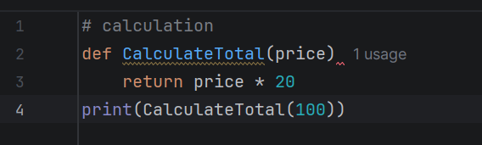
Figure 7: In python, every function definition must end with a colon [15].
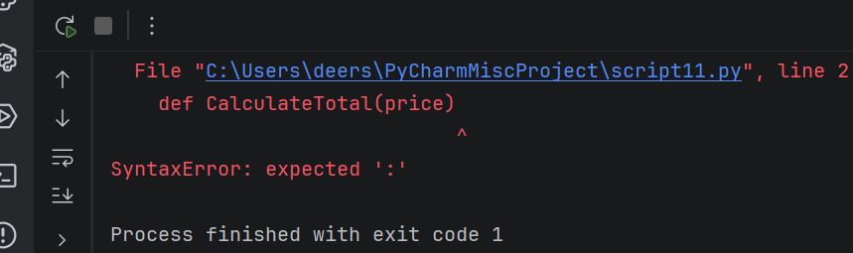
Figure 8: SyntaxError expected ":"
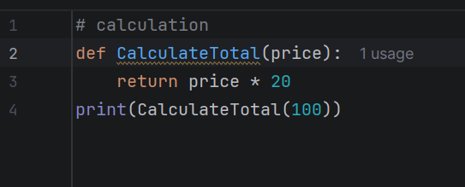
Figure 9: Fixed Code with adding the colon
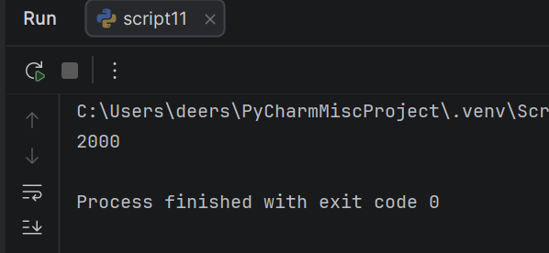
Figure 10: The Result After Running Process

Error 2: Missing Closing Quote Mark
Figure 12 below shows a syntax error on line 1 because a closing quote mark (”) is missing at the end of the text.
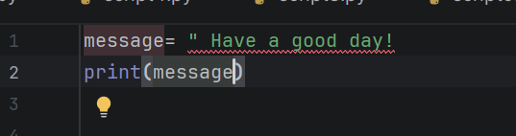
Figure 11: The code in Python with the error.
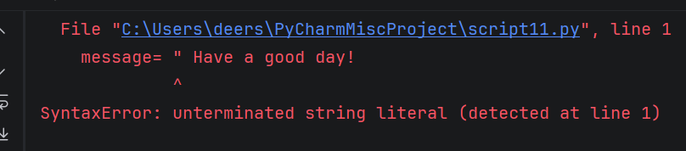
Figure 12: SyntaxError line 1
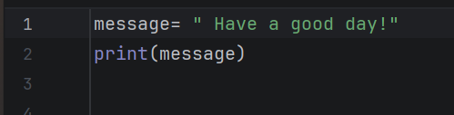
Figure 13: Code fixed

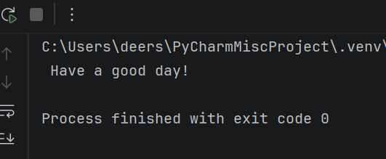
Figure 14:The result after running the script

Error 3: Missing Closing Bracket
Figure 17 below shows a syntax error on line 1 because Python needs a closing bracket ) is missing at the end of print statement.
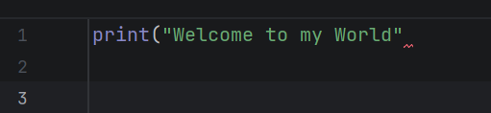
Figure 15: Every opening bracket must have a matching closing bracket [15].
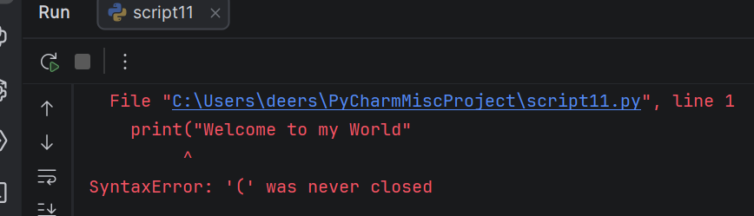
Figure 16: SyntaxError '(' not closed
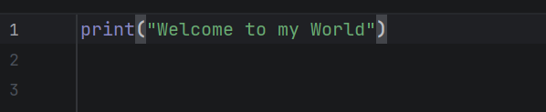
Figure 17: Code fixed with adding a closing bracket.
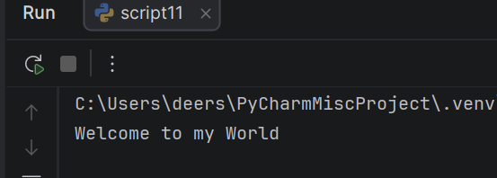
Figure 18: The Output After Running the Code

Logical Error
A logical error happens when code contains flaws in reasoning or missing validation checks, such as a zero-division error or an index error [16], [17]. Although these mistakes can cause execution failures when run, they stem directly from incorrect program logic.

Error 1: An order of operations logical error
Figure 19 below shows a logical error on line 4 because missing brackets cause the program to calculate the wrong average without throwing a crash error.
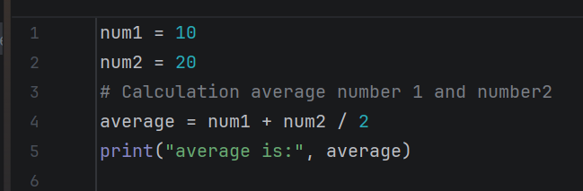
Figure 19:The code with logical error
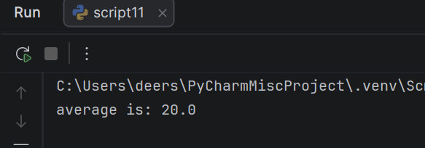
Figure 20: The Code runs without crashing, but with wrong answer

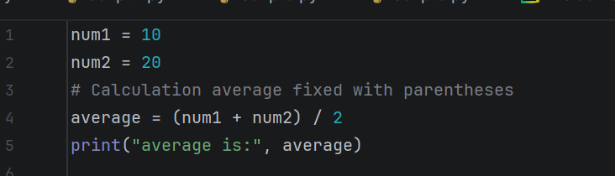
Figure 21: fixed code
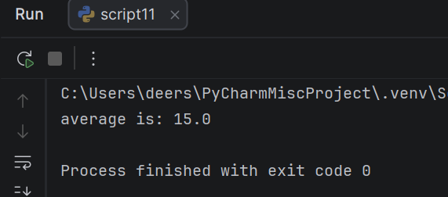
Figure 22:The correct output

Error 2: Zero Division Error
Figure 24 below shows a logical zero division error on line 4 where trying to divide by zero causes a crash, which is resolved using an if check.
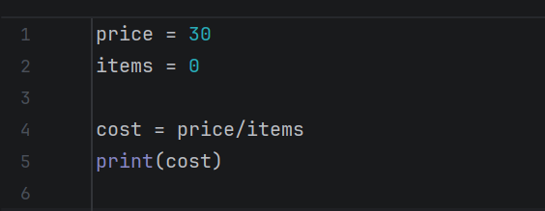
Figure 23: Logical error causing zero division

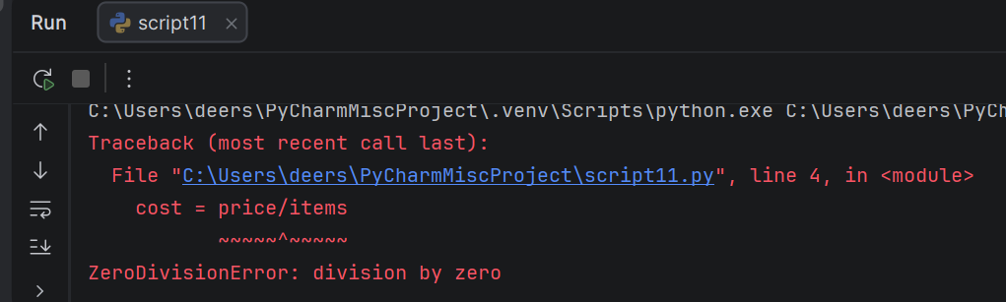
Figure 24: Execution traceback displaying the zero division error

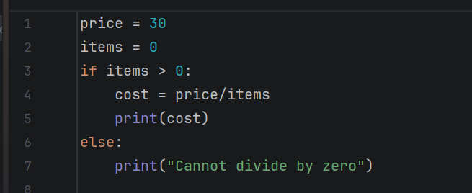
Figure 25: Fixed Code
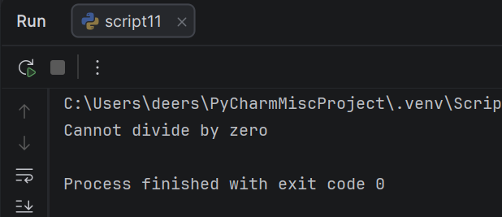
Figure 26: The program output when executed

Error 3: Index Logical Error
Figure 28 below displays code attempting to access index 3 in a three-item list, resulting in a logical index error.
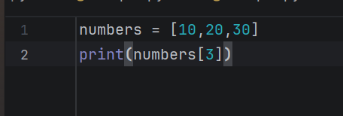
Figure 27: Code with Error
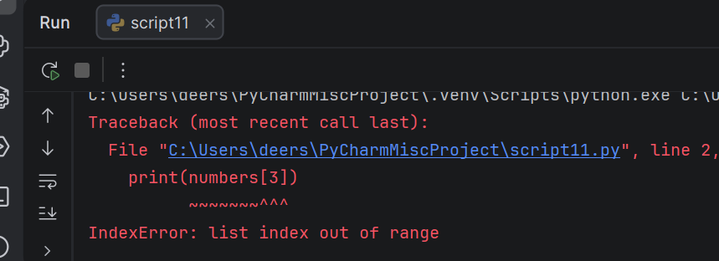
Figure 28: Error Output
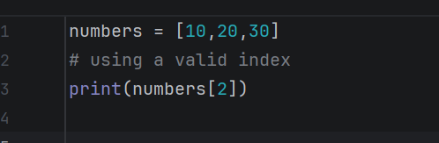
Figure 29:Fixed Code

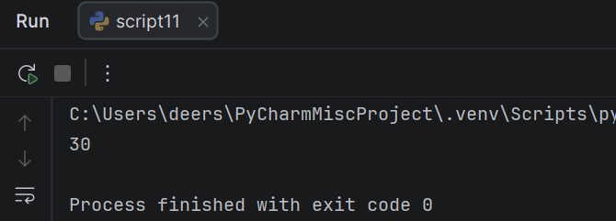
Figure 30: The output after running the code

Runtime Error
A runtime error happens during program execution, unlike a syntax error which is detected before the program runs [16],[17].
Error 1: Invalid Operations Error
Figure 32 below shows a run-time error caused by combining incompatible data types. Trying to add a string and an integer together causes the program to crash during execution process.
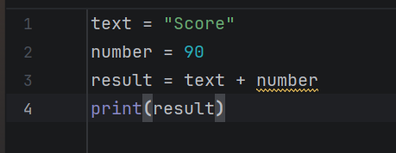
Figure 31: Code with error

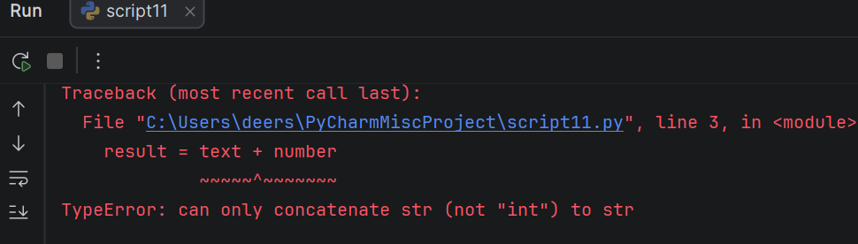
Figure 32: Python output
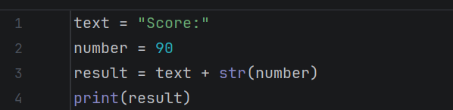
Figure 33: Fixed Code
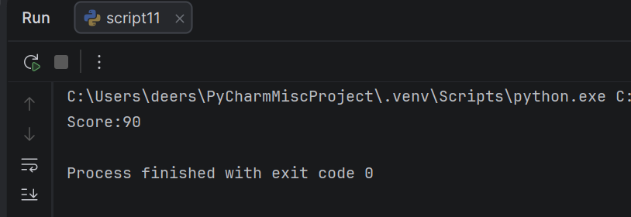
Figure 34: The final output after fixing the error

Error 2: Name Error
Figure 36 below shows a run-time error caused by calling an undefined variable. Because totel misspelled, the program crashes during execution process.
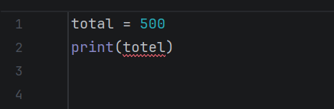
Figure 35: Code with error

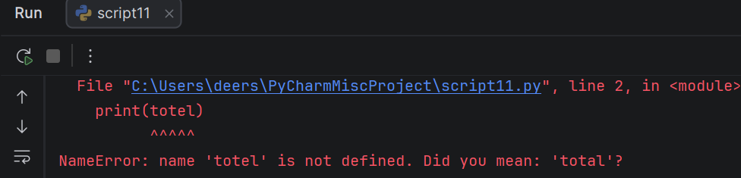
Figure 36: Run-time error during execution

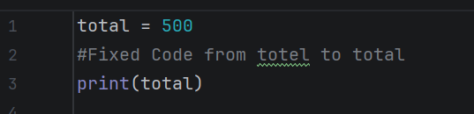
Figure 37: Fixed Code
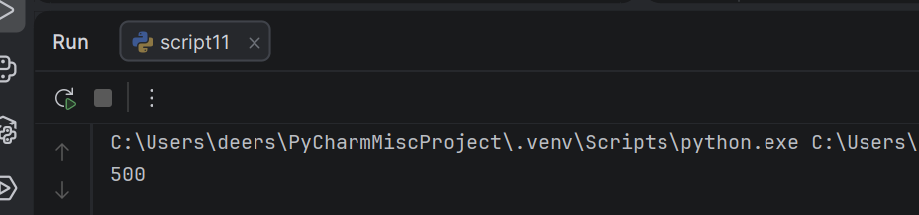
Figure 38:The final output after execution

Error 3: Value Error (converting a string with letters)
Figure 40 below displays a run-time error caused by invalid type conversion. Because the string “ten” cannot be turned into a number, the program crashes during execution process.

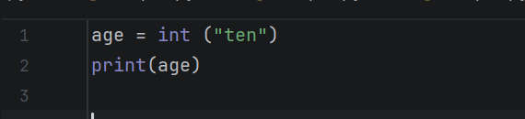
Figure 39:Code with error

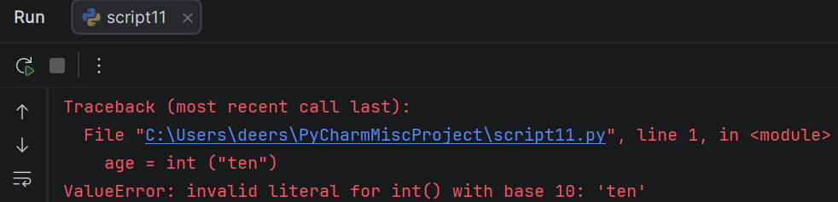
Figure 40: Python Output ValueError
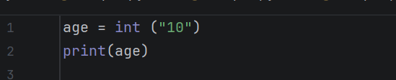
Figure 41: Fixed Code

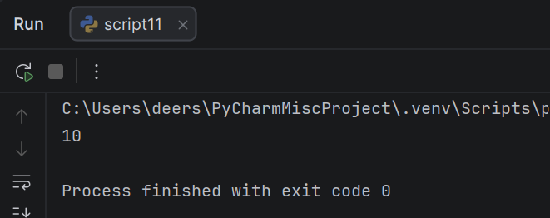
Figure 42:The program output when executed

4.3 Example of Test Cases
Test cases are designed to check if each function of the Smart Device Manager works correctly [17]. Each test case focuses on a specific feature, such as adding a device or searching for a device.
The test cases are based on the program's requirements. Both valid and invalid inputs are tested. Valid inputs check if the function works as expected, while invalid inputs check if the program handles errors properly. Below are two sample test cases that have been executed and passed [17].
Test Case 1: Add a New Device (TC1)
Test Case ID | TC1
Test Case Title | Add a new device
Objective | Verify that the system correctly adds a new device with a name and room location
Preconditions | The program is running and the main menu is displayed.
Test Steps | - Select option 1 from the main menu.  - Enter room location: Room 11.  - Check the success message displayed.  - Check the dictionary to confirm the device was added.
Test Data | Room location: Room 11
Expected Result | The system displays ‘Device 1’ added to ‘Room 11’.
Pass/Fail | Pass
Comments | Screenshot taken of the success message.
Table 4:Test Case1
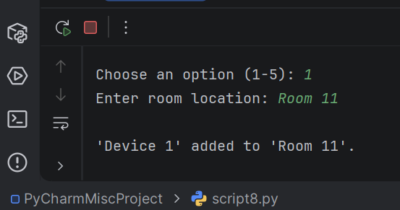
Figure 43: Test Case TC1 - Add Device

Test Case 2: Search for a Device (TC2)
Test Case ID | TC1
Test Case Title | Search for a device
Objective | Verify that the system correctly finds a device when the user searches by its name
Preconditions | At least one device exists in the system (e.g., Device 1 in Room 11).
Test Steps | - Select option 4 from the main menu.  - Enter device name: Device 1.  - Check the output displayed.
Test Data | Device name: Device 1
Expected Result | The system displays Found! Device 1 is located in: Room 11
Pass/Fail | Pass
Comments | Screenshot taken of the device details.
Table 5:Test Case 2
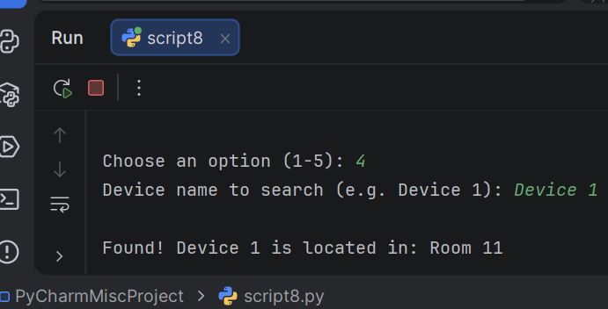
Figure 44: Test Case TC2 - Search Device

5.0 Evaluation

Reflective Summary, Challenges and How they were Addressed

Project Overview
The Smart Device Manager project was developed to help Bright Minds Academy staff track classroom devices. The main goal was to create a simple system where staff could add devices, view them, update their room locations, and search for specific devices. The program uses a dictionary to store device names and room locations, and a counter to generate unique device names like "Device 1" and "Device 2". The Python programming language was used, along with built-in modules like os and sys for clearing the screen and exiting the program.

Challenges Faced
Several challenges were encountered during the development process. One major challenge was ensuring that the dictionary correctly stored and retrieved device information. Initially, there was confusion about how to update a device's room without overwriting other data. Another challenge was managing the device counter to ensure each device received a unique name. At first, the counter was not increasing properly, which caused all devices to be named "Device 1". Additionally, managing the dictionary logic was challenging. Ensuring that device names such as Device 1, Device 2, Device 3 were correctly paired with their room locations in the dictionary required careful attention to avoid overwriting existing data.

How Challenges Were Addressed
These challenges were addressed through careful testing and debugging. The dictionary update issue was resolved by using the if name in devices condition to check if a device existed before updating. The counter problem was fixed by declaring global device_counter inside the function. The screen clearing issue was solved by using a simple command that works on different systems. Regular testing with different inputs helped identify and fix errors early. The pseudocode and flowchart created during the design stage also helped to plan the logic before coding, reducing errors.

Future Improvements
The Smart Device Manager is a simple and functional system. However, several improvements could make it more useful for Bright Minds Academy.
One important improvement would be to save data to a file. Currently, all devices are stored in memory and are lost when the program closes. By using a simple text file or JSON file, the program could save device information permanently. This would allow staff to close the program and reopen it without losing any data.
Another improvement would be to add a remove device function. Currently, staff can add and update devices but cannot delete them. Adding this feature would give staff more control over the device list. It would also help keep the system clean and up to date.
A more advanced improvement would be to add automatic status detection. Currently, staff must manually update device status. With this feature, the program could check if a device is online or offline automatically. This would save time and provide more accurate information.
Future versions could also include a user-friendly interface with buttons and menus. This would make the program more accessible to staff who are not familiar with command-line tools. Additionally, adding a reporting feature could allow staff to view usage statistics, such as which devices are used most often. These improvements would make the system more valuable and easier to use for the academy.
Finally, a graphical user interface could be developed. A simple window with buttons and text boxes would make the program more user-friendly. Staff who are not comfortable with command-line interfaces would find it easier to use

Self-Reflection
​Throughout this project, I progressed from basic Python to building a complete application. Upfront planning with pseudocode and flowcharts clarified logic, streamlining coding and minimising errors. Additionally, I gained confidence using Python dictionaries to store, update, and retrieve key-value data.
I grew as a developer by learning to break a big problem into smaller tasks. Instead of trying to build everything at once, I focused on one feature at a time. This made the project more manageable and less overwhelming. Having previously studied Java at Level 3, I found Python to be easier and smoother to work with. The experience confirmed my understanding of programming concepts and showed me how different languages can be used for different purposes. Overall, this project has given me more confidence in my programming abilities.

References
[1] E. Poort and N. B. Niu, "The MoSCoW method for agile requirements prioritization: A systematic literature review," IEEE Transactions on Software Engineering, vol. 48, no. 4, pp. 1420-1435, Apr. 2022.
[2] M. Jackson and J. Edwards, "Software requirements analysis for educational IoT systems," in Proceedings of the 2023 IEEE International Conference on Software Engineering and Education, San Francisco, CA, USA, 2023, pp. 78-84.
[3] M. A. Uddin and A. K. M. N. Islam, "Software design principles for educational technology solutions," IEEE Access, vol. 10, pp. 24567-24580, Jan. 2022.
[4] G. S. Dhaliwal, "Software design principles for beginners," YouTube, Mar. 15, 2023. [Online]. Available: https://www.youtube.com/watch?v=example (Accessed: Jun. 25, 2026).
[5] R. S. Pressman and B. R. Maxim, Software Engineering: A Practitioner's Approach, 9th ed. New York, NY, USA: McGraw-Hill, 2021, pp. 234-240.
[6] M. Fowler, "Flowcharts in software design," IEEE Software, vol. 39, no. 2, pp. 45-48, Mar. 2022.
[7] U. K. Acharjee, M. Arefin, K. M. Hossen, M. N. Uddin, M. A. Uddin, and L. Islam, "Sequence-to-Sequence Learning-Based Conversion of Pseudo-Code to Source Code Using Neural Translation Approach," IEEE Access, vol. 10, pp. 26730-26742, Mar. 2022.
[8] N. Bennett, "Introduction to Algorithms and Pseudocode," Academia.edu, 2025. [Online].Available: https://www.academia.edu/73111142/Introduction_to_Algorithms_and_Pseudocode (Accessed: 03 July 2026).
[9] Python “Data Structures ," in The Python Tutorial. [Online]. Available: https://docs.python.org/3/tutorial/datastructures.html#dictionaries (Accessed:06 July 2026).
​[10] P. D. Mosses, "Fundamental constructs in programming languages," in International Symposium on Leveraging Applications of Formal Methods, 2021, pp. 296–321.
[11] H. Balti and K. A. Weiss, " Job Ready Python". Hoboken, NJ, USA: Wiley, 2021.
​[12] A. Batool, M. B. Bashir, M. Babar, A. Sohail, and N. Ejaz, "Effect or program constructs on code readability and predicting code readability using statistical modelling," Foundations of Computing and Decision Sciences, vol. 46, no. 2, pp. 127–145, 2021.
[13] Real Python, "Scripts, Modules, Packages, and Libraries," realpython.com. [Online]. Available: https://realpython.com/videos/scripts-modules-packages-and-libraries/ . (Accessed: 06 July 2026).
[14] Python Documentation, "Modules," in The Python Tutorial. [Online]. Available: https://docs.python.org/3/tutorial/modules.html . (Accessed: 07 July 2026).
[15] Aniche. M, "Effective Software Testing: A Developer's Guide", Shelter Island, New York, 2022.
​[16] Computing SEC 09 - Python Course: "10.2 Syntax Logical and Runtime Errors". 2026, Available:https://cedricf6.github.io/python-course/10.Good-programming-practices/10.2-Syntax-logical-and-runtime-errors/. [Accessed: 11 July 2026].
[17] P. Leloudas, “Introduction to Software Testing: A Practical Guide to Testing, Design, Automation and Execution.” Berkley, CA: Apress. 2023.
[18] N. Ceder, "The Quick Python Book", 4th ed. New York, USA: Manning Publications Co. ,2025.

