

What is the main idea of the whole text?
Social media platforms such as TikTok, Instagram, and Facebook can help small local businesses grow and get more customers.

What is one key point that supports the main idea, and which specific example from the text shows this?
People will travel really far to visit these businesses after seeing the product going viral on social media. Like the example shown for Honywood Sandwich Shop where customers travel 3 hours just to try their famous chicken burgers after seeing them on TikTok.

What is the different key point that supports the main idea, and which specific example from text shows this?
Social media works for all kinds of businesses, not just food places. Krystals Boutique is a good example- their videos got millions of views and customers even travelled from abroad to come to their shop.

Which part of the text do you think is most important, and why?
It is important to be real and honest online. It makes people trust you and support your businesses like Chloe & Ross said that people buy from people. So, when your genuine, it makes people trust and support you.

REFLECTION

What did you find difficult in this task, and why was it difficult?
I found it a bit hard at first to work out the main idea because there were a few different businesses talking about in the text. I wasn't sure how to put all theirs stories together into one clear main message.

What helped you with these difficulties, and how did it help you?
Reading through each business one by one really helped me. I noticed that every single one of them grew and got more customers because of social media, so that made it really clear what the main point was.

Assessment 1 – Reading Task Template
PART 1: Upload your photo of your A3 in-class notes here:

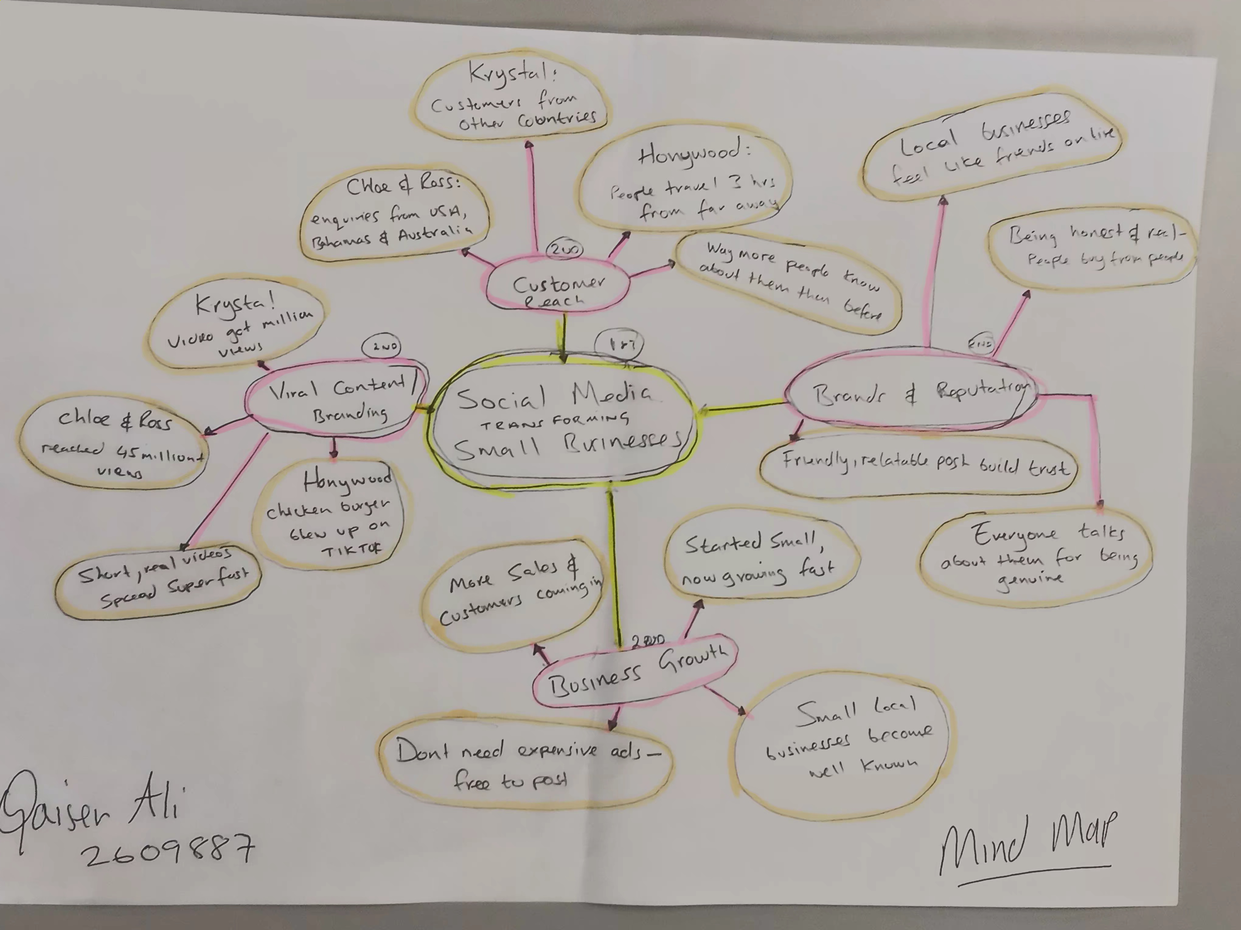

Qaiser Ali 2609887

