

An investigation into the user experience of modern web messaging platforms
by
Tomos Leggett
Supervisor: Michael Dacey
Project submitted as part of the requirements for the award of
BSc (Hons) Computing (stream)
BEng (Hons) Web Development
April 2022

Abstract
In this project, the author will aim to develop a fully functional web-based chat application using modern web technologies including the react framework and node.js. The aim of this project is to develop said application and incorporate modern user experience practices and test the usability of the application and the effectiveness of the user experience design using a method of usability testing known as ‘contextual inquiry’. A contextual inquiry is a method of usability testing involving an interview with a candidate in which the author will observe the candidate using the application blindly without any instruction during the interview, and will only interrupt the interview when necessary or when the author has noticed something unusual about the candidate’s actions. The author will take notes during the interview and will use the findings to evaluate the success of the usability. The deliverable featured a fully functional chat application built on the chat-engine API and featured the ability to create and sign into accounts, create group chats, send messages and images and even rename and kick users. The author conducted a successful contextual inquiry on 5 candidates and concluded that the web application itself had various usability issues that could be improved upon, but also showcased success in the implementation of already established user experience design principles such as the theory of mental models and common UX laws.

Table of Contents

Abstract 2
Table of Contents 3
Introduction 5
Literature review 6
Introduction 6
What is User Experience design? 6
Before UX design: Human Computer Interaction Design (HCI Design) 8
What does a UX designer do? 8
The theory of ‘mental models’ 9
User experience design in web development 10
User Experience of Instant Messaging Platforms 11
What is usability testing? 11
Conclusion 12
Methodology 14
Developing the web application 14
Design and Implementation 18
Requirements 18
Brand design and identity 20
Choosing a font 22
Choosing the appropriate back-end engine 22
Designing a Prototype design 23
Using WebHooks 29
Issues with the code 29
Testing 31
Evaluation 47
Conclusion 49
Reflection 50
References 52
Appendices 54
Declaration Form and Form of Consent 54
App.css 54
App.js 74
index.js 76
Components 76

Introduction
In this project, the author will be developing a web-based chat application. The author will also be researching the importance of user experience design and how it affects the usability and performance of a web application. Then, the author will use this research to design and develop a web-based chat application and test the effectiveness of the usability using an appropriate usability test.
The initial aim is to develop a fully functional instant messaging web application using React and node.js and conduct and test the user experience using an appropriate usability test.
Having initially researched modern user experience theories and practices, the author’s objectives will be to first design a prototype of the web application with these theories and practices in mind using a prototyping tool such as Figma. Once the prototype has been completed, the author will then develop said application around modern user experience practices using the React framework and Node.js. Once said web application has been developed, a usability test will be conducted to measure the effectiveness of the user experience design concepts the author has used when designing and developing the user experience.
In the following chapters, the author will showcase the initial design of the web application through a prototype produced with Figma followed by the implementation and development of the application itself, and finally, the usability test, which is a contextual inquiry test conducted with 5 applicants.

Literature review

Introduction
The author will be investigating the user experience of modern web messaging platforms. To develop a better understanding of current literature regarding user experience design, analysing user experience, defining good user experience design and usability testing, a literature review will be conducted. The literature review will help the author develop a better understanding of what literature is currently out there regarding the topic of the project and develop a firm understanding of the fundamentals of user experience design and evaluation when developing this project. This literature review will include research on user experience design, the history of user experience design, why we need user experience design, what a UX designer needs to do, why user experience is important and what usability testing is along with literature regarding the user experience conventions for web applications and instant messaging applications. This investigation will not include project specifics that aren’t relevant to the user experience, such as literature regarding web application development and server-side technologies, as this project focuses on evaluating a web application’s user experience.

What is User Experience design?
When people think of product design, they often think of what makes a certain product or service aesthetically pleasing to the eye. To most people, crediting a product as ‘well designed’ is often a remark on the aesthetical appearance of the product, whether they’re referring to the product’s appearance or whether a product feels good to touch or use, that is the typical meaning of a “well designed” product. Some examples of this may include furniture, a person may perceive a certain chair to be “well designed”, or perhaps the design of a new expensive car. After all, a product that is pleasant to look at garners the most attention from the end-user. However, another important element of product design that might be considered when designing a product is in the functional sense. When designing the functionality of a product, the words “well designed” take a different meaning. In this sense, a “well designed” product is a product that does what it needs to do well and efficiently. In this case, a “poorly designed” product is one that either struggles to do what it was designed to do, or somehow, doesn’t at all. A “poorly designed” smartphone, for example, is one that can’t make phone calls, or perhaps a more common concept, a poorly designed printer that won’t print. The aesthetical appearance of a product becomes meaningless if the product isn’t designed to do what it’s intended to do, no matter how good it looks or feels in the hands.
User experience is very similar to product design but takes a different approach to design a product or service, by going beyond designing a product to be functional or aesthetically appealing.
For user experience designers, the design of the product is dictated by its functionality. User experience designers often design their products not so much based on functionality but rather based on the human psychology and behaviour of the end-user. [1]
Peter Moville’s usability.gov ‘User Experience’ honeycomb notes that in order to develop a product with meaningful UX, the information outputted must be:
- Useful
The content itself must have a need and provide a use for the end-user.
- Usable
The site itself must be easy to use for the end-user.
- Desirable
The end-user must feel some appreciation towards the image, identity, brand and other design elements.
- Findable
The end-user should be able to find and navigate content both on-site and off-site. (For example, the website should attempt to enhance search engine optimisation).
- Accessible
All end users must be able to access this site, including people with disabilities such as users with vision loss, blindness or other disabilities that may impact the user experience.
- Credible
Trust with the end-user must be obtained (the end-user needs to believe what they’re told). [2]

Before UX design: Human Computer Interaction Design (HCI Design)
HCI stands for Human-computer interaction, it’s the concept of designing an interface with human interaction in mind. Designing a good HCI system ensures that the computer program is designed for humans who will ultimately be using these interactive systems. Good Human-computer interaction understands human psychology, its capabilities and its limitations. The term was coined in the 1980s but wasn’t the first example of a systematic study of human performance when interacting with machines. Traditionally speaking, machine ergonomics was a major study and eventually in 1949, the Ergonomics Research Society was formed. These studies focused on the ergonomics of machines that were computerised or simply mechanical and took factors such as user performance into account when using any system, whether computerised or not. Eventually, the rise of computer usage encouraged researchers to specialise in the field of computer-aided interaction. Originally coined ‘man-machine interaction’ it was eventually renamed ‘human-computer interaction’ as we know it today. [3]

What does a UX designer do?
A user experience designer’s job is to design a product that delivers an overall enjoyable experience to the user. UX designers typically design computer interactive systems and services that enhance the lives of the end-user. A UX designer must design these systems around the end user’s psychology and human behaviour. If the product isn’t accessible by the end-user, or the usability of the product is frustrating or confusing then the product lacks efficient user experience design. A lot of user experience design is focused on the human and how they interact with computerised systems.
A good example of the importance of user experience design is our history of designing interactive systems in the past. In past examples, interactive systems were often developed and designed by programmers and computer enthusiasts who were far more computer literate than the average layman. This method of designing these services often led to poor accessibility and a steep learning curve for users who, for example, didn’t use a computer system every day. Interacting with an unfamiliar system for the first time can be difficult, but before research on user experience was well established, the accessibility of these interactive systems was often poor due to the aforementioned confusing designs constructed by software developers as opposed to product designers. [4]

The theory of ‘mental models’
The term ’user experience was coined by a cognitive psychologist named Donald Norman. Donald Norman was the vice president of the Advanced Technology Group at Apple. Norman invented the term ‘user experience’ as an umbrella term for a user’s overall experience with a system, including the physical and manual interaction along with the design, graphics and interface. Norman’s research often focused less on the aesthetical design of products, and more on how the user interacts with the technology they’re using. Norman emphasised a major element of user experience, every human is different. Humans interact with computers in different ways, because we learn in different ways, and our perceptions of how we interact with computer systems are different.
In the early 90s, an American businessman and philanthropist by the name of Charles Thomas Munger coined the theory of ‘mental models’. This term is often used in a variety of different industries, including user experience. The definition often changes based on the context of the industry, however, the key concept of mental models remains. The human knowledge and understanding of a particular concept is shaped by their mental model.
A mental model represents the overall thought process that goes into a human’s understanding of how things in their surrounding environment work. These mental models are often formed based on previous experiences and are often responsible for shaping human behaviour. It’s seen that humans often approach and solve problems in different ways based on their mental models, which can be influenced by a variety of things - often, mental models are based on the human’s beliefs, rather than blatant facts. User experience designers are often expected to work around what the user thinks they know about their website design.
Why is this important for user experience designers? People’s mental models are shaped based on their experience not only with your website but with other websites as well. User experience designers must concentrate on methods of ensuring consistency between the layout and user experience of their website and other websites that users have already built a mental model of. [5]

User experience design in web development
Developing a website with good user experience design is incredibly important for businesses. One good example of the importance of good user experience design on the subject of web development is the Baymard Institute’s checkout usability study. This study showcased why customers were abandoning their shopping carts on e-commerce platforms by closing the page before even checking out. They concluded that the vast majority of shopping carts on e-commerce websites are abandoned, a surprising 68.8% of customers will abandon their shopping carts, which can take a big toll on business revenue. Most of the time the reasoning behind this phenomenon was justified, for example, a lot of customers were simply comparing prices or delivery fees being too high, all of which isn’t the responsibility of bad user experience design. However, customers would often abandon their shopping carts for avoidable reasons related to user experience, for example, 18% of users abandon their shopping carts because the checkout process is either too long or too complicated. Considering 18% is a significant number of potential sales lost due to poor user experience design, something that can ultimately be fixed with a simple inexpensive redesign along with a greater focus on user experience studies showcases just how impactful good user experience design can be. [6]

User Experience of Instant Messaging Platforms
The challenges of user experience design when designing instant messaging platforms is less to do with designing the product to appeal to end-users, as most instant messaging platforms have already achieved this goal. For instant messaging applications to succeed, designers need to find a way of keeping users on the platform, as it takes very little effort for the end-user to switch messaging applications when a better alternative is found. This is because switching messaging applications is extremely easy, and not much is sacrificed when switching, unlike say, switching cloud providers, it’s much easier to switch messaging applications because there’s a lot less at stake to sacrifice in terms of data or features. [7]
Before designing an instant messaging platform, a user experience designer must first understand how most instant messaging platforms work. This includes an understanding of how the client interacts with our messaging service. Clients can be either mobile applications or websites, these clients do not directly interact with each other, instead, they interact with the messaging server, which typically stores message data and relays it back if or when the user is online.
Receiving a message from the client-side, however, is a little different. HTTP is not designed for receiving messages, as it is client-initiated, this is an issue when developing a web-based instant messaging client. Luckily, solutions to these problems have already been designed. The main solution is web sockets, which allows message data to be requested and received continuously and asynchronously, reducing the need for the end user to refresh the page constantly, hindering the user experience of the messaging application greatly. [8]

What is usability testing?
Society has progressed to the point where a user can quit a bad user experience by simply closing a tab or a window. Websites these days have only 50 milliseconds to make a good impression according to research, which highlights the importance of good usability. Usability is a major factor in the decision making when developing or supporting a digital application. This is where usability testing comes in.
When you develop a certain level of understanding of a product, such as a video game or a piece of software on your mobile phone, you might know a little too much about said product to understand how usable that product is if, say, someone else used it. Is that product usable to other people if they don’t know as much as you about the product? This is the heart of what makes usability testing so crucial when developing an application. [9]
One major key of good usability design is focusing on the product’s design before developing it, and instead focusing on setting the specific usability goals early in the production and ensuring the product succeeds at these user experience goals during the development of the product.
However, if you only have vague goals for the user experience of your product, evaluating how well you’ve designed the product becomes tricky. You couldn’t tell whether your product is truly ‘user-friendly’ without ensuring a clear basis for evaluation.
To develop a method of evaluating these goals rationally, usability testing techniques must be put into practice. These techniques allow developers to accurately evaluate these goals by identifying users, interviewing users and observing how they use your product, along with analysing jobs and tasks in the meantime. [10]

Conclusion
In summary, user experience is a key element in driving traffic and ensuring standards of usability when developing an application, being web application or otherwise. The theory of mental models demonstrates the importance of consistency and understanding of how humans interact with computer programs.
A surprising significant gap in existing knowledge is a lack of research on the user experience of instant messaging applications in general. Only a handful of articles and other resources could be found regarding developing or evaluating the UX of an instant messaging application.

Methodology
The author will need to investigate the effectiveness of the user experience of their web application using common usability testing methodologies. Using these methodologies, the author can evaluate based on qualitative data gathered via interviews. The author will then evaluate the effectiveness of the user experience based on these interviews by using a contextual inquiry.

Developing the web application
Before the contextual inquiry takes place, an instant messaging application needed to be developed. The application will run on node.js, as node.js is perfect for real-time applications due to its event-driven, asynchronous non-blocking I/O model, which makes it perfect for building an instant messaging platform.
The author will also be using chat-engine to power the back-end of the platform. Chat-engine is free for up to 15 users and allows the author to manage the back-end efficiently with a graphical user interface. This method is far less time consuming than say manually developing the backend, which isn’t being investigated. This back-end client uses an API to communicate with the web application.
The website’s user interface will be written in React. React is a JavaScript framework for developing user interfaces for web applications. React is a JavaScript library for splitting different sections of the page into user interface components, and re-using them. React also improves the speed of the web application, as it uses a virtual DOM as opposed to the browser’s DOM. The author will use React because it is currently (as of 2022) the most popular JavaScript front-end libraries with a strong foundation, and due to its popularity, has a large and stable user base, which means higher quality documentation and support.
The application will be developed using Visual Studio Code, a free integrated development environment by Microsoft. Visual Studio Code has a large and stable user base, much like React, the documentation and support are higher quality. Add-ons can be installed using Visual Studio Code, which extends the IDE’s toolset to support web technologies such as React which makes the programming more fluent and efficient.
Finally, the web application will be hosted on 2 different platforms:
- When testing the web application
The web application will run via a home Linux server with node.js installed.
- When deploying the web application
The web application will be migrated to Microsoft Azure, a cloud service provided by Microsoft. This service will migrate the web application to the cloud, which brings additional benefits such as security, efficiency and scalability. The author can use Microsoft Azure free of charge for a limited time thanks to Azure’s student benefits. However, hosting the website in the cloud whilst developing it would be a waste of Azure’s free trial. Developing and testing the website via the home Linux server is the most economically viable methodology. The web application will be migrated once development has concluded.
As this project is centred around investigating the user experience of an instant messaging platform, the author will need to uncover problems with their current design. The author will also need to discover opportunities on how to improve the design. Through usability testing, the author can investigate the end user’s behaviour when using instant messaging platforms. [11]

Conducting a contextual inquiry
Contextual inquiry is an alternative qualitative research methodology to surveys and interviews. Contextual inquiries don’t remove the end-user from the environment and survey their experiences after. Surveys and interviews have the disadvantage of relying on the end-user to re-call their experience, which often means they summarise their experience and miss out on important elements of reasoning, motivation and mental models. Contextual inquiries allow end-users to talk about their experience whilst they’re experiencing it, as opposed to after. This, in turn, provides a much richer in-depth outlook on the user experience and why end-users make their decisions.
A major advantage to contextual inquiries when evaluating user experience is a deeper understanding of things that end users might miss out on if they did, say, a survey. This allows a greater in-depth look into how end-users interact with the web application.
The contextual inquiry methodology is based on the relationship between the tester and the end-user, commonly referred to as the “master craftsman” and the “apprentice”, where the apprentice is the tester observing the end-user, who identifies as the master craftsman. The apprentice will observe the master craftsman and ask questions naturally.
The contextual inquiry uses a 4 part session plan of the following:
- Step 1: The Primer
This section of the inquiry is designed to help ease the participant into the current environment. During the primer, the author will introduce themselves and develop a relationship with the participant to ensure they’re comfortable in the current environment. The author will then explain to the participant what will be expected during the interview (this is where the author validates any misunderstandings the participant may have about the interview).
- Step 2: The transition
This is when the transition between the primer and the interview itself happens. The author will confirm with the participant that the interview itself is beginning. The participant will be made fully aware that they will be watched whilst they use the web application, and that the author may interrupt whenever an interesting behaviour needs to be discussed.
- Step 3: The contextual interview
The contextual interview itself is the main part of the process. It mostly conducts a 2-step loop where the author watches the participant and notes their actions and processes. If the participant does something out of the ordinary that the author doesn’t understand, the author will ask the participant to clarify why they took that approach or any other enquiries related to the interview to develop a better understanding of the user’s mental models.
- Step 4: The wrap-up
The wrap up consists of the author re-evaluating all the notes taken from the interview. The wrap-up allows the author to clarify anything that they might not understand about the interview or the participant’s actions. During this time, the author will specify their findings and notes. The participant may also clarify their actions whilst the author discusses their interpretations. [12]

The disadvantages of contextual inquiries
Although the author believes that a contextual inquiry is an appropriate usability test methodology, there are a few disadvantages to this methodology, for example:
- Participants must lead the session
Unlike surveys and interviews, with a contextual inquiry, the examiner is looking to evaluate the user’s natural flow when navigating the user interface, which means the participant cannot be told how to use the web application. To successfully develop an understanding of the participant’s mental model and user flow when covering the entire scope of the web application, the author may need to instruct the participant to complete certain tasks. The author may ask the participant to perform a certain action disguised as a question. [13]

Design and Implementation

Requirements
To develop a well-designed web application, it is trivial that the requirements are defined before the application is initially developed. Defining the requirements assists the author in ensuring the product is practical and useful to the end-user. Defining requirements also ensures the author develops the application in a timely and effective manner, without wasting time on features that are neither required nor effective in their design and ensuring the author delivers on the specifications that makes the application useful to the end-user in the first place.
The author decided to establish the requirements by storyboarding using Figma Jam and developed several user stories based on each of the activities the chat application is responsible for.
User stories are a method of designing the requirements for a particular piece of software from the perspective of a user. Each user story details elements of the application that a user would look for in a particular application. User stories exhibit familiar characteristics of traditional software user requirement techniques. Unlike developing traditional use cases, user stories are far less ambiguous and are far easier to interpret as requirements, as they are often short and precise. This means for the author, an understanding of the exact requirements of this web application is far easier, which means planning the design of the application is also far more streamlined, as the requirements aren’t too large to give estimations, unlike traditional use case requirements. [14]

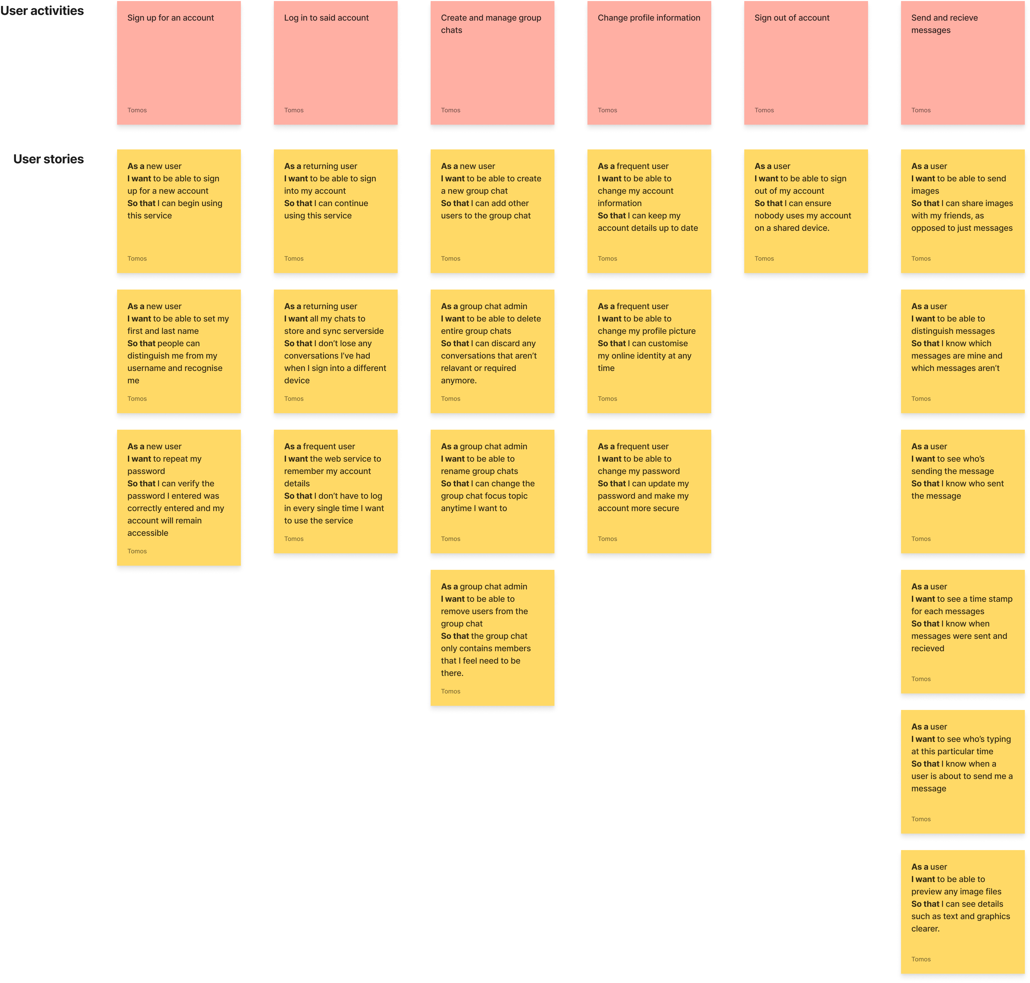
Figure 1 – A whiteboard of user stories outlining project requirements
Perhaps the most important requirements are based on the purpose of the software in the first place. The purpose of this chat application is to allow users to converse over the web. As this is a web-based project, user information will be stored server-side, as opposed to locally, which means the ability to create and sign in to a user account will be required.
This means a log in or sign up screen is required, which will allow users to log in to their accounts or sign up for a new one. These accounts should
Another essential requirement is the ability for users to create chat rooms and add users to said chat rooms and converse. Users should be able to differentiate between their messages and other messages. When multiple users are part of the same group chat, there should be a clear indication of which message was sent by the user. Messages that were sent by other users require a visual indication of who sent said message, along with their profile picture.
Another requirement is group messaging management. Users should be able to create group chats and add other users quickly and efficiently. Multiple users should be able to communicate at the same time with no issues. Users should be able to create as many group chats as they want and should be able to name and rename said group chats anytime they want.

Brand design and identity
Before the initial prototype design, a logo will need to be developed, along with a colour scheme and a font.
Developing an appropriate logo for the web application is required, as a logo is what gives the application identity. According to the book “Logo Design Love: A Guide to Creating Iconic Brand Identities” by David Airey, the simplest design is often the most effective, as a simple logo often meets the design requirements of an iconic logo, which is what makes a logo effective.
“Simplicity helps a design be more versatile. Adopting a minimalistic approach enables your logo to be used across a wide range of media, such as on business cards, billboards, pin badges, or even a small website favicon” [15]
- Logo Design Love: A Guide to Creating Iconic Brand Identities by David Airey
The author decided to consider this concept and developed an easy to recognise logo using Figma via vector illustration.
To achieve this minimalistic appearance, a simple boilerplate design of the iconic “chat bubble” shape was taken into consideration throughout the initial logo design. Developed using a simple rectangle and scalene triangle. The author initially wanted to do more with this boilerplate design, and so it went through many different iterations, such as:

The name ‘PicoChat’ was used as it emphasised the small but powerful scale of the application and its use cases compared to other chat applications being cluttered with unnecessary features, which affects the usability of the application.
The first iteration, which had the word “Hi” written inside the bubble to signify that the chat application was designed for friendly non-verbose conversation, was rejected by the author. The “Hi” itself was far too hard to see when the logo was present on both the header and as a favicon.
The chat bubble itself also had sharp edges, which hinders user experience, as sharp edges require more cognitive load and are generally less appealing due to the brain’s nature of parsing sharp edges as dangerous - This phenomenon is known as the “bouba-kiki effect.” [16]
Eventually, the logo was rounded and the “Hi” inside the chat bubble was removed for a minimalistic, simplistic logo, as seen below:


Choosing a font
According to the book “The principles of Beautiful web design” sans-serif fonts are extremely legible and practical for a wide array of purposes, including web design due to the clear legibility and clean appearance compared to the heavier serif fonts, which due to the increased amount of detail, become hard to read when used in small sizes or on lower-resolution displays. [17]
The author aimed for an attractive and easy to read sans-serif font that must be free to use with personal projects. The author used Google Fonts to import fonts to the stylesheet, as Google fonts is a well maintained and recognised font repository, the risk of losing access to the font file is very slim, and the load times are quick.
The font choice the author chose was Plus Jakarta Sans, due to its sans-serif format, easy legibility and modern appearance, which pairs well with the application’s modern design. [18]

Choosing the appropriate back-end engine
As the project is focused on the front-end design aspect of the application, a back-end chat application engine with an appropriate REST API was required. This would allow the author to develop the application without first having to develop a back-end API which would be both costly and time-consuming. The author chose chatengine.io, which is a developer-friendly chat engine with a powerful REST API. This REST API is well documented by the developers of the engine and includes incredibly useful features such as a custom JSON section for all users and messages, which allows the developers to implement custom data for user details and chat details. Other features include event hooks, which allows the author to develop custom code based on events such as when a user is typing or when a user has gone offline, which allows for more advanced features to be developed, such as online status indicators and typing indicators. [19]

Designing a Prototype design
Prototyping software is a key element in creating successful user experiences for many software developers. When prototyping software, the designer can depict the software requirements in a more visual manner, rather than describing the requirements themselves. The ability to wireframe the software before its implementation allows the designer to make changes to the interface whilst reducing the effort of manually redesigning the software through code, which also saves a significant amount of time. Most importantly, prototyping allows the designer to see the design before its implemented. t.ly/Nil2
The author developed the initial prototype design using Figma, as seen below.
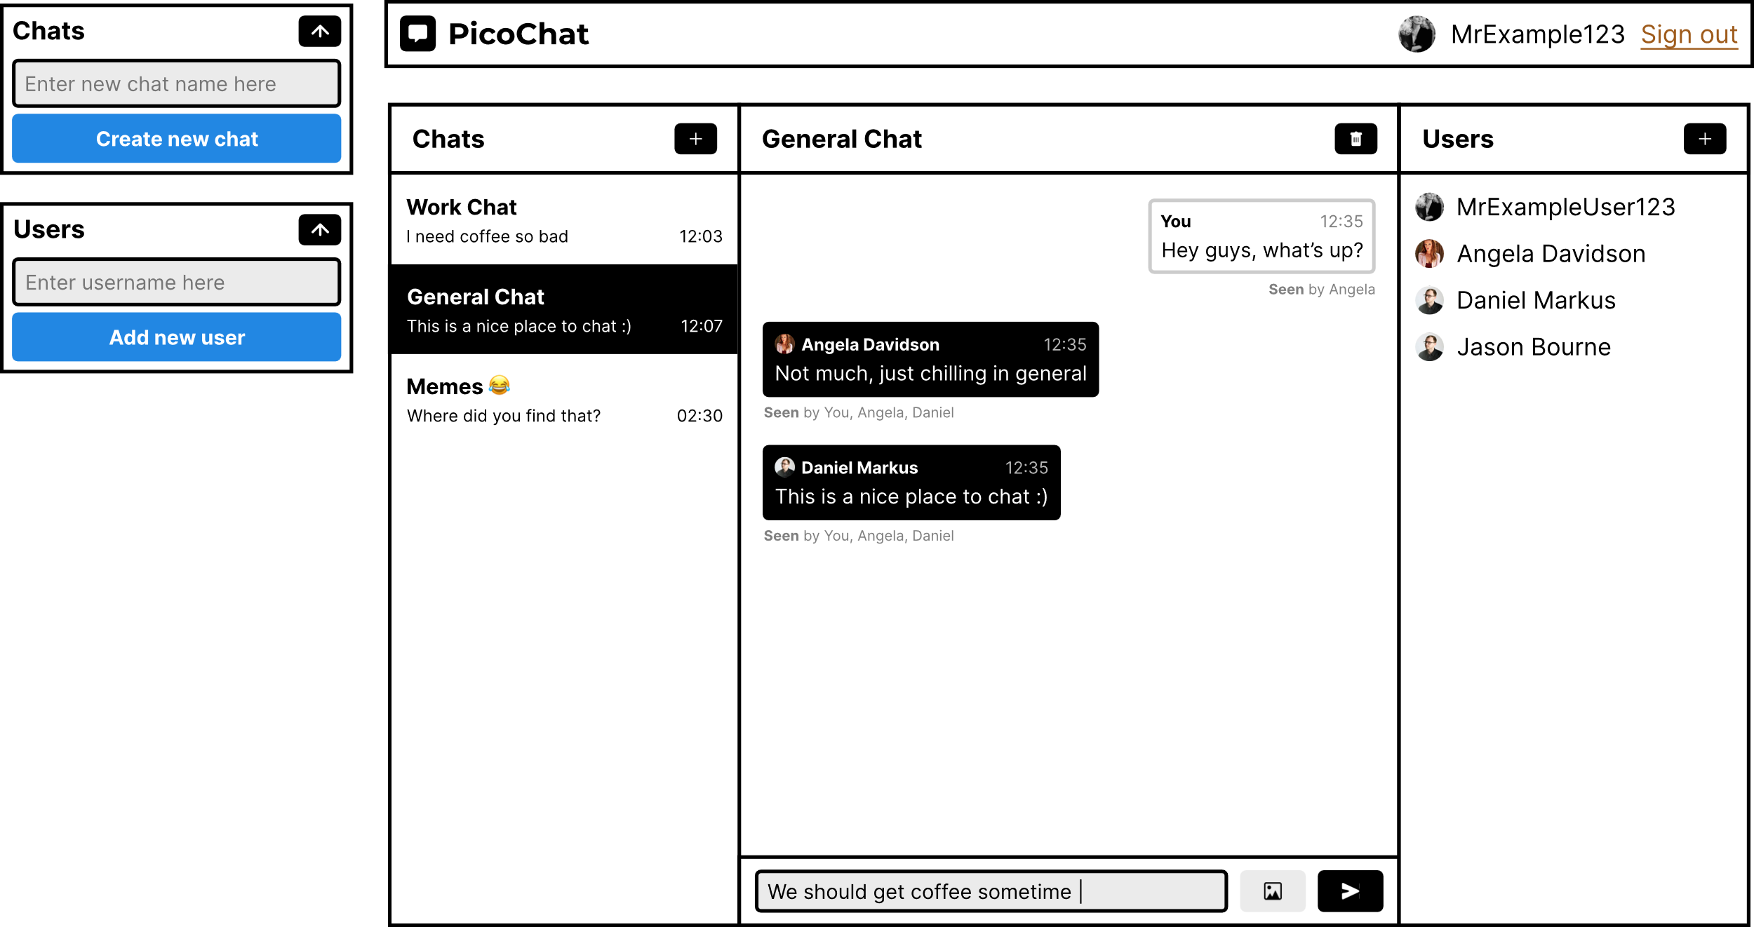

This is the initial prototype, which showcases the layout of the web application based on the requirements. The application itself consists of 5 different components.
One of the main core UX theories that influenced this application’s development was Jakob’s law, which indicates that websites and applications should tone down their distinct design in place of a more conventional design. As most users spend their time on other websites, users prefer a more familiar experience. The author designed the application to be conventional, with the placement of most components relating to already existing web applications, for example, the placement of the profile badge and the sign out button is on the top right, a common convention across most websites. [20]
The author also designed the icons such as the add chat icon, delete chat icon, photo picker icon and send message icon to be minimalistic in detail to follow the law of Prägnanz, which indicates that humans interpret simple shapes and icons far quicker than complex ones, as it requires less cognitive power. [21]
As for the placement of buttons next to the headers of each component, Gestalt’s laws of grouping was taken into consideration, where elements that are visually grouped are also perceived by the human eye as related in functionality, which is why the author designed the icons to appear next to the header of each component, rather than in one typical ‘settings’ component [22]

Implementing the login screen
React uses a component system, which allows the author to develop react based components and implement them as HTML tags in the main application file. Not only can components be added as HTML tags, but properties can be passed through components in a similar sense that properties can be passed through regular HTML tags.
One of these components is the chat engine component itself, which uses the following properties:
<ChatEngine
height="100%"
projectID="d58c08b4-7cb8-4cbd-bd4b-fd4d987b05c5"
userName='Tomos'
userSecret='Password'
/>
When these properties are passed through the component, it renders the chat engine component with these specific credentials. The project ID property identifies the current project so that the chat engine API can connect successfully. The user credentials are then set via the ‘userName’ and ‘userSecret’ properties.
These properties, however, can be changed dynamically with JavaScript server-side logic. This allows the author to implement a login screen component, that allows these credentials to change in the first place and give specific users access.
The main app script returns two different components, as follows:
if(!localStorage.getItem('username')) return <LoginForm /> // Check local storage for a saved username, if it doesn't exist, return the loginform component.
return ( // If the username DOES exist in local storage, return the chat engine component with the appropriate credentials
<ChatEngine
height="100%"
projectID="d58c08b4-7cb8-4cbd-bd4b-fd4d987b05c5"
userName={localStorage.getItem('username')} // Returns the username from local storage
userSecret={localStorage.getItem('password')} // Returns the password from local storage
renderChatFeed={(chatAppProps) => <ChatFeed {...chatAppProps} />} />
)
As you can see, the author has implemented a local storage based system that checks the local storage of the web browser for a username. If that username exists, then we can assume there’s an associated password and account information is already locally stored. We can retrieve this information from local storage and authenticate the user automatically.
If however, there is no username attribute stored in the local storage, we can assume the user hasn’t created an account. Instead of loading the chat engine component, we can instead load a custom made log in screen component created by the author.


This component features a form, which can change dynamically without having to refresh the page. The author needed the login screen to be one core component, rather than making a separate sign up component. To ensure the single page nature of web applications, this component needed to handle both logins and sing ups without redirecting the user to a separate page or loading a separate component altogether.
The method the author used to achieve this was by using the login form as a signup form with other hidden text boxes. The “Sign up” label on the top right of the form is a checkbox disguised as a hyperlink, with the checkbox itself hidden using CSS. When this button is checked, the form dynamically resizes, and new form elements appear, as follows:


var divsToHide = document.getElementsByClassName("signUpOnly"); // For hiding all the dividers that shouldn't appear unless signing up
function handleSignUp() { // When the sign up checkbox changes state
if (document.getElementById("signUp").checked === true) // If the checkbox is checked
{
for(var i = 0; i < divsToHide.length; i++){
divsToHide[i].style.display = "flex";
} // Loop through the document and display all sign up only dividers
document.getElementById("loginCard").style.width = "600px"; // adjust the size of the form so it's not so squished together
document.getElementById("loginLabel").innerHTML = "Sign up"; // Change the label of the log in button to "sign up"
document.getElementById("signUpLabel").innerHTML = "I have an account" // Change the checkbox label to "I have an account"
}
else // If the user isn't signing up (the signup checkbox isn't checked)
{
for(i = 0; i < divsToHide.length; i++){ // Loop through all dividers that should be hidden when logging in
divsToHide[i].style.display = "none"; // Don't display them
}
document.getElementById("loginCard").style.width = "400px"; // Revert back to the form's default configuration
document.getElementById("loginLabel").innerHTML = "Log in";
document.getElementById("signUpLabel").innerHTML = "Sign up"
}
}
Above is a snippet of the login form component that handles the event in which a user checks the signup checkbox. As you can see, certain components are either changed or hidden when the user checks the checkbox, so the form dynamically changes on the front end despite being the same form, which helps establish ambiguity for the end-user.
The author used the AXIOS API engine built into node.js, which is a powerful API engine that supports REST API requests. The chat engine REST API allows the end-user to create an account, which is how sign up and log in is handled.
One problem with this system however is based on the way the REST API works in the background. When a user submits their login or sign up information, there’s no visual indication that the system is busy processing the data, and so, when the user clicks “login”, there is a short delay in which nothing happens before the user is redirected to the chat application.
To rectify this issue, the author designed a visual indicator that informs the user of a processing request. Said visual indicator would dim the login button to signal the inactivity of the button, and the label would be replaced with a small spinning wheel until the request ended.
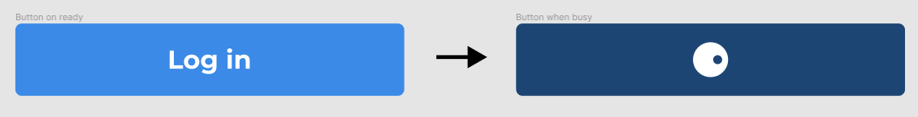

The author also found the REST API would return not only an error code on error but a non-verbose description of the error. This came in handy when designing the validation of the login form. Originally, the login form would translate error codes or verbose error messages into a user-friendly error indicator above the login/sign up button, but instead, said error dialogue uses the response data from the REST API. For example, when attempting to sign up with an already existing username:
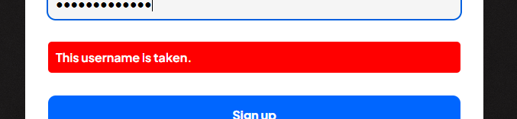

Using WebHooks
One of the design requirements was a notification noise to alert users when a new message has arrived. To implement this feature, the author used a react event hook that plays a sound. The sound itself was sourced from a website known as freesounds.org, which is a collaborative database of free to use sounds released under a Creative Commons License. the author needed to use a short snappy sound that will grab the attention of the user.

Issues with the code
One issue the author frequently had was performance issues. Messages would often showcase a small delay before appearing. The author was able to use the developer tools built into the web browser to inspect any issues. Upon opening the browser console, the author discovered for every character that was typed in the text box, the API was called. When the API was called, it would return an error 429. According to the official Mozilla web documentation, the HTTP response code 429 indicated that there were too many requests being made. This was likely because a request was sent to the server every single time a character was inputted into the field, which proved to hinder performance on the front end, as a variable lag was introduced as the server would only respond when enough time has elapsed between the several requests caused by the user typing in the text box.
The issue was caused by a function from the chat engine module known as ‘isTyping’ under an event that handles when the user is typing on the text box, it’d send the request each time the user was typing, as follows:
const handleChange = (event) => { // When the user is typing
setValue(event.target.value) // Set the value of the text box as the current value (or the text box will be blank when typing)
if(event.target.value === '') // If the text box is completely blank
{
sendMessageButton('disable'); // Call a function that disables the send message button
}
else // otherwise
{
sendMessageButton('enable'); // enable it again
}
isTyping(props, chatId); // Update who's typing
}
To address the issue, the author removed the isTyping function and replaced it with an event hook, which reduces the number of requests drastically. The console did not log the error and performance was improved drastically. [23]
Another major issue with the development of the project’s code is with developing the chat settings component. A function used to add users to chats known as ‘addUser()’ was documented to take the credentials, the chat ID and the username as parameters, however, the author had difficulty carrying the chat ID parameter, as chat engine would return the chat object as ‘null’ for this particular component. Due to time constrains, the author had to abandon the re-designed chat settings component, and the default chat-engine component would render in its place instead.

Testing
To verify whether this chat application works properly, various tests will need to be conducted. The most important test is the usability test, as the usability of this web application is a major element of its design. However, other tests will need to be conducted, such as unit tests and system tests to ensure the application is working in its current form.

Testing the log in/sign up screen
The login screen itself should allow users to log in with the correct data immediately. It should also showcase any appropriate error dialogues if the information is inaccurate. Each form element is also set as required, so the user shouldn’t be able to submit the form if any of the entries are blank. The enter key should also submit the form straight away without having to click the “log in” button.
To test if required fields stop the end user from submitting a blank form, the author tested submitting the form with a blank username and password, blank username and filled password and filled username and a blank password.
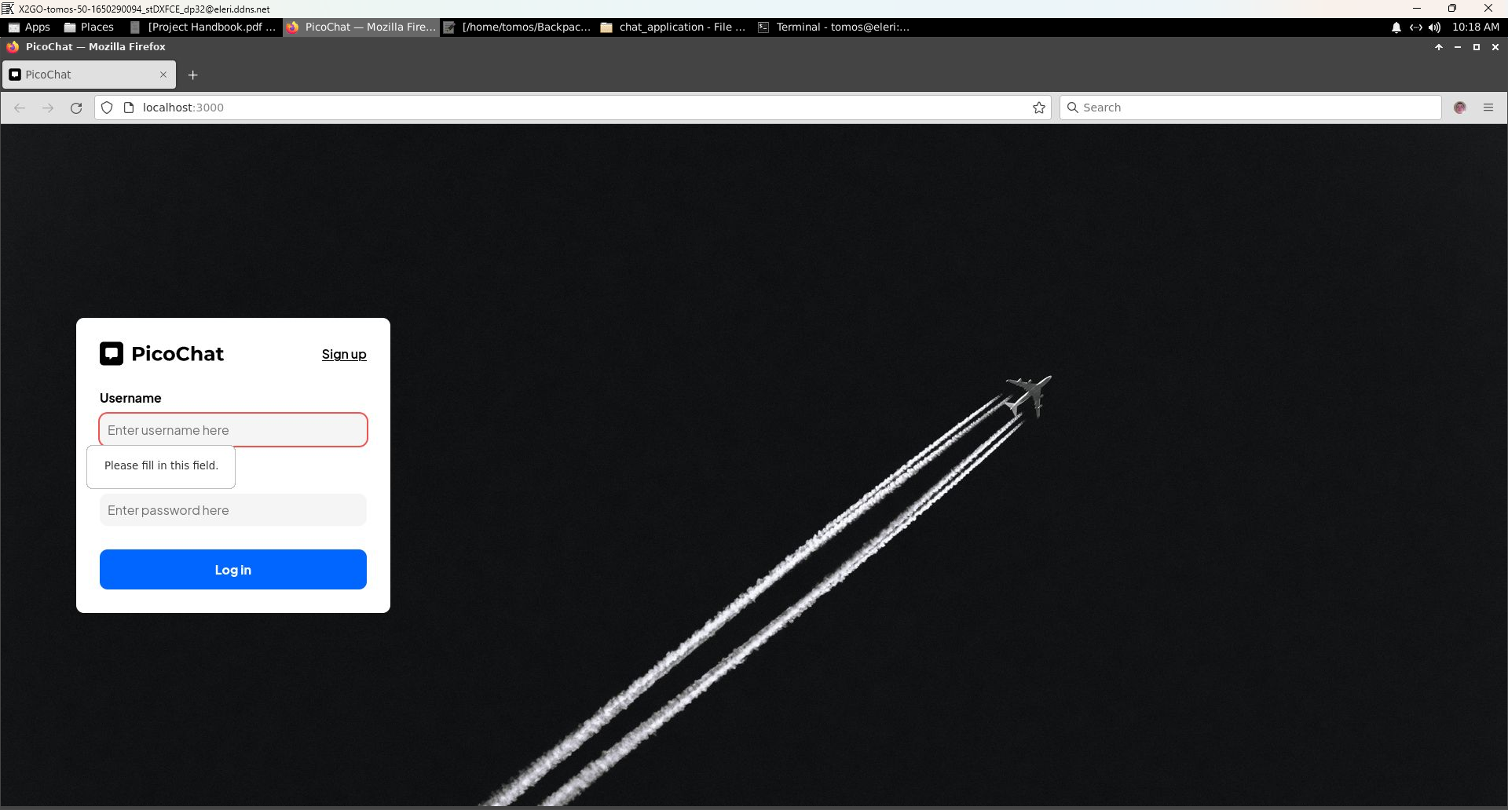
As you can see, the form will not allow the end-user to submit any blank data. The page doesn’t refresh and the data remains in the field. The test has passed successfully.
When inserting the correct username but incorrect password or vice versa, an error dialogue should appear above the submit button to inform the end-user that their username or password is incorrect. Submitting the correct username but incorrect password (and vice versa) showcased the error message successfully, as evidenced in the screenshot below
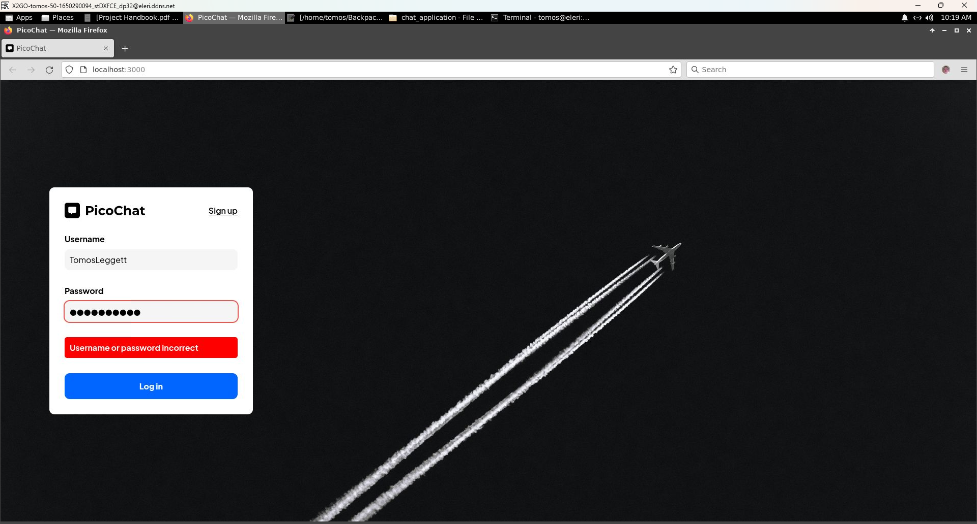
When the user submits the correct username and password, a visual indication should appear above the button. The button should darken, and a loading icon should take the place of the button label to signify that the data is being submitted. The author submitted the correct username and password, and the loading icon appeared successfully, as evidenced below.
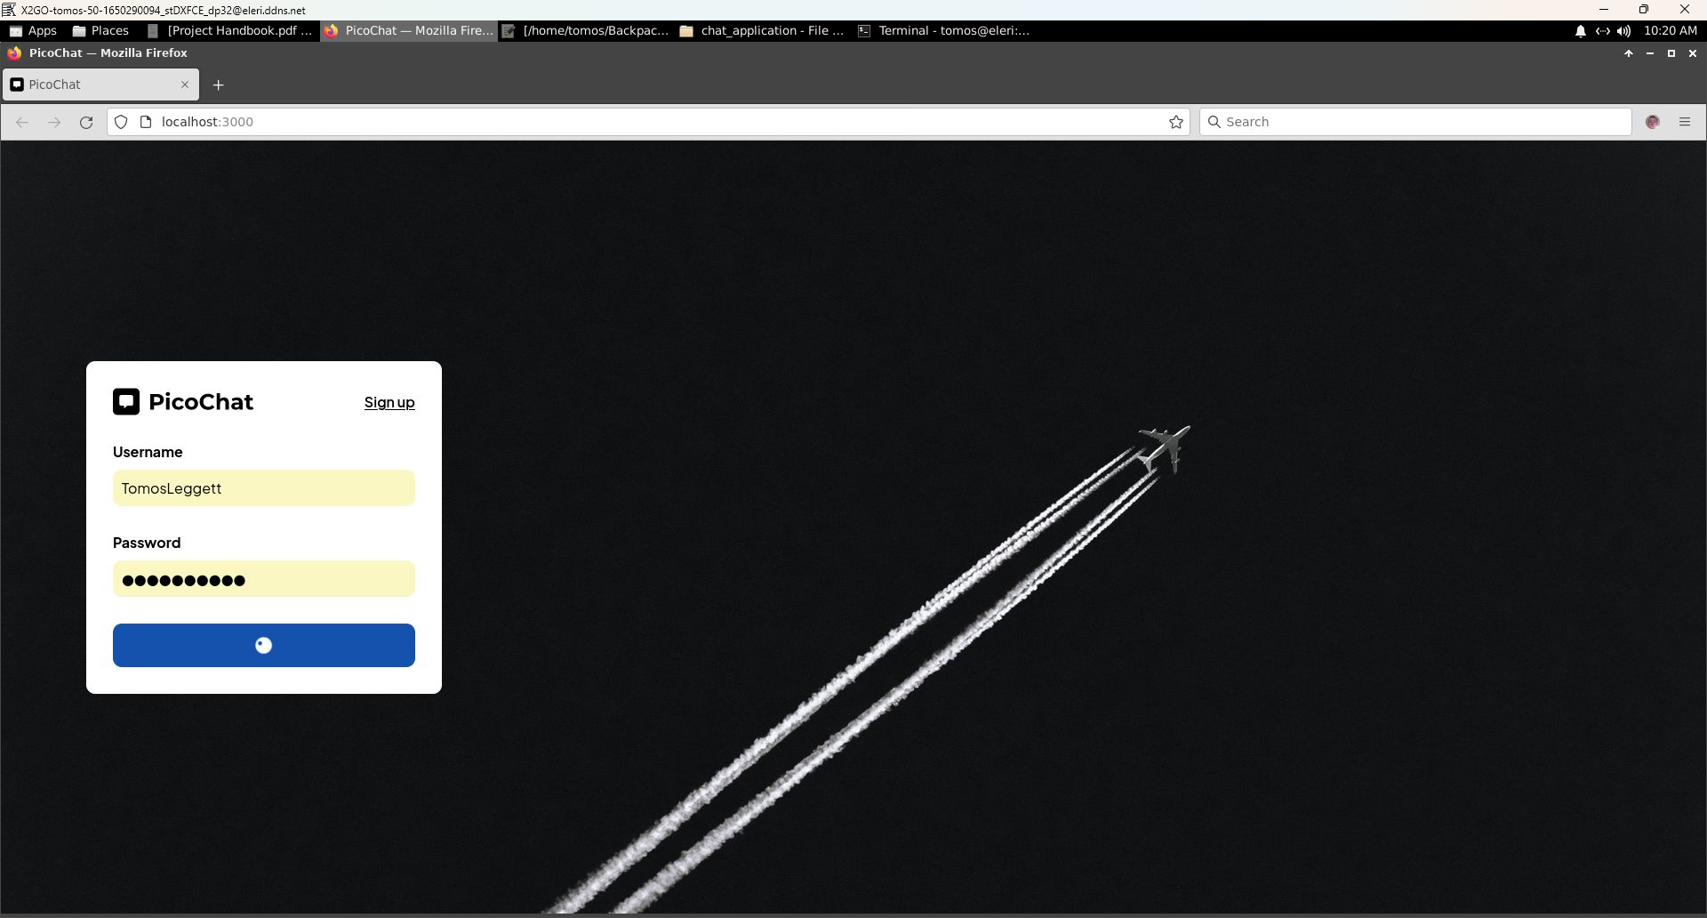
When the user checks the ‘sign up’ hidden checkbox, the form should adjust accordingly to allow the user to sign up. When the author clicked the signup button, the form adjusted successfully, as evidenced below.
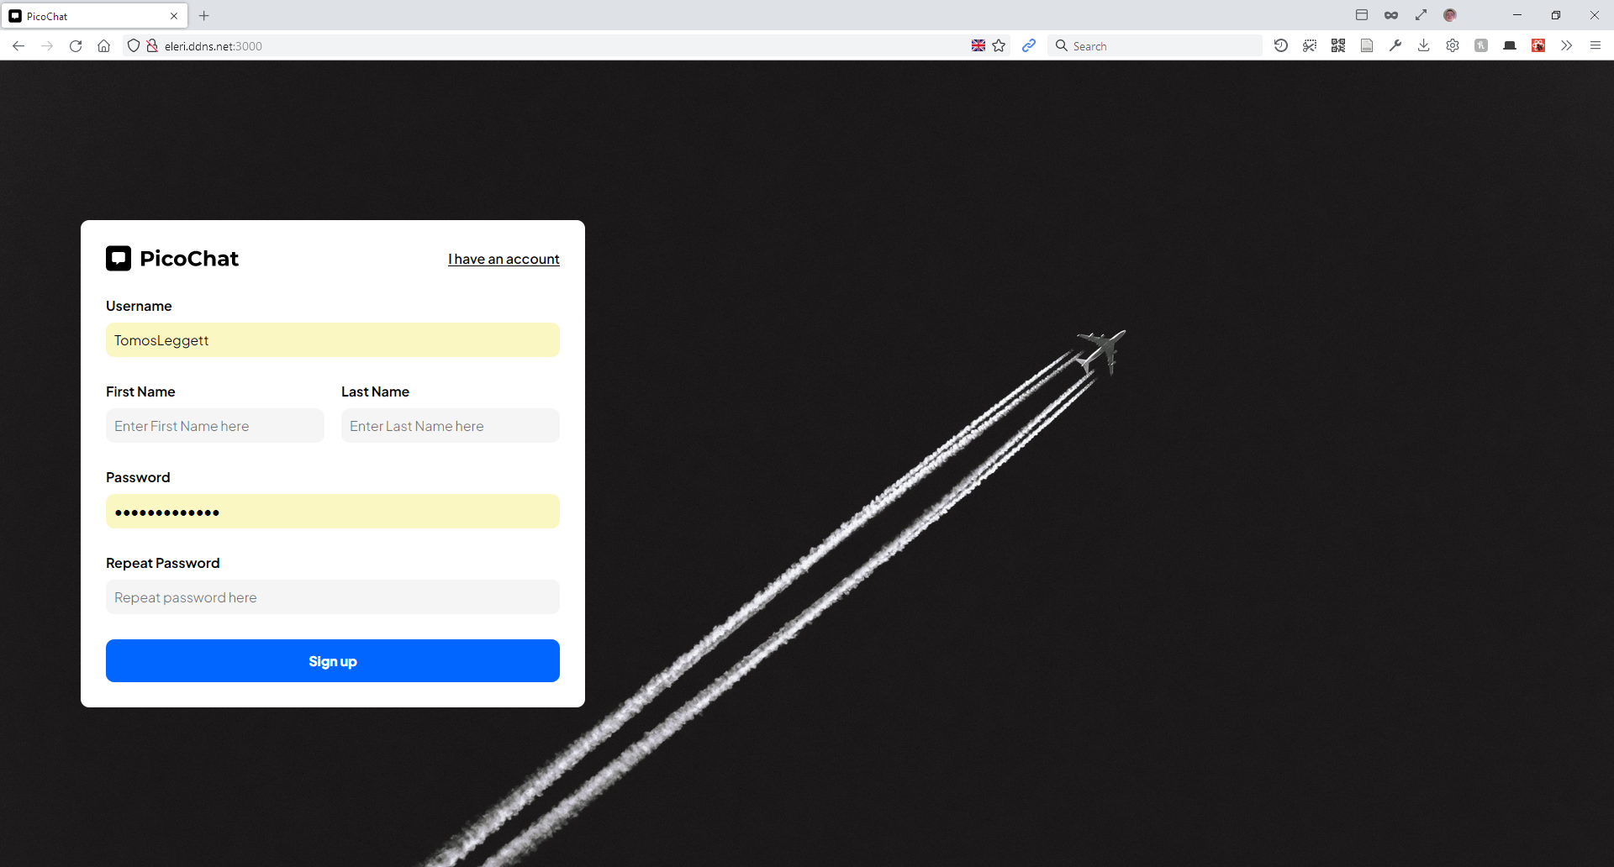

The signup form should not allow any blank fields at all. A test was conducted on each form to ensure no input field could be left intentionally blank.
When leaving the username field blank, the web browser automatically focuses on the username field when the enter key is pushed or the signup button is pressed.
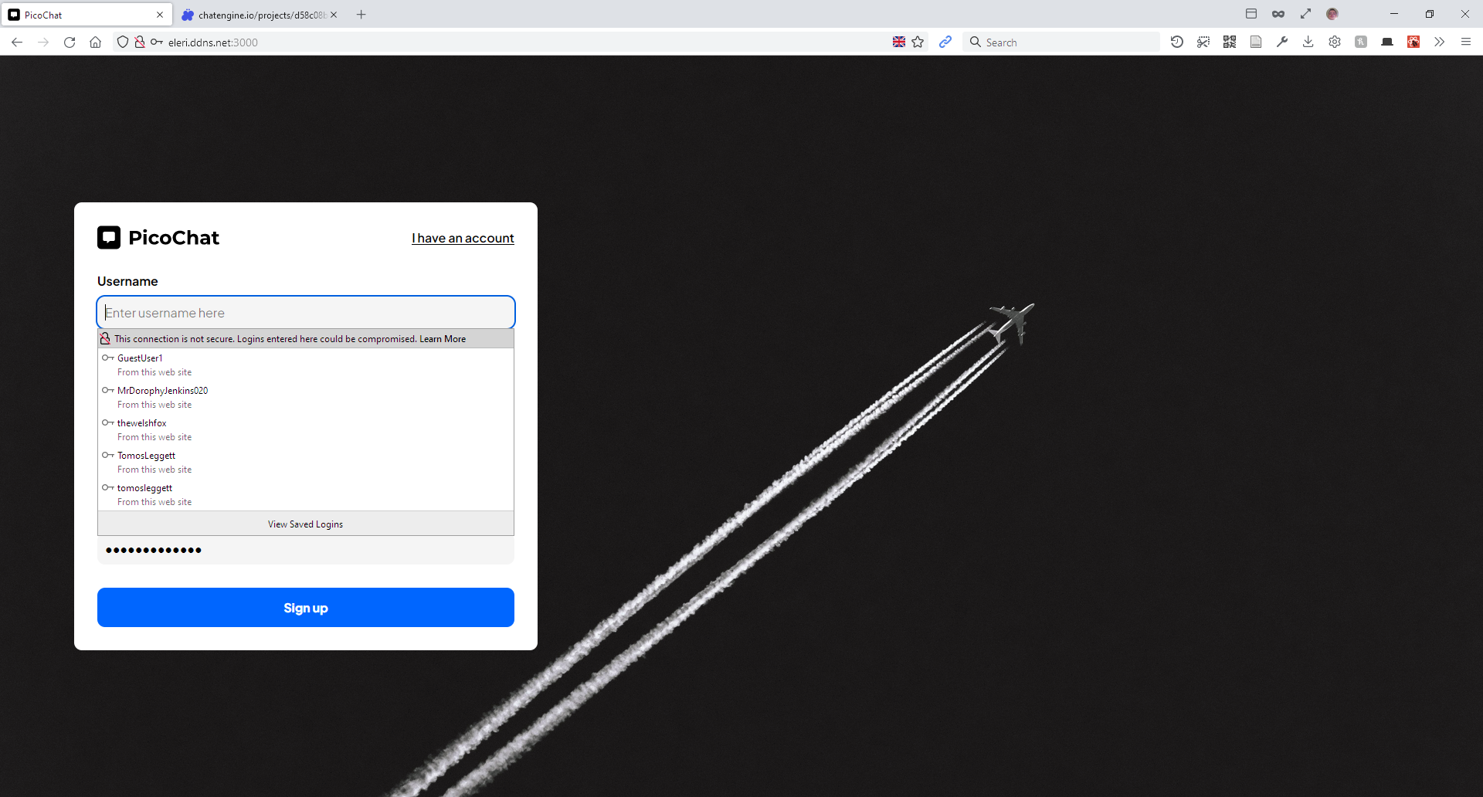

The same can be said for the first and last name input field.
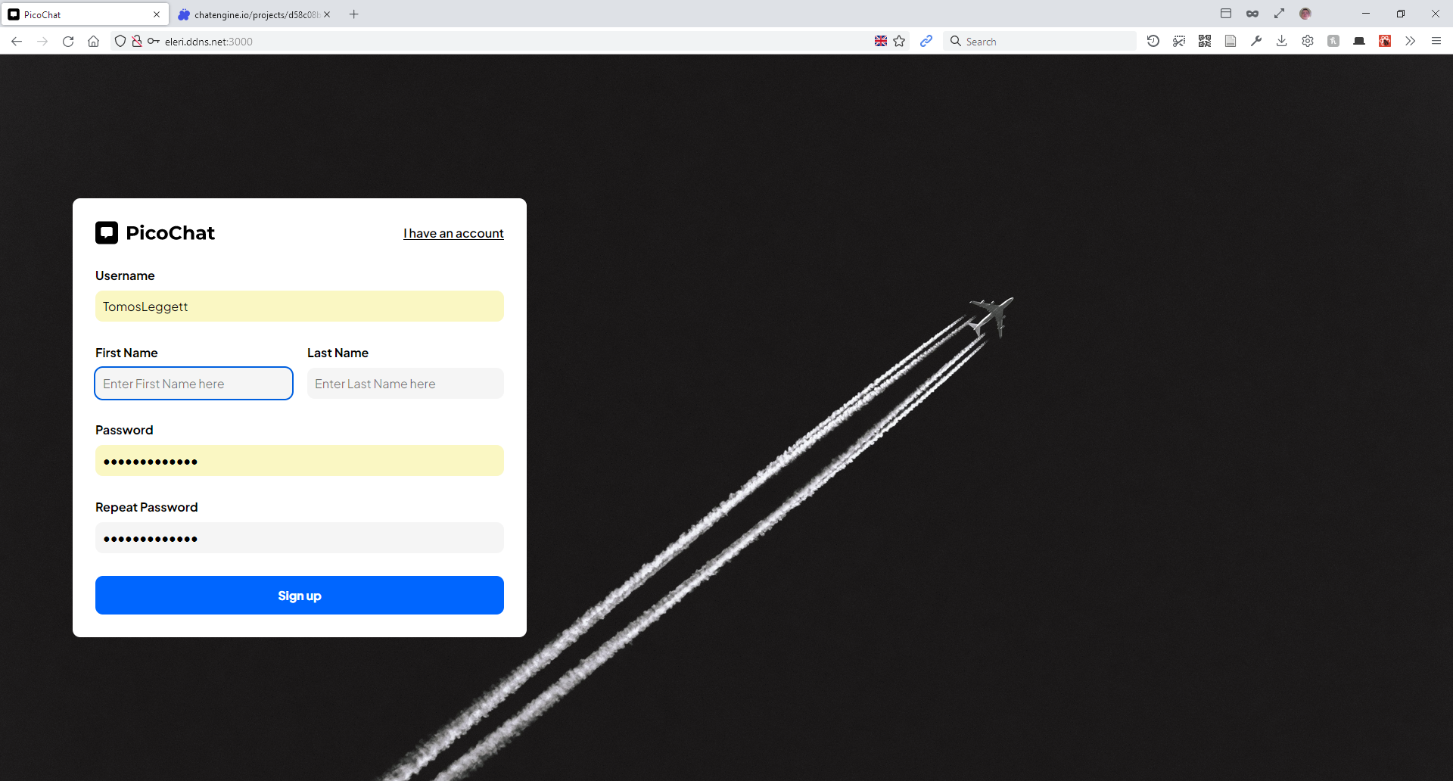

And finally, leaving both or either the password or repeat password field blank will not allow the form to submit, as evidenced below.
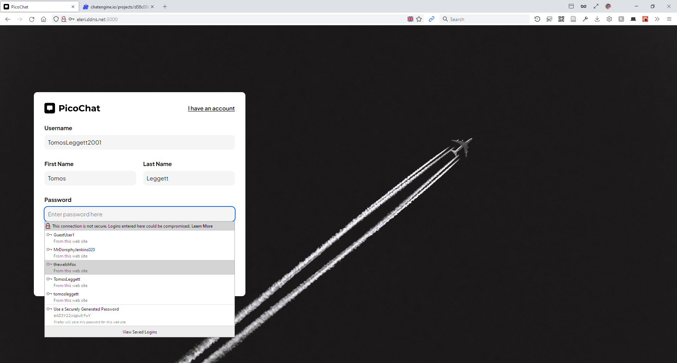

The form would not submit unless all fields were completed, which meant this particular test was a success.
Signing up for an account that already exists should return a ‘Username is taken’ error dialogue. The author created a new account by the name of ‘TestUser123’ and attempted to sign up with the same username once more.
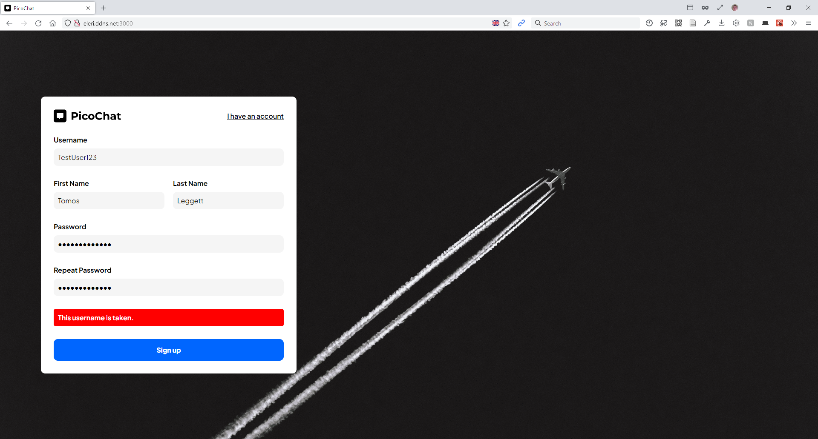

The error dialogue appeared correctly and stated the error, which means the test was a success.
Another element of the signup form is validation to ensure the password and repeat password fields are correct. To test this, the author removed a character from the ‘repeat password’ field.
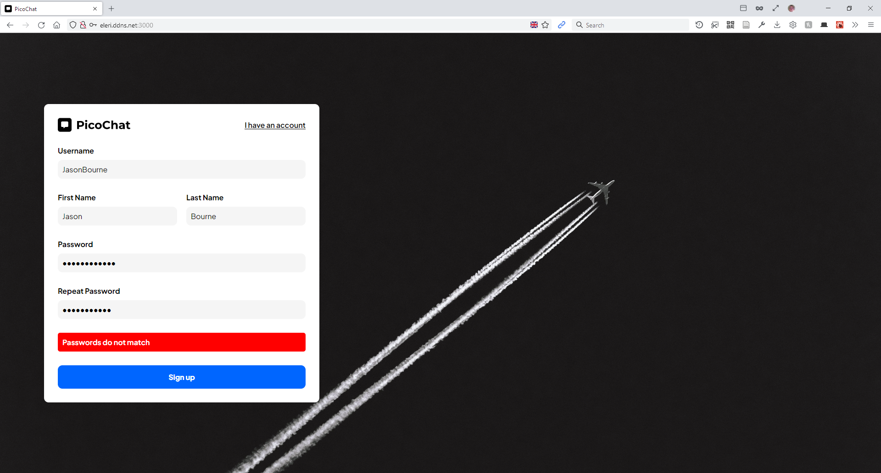

The test was a success, and the error appeared as designed. The form did not submit the information and no API calls were placed, which means an account cannot be created unless the passwords matched.

Testing the messaging platform
Two new accounts were created, one by the name of BobJones, the other SallySmith, as seen below:
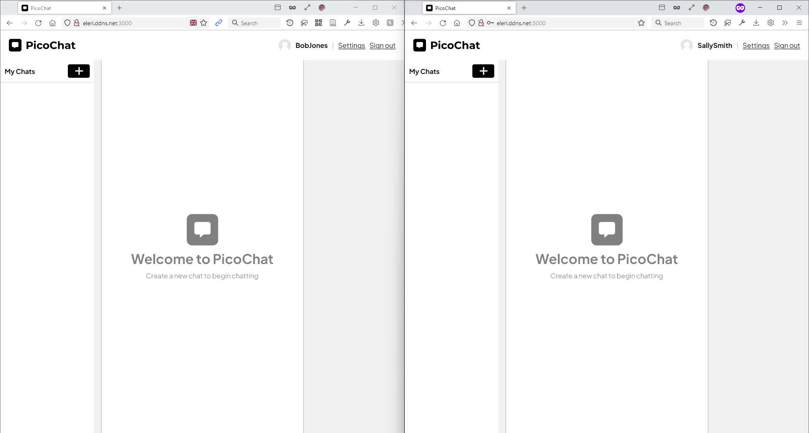

As a test, Bob Jones will create a new chat by the name of “Conversation”. The chat should appear in the “My Chats” section.
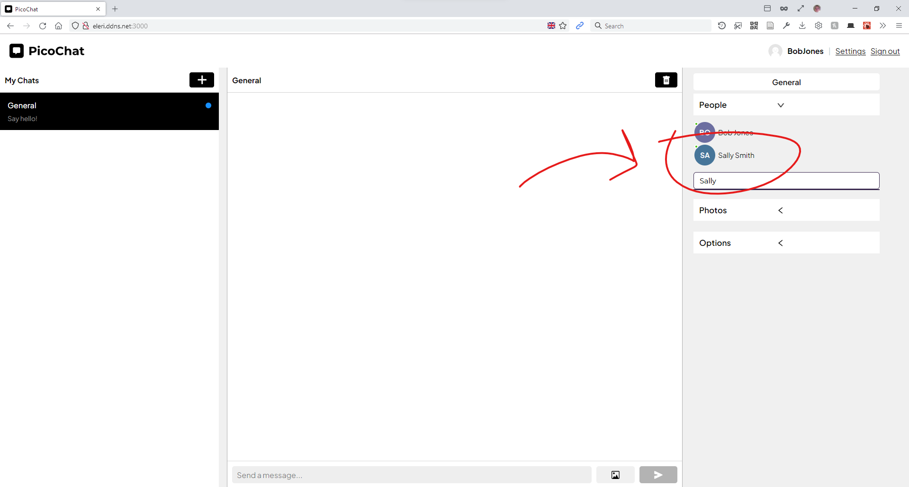

Bob Jones added Sally Smith to the chat successfully, now “General” should appear in Sally Smith’s list of chats.
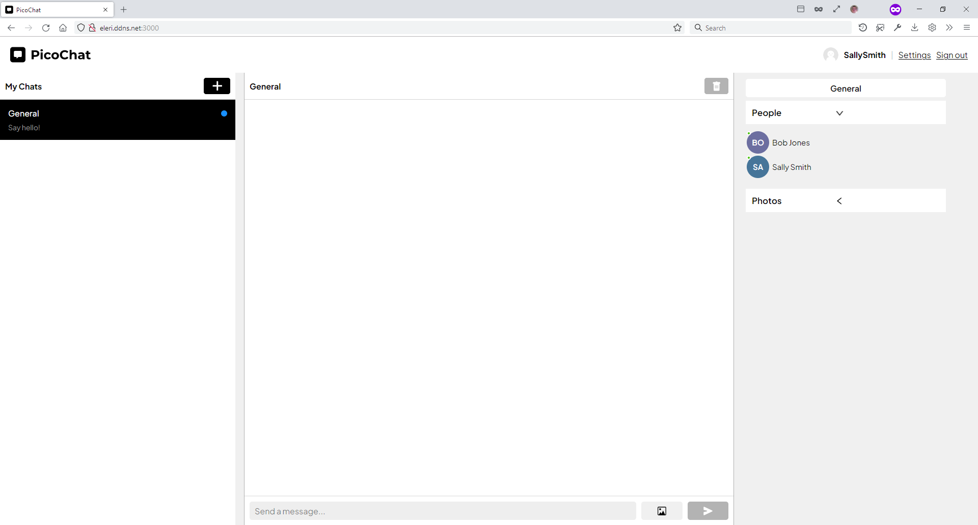

“General” appeared successfully in Sally Smith’s chat list. Sally and Bob can now interact. We’ll test this by sending “Hello” as both Bob and Sally respectfully.
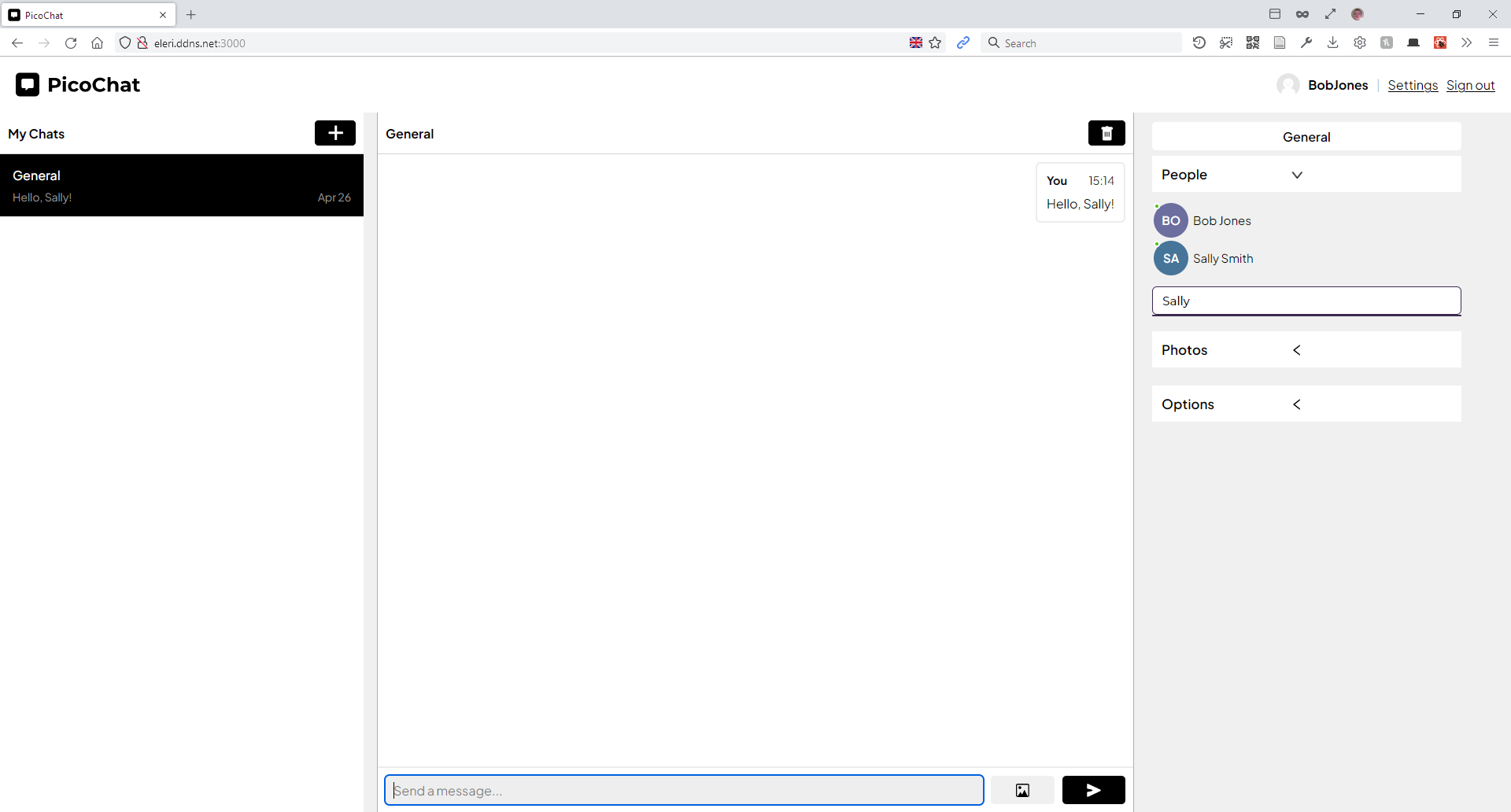

The message was sent successfully, Bob sent the message to Sally, and Sally received it.
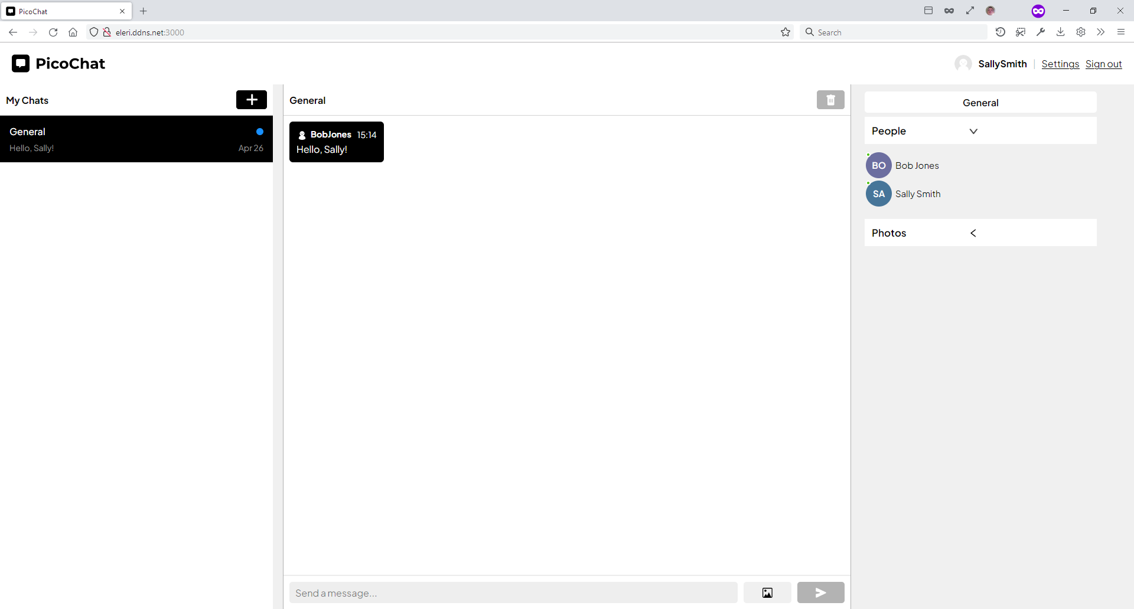

And vice versa,
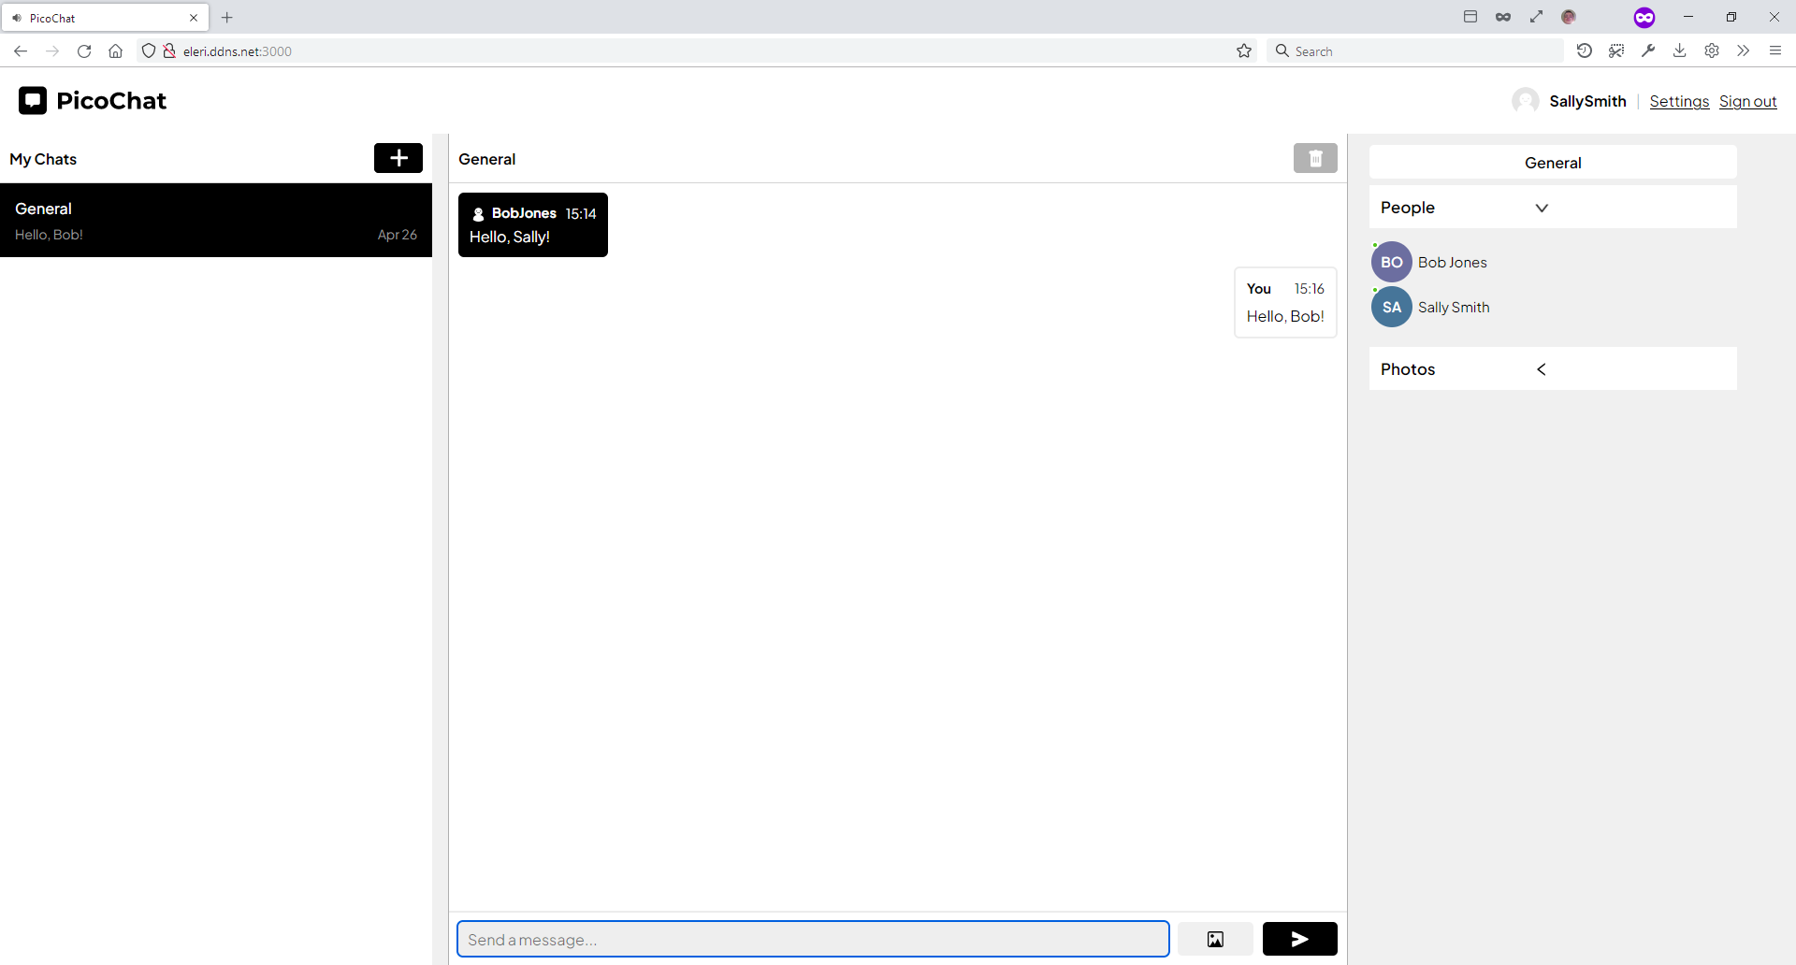

Images will need to be sent as well. To test this, Sally will send Bob an image of a flower.
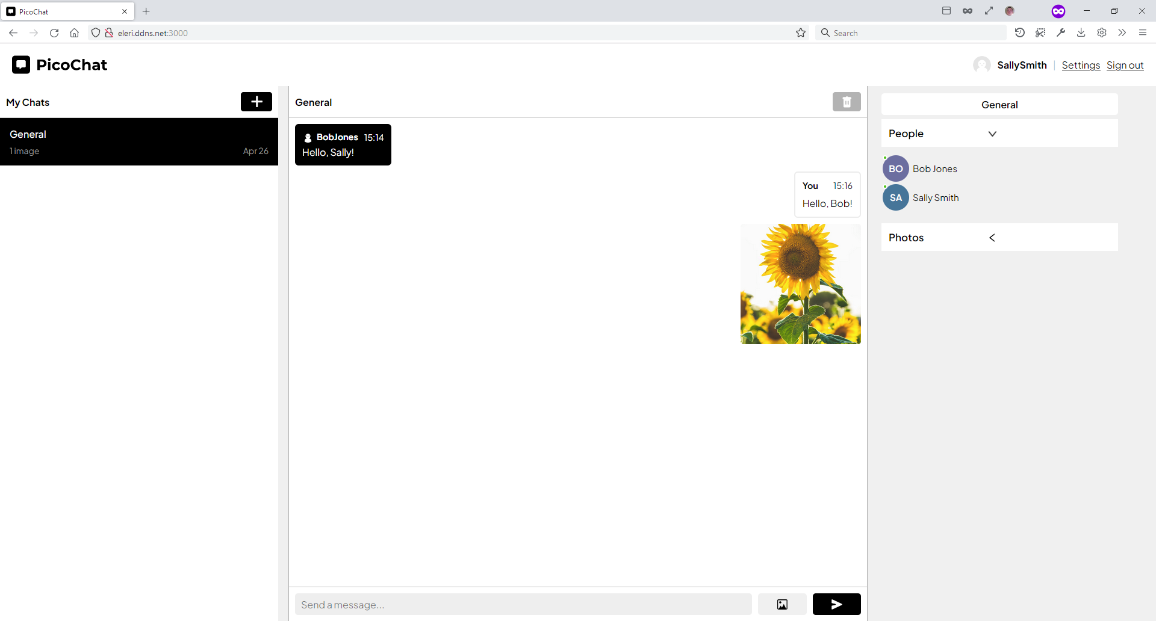

Bob receives it successfully:
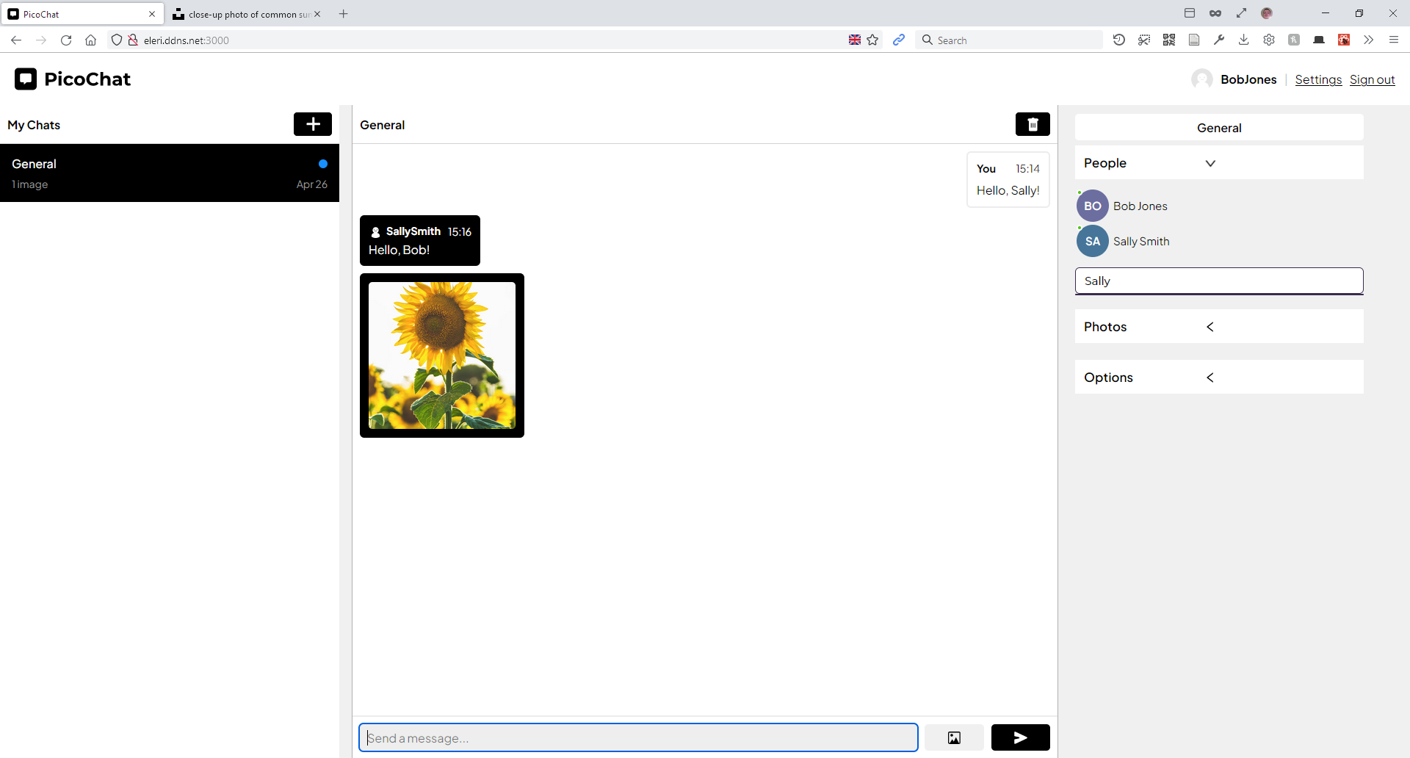

Usability testing
The usability testing was conducted to test the usability of the web page. This test was conducted as a contextual inquiry methodology with 5 users. To test the group chat functionality, the author would take the role of other users and would roleplay the group chat interaction via different browser sessions.
Each user is advised beforehand that they’d need to create a group chat named “Summer vacation” and add 3 users with the username “John”, “James” and “Frank”. They’d need to send a few messages and at least an image, then they’d need to kick at least one member, delete the chat and sign out.
The subjects (apprentices) were as follows:
Subject # | Relation | Age | Username
1 | Mother | 60 | allylegg
2 | Father | 63 | nleggett223
3 | Brother | 30 | heddwch65
4 | Friend | 20 | SJamesWoods
5 | Friend | 21 | kittenwire
Summary of interview with Test Subject 1
- The user initially attempted to sign up using the login form. User realised they were filling the login form via the “Log in” label on the button and proceeded to click “Sign up”. A clearer indication of the form may be required.
- Sign up form was a success, the user filled in all fields and made a mistake when inputting a repeated password. Error message signified error and the error was corrected immediately.
- The user took a while to find the add chat button. Eventually, when found, the user added a new chat successfully with the appropriate name. The user noted the short delay when adding the chat and attempted to add another, but didn’t proceed when the new chat was created. A clearer indication that the system is busy when adding chats may be required.
- The user expanded the people tab and added all 3 users successfully.
- After adding each member, a small 12 message conversation was successfully conducted.
- The user immediately knew how to send an image successfully and sent a picture of their dog. This indicates the image button placement was successful.
- The user clearly showcased confusion when attempting to kick a user, but when hovering over the username label, they eventually found the bin icon and clicked it. The user kicked John successfully.
- The user knew how to delete the chat immediately and did so without any problems.
- The user knew exactly how to sign out and did so immediately. This signifies that the sign out button placement is familiar and appropriately placed.
Summary of interview with Test Subject 2
- The user paused for around 7 seconds before clicking “Sign up”, indicating that the sign up button may not be clear.
- The sign up form was a success, the user filled in all forms correctly.
- The user first struggled to understand how to add chats. The author had to intervene to show the user which button to press. This indicates for some users the “Add chat” button isn’t clear enough and may need to be labelled appropriately.
- The user added a new chat successfully.
- When attempting to add users to the chat, the user attempted to click the “settings” label next to the profile. When asked why the user felt this was the appropriate button to press, the user exclaimed that “this must be where the chat settings are where I can add a user” before eventually using the “people” tab.
- The user used the people tab to add all 3 users of the chat successfully with no problems. The user commented “I didn’t know there’ll be a delay when I add users” which signifies that a loading icon should have been added.
- A short conversation was roleplayed successfully, the user had no problems identifying which message was theirs.
- An image was sent successfully with no problems, indicating the success of the image picker design.
- The user struggled to find the kick button for either user and eventually gave up.
- The user took a few seconds to find the delete chat button but did in fact delete the chat successfully.
Summary of interview with Test Subject 3
- The user checked the sign-up checkbox straight away, despite the other two subjects initially struggling.
- The sign up was a success, user signed up with Vietnamese characters and the username contained spaces, but it was still parsed successfully and the account was created.
- The user initially struggled logging in, but realised their password was incorrect almost immediately, which indicates the error message design was a success.
- The user commented on the login screen appearing after the signup screen and how it seemed redundant to log in after signing up.
- Upon logging in, user complimented on the website’s aesthetic design, indicating its successful appealing design.
- The user added a chat almost immediately without any pauses or assistance. User typed the chat name without spaces. When prompted to explain why the user typed the name of the chat as a string, the user exclaimed “I don’t know it’s easier”.
- The user immediately expanded the “People” tab and added the 3 users with no problems.
- The user attempted to select multiple images to send and was disappointed that only one photo could be sent at a time, but successfully sent a photo.
- The user unfortunately deleted the chat before kicking any users and signed out immediately.
Summery of interview with Test Subject 4
- The user went straight to “sign up” almost immediately and completed the form with no problems.
- The user commented on having to sign in again after signing up.
- The user commented on the “professionalism” of the web application and referred to it as “like a real chat app”.
- The user created the group almost immediately with no problems.
- The user initially struggled to find how to add another user, but eventually expanded the “people” tab and added all 3 users successfully.
- The user roleplayed conversation, but not for very long.
- The user immediately sent around 4 photos.
- The user criticised the application’s inability to clip the chat feed and prevent scrollbars from appearing, referring to it as “annoying”.
- The user struggled to find the kick button for each users. All 3 users were kicked.
- The user deleted the chat and signed out immediately.
Summery of interview with Test Subject 5
- The user first began typing their username into the login field, before realising mid-way that they were on the sign up form, instead clicked “sign up” immediately.
- The user complimented the aesthetic design of the form and the animation, stating “it looks really professional”.
- The user signed up with no problems.
- The user criticised the appearance of the login screen after signing up, stating “I thought I already did all this?” which indicates that most users are familiar with sign up logging them in automatically.
- User added a group chat immediately, and had no problems finding the “People” tab and adding all 3 users.
- User roleplayed conversation for a brief amount of time before sending a picture.
- User initially struggled to find the kick button, and first attempted to right click the user label on a message before hovering over the username label on the chat settings component and discovering it. User criticised this design approach and suggested the kick button should be clearer.
- User deleted the chat immediately and signed out with no problems.

Evaluation
In conclusion, the data evauated from the contextual inquiry gives an interesting insight into both the success of the application’s design and many of its flaws. Perhaps one of the biggest flaws in the application’s design is the lack of indication when the system is busy sending a request, which was a common theme among candidates who would often comment on the issue or would show clear indications of confusion after submitting a form or sending a message. This data showcases how important visual cues are when the system is busy. However, the data also showcased elements of success. The most successful element was the login and signup screen. Rarely did users have issues with completing this form, however, some users showcased a slight confusion as to whether they were on the signup or login form. Some users also criticised the program’s inability to log in users who had just signed up, with most seemingly showcasing an irate tone when discussing the design flaw. Another element of success for this particular design was the button placements, new message form design and overall design functionality wise of the chat application. All users successfully created accounts and logged in without any problems. All users were able to create new group chats, add all 3 test members, send a photo, kick users, delete the chat and sign out. The author was at least expecting issues with core functionality, but all candidates managed to successfully complete all tasks.
The initial aim of this project was to develop a fully functional chat application. This was a success. The author was able to develop a fully functional group based web chat application with functionality including the ability to send images and create group chats. The author, however, found that the chat application didn’t meet all of the project requirements that were initially set due to time constraints and issues with the code. Although the grand majority of the web application contained components purely created by the author, some components were initially redesigned by the author, but problems arose with the chat engine API that hindered these features. The contextual inquiry itself did deliver sufficient data on which elements of the application’s design were successful and which weren’t.
If the author was given the chance to conduct this personal project again, there would be a lot of elements that would have been done differently. For one, the author felt as if their time management skills could have been better orchestrated. Although the initial aim of developing a web application was met, the web application itself could have been a lot better had the author managed their time organisation skills more appropriately. Several complications, both around the project and personal complications hindered the timescale of the application development, along with the unexpected difficulty of developing a React application, the author now realises that perhaps a different less advanced framework should have been used when developing the application, so that the application could have been developed faster and the final usability test wasn’t as rushed. The author would have also conducted 2 contextual inquiries instead of one, one initially for the first design, and another based on a redesign. This methodology would have allowed the author to collect information on the usability of the initial design but also verify that the re-design based on feedback produces better usability results and validates the contextual inquiry and its effectiveness.

Conclusion
In conclusion, the author has successfully developed a web-based chat application using the react framework and node.js. The application itself is functional and users can create new accounts or login to already existing accounts. The application itself is based on the chat-engine API but most of the components have been redesigned from scratch by the author. The author designed the application based on existing UX research and developed an initial prototype design using the Figma prototype tool based on the requirements. The requirements themselves were produced using a board of user stories. The author then performed a contextual inquiry on 5 candidates to test the effectiveness of the user experience. The data itself helped evaluate the effectiveness of the application, and showcased elements that were well designed along with elements that needed improvement. The author believes this research showcases successful elements of design when developing a conventional chat application along with which elements work and which elements don’t. Unfortunately, due to time constraints and other issues with the code, not all application requirements were met, but the application was still functional for basic group chat messaging.
Had time not been a constraint and the development project itself showcased not only a functional chat application but one with a better feature set, such as the inclusion of read-receipts and other initial requirements as discussed in the requirements section, the author believes a clearer indication of the success of the user experience could be established.

Reflection
The author has learnt a great deal throughout this project, especially based on front end web development, a concept the author has been passionate about since childhood. Throughout this project, the author had learnt and developed many web development skills that may aid future web development projects. This includes using node.js as a backend, hosting a web server, using the node package manager to manage node modules and more. But perhaps the most important aspect of this project the author can take away is the use of the react framework. Before this project, the author had never used the react framework to develop a web application, which meant this project required the author to learn react whilst developing a react application. This is both something the author is disappointed and proud of. Disappointed in the fact that the author had under-estimated the learning curve react requires to master due to its heavy-handed use of JSX, a fork of JavaScript the author isn’t quite familiar with. However, the author is proud of their ability to overcome this learning curve, despite a frustrating learning curve and an unfamiliar development environment, the author had learnt a considerable amount about react and JSX thanks to this project. Although not exactly a professional react developer at this point, the author still appreciates the react framework as a development tool and will be using it again sometime in the future to further expand their knowledge. Looking back, the author should have used a framework they’re more familiar with, which would have reduced the number of issues with the project and sped up the process of development as the author would have been more familiar with the development environment and would understand the language, the errors and the techniques better.
One major issue throughout this entire project was perhaps the time scale and organisation. As the author had underestimated the scale of react development compared to vanilla HTML, CSS and JavaScript development, the project was still being developed, tweaked and maintained far beyond the timescale that was set, which ties into the organisational skills of the author, who could have managed their time far better in the future. If the author was to conduct the project again, this time with a far greater understanding of the React framework and JSX, the project development itself would perhaps not only conclude far earlier in the project’s time span, but the organisational skills of the author would have been much better as a whole, due to a greater understanding of react as a whole. Because of the lack of organisational skills due to the underestimated project scope, the initial aims and objectives were perhaps hindered, which left the author slightly disappointed in the state of their project towards the end of the development, along with the quality of their report.

References
[1] J. J. Garrett, The Elements of User Experience: User-Centered Design for the Web and Beyond. Pearson Education, 2010.
[2] ‘User Experience Design’, Semantic Studios, Jun. 21, 2004. https://semanticstudios.com/user_experience_design/
[3] A. Dix, J. Finlay, G. D. Abowd, and R. Beale, Human-computer Interaction. Pearson Education, 2004.
[4] D. Benyon, Designing User Experience. Pearson UK, 2019.
[5] I. Young, Mental Models: Aligning Design Strategy with Human Behavior. Rosenfeld Media, 2008.
[6] ‘Reasons for Cart Abandonment – Why 68% of Users Abandon Their Cart (2021 data) – Articles’, Baymard Institute. https://baymard.com/blog/ecommerce-checkout-usability-report-and-benchmark
[7] S. Caro-Alvaro, E. Garcia-Lopez, A. Garcia-Cabot, L. de-Marcos, and J.-J. Martinez-Herraiz, ‘Identifying Usability Issues in Instant Messaging Apps on iOS and Android Platforms’, Mobile Information Systems, vol. 2018, pp. 1–19, Oct. 2018, doi: 10.1155/2018/2056290.
[8] ‘Design a chat system’. https://systeminterview.com/design-a-chat-system.php.
[9] C. M. Barnum, Usability Testing Essentials: Ready, Set …Test! Morgan Kaufmann, 2020.
[10] J. S. Dumas, J. S. Dumas, and J. Redish, A Practical Guide to Usability Testing. Intellect Books, 1999.
[11] W. L. in R.-B. U. Experience, ‘Usability Testing 101’, Nielsen Norman Group. https://www.nngroup.com/articles/usability-testing-101/
[12] W. L. in R.-B. U. Experience, ‘Contextual Inquiry: Inspire Design by Observing and Interviewing Users in Their Context’, Nielsen Norman Group. https://www.nngroup.com/articles/contextual-inquiry/
[13] ‘Why Are Contextual Inquiries So Difficult? :: UXmatters’. https://www.uxmatters.com/mt/archives/2012/06/why-are-contextual-inquiries-so-difficult.php
[14] ‘Chapter 15: Requirements and User Stories’. https://www.agilebusiness.org/page/ProjectFramework_15_RequirementsandUserStories.
[15] D. Airey, Logo Design Love: A Guide to Creating Iconic Brand Identities. New Riders, 2009.
[16] N. Peiffer-Smadja and L. Cohen, ‘The cerebral bases of the bouba-kiki effect’, NeuroImage, vol. 186, pp. 679–689, Feb. 2019, doi: 10.1016/j.neuroimage.2018.11.033.
[17] J. Beaird, The Principles of Beautiful Web Design. SitePoint, 2010.
[18] ‘Google Fonts’, Google Fonts. https://fonts.google.com/specimen/Plus+Jakarta+Sans
[19] ‘Chat Engine | Simple APIs & UI Kits’. https://chatengine.io/
[20] W. L. in R.-B. U. Experience, ‘End of Web Design’, Nielsen Norman Group. https://www.nngroup.com/articles/end-of-web-design/
[21] R. Fraher and J. Boyd-Brent, ‘Gestalt theory, engagement and interaction’, in CHI ’10 Extended Abstracts on Human Factors in Computing Systems, New York, NY, USA, Apr. 2010, pp. 3211–3216. doi: 10.1145/1753846.1753960.
[22] Z. Xu and J. Miller, ‘Identifying semantic blocks in Web pages using Gestalt laws of grouping’, World Wide Web, vol. 19, no. 5, pp. 957–978, Sep. 2016, doi: 10.1007/s11280-015-0370-0.
[23] ‘429 Too Many Requests - HTTP | MDN’. https://developer.mozilla.org/en-US/docs/Web/HTTP/Status/429

Appendices

Declaration Form and Form of Consent

Declaration Form
I Tomos Joseph Leggett declare that I am the sole author of this Project; that all references cited have been consulted; that I have conducted all work of which this is a record, and that the finished work lies within the
prescribed word limits. This work has not previously been accepted as part of any other degree submission.

Form of Consent
I Tomos Joseph Leggett hereby consent that my Project, submitted in candidature for the B.Sc. (Hons) Computing (Web Development) degree, if successful, may be made available for inter-library loan or photocopying (subject to the law of copyright), and that the title and abstract may be made available to outside organisations.

App.css
/* CHAT STYLES */
* {
font-family: 'Plus Jakarta Sans', sans-serif;
transition: all 0.5s;
}
@import url('https://fonts.googleapis.com/css2?family=Plus+Jakarta+Sans:wght@400;500;600;700;800&display=swap');
#hiddenForm
{
display: none;
}
.newChatElement
{
display: flex;
flex-direction: column;
padding: 10px;
background-color: white;
border-bottom: 1px solid lightgrey;
gap: 10px;
}
.newChatHeader
{
display: flex;
flex-direction: row;
justify-content: space-between;
align-items: center;
font-weight: bold;
}
.newChatForm
{
display: flex;
flex-direction: column;
gap: 5px;
}
.newChatForm > button
{
padding: 10px;
font-size: 1rem;
background-color:rgb(0, 102, 255);
color: white;
font-weight: bold;
border: 0px;
border-radius: 5px;
}
input
{
font-size: 1rem;
padding: 10px;
}
.newChatButton, .deleteChat
{
display: flex;
align-items: center;
justify-content: center;
padding: 5px;
background-color: black;
color: white;
padding-left: 15px;
padding-right: 15px;
border-radius: 5px;
cursor: pointer;
user-select: none;
border: 1px solid black;
}
.welcomeScreen
{
height: 100%;
width: 100%;
display: flex;
flex-direction: column;
align-items: center;
justify-content: center;
gap: 10px;
opacity: 0.5;
user-select: none;
}
iframe
{
display: none;
}
.profilePicture
{
width: 30px;
height: 30px;
border-radius: 10000px;
}
p
{
padding: 0;
margin: 0;
}
b
{
font-weight: 700;
}
html, body
{
height: 100%;
display: flex;
flex-direction: column;
}
.username
{
font-weight: bold;
}
#root
{
height: 100vh;
}
.ce-chat-engine, .ce-wrapper
{
height: 100%;
display: flex;
width: 100%;
}
#header
{
display: flex;
flex-direction: row;
padding: 20px;
justify-content: space-between;
align-items: center;
height: 72px;
}
.user-details
{
display: flex;
gap: 10px;
align-items: center;
}
.ce-chat-list {
border-right: 1px solid lightgray;
background-color: white !important;
}
.ce-active-chat-card {
background-color: #000000 !important;
border-radius: 0px !important;
color: white !important;
}
.ce-settings, .ce-settings-container
{
display: flex !important;
flex-direction: column;
gap: 5px !important;
}
.ce-chat-subtitle-text {
color: #777777;
}
.ce-text-input {
font-weight: 1rem;
border-radius: 5px !important;
}
.ce-primary-button {
border-radius: 6px !important;
background-color: #7554a0 !important;
position: relative;
bottom: 1px;
}
.ce-danger-button {
background-color: white !important;
border-radius: 22px !important;
}
.ce-settings {
background-color: rgb(240, 240, 240) !important;
}
.ce-autocomplete-input {
border-radius: 6px !important;
border: 1px solid #3b2a50 !important;
}
.ce-autocomplete-options {
border-radius: 6px !important;
border: 1px solid #3b2a50 !important;
background-color: white !important;
}
.ce-chat-settings-container {
padding-top: 12px !important;
}
.ce-chat-avatars-row {
display: none !important;
}
/* CUSTOM FEED */
.chatFeed
{
display: flex;
justify-content: space-between;
flex-direction: column;
height: 100%;
width: 100%;
background-color: white;
}
.chat-title-container {
width: calc(100% - 36px);
padding: 18px;
text-align: center;
}
.chat-title {
color: #7554a0;
font-weight: 800;
font-size: 24px;
}
.chat-subtitle {
color: #7554a0;
font-weight: 600;
font-size: 12px;
padding-top: 4px;
}
.senderLabel
{
font-weight: bold;
font-size: 0.8rem;
margin-bottom: 5px;
}
@keyframes messageSlideIn
{
from
{
padding-top: 15px;
opacity: 0;
}
to
{
padding-top: 10px;
opacity: 1;
}
}
body, html
{
height: 100vh;
max-height: 100vh;
display: flex;
flex-direction: column;
}
.chats
{
display: flex;
justify-content: flex-start;
gap: 10px;
padding: 10px;
flex-direction: column;
height: 100%;
overflow: auto;
}
.message-block {
width: 100%;
display: flex;
flex-direction: row;
}
.message-avatar {
width: 44px;
height: 44px;
border-radius: 22px;
color: white;
text-align: center;
background-repeat: no-repeat;
background-position: center;
background-size: 48px;
}
.message, .theirMessage {
padding: 12px;
font-size: 1rem;
border-radius: 6px;
display: flex;
flex-direction: column;
gap: 5px;
}
.theirMessage {
background-color: black;
color: white;
}
.username-and-avatar
{
display: flex;
gap: 5px;
}
.avatar-image
{
border-radius: 999px;
height: 19px;
width: 19px;
background-image: url(./components/loading.svg)
}
.wrapper
{
background-color: #242221;
background-image: url(resources/loginScreen/1cheap.jpg);
background-image: url(resources/loginScreen/1.jpg);
background-repeat: no-repeat;
background-attachment: fixed;
background-size: cover;
}
.message-details
{
display: flex;
justify-content: space-between;
padding-bottom: 5px;
font-size: 0.9rem;
align-items: center;
gap: 10px;
}
.message-image {
object-fit: cover;
border-radius: 5px;
height: 200px;
width: 200px;
}
.message-image:hover
{
height: 500px;
width: 500px;
}
.read-receipts {
position: relative;
bottom: 6px;
}
.read-receipt {
width: 13px;
height: 13px;
border-radius: 13px;
margin: 1.5px;
background-repeat: no-repeat;
background-position: center;
background-size: 14px;
}
button
{
cursor: pointer;
}
ChatEngine
{
height: calc(100vh - 71px) !important;
overflow: none;
}
.message-form-container {
position: absolute;
bottom: 0px;
width: calc(100% - 36px);
padding: 18px;
background-color: #f0f0f0;
}
.messageBox {
overflow: hidden;
background-color: white;
display: flex;
padding: 10px;
border-top: 2px solid rgb(236, 236, 236);
width: 100%;
bottom: 0;
gap: 10px;
}
.disabled
{
opacity: 0.3;
user-select: none;
cursor: not-allowed;
}
.imageUploadButton
{
display: flex;
justify-content: center;
align-items: center;
width: 100px;
background-color: #f0f0f0;
border: none;
border-radius: 5px;
cursor: pointer;
}
#submit
{
display: flex;
justify-content: center;
align-items: center;
width: 100px;
background-color: black;
border: none;
color: white;
border-radius: 5px;
}
.messageInput {
padding: 10px;
background-color:rgb(238, 238, 238);
border: none;
width: 100%;
font-size: 1rem;
border-radius: 5px;
gap: 5px;
}
.image-button {
cursor: pointer;
padding: 0px 12px;
height: 100%;
}
.send-button {
height: 42px;
background-color: white;
border: 1px solid white;
padding: 0px 18px;
cursor: pointer;
}
.send-icon {
top: 1px;
position: relative;
transform: rotate(-90deg);
}
.picture-icon {
top: 1px;
position: relative;
font-size: 14px;
}
/* FORM STYLES */
*,
*::after,
*::before {
margin: 0;
padding: 0;
box-sizing: border-box;
font-size: 62,5%;
}
@keyframes spinn {
100% {
transform:rotate(360deg);
}
}
span
{
width: 100%;
}
#signOutButton, #settingsButton
{
text-decoration: underline;
cursor: pointer;
}
.chatHeader
{
padding: 10px;
border-bottom: 1px solid lightgrey;
height: 57px;
display: flex;
font-weight: bold;
align-items: center;
justify-content: space-between;
}
#divider
{
opacity: 0.3;
}
#loadingIcon
{
animation: spinn linear 1s infinite;
width: 19px;
display: none;
transition: all 0.5s;
}
.wrapper
{
display: flex;
height: 100%;
align-items: center;
justify-content: left;
transition: all 0.5s;
padding-left: 5%;
}
.accountInput
{
background-color: rgb(245, 245, 245);
font-size: 1rem;
padding: 10px;
border-radius: 10px;
border: none;
transition: all 0.5s;
}
.flexRow
{
display: flex;
flex-direction: row;
width: 100%;
gap: 20px;
justify-content: space-between;
transition: all 0.5s;
}
.inputGroup
{
display: flex;
width: 100%;
gap: 10px;
justify-content: space-between;
transition: all 0.5s;
}
.userInput
{
display: flex;
flex-direction: column;
gap: 10px;
width: 100%;
transition: all 0.5s;
}
.form
{
background-color: white;
color: black;
padding: 30px;
display: flex;
flex-direction: column;
gap: 30px;
border-radius: 10px;
width: 400px;
transition: all 0.5s;
}
.input {
color: #333;
font-size: 1.2rem;
margin: 0 auto;
padding: 1.5rem 2rem;
border-radius: 0.2rem;
background-color: rgb(255, 255, 255);
border: none;
width: 90%;
display: block;
border-bottom: 0.3rem solid transparent;
transition: all 0.3s;
outline: none;
margin-bottom: 25px;
}
#firstName, #lastName, #repeatPassword
{
display: none;
}
.logoContainer
{
display: flex;
align-items: center;
justify-content: space-between;
}
.logoContainer > input
{
display: none;
}
.logoContainer > label
{
cursor: pointer;
font-weight: 600;
text-decoration: underline;
}
.title {
text-align: center;
color: white;
margin-bottom: 30px;
width: 100%;
font-size: 2.3em;;
}
.button
{
padding: 15px;
font-size: 1rem;
background-color: rgb(0, 102, 255);
color: white;
font-weight: 800;
border-radius: 10px;
border: none;
cursor: pointer;
display: flex;
align-items: center;
justify-content: center;
}
#error
{
padding: 10px;
font-weight: bold;
background-color: red;
color: white;
border-radius: 5px;
display: none;
}

App.js
import React from 'react';
import {ChatEngine} from 'react-chat-engine';
import LoginForm from './components/LoginForm'
import ChatFeed from './components/ChatFeed';
import header from './components/Header'
import './App.css';
import NewChatForm from './components/NewChatForm'
import boopSfx from './assets/thisIsaSound.mp3'; // The notification noise when recieving a new message
const App = () => {
var boopSound = new Audio(boopSfx); // A variable for the notificiation noise
if(!localStorage.getItem('username')) return <LoginForm /> // Check local storage for a saved username, if it doesn't exist, return the loginform component.
return ( // If the username DOES exist in local storage, return the chat engine component with the appropriate credentials
<ChatEngine
height="100%"
projectID="d58c08b4-7cb8-4cbd-bd4b-fd4d987b05c5"
userName={localStorage.getItem('username')} // Returns the username from local storage
userSecret={localStorage.getItem('password')} // Returns the password from local storage
renderChatFeed={(chatAppProps) => <ChatFeed {...chatAppProps} />} // Renders the actual chat feed as a component
renderNewChatForm={(creds) => <NewChatForm {...creds} />} // Renders the new chat form
onNewMessage={() => {boopSound.play()}} // Plays a sound when a new message arrives
/>
)
}
export default App

index.js
import React from 'react';
import ReactDOM from 'react-dom';
import App from './App'; // Renders the application
ReactDOM.render(<App />, document.getElementById('root'));

Components

Chat Feed
import React from 'react';
import {deleteChat} from 'react-chat-engine'
import MessageForm from './MessageForm';
import MyMessage from './MyMessage';
import TheirMessage from './TheirMessage';
import Emblem from './emblem.svg';
import DeleteIcon from './deleteIcon.svg';
const ChatFeed = (props) => {
document.getElementById("header").style.display = "flex"; // Display the header when the chat feed loads.
const { chats, creds, activeChat, userName, messages } = props; // Get all properties.
const chat = chats && chats[activeChat]; // This variable will be false unless both all chats and the current active chat has been loaded.
const whoReadThisMessage = (message, isMyMessage) =>
{
chat.people.map((person, index) => person.last_read === message.id && ( // Map all who read this message
person.person.first_name // return their names
))
}
const renderMessages = () => { // Render any new messages
const keys = Object.keys(messages); // Create a new array of keys based on the messages JSON objects.
return keys.map((key, index) => { // Return a map of each message based on the index
const message = messages[key]; // Set the message as a variable based on the current key
const lastMessageKey = index === 0 ? null : keys[index - 1]; // True if it's the last message
const isMyMessage = userName === message.sender.username; // True if the message sender is my username
return (
<div key={`msg_${index}`} style={ isMyMessage ? { justifyContent:'flex-end'} : { justifyContent:'flex-start'} } className="message-block"> // If the message is my message, justify the message to the end of the flexbox container (the far right), otherwise, do the opposite (the far left).
<div class="messageContent"> // Create a div for the message content
{
isMyMessage // Is this my message?
? <MyMessage message={message}/> // If true, display a MyMessage component with message data
: <TheirMessage message={message} lastMessage={messages[lastMessageKey]} /> // If not, dispay a TheirMessage component with THEIR data along with the last message key.
}
<div class="readReceipts">
{whoReadThisMessage(message, isMyMessage)}
</div>
</div>
</div>
)
})
}
renderMessages(); // Render the messages
// If no chat object has loaded yet, show the welcome screen to guide the user on how to add a new chat
if(!chat) return <div class="welcomeScreen" >
<img src={Emblem} width="75px" alt="Emblem" />
<h1>Welcome to PicoChat</h1>
<p>Create a new chat to begin chatting</p>
</div> ;
const isChatAdmin = userName === chats[activeChat].admin.username // Checks to see if the user is the chat admin
return (
<div className="chatFeed">
<div className="chatHeader">
{chats[activeChat].title // Return the active chat title for the header of the chat}
{
isChatAdmin // If we're the chat admin, create a delete chat button, otherwise, place a disabled one in its place.
? (<button id="deleteChatButton" onClick={() => deleteChat(creds, activeChat)} class="deleteChat"><img height="20px" src={DeleteIcon} alt="Delete" /></button>)
: (<button class="disabled deleteChat"><img height="20px" src={DeleteIcon} alt="Delete" /></button>)
}
</div>
<div className="chats">
{renderMessages()}
</div>
<MessageForm {...props } chatId={activeChat} />
// Return a message form component and carry the properties, set the chatId as the current active chat.
</div>
)
}
export default ChatFeed;

Header
import React from 'react';
import ReactDOM from 'react-dom';
import Modal from 'react-modal';
import loadingIcon from './loading.svg'; // Import default profile picture
var axios = require('axios'); // Use the AXIOS API thingy.
var username = localStorage.getItem('username'); // Get the stored username from storage
var password = localStorage.getItem('password'); // Get the stored password from storage
var config = { // Set up the configuration for AJAX call
method: 'get',
url: 'https://api.chatengine.io/users/me/',
headers:
{
'Project-ID': 'd58c08b4-7cb8-4cbd-bd4b-fd4d987b05c5',
'User-Name': username,
'User-Secret': password
}
};
var avatar; // Create a new variable to handle avatar URL data
axios(config)
.then(function (response) { // When there's a response from the back-end
avatar = response.data.avatar; // Set the avatar response data as the avatar variable
// Setting the profile picture
if (String(avatar) === "null") // If the profile picture isn't yet set by the user
{
document.getElementById("profilePicture").src= loadingIcon; // Set the profile picture as the default profile picture
}
else // otherwise
{
document.getElementById("profilePicture").src= avatar; // Set the profile picture as the user's choice of profile picture
}
})
.catch(function (error) { // If there's an issue
console.log("Error recieving data for header - is the user even logged in?") // Log it in the developer log
});
function openSettings()
{
}
function signOut() // When the user clicks the sign out button on the header
{
localStorage.removeItem('username'); // Delete the username from storage
localStorage.removeItem('password'); // Delete the password from storage
window.location.reload(); // Reload the web page (The sign up form will appear due to a lack of stored user credentials)
}
const Header =
<><><svg width="159" height="31" viewBox="0 0 159 31" fill="none" xmlns="http://www.w3./2000/svg">
<rect y="0.459991" width="30" height="30" rx="5" fill="black"/>
<path fill-rule="evenodd" clip-rule="evenodd" d="M9.20975 8.09253C8.10518 8.09253 7.20975 8.98796 7.20975 10.0925V18.0376C7.20975 19.1422 8.10518 20.0376 9.20975 20.0376H11.6513C12.0284 20.0376 12.217 20.0376 12.3341 20.1548C12.4513 20.2719 12.4513 20.4605 12.4513 20.8376V21.5635C12.4513 22.3186 12.4513 22.6961 12.6851 22.8029C12.9189 22.9097 13.2043 22.6626 13.775 22.1683L16.0098 20.2329C16.1213 20.1363 16.1771 20.088 16.2447 20.0628C16.3123 20.0376 16.386 20.0376 16.5335 20.0376H20.7903C21.8948 20.0376 22.7903 19.1422 22.7903 18.0376V10.0925C22.7903 8.98796 21.8948 8.09253 20.7903 8.09253H9.20975Z" fill="white"/>
<path d="M49.65 6.95999H42.075V24.46H46.125V19.635H49.65C54.325 19.635 57.25 17.21 57.25 13.31C57.25 9.38499 54.325 6.95999 49.65 6.95999ZM49.425 16.335H46.125V10.26H49.425C51.9 10.26 53.15 11.385 53.15 13.31C53.15 15.21 51.9 16.335 49.425 16.335ZM61.8164 9.13499C63.2664 9.13499 64.2414 8.18499 64.2414 6.88499C64.2414 5.68499 63.2664 4.78499 61.8164 4.78499C60.3664 4.78499 59.3914 5.73499 59.3914 6.95999C59.3914 8.18499 60.3664 9.13499 61.8164 9.13499ZM59.8664 24.46H63.7664V11.01H59.8664V24.46ZM73.8859 24.66C76.7109 24.66 78.9359 23.41 79.9109 21.26L76.8859 19.61C76.1609 20.91 75.0859 21.46 73.8609 21.46C71.8859 21.46 70.3359 20.085 70.3359 17.735C70.3359 15.385 71.8859 14.01 73.8609 14.01C75.0859 14.01 76.1609 14.585 76.8859 15.86L79.9109 14.235C78.9359 12.035 76.7109 10.81 73.8859 10.81C69.5109 10.81 66.3859 13.685 66.3859 17.735C66.3859 21.785 69.5109 24.66 73.8859 24.66ZM88.3855 24.66C92.6605 24.66 95.7605 21.785 95.7605 17.735C95.7605 13.685 92.6605 10.81 88.3855 10.81C84.1105 10.81 80.9855 13.685 80.9855 17.735C80.9855 21.785 84.1105 24.66 88.3855 24.66ZM88.3855 21.46C86.4355 21.46 84.9355 20.06 84.9355 17.735C84.9355 15.41 86.4355 14.01 88.3855 14.01C90.3355 14.01 91.8105 15.41 91.8105 17.735C91.8105 20.06 90.3355 21.46 88.3855 21.46ZM107.017 24.76C110.067 24.76 112.592 23.66 114.242 21.635L111.642 19.235C110.467 20.61 108.992 21.31 107.242 21.31C103.967 21.31 101.642 19.01 101.642 15.71C101.642 12.41 103.967 10.11 107.242 10.11C108.992 10.11 110.467 10.81 111.642 12.16L114.242 9.75999C112.592 7.75999 110.067 6.65999 107.042 6.65999C101.592 6.65999 97.5424 10.435 97.5424 15.71C97.5424 20.985 101.592 24.76 107.017 24.76ZM124.877 10.81C123.152 10.81 121.652 11.36 120.602 12.41V5.90999H116.702V24.46H120.602V17.81C120.602 15.335 121.952 14.185 123.827 14.185C125.552 14.185 126.552 15.185 126.552 17.36V24.46H130.452V16.76C130.452 12.66 128.052 10.81 124.877 10.81ZM139.413 10.81C137.263 10.81 135.088 11.385 133.613 12.435L135.013 15.16C135.988 14.385 137.463 13.91 138.888 13.91C140.988 13.91 141.988 14.885 141.988 16.56H138.888C134.788 16.56 133.113 18.21 133.113 20.585C133.113 22.91 134.988 24.66 138.138 24.66C140.113 24.66 141.513 24.01 142.238 22.785V24.46H145.888V16.785C145.888 12.71 143.513 10.81 139.413 10.81ZM139.113 22.035C137.738 22.035 136.913 21.385 136.913 20.41C136.913 19.51 137.488 18.835 139.313 18.835H141.988V20.21C141.538 21.435 140.413 22.035 139.113 22.035ZM157.042 21.06C156.617 21.385 156.042 21.56 155.467 21.56C154.417 21.56 153.792 20.935 153.792 19.785V14.31H157.142V11.31H153.792V8.03499H149.892V11.31H147.817V14.31H149.892V19.835C149.892 23.035 151.742 24.66 154.917 24.66C156.117 24.66 157.292 24.385 158.092 23.81L157.042 21.06Z" fill="black"/>
</svg>
</><div class="user-details">
<img id="profilePicture" src={loadingIcon} className="profilePicture" alt="Profile" ></img>
<label class="username">{localStorage.getItem('username')}</label>
<label id="divider">|</label>
<label id="settingsButton" onClick={openSettings}>Settings</label>
<label id="signOutButton" onClick={signOut}>Sign out</label>
</div></>
ReactDOM.render(Header, document.getElementById('header'));
export default Header

Log in form
import {useState} from 'react';
import axios from 'axios';
import React from 'react';
const LoginForm = () => {
const [username, setUsername] = useState('');
const [password, setPassword] = useState('');
const [firstName, setFirstName] = useState('');
const [lastName, setLastName] = useState('');
document.getElementById("header").style.display = "none"; // Hide the header
var divsToHide = document.getElementsByClassName("signUpOnly"); // For hiding all the dividers that shouldn't appear unless signing up
function handleSignUp() { // When the sign up checkbox changes state
if (document.getElementById("signUp").checked === true) // If the checkbox is checked
{
for(var i = 0; i < divsToHide.length; i++){
divsToHide[i].style.display = "flex";
} // Loop through the document and display all sign up only dividers
document.getElementById("loginCard").style.width = "600px"; // adjust the size of the form so it's not so squished together
document.getElementById("loginLabel").innerHTML = "Sign up"; // Change the label of the log in button to "sign up"
document.getElementById("signUpLabel").innerHTML = "I have an account" // Change the checkbox label to "I have an account"
}
else // If the user isn't signing up (the signup checkbox isn't checked)
{
for(i = 0; i < divsToHide.length; i++){ // Loop through all dividers that should be hidden when logging in
divsToHide[i].style.display = "none"; // Don't display them
}
document.getElementById("loginCard").style.width = "400px"; // Revert back to the form's default configuration
document.getElementById("loginLabel").innerHTML = "Log in";
document.getElementById("signUpLabel").innerHTML = "Sign up"
}
}
const handleSubmit = async(e) => { // When the submit button is pressed
e.preventDefault(); // DON'T REFRESH THE PAGE!!!
if (document.getElementById("signUp").checked === true) // If the user is signing up
{
if (document.getElementById("passwordRepeatInput").value === document.getElementById("passwordInput").value) // If the repeat password is the same as the inputted password
{
document.getElementById("login").style.backgroundColor = "#1552ae";
document.getElementById("loadingIcon").style.display = "block";
document.getElementById("loginLabel").style.display = "none";
const userData = {'username':username, 'first_name':firstName, 'last_name':lastName, 'secret':password}; // Create a userData object for the API based on what was entered in the form
var config = { // Create a config object for the API request I'm about to submit
method: 'post', // Create a POST REQUEST
url: 'https://api.chatengine.io/users/', // To this particular URL
headers: {
'PRIVATE-KEY': 'e71367e6-fabb-40ba-9573-78cd9b456783' // Set the private key for this particular project so that chat engine can identify my project
},
data : userData // Submit the data entered in the form
};
axios(config) // Push this request with the AXIOS API.
.then(function (response) { // If everything goes smoothly
alert("Account created"); // Tell the user the account was created successfully
window.location.reload(); // Reload the page
})
.catch(function (error) { // If there's an error
document.getElementById("error").style.display = "block"; // Display an error dialogue below the form
document.getElementById("error").innerHTML = error.response.data.message; // Show the error response message from the API
document.getElementById("login").style.backgroundColor = "#0066ff";
document.getElementById("loadingIcon").style.display = "none";
document.getElementById("loginLabel").style.display = "block";
});
} // If the passwords don't match in the first place
else
{
document.getElementById("error").style.display = "block"; // Display the error dialogue below the form
document.getElementById("error").innerHTML = "Passwords do not match"; // Alert the user the passwords don't match.
}
}
else
{
const authObject = {'Project-ID':"d58c08b4-7cb8-4cbd-bd4b-fd4d987b05c5", 'User-Name': username, 'User-Secret': password}; // Create a new object called authObject which contains all the authorisation data
document.getElementById("login").style.backgroundColor = "#1552ae";
document.getElementById("loadingIcon").style.display = "block";
document.getElementById("loginLabel").style.display = "none";
try {
await axios.get('https://api.chatengine.io/chats', {headers: authObject}); // Send a request to the API with the authObject in the header
localStorage.setItem('username', username); // Save the username in local storage
localStorage.setItem('password', password); // Save the password in local storage
window.location.reload(); // Reload the window
} catch (error) { // If there's an error
document.getElementById("error").style.display = "block"; // Show the error block
document.getElementById("error").innerHTML = "Username or password incorrect"; // Change the error block label to detail the appropriate error
document.getElementById("login").style.backgroundColor = "#0066ff";
document.getElementById("loadingIcon").style.display = "none";
document.getElementById("loginLabel").style.display = "block";
}
}
}
return (
<div className="wrapper" >
<form className="form" id="loginCard" onSubmit={handleSubmit}>
<div class="logoContainer">
<svg width="159" height="31" viewBox="0 0 159 31" fill="none" xmlns="http://www.w3.org/2000/svg"><rect y="0.459991" width="30" height="30" rx="5" fill="black"/><path fill-rule="evenodd" clip-rule="evenodd" d="M9.20975 8.09253C8.10518 8.09253 7.20975 8.98796 7.20975 10.0925V18.0376C7.20975 19.1422 8.10518 20.0376 9.20975 20.0376H11.6513C12.0284 20.0376 12.217 20.0376 12.3341 20.1548C12.4513 20.2719 12.4513 20.4605 12.4513 20.8376V21.5635C12.4513 22.3186 12.4513 22.6961 12.6851 22.8029C12.9189 22.9097 13.2043 22.6626 13.775 22.1683L16.0098 20.2329C16.1213 20.1363 16.1771 20.088 16.2447 20.0628C16.3123 20.0376 16.386 20.0376 16.5335 20.0376H20.7903C21.8948 20.0376 22.7903 19.1422 22.7903 18.0376V10.0925C22.7903 8.98796 21.8948 8.09253 20.7903 8.09253H9.20975Z" fill="white"/><path d="M49.65 6.95999H42.075V24.46H46.125V19.635H49.65C54.325 19.635 57.25 17.21 57.25 13.31C57.25 9.38499 54.325 6.95999 49.65 6.95999ZM49.425 16.335H46.125V10.26H49.425C51.9 10.26 53.15 11.385 53.15 13.31C53.15 15.21 51.9 16.335 49.425 16.335ZM61.8164 9.13499C63.2664 9.13499 64.2414 8.18499 64.2414 6.88499C64.2414 5.68499 63.2664 4.78499 61.8164 4.78499C60.3664 4.78499 59.3914 5.73499 59.3914 6.95999C59.3914 8.18499 60.3664 9.13499 61.8164 9.13499ZM59.8664 24.46H63.7664V11.01H59.8664V24.46ZM73.8859 24.66C76.7109 24.66 78.9359 23.41 79.9109 21.26L76.8859 19.61C76.1609 20.91 75.0859 21.46 73.8609 21.46C71.8859 21.46 70.3359 20.085 70.3359 17.735C70.3359 15.385 71.8859 14.01 73.8609 14.01C75.0859 14.01 76.1609 14.585 76.8859 15.86L79.9109 14.235C78.9359 12.035 76.7109 10.81 73.8859 10.81C69.5109 10.81 66.3859 13.685 66.3859 17.735C66.3859 21.785 69.5109 24.66 73.8859 24.66ZM88.3855 24.66C92.6605 24.66 95.7605 21.785 95.7605 17.735C95.7605 13.685 92.6605 10.81 88.3855 10.81C84.1105 10.81 80.9855 13.685 80.9855 17.735C80.9855 21.785 84.1105 24.66 88.3855 24.66ZM88.3855 21.46C86.4355 21.46 84.9355 20.06 84.9355 17.735C84.9355 15.41 86.4355 14.01 88.3855 14.01C90.3355 14.01 91.8105 15.41 91.8105 17.735C91.8105 20.06 90.3355 21.46 88.3855 21.46ZM107.017 24.76C110.067 24.76 112.592 23.66 114.242 21.635L111.642 19.235C110.467 20.61 108.992 21.31 107.242 21.31C103.967 21.31 101.642 19.01 101.642 15.71C101.642 12.41 103.967 10.11 107.242 10.11C108.992 10.11 110.467 10.81 111.642 12.16L114.242 9.75999C112.592 7.75999 110.067 6.65999 107.042 6.65999C101.592 6.65999 97.5424 10.435 97.5424 15.71C97.5424 20.985 101.592 24.76 107.017 24.76ZM124.877 10.81C123.152 10.81 121.652 11.36 120.602 12.41V5.90999H116.702V24.46H120.602V17.81C120.602 15.335 121.952 14.185 123.827 14.185C125.552 14.185 126.552 15.185 126.552 17.36V24.46H130.452V16.76C130.452 12.66 128.052 10.81 124.877 10.81ZM139.413 10.81C137.263 10.81 135.088 11.385 133.613 12.435L135.013 15.16C135.988 14.385 137.463 13.91 138.888 13.91C140.988 13.91 141.988 14.885 141.988 16.56H138.888C134.788 16.56 133.113 18.21 133.113 20.585C133.113 22.91 134.988 24.66 138.138 24.66C140.113 24.66 141.513 24.01 142.238 22.785V24.46H145.888V16.785C145.888 12.71 143.513 10.81 139.413 10.81ZM139.113 22.035C137.738 22.035 136.913 21.385 136.913 20.41C136.913 19.51 137.488 18.835 139.313 18.835H141.988V20.21C141.538 21.435 140.413 22.035 139.113 22.035ZM157.042 21.06C156.617 21.385 156.042 21.56 155.467 21.56C154.417 21.56 153.792 20.935 153.792 19.785V14.31H157.142V11.31H153.792V8.03499H149.892V11.31H147.817V14.31H149.892V19.835C149.892 23.035 151.742 24.66 154.917 24.66C156.117 24.66 157.292 24.385 158.092 23.81L157.042 21.06Z" fill="black"/></svg>
<input type="checkbox" name="signUp" id="signUp" onClick={handleSignUp} />
<label id="signUpLabel" for="signUp">Sign up</label>
</div>
<div id="Username" className="userInput">
<h4>Username</h4>
<input className="accountInput" type="text" value={username} onChange={(e) => setUsername(e.target.value)} placeholder="Enter username here" required />
</div>
<div id="firstName" className="flexRow signUpOnly">
<div className="userInput">
<h4>First Name</h4>
<input className="accountInput" required onChange={(e) => setFirstName(e.target.value)} type="text" value={firstName} placeholder="Enter First Name here" />
</div>
<div className="userInput">
<h4>Last Name</h4>
<input className="accountInput" required onChange={(e) => setLastName(e.target.value)} type="text" value={lastName} placeholder="Enter Last Name here" />
</div>
</div>
<div className="userInput">
<h4>Password</h4>
<input id="passwordInput" className="accountInput" type="password" value={password} onChange={(e) => setPassword(e.target.value)} placeholder="Enter password here" required />
</div>
<div id="repeatPassword" className="userInput signUpOnly">
<h4>Repeat Password</h4>
<input id="passwordRepeatInput" required className="accountInput" type="password" placeholder="Repeat password here" />
</div>
<div iD="error">
Username and/or password incorrect.
</div>
<button id="login" onClick={handleSubmit} type="submit" className="button">
<span id="loginLabel">Log in</span>
<img alt="Loading..." id="loadingIcon" src="loading.svg"></img>
</button>
</form>
</div>
);
}
export default LoginForm

Message Form
import React from 'react';
import {useState} from 'react';
import {sendMessage, isTyping } from 'react-chat-engine';
import SendIcon from './sendIcon.svg';
import uploadImageIcon from './imageIcon.svg';
const MessageForm = (props) => { // Carry all properties
const [value, setValue] = useState('');
const {chatId, creds} = props; // Set the properties (chatId and creds)
const handleSubmit = (event) => { // When the ENTER key is pressed on the input field
event.preventDefault(); // Pretents the browser from annoyingly refreshing everytime the user submits the form.
const text = value.trim(); // Trims the whitespace off the start and the end of the input
if (text.length > 0) sendMessage(creds, chatId, {text}); // If the message isn't blank
setValue(''); // Resets the value once the message has been sent
}
function sendMessageButton(mode) // A function that changes the class of the send message button appropriately to disable it when nessecary using a switch statement that either adds or removes the "disabled" class based on the return parameter
{
switch(mode) {
case 'disable':
document.getElementById("submit").classList.add("disabled")
break;
case 'enable':
document.getElementById("submit").classList.remove("disabled")
break;
default:
document.getElementById("submit").classList.add("disabled")
}
}
const handleChange = (event) => { // When the user is typing
setValue(event.target.value) // Set the value of the text box as the current value (or the text box will be blank when typing)
if(event.target.value === '') // If the text box is completely blank
{
sendMessageButton('disable'); // Call a function that disables the send message button
}
else // otherwise
{
sendMessageButton('enable'); // enable it again
}
}
const handleUpload = (event) => // When the user uploads an image instead of sending a message
{
sendMessage(creds, chatId, {files: event.target.files, text: ''}) // Send a message with an image instead of text
}
return (
<form className="messageBox" onSubmit={handleSubmit}>
<input id='messageInput' className="messageInput" placeholder="Send a message..." value={value} onChange={handleChange} onSubmit={handleSubmit}></input>
<label className="imageUploadButton" htmlFor="imageUploader" >
<img src={uploadImageIcon} height="17px" alt="Upload an image" />
</label>
<input id="imageUploader" type="file" multiple={false} style={{display: 'none' }} onChange={handleUpload} />
<button id="submit" type="submit" className='disabled'>
<img height="17px" src={SendIcon} alt="Send" />
</button>
</form>
);
}
export default MessageForm; // React is hard

My Message
import React from 'react';
const MyMessage = ({ message }) => { // Parse the message data
if(message?.attachments?.length > 0) // If the message contains an image
{
return (
<img src={message.attachments[0].file} alt="message-attachment" className="message-image" /> // Return the image
)
}
const timeUncut = message.created; // Cut the timestamp so it's parsable
const timeToCut = timeUncut.slice(11, 16); // Cut the date and other unessecary data
return (
<div className="message" style={{color: 'black', backgroundColor: 'white', border: '2px solid #ECECEC'}}>
<div className="message-details">
<div className="username-and-avatar">
<b>You</b>
</div>
<label>{timeToCut}</label>
</div>
{message.text}
</div>
);
}
export default MyMessage;

New Chat Form
import React from 'react';
import Axios from 'axios';
import {useState} from 'react';
import { newChat } from 'react-chat-engine';
import AddIcon from './addIcon.svg'
function CreateNewChatElement(creds)
{
const [chatName, setChatName] = useState('');
var formsToHide = document.getElementById("hiddenForm"); // Set a variable to hide the form easily
var hiddenCheckBox = document.getElementById('newChatToggle'); // Set a variable for the hidden checkbox
function checkboxChecked(e) // An event for when the checkbox has been checked
{
if(e.target.checked === true) // If the checkbox has been checked
{
formsToHide.style.display = "flex"; // Display the forms
}
else
{
formsToHide.style.display = "none"; // Don't display the form
}
}
function createNewChat(e) // When a new chat is submitted
{
const data = {title: chatName}; // Set a data object containing the title of the chat (The API needs this one line wrapped in a JSON object for some reason)
e.preventDefault() // DON'T REFRESH!!!
newChat(creds, data); // Create a new chat using the newChat function
e.target.value = ''; // Set the input to blank again
formsToHide.style.display = "none" // Hide the input
hiddenCheckBox.checked = "false"; // Set the checkbox to unchecked
}
return (
<div className='newChatElement'>
<div className='newChatHeader'>
<label>My Chats</label>
<input onChange={checkboxChecked} hidden type="checkbox" id="newChatToggle" name="newChatToggle" ></input>
<label for="newChatToggle" className='newChatButton'><img height="20px" alt="Add new chat" src={AddIcon} /></label>
</div>
<form id='hiddenForm' className='newChatForm'>
<input onChange={(e) => setChatName(e.target.value)} value={chatName} placeholder='Enter new chat name here...' required />
<button type='submit' onClick={createNewChat}>Create new chat</button>
</form>
</div>);
}
export default CreateNewChatElement;

Their Message
import React from 'react';
import defaultAvatar from './loading.svg'
const TheirMessage = ({ lastMessage, message}) => {
const isFirstMessageByUser = !lastMessage || lastMessage.sender.username !== message.sender.username;
const timeUncut = message.created;
const timeToCut = timeUncut.slice(11, 16); // Cut the date and other data so there's only a timestamp
if (String(message.sender.avatar) === "null")
{
message.sender.avatar = defaultAvatar;
}
return (
<div className="theirMessage">
{message?.attachments?.length > 0 // If the message contains an image
? // True - Is an image
(
<img src={message.attachments[0].file} alt="An image that was sent" className="message-image" /> // Return the image
)
: // False - Not an image
(
<div>
<div className="message-details">
<div className="username-and-avatar">
<img className="avatar-image" id="avatar-image" src={message.sender.avatar} alt="" />
<b>{message.sender.username}</b>
</div>
<label>{timeToCut}</label>
</div>
{message.text}
</div>
)
}
</div>
);
}
export default TheirMessage;

