Destination Management: Maldives

Renata Varju
(2027787)

Sustainable Hospitality & Tourism Management
(BMIH5006)

Ruth Taylor-Davies

Table of Contents
Executive Summary 3
Introduction 4
What is Destination Management? 4
Tourism of the Maldives 4
Discussion 5
Butler (1980)'s tourist area life cycle (TALC) model 5
Tourism development of Maldives based on the TALC model 6
Sustainable aspects of the 5TMP 8
Environmental sustainability 8
Socio-cultural sustainability: 9
Economic sustainability 11
Conclusion and recommendations 12
Reference 13

Executive Summary

- This paper evaluates how well the Fifth Tourism Master Plan of Maldives (5TMP) incorporates sustainable tourism concepts. 5TMP examines tourism development priorities and aims to make Maldives the top sustainable tourist destination.

- Destination management organises and coordinates a tourism destination's sections and connects different parts strategically to improve it.

- The Maldives is one of the world's economically impoverished nations. Tourism will be indispensable for the nation's continued prosperity. It is a rapidly expanding economic sector that may attract travellers throughout the year.

- Following the stages of the TALC model we have reached the present, where the tourism sector is one of the fastest growing industry of Maldives, its growth rate is higher than GDP growth.

- The 5TMP establishes 15 objectives and a comprehensive list of strategies to achieve them, which constitute the key pillars of sustainability (environmental, socio-cultural, economic) required to enhance Maldives' standing as a globally competitive tourism destination.

Introduction

The present report aims to conduct a critical evaluation of the extent to which the principles of sustainable tourism are incorporated in the development management plan, called Fifth Tourism Master Plan of Maldives (5TMP). The goals related to environmental, socio-cultural and economic sustainability will be assessed independently and the corresponding implementation strategies will be analysed in relation to the fundamental principles of development.

What is Destination Management?

Destination management involves the systematic and aligned leadership of all the part components that constitute a tourist destination. Destination management utilises a strategic approach to integrate disparate elements in order to improve destination management. Integrated management practises can mitigate the occurrence of redundant functions and overlapping efforts in areas such as promotion, visitor services, training, and business support. It also helps identify managerial deficiencies. (UNWTO, 2023)

Tourism of the Maldives

Despite having a reputation for being a luxurious holiday destination, the Maldives is one of the economically poorest countries in the world, with a growing economy centred on boat construction and fishing. In order for the country to continue to thrive, tourism will be essential. It is a quickly expanding economic sector that may draw tourists all year long (Apacoutlook, 2019).
The tourism sector makes a significant contribution of 26% to the Gross Domestic Product (GDP) of the country. In the year 2019, the Gross Domestic Product (GDP) experienced a growth rate of 7%. Additionally, the tourism sector exhibited a growth rate of 13%. Tourism is a significant source of earnings for the locals. A survey, conducted in 2019, reveals that resort employment at 44954 in the 147 resorts in operation. 47% of the employees were locals. (Shazna, 2020, p. 6-11)
The hospitality market has grown over the past 10 years as a result of the flexibility that people now have the right to build guesthouses on their own islands, challenging the resorts that have historically ruled the local accommodation market (Apacoutlook, 2019).

Discussion

The plan conducted by 5TMP investigates the key focus areas for the development of the tourism sector. They involve commercial and human resource improvement, environmental preservation, information and communication technology, social and cultural, safety and security and legal environment development. The mission of 5TMP's is to make Maldives the top sustainable tourism destination of the world by embracing UN Sustainable Development Goals and worldwide best practises. (Ministry of Tourism, 2023)
The Maldives had two resorts with 280 beds when tourism began in 1972. By 2018, the Maldives had 145 resort islands with 32137 beds. 71% of bed capacity that year. Sun, water, and sand have traditionally given the Maldives a tourism edge. However, pioneering businesses launched tourism in the country. (Ministry of Tourism, 2019)

Butler (1980)'s tourist area life cycle (TALC) model

The TALC model (Figure 1) is a theoretical framework that delineates the evolutionary trajectory of a tourism destination across distinct and identifiable phases. It shows the evolution of a particular tourism destination. According to the model, a tourism destination undergoes a series of six different phases, which are exploration, involvement, development, consolidation, stagnation, and either decline or rejuvenation. (Butler, 1980)
The model predicts that the growth of tourism and subsequent increase in visitors may result in the emergence of environmental and social issues. These problems could significantly diminish the appeal of the destination, ultimately leading to its decline (Stainton, 2021).
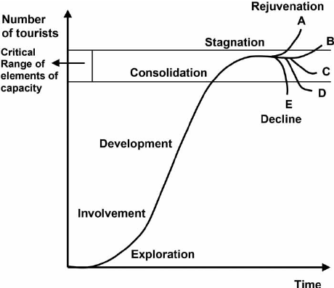
Figure 1 (Butler, 1980)

Tourism development of Maldives based on the TALC model

- Exploration phase
At the beginning of the exploration process in the 1970s, there are no amenities for tourists. After that, locals provide low-quality basic services to tourists using domestic resources, while the state provides basic transportation infrastructure.
- Involvement phase
Poor transportation and a shortage of competent labour were the industry's main obstacles in the beginning. As a result, untrained locals supplied the fundamental services for tourists. Divers from Europe made up the majority of the tourists, who were more interested in the beauty of the ocean floor than the quality of the local cuisine or other amenities. The outcome was that the industry didn't grow until 1976.
- Development phase
The development stage began in the second half of the 1980s, when the establishment of institutions, international learning, and infrastructure investment led to a fast improvement in service quality. In 1983, the government created the Tourism Master Plan and formalised the one-resort, one-island (OROI) idea. In the OROI, only a few uninhabited islands that have been leased expressly for tourist-related activities are now used for the production and consumption of tourism (such as accommodation, dining, and recreation). As a result, lodging for tourists on inhabited islands was outlawed.
- Consolidation phase
The existence of significant transnational chains in a nation is one of the signs of the consolidation phase, according to Butler. The ownership proportion of resort owners in the Maldives is depicted in Figure 2. According to data, 30% of resort operators were foreigners by 2005, and 18% were international and local companies working together in joint ventures. In fact, by 2016, the Maldives was home to at least one property from more than 35 big worldwide companies. (Zuhuree, 2021)

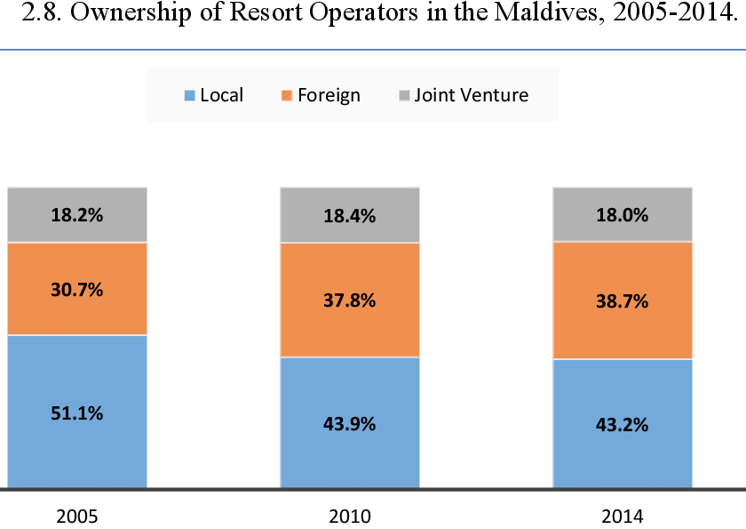
Figure 2 (Zuhuree, 2021)

- Stagnation and rejuvenation phase
Just before the start of COVID-19, tourism was one of the most rapidly expanding industries in the Maldives, with growth rates that surpassed those of the GDP. Small countries that rely heavily on tourism might look at the pandemic as a chance to unlock the potential of their industry and lay the road for sustained growth going forward. Maldives made a deliberate attempt to reopen its border to travellers in July 2020 but developed tight cleanliness measures, including one of the world's fastest COVID-19 vaccine campaigns. In 2020, a promotional campaign was launched with the slogan "Isolation never looked this good," aimed at showcasing the unique status of the location as a specialised destination. The campaign also emphasised the significance of sustainable tourism practises.
Due of widespread need for high-speed internet and contactless services, the government is investing in digital technologies. Goal 10 of the plan also deals with the further development of high-speed fibre internet. In Maldives, over 60% of the population has broadband Internet with reasonably high bandwidth speed, whereas other tourism-dependent South Asian nations are still trailing, restricting the possibility of travellers working remotely. (Mercer-Blackman, 2022)

Sustainable aspects of the 5TMP

In the world that has recovered from the pandemic, there is already a greater emphasis being placed on the health, safety and security of the tourist industry. As a result, the 5TMP formulates 15 goals and sets out an extensive list of strategies to achieve them, that constitute the pertinent pillars of the sustainability needed to improve Maldives' position as a globally competitive tourism destination.

Environmental sustainability

Goal 4

The 4th goal is to maintain the country's reputation as the most sought-after tourist destination in the world by protecting its beaches, sandy shorelines and marine life. The Maldives’ tourist sector is taking initiatives to remove needless single-use plastic goods and is collaborating with stakeholders and island governments to monitor and put into place measures to decrease food waste in order to protect the natural beauty of the Maldives. Furthermore, improve planning guidelines, knowledge sharing and finance access to build climate resilience in tourism infrastructure. It also aims to create another low-cost, internationally supported climate finance fund, like the Green Climate Found (GCF) to support in-need tourist destinations with the implementation of climate adaption strategies. (Ministry of Tourism, 2023)
Maldives islands are extremely vulnerable to severe weather because of their low elevation. Accelerated sea level rise brought on by climate change has a severe impact on the islands and may even put their very survival in risk. These problems will be solved by this project, which will improve coastal management, including coral reefs and natural sandy beaches' defence capacities. This will be accomplished by knowledge exchange, early warning and early response, and integrated coastal zone management. (GCF, 2021)

Goal 5
The objective is to facilitate the swift implementation of established renewable energy technologies and energy storage systems to guarantee uninterrupted access to cost-effective and environmentally-friendly energy for all tourist facilities. (Ministry of Tourism, 2023)
There is a significant opportunity for resorts to implement and expand renewable energy systems, which necessitates accelerated expansion. Solar panels can be installed in resorts. This goal has already been achieved to a large extent, and the pursuit of beauty and aesthetic harmony with the environment has already emerged as a secondary goal. (Kanowsky, 2022)
One of the major air pollution source sector is the transport sector. Existing technologies and inventive designs can facilitate the transition to tourism transport with net-zero emissions. Resorts have utilised electric vehicles for several years. And hybrid and electric speedboats are now available for passenger transportation on the water. (CCAC, 2019)

Goal 6
Although the objectives include increasing environmentally sustainable international transport services, the strategies do not actually include an action plan to implement this. The strategies are more focused on easier navigation between the islands and increasing the comfort and luxury experience of the guests.
The first aim of the Goal 6 is to increase the number of international flights and seats to the Maldives, which goes completely against sustainable environmental protection objectives, since air transport is one of the most polluting forms of human transport. According to the World Travel & Tourism Council, the travel sector is responsible for 8% to 11% of global greenhouse gas emissions, a large portion of which comes from transportation, particularly aircraft. (Ledsom, 2023)

Socio-cultural sustainability:

Doxey's irritation index:

Despite the boom in tourism and all its positive returns, the initial euphoria of the local society can quickly turn into apathy. Later, the invasion of tourists can already irritate the local residents, who harbour hostile feelings towards the newcomers and become hostile towards them. This change, in the feelings of local people in context with the number of tourist, is defined by Doxey's irritation index (Figure 3), which describes the four stages of euphoria, apathy, irritation, and antagonism. (Tourism Teacher, 2023)

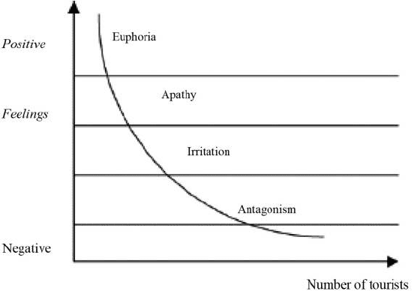
Figure 3 (Tourism Teacher, 2023)

This can easily happen in the Maldives too. Not only because of the ever-increasing number of tourists, but also because of the huge cultural difference between the local, mainly Muslim population and tourists from mainly Western-type societies.
Another important question that arises along the lines of religion is the position of women. However, the position of women in Maldivian culture could influence the country's future tourism development. Certain strict Islamic beliefs prohibit the employment of women. Due to security concerns and a male-dominated work environment, many women choose not to enter the tourism industry. Typically, women earn lower than comparable men. In addition, some families may be concerned about the impact of such intercultural activities that affect their daughters' reputations and well-being. The first goal of the plan deals with this salary difference problem.
(Yue, 2019)

The preservation of the cultural traditions is an important aspect of the plan. The Goal 3 aims to achieve this, for example, by promoting Maldivian cuisine to international visitors, establishing quality and health and safety standards for Maldivian cuisine, financing for projects involving specialty restaurants, cafes, and local delicacies, organising an annual Maldivian food festival, featuring international culinary challenges, and provided training in culinary and plating skills for island-based entrepreneurs. These can be hugely beneficial to locals and the economy. (Ministry of Tourism, 2023)

Economic sustainability

Ideally, the tourism industry incorporate local businesses and provide them with benefits. Therefore, sustainable tourism endeavours to retain a significant amount of the revenue within the region, thereby channelling profits towards indigenous enterprises.
From an economic sustainability perspective, the provision of tourism offerings is aimed at generating long-term benefits for the region, including the creation of numerous employment opportunities, improved infrastructure, and significant contributions to the local economy. Maintaining employment opportunities under equitable remuneration and working conditions is a crucial aspect of economic sustainability. (Jill on Journey, 2023)
Maldives tourism has grown steadily and play a very important role of the local economy. 155 resorts, 13 hotels, 624 guest homes, and 158 safari hotels operated in March 2020 (MMA Statistics Database, 2020). 15 resorts opened in 2019 and 3 more before January 2020. Tourism employs almost 20% of Maldivians. (Sigdel, 2023)

Therefore, the 5tm plan also placed great emphasis on the development of these areas. For example, Goal 7 aims, among other things, to educate local people and expand their career opportunities through training within the sector. Another objective is to enhance revenue generation prospects by means of sustainable procurement and equitable trade endeavours for indigenous communities. This will be achieved by advocating for sustainable local seafood in tourist establishments, endorsing the organic cultivation of locally sourced products, and establishing markets in regional tourism hubs for the procurement of local produce.

Conclusion and recommendations

Evaluating the plan as a whole, we can therefore conclude that it affects sustainability in all its aspects and in almost every case formulates a clear goal and a strategy to be implemented. If these goals are met, Maldivian tourism will become sustainable in the future, the environment will be protected, the interests of local people and their culture will be properly represented and supported, and the economy will soar.

A recommendation can be formulated to eliminate the cultural differences between local residents and tourists. Younger generations are more concerned with protecting the environment and calling for social and environmental justice (Driver, 2023). Therefore, since they will be the traveling public in the near future, they should be given the opportunity to participate in a cross-cultural training when they choose a destination. Since education also went online during covid, a lot of experience was gathered in relation to online training, which could be used to eliminate cultural differences that arise during travel (Koksal, 2020).

Reference

Apacoutlook (2019) ‘Visit Maldives : Inside the tourism industry of Maldives’, 16th September. Available at: https://www.apacoutlookmag.com/industry-insights/article/767-inside-the-tourism-industry-of-maldives (Accessed: 31 May 2023).

Butler, R.W. (1980) The concept of a tourist area cycle of evolution: Implications for management of resources. Canadian Geographer/Le Géographe canadien, 24(1), pp.5-12.

CCAC (2019) Maldives’ first National Action Plan on Air Pollutants highlights local air pollution benefits of climate action. Available at: https://www.ccacoalition.org/en/news/maldives%E2%80%99-first-national-action-plan-air-pollutants-highlights-local-air-pollution-benefits (Accessed: 7 June 2023).

Driver, G. (2023) ‘A Gen-Z Mindset Can Positively Influence An Entire Culture’, Forbes, 17th March. Available at: https://www.forbes.com/sites/forbeshumanresourcescouncil/2023/03/17/a-gen-z-mindset-can-positively-influence-an-entire-culture/?sh=6cd7b861e784 (Accessed: 10 June 2023).

GCF (2021) GCF (2021) FP165 - Building Climate Resilient Safer Islands in the Maldives. Available at: https://www.greenclimate.fund/project/fp165 (Accessed: 4 June 2023).

Jill on Journey (2023) The three pillars of sustainability tourism. Available at: https://jillonjourney.com/the-three-pillars-of-sustainability-in-tourism/ (Accessed: 9 June 2023).

Kanowsky, H. (2022) ‘This Maldives Resort Runs Completely on Solar Power’, One Green Planet [blog]. Available at: https://www.onegreenplanet.org/environment/this-maldives-resort-runs-completely-on-solar-power/ (Accessed: 6 June 2023).

Koksal, I. (2020) ‘The Rise Of Online Learning’, Forbes, 2 May. Available at: https://www.forbes.com/sites/ilkerkoksal/2020/05/02/the-rise-of-online-learning/?sh=2800f94c72f3 (Accessed: 10 June 2023).

Ledsom, A. (2023) ‘22% Jump In Airfares Expected As Airlines Tackle Climate Change’, Forbes, 30th April. Available at: https://www.forbes.com/sites/alexledsom/2023/04/30/22-jump-in-airfares-expected-as-airlines-tackle-climate-change/?sh=e012d976e0d1 (Accessed: 8 June 2023).

Mercer-Blackman, V. (2022) ‘The changing face of tourism and work: How Maldives is successfully adapting to the pandemic’, World Bank [blog]. 26th January. Available at: https://blogs.worldbank.org/endpovertyinsouthasia/changing-face-tourism-and-work-how-maldives-successfully-adapting-pandemic (Accessed: 4 June 2023).

Ministry of Tourism (2019) T O U R I SM Y E A R B O O K 2019. Available at: https://www.tourism.gov.mv/dms/document/f5f522de183dde8f0f012884cecb1706.pdf (Accessed: 1 June 2023).

Ministry of Tourism (2023) MALDIVES FIFTH TOURISM MASTER PLAN 2023–2027 GOALS AND STRATEGIES. Available at: https://www.tourism.gov.mv/dms/document/4969b4831928f1bdf3506340fb6974fc.pdf (Accessed: 1 June 2023).

Shazna, A. (2020) EMPLOYMENT IN RESORTS 2020. Available at: https://statisticsmaldives.gov.mv/nbs/wp-content/uploads/2021/10/ResortEmployeeSurvey2020.pdf (Accessed: 1 June 2023).

Sigdel, B. (2023) ‘Tourism Oriented Economy of the Maldives: Issues and Prospects’, TURKISH CENTER for ASIA PACIFIC STUDIES, 9th January. Available at: http://www.asianpacificcenter.org/maldives-economy.html (Accessed: 10 June 2023).
Stainton, H. (2021) Butler's Tourism Area Lifecycle Model Made SIMPLE [video]. Available at: https://www.youtube.com/watch?v=ce_U7xGkVTk (Accessed: 3 June 2023).

Tourism Teacher (2023) What is Doxey’s Irritation Index and how does it work?. Available at: https://tourismteacher.com/doxeys-irritation-index/ (Accessed: 8 June 2023).

UNWTO (2023) Policy and destination management. Available at: https://www.unwto.org/policy-destination-management#:~:text=Destination%20management%20consists%20of%20the,better%20management%20of%20the%20destination (Accessed: 31 May 2023).

Yue, B. (2019) ‘Culture vs Tourism : The Maldives Lesson’, Gaia Discovery, 4th February. Available at: https://www.gaiadiscovery.com/latest-places/maldives-cultural-balance (Accessed: 9 June 2023).

Zuhuree, I. (2021) EVOLUTION OF TOURISM INDUSTRY IN THE MALDIVES. Available at: http://saruna.mnu.edu.mv/jspui/bitstream/123456789/13650/1/Evolution%20of%20tourism%20industry%20in%20the%20Maldives.pdf (Accessed: 3 June 2023).

