Drafts/plan and ideas to write about
The survival of women through museum art exhibition vs public displays

Feminism, activism and “the Institute”

In and out of the Museum – the too different ways thaty feminist chose to display there work one bing in a meusem where the crowd that are viewing the work are often wealthy were out oof the meusem work is often able to be viewed out in oublic and were every one can vewi them

Feminism- the belief and aim that women should have the same rights and opportunities as men

because this is where Ghada Amer and Gorilla can be positioned in relation to feminism. the belief and aim that women should have the same rights and opportunities as men; the struggle to achieve this aim

Activism - what is and how these artists user it. Amer’s use within the subject matter itself GG’s use of performance and public visibility.

Culture jamming- the taking of normal things specifically adverts and pre established written or iconic things and changing them/ adding things to them that then make them have the complete opposite meaning of what the original advertisement or message once did

Institution – the different type of place and public that shows/displays art work

introduction
The purpose of this essay is to examine the work of key female artists who have critiqued the role of the museum institution as a place to witness the work of female artists.Throughout history there has always been a lack of representation of women in any forms of media but for the longest time especially in art it has been a heavily male dominated world. So, for this essay I wanted to look at how women slowly but surely, I started to represent themselves through art and even how the feminism movement in art started to have a political impact as well as staying in the art world. To show this I wanted to look artist and art movements like The Gorilla Girls, Ghada Amer, Barbara Kruger and many other important women in the art space also withmetion and reference to Judy Chicago. Some artist chose to look at feminism and the feminism art movement through galleries pieces and having it displayed thorough museums were as other artist such as the gorilla girls and Barbara Kruger chose to use culture jamming and public displays/ demonstrations of activism as a means of getting the message of feminism across to the wider public and my aim though this essay is to compare the two ways of art movements

Midsection/content
To start off I wanted to look at the artist Ghada Amer, she is a museum artist that looks at, in her word *1’the ambiguous, transitory nature of the paradox that arises when searching for concrete definitions of east and west, feminine and masculine, art and craft. Through her paintings, sculptures and public garden projects, Amer takes traditional notions of cultural identity, abstraction, and religion fundamentalism and turns them on their heads.’ I’m choosing to focus on her work that looks at femininity and that demonstrate the idea of feminism in her work. Which leads me to looking at two of her works one museum exhibition and another pieces of here work called, Rainbow Lulu (2018 acrylic, embroidery and gel medium on canvas)

*2
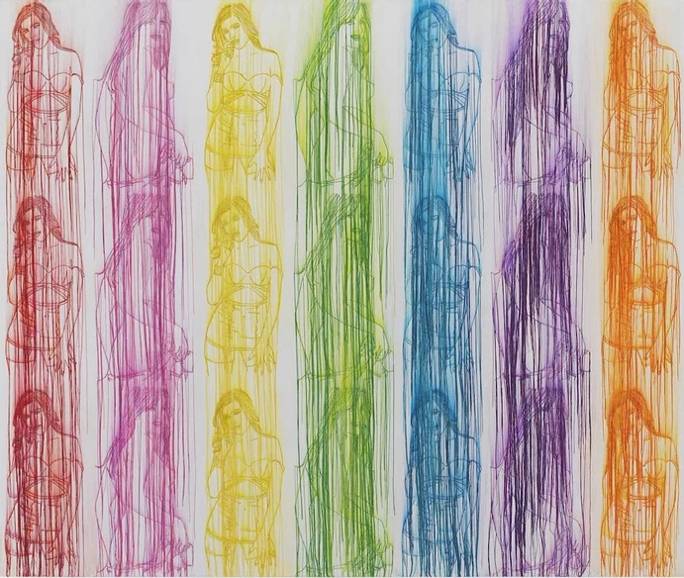

I am going to focus on the work of female artist and feminist Ghada Amer and the Gorilla Girls so that I can compare and contrast the way their work has been publicly displayed.

The work ‘rainbow Lulu’ shows female bodies in several different bodily compositions with several different colours were her main objection of this piece of work is to *3‘reject oppressive laws set in place to govern women’s attitudes towards their bodies. By depicting explicit sexual acts with the delicacy of needles and thread, their significances assumes a tenderness that simple objectification ignores’ and with using the stereotypical medium of embroidery
Conclusion

References/research:
Quote *1 = https://www.ghadaamer.com/paintings
Image *2 = https://www.ghadaamer.com/paintings
Quote *3 = https://www.artemorbida.com/ghada-amer/?lang=en

Gorilla Girls Outside of the institute

Judy Chicago,(she sets the precedent for other future woman artsits to have a voice and is more associated with second wave feminism – you could mention this but might be too big a topic for this essay).

I am going to focus on the work of female artist and feminist Ghada Amer and the Gorilla Girls so that I can compare and contrast the way their work has been publicly displayed.

