  ESSAY  Covid19 UK | Lecturer: Vasilios Tavlaridis  Management Economics LCBB5003_BIRM

Table of Contents
Introduction 2
Main body 2
Effects of Covid 19 on pricing in the UK……………………………………………………. 3
Covid 19 effects on employment……………………………………………………………. 4
Covid 19 effects on cost of living…………………………………………………………… 7
Covid 19 effects on inflation UK…………………………………………………………… . 7
Recommendations…………………………………………………………………………………....8
Conclusion 8
References 9

Introduction
The impact of Covid 19 is being experienced globally and the UK is not an exception. It is over a year since the lockdown was imposed in the UK. With the precedent in the lockdown, the economy experienced unprecedented changes, which made the policymakers battle with the mitigation of the economic impact of Covid 19. According to Office for National Statistics (2021), the UK’s gross domestic product fell by 20% and then rose partially over the summer. Although there was a partial rise in the GDP in summer, the economy was affected by the constant high level of Covid 19 in 2021, which led to the government imposing a countrywide lockdown. Before the effects of the pandemic prevailed, the economy was 7.8% lower in February 2020, and in October 2020, it was below the recovery peak (3.1%) as compared to the previous months, despite the recovery measures put in place (Office for National Statistics, 2021). In addition, in January 2021, the UK left its largest trading and investment partner, the European Union. This made the stark in the volumes of goods trade. There was a fall of 19.3% of the total goods exported, which was driven by a 40% export fall with the European Union (De Lyon and Dhingra, 2021). Consequently, imports were affected as the UK suffered a 21.6% fall in imports (Office for National Statistics, 2021). The decline in trade for both the exports and imports can be argued that they were caused partly by the prevalence of Covid 19. Moreover, Covid 19 greatly affected the pricing, the UK employment, which even resulted in the cost of living being high. This report discusses in depth the effects of covid 19 on price, employment, and cost of living in the UK economy.

Effects of Covid 19 on pricing in the UK

Firms use their unit costs in determining their pricing decisions. Moreover, it provides useful information on the inflationary pressure in the economy. Factors such as Covid 19 Job Retention Scheme did add volatility to wage and productivity data, which led to the interpretation of some measurements of the unit cost being difficult. (Bank of England, 2021). Moreover, Davies (2021) reported that the price volatility is currently high since 1991 in addition to the increasing price levels. Since there was a fall in trade in 2020, the UK experienced a fall in sales by 6%. By considering the role played by fixed costs (rent and loan repayment) which largely remain unchanged, the unit costs rose by 5% (Bank of England, 2021). Over a similar period, a survey conducted by the Bank of England showed that the unit costs in the UK increased by a staggering 6% due to the Covid 19 prevalence and the rise in the unit costs might have affected the pricing decisions of firms in the UK. For example, while analysing the Decision Maker Panel (DMP) Survey, the Bank of England (2021) suggested that the increase in the unit costs did exert upward pressure on prices, and for the companies to maintain profitability index, they had to pass through higher cost pressure. Moreover, as the demand decreased, the companies had to lower their prices due to the reduced demand exerting downward pressure on their prices. Lowering prices hence encouraged the purchase of the company’s goods and services.
In discussing the increase in pricing, firms that increased their pricing experienced upward pressure on the unit costs of their production and had less cash on their balance sheets before the Covid 19. They increased their pricing since they may have been less able to absorb the rising average costs of production (Office for National Statistics, 2021). On contrary, the service providers experienced less unit costs as the impact of the higher unit costs were only higher for the manufacturing sector. Between February and December 2020, the inflation of core goods CPI increased by 0.8% as compared to a 0.6%-point fall in CPI inflation of core services in the same period.
Government of United Kingdom has played a crucial role in minimising the impact of crisis over the economy of UK. For instance, government authorities of UK were contributing consistent and maximum efforts towards managing the crisis in the most effective manner in order to provide relief to people residing in UK as well as other economic nations. The primary and major efforts initiated by government of respective nation were inclusive of reduction in tax rates, introduction of additional subsidies, relief in paying dues and loans, regulating wages of employees and labour, etc (Eikhof,2020). All these positive initiatives were aimed at effective crisis management with consideration of all the factors as well as aspects associated with the same. In addition to that, people in society as well as business organisation were provided with a relief of reduction in tax rates in order to provide support to them in the phase of pandemic due to COVID-19.
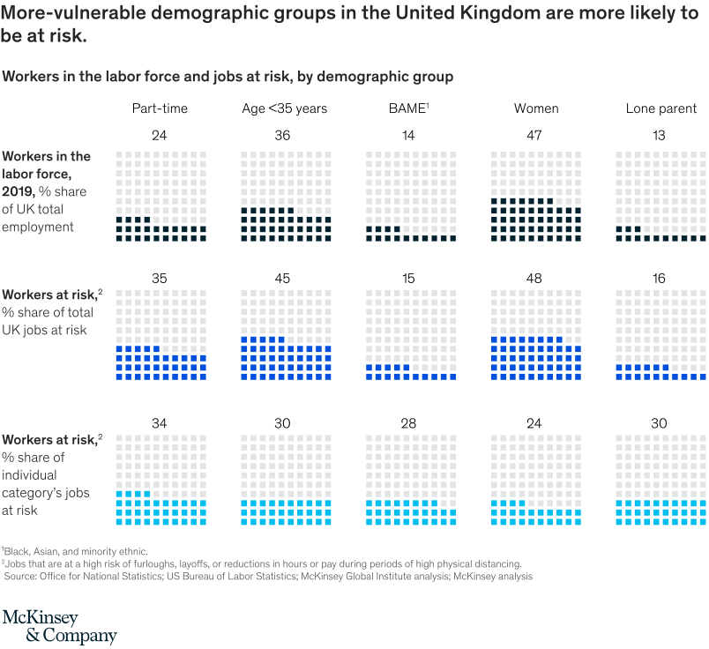

Covid 19 effects on Employment
In March, the UK government imposed a countrywide lockdown and this meant that people could not go to work. Only the service providers such as those providing electricity and food were allowed to continue working. The lockdown disrupted business operations hence this meant that many employees could not go to work, and customers could not buy the firm's products or services (Fana, Torrejón Pérez and Fernández-Macías, 2020). Businesses were affected and they had to let their employees go since they could not run their businesses without any income. As a result, several people lost their employment. The effect was adversely experienced in restaurants, theatres and construction companies.
In construction companies, it initially remained operational when social distancing was introduced but was halted when this social distancing among the subcontractors was breached. Moreover, in April 2020, Scotland halted all non-essential constructions and by the 17th same month, about 2434 UKs sites had halted their operations. According to data provided by Office for National Statistics (2021), about over 80% of UK construction companies had either furloughed their employees or laid them off.
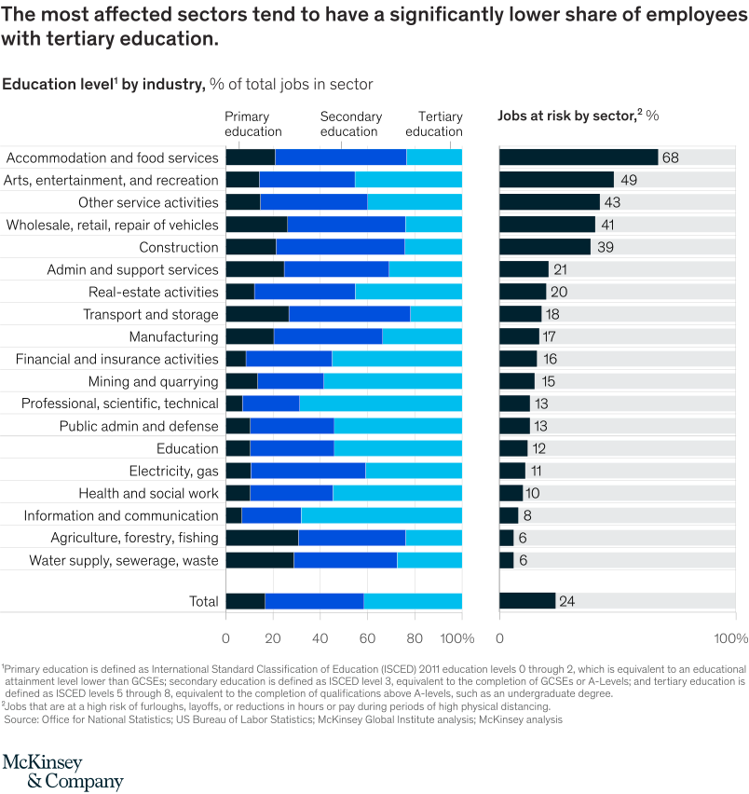
Furthermore, the effects on employment across sectors are highly uneven. The furlough statistics show how the different sectors fared. For instance, in accommodation and food services, they experienced 73% and 46% of employees in construction companies were furloughed (Resolution Foundation, 2021). The same fate was experienced in water utilities, information, and communication who had 14% and 13% respectively. The pandemic rarely affected the education sector although colleges, schools, and universities had closed as those who are employed in this sector continued receiving their dues.
Jobs at risk included those working in retail and wholesale sectors, which comprised about 1.7 million jobs. Moreover, the second hit category was the accommodation and food service sector, which had 1.2 million jobs at risk. Businesses were conducted online, which saw several employees working from home whereas some had their contracts terminated. In the UK, prior to the pandemic, retail services were conducted online but this accelerated when the crisis occurred. Therefore, despite the retail and wholesale sector being a large employment sector in the UK, the job risk was high. The reason behind it being at job risk is due to the factors such as physical proximity, which made the business not continue (De Lyon and Pessoa, 2021). Moreover, it is not possible to work remotely in all occupations since the working environment is fixed, or needs specialists. Consequently, not all employers can provide the required items to the employees working remotely, for example, providing IT equipment (Allas, Canal and Hunt, 2020). Furthermore, due to the change in customer demands, firms experienced a decline in customer demand, which led to a decrease in business revenues. Therefore, for the companies to continue paying their staff they needed a stable income flow, which was unattainable (Allas, Canal and Hunt, 2020). Many manufacturing companies were then affected with exception of groceries and at-home entertainment.
The pandemic also made the most vulnerable workers be at risk. Jobs are classified as vulnerable when the median gross hourly pay is below £10 (Major, Eyles and Machin, 2020). Moreover, jobs at risk correlate with education and about 50% of workers who had jobs in hospitality, retail and construction did not qualify for a Certificate of Secondary Education. The part-time workers were also greatly affected by Covid 19 in their employment status. In the UK, about 45% of part-time workers are younger people below 35 years of age. Young women are the most affected category as they mostly represent trade-in sales and retail assistants, receptionists, waiters and cleaners. Overall, women were highly vulnerable to losing their jobs compared to men as the pandemic affected the hospitality and retail sectors. In addition, the non-white employees were greatly affected by the pandemic as their work environment had related furloughs and layoffs. In the UK, the non-whites share a workforce of about 14%, and with the pandemic, they filled around 15% of the jobs at risk (Lambert and Van Reenen, 2021). Furthermore, the lowest-income areas in the UK faced the greatest challenge during the Covid 19 and much has to be done to correct the furloughs and layoffs. For example, once the restrictions are lifted, organisations should quickly return to operations.
National income of UK has been affected by pandemic phase of coronavirus spread in economy. For instance, inability of businesses in paying salaries and wages to their employees has resulted in loss of job or employment opportunities by individuals. Almost each and every business organisation has taken this step of dismissal of employees due to huge losses incurred in the phase of COVID-19. On the other hand, issues of getting lower salaries and wages has been experienced by many individuals engaged in a business organisation. In addition to that, the deduction in salaries was either promised to be paid with future salary or not to be paid according to policies of that particular business organisation (Lim, and To, 2021). This issue further resulted in increasing rate of unemployment in the economy of United Kingdom due to loss as well as lack of job.
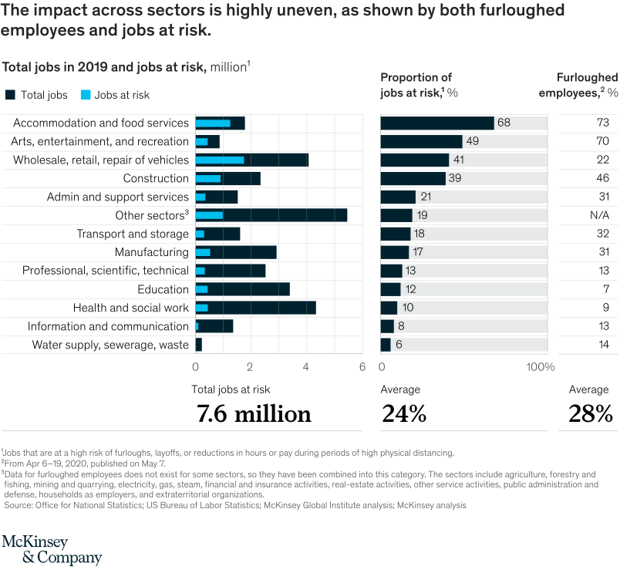

Effects of Covid 19 on the cost of living in the UK and inflation
The pandemic is mounting pressure on the UK government as it is trying to tackle the worsening living costs, which are under crisis. Inflation is high with a record of increasing household energy bills. The bank of England did a project that the living cost will continue rising, with an increase of about 6% by April 2022 (The Guardian, 2022). The inflation is because of the change in demand for products after the lockdown. Prices fell sharply, and during the pandemic, the supply chain was disrupted, which hindered factory production.
The current inflation is the highest in three decades, and it is affecting all areas of the UK. The poor households are affected the most as they find it harder to cope with similar rates of inflation (The Guardian, 2020). For example, essentials such as food, which forms a larger proportion of their daily expenditure have become so high making it difficult for them to purchase. Averagely, poor households spend almost twice on food and house bills as compared to the past.
In addition, prices of fuel have gone high. The high prices of petrol and diesel have added more on costs as they have hit the highest level on record in UK’s history. These prices are due to the sharp rise in global oil prices after the lockdown (The Guardian, 2022). The pandemic resulted in an increase in gas prices, which have soared in the recent months after lockdown, cold weather that drained reserves and lower levels of wind, which affected renewable energy production. The gas and electricity supplier in the UK is experiencing it hard due to the surge in electricity. According to The Guardian (2022), there is an expectation that households will pay 50% more for their gas and electricity by April, which is a £600 increase on average of their annual utility bill.
With the Covid 19 prevalence, it is projected that the rise in tax and energy prices increases will squeeze budgets. Most poor households in the UK are spending most of their income on energy and they are likely to be hit hard by the increase in energy bills. Their energy spending is likely to increase from 8.5% to 12% of their budget, which is thrice what is projected from the rich. Although the increases will affect both the rich and the poor, the latter situation will be affected the most (The Guardian, 2020).
Wage growth is not left out with the prevalence of the pandemic. The real wages suffered in the UK because of the changing prices. As reported by Office for National Statistics (2020) due to the Global Financial Crisis in 2008, the real wage fell sharply and never returned to pre-crisis until 2019. With the pandemic leading to the closure of businesses, the nominal wage growth reduced sharply. Before the Covid 19, the nominal wage growth was about 3.1%, as compared with 0.9% a year later. The change in wage growth as reported by Office for National Statistics (2021) is due to the unemployment rate since low wage workers were likely to become unemployed.

Recommendations
The pandemic affected mostly the vulnerable people who lost their jobs. Most businesses were closed and the government has to develop other strategies to correct the pandemic mess. Therefore, the UK government should prioritise strategies that channel support to the vulnerable segment of its population. As it waits for the furloughs and job losses information, the government should develop mechanisms that will help the vulnerable population, such as the lowest-income regions. Moreover, the government needs to initiate retraining and reskilling unemployed people, before people get back to their productive work. Training adults before resuming their work is important during the Covid 19 period since it will aid in producing high returns on investment. Businesses, need to plan and anticipate the recovery shape and prepare for the new normal.

Conclusion
The prevalence of Covid 19 affected the UK economy in its early stages. The economy drastically dropped due to the countrywide lockdown, most people lost their jobs, but this affected most of the hospitality, construction, retail and wholesale, and entertainment sector. A drop in employment consequently shows the hardship the UK citizens went through. The cost of living increased, pricing of commodities also went high due to the increase in the unit cost of production, which led to the upward pressure on prices. Manufacturing sectors were forced to increase their commodity prices but were later forced to reduce their prices due to the change in demand of customers. High taxes after the lockdown are also eminent as the government is trying to correct the pandemic mess. Although the economy was affected, the UK government should initiate strategies that will help in restoring the economy. For example, prioritising the initiatives that will help the vulnerable people who are at risk of losing their jobs

References
Allas, T., Canal, M. and Hunt, V. (2020). Covid-19 in the United Kingdom: Assessing jobs at risk and the impact on people and places. McKinsey and Company Article, 11.
Bank of England. (2021). How has Covid affected Firms' Costs and Prices? [online] Available at <https://www.bankofengland.co.uk/bank-overground/2021/how-has-covid-affected-firms-costs-and-prices> [Accessed 31 March 2022].
Davies, R. (2021). Prices and inflation in the UK-A new dataset (No. 55). Centre for Economic Performance, LSE.
De Lyon, J. and Dhingra, S. (2021). The impacts of Covid-19 and Brexit on the UK economy: early evidence in 2021. London: Centre for Economic Performance, London School of Economics and Political Science.
De Lyon, J. and Pessoa, J.P. (2021). Worker and firm responses to trade shocks: The UK-China case. European Economic Review, 133, p.103678.
Fana, M., Torrejón Pérez, S. and Fernández-Macías, E. (2020). Employment impact of Covid-19 crisis: from short term effects to long terms prospects. Journal of Industrial and Business Economics, 47(3), pp.391-410.
Lambert, P. and Van Reenen, J. (2021). A Major Wave of UK Business Closures by April 2021?: The Scale of the Problem and what Can be Done. Centre for Economic Performance, London School of Economics and Political Science.
Major, L.E., Eyles, A. and Machin, S. (2020). Generation COVID: Emerging Work and Education Inequalities. A CEP COVID-19 Analysis. Paper No. 011. Centre for Economic Performance.
Office for National Statistics. (2022). GDP monthly estimate, UK: February 2021 – Office. [online] Available at: < https://www.ons.gov.uk/releases/gdpmonthlyestimateukfebruary2021> [Accesesed 31 March 2022].

