A comparison of the marketing methods of two multinational hotel brands
Sheraton & Premier Inn

Emilia Ramona Sipos
Student id 2211874
Marketing Essentials: BMIH1005
Ruth Taylor Davies
04.11.2022

This essay purpose is to show a comparison between Sheraton and Premier Inn hotel from their approaching to marketing methods and strategies perspective.
Sheraton was chosen as Sheraton Hotels and Resorts is a successful brand therefore the potential to illustrate a worth following marketing approach upon research being done is increased. Premier Inn was chosen as it is a brand that had increased its image therefore their marketing approach would be interesting to be researched further. Firstly, Sheraton is an international luxury brand that is actually owned by Marriott (Marriott International, 2022) with 463 locations (Sheraton official website, 2022). Secondly, Premier Inn is a British hotel chain that differentiates itself from Sheraton from prices perspective, meaning that it is not a luxurious brand, furthermore it practices premium quality at economy prices (Premier Inn official website, 2022).
Marketing in its entire is based on attracting more customers by offering them a superior value meanwhile keeping already existing customers by offering them value and satisfaction. The key words that describe what marketing means are satisfying customer needs, which leads to different marketing strategies, and then to a market position. (Kotler, 2019, p.5-6) The analysis of past years demonstrates that beginning with 1949 Sheraton expanded internationally by purchasing existing hotels from around the globe from countries such as Canada, United States, North America, Israel, Jamaica, France, Australia implementing (History of Sheraton Corporation, 2022). Therefore, the marketing strategy was based on expanding total demand whilst specialising in serving market niches being a semi-luxury brand. Niching is profitable because the target customer group is known extremely well by the market nicher, Sheraton in this case. (Kotler, 2019, p.567)
Premier Inn was founded by Whitbread in 1987, its initial name was “Premier Travel Inn”, then in 2004 that name was shortened to Premier Inn. At the moment it is UK’s largest budget hotel brand, having a number of 800 hotels. (The Telegraph, 2004). The main difference between the two hotels extracted just by looking at their history is their positioning, Sheraton being a semi-luxury brand and niche targeting and Premier Inn being a budget brand with a subjective positioning tangible-dominant because they promote a tangible service, they guarantee a good sleep.
Blythe describes segmentation such as:
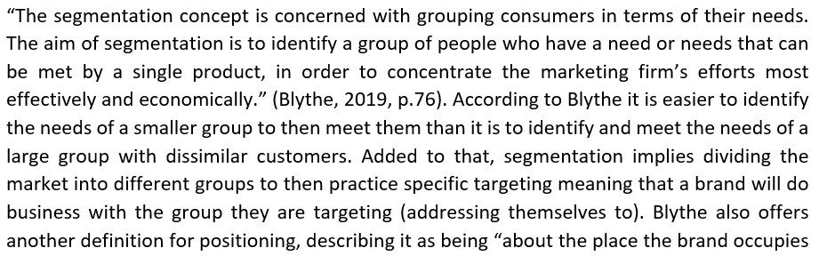

Market segmentation applied to hospitality industry involves categorizing types of guests a certain hotel receives by dividing them depending on characteristics such as their age, channel used to make the booking, or their sensitivity to pricing. Demographic segmentation in hospitality industry refers to targeting prospects based on their income or age. (Watson, Market segmentation in the hospitality, 2021).
A good market segment can be defined as a group in which its members are similar and have common aspects meanwhile these consumers are going to be different from consumers that are in other market segment. (The Business Professor website, Gordon, 2021). Applying this to Sheraton example it can be said that they have successfully identified their market segment in guests that seek semi-luxury services. On the other side Premier Inn had applied the same segmentation only that it targets guests that seek budget services. Sheraton based its marketing strategy in their mission, which is to be customers favourite brand by providing excellent customer service and their target market is middle to upper class. Sheraton marketing strategy always implies consumer and market research by delivering marketing campaigns based on consumers behaviour and by effectively using their feedback. Sheraton makes use of mass marketing, and this intensive distribution strategy allows this brand to maximise its coverage in the hospitality market. In its customer focused strategy, Sheraton goal is to fulfil guest’s functional needs alongside their emotional needs, aiming to build a strong emotional bond with the guests which later on results in consumer loyalty. Premier Inn strategy, as described on Whitbread official website is the vertically integrated model, meaning that the brand delivers consistent superior customer experience and value for the money meanwhile creating value for its stakeholders. Premier Inn operating model places it on first place, being UK’s strongest hotel brand. The key components of the model are “low-cost customer acquisition and retention, high quality experience, consistent execution, no brand fees, standardised model and rooms, first choice for more travellers”. (Whitbread official website, 2022). It can be concluded that both brands have in common their customer orientated marketing approach, although they differentiate by their target, one being orientated toward luxury and the other toward budget.
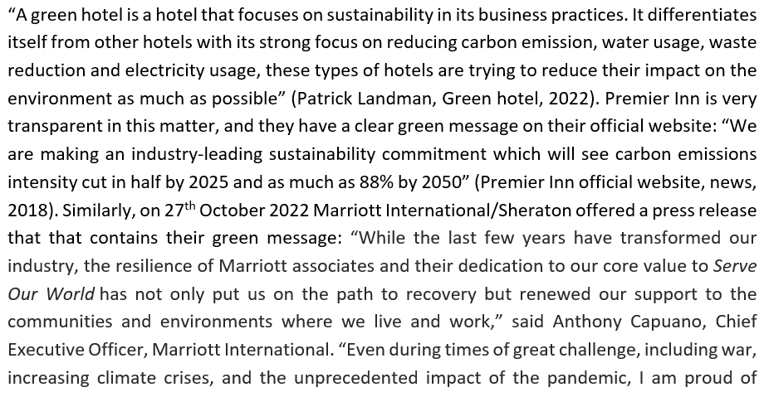
Marriott’s continued dedication to its sustainability and social impact journey and commitment to our many stakeholders.” (Marriott official website, news, 2022). Marriott, including Sheraton had made public the fact that the brand is committed to reach zero greenhouse gas emission by 2050.
Premier Inn emphasized their customer orientated strategy during Covid-19 pandemic by implementing flexible rates so that their consumers could amend or cancel their hotel stay alongside with offering full refund if. The brand also raised its transparency and honesty towards customers: “As ever, caring for our guests and team members is our top priority. It’s one of the main reasons that check-in is from 3pm, just to give teams enough time to clean our rooms to the highest Premier Inn Clean Protect standards. Also, to keep up our hotels running as smoothly and safely as possible, we’re continuing to follow all relevant Covid-19 measures too. Additionally, due to a high volume of messages, there might be a delay in hearing back from our customer support team- just know that we’re working hard as possible to respond as quickly and helpfully as we can. With all this in mind, we just wanted to ne honest with you about where we’re at and thank you for being patient with us. We won’t rest easy until you can.” (Premier Inn, 2022). The most recent update in regards with Covid-19 was released by Marriott International/Sheraton on 10 October 2022 and stated the following: “We are closely monitoring the Centres for Disease Control and Prevention and World Health Organisation’s statements regarding the novel Coronavirus cases and following guidelines from these agencies and the local health departments. The wellbeing of our guests and associates is of paramount importance.” (Marriott, 2022). However, unlike Premier Inn, they have added to their marketing strategy an app that allows guests to reduce contact from check-in to check-out.
A potential marketing development or enhancement would be for Premier Inn the idea of offering its consumers the option to have their stay sorted out through an app, following Sheraton’s example. And for Sheraton, on the other side, they could consider improving their transparency with their audience, following the model of Premier Inn.
Both Sheraton and Premier Inn are strong brands, that developed strategies that place the customer at the core, so they are very similar in their mission which is in both cases to deliver excellent customer experience. Sheraton and Premier Inn have demonstrated that customer attraction and retention is the key in order to be a successful brand. Both brands applied marketing strategies that place the customer at the centre. What differentiates these two brands is their targeting, first one targeting semi luxury segment, second one budget segment. Another difference is that Premier Inn is very honest and transparent at the same time with its guests whilst Sheraton don’t have the same transparency judging by both hotels’ official websites at the ‘news’ section. However, both brands have demonstrated that a good marketing will bring with it success and high profits.

Reference list
Blythe, J., & Martin, J (2019) Essentials of Marketing, Pearson Education, Limited, Harlow.
Green hotel definition, Patrick Landman, 2022. Available at https://www.xotels.com/en/glossary/green-hotel#:~:text=A%20green%20hotel%20is%20a%20hotel%20that%20focusses,impact%20on%20the%20environment%20as%20much%20as%20possible. (Accessed: 31 October 2022).
History of Sheraton Corporation (2022) ITT Sheraton Corporation. Available at https://www.referenceforbusiness.com/history2/21/ITT-SHERATON-CORPORATION.html (Accessed: 31 October 2022)
Jason Gordon, Market segmentation- explained, 28 September 2021. Available at https://thebusinessprofessor.com/en_US/principles-of-marketing/market-segmentation-definition (Accessed: 31 October 2022).
Kotler, P., Armstrong, G., and Oprenisk, M. O. (2018) Principles of Marketing (17th Edition) London; Pearson.
Kotler, P., Armstrong, G., Harris, L.C., He, H. (2019) Principles of Marketing, (9th Edition) Pearson Education Limited, Harlow, United Kingdom.
Marriott International (2022) Marriott Premium Brands. Available at https://www.hotel-development.marriott.com/brands/premium-brands (Accessed: 27 November 2022)
Marriott official website, Covid 19, 2022. Available at https://clean.marriott.com/#commitment (Accessed: 31 October 2022)
Marriott official website, News, 2022. Available at https://news.marriott.com/news/2022/10/27/marriott-international-publishes-latest-report-on-environmental-social-and-governance-progress (Accessed: 31 October 2022)
Premier Inn official website (2022) About Us/International Development. Available at https://www.premierinn.com/gb/en/business/international-development.html (Accessed: 28 November 2022)
Premier Inn official website, Coronavirus update, 2022. Available at https://www.premierinn.com/gb/en/covid-19.html (Accessed: 31 October 2022)
Premier Inn official website, News, 2018. Available at https://www.premierinn.com/gb/en/news/2018/world-earth- day.html#:~:text=22%2F04%2F2018%20%7C%20Our%20Earth%20Day%20commitment%20to%20cut,reduce%2C%20reuse%20and%20recycle%20the%20resources%20we%20use. (Accessed: 31 October 2022)
Sheraton official website (2022) Sheraton locations. Available at https://sheraton.marriott.com/destinations/ (Accessed: 27 November 2022)
The Telegraph (2004) Whitbread wins Premier title, by Alistair Osbourne. Available at https://www.telegraph.co.uk/finance/2890905/Whitbread-wins-Premier-title.html (Accessed: 31October 2022 )
Tim Watson, Market segmentation in the hospitality industry, 9 November 2021. Available at https://winpos.uk/market-segmentation-in-the-hospitality-industry/#:~:text=Market%20segmentation%20in%20the%20hospitality%20industry%20involves%20subdividing,booking%20channel%2C%20price%20sensitivity%2C%20booking%20lead%20time%2C%20etc. (Accessed: 31 October 2022)
Whitbread official website, About us. Available at https://www.whitbread.co.uk/about-us/our-business-model/ (Accessed:
31 October 2022)

