INTRODUCTION
A company that intends to invest in a foreign country and expand its market, must consider several factors before making a choice. Firstly, the company must analyse the new market and its characteristics, then the competitors and their potential, the legislative and political environment, the stability of the government and of currency, and lastly evaluate the cultural and social factors that might have an impact on the company, such as consumer behaviour and the type of labour force (Griffin & Pustay, 2015).
This report aims to analyse the international business strategies and practices used by the Harley-Davidson company in the Australian target market. Critically evaluate the main features which contribute to the international business environment and its main institutions, evaluate the modes of entry, and management strategies in a foreign country; and apply models, techniques, and theoretical frameworks in the company’s strategic management. It will analyse Harley-Davidson’s external and internal industry environment using tools like PESTEL analysis and Porter’s Five Forces, Global Value chain analysis and SWOT analysis. The first part will analyse Harley-Davidson’s company history, the financial situation in the last 5 years, the workforce, and its products and markets. The mission of the company and the strategic objectives will be assessed. In the second part, it will be analysed the framework Hofstede for home and host country for a good assessment of social and cultural factors; the Pestel framework for assessing political, economic social technological, environmental and legal factors influencing the business and Porter’s five forces to evaluate the competitiveness of the business, both help to evaluate the external environment. Then it will be analysed Porter’s national diamond and Australia’s business risk. In the third part will the global value chain model, SWOT analysis, international strategies, entry modes, and Corporate social responsibility will help to have a better understanding of company’s internal factors. At least conclusion and recommendations.

COMPANY BACKGROUND
Harley-Davidson is a company that has been producing motorcycles since 1903, with its headquarters in Milwaukee, Wisconsin, U.S.A. The founders, William Harley and Arthur Davidson transformed their passion for cycling into an innovative product that has become a status symbol for decades. They had the idea of applying an engine to a bicycle to reach the lake faster and enjoy fishing for a longer time, so they started experimenting in the backyard of their house with the prototype of a future motorcycle ( Harley-Davidson, 2005). Over the decades, the company has alternated highly successful moments of sales and expansion in the global market with moments of crisis and division. During the last 5 years, the company’s financial situation has remained almost unchanged, with revenue values around 5/6B$ (2017y. $5,647B, 2018y. $5,717, 2019y. $5,362, 2020y. $4,054) (Harley-Davidson, 2021) but during the pandemic period, there was a that brought revenue to the $ 4,054B. The revenue of the company is 4,540,240 $ at the end of 2021 with an increase of 31.62% compared to 2020 and operating income was $0.823B for 2021, an 8407.48% Increase from 2020 (Harley Davidson Inc, 2022). Following the pandemic crisis, the Company has planned a Hardwire Strategic Growth Plan for the five years 2021-2025 which aims for long-term profitable growth and shareholder value, intending to improve its position as the most desirable motorcycle brand in the world. A plan that also aims to improve the performance of its products, improve the electric motorcycle, enhance the human resources that work for the company, to further retain consumers and expand its market(Zeitz, 2021). Today the company has 1400 independently dealerships in 100 countries, 5.879 employees worldwide, and a Harley-Davidson Museum in Milwaukee (Harley-Davidson, 2021).

THE COMPANY MISSION AND STRATEGIC OBJECTIVES
The company's mission is to continue building motorcycles, so that customers may experience the adventure and the sense of freedom by riding one. To maintain the Harley Davidson myth while enhancing their traditional way to create performing and unique designed motorcycles through the application of innovative materials and techniques that improve the performance of products (Harley-Davidson, 2021).
The company has set a five-year, 2021- 2025, growth strategy based on enhancing the brand's perception of lifestyle, maximizing the segments in which the company is the global leader. This strategic plan is called The Hardwire and the ambition is to enhance the company as the most desirable motorcycle brand in the world (Zeitz, 2021). Below are the objectives of the company in more detail.
PROFIT FOCUS: the company will invest resources and energy in enhancing those segments that have always been driving higher profits such as Touring, Trike and Large Cruiser models. The company wants to inspire loyal customers to upgrade to exciting new products and offer a new bike that provides innovation and originality or a reliable used motorcycle (Zeitz, 2021). The enhancement will aim to attract new customers by providing more advanced and reliable products (Harley-Davidson, 2021).
SELECTIVE EXPANSION AND REDEFINITION: the company will invest in the most profitable segments such as Adventure Touring and middleweight Cruiser. Invest in attractive and profitable segments that deliver a balanced combination of volume, margin and potential that are well aligned with its product and brand capabilities. A clear path to leadership, such as the new product Pan America, which since realise, in September 2021, became the top-selling touring machine in the United States, ran out of all models (Zeitz, 2021). Harley-Davidson renews the focus on craftsmanship and manufacturing as well as great responsiveness to the customization and choice that matters with riders of H-D bikes. The company intends to redefine the global markets of reference by targeting countries such as the United States, Germany, Austria and Switzerland, Italy, the United Kingdom, Japan, Australia, New Zealand, China, France, and Canada (Harley-Davidson, 2021).
LEAD IN ELECTRIC: the company has decided to invest in innovation and respect for the environment, producing electric motorcycles with zero environmental impact. Moreover, the company aims to be a leader in the field and thanks to the creation of LiveWire (the first model of an all-electric motorcycle), is considered one of the best electric motorcycles in the world. The mission is to combine the innovation of electric motorcycles with the attractive design that is distinctive of Harley Davidson (Harley-Davidson, 2021). The company has a team dedicated to developing the most desirable electric motorcycle in the world (Zeitz, 2021).
GROWTH BEYOND BIKES: Harley-Davidson not only produces motorcycles, but also lots of complementary goods, including men's and women's leathers, riding gear and sportswear, accessories for motorcycle maintenance, and replacement motorcycle components (Harley-Davidson, 2021)
CUSTOMER EXPERIENCE: Harley-Davidson is always customer-focused: the customer is the core of the brand business and the target for investments of the company. It is an inclusive customer focus vision: every customer is welcome: loyal customers, occasional customers, customers who buy a new or used bike, or simply lovers of the lifestyle that H-R (Harley-Davidson) represents, that is, a life of freedom and adventure (Zeitz, 2021). The existing customers are a huge resource and very important for the company's profitability because of regular customers, so the plan HardWire works to strengthen and maintain its relationship with them (Zeitz, 2021).
INCLUSIVE STAKEHOLDER MANAGEMENT: The company aims to take care of all those involved in its activities as customers, suppliers, employees, investors, and dealers (stakeholders). This link with stakeholders goes beyond the financial and profit aspect, but it refers to ‘taking care as the vision and basic idea of the company (Harley-Davidson, 2021).

COUNTRIES’ SPECIFICATIONS: U.S. and Australia
When a company decides to invest in a foreign country, there are always reasons that go beyond the presence of a thriving market for the company. So, Harley Davidson has opted to invest in the Australian market not only because the market has historically had higher sales and a large client base, but also for economic, political, and cultural reasons. To have a better understanding and deeply analyse these reasons, we can use various frameworks.
HOFSTEDE’S MODEL APPLIED TO U.S.A. AND AUSTRALIA
Hofstede’s model can help to analyse the cultural scenario. Hofstede’s model is the result of the studies and research of Geert Hofstede, a Dutch psychologist among the pioneers of cultural studies in the management and impact of national culture on business practices. Hofstede identified the key features to studying the cultural dynamics of a country (Rugman & Collinson, 2012) : the distance of power, masculinity, long-term orientation, individualism, uncertainty avoidance, and indulgence.
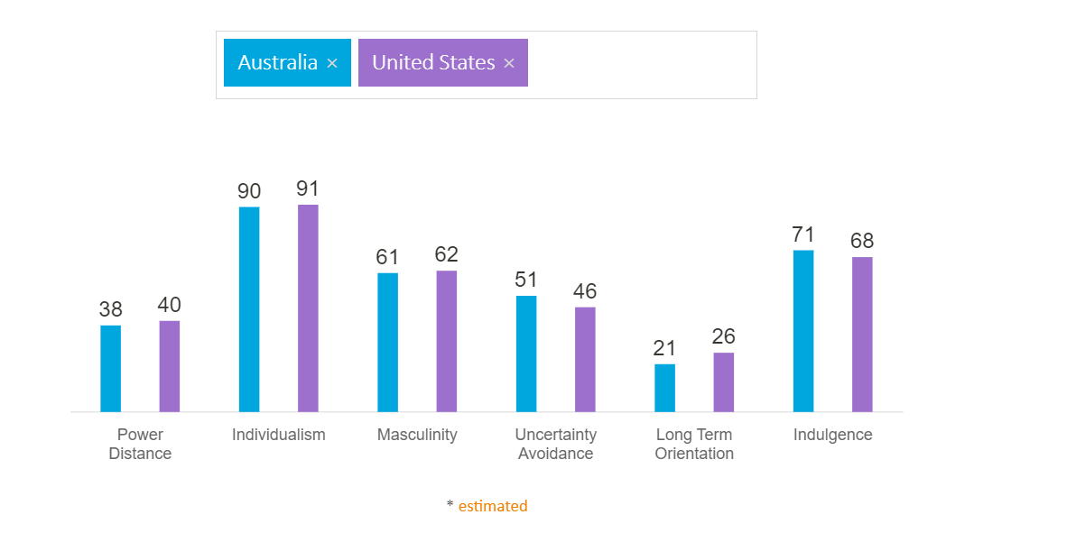
SOURCE: (Hofstede insights, 2022)
The comparison between the home and host country is very interesting because they have nearly the same results, and the figures are very similar. Both countries have societies with similar values and traditions, and so their markets. A good market in which to invest for Harley Davidson.
The power distance records a value between 40(U.S.) and 38 (Australia), so quite in the middle. This means they are inclined to a centralized and decentralized type of government but tend to prefer a decentralized one.
The value of Individualism is 90 and 91, a very high value. U.S. and Australia are the most individualist countries in the world. Individualists watch over their own needs, value personal success and make their interests to prevail.
The masculinity value is 61 and 62. Masculinity represents the society’s inclination toward obtaining results, assertiveness and material rewards derived from success: this society, in general, is more competitive.
The uncertainty avoidance value is 46 and 51. A country with a low score in this index shows entrepreneurial people, people who are more prone to take risks.
Long-term orientation value is 21 and 26. A low score for both nations indicates that they have societies that prefer to maintain traditions and norms honoured by time, while they look at social change with suspicion. The United States also has a highly rigid view of social ethics and religion (Hofstede insights, 2022).
The indulgence value is 71 and 68. Countries with a high score in Indulgence show the willingness to enjoy life, satisfy their own needs, to spend good free time. Generally, they have a positive attitude and optimism (Hofstede insights, 2022)
EXTERNAL ANALYSIS
PESTEL ANALYSIS
UNITED STATES OF AMERICA |  |  |  | AUSTRALIA
POSITIVE |  | NEGATIVE |  | POSITIVE | NEGATIVE
P  O  L  I  T  I  C  A  L | - Strong presidential democratic political system  - A fair and transparent electoral process and policy (MarketLine, 2022).  - New progressive policies (MarketLine, 2022).  - Significant political and economic power over both domestic and international policymaking. | - The rising intensity of tension with Iran (MarketLine, 2022).  - Hostile and difficult relationship with Russia after the Ukraine-Russia conflict (MarketLine, 2022).  - The increase in terrorist attacks and violent crimes (MarketLine, 2022). |  | - Strong and stable democratic government  (OECD, 2022)  - Representative and decentralized government  - Compulsory voting system  - Transparency from the political parties. | - Difficulties in relationship with China.  - Humanitarian problems and asylum seekers (AHRC (Australian human rights commission), 2021)
E  C  O  N  O  M  I  C | - One of the world's largest, most stable, and powerful economies.  - Economic growth continues despite post-covid recession (MarketLine, 2022) | - High public debt  - High corporate debt (MarketLine, 2022).  - Global economic recession (Brexit, Ukraine-Russia conflict, China deals).  - The growth of the inflation rate (MarketLine, 2022) | - Stable fiscal framework.  - Low-cost country: many foreign companies have their headquarters in Australia (PwC, 2022).  - Several governmental  measures to support individuals, businesses, and the economy during and after global crises (Covid 19). |  | - Importation of several key products.  - Increasing household debt (MarketLine, 2022)
S  O  C  I  A  L | - High quality of life.  - The government has a benefits system for older people, disabled and unemployed people (MarketLine, 2022)  - Diversity, people from all over the world live in the U.S. | - High social and economic inequity.  - Privatization of the healthcare system and high medical expenses for the population (MarketLine, 2022).  - The presence of an ageing future population (MarketLine, 2022).  - Racial tensions are increasing in some states of the country. | - High quality of life  - One of the best education systems  - Good healthcare system (Healthcare channel, 2020). |  | - High social and economic inequality (MarketLine, 2022)  - High suicide rate (NSW AUSTRALIA, 2022)
T  E  C  H  N  O  L  O  G  I  C  A  L | - Global leader in science, innovation and technologies  - Significant development of emerging technologies (3D print) (MarketLine, 2022). | - Competition of other emerging countries in technologies.  - Cyber-attacks risk | - High investment in tech innovation  - Government plan Digital Economy Strategy (MarketLine, 2022)  - The encryption new law (BBC, 2012). |  | - Low percentage of degrees in science and engineering (MarketLine, 2022).  - Low investment in research and development from Government.
L  E  G  A  L | - A fair and efficient legal and judicial system  - A strong legal system to protect Intellectual property rights.  - continuous development of new legal laws (MarketLine, 2022). | - Ineffective taxation system  - The federal states are regulated by a variety of commercial laws that create issues for businesses (MarketLine, 2022). | - One of the strong business environments in the world (MarketLine, 2022).  - Great legal rights (MarketLine, 2022).  - Government transparency. A total absence of corruption in government (MarketLine, 2022) |  | - The country has to enhance the protection of minority investors (MarketLine, 2022)
E  N  V  I  R  O  N  M  E  N  T | - Effective environmental protection laws.  - A vast landscape and geographic diversity. | - Deforestation and natural disasters.  - Inappropriate methods of waste management  - High presence of plastic waste in the ocean and related pollution issues (MarketLine, 2022). | - Great attention to environment’s protection (MarketLine, 2022)  - The government supports the rising of renewable energy (MarketLine, 2022).  - The Agriculture 2030 plan (MarketLine, 2022) |  | - The increasing number of bushfires and the consequent loss of endangered species.  - The effects of climate change and the loss of biodiversity (MarketLine, 2022).
INDUSTRY FIVE FORCES
Before making any strategic decisions for the firm or investing in a new venture, particularly an international one, it is important to consider several issues that are external to the business. First of all, have a good understanding of the industrial sector in which you are investing, including its basic elements, profitability, level of competition and who are the competitors, and any potential risks (Brooks, et al., 2011). To this purpose, you can use the Porter’s five forces model, which analyses the 5 external forces affecting a business: the rivalry among existing competitors, the threat of new entrants, the bargaining power of suppliers, the bargaining power of buyers, and the threat of substitutes.
RIVALRY
In the Australian motorcycle market, the main motorcycle manufacturers are Honda, Yamaha, and Kawasaki which represent the competitors for H-D. They are multinational companies with products of excellent quality and design and great appeal to consumers thanks to their brand names. Some of these businesses also expand their product offerings, growing even more powerfully and independently on the market (MarketLine, 2021). So, the power of rivalry is strong. For H-D to maintain a competitive advantage, the company must keep making investments in product quality, distinctive design, and customer retention.
THREAT OF NEW ENTRANTS
There are several barriers to entry in the motorcycle industry, including high product costs, advanced technology, the existence of industry leaders with strong customer loyalty, and the challenge of persuading existing customers. The cost of production in Australia is further increased by rules regulating compliance and safety standards and there are high taxes on imports. Although new motorcycle segments could enter the niche market, with more affordable products and more suitable for the younger generations (MarketLine, 2021). Therefore, the threat of new entrants is moderate.
BARGAINING POWER OF SUPPLIERS
In the motorcycle industry, it is important to supply raw materials, therefore the steel industry, which can increase the power of suppliers. The global steel industry is dominated by 2 large multinationals, ArcelorMittal and Hebey Steel, offering a high range of products and able to set lower prices than other suppliers. But suppliers must also keep up with the development of safety and laws that change in countries around the world and even with the high cost of skilled labour needed in this field (MarketLine, 2021). Suppliers’ power is moderate.
BARGAINING POWER OF BUYERS
Direct buyers in the motorcycle market are motorcycle dealers. The two main categories are Motorcycle dealers, who have the power to sell more brands and therefore more' freedom', and franchise manufacturer dealers. Consumers exercise only their power of preference. In Australia, the great distances of the country do not allow to consider the motorbike as a main mode of transport but only as a pastime. Also costs of motorbikes are particularly expensive. Furthermore, the market's limited brand selection reduces consumer power (MarketLine, 2021). Buyers’ power is moderate.
THREAT OF SUBSTITUTES
Products substitutes in the motorcycle market consist of other types of vehicles or means of transport. The strength of these substitutes depends on several variables: the income of the population, the capillarity of the transport system, the weather, and the type of urbanization. In Australia, public transport is not so prominent because of geographical dispersion. The population tends to prefer moving by car (only 1 out of 13 choose to buy a motorcycle) and the bike is seen mainly as a hobby (MarketLine, 2021). The threat of substitutes is moderate.
MARKET ANALYSIS
After experiencing a fall in 2020 as a result of the pandemic, the Australian motorcycles market faced a growth of 3,5% in 2021 compared to 2020, and it is predicted yet that growth would exceed 32.3% in 2025, with earnings of 603 million dollars and a production volume of 79.4 thousand units (MarketLine, 2021).
Although there is still a lot of interest in the motorbike business, there is now more competition thanks to the existing and emerging manufacturers. In addition, the market continues to change rapidly with companies facing tougher environmental regulations and advanced technologies (MarketLine, 2021). The main competitors in the Australian market are: Honda, Yamaha, Kawasaki, and Suzuki; Honda is the largest company with a market share of 23.9%.
The key success factors of the major brands are:
- low production costs and sales of products at reasonable prices that adapt to the challenges of the market.
- extensive network for production and sales.
- satisfy the demands of the target market and limit the market expansion.
- Develop of sophisticated production techniques and production of cutting-edge motorcycle components.
- high performance and quality and creating a powerful brand image (MarketLine, 2021).
The motorcycle market is constantly evolving. For example, Yamaha intends to expand personal mobility by continuing to combine refined design with high performance (MOTOROiD concept model, an autonomous motorcycle) (MarketLine, 2021). Honda focuses on the production of electric motorcycles and replacement batteries, so it relies on quality to grow. Suzuki recently focused on enhancing its product and is currently planning to introduce new scooters and larger motorcycles to transition to higher-performance motorcycles, where the market is rising (MarketLine, 2021).
Sales volume of leading motorcycle models in Australia (June 2020). Source: (Statista, 2020)

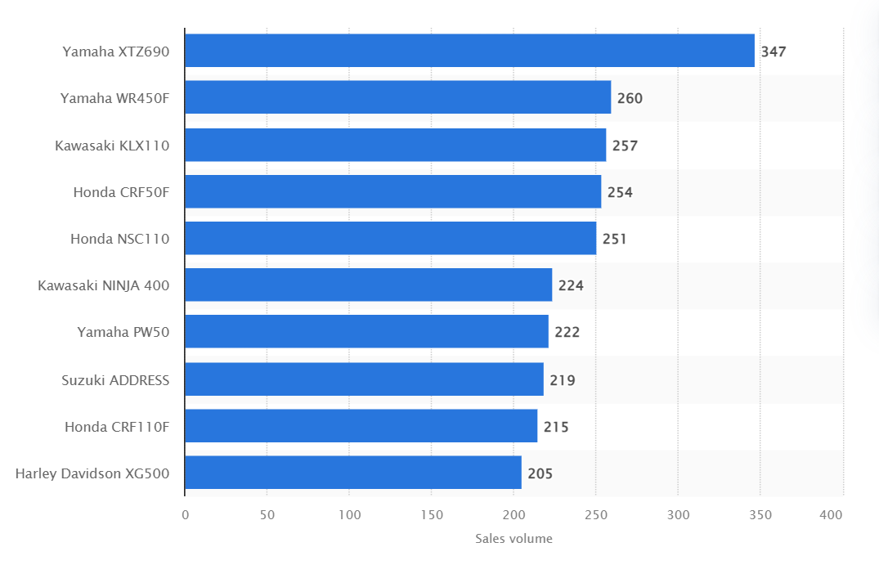

HOST COUNTRY ANALYSIS- AUSTRALIA
PORTER’ NATIONAL DIAMOND MODEL
Michael Porter, famous American economist, argues that the key to a nation’s advantage and wealth is the productivity of businesses and workers and that the national and regional environment can support that productivity. Porter identifies four connected factors that determine the competitive advantage of a nation and that can lead to success in an industrial sector: factor conditions, demand conditions, related and supporting industries, firm strategy, structure and rivalry (Rugman & Collinson, 2012).
Figure : Porter’s diamond model
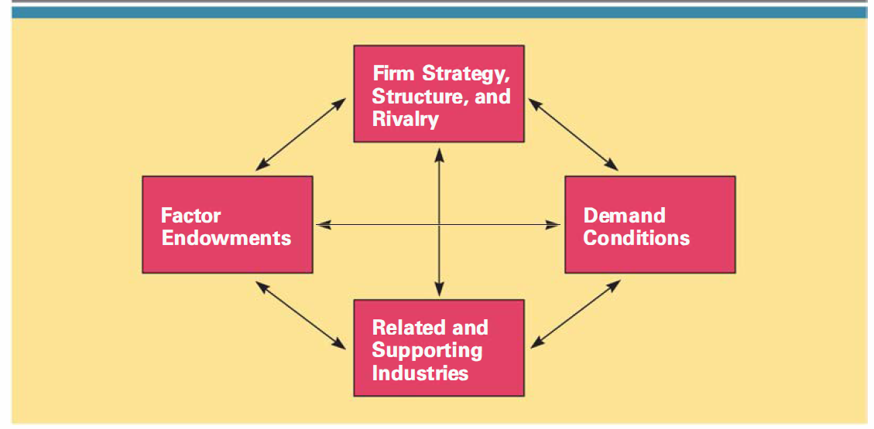
Source: (Hill, 2013)
The main factor of Porter’s diamond that influenced Harley-Davidson’s choice to invest in the Australian market was demand conditions. The Australian market is very thriving and lively.
Figure : Motorcycles per 20.000 people
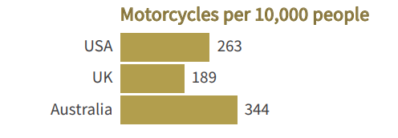
Source: (FCAI, 2020).

Sales figures indicate that in 2021 there was an increase of 13.4% of sales. 53,118 off-road motorcycles were sold, an increase of 18.8% compared to 2020. Road motorcycles sold 37,270 units; an increase of 6.8% percent compared to 2020 figures (FEDERAL CHAMBER OF AUTOMOTIVE INDUSTRIES, 2022). Harley Davidson motorcycles were introduced in the Australian market about 1912, just ten years after the Davidson brothers produced their first model. Robust and reliable compared to other bikes on the market, the Harley thrived in the harsh Australian conditions. Almost a century later, Harley-Davidson is still one of the most popular motorcycle brands on Australian roads. More than a motorcycle, the Harley-Davidson has become a design icon and a symbol of freedom and adventure (MAAS Museum, 2022).
The rivalry is the second main element of the Harley Davidson choice. The domestic environment in which businesses compete shape their ability to compete in international markets. To survive, companies faced vigorous contest national must continually strive to reduce costs, increase product quality, increase productivity, and develop innovative products (Griffin & Pustay, 2015). H- D has developed the ability to face the competition over the years. Its main competitors in Australia are the same as in the US market: Honda, Kawasaki, and Suzuki. The difference is that in the US H-D dominates the market, while Australia tries to keep its position. The third reason is supported industries, there are about 880 motorcycle service enterprises in Australia, which employ almost 4,000 people including 1,700 bikes mechanical engineering. These companies have an annual turnover of 1.8 billion dollars. In Australia are sold more than 40 brands of motorcycles, therefore there are numerous authorized dealerships throughout Australia, and other companies related to the motorcycle such as workshops and sellers of clothing and accessories (FCAI, 2020). Since the pandemic period, more and more Australians use off road motorcycles to increase their fitness, as a form of mental well-being and as a way of experiencing the Australian territory. This is a condition that politicians are taking into account, thinking about spaces to be made available and with new regulations (FEDERAL CHAMBER OF AUTOMOTIVE INDUSTRIES, 2022). So, the government is involved and attentive to the motorcycles industry.

AUSTRALIA BUSINESS RISKS ANALYSIS
Australia has always had a stable government and economy, no recession for 30 years until the 2019 pandemic. Today, despite the recovery and growth of GDP in 2022, Australia continues to face some economic issues: rising inflation, household debt, climate change issues and natural disasters, the consequences of the lockdowns in China that have limited imports. The priority for the government is to design medium-term reforms to improve this situation. But despite these problems, Australia is a low business risk country (OECD, 2022). The Strengths of Australia are geographical closeness to the fast-growing Asian economy, high quality of life, extensive mineral resources supply, medium public debt, high potential for tourism. The weaknesses and potential risks are significant vulnerability to fluctuations in commodity prices (especially iron ore, coal and LNG), strong reliance on Chinese imports for the economy, significant household debt, lack of infrastructure, Risks by climate change, inequality among Member States (COFACE, 2022).
INTERNAL ANALYSIS
GLOBAL VALUE CHAIN
This is an effective tool for internal analysis of the company. This analysis divides the activities of a company into primary and secondary. The primary activities are: inbound (the production, the supply of raw materials, the activities of logistics), the operations (the activities of materials’ working and production of the goods), outbound logistics (the distribution to customers), marketing and sales (strategies of promotion and sale of products) and service (after-sales service) (Rugman & Collinson, 2012). The secondary activities are the firm’s infrastructure (all the management areas of business), Human resources (labour), technology (research and development), and procurement (supply raw material and other components) (Rugman & Collinson, 2012). This is a way to analyse how a firm can create a competitive advantage for itself and helps to understand how to add value for the customers through both, primary and secondary activities. We analyse 3 macro areas of the value chain of Harley Davidson.
Figure : Global value chain model
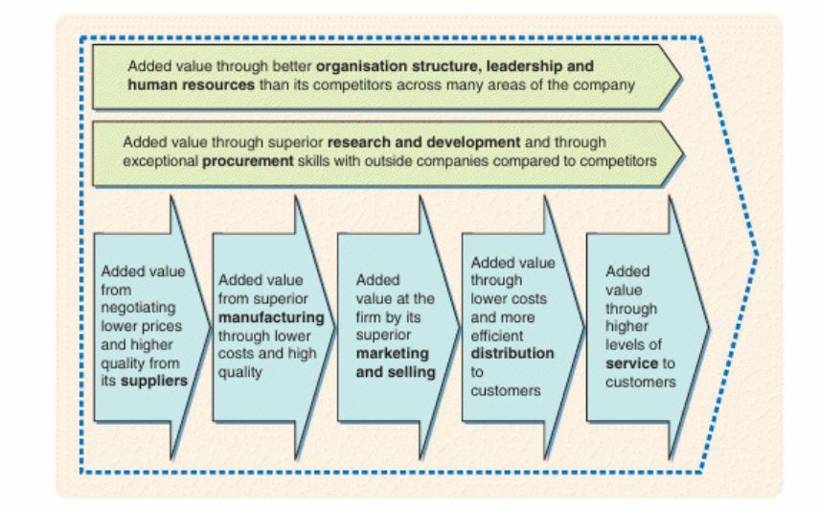
Source: (Lynch, 2018)
GLOBAL PRODUCTION
For the supply of raw materials, the company needs the steel industry, which has several sources but few large companies that hold the global monopoly. The major metal-producing countries are Australia, China, South Africa, Russia and the United States. Instead, for the petrochemical industry: Russia, Saudi Arabia, and the United States dominate production (MarketLine, n.d.). Many industries work as third parties for Harley Davidson, especially companies in Asia, Chinese and Korean companies that produce some components that do not have competition on the market in terms of quality. Currently, H-D has factories in Brazil, Australia, U.S. and Thailand. Recently, in 2018, HR moved its factories out of the United States for taxation reasons, especially after the increase in duties to be paid in Europe for some goods imported from the United States, such as motorcycles (BBC, 2018). In 2019 H-D decided to open a factory in Thailand to overcome the problem of increased import tax on steel and aluminium for the United States and the lower costs of labour and the easiness of procurement of some raw materials. The Harley Davidson production is based on Just-in-time system, under this concept, products are not built until the product is ordered and paid. In this way, the company eliminates waste as inventory stock and consumers have their products delivered quicker.
GLOBAL MARKETING
Harley Davidson is an example of a company that has been able successful to develop an excellent marketing strategy after studying its customer. Firstly, the company has been able to impose its products on the market as a lifestyle rather than means of transport, having an H-D motorcycle is synonymous with rebellion, freedom, and adventure, so the company has successfully positioned its brand (unique brand positioning) (Pafitis, 2020).
Secondly, it has built customer loyalty, also through the creation of associations (Harley Owner Group), and gatherings of enthusiasts. So, the company organizes unique events, for charitable purposes and fun purposes (organising big unique events) (Pafitis, 2020).
And lastly, by diversifying the products and entering the apparel market, customers now have the option to shop for garments even if they don't possess motorcycles (diversification) (Pafitis, 2020).
GLOBAL HUMAN RESOURCES MANAGEMENT
Over the years, as the firm experienced positive and negative phases in succession, H-D realized that to improve its performance it had to use strategies to manage the workforce. With the support of the tool, The Accenture Human Capital Development Framework, HR management identified the crucial points for this improvement: increased employee involvement, workforce competency, workforce flexibility, and the development of benefits and incentives (Harold, et al., 2006). Today, as we can read on the official website, H-D focuses on the recruitment and retention of the best talents to maintain the legend and develop innovations. They offer career opportunities, the flexibility of working, rewards for those who get great results, make employees identify with the brand and are proud of it, manage the workforce with equity and offer equal opportunities, and offer benefits (health benefits and financial benefits) (Harley Davidson, 2022).

SWOT ANALYSIS
STRENGTHS | WEAKNESSES
- CULT BRAND, STRONG MARKET POSITION  The unique style and design of the motorcycles have made the brand become a niche and cult brand.  - CUSTOMER LOYALTY  Harley Davidson has created a cult brand that is also a philosophy of life, together with promotional strategies resulting in customers being very loyal to the company.  - STRONG R&D DEPARTMENT  Harley-Davidson invests a lot of money in research and development to improve the quality of its products (Harley-Davidson, 2021).  - WIDE DISTRIBUITION NETWORK  The company uses a network of independent dealers and distributors to advertise its products (MarketLine, 2022). More than 1400 dealerships in 100 countries (Harley Davidson, 2021). | - HIGH DEBT RISK  In 2020, the company reported a rise in debt. High debt is always a source of concern for both shareholders and the company, which is, therefore, more vulnerable to changes in the economic scenario (MarketLine, 2022).  - SUPPLIERS  Harley Davidson relies only on one supplier for some components of the production, this implies that changes or unforeseen in the supply would interrupt the production (Bhasin, 2020)
OPPORTUNITIES | THREATS
- HYBRID AND ELECTRIC MOTORCYCLES  The company could focus on improving its offer of electric and hybrid motorcycles, more reliable for customers and respectful of the environment, to become a leader in the segment (MarketLine, 2022).  - EXPANSION OF TARGET MARKET  The company could aim to extend its target market with marketing strategies oriented to the segment of women and young bikers (Bhasin, 2020). | - HIGH COMPETITION  The company has to face high competition in the sector, where there are companies that offer better quality products. This pressure from competition could influence the company and lead it to decisions that can affect business (MarketLine, 2022).  - RISING LABOR COSTS IN THE U.S.  In the United States, which is the first market country for the company, the government has imposed increases in the minimum wage, and this has increased labour costs that could affect the company’s profits (MarketLine, 2022).

INTERNATIONAL STRATEGIES
Any company that operates internationally must have a global strategy to develop and manage the markets of the countries where it makes investments. The following two elements are crucial when deciding how to manage a global company: the potential cost gains arising from global integration (such as marketing, production or research economies of scale) and the pressures to respond to local market conditions.
There are 4 basic strategies:
global standardization strategy, Transnational strategy, international strategy and Localization strategy (Hill, 2013).
figure:
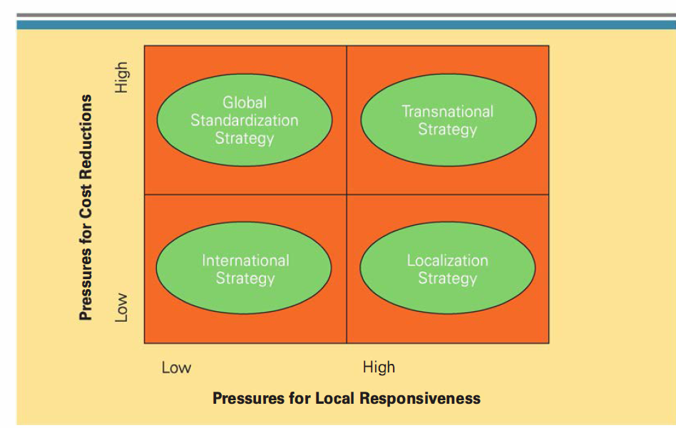
Source: (Hill, 2013)
The international business approach adopted by HD is the global strategy. This strategy is founded on the idea that a multinational corporation considers the world as a single market and that its main goal is to provide standardised products and services that respond to the demands of customers across the world (Griffin & Pustay, 2015).. Actually, Harley-Davidson main priorities are improving profitability and profit growth, which are accomplished through reducing costs as a result of economies of scale, learning effects, and localization economies (Hill, 2013). The company strategic goal is to pursue a low-cost strategy on a global scale. H-D does not operate any change in the production of goods following the customers needs of the target country market of the country. Products are the same for any country worldwide, they do not take into consideration local culture, so pressure for responsiveness is low. Furthermore, in order to remain competitive and keep product costs low, the company doesn't change its production or design methods because doing so would be expensive, so pressure for cost reduction is quite high.
ENTRY MODES
When a company invests in a foreign country, needs to consider many factors. One of these is to choose an international strategy to achieve company objectives and carry-on strategies (Daniels, 2019). Firms can use six different modes to enter foreign markets: exporting, turnkey projects, licensing, franchising, establishing joint ventures with a host-country firm, or setting up a new Wholly owned subsidiary in the host country. Each entry mode has advantages and disadvantages (Hill, 2013). The entry strategy adopted by HD for the Australian target market is Exporting, its products are basically made in the US and then exported worldwide.
Exporting goods has two major advantages: avoiding the high costs of establishing manufacturing operations in the host country. Secondly, exporting can help an enterprise to achieve the experience curve and localization economies (Hill, 2013). The disadvantages are high transport costs, problems with the local policies of the foreign country in which you operate, and tariff barriers that can make exporting uneconomical. H-D has recently made a lot of decisions based on tax increases. For instance, due to an increase in the tax on the import of steel and aluminium, H-D has established a plant in Thailand. In addition, there has been an increase in E.U tariffs for the export of motorcycles from the United States to the EU and the United States, which meant that the production of motorcycles for the European market was no longer feasible directly from the United States (Taylor, 2021).
CORPORATE SOCIAL RESPONSIBILITY
Corporate social responsibility (CSR) is the set of commitments that a business undertakes to protect and improve the society in which it operates. Commonly, three are the objectives in formulating and implementing their strategies and decisions:
● achieving the economic mission, delivering profits for shareholders and creating value for stakeholders (People)
● Protecting the natural environment (planet)
● Improving the general welfare of society (profit)
Harley-Davidson’s corporate social responsibility:
- Develop an inclusive and diverse workforce for all employees and the global dealer network. Support employees for education, well-being, and sport. Establish a sustainable work environment, policies and practices (people) (Harley-Davidson, 2021).
- Commitment to net zero carbon emissions for all products and operations. Increase and improve the production of electric vehicles. Achieve 4,1% of waste to landfill (planet).
- $ 700 M of economic contribution through wages and related taxes. $ 3 B economic impact through purchase of goods and services. $2 M in grants made by The Harley-Davidson foundation for communities (profit) (Harley-Davidson, 2021).

CONCLUSION AND RECCOMENDATIONS

