Component 2 - Research Report
Student Name:George-Daniel Olteanu
Student Number:2126838
Lecturer Name:Seyed Navid Nasirpour
Module: BMSW4003_BIRM Digital Skills and Research Methods.
Title: Report – Research report

Introduction

The research report is based on the survey created in class that aims to understand better the collaboration between students and the tools used in order to collaborate when given a task. The report aims to analyse the results from the survey and understand the design of the research and discuss if the results fit with the literature identified. Collaboration is one of the best ways to give a great educational experience, and some of the main advantages of a collaborative educational environment include brainstorming that creates new and innovative ideas, learning more about each student’s potential and skills, developing thinking skills while improving social and interpersonal skills, and creating an overall better learning experience where both students and lecturers are looking forward to getting involved and learn (NEA, 2018). Also, in the modern world, collaboration is made even easier by using technology, and it is extremely useful for students to learn collaborative technologies early in their studies because they will surely use them for their entire careers. Some of the most common and easy to use collaborative technologies include mobile phones, video conferences, emails, instant messages and e-learning, while some of the biggest benefits of these technologies are having effective teams, cutting costs, accessing people and information internationally, and reducing the time lost with offline meetings (Abegg et al., 2018).

Research design

Research question

The questions that were used in the survey aimed to identify if the people who answered were familiar with the Microsoft Office 365 if the MS Teams is one of the most used platforms for students to collaborate, and what other apps like PowerPoint, Excel, Word, Streams or Forms do they use for the work done at the university. The overall aim of the questions was to identify what students believe to be one of the most used apps to collaborate with their colleagues in order to deliver high quality work and how the apps can help them without having to meet face to face.

Method

The questions chosen for the survey were: I consent to take part in this questionnaire voluntarily; What is your age?; Are you familiar with Microsoft Office 365?; Are MS Teams the most used platform for student communication?; Rank these applications according to how frequently you use them to collaborate with others on the OneDrive (Most frequent at the top); I use MS Teams most frequently to collaborate with others; What is the most used application to communicate with other students?. The questions were appropriate for the purpose of the research and did not ask for any personal or inappropriate answers from the participants. The questions were chosen with the aim of identifying which applications from the Microsoft pack the students use the most and are MS Teams is a popular application to use for an effective collaboration between students.
The research method chosen for this particular project was quantitative research that gathered numerical data and analysed them through statistical analysis in order to identify patterns and generalise on how students collaborate within the university. The research tried to discover how many people use these tools, how often and to what extent these digital tools are helpful for collaboration (University of Newcastle, 2022).
In order to recruit participants for this particular survey, the best choice was to leverage the personal network, especially the people from university or other close friends who were studying. The survey requested for the participants to be students in order to answer the main questions of which tools students use to collaborate within the university. Although the survey has only ten answers, the answers are relevant because the participants are within different age groups, using different tools and studying different courses at the same university. For the research to be concluded, more questions need to be asked, and a wider audience needs to be reached for the answers to be properly analysed and relevant. In this case, the results are relevant for this group and can only be applied to the students from this course.

Ethical considerations

Fisher (2020) identifies that for questionnaire research, there are some ethical considerations that need to be followed and respected, such as the confidentiality of the participants, getting informed consent from each participant, keeping the anonymity of the participants, not pressuring or persuading people into participating to the survey, failure to disclose interest and informing the participants how and where the results of the surveys will be used. The participants of the current survey were properly informed that their information is private, and the results of the survey will only be used in order to write an academic report regarding the use of technology in collaborating with students.

Results

The first question asked every participant to agree voluntarily to participate in the following questionnaire, and as it can be seen from Chart 1, all the participants agreed

The second chart showcases the ages of the participants of the survey, with a majority of answers being between 19 to 28 years old but also had participants from 29 to 38 years and 39 to 48 years old. Based on the age of age participant different pattern could be analysed during the survey.

The third chart showcases that 90% of the
participants in the surveys are familiar with the Microsoft Office package and have used some of the applications in the package at least once.

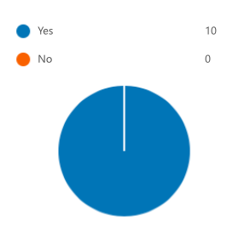
Chart 1 – Voluntarily consent

Chart 2 – Age of participants
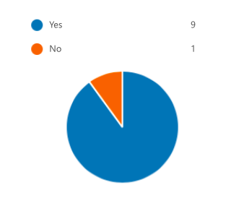
Chart 3 – People who use Microsoft Office

The fourth chart identifies how many of the participants used MS Teams for student collaboration and communication. 50% of the participants admitted that they frequently use this platform to collaborate with other colleagues, while the other half said they don’t use it.

The fifth chart identifies what applications students use, such as 10% of them use MS Forms, 20% of them use MS Streams, 20% of them use MS Excel, 30% use MS PowerPoint and 20% use MS Word. Compared to the other applications 50% of participants agreed that they MS Teams to collaborate with colleagues.

The sixth chart identified how many of the students use MS Teams to collaborate: 10% strongly agree, 50% agree, 10% neutral, 20% disagree, and 10% strongly disagree.

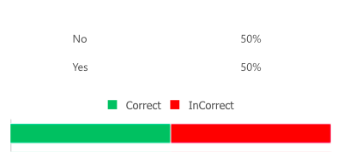

Chart 4 - Using MS Teams for collaboration

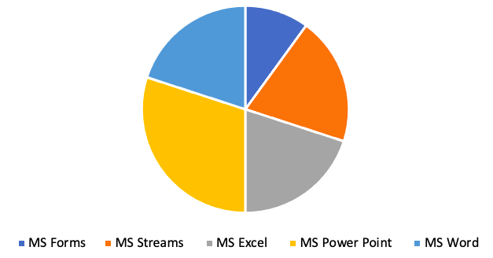
Chart 5 – Application students use to collaborate

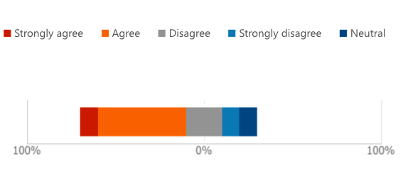
Chart 6 – Students using MS Teams to collaborate

The seventh chart divides the participants of the survey into people who use Zoom, WhatsApp, MS Teams and MS Outlook. The most used apps include MS Teams and MS Outlook.

Chart 7 – Applications used by students

Discussion

The results detailed in the section above, gathered through the survey realised in the class, tried to showcase how students collaborate during their time spent at the university and what tools are making this collaboration easier. As seen from the chart above, students use a number of digital tools in order to collaborate, such as the Microsoft Office package, but also non-academic tools such as Zoom, WhatsApp, Facebook Messenger and other online chats. Except for the digital tools, students collaborate also face to face during classes and seminars, while they put the bases for the main work and decide the details over digital tools. The survey also identified that even if 50% of the student have heard before of MS Teams and they would give it a chance, only 20% are actually using the application to collaborate with others. The results also confirmed the hypothesis that collaboration amongst students is crucial for their results, and it helps them develop a multitude of skills that will be extremely helpful in their future careers. The universities are doing as much as they can in order to help with this collaboration by introducing modules and assignments that are designed to help students work in teams and discover new technologies. The main advantages of the collaborative learning include creating a constructive competitiveness amongst students, which pushes them to do more and get involved, improves the relationships between students and between students and lecturers, and learning new technologies that were actually pushed by the Covid 19 pandemic and the real need to learn and collaborate in the digital space (The Hindu, 2021).
Moseley (2022) identifies that effective collaboration is a skill that needs to be learned, and it is key to bring together different people with different personalities and backgrounds from different departments and work together as one efficient and effective team. Some of the key skills that can be learned through collaboration include open-mindedness, communication, organisation, long-term thinking, adaptability and debate. All of the mentioned skills can be learned through a successful collaboration starting from the first years of university and improved or adapt them in the workplace. As seen from the results of the survey, students of different ages and come from different backgrounds, and although some of them would like to get involved more, sometimes they simply do not have the time between studies, work and maybe a family. Although collaborative technology has been mostly pushed by the pandemic, it was an extremely useful tool for most of the people and the universities that really understood that are now trying to push their students even more to learn different digital tools. Go Guardian (2018) also identified that lecturers use different skills and techniques, but also the power of technology, in order to organise the students, keep them engaged and focused on task and be more academically productive. Technology is also a great way to keep track of their student's achievements, to use gamification in order to improve static lessons, to support self-directed learning, to encourage collaborations and to enable differentiated instruction for different learning styles. The survey can also be used as gamification for students to have the most answers and come up with the best questions in order to confirm the hypothesis created in class. Lastly, the survey showed that people are willing to participate in surveys on different subjects as long as they are informed about the reason for the survey, the theme and the time they will spend completing it.

Conclusion

In conclusion, the report analysed the importance of digital collaboration between students in order to create a successful group work and the tools they use in order to collaborate efficiently. The survey showcased that there are a large number of tools that students use, from classic tools such as online messengers to academic tools such as the Microsoft Office package, and that different people collaborate differently based on their experience with certain applications, based on their age and other preferences. The survey also showcased that the MS Teams is not a tool that most people use even if they know about its existence. A more complete questionnaire with more questions and a bigger number of participants would be necessary in order to fully understand the reasoning behind the choices the students make. Also, the lecturers and the university have a big impact on the choices the students make due to the online tools the university provides for their students, their platform and the paid applications that students can use for free. Without considering the applications that students use on a daily basis in their personal lives, the most used applications used by students are the free ones and the ones that are required to be used by the university.

References

Abegg, N., Butler, H., Witsman, S. (2018) Collaborative technology, available at: https://www.siue.edu/~hbutler/documents/CMIS342Report.pdf (Accessed at: 26 Jul 2022)

GoGuardian (2018) 4 Benefits of using technology in the classroom, available at: https://www.goguardian.com/blog/4-benefits-of-using-technology-in-the-classroom (Accessed at: 1 Aug 2022)

Moseley, C. (2022) 6 crucial collaboration skills (and how to foster them), available at: https://blog.jostle.me/blog/6-collaboration-skills-and-how-to-foster-them (Accessed at: 1 Aug 2022)

NEA (2018) Benefits of collaboration, available at: https://www.nea.org/professional-excellence/student-engagement/tools-tips/benefits-collaboration (Accessed at: 26 Jul 2022)

The Hindu (2022) Collaboration is key, available at: https://www.thehindu.com/education/why-collaborative-learning-is-important-even-in-the-digital-age/article34261313.ece (Accessed at: 1 Aug 2022)

University of Newcastle (2022) Research methods: what are the research methods? Available at: https://libguides.newcastle.edu.au/researchmethods (Accessed at: 26 Jul 2022)

Appendix A – A blank copy questionnaire



