

A Strategic Change Plan for Aston Martin Lagona

BA(Hons) Leadership and Management

Leading und Implementing Change

LCLM 6003

Student Name: Valentyna Staskus

Student Number: 3423885

Lecturer Name: Dr Mustakkima Afrin

Submission date: 21 August 2026
Table of content

Executive summery

This research proposal investigates the impact of digital transformation on organisational performance at Marks & Spencer (M&S). Digital technologies such as artificial intelligence (AI), data analytics, e-commerce, and omnichannel retailing are transforming the retail industry and changing how organisations improve efficiency, customer experience, and competitiveness (Verhoef et al., 2021). Although M&S has invested in a range of digital initiatives, there is still uncertainty about how these investments contribute to overall organisational performance.

The purpose of this research is to examine the relationship between digital transformation and organisational performance within M&S. The study will focus on key areas including operational efficiency, customer experience, employee adaptation, and organisational change. A review of current academic literature will identify the main theories, debates, and research gaps related to digital transformation (Vial, 2019). The research will also explain the methodology used to collect and analyse data while considering research ethics, reliability, and validity (Saunders, Lewis and Thornhill, 2023).

The findings are expected to provide a better understanding of how digital transformation supports organisational performance and may help M&S make more informed strategic decisions. The study will also contribute to existing knowledge by examining digital transformation within the context of a leading UK retailer (Vial, 2019).

Introduction

Marks & Spencer (M&S) is one of the UK's leading retailers, operating in clothing, home, and food markets. Like many retailers, the company is responding to changing customer expectations and increasing competition through digital transformation. According to Verhoef et al. (2021), digital transformation involves integrating digital technologies with organisational processes to improve business performance and create value for customers.

This research investigates how digital transformation influences organisational performance at M&S. It focuses on areas such as operational efficiency, customer experience, employee adaptation, and organisational change. The proposal includes the business problem, research aim, objectives and questions, a critical review of the literature, the proposed research methodology, and the expected business relevance of the study.

- Critical Business Analysis of Aston Martin Lagonda

Recent History of the Organisation

Aston Martin Lagonda has experienced ongoing financial instability and restructuring, reflecting long-term challenges in achieving sustainable profitability despite its strong brand reputation (Aston Martin Lagonda, 2024). Although the company has maintained its position in the ultra-luxury automotive market, its reliance on external investment highlights structural weaknesses compared with more financially stable competitors such as Ferrari and Porsche.

The introduction of the DBX SUV was a necessary strategic shift in response to changing market demand, particularly the global growth in luxury SUV consumption. While this improved revenue performance, it also created tension between commercial success and brand heritage, as diversification risks weakening the firm’s traditional sports car identity (McKinsey & Company, 2023). Similarly, participation in Formula One has strengthened global brand visibility, but its financial return is indirect and long-term rather than immediately profitable (Porter, 2008).

Micro and Macro Environment Analysis

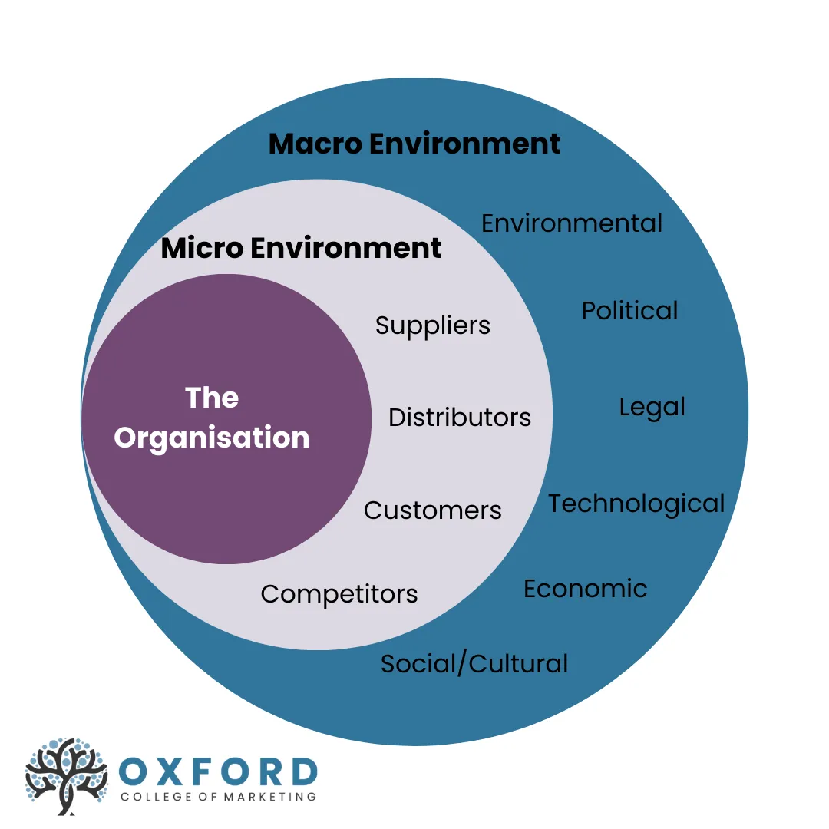

Figure 1. Relationship between the micro and macro business environment.
Source: Adapted from Oxford College of Marketing (n.d.).

Understanding the micro and macro environments is important for analysing the factors that affect Aston Martin Lagonda's strategic decisions and long-term success. The microenvironment includes factors that directly influence the company's daily operations, such as customers, suppliers, distributors, and competitors. These factors affect the organisation's ability to meet customer needs and remain competitive. In contrast, the macro environment includes wider external factors such as political, economic, social, technological, legal, and environmental (PESTLE) influences. Although Aston Martin cannot control these external factors, they have a major impact on the company's strategy, business performance, and future development (Kotler, Keller and Chernev, 2021; Burnes, 2017).
Analysing both environments is particularly important for Aston Martin as the company is adapting to digital transformation while responding to challenges such as Brexit, changing customer expectations, stricter environmental regulations, and the transition to electric vehicles. Understanding these internal and external influences helps the company identify opportunities, reduce potential risks, and make informed strategic decisions that support long-term growth and competitiveness. Figure 1 illustrates how the micro and macro environments together influence Aston Martin's business performance.

PESTLE Analysis (Critical Evaluation)

For a global organisation such as Aston Martin Lagonda, PESTLE is particularly important because it helps identify how international forces such as regulation, economic conditions, technological change, and sustainability pressures shape strategic direction. It is widely used in strategic management to support effective decision-making and long-term planning by providing a structured understanding of external risks and opportunities (Burnes, 2017; Vial, 2019). In the context of the global automotive industry, PESTLE analysis is essential for assessing how external disruptions such as Brexit, COVID-19, and the shift towards electric vehicles impact competitiveness and organisational change (McKinsey & Company, 2022; PwC, 2023).

 | External factors to consider | Factors effected within the industry | Importance to organisation
Political | Brexit, UK automotive policies, government support for electric vehicles (EVs), international trade agreements and the UK Net Zero Strategy. | Automotive manufacturers must accelerate the transition to electric vehicles while adapting to changing trade regulations and government policies (UK Government, 2024). | High – Aston Martin must invest in electrification and maintain regulatory compliance to remain competitive.
Economic | Inflation, exchange rate fluctuations, rising interest rates, COVID-19 recovery and global supply chain instability. | The COVID-19 pandemic disrupted production, reduced global vehicle demand, created semiconductor shortages and increased manufacturing costs. Inflation has also reduced consumer purchasing power (PwC, 2023). | High – Economic uncertainty affects production costs, profitability and demand within the luxury vehicle market.
Social | Changing consumer preferences, environmental awareness, digital purchasing behaviour and demand for sustainable luxury products. | Consumers increasingly value environmentally responsible vehicles, advanced digital technologies and personalised customer experiences. Online research and digital purchasing channels have become more important following the COVID-19 pandemic (Deloitte, 2023). | Medium–High – Aston Martin must preserve its luxury brand while responding to changing customer expectations and digital engagement.
Technological | Artificial intelligence (AI), digital manufacturing, Industry 4.0, automation, connected vehicles and electrification. | Rapid technological innovation is transforming vehicle design, manufacturing processes and customer experience. AI and digital technologies improve operational efficiency, product quality and innovation capability (Vial, 2019; Bawack et al., 2022). | Very High – Digital transformation is fundamental to Aston Martin's long-term competitiveness and transition towards electrified vehicles.
Legal | Vehicle safety legislation, emissions regulations, data protection requirements and post-Brexit regulatory changes. | Automotive manufacturers must comply with stricter environmental regulations, cybersecurity standards and product safety requirements across different international markets. | High – Compliance reduces legal risks, protects brand reputation and supports continued access to global markets.
Environmental | Climate change, carbon reduction targets, sustainable manufacturing, circular economy practices and resource efficiency. | Governments and consumers increasingly expect manufacturers to reduce carbon emissions throughout the vehicle life cycle. This has accelerated investment in hybrid and electric vehicle technologies (McKinsey & Company, 2022). | Very High - Sustainability has become a strategic priority, influencing product development, manufacturing processes and corporate reputation.

Figure 2. PESTLE Analysis of Aston Martin Lagonda.( Created by V. Staskus)

Political factors
Brexit has increased customs requirements, border checks, and supply chain costs for UK automotive manufacturers, creating additional pressure on production and international trade (SMMT, 2024). For Aston Martin Lagonda, these changes have increased administrative costs and disrupted the movement of parts between the UK and European suppliers. Although the company has expanded into international markets, Brexit continues to affect operational efficiency and supply chain resilience.

Economic factors
Aston Martin is strongly affected by global economic cycles due to its luxury market position. According to the World Bank (2024), inflation, rising interest rates, and reduced purchasing power lower demand for high-value vehicles, although high-net-worth customers provide some stability, resulting in volatile rather than steady growth.

Social factors
Consumer preferences are increasingly shifting towards sustainability, ethical consumption, and experiential luxury. While this benefits SUV and lifestyle-oriented models, it presents a challenge to Aston Martin’s traditional identity as a manufacturer of high-performance sports cars. As a result, the organisation must balance heritage branding with evolving consumer expectations (Kotler et al., 2021).

Technological factors
Digital transformation, AI, and automation are reshaping the automotive industry through smart manufacturing and digital customer engagement. According to Davenport and Ronanki (2018), these technologies are transforming how firms operate and compete. However, Aston Martin risks falling behind if it does not invest further in electrification, software, and digital infrastructure.

Legal and Environmental factors
Stricter emissions regulations and sustainability requirements are driving rapid industry-wide electrification. These regulatory pressures increase compliance costs, particularly for smaller manufacturers with limited economies of scale. In addition, environmental expectations are pushing firms to adopt low-carbon production methods and sustainable supply chain practices (European Commission, 2024).

Overall, the PESTLE analysis demonstrates that Aston Martin operates in a highly complex and externally driven environment. Political and legal pressures from Brexit and emissions regulations, combined with technological disruption and shifting consumer expectations, are forcing the organisation to accelerate its digital transformation and electrification strategy. These external forces highlight the necessity for effective strategic change management to ensure long-term competitiveness and sustainability.

SWOT Analysis (Critical Summary)

A SWOT analysis provides a structured assessment of the company's internal strengths and weaknesses alongside the external opportunities and threats influencing its strategic development. This helps the organisation make informed decisions to improve its competitiveness in the rapidly changing automotive industry (Kotler, Keller and Chernev, 2021).

Strengths

Aston Martin's greatest strength is its globally recognised luxury brand, which is built on a long heritage of craftsmanship, exclusivity, and high-performance vehicles. This strong brand reputation supports premium pricing and high customer loyalty. However, despite its brand value, the company has struggled to achieve consistent financial performance (Aston Martin Lagonda, 2024).

Weaknesses
The company's main weakness is its financial position, including high debt levels and relatively low production volumes compared with larger luxury automotive manufacturers. These factors limit economies of scale and reduce its ability to invest in new technologies and product development (Aston Martin Lagonda, 2024).

Opportunities
Growing demand for electric vehicles, digital technologies, and sustainable mobility presents valuable growth opportunities for Aston Martin. According to McKinsey & Company (2022), investment in electrification, digital innovation, and sustainability can strengthen long-term competitiveness while helping automotive manufacturers respond to changing customer expectations.

Threats
Aston Martin faces strong competition from established luxury manufacturers and electric vehicle producers. In addition, economic uncertainty, stricter environmental regulations, and rapidly changing technology continue to increase pressure on the company's future growth and profitability (Aston Martin Lagonda Global Holdings plc, 2025; McKinsey & Company, 2022). The company's transition towards electrification and compliance with increasingly demanding environmental regulations also present significant strategic and financial challenges.

Porter’s Five Forces Analysis of Aston Martin Lagonda

Porter’s Five Forces framework is used to evaluate the competitive pressures within an industry and understand how these forces influence an organisation’s strategic position (Porter, 1985). For Aston Martin, this analysis is important because the luxury automotive market is highly competitive, technologically changing, and affected by the transition towards electric vehicles.

Force | Impact on Aston Martin | Level of Pressure
Competitive rivalry | Aston Martin competes with established luxury manufacturers, including Ferrari, Porsche and Bentley, as well as electric vehicle manufacturers. Strong competition requires continuous innovation and product differentiation to maintain market share (Porter, 2008; McKinsey & Company, 2022). | High
Threat of new entrants | High capital investment, advanced engineering expertise and strong brand reputation create barriers to entry. However, new electric vehicle manufacturers supported by advanced technology continue to increase competition (Porter, 2008). | Moderate
Bargaining power of suppliers | The company depends on specialist suppliers for batteries, electronic systems and luxury components. Supply chain disruption following Brexit and technological change has increased supplier influence (Burnes, 2017). | High
Threat of substitutes | Customers have increasing access to luxury electric vehicles, hybrid models and alternative premium brands. Growing demand for sustainable mobility increases substitution pressure (Kotler, Keller and Chernev, 2021; McKinsey & Company, 2022). | Moderate-High
Bargaining power of customers | Luxury vehicle customers have high expectations regarding quality, innovation, sustainability and digital technology. Access to several premium brands strengthens customer bargaining power (Kotler, Keller and Chernev, 2021). | High

Figure 3. Porters five Forces Analysis of Aston Martin Lagonda.
Source: Created by V. Staskus.

Overall, Porter's Five Forces analysis indicates that Aston Martin operates within a highly competitive industry where rivalry, supplier influence and customer bargaining power represent the greatest challenges. To strengthen its competitive advantage, the company should continue investing in digital transformation, electrification and sustainable innovation while maintaining the exclusivity of its luxury brand.

Referencing

Aston Martin Lagonda Global Holdings plc (2025) Annual Report and Accounts 2024. Gaydon: Aston Martin Lagonda Global Holdings plc. Available at: Aston Martin corporate investor website (Accessed: 17 July 2026).

Burnes, B. (2017) Managing Change. 7th edn. Harlow: Pearson.
Davenport, T.H. and Ronanki, R. (2018) ‘Artificial intelligence for the real world’, Harvard Business Review, 96(1), pp. 108–116.

Kotler, P., Keller, K.L. and Chernev, A. (2021) Marketing Management. 16th edn. Harlow: Pearson.

Kraus, S., Durst, S., Ferreira, J.J., Veiga, P., Kailer, N. and Weinmann, A. (2022) ‘Digital transformation in business and management research: An overview of the current status quo’, International Journal of Information Management, 63, article 102466. doi: 10.1016/j.ijinfomgt.2021.102466.

Porter, M.E. (1985) Competitive Advantage: Creating and Sustaining Superior Performance. New York: Free Press.

Porter, M.E. (2008) ‘The five competitive forces that shape strategy’, Harvard Business Review, 86(1), pp. 78–93.

Society of Motor Manufacturers and Traders (SMMT) (2024) SMMT Motor Industry Facts 2024. London: Society of Motor Manufacturers and Traders. Available at: SMMT website (Accessed: 17 July 2026).

Vial, G. (2019) ‘Understanding digital transformation: A review and a research agenda’, The Journal of Strategic Information Systems, 28(2), pp. 118–144. doi: 10.1016/j.jsis.2019.01.003.
Kotler, P., Keller, K.L. and Chernev, A. (2021) Marketing Management. 16th global edn. Harlow: Pearson.

Saunders, M.N.K., Lewis, P. and Thornhill, A. (2023) Research Methods for Business Students. 9th edn. Harlow: Pearson.

Verhoef, P.C., Broekhuizen, T., Bart, Y., Bhattacharya, A., Dong, J.Q., Fabian, N. and Haenlein, M. (2021) ‘Digital transformation: A multidisciplinary reflection and research agenda’, Journal of Business Research, 122, pp. 889–901. doi: 10.1016/j.jbusres.2019.09.022.

Vial, G. (2019) ‘Understanding digital transformation: A review and a research agenda’, The Journal of Strategic Information Systems, 28(2), pp. 118–144. doi: 10.1016/j.jsis.2019.01.003

