07/12/2025
University of Wales Trinity Saint Davids
London Campus
Module Name: Computer Architecture and Operating Systems
Module Code: ACCA 4022

Student Name: Proletka Asenova Dimitrova
Student ID: 2441586
Group: 3

Lecturer’s Name: Koushik Modak
Computer Architecture and Operating Systems
Component 2-Coursework
Table of Contents
Introduction 2
Main Body 2
Key functions of general Operating Systems 2
Use of Windows OS CLI commands 2
Use of Linux OS CLI commands 2
Use of Windows OS scripts (Batch Scripting) 2
Use of Linux OS scripts (Bash Scripting) 2
Conclusion 2
References 2

Introduction
This report is written for the Computer Architecture and Operating Systems module. The main goal of this assignment is to show my understanding of how Operating Systems work, focusing on Windows and Linux.
The report is divided into five tasks. In Task 1, I explain the key functions of an operating system, such as memory and process management. In Tasks 2 and 3, I demonstrate how to use command-line tools (CLI) in both Windows and Linux to manage the system. Finally, in Tasks 4 and 5, I present simple scripts using PowerShell and Bash to automate basic tasks.
This report demonstrates both my theoretical knowledge and my practical skills in using different operating systems.

Main Body

Key functions of general Operating Systems

Process Management
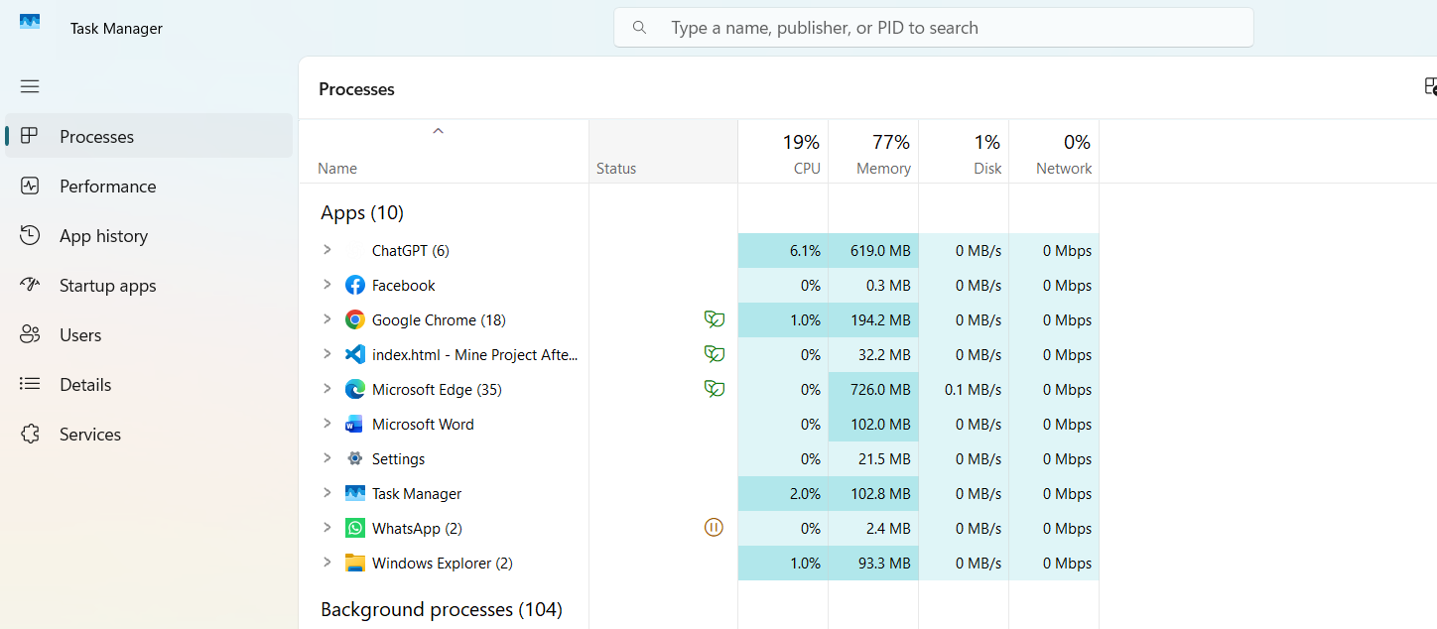
The screenshot below shows the Process Management function within the Windows Task Manager. One of the main jobs of an Operating System is to manage all running programs (processes). The OS decides which process gets access to the CPU and for how long. As seen in the image, the OS displays real-time data on how much CPU, Memory, and Disk resources each application is using. This tool allows the user to monitor system performance and terminate (close) any applications that are not responding.

The Performance tab
Demonstrates how the OS monitors RAM usage. It ensures efficient memory allocation for running applications.
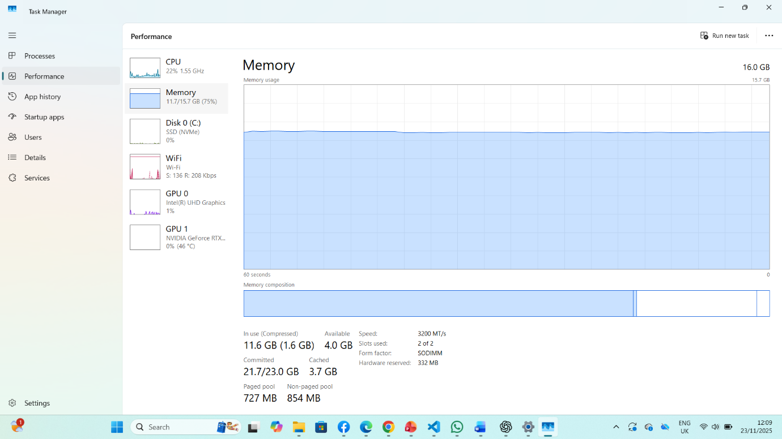

File System and Storage Management
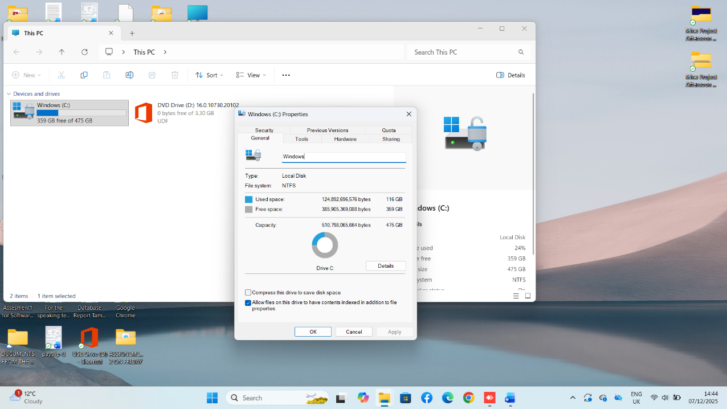
The screenshot above displays the properties of the Local Disk (C:), specifically within the General tab. This clearly demonstrates the File System Management function of the Operating System.
User Account Management
This screenshot demonstrates the User Management function. Modern operating systems are designed to be multi-user systems, meaning they support multiple distinct accounts on a single machine.
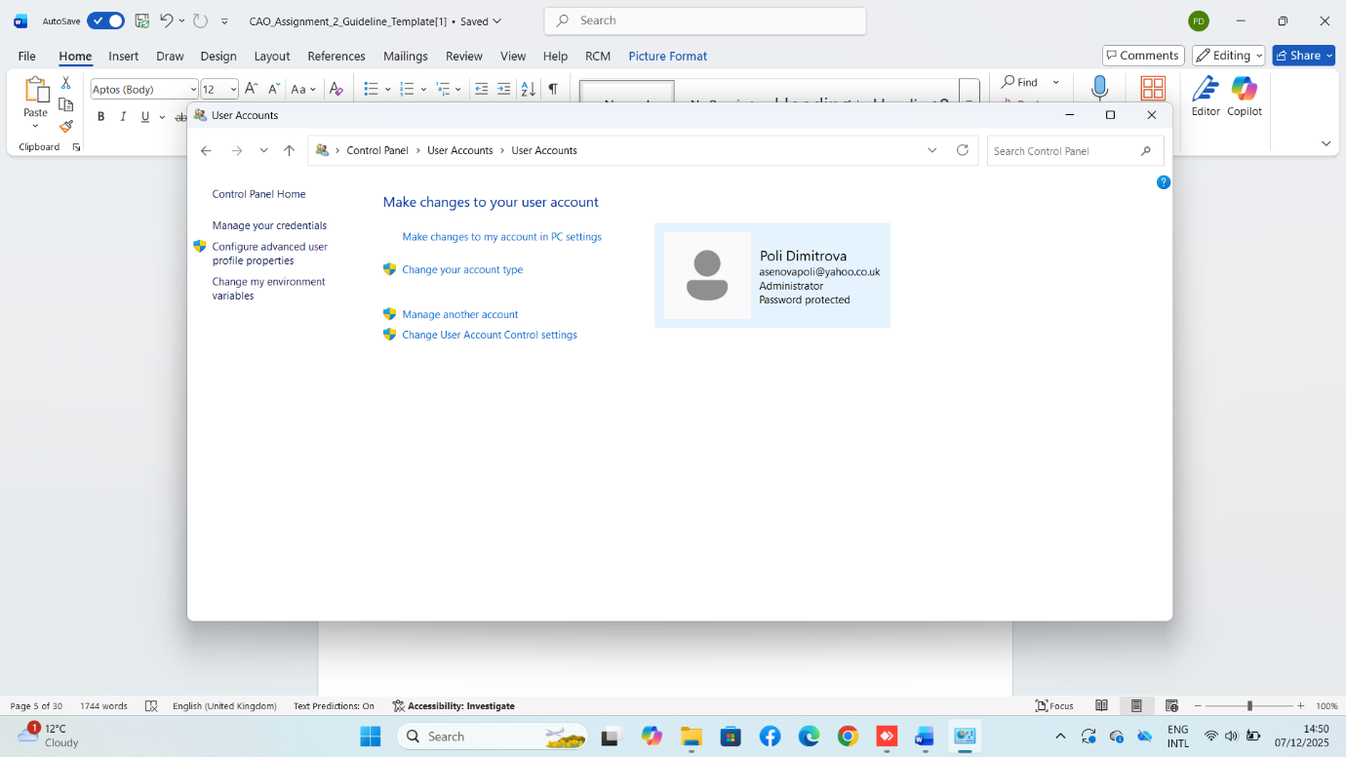

Use of Windows OS CLI commands
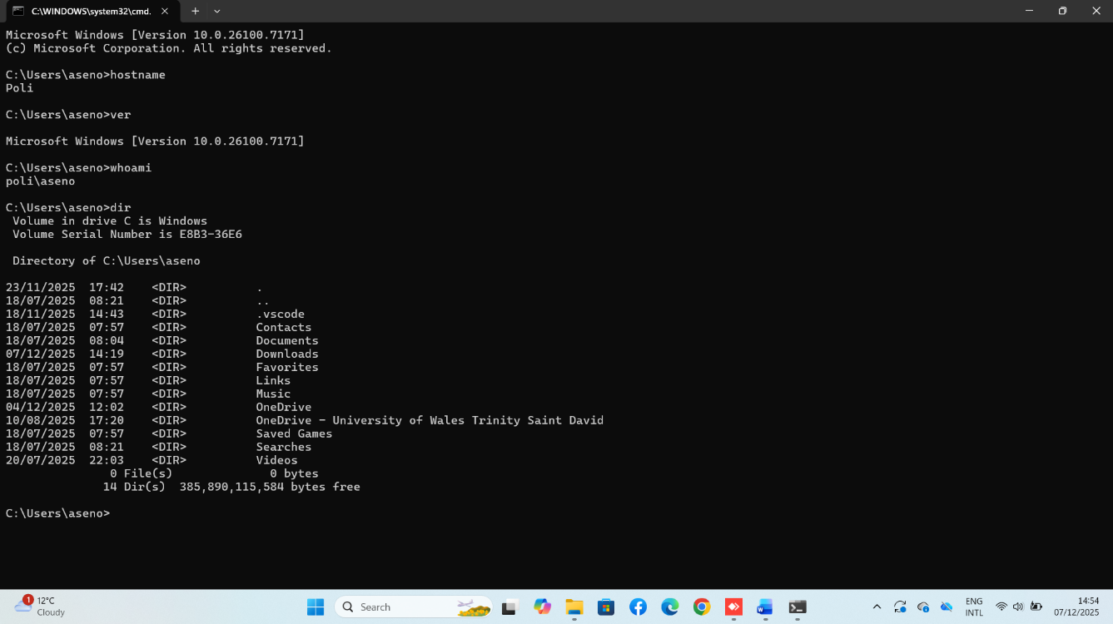
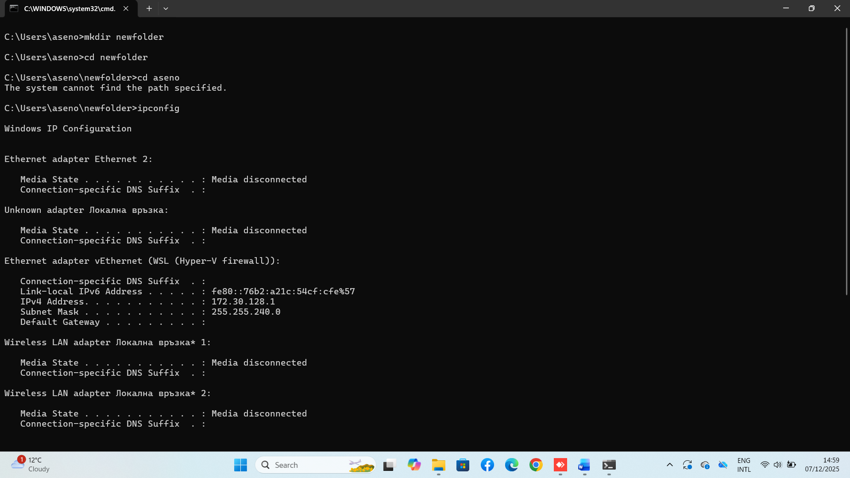

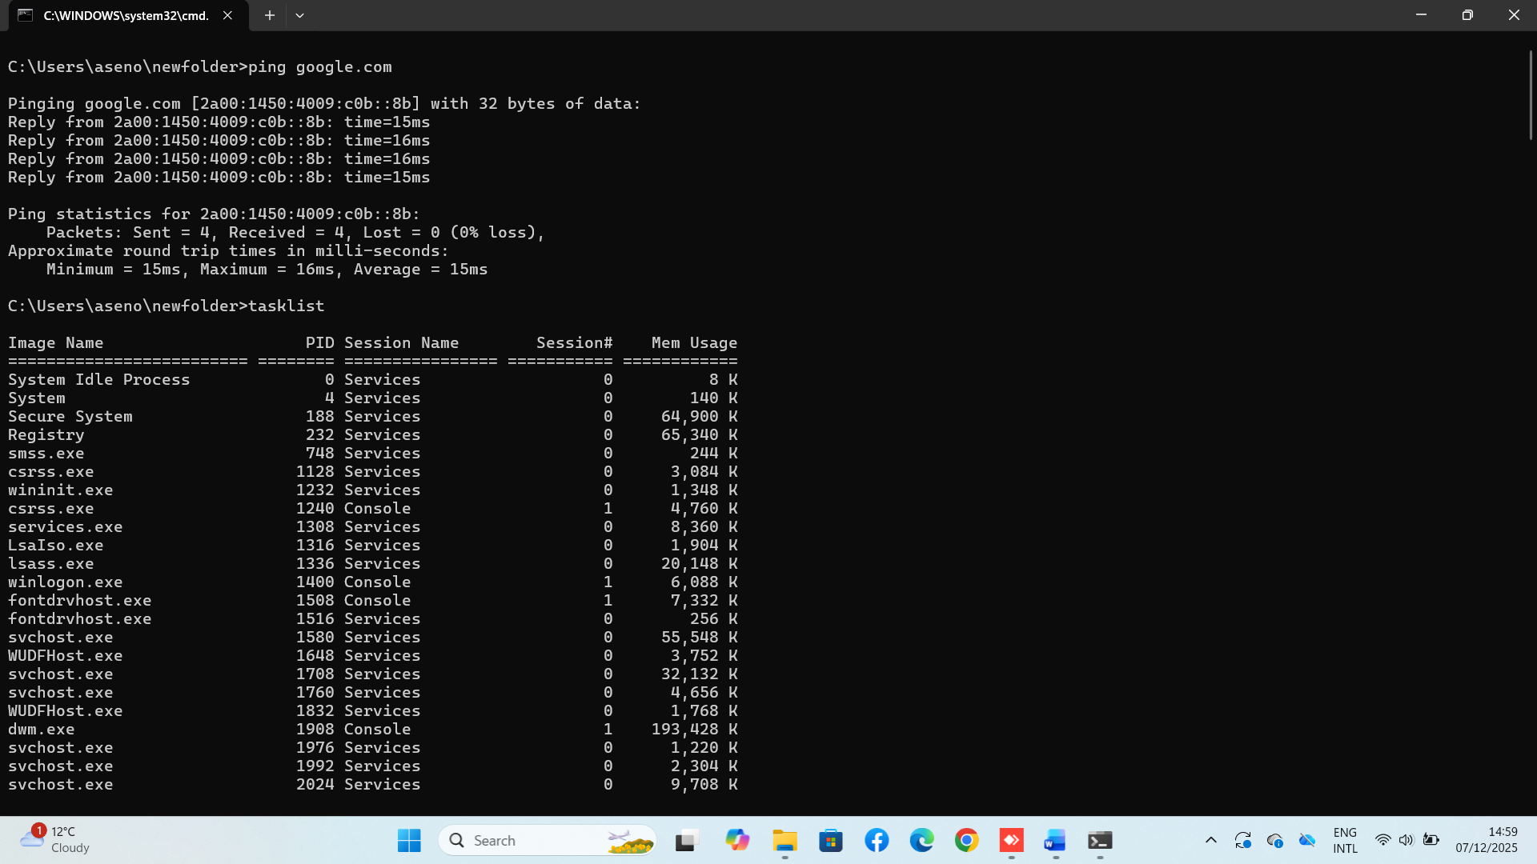

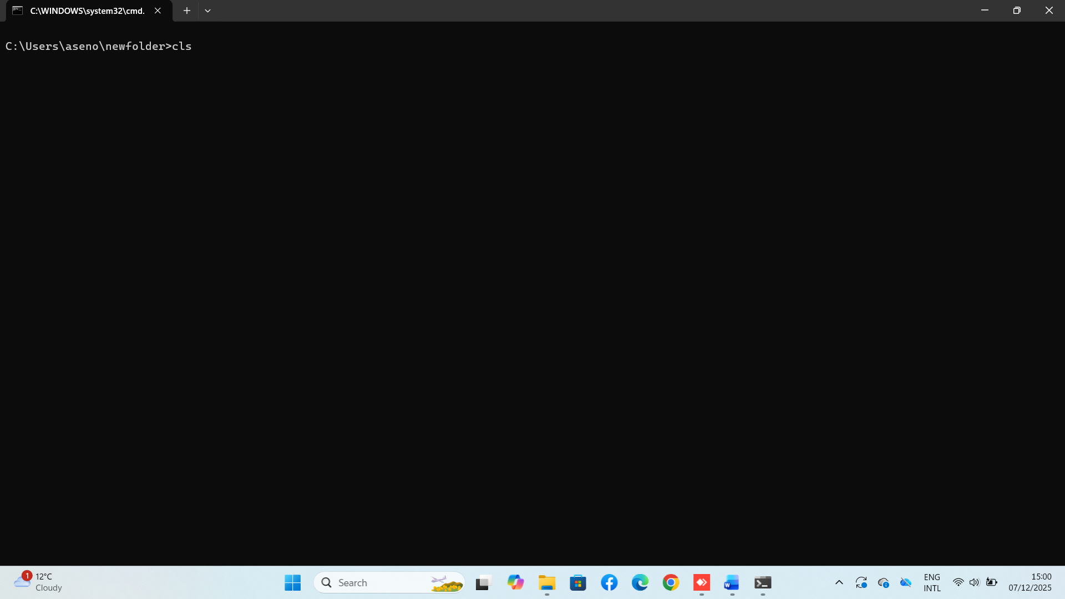

Use of Linux OS CLI commands

Here because I don’t have a Linux machine, I have used an online Linux Terminal simulator.
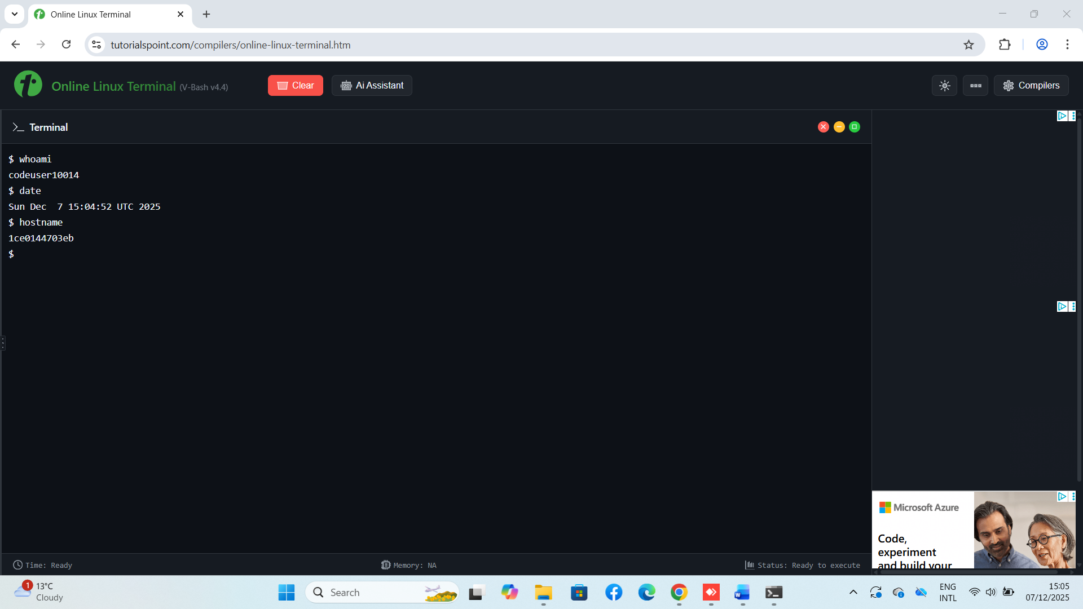

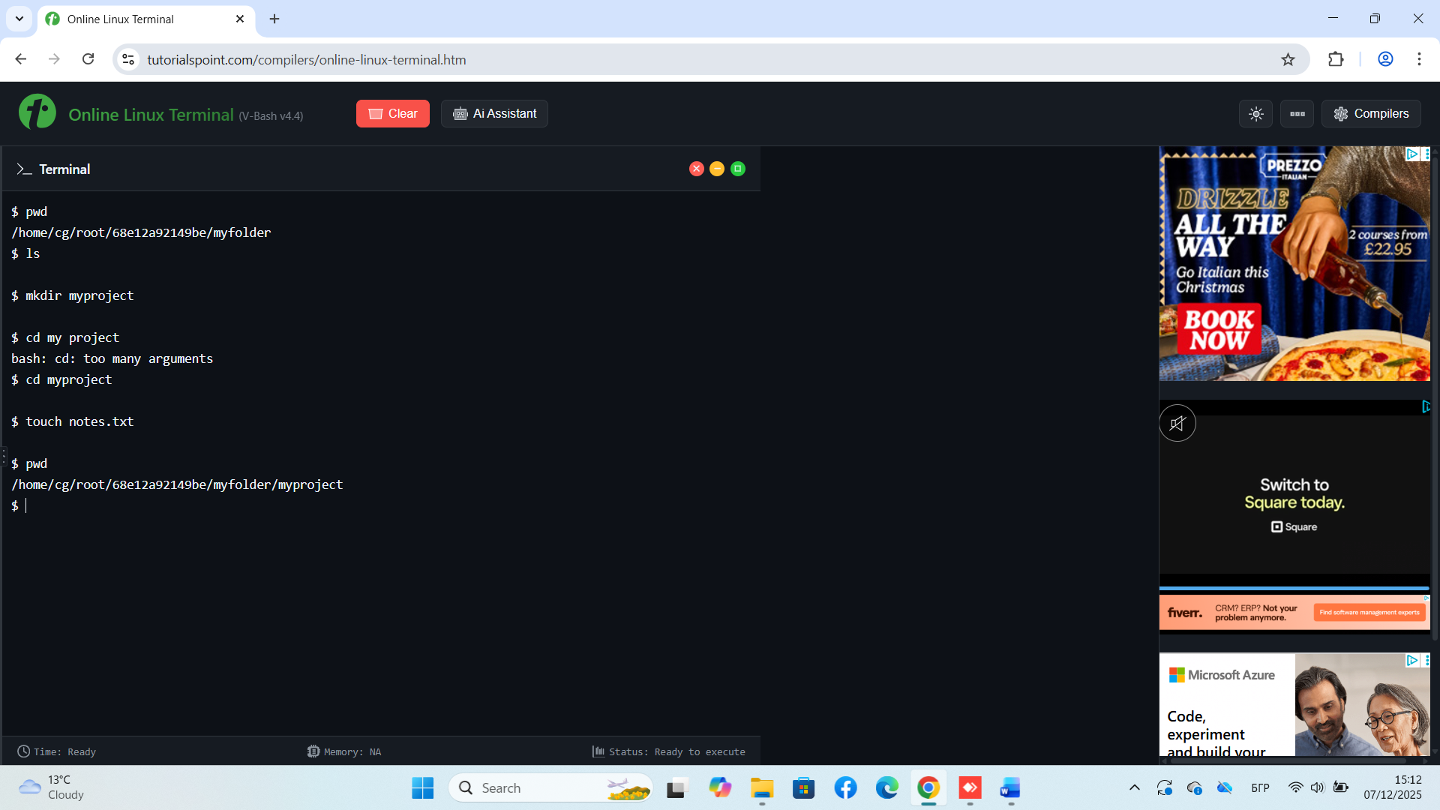

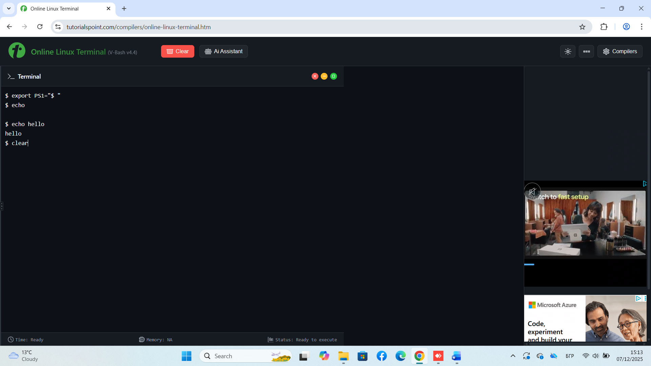

Use of Windows OS scripts (Batch Scripting)
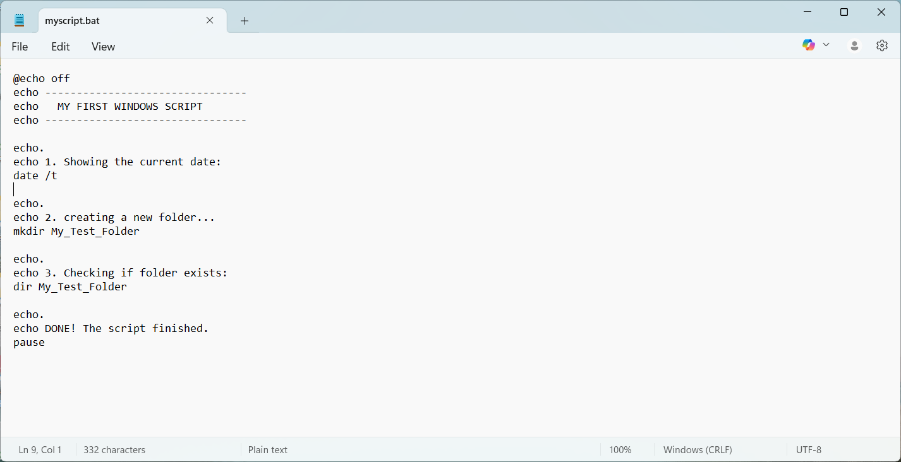
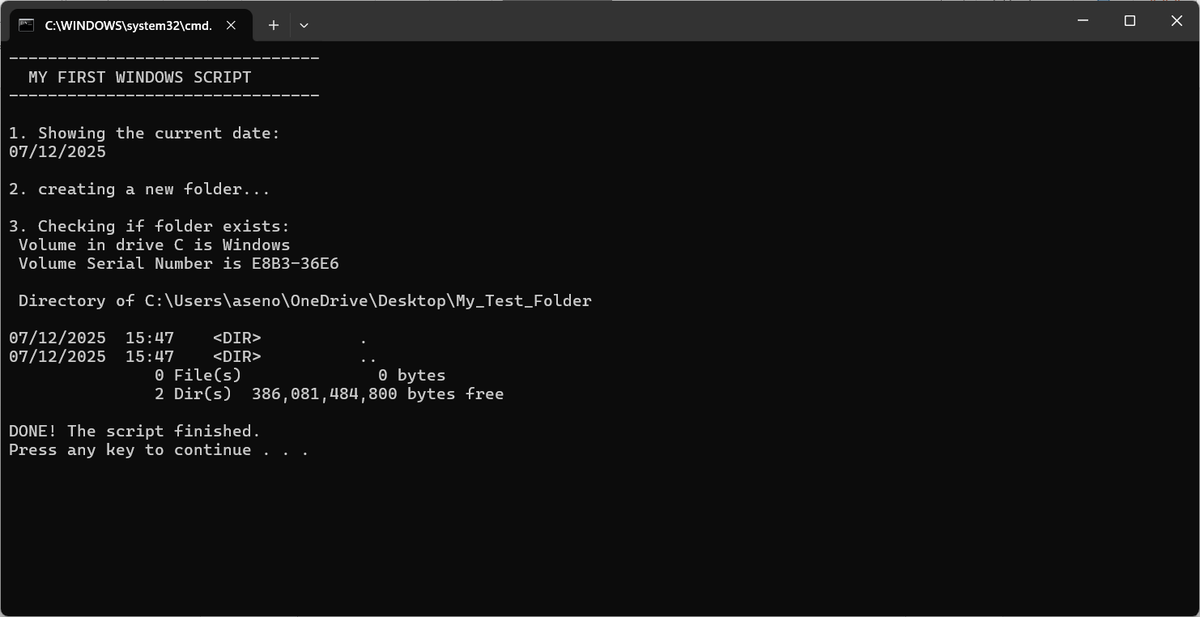

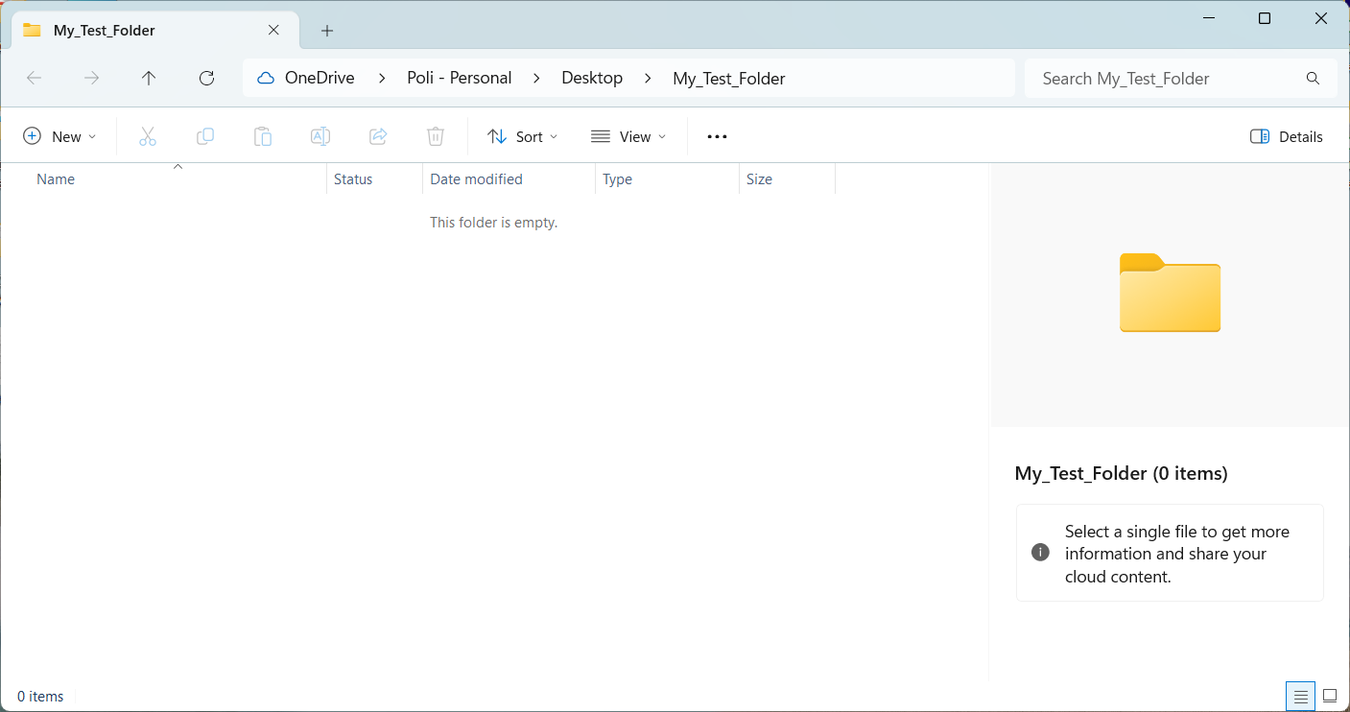
I created this script to automate a few simple tasks. Here is exactly what it does, step by step:
- Cleaning the View: The command @echo off is used at the start. It tells the computer to hide the "code" and only show the results. This makes the black window look cleaner and easier to read.
- Showing the Date: The script asks the system for today's date using date /t and displays it on the screen.
- Creating a Folder: This is the main job of the script. The command mkdir My_Test_Folder automatically creates a new empty folder in the current location. This saves me from clicking "New Folder" manually.
- Verification: After creating the folder, the script uses dir to look inside and confirm that the folder exists.
- Pause: Finally, the pause command stops the window from closing immediately. It waits for me to press a key, so I have time to read the information.

Use of Linux OS scripts (Bash Scripting)

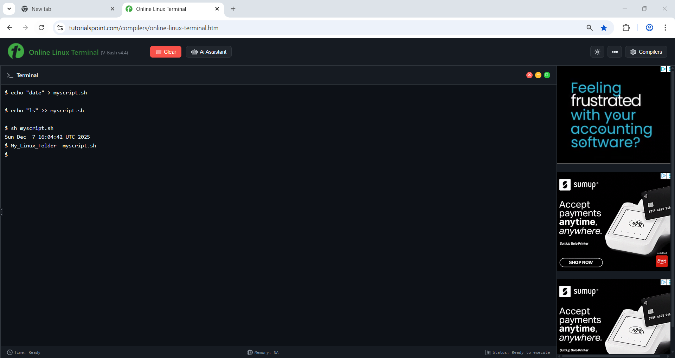

For the last task, I created a basic Bash script . I used the online Linux terminal to demonstrate that a script is simply a text file containing commands.

Script Description: I created a file named myscript.sh. As shown in the screenshot, the script runs just two commands automatically:
- Date Command: The script runs date to display the current system time.
- List Command: Then, it runs ls to show the files in the current directory.

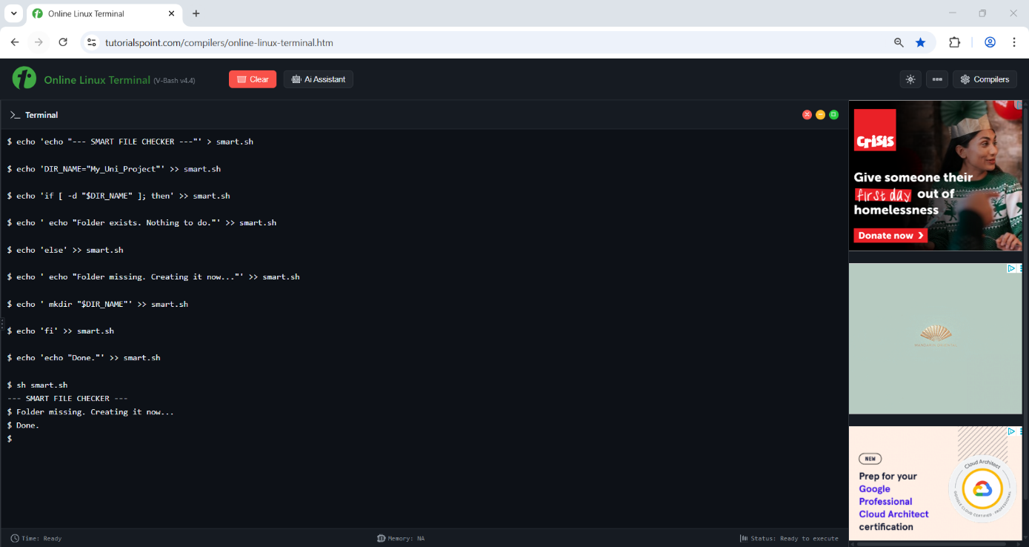

For the final task, I created a more advanced Bash script using an online Linux terminal. Instead of just running commands linearly, this script uses conditional logic (if/else) to make decisions based on the system's state .

Script Analysis: I created a file named smart.sh. As shown in the screenshot, the script performs the following logic:
- Variables: I defined a variable DIR_NAME="My_Uni_Project". Storing data in variables makes the script reusable and easier to modify later.
- Conditional Logic (If/Else): The core of the script is the if [ -d ... ] statement. This command checks if the directory already exists on the system.
- If it exists: The script prints a message and does nothing, preventing errors.
- If it does not exist (Else): The script automatically runs mkdir to create the folder.

Conclusion
In conclusion, this coursework provided a comprehensive practical exploration of Operating System architecture. By navigating through both Windows and Linux environments, I gained a deeper understanding of how an OS acts as an intermediary between the user and the hardware.
A key part of my learning was mastering file system navigation. I understood that commands like dir (in Windows) and ls (in Linux) are essential for verifying file structures and tracking data. I learned not only how to list files, but how to organize them logically using mkdir to create directories and cd to move between them. This experience demonstrated that the Command Line Interface (CLI) gives me direct and fast control over the system, unlike the graphical interface where many processes are hidden.
Finally, the development of Batch and Bash scripts highlighted the importance of automation. By implementing conditional logic in the Linux script, I learned how to create tools that adapt to the system's state. Overall, these tasks bridged the gap between theory and practice, giving me the confidence to work with system commands.

References
[1] Microsoft, "Windows Commands: A comprehensive reference," Microsoft Learn, 2024. [Online]. Available: https://learn.microsoft.com/en-us/windows-server/administration/windows-commands/windows-commands. [Accessed: Dec. 07, 2025].

[2] Ubuntu, "The Linux command line for beginners," Ubuntu Tutorials, 2024. [Online]. Available: https://ubuntu.com/tutorials/command-line-for-beginners. [Accessed: Dec. 07, 2025].

[3] Red Hat, "13 resources for learning to write better Bash code," Red Hat Blog, 2021. [Online]. Available: https://www.redhat.com/en/blog/learn-bash-scripting. [Accessed: Dec. 07, 2025].

[4] Microsoft, "Troubleshoot processes by using Task Manager," Microsoft Learn, 2025. [Online]. Available: https://learn.microsoft.com/en-us/troubleshoot/windows-server/support-tools/support-tools-task-manager. [Accessed: Dec. 07, 2025].

[5] GNU Project, "Bash Reference Manual," GNU.org, 2024. [Online]. Available: https://www.gnu.org/software/bash/manual/bash.html. [Accessed: Dec. 07, 2025].

[6] IBM, "Basic Linux commands," IBM Documentation, 2023. [Online]. Available: https://www.ibm.com/docs/en/aix/7.2?topic=commands-basic-linux. [Accessed: Dec. 07, 2025].

[7] GeeksforGeeks, "Basics of Batch Scripting," GeeksforGeeks, 2024. [Online]. Available: https://www.geeksforgeeks.org/linux-unix/basics-of-batch-scripting/. [Accessed: Dec. 07, 2025].
[8] TutorialsPoint, "Execute Linux Commands Online," TutorialsPoint Coding Ground, 2024. [Online]. Available: https://www.tutorialspoint.com/unix_terminal_online.php. [Accessed: Dec. 07, 2025].

[9] Microsoft, "echo | Microsoft Learn," Microsoft Learn, 2023. [Online]. Available: https://learn.microsoft.com/en-us/windows-server/administration/windows-commands/echo. [Accessed: Dec. 07, 2025].
[10] Red Hat, "10 basic Linux commands you need to know," Red Hat Blog, 2019. [Online]. Available: https://www.redhat.com/en/blog/basic-linux-commands. [Accessed: Dec. 07, 2025].

