Qualification: CIPD Diploma in Applied Human Resources

Module Name:

Contributing to Resourcing and Talent Planning in the Organisation

Word Count: 2773

Student Name: Carys Francis
Student Number: 1904626
CIPD Membership Number: 55382687

By signing below, I confirm that the work/evidence presented is my own, unaided work. I understand the regulations pertaining to candidate malpractice and the action that may be taken as a result.

Signed: C Francis
Date: 21/05/2021

Contents

Activity one………………………………………………………….…Pages 6-19

Be able to review and evaluate an organisations approach to talent planning

Activity two…………………………………………………………….Pages 20-25

Be able to recommend ways to improve an organisations approach to talent planning

Activity three……………………………………………………..……Pages 26-48

Be able to contribute to people resourcing activities

Reference list……………………………………………………...….Page 49

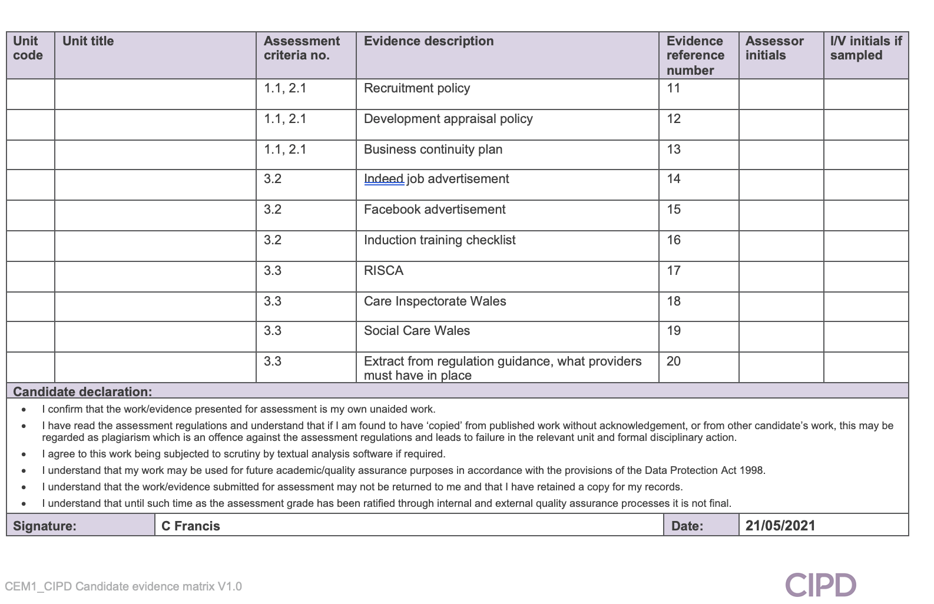
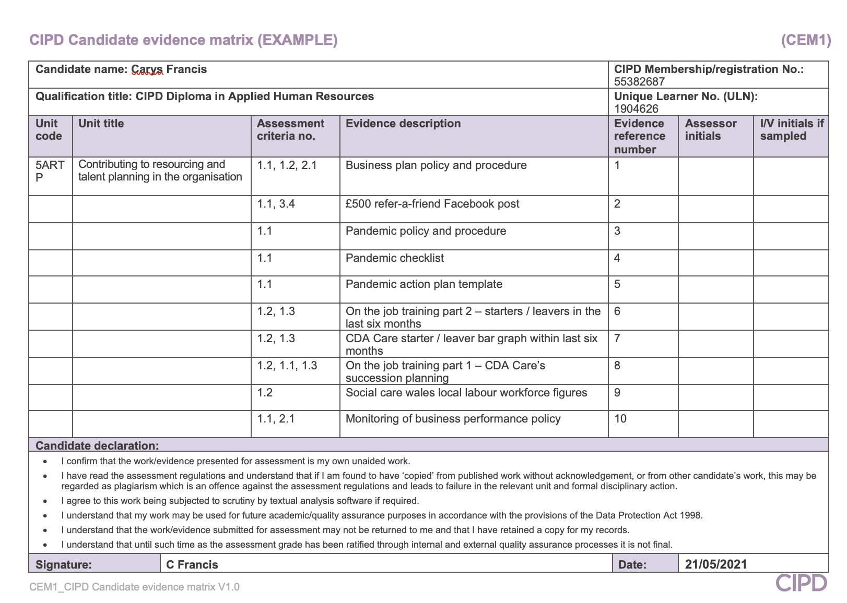

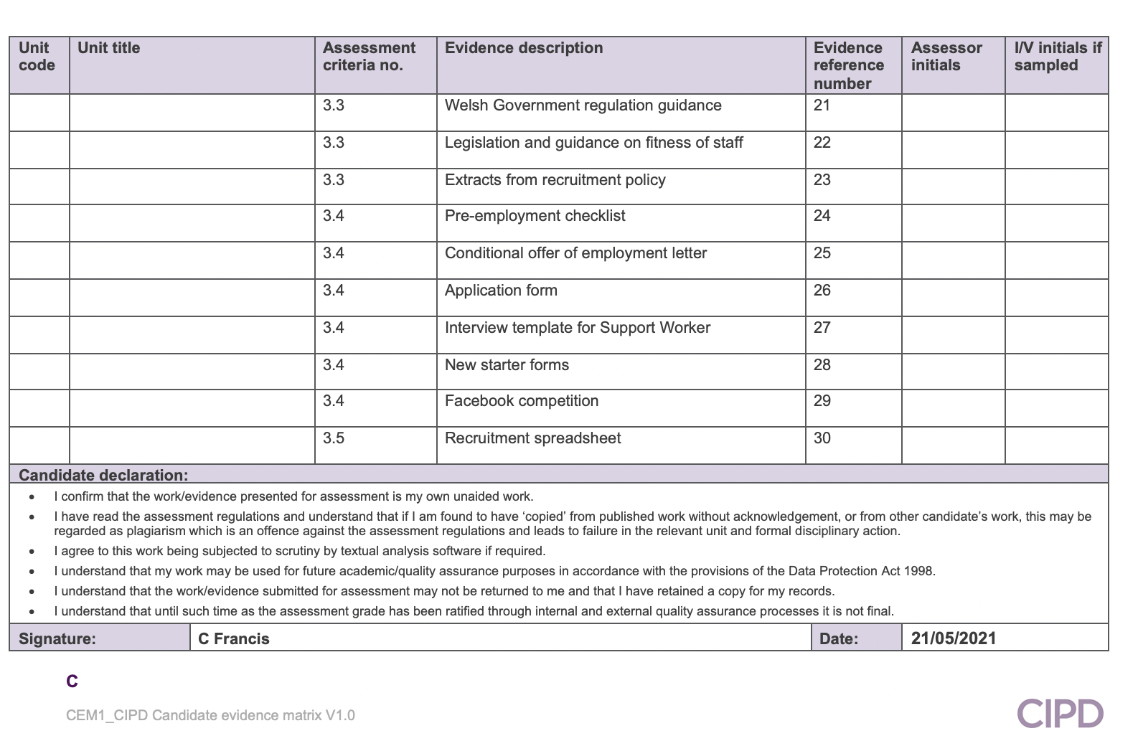

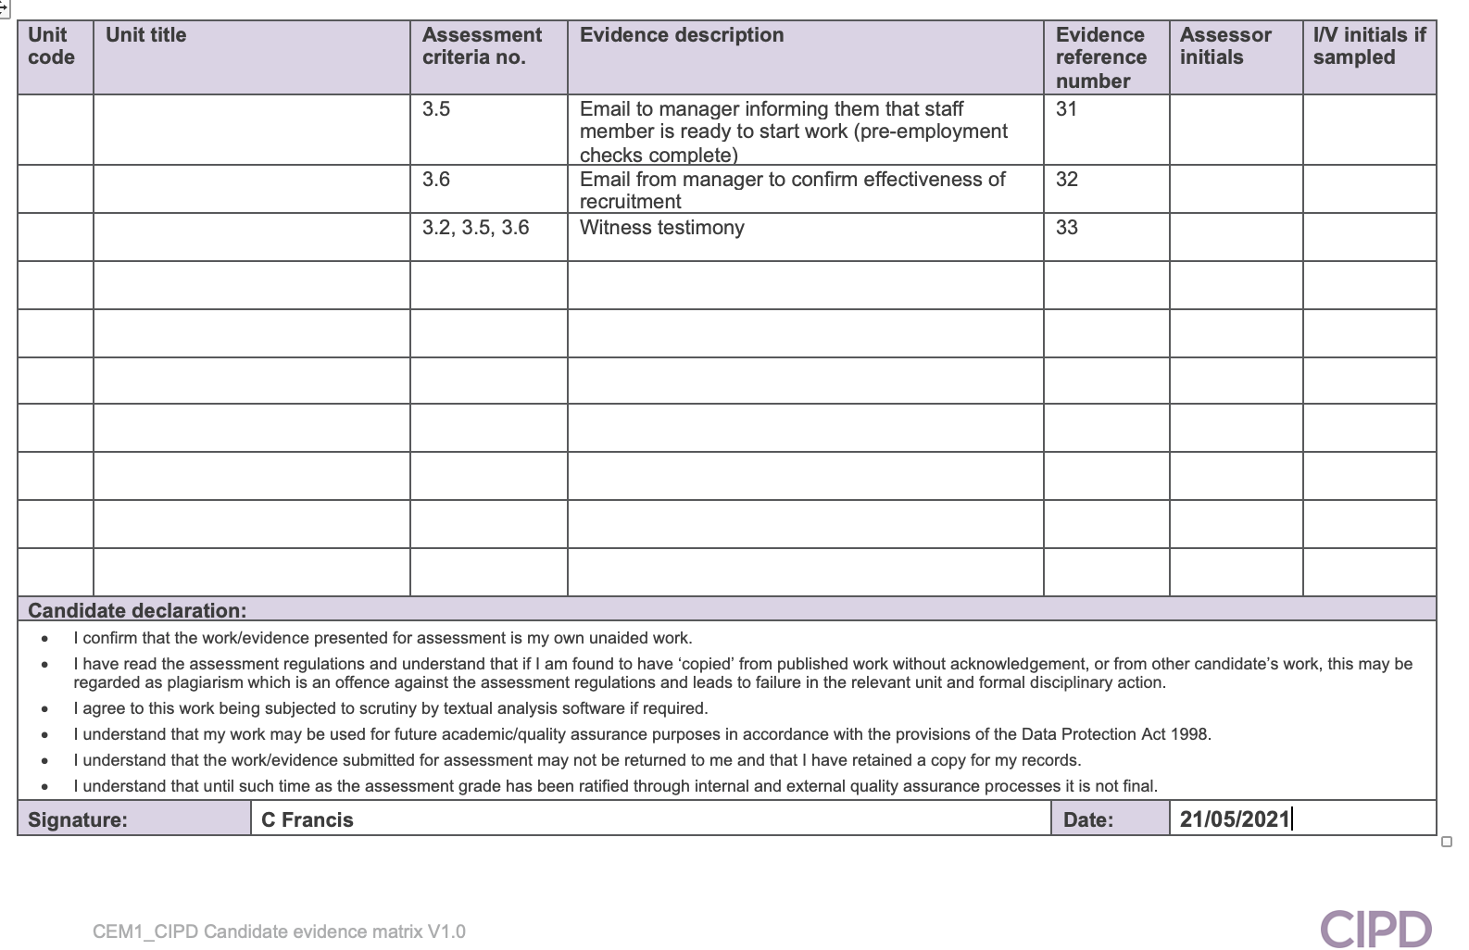

Contributing to Resourcing and Talent Planning

LO1: Be able to review and evaluate an organisations approach to talent planning

  - Assess how and to what extent the organisation undertakes workforce and talent planning.

(ev1). CDA Care’s approach to workforce and talent planning is mainly informal. Recruiting within the domiciliary care sector can be very unpredictable and due to this there are always unlimited vacancies for support workers within CDA Care. The reason for this is due to the high turnover of staff within the health and social care sector, the fact that there are always individuals in the community awaiting a care package, and high levels of sickness absence (especially during the Covid-19 pandemic). The Covid-19 pandemic has had a big impact on the recruitment of staff within CDA Care, with the number of people seeking roles in domiciliary care decreasing since the start of the pandemic. Recruitment incentives and initiatives have been introduced such as £500 refer-a-friend scheme for the month of May (ev2). Different methods of networking and recruiting utilised by CDA Care include: Facebook, Indeed, and networking with agencies and job centres. Networking with agencies has been essential during the pandemic to ensure there is a pool of available support workers to hire from the agency in case of emergencies.

In response to the decrease in applicants for the position of support worker, CDA Care have had to look at different ways of trying to retain the staff that are already employed by offering career development opportunities and allowing flexible working. Many employees have found themselves with no childcare whilst the schools have been closed during lockdowns, therefore, to avoid the risk of losing these employees we have allowed them to be able to work under flexible working arrangements on a temporary basis.

A ‘pandemic checklist’ which forms part of CDA Care’s pandemic policy and procedure (ev3) has been issued to the management team which has helped them identify how many staff members they need to be able to deliver their services, and the measures that need to be implemented in a situation where key staff are unavailable for work (ev4). Included with this is an action plan template for the management team to use during the pandemic. (ev5).

  - Analyse internal and external information relating to the organisation’s future people and skills needs and the availability of talent.

Internal

CDA Care’s organisational goals have remained the same throughout the pandemic and it is evident that there has been a high demand for care throughout this time (Welsh Government, 2021), meaning it has been and continues to be mostly business as usual for the organisation. However, due to the social distancing guidelines that have been implemented in response to the pandemic, this has meant that certain strategies such as training and development, and recruitment, have had to be adapted. All training including induction sessions for new employees has had to be held remotely over Microsoft Teams. Interviews for new members of staff have also had to be held remotely, in-line with social distancing guidelines.

The availability for talent during the pandemic has been challenging (Social Care Wales, 2020, recruiting staff) with the number of individuals requiring care in the community increasing, and the number of people applying for job roles in the domiciliary care sector decreasing. In addition to this, it has been difficult to retain staff during the pandemic due to many different reasons, one of those reasons being the pressure of the pandemic on organisations and their workforce. In the last six months CDA Care have recruited sixty-two new support workers, however, have also lost fifty support workers (ev6) (ev7).

CDA Care’s succession planning consists of policies such as: business planning, business performance, recruitment, development, and business continuity. The business continuity policy is reviewed on a regular basis to ensure the impact of a pandemic or emergency is minimal (ev8).

External

On 1st June 2020 Social Care Wales (2020) published a local labour force survey, stating that at the time there were 19,637 domiciliary care workers on the register in Wales. 64% of those hold a qualification relevant to their job role, whilst 22% of those were required to complete their qualification within three years of registering. 48% work in the private sector, whilst others were employed by local authorities, the remaining worked either for agencies or in the third sector. The average age of those workers are 44 years old, with 84% being female, and 96.5% of British ethnicity (ev9).

Covid-19 has had a big impact on resourcing and talent planning within health and social care. With organisations having to introduce social distancing measures it has been challenging to recruit new employees from other sectors due to not being able to deliver the appropriate training and induction. Recruiting within the sector has also been challenging as people have been holding off applying for new jobs due to uncertainty around the pandemic (search, 2020).

  - Assess the extent to which current organisational planning activities are addressing potential needs.

According to Taylor and Woodhams (2016) there are four steps that should be followed when resourcing and talent planning: ‘forecast’ the future demand for people and skills; predict what skills the business will have; recognise the gap between the demand and the supply; create a plan to fill the gap. These four stages can be completed using different approaches: systematic – predict future needs based on past trends; managerial judgement – make decisions based on management’s experience and knowledge; ‘working back from costs’ – use the future budget to decide how many staff the organisation can afford. All employees should be offered opportunities for career development, and also training and learning opportunities.

To be successful, resourcing strategies must be based on attracting the right people to the organisation and should focus on allowing the business to stand out from competitors. When developing a strategy, it is useful to take into account the following factors: study what competitors are doing, the organisations position in relation to the labour market, and employer branding (Taylor and Woodhams, 2016).

Considering the best practice guidance and CDA Care’s current approach to talent planning, it is evident that a more robust strategy could be implemented within the organisation. Currently, business needs aren’t being met as they should due to the lack of available staff (support workers) however by adopting the best practice approach set out by Taylor and Woodhams (2016) and using a systematic approach to look at past trends we could better plan for the future and be more pro-active rather than just dealing with what is happening at that moment.

(ev6, ev7, ev8).

Evidence:

Business plan policy and procedure (ev1)
£500 refer-a-friend Facebook post (ev2)
Pandemic policy and procedure (ev3)
Pandemic checklist (ev4)
Action plan template (ev5)
On the job training part 2 – leavers within the last six months (ev6)
CDA Care starter / leaver bar graph within the last six months (ev7)
On the job training part 1 – CDA Care’s succession planning (ev8)
Social Care Wales local labour workforce figures (ev9)
Monitoring of business performance policy (ev10)
Recruitment policy (ev11)
Development appraisal policy (ev12)
Business continuity plan (ev13)

Evidence No 1.

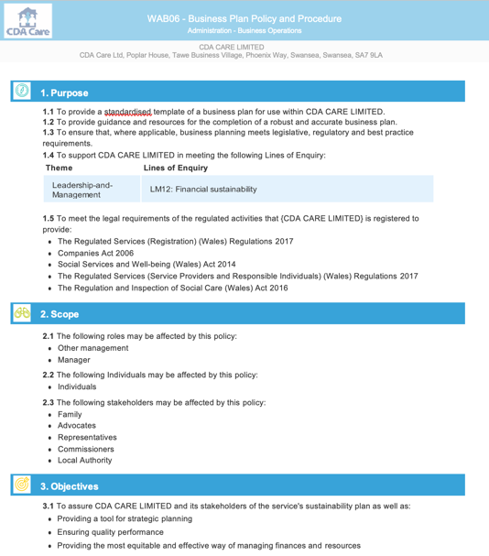

Evidence No 2.



Evidence No 3.

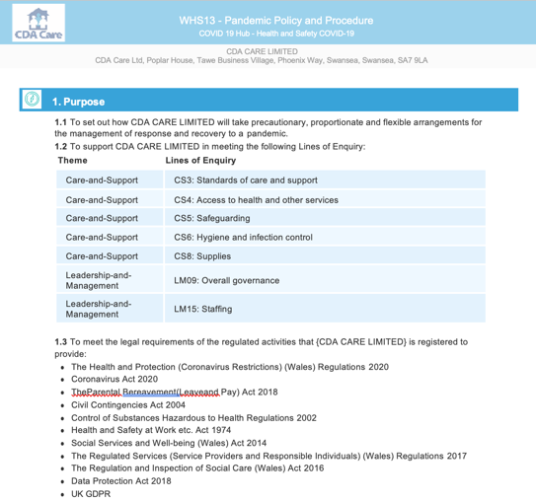

Evidence No 4.
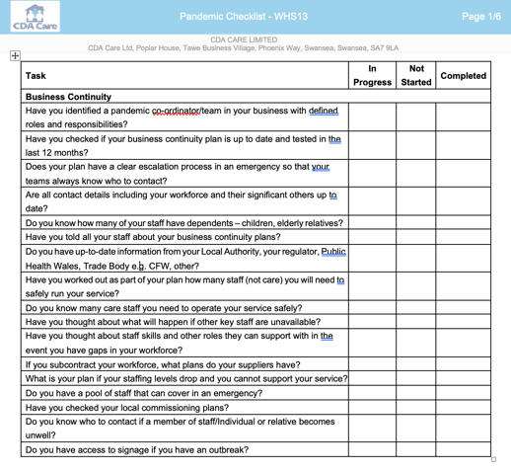

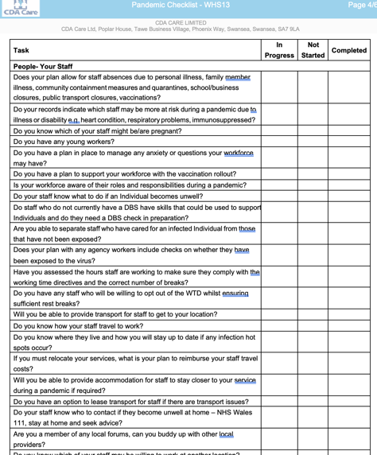

Evidence No 5.

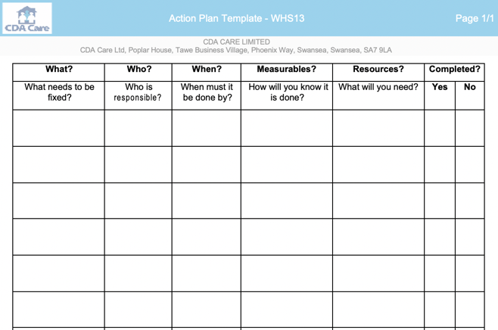

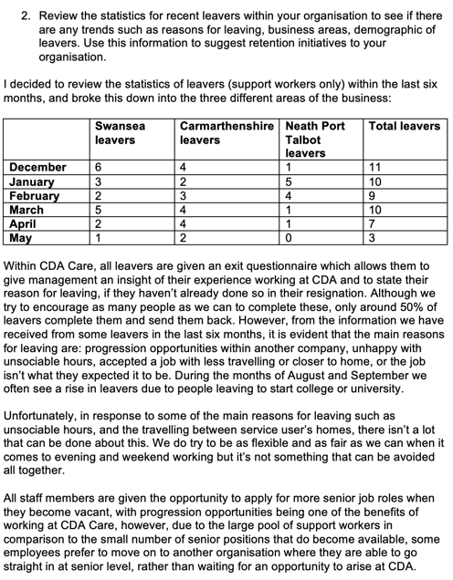
Evidence No 6.

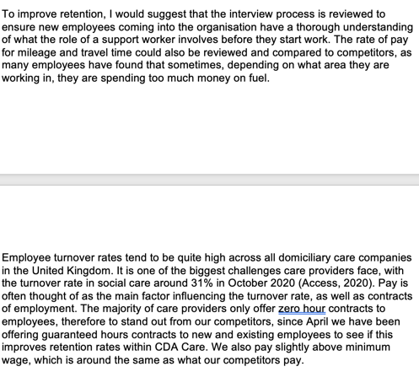

Evidence No 7.

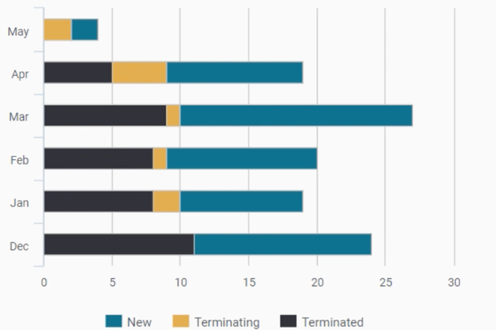

Evidence No 8.

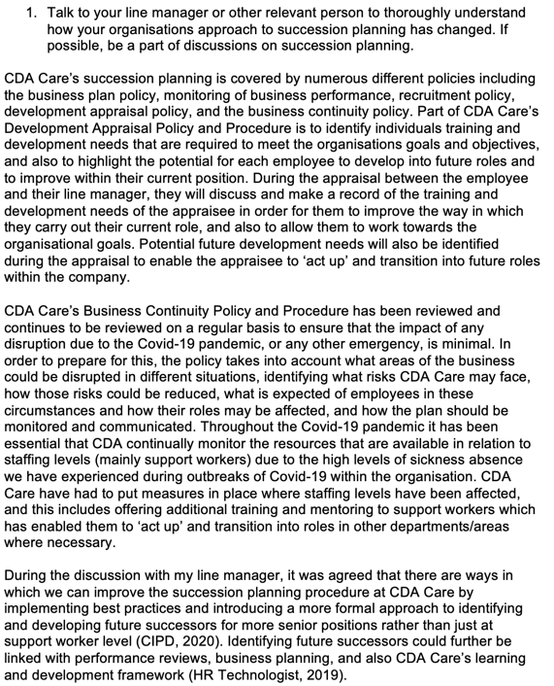

Evidence No 9.

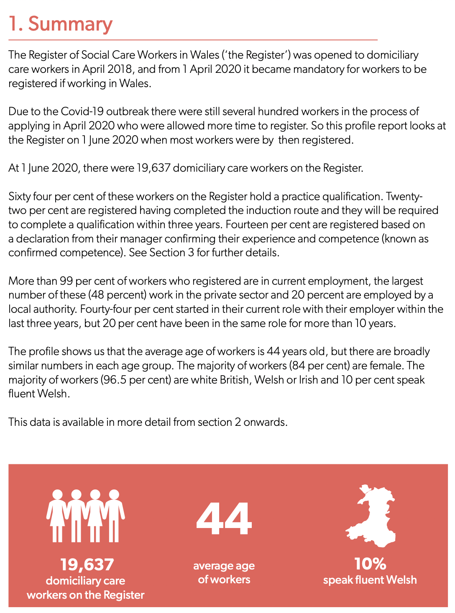

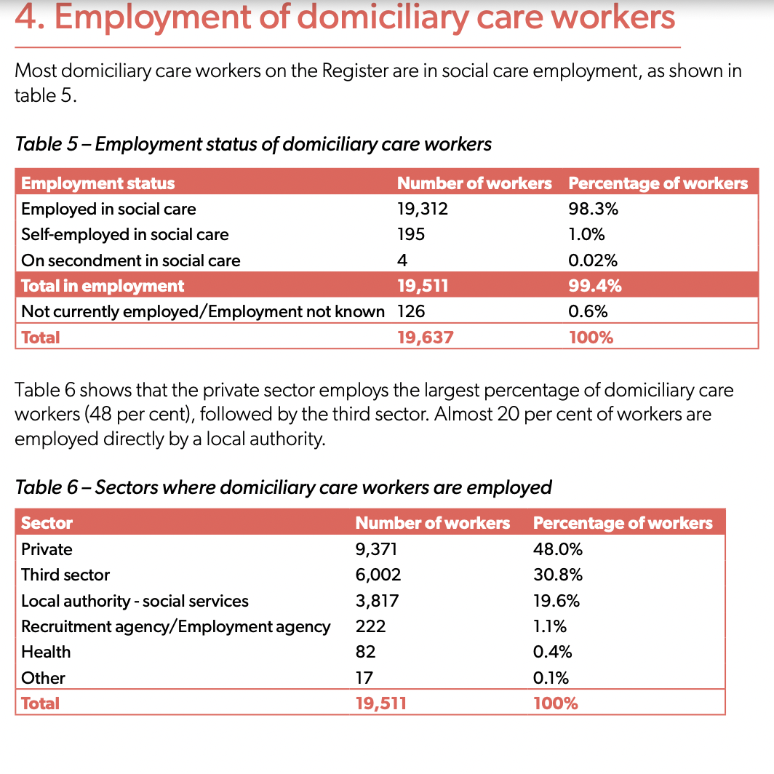

LO2: Be able to recommend ways to improve an organisations approach to talent planning

2.1 Make reasoned recommendations for how the organisation can maintain an appropriate number of people with the skills required by the organisation.

When comparing CDA Care’s current approach to resourcing and talent planning to best practice and guidance, it’s evident that there are multiple areas that could be improved in order to get the most out of talent planning. Due to the approach being mainly informal, there are no policies, procedures, or strategies in place to reflect the succession planning that takes place, or no documentation to back this up. Although CDA Care’s succession planning process is briefly covered in policies such as: business planning (ev1), monitoring of business performance (ev10), recruitment (ev11), development appraisal (ev12) and business continuity (ev13), a more formal approach reflected within a succession planning policy would ensure that we are getting the most out of succession planning. Succession planning could then also be in place for management roles, as well as just at support worker level. This will benefit CDA Care by having the right talent available to fill job roles at short notice and will save time and money in the recruitment process (Williams, 2019).

Other recommendations include:

Develop a robust resourcing and talent planning strategy

Taylor (2014) states that organisations are more likely to be able to improve organisational performance and efficiency where there is a strategic approach in place in relation to resourcing and talent planning. A strategy should be developed based on CDA Care’s overall business strategy, and mission and values. A systematic approach should be taken and past trends within CDA Care should be analysed, the results of this can then be incorporated into the strategy. The strategy should take into account the following factors: what future talent will be required and when, where the talent can be sourced, workforce planning – how many employees will be required and what skills/qualifications they will need, and ways of retaining employees. The most effective and cost appropriate channel of recruiting should be identified and also incorporated into the strategy. Once complete, the strategy should be reviewed on a regular basis to ensure efficiency and any changes should be communicated to all staff, especially those who are responsible for the recruitment and retention of employees (Randstad, 2019).

Improve employer branding

Employer branding has proven to be an effective strategy when resourcing and talent planning. According to Alina (2017) employer branding creates two different assets to the organisation: ‘brand associations’ which would make CDA Care attractive to potential new employees, and secondly ‘brand loyalty’ which builds a positive culture within the organisation and brand identity, leading to motivated, loyal employees. This is also sometimes referred to as ‘employee value proposition’ – what the organisation ‘stands for, requires and offers as an employer’. Having a positive employer brand will allow CDA Care to stand out from competitors and to be in a good position in the labour market. Employer brand should also form the organisational approach to people management (CIPD, employer branding, 2020). CDA Care could monitor employee brand by analysing quantitative and qualitative data, such as attrition rates, number of job applicants, survey responses, etc. CIPD state that there are four stages to developing employer brand: discover how the employer is perceived by stakeholders, decide what the employee value proposition is, implement and communicate the brand, and review and make amendments/improvements where necessary. Employer branding should be consistent with the recruitment process, job specifications, and person specifications (Randstad, 2019).

Be aware of external labour markets

It would be beneficial for CDA Care to be more aware of external labour markets and how it impacts on the organisation. Analysing this information will help to predict the talent that is available and will be available in the future and will also provide information on what competitors are doing. CDA should be aware of who competitors are and how attractive they are to new recruits, how many people they recruit and the pay/benefits that they offer employees. It would also be beneficial to be aware of trends such as skills, geographical areas, and qualifications, etc. Sources of this type of information include the Government website, office for national statistics and professional bodies (XpertHR, 2021). To enable resourcing and talent planning to be successful it’s important that CDA has a breadth of knowledge in the labour market. CDA should be aware of where current staff have come from and what they were doing before they came to CDA, and when employees have left, where they have moved on to (who are the employers and what location are they in). Other data that needs to be monitored include the characteristics of the working population, such as age, sectors of employment and skills/qualifications. It’s important to have a good understanding of what competitors are offering and whether any skills gaps are getting worse or better (CIPD, workforce planning practice, 2018).

Evidence:

Business plan policy (ev1)
Monitoring of business performance policy (ev10)
Recruitment policy (ev11)
Development appraisal policy (ev12)
Business continuity plan (ev13)

Evidence No 10.
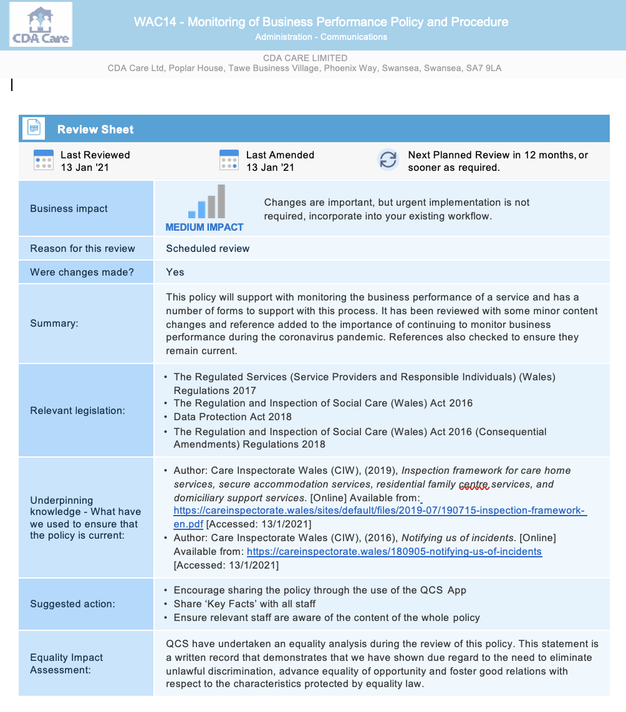

Evidence No 11.

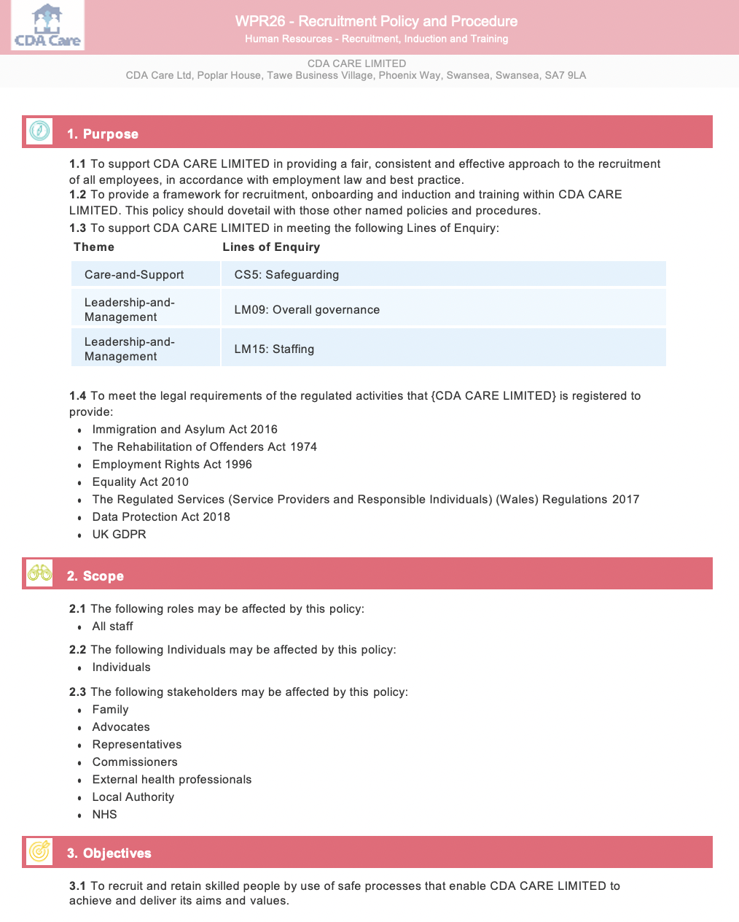

Evidence No 12.

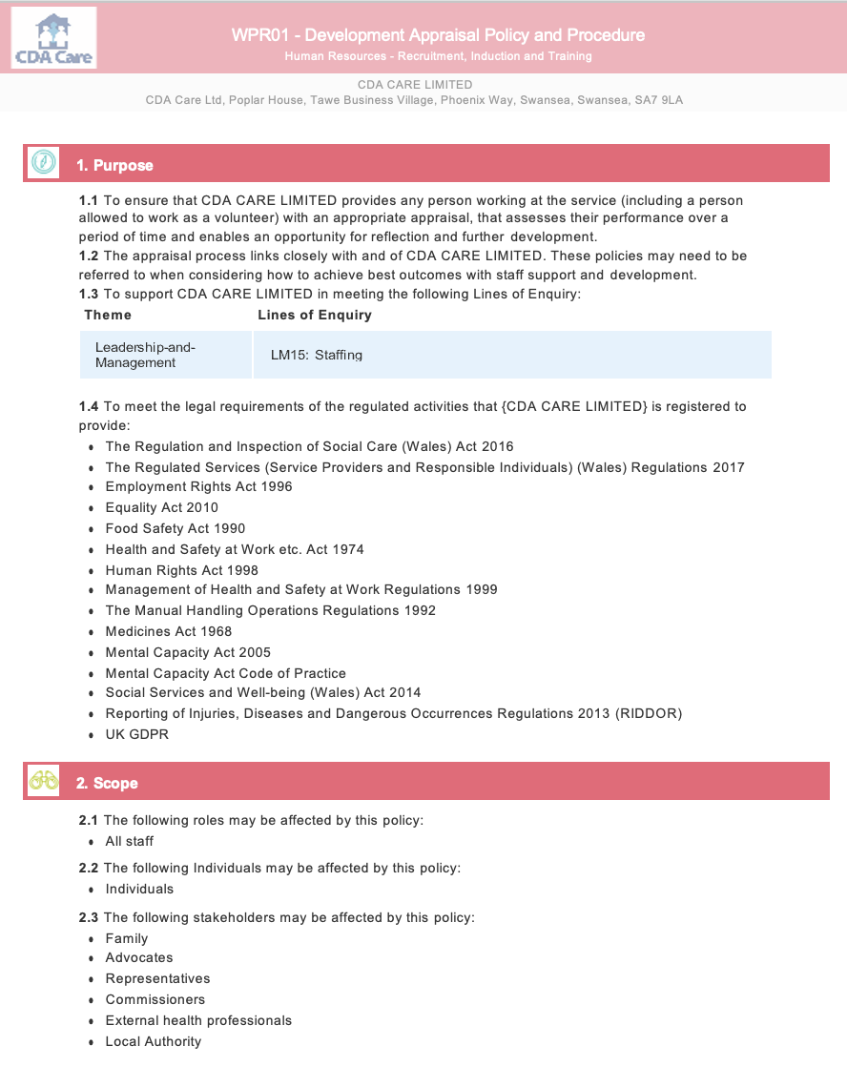

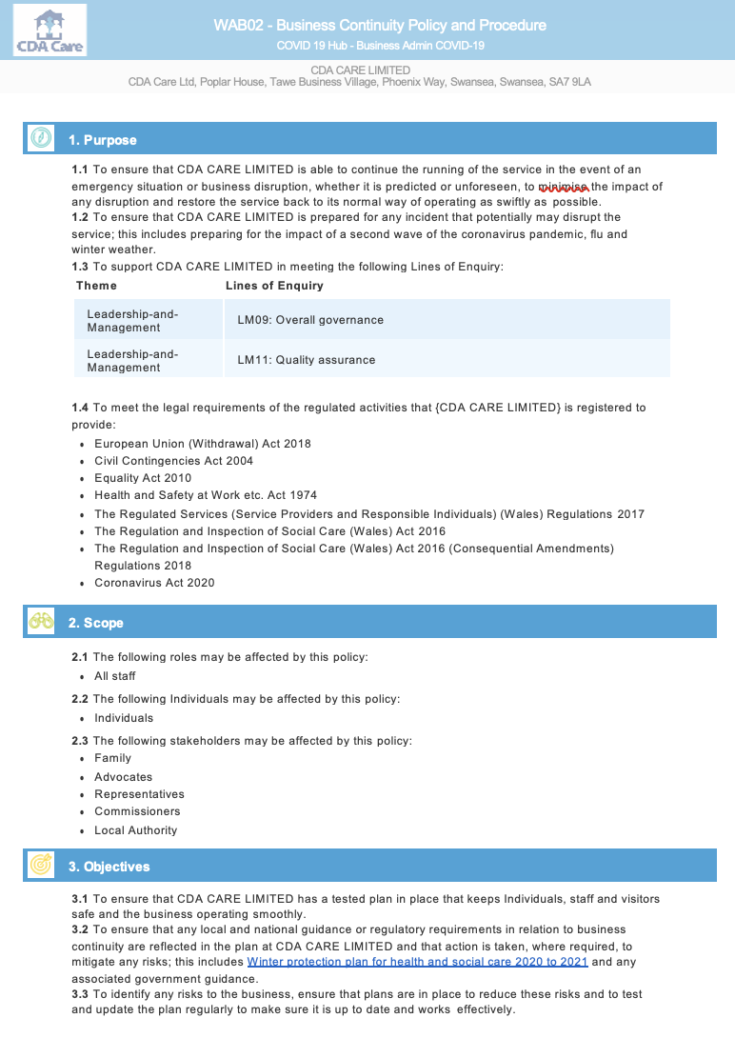
Evidence No 13.

LO3: Be able to contribute to people resourcing activities

3.1 Identify and explain the rationale for a specific resourcing activity within the organisation.

Recruitment and selection is a vital part of my role as HR Manager within CDA Care, without recruitment the services that we deliver wouldn’t be able to continue. It is my responsibility to ensure that recruitment and selection procedures are in line with company policy, legislation, and regulations set out by care inspectorate wales and social care wales. It’s also important that all candidates go through the relevant pre-employment checks to ensure a safe working environment for employees, and the services users that we care for in the community, in their own homes. A part of this responsibility includes ensuring all new employees successfully complete the induction training programme so that they have the correct knowledge and skills to be able to carry out their role as a support worker safely.

3.2 Agree roles and responsibilities with other contributors to the activity.

There are multiple people involved in the recruitment and selection process, and all have different responsibilities:

My role is to post job advertisements online (Indeed (ev14), Facebook (ev15)), ensure policies and procedures are in line with legal requirements, carry out all pre-employment checks, create personnel files, ensure candidate is compliant before handing over to line manager to commence work. We have also recently recruited a ‘recruitment administrator’ who I am currently training to take responsibility of these tasks.

The training manager has a responsibility to ensure that each candidate participates and completes the induction training programme, which covers all mandatory topics (manual handling, administration of medication, etc.) (ev16). The training manager will also monitor the behaviour of candidates throughout the training programme and will bring any concerns to my attention.

The registered managers will screen applications that we receive online and will interview those who are suitable. Once the manager has completed the interview, they will then inform me as to who is successful and who isn’t successful, for me to complete necessary paperwork/documentation.

3.3 Identify organisational procedures and legislative requirements which underpin the activity.

It is mandatory that CDA Care’s recruitment and selection process is in line with ‘Regulation and Inspection of Social Care Wales Act 2016’ (RISCA) (ev17), as well as general employment law and national minimum standards for care. CDA Care is regulated by the professional body Care Inspectorate Wales (2021) (ev18) and Social Care Wales (2021) (ev19). Social Care Wales set out the standards for the care and support workforce, and work with the government to improve outcomes in the health and social care sector. The regulations dictate that care providers must have in place: ‘policies and procedures for recruitment, rigorous practices for recruiting and vetting staff, a management structure, systems, and processes for induction, ongoing supervision, training and development of staff’ (ev20). The Welsh Government provide statutory guidance relating to ‘The Regulated Services (service providers and responsible individuals) (Wales) Regulations 2017’ for care providers (ev21). The guidance sets out minimum requirements for pre-employment checks including a criminal record check with the Disclosure and Barring Service (2021), written references, and the correct skills and competency to carry out the role of a support worker (ev22). CDA Care’s recruitment policy (ev23) is written in accordance with employment law and legislation, and best practice guidance.

3.4 Plan and prepare for agreed role, ensuring the availability of any materials or resources required.

To ensure compliancy with company procedure and legislative requirements, I created a pre-employment checklist to be used my myself and the recruitment administrator at CDA Care (ev24). I have also drafted offer of employment letters (ev25), application forms (ev26), interview templates (ev27), and new starter forms (ev28) to assist with the recruitment process, and to ensure that myself and management have access to the materials/resources that we require.

In the past I have liaised with online jobs boards such as Indeed, Monster, and Total Jobs to agree a budget on our job advertisements. After trialling different online jobs boards, we found Indeed to be the most successful, therefore this is the only jobs board that we are currently utilising. I also set up a CDA Care Facebook page to promote our employer brand and advertise job vacancies. This page has also been used to advertise recruitment incentives such as refer-a-friend (ev2) and other competitions to promote the organisation (ev29).

3.5 Undertake agreed role in a timely and accurate manner, in line with organisational procedures and legislative requirements.

Recruitment and selection responsibilities are a daily part of my role as HR manager, even though we currently have a recruitment administrator in training preparing to take over these tasks, I am still responsible for ensuring that company procedure is followed at all times and that we are compliant with law and legislation. Due to the urgency of the need for support workers within the teams, especially during the Covid-19 pandemic, it’s essential that myself and the recruitment administrator work as quickly and efficiently as possible to complete pre-employment checks for new starters to get them into work as soon as possible. To monitor this between us, I created a spreadsheet that is accessible to all relevant employees to keep track of who is at what stage in the recruitment process (ev30). Once all pre-employment checks are complete I will then email the relevant manager to inform them that the applicant is ready to start work, and will inform the manager of any further paperwork that needs to be completed with that person when they come in to collect their uniform and work equipment (ev31).

3.6 Reflect on the effectiveness of the resourcing activity in meeting required objectives and report back to stakeholders.

Overall, the recruitment and selection procedure currently in place in CDA Care works well to ensure that vetting of new applicants is an efficient process and is completed in a timely manner. It also ensures that national minimum standards, and requirements set out by law and legislation and professional bodies (such as care inspectorate wales, etc.) are being met. The leadership team within CDA Care are satisfied that the process meets objectives and requirements (ev32). Sixty-two new support workers have been recruited within the last six months, with another twelve currently being vetted. These figures are satisfactory considering the current restrictions due to Covid-19.

Evidence:

£500 refer-a-friend Facebook post (ev2)
Indeed job advertisement (ev14)
Facebook job advertisement (ev15)
Induction training checklist (ev16)
RISCA (ev17)
Care Inspectorate Wales (ev18)
Social Care Wales (ev19)
Extract from regulation guidance, what providers must have in place (ev20)
Welsh Government Regulation guidance (ev21)
Legislation and guidance on fitness of staff (ev22)
Extracts from recruitment policy (ev23)
Pre-employment checklist (ev24)
Conditional offer of employment letter (ev25)
Application form (ev26)
Interview template for Support Worker (ev27)
New starter forms (ev28)
Facebook competition (ev29)
Recruitment spreadsheet (ev30)
Email to manager informing them that staff member is ready to start work (all pre-employment checks complete) (ev31)
Email from manager to confirm effectiveness of recruitment (ev32)
Witness testimony (ev33)

Evidence No 14.

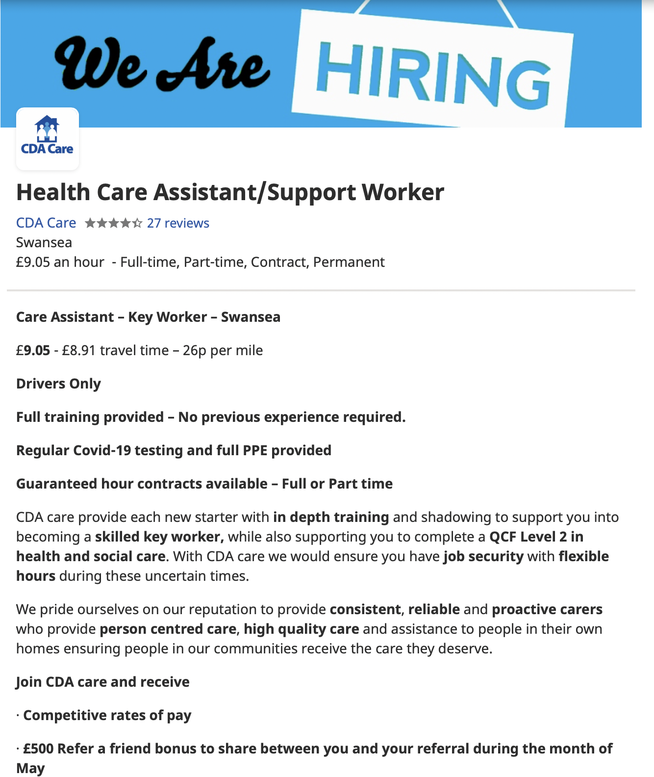

Evidence No 15.

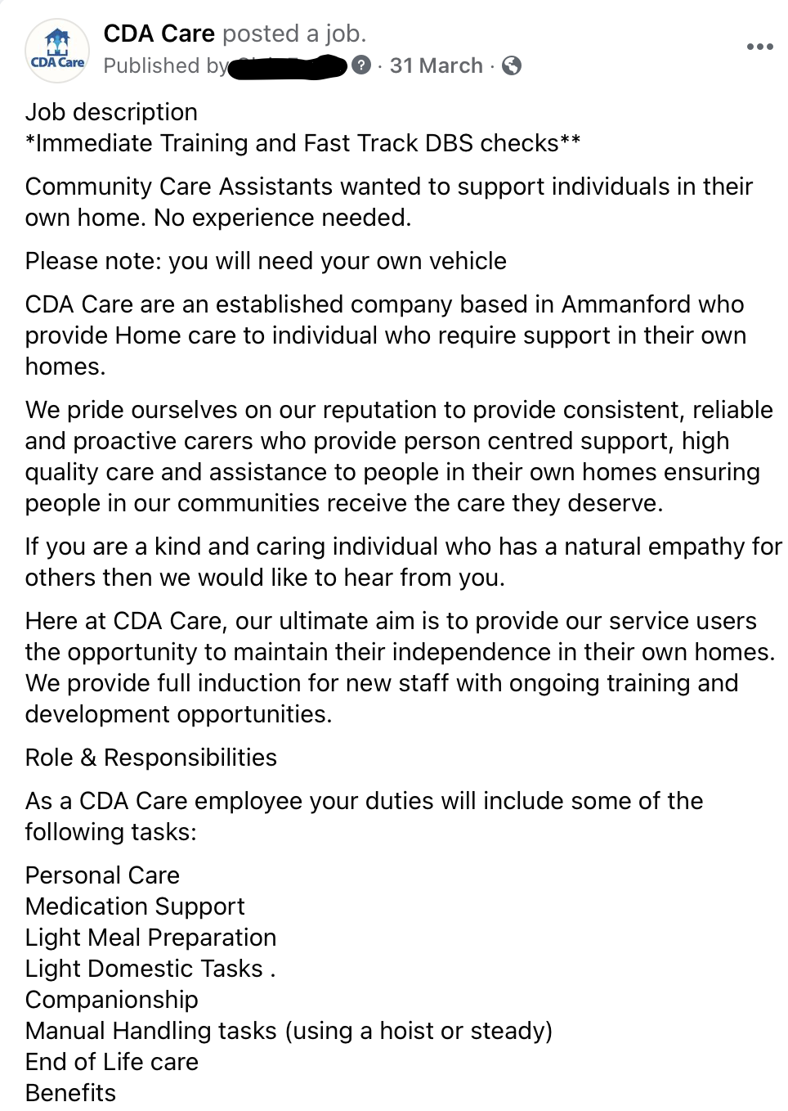

Evidence No 16.

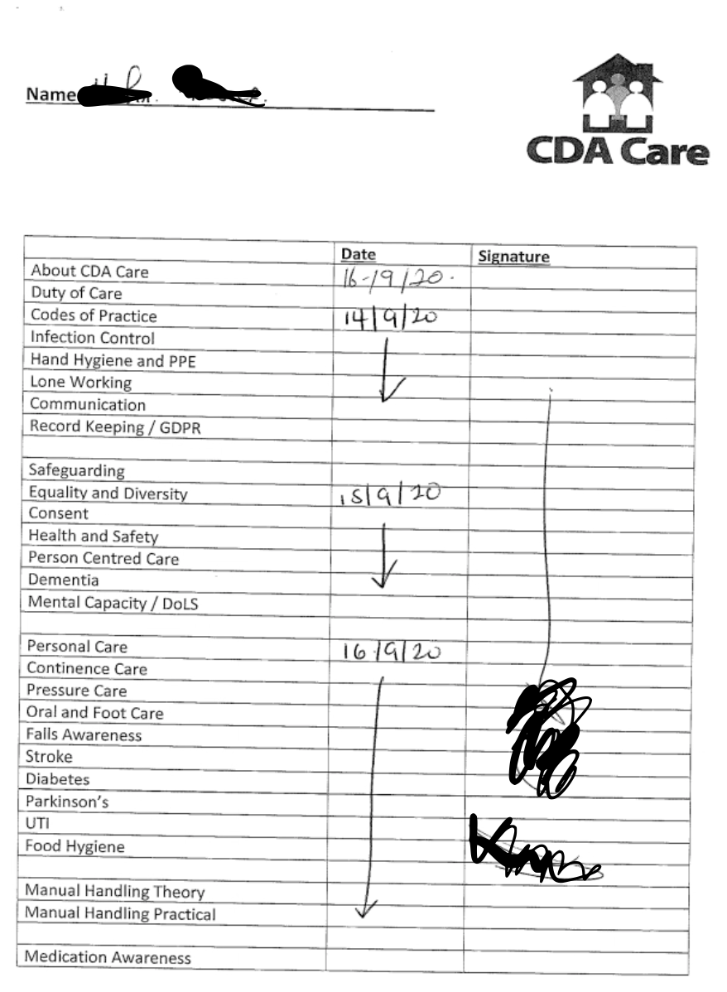

Evidence No 17.

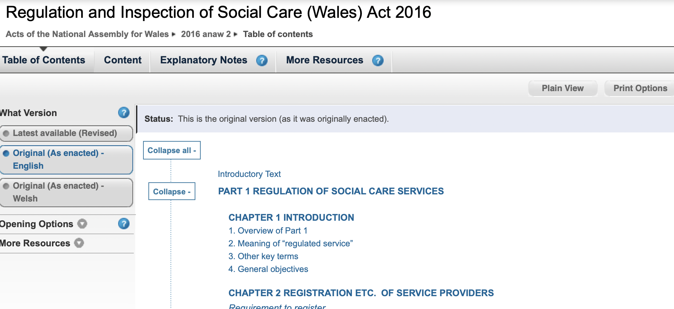

Evidence No 18.

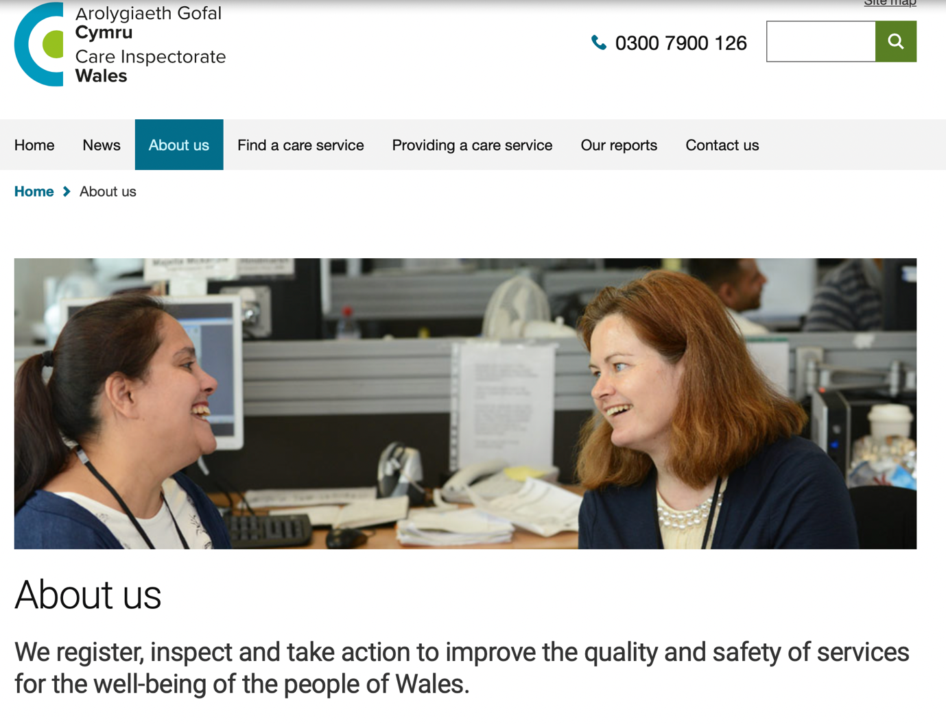

Evidence No 19.

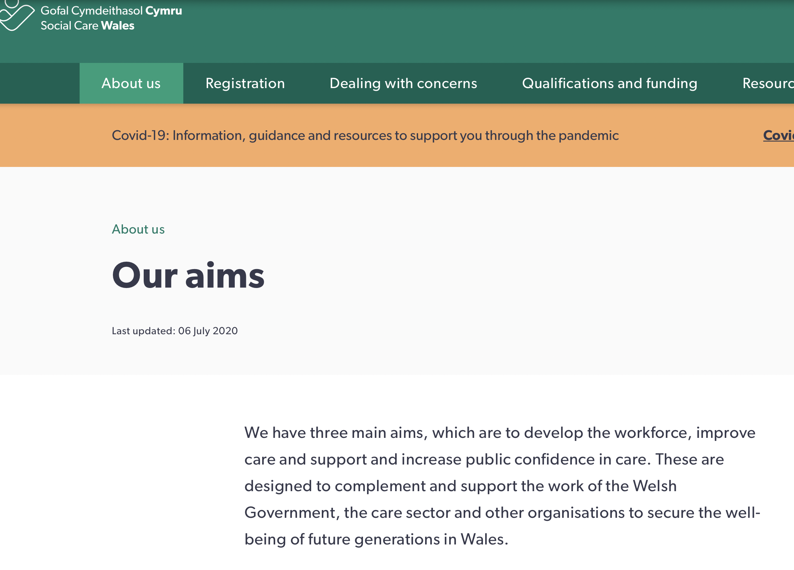

Evidence No 20.

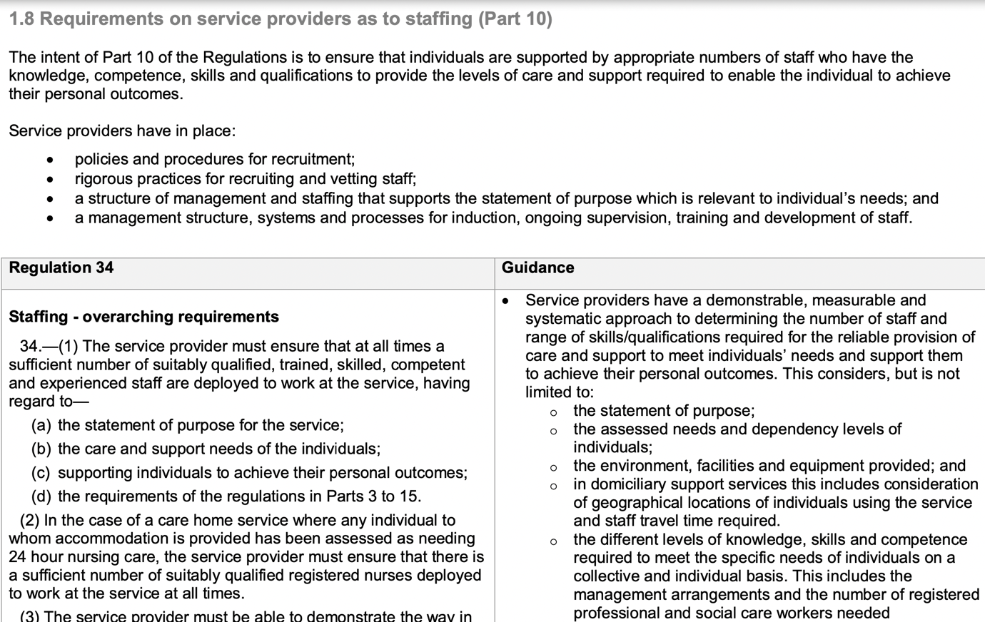

Evidence No 21.
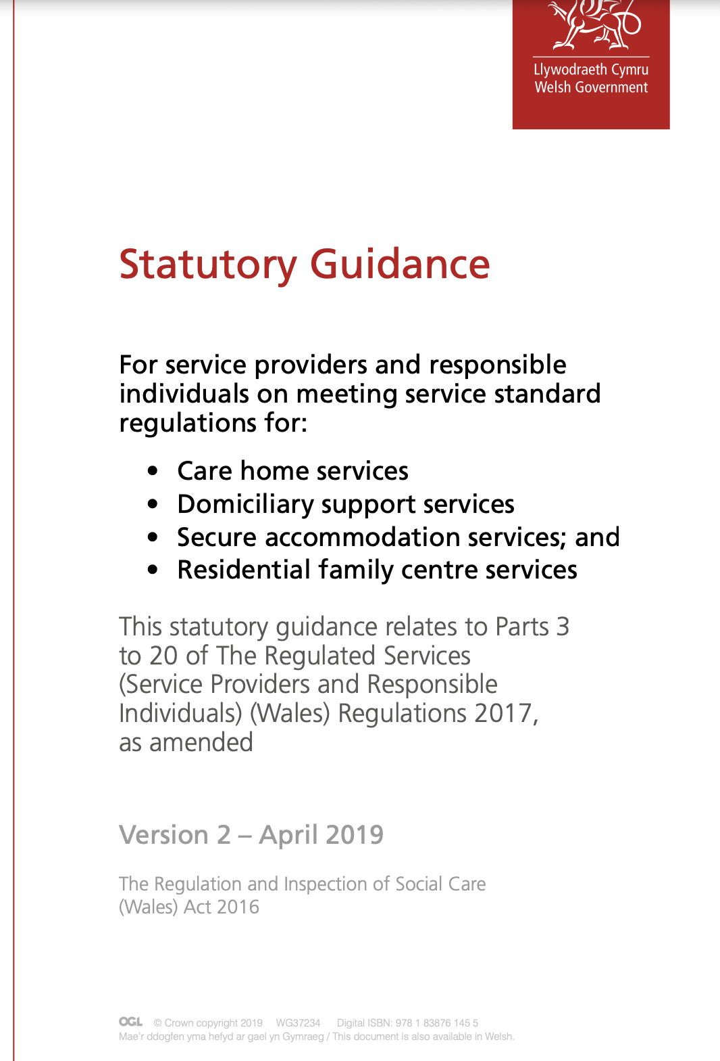

Evidence No 22.

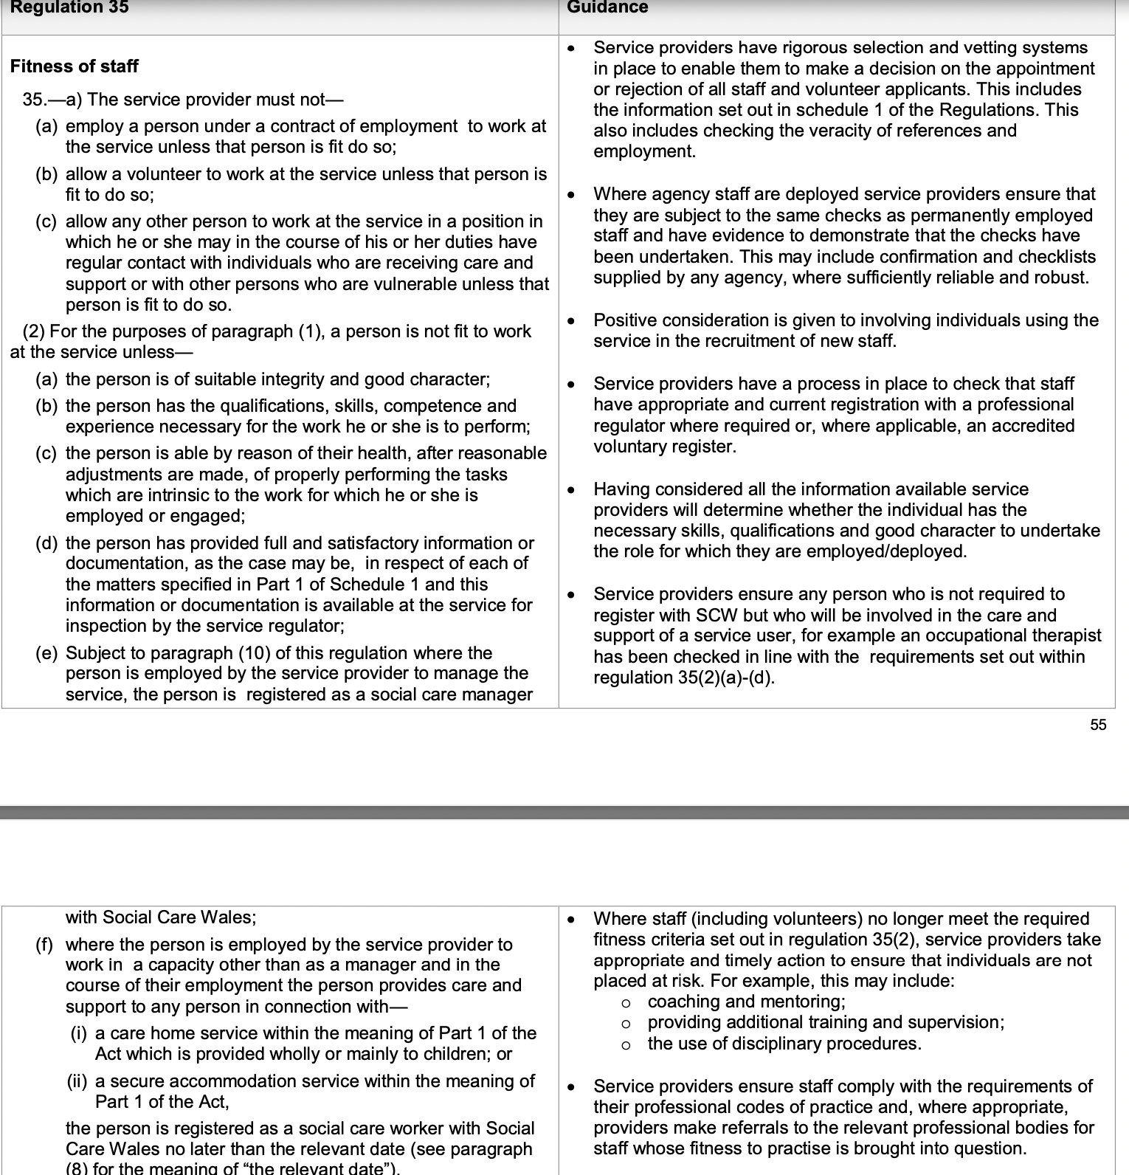

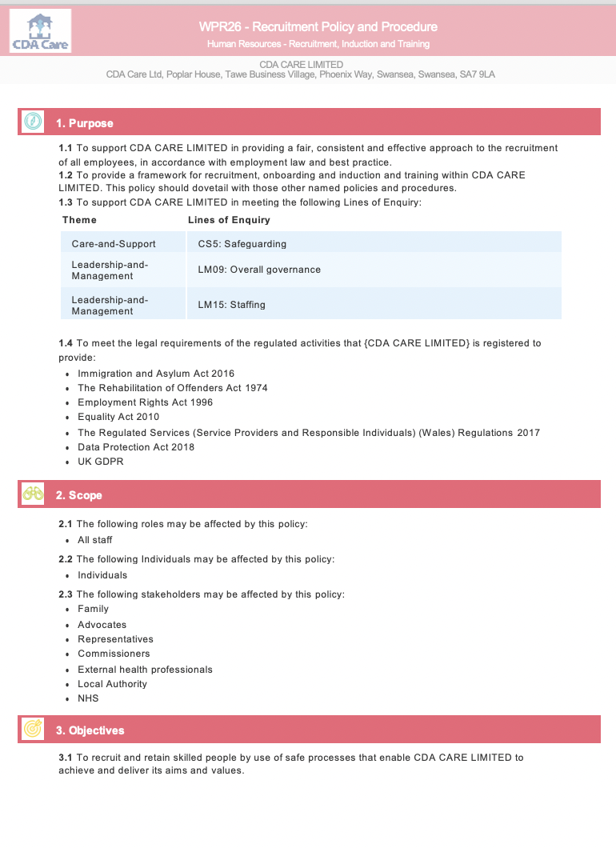
Evidence No 23.

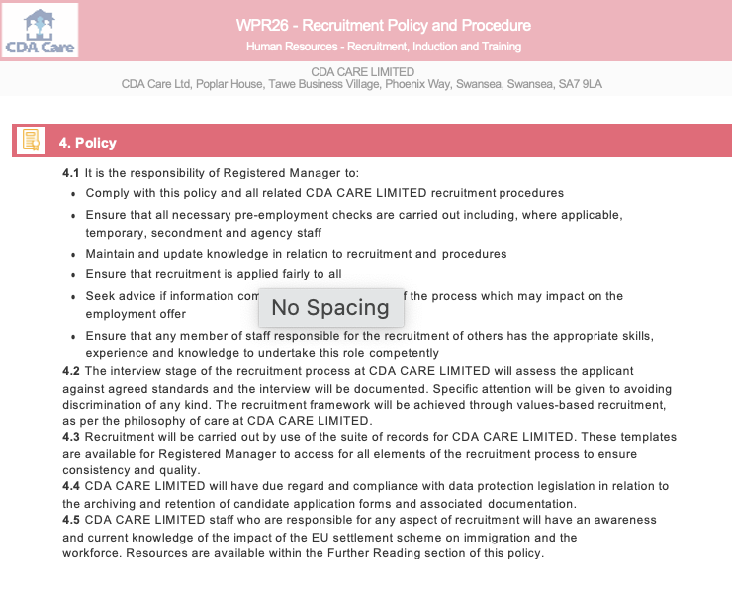

Evidence No 24.

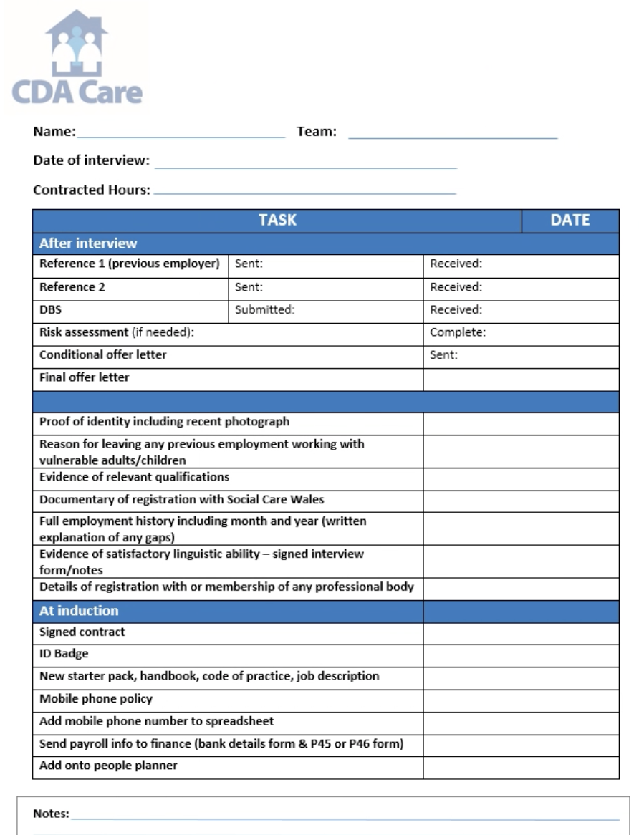

Evidence No 25.

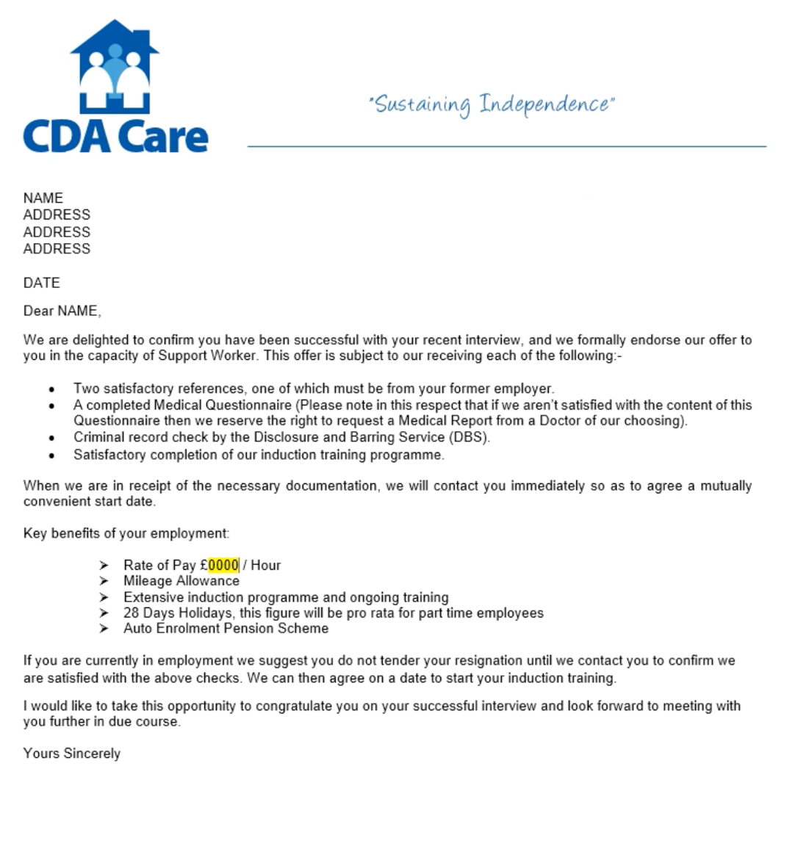

Evidence No 26.

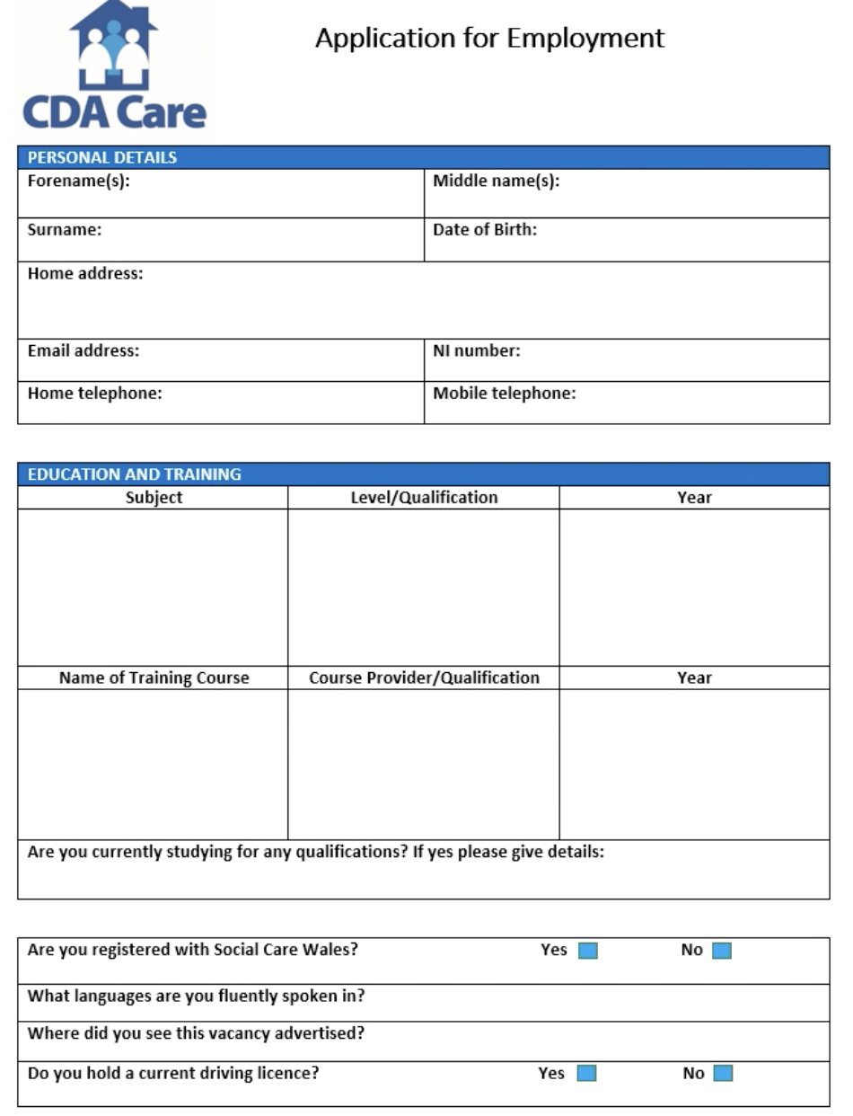

Evidence No 27.

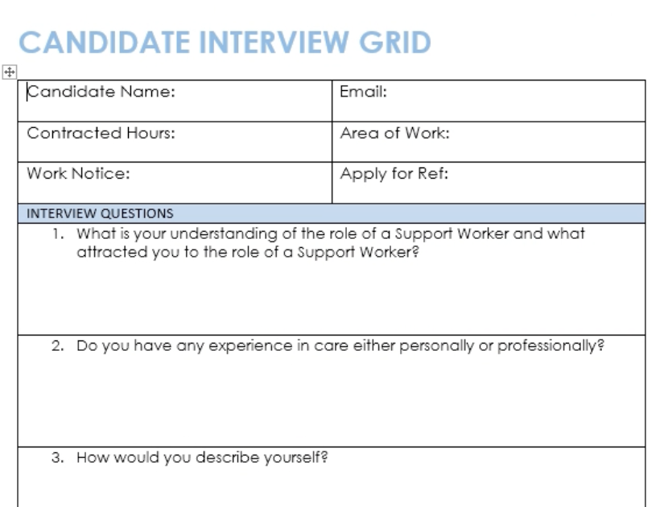

Evidence No 28.

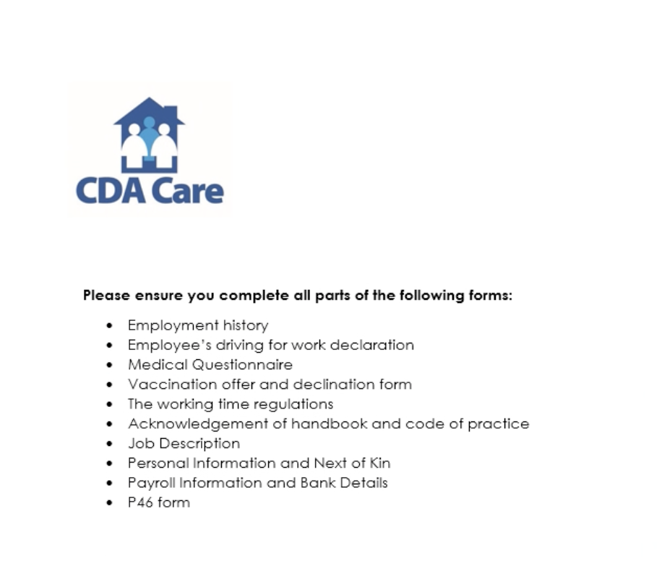

Evidence No 29.



Evidence No 30.

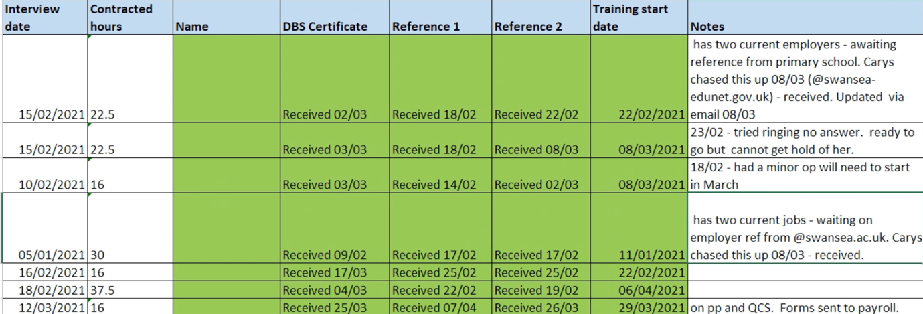

Evidence No 31.

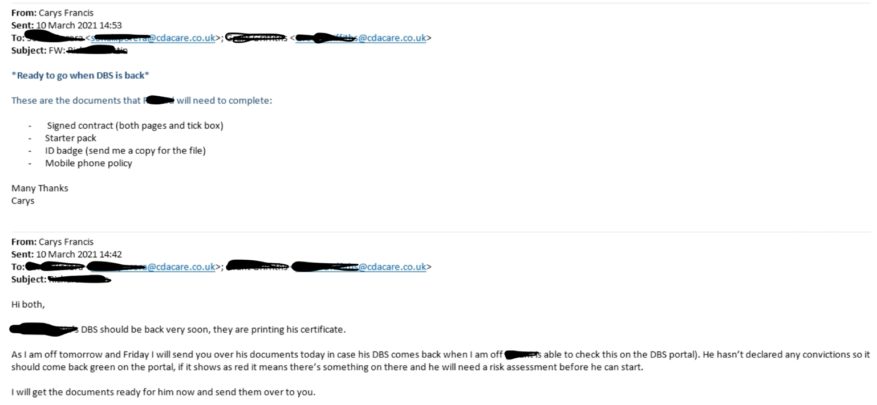

Evidence No 32.

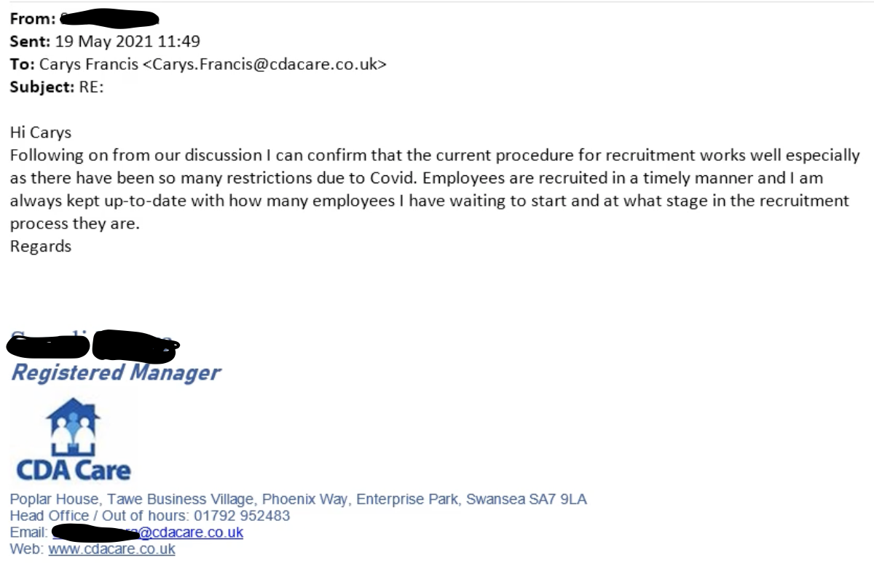

Evidence No 33.

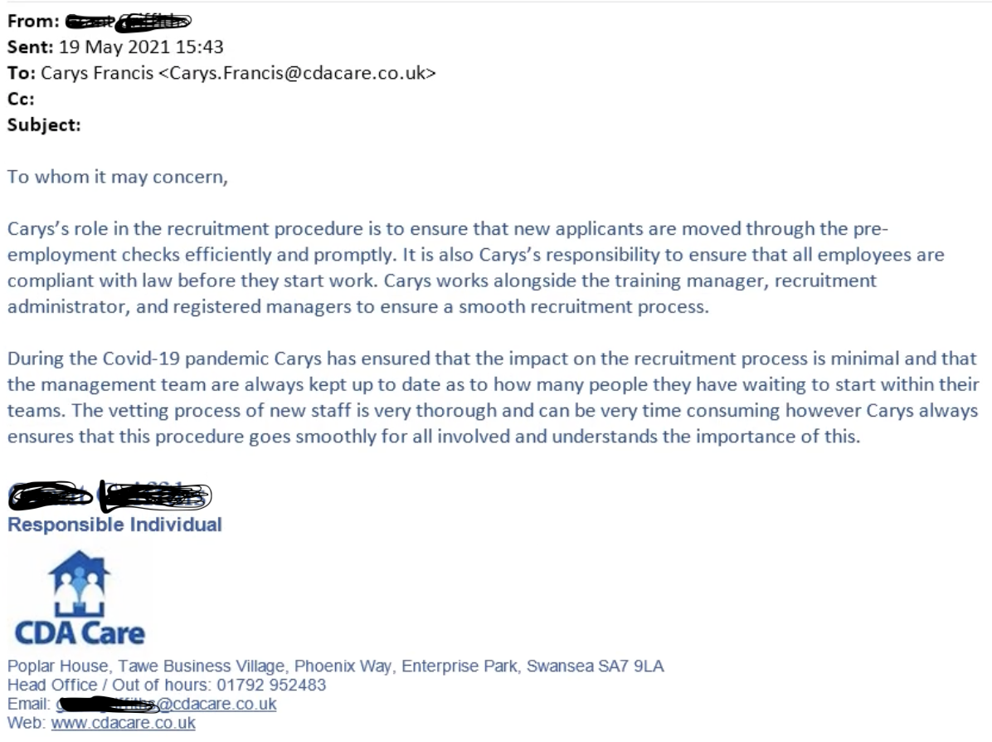

References:

Alina, M (2017) Employer branding and talent management in the digital age [research report]. Available at: https://www.researchgate.net/publication/317999313_Employer_Branding_and_Talent_Management_in_the_Digital_Age (Accessed: 4th May 2021)

Care Inspectorate Wales (2021). Available at: https://careinspectorate.wales (accessed: 9th May 2021)

CIPD (2018) Workforce planning practice [guide]. Available at: https://www.cipd.co.uk/Images/workforce-planning-guide_tcm18-42735.pdf (Accessed: 5th May 2021).

CIPD (2020) Employer branding [factsheet]. Available at: https://www.cipd.co.uk/knowledge/fundamentals/people/recruitment/brand-factsheet#gref (Accessed: 4th May 2021)

Disclosure and Barring Service (2021). Available at: https://www.gov.uk/government/organisations/disclosure-and-barring-service (Accessed: 10th May 2021)

Randstad (2019) Building a resourcing strategy [article]. Available at: https://www.randstad.co.uk/market-insights/attracting-recruiting-talent/building-a-resourcing-strategy/ (Accessed: 4th May 2021)

Search (2020) Social care recruitment during the coronavirus pandemic [website]. Available at: https://www.search.co.uk/blog/2020/05/social-care-recruitment-during-the-coronavirus-pandemic (Accessed: 3rd May 2021)

Social Care Wales (2020) Recruiting staff [website]. Available at: https://socialcare.wales/service-improvement/recruiting-staff (Accessed: 3rd May 2021)

Social Care Wales (2020) Domiciliary care workers on the register [report]. Available at: https://socialcare.wales/cms_assets/file-uploads/Domiciliary-Care-Workers-on-the-Register.pdf (Accessed: 3rd May 2021)

Social Care Wales (2021). Available at: https://socialcare.wales (accessed: 9th May 2021)

Taylor, S. and Woodhams, C. (2016) Human Resource Management: people and organisations. 2nd edn. London: CIPD

Taylor, S. (2014) Resourcing and talent management. 6th edn. London: CIPD

Welsh Government (2021) Health and social care in wales – Covid-19: looking forward [article]. Available at: https://gov.wales/sites/default/files/publications/2021-03/health-and-social-care-in-wales--covid-19-looking-forward_0.pdf (Accessed: 3rd May 2021)

Williams, H. (2019) Why succession planning is important [article]. Available at: https://www.cio.com/article/3522139/why-succession-planning-is-important.html (Accessed: 5th May 2021)

XpertHR (2021) Workforce planning [guide]. Available at: https://moodle.uwtsd.ac.uk/pluginfile.php/363930/mod_resource/content/0/Workforce%20Planning%20Guide%2C%20Hirsh%20-%20recommended.pdf Accessed: 5th May 2021)

