Module Code: LCHS7009
Lecturer Name: Diola Bijlhout
Module Name: Population Health and Digital Health Promotion
STUDENT NAME : SONA JANDI SILA
STUDENT ID : 2216032
Topic: Task 1- Blogs 2 entries
Blog 1 Word: 583
Blog 2 Word: 586
Blog 1: Critically discuss the impact of BeYou+ currently used for digital health promotion intervention
Public Health Problem
Human Immunodeficiency Virus/Acquired Immunodeficiency Syndrome (HIV/AIDS) is a significant public health problem where the virus attacks body’s immune system destruing cells and making the body vulnerable to infections (Gillespie et al., 2019). In the UK around 100,000 people are living with HIV with serious morbidity, significant mortality and high costs of treatment (PHE, 2026). Thanks to the remarkable advances making HIV/AIDS now a manageable long-term condition where people are self-managing and engaging with HIV care in the UK.
Despite the UK government undertaking prevention and health promotion measures by achieving the UNAIDS 95-95-95 targets, inequalities related to diagnosis, treatment adherence and viral suppression especially among the young people of the age of 15-24 years is a persistent problem (UK Government, 2026). As of 2024, around 91% of the young people of the age of 15-24 years received treatment achieving viral suppression which is lower than 99% achieved in older age groups with treatment coverage lowest among young people at 96% (UKHSA, 2026). This signified a risk of poorer health outcomes and onward transmission by the young people and these health disparities underscored the importance of interventions which will improve treatment adherence, self-management, and engagement with HIV/AIDS care and treatment (Delpech, 2022).
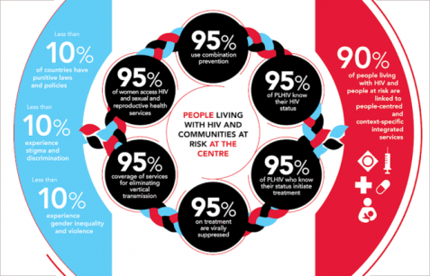
(UNAIDS, 2021)
Digital Technology – BeYou+
Living with HIV is beyond just taking daily medications; it requires the patients to engage in self-management, continuous engagement and regular monitoring within the healthcare services. This is where digital technologies come into place, making a difference to the public health problem (Whiteley et al., 2021). BeYou+ is an existing digital technology developed as a mobile health application helping the people to manage their HIV/AIDS condition through symptom management medication reminders and wellbeing tracking, personalised self-management tools and securing health record management. This mobile health application supported informed self-management and promoted treatment adherence for HIV/AIDS that improved vital suppression, promoted equitable HIV/AIDS care and enhanced long-term health outcomes (Mad Trust, 2026).
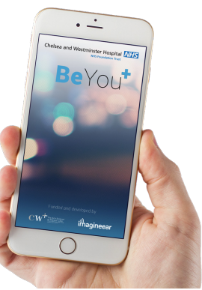
(Mad Trust, 2026)
How BeYou+ is promoting health?
British HIV Association (BHIVA) Conference revealed the BeYou+ evaluation indicating that users found features like health information, medication reminders, goal setting, laboratory test tracking to be beneficial and successfully improved self-management and supported engagement with HIV/AIDS care (Brown et al., 2017). According to Duthely and Sanchez-Covarrubias (2020), mobile health application for HIV/AIDS ensures promotion of healthy behaviours including informed self-care and improved treatment adherence. The findings suggest that BeYou+ has strengthened HIV self-management and promoted health of the people living with HIV/AIDS.
Impact of BeYou+ in health problem
BeYou+ HIV health promotion mobile application has been considered as an empowering tool for the people living with HIV/AIDS to manage their condition actively. The advantage of this digital technology lay in supporting the young adults for goal setting, medication reminders, secure self-monitoring and laboratory result tracking using digital features, which in turn enhances treatment adherence, sustained engagement with HIV/AIDS services and informed self-care (Duthely and Sanchez-Covarrubias, 2020). The impact of BeYou+ is also limited by shortfalls including usability issues including inconsistent information structure along with lack of flexibility in notifications and poor support for medication adherence and broader symptom tracking (Duthely and Sanchez-Covarrubias, 2020).

(Mad Trust, 2026)
Address Shortfalls
The shortfall related to medication adherence and broader symptom tracing could be addressed through continuous user-centred design improvements and regular co-production with the people living with HIV/AIDS (van der Westhuizen et al., 2020). There is also a need for incorporating personalised medication support with adaptive notifications that would improve user engagement and usability (Tran et al., 2023).

References
Brown, D., Waugh, S., Bussone, A. and Stumpf, S. (2017) Evaluation of BeYou plus an mHealth application to support self-management strategies for people living with HIV. Available at: https://openaccess.city.ac.uk/id/eprint/21025/1/BHIVA.abstract.2017.pdf (Accessed: 2 July 2026).
Delpech, V. (2022) ‘The HIV epidemic: global and United Kingdom trends’, Medicine, 50(4), pp. 202–204. Available at: https://doi.org/10.1016/j.mpmed.2022.01.002.
Duthely, L.M. and Sanchez-Covarrubias, A.P. (2020) ‘Digitized HIV/AIDS Treatment Adherence Interventions: A Review of Recent SMS/Texting Mobile Health Applications and Implications for Theory and Practice’, Frontiers in Communication, 5. Available at: https://doi.org/10.3389/fcomm.2020.530164.
Gillespie, S.L., Chinen, J., Paul, M.E. and Shearer, W.T. (2019) ‘Human Immunodeficiency Virus Infection and Acquired Immunodeficiency Syndrome’, Clinical Immunology, pp. 545-560.e1. Available at: https://doi.org/10.1016/B978-0-7020-6896-6.00039-9.
Mad Trust (2026) BEYOU+ CHELSEA & WESTMINSTER HOSPITAL NHS FOUNDATION TRUST. Available at: https://www.madtrust.org.uk/project/beyou-chelsea-westminster-hospital-nhs-foundation-trust/ (Accessed: 2 July 2026).
PHE (2026) HIV: surveillance, data and management, GOV.UK. Available at: https://www.gov.uk/government/collections/hiv-surveillance-data-and-management (Accessed: 2 July 2026).
Tran, B.X., Bui, T.M., Do, A.L., Boyer, L., Auquier, P., Nguyen, L.H., Hai, A., Ngo, T.V., Latkin, C.A., Zhang, B., Ho, C.S.H. and Ho, R.C.M. (2023) ‘Efficacy of a Mobile Phone–Based Intervention on Health Behaviors and HIV/AIDS Treatment Management: Randomized Controlled Trial’, J Med Internet Res , 25, pp. e43432–e43432. Available at: https://doi.org/10.2196/43432.
UK Government (2026) New HIV report shows progress but inequalities persist in access to testing, PrEP and early diagnosis, GOV.UK. Available at: https://www.gov.uk/government/news/new-hiv-report-shows-progress-but-inequalities-persist-in-access-to-testing-prep-and-early-diagnosis (Accessed: 2 July 2026).
UKHSA (2026) ‘HIV testing, PrEP, new HIV diagnoses and care outcomes for people accessing HIV services: 2025 report’. Available at: https://www.gov.uk/government/statistics/hiv-annual-data/hiv-testing-prep-new-hiv-diagnoses-and-care-outcomes-for-people-accessing-hiv-services-2025-report (Accessed: 2 July 2026).
UNAIDS (2021) 2025 AIDS targets: The next generation of goals for the global AIDS response, Www.unaids.org. Available at: https://www.unaids.org/en/resources/presscentre/featurestories/2021/july/20210721_2025-aids-targets (Accessed: July 15, 2026).
van der Westhuizen, D., Conrad, N., Douglas, T.S. and Mutsvangwa, T. (2020) ‘Engaging Communities on Health Innovation: Experiences in Implementing Design Thinking’, International Quarterly of Community Health Education, 41(4), pp. 101–114. Available at: https://doi.org/10.1177/0272684x19900880.
Whiteley, L.B., Olsen, E.M., Haubrick, K.K., Odoom, E., Tarantino, N. and Brown, L.K. (2021) ‘A Review of Interventions to Enhance HIV Medication Adherence’, Current HIV/AIDS Reports, 18, pp. 443–457. Available at: https://doi.org/10.1007/s11904-021-00568-9.

Blog 2: Critically discuss the impact of a Wearable HIV Promotion Device for the digital health promotion intervention
Public health problem
Thanks to the significant medical advances that led to the UK government’s progress towards ending HIV transmission but the HIV/AIDS remains a public health concerns. There have been persistent gaps in engagement with HIV prevention and treatment with ongoing new infections (UK Government, 2026). AS of 2024, around 3043 new HIV diagnoses has been recorded across the UK and young people remain a vulnerable population group with lowest treatment coverage of 96% compared to 99% among older population (UKHSA, 2026). This has increased the risk of poorer health outcomes along with onward transmission of HIV/AIDS through the young population. This again highlights the need for innovative digital technologies that would provide personalised medication support with adaptive notifications to improve medication adherence, testing uptake, continuous health education and thereby end new HIV transmissions by 2030 (Hein, Vrijens and Hiligsmann, 2020).
Digital technology designed- Wearable HIV Health Promotion Device
The new digital technology for health promotion of young people with HIV/AIDS is Wearable HIV Health Promotion Device. This digital health technology is a smartwatch based device that supports HIV prevention by focusing on self-management (Marquard et al., 2018). The wearable device has key feature of providing personalised medication support, HIV testing kit ordering system, PrEP and appointment reminders which enhances adherence and continuity of care. The device is embedded with biometric sensors that monitors stress levels and provide educational notifications on HIV prevention and treatment and healthy sexual behaviours (Romero et al., 2021).
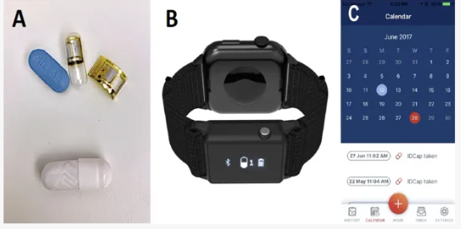
(Nimbalkar et al., 2026)
Digital technology in health problem
The designed technology, Wearable HIV Health Promotion Device will be used in health promotion by improving healthy sexual behaviours for young people along with providing personalised and real-time support for HIV prevention and management. For young people living with HIV/AIDS, the device would encourage treatment adherence, reduce missed doses and improve engagement through personalised medication support, PrEP and HIV testing and appointment reminders (Nimbalkar et al., 2026). Additionally stress monitoring would promote the young users to identify psychological distress early and access mental health support. Additionally, educational notifications helps to increase HIV knowledge and awareness while reduce misinformation (Jolly et al., 2025).
Impact of digital technology in health promotion
Let’s understand how can the Wearable HIV Health Promotion Device could enhance health promotion for people living with HIV/AIDS. The advantage of this device is that it would significantly improve medication adherence by supporting medication, PrEP and appointment reminders and also increase the uptake of HIV testing (Menassa et al., 2025). The device is also advantageous in providing health education and stress monitoring to sustain engagement and encourage seeking early mental health support (Jolly et al., 2025). The disadvantages of the device could be high costs restricting its access to the young employed people, young people from disadvantageous populations and this would widen health inequalities. The device also has shortfalls in terms of concerns over data privacy, user confidentiality and cybersecurity that will reduce acceptance and trust over the device (Cilliers, 2020).
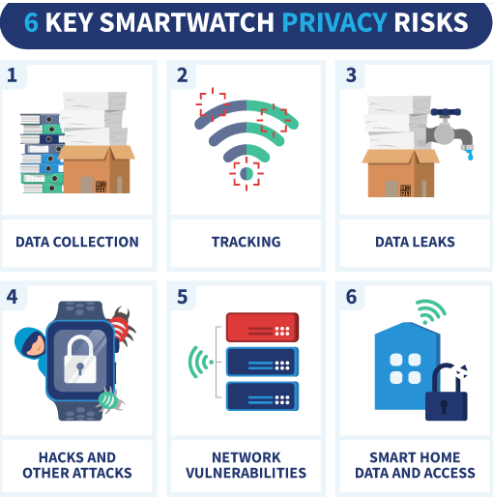
(Marks, 2019)
Addressing shortfalls
The shortfalls could be addressed by subsidising the device for the disadvantageous and unemployed young people through NHS-led public health HIV/AIDS programmes. This would help to manage cost of the device and improve affordable reducing health inequalities (Tariq, 2025). Additionally, robust cybersecurity measures with multi-factor authentication, end-to-end encryption and compliance with UK General Data Protection Regulation (UK GDPR) could enhance confidentiality and data security of the wearable devices while transparent privacy policies would enhance trust and acceptance for sustained engagement with the digital technology (Doherty et al., 2025).

References
Cilliers, L. (2020) ‘Wearable devices in healthcare: Privacy and information security issues’, Health Information Management Journal, 49(2-3), p. 183335831985168. Available at: https://doi.org/10.1177/1833358319851684.
Doherty, C., Baldwin, M., Lambe, R., Altini, M. and Caulfield, B. (2025) ‘Privacy in consumer wearable technologies: a living systematic analysis of data policies across leading manufacturers’, npj Digital Medicine, 8(1). Available at: https://doi.org/10.1038/s41746-025-01757-1.
Hein, A.-E., Vrijens, B. and Hiligsmann, M. (2020) ‘A Digital Innovation for the Personalized Management of Adherence: Analysis of Strengths, Weaknesses, Opportunities, and Threats’, Frontiers in Medical Technology, 2, p. 604183. Available at: https://doi.org/10.3389/fmedt.2020.604183.
Jolly, A., Pandey, V., Sahni, M., Leon-Castro, E. and Perez-Arellano, L.A. (2025) ‘Modern Smart Gadgets and Wearables for Diagnosis and Management of Stress, Wellness, and Anxiety: A Comprehensive Review’, Healthcare, 13(4), pp. 411–411. Available at: https://doi.org/10.3390/healthcare13040411.
Marks, T. (2019) The Privacy Risks of Your Smartwatch | VPNOverview, VPNoverview.com. Available at: https://vpnoverview.com/privacy/devices/privacy-risks-smartwatch/ (Accessed: 3 July 2026).
Marquard, J., Saver, B., Kandaswamy, S., Martinez, V., Simoni, J., Stekler, J., Ganesan, D. and Scanlan, J. (2018) ‘Designing a wrist-worn sensor to improve medication adherence: accommodating diverse user behaviors and technology preferences’, JAMIA open, 1(2), pp. 153–158. Available at: https://doi.org/10.1093/jamiaopen/ooy035.
Menassa, M., Wilmont, I., Beigrezaei, S., Knobbe, A., Arita, V.A., Valderrama, J.F., Bridge, L., Verschuren, W.M.M., Rennie, K.L., Franco, O.H. and van der Ouderaa, F. (2025) ‘The future of healthy ageing: Wearables in public health, disease prevention and healthcare’, Maturitas, 196, p. 108254. Available at: https://doi.org/10.1016/j.maturitas.2025.108254.
Nimbalkar, D., Goodman, G., Hokayem, J., Albrechta, H., Loo, L., Lee, J., Goldfine, C., O’Cleirigh, C., Mayer, K., Alpert, P. and Carnes, C. (2026) ‘Feasibility, acceptability, and user perspective of a next-generation wrist-worn receiver and digital pills for HIV pre-exposure prophylaxis: a pilot study’, Frontiers in Psychiatry, 17, p. 1550058. Available at: https://doi.org/10.3389/fpsyt.2026.1550058/full.
Romero, R.A., Klausner, J.D., Marsch, L.A. and Young, S.D. (2021) ‘Technology-Delivered Intervention Strategies to Bolster HIV Testing’, Current HIV/AIDS Reports, 18(4), pp. 391–405. Available at: https://doi.org/10.1007/s11904-021-00565-y.
Tariq, M.U. (2025) ‘Navigating the Convergence of IoMT and Generative AI in Global Healthcare’, Advances in healthcare information systems and administration book series, pp. 513–534. Available at: https://doi.org/10.4018/979-8-3693-6180-1.ch022.
UK Government (2026) New HIV report shows progress but inequalities persist in access to testing, PrEP and early diagnosis, GOV.UK. Available at: https://www.gov.uk/government/news/new-hiv-report-shows-progress-but-inequalities-persist-in-access-to-testing-prep-and-early-diagnosis (Accessed: 2 July 2026).
UKHSA (2026) ‘HIV testing, PrEP, new HIV diagnoses and care outcomes for people accessing HIV services: 2025 report’. Available at: https://www.gov.uk/government/statistics/hiv-annual-data/hiv-testing-prep-new-hiv-diagnoses-and-care-outcomes-for-people-accessing-hiv-services-2025-report (Accessed: 2 July 2026).

