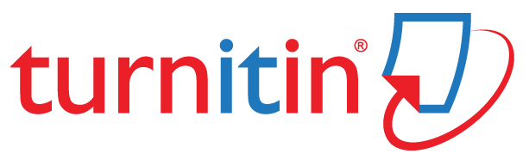


BMMB7012 – Marketing Management
Assignment 1
Submission Template

Printed Name: _SuiBin Yang _ _ _ _ _ _ _ _ _ _ _ _ _ _ _ _ _ _ _ _ _ _ _ _
Signature: _ _ _ _ _ _ _ _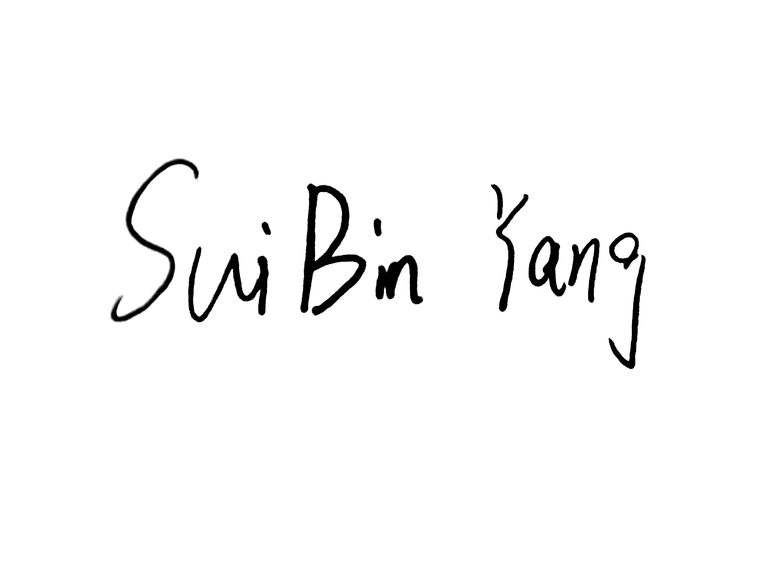 _ _ _ _ _ _ _ _ _ _ _ _ _ _ _ _ _ _

Please list your group members (names & ID) in the box below:
1.Haotian Guo (2230865)
2.Xinke Gong (2230419)
3.Suibin Yang (2227824)
4.Qin Na(Leader)(2231286)

Please state your chosen organisation & contemporary issue in the box below:
Selected Organisation: Pepsi-Cola

Selected Contemporary Issue:
1、The threat of new entrants to the Chinese beverage market is relatively high due to low barriers to entry and emerging health consciousness trends./2、High bargaining Power of Suppliers in China market.

