

Postgraduate/Distance Learning Assignment coversheet & feedback form

THIS SHEET MUST BE THE FIRST PAGE OF THE ASSIGNMENT YOU ARE SUBMITTING (DO NOT SEND AS A SEPARATE FILE)

For completion by the student:
Student Name:
Eleonora D’Uva
Module code: HPCA7019 Module title: Sacred Skies | Student ID number: 2014860 | Educational support needs: No
Module tutor: Bernadette Brady

Assignment due date: 14 May 2021
If your module has multiple submissions please indicate which piece of work this is.

2nd
I confirm that this is my original work and that I have adhered to the University policy on plagiarism.
Signed …………Eleonora D’Uva…………………………………………………
Email submission: if you are submitting this form via email, please tick this box □
(as a substitute for your signature) to confirm that you agree to the above
declaration.

Assignment Mark
WILL BE
Final Mark GIVEN ON
TURNITIN

NB. All marks are provisional until confirmed by the Final Examination Board.

PLEASE NOTE: ALL COMMENTS WIL BE POSTED ON TURNITIN

For completion by Marker 1 :

Comments:
Marker’s signature: |  | Date:
For completion by Marker 2/Moderator:

Comments:
Marker’s Signature: | Date:
AGREED INTERNAL MARK (where necessary): Comment on process of arriving at agreed mark:
External Examiner’s comments (if relevant)
External Examiner’s Signature: | Date:

‘Compare and contrast three works of music from three different cultures’
Word count 5152

Introduction
The aim of this essay is to compare and contrast the cultural representation of the sky in three works of music from three different cultures, Japanese, with Summer tears diary, Italian with Le Acciughe Fanno il Pallone and Australian-Western contemporary with Child of the universe. For each, three themes were found from the songs’ context that are briefly introduced after the related song description and are grouped and discussed in detail after the literature review. The full lyrics, including a self made translation, are included in the Appendix after the bibliography.

Primary Sources

Summer Tears Diary

Summer Tears Diary is a song written by Japanese songwriter and lyricist Saori Kodama and composed by musician Mito for the anime ‘’Aikatsu Stars!’’ in 2016, to serve as an image song for two of the main idol characters, Yozora and Mahiru, two teenage sisters separated by life choices, who are able to meet again and confront each other on the day of the Japanese festival Tanabata. Different versions of the song exist, depending on the story and characters singing: the first appearance of this song is in episode 14 of the anime, and the main performer is Mahiru (Kana Hoshizaki) who is trying to catch up with her older sister as Tanabata approaches; the second appearance occurs on episode 15, performed by Mahiru and Yozora (Miho Amane) as the two sisters clear their misunderstandings under the night sky, with Yozora stating that she was waiting outside, faithful that her sister would come and meet her. Although the song is not further used in the anime, in episode 64 Yozora crosses continents to see Mahiru on the night of Tanabata, stating the two of them are like Hikoboshi and Orihime, destined to meet on that one night. Different variations were performed in live concerts, by either both Hoshizaki and Amane or Amane solo, where they impersonated the relative character (as showed in Figure 1).
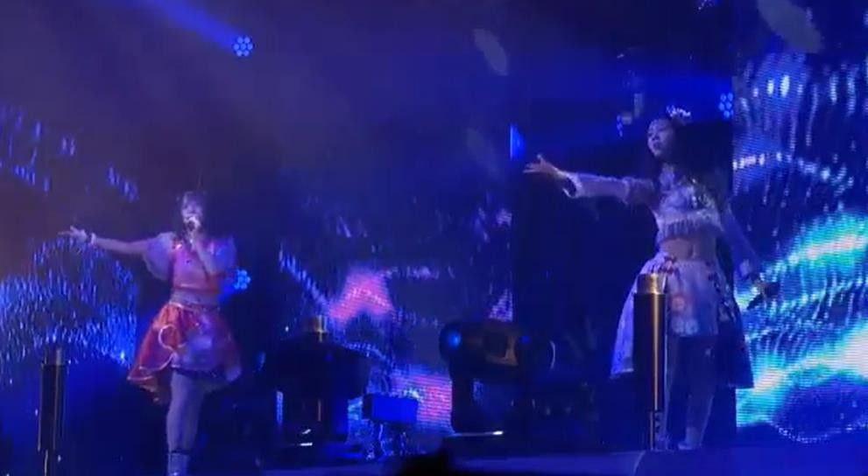
Figure 1 - Amane and Hoshizaki live performance

The lyrics and music of Summer Tears Diary have melancholic and nostalgic traits, while the choreography mirrors some aspects of the star festival that will be further discussed in the next section; as per its use in an idol anime, the overall performance is centred around the theme of Tanabata, from the clothes that take inspiration from Chinese culture to the stage that either resembles a Chinese or Japanese garden at night time, or represents a stage used for music and dance performance during summer festivals in Japan (see Figure 2 for comparison).
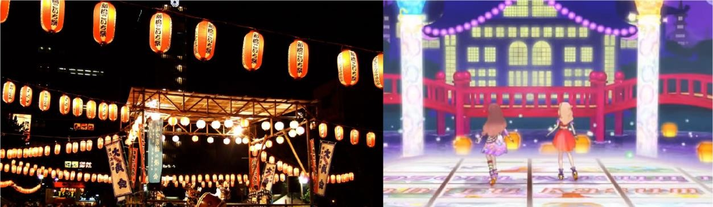
Figure 2 - A typical summer festival stage and the anime stage

Born in China, the legend of Tanabata became a common story in the Japanese court only after the Heian period (794 - 1185) and, although different versions exist, it revolves around the figures of two lovers, Orihime and Hikoboshi, whose fate is to meet only once a year, precisely on the seventh night of the seventh month¹. The legend of Tanabata is directly connected to the myth of creation of the Milky Way, or the silver river that should forever separate Orihime and Hikoboshi, who represent the stars Vega and Altair in the Lyra and Aquila constellations, respectively, as part of the Summer Triangle along with Deneb.
Although Orihime and Hikoboshi should live forever apart, their sadness moves the gods, who decide to allow the two lovers to meet once a year, with Deneb being the connection or the chaperone who accompanies Orihime to her husband.

The three themes that can be recognised in the song are:

- Astronomy and astrology in Japan come from the Chinese tradition and were intertwined with each other to mirror human affairs, in this case the analogy between the two lovers and the two sisters who were separated.
- View of the non-human realm as representative of inner feelings experienced through profound association with phenomena connected with the seasons (meeting only once a year for a brief period, that has become a recognised festival).
- No legends about heroes or mythological beings having their stories based among the stars, so that they appear more relatable to people, and that’s why we can compare two sisters to two lovers - from the story in the stars come stories on Earth.

1 Taylor Stewart (2020). ‘Tanabata: A Japanese Holiday of Love’. Tokyo Weekender.

Le Acciughe Fanno il Pallone

Le Acciughe Fanno il Pallone (lit. anchovies make the ball) is a song written by Genoese singer and songwriter Fabrizio De André and lyricist Ivano Fossati in 1996, where the authors refer to the legends and popular chronicles of their city and to the life of fishermen. Fabrizio De André is one of the cornerstones of the Italian musical scene: deeply influenced by the overseas school of Bob Dylan and Leonard Cohen, but even more by the French one of the chansonnier, he was among the first to break the dogmas of the Italian song, with his dark ballads, crowded with lost souls, marginalized and derelict from every corner of the world. He drew on the most disparate sources, from medieval ballads to the Provençal tradition, from the "Anthology of Spoon River" to the songs of Sardinian shepherds, from Cecco Angiolieri to the Gospels, from Baudelaire’s "The Flowers of Evil" to Fellini, themes that over the years have been accompanied by an intelligent musical evolution, never inclined to easy fashions and compromises².
De André used the language of a non-aligned poet, with the irreverent force of irony to shatter any convention, as ultimately his is a desperate message of freedom and redemption against "the laws of the pack" and the arrogance of power.
The album Anime Salve (lit. saved souls), that includes Le Acciughe Fanno il Pallone, is presented as a journey full of suggestions and encounters with lonely characters - like fishermen, who inhabit secluded corners of the Earth, from Bahia to Genoa and Sardinia, where he lived for years. The music is mostly acoustic (see Figure 3), with a strong presence of guitar accompanied by traditional instruments from different parts of the world and contributes to create the atmosphere of the songs along with the lyrics: the listener of Le Acciughe Fanno il Pallone almost feels in the same boat with the fisherman during the catch at night, observing around at the sky and the town in the distance.
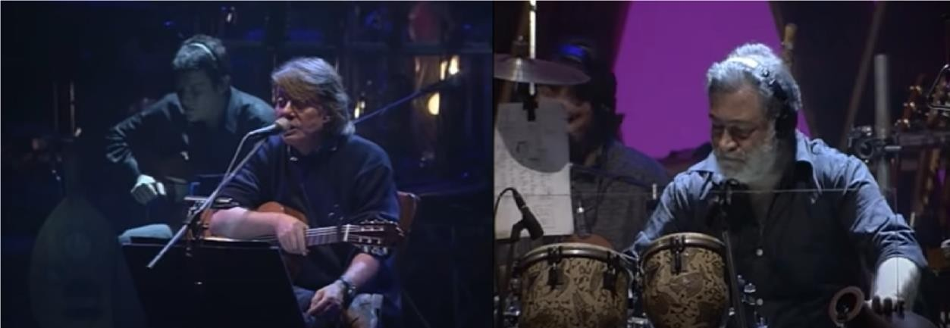
Figure 3 - Fabrizio De André live performance of Le Acciughe Fanno il Pallone

In Genoa (but also in other parts of Italy), a folk story has been handed down for generations that at the beginning of the world anchovies were the Engrauline stars, but they were the most vain of the whole sky; one day, their comments made the Moon cry and the other stars, who loved the Moon for its beauty and kindness, complained to God who decided to punish the Engraulines by turning them into fishes: in this way they would be silent forever and would still delight humans as food, instead for their radiance³. This is the reason why

2 AAVV, ‘Fabrizio De André’. Biografie Online.
3 Mití Vigliero Lami, (1998). La leggenda delle acciughe.

anchovies come back to the surface of water attracted by the artificial mirage of fishermen’s lampas, as they would like to return to the sky, but instead they end up in the nets: the related concept is that anchovy fishermen are star fishermen.

The three themes that result from this song are:
- Sky myths are used to reveal an unknown story that can be passed down to future generations to know why something is the way it is (in this case, why anchovies are caught with lampas).
- Humans and mythological beings have similar lives and problems, and they can relate to each other despite belonging to two different realms.
- Myths and folktales want to teach a lesson, as it generally is the case with Greek and Roman mythology. In this case, the song is an invitation to seize the moment, both for the fisherman and the anchovies.

Child of the Universe

Child of the Universe is a song written by Australian singer and songwriter Delta Goodrem and musician Gary Clark for her album with the same title in 2012. In a track by track description video series on her YouTube channel, Goodrem stated that she has always ’tried to work out different theories about life’ and she has always thought that she is not owned or defined by anybody or any specific thing, so, driven by an interest in physics, she decided to use the concept of being a child of the universe to communicate this feeling to her fans⁴. In another interview she discussed the whole album and said that she focused on ‘acoustic guitar and piano [...] enjoying writing songs that are more stripped back’, adding that she was revisiting her original writing style, ‘experimenting with different chord changes and different areas of music’⁵. There are no live recordings for the full song at the moment, although there are videos in which Goodrem performs part of it (usually the chorus) as a filler, bridge or medley between and with other songs of hers; two examples with Goodrem playing the drums and the piano are shown in Figure 4.

Figure 4 - Delta Goodrem live performance of Child of the Universe

Child of the Universe begins with a reef before the piano, Goodrem’s main instrument, accompanies through the song, along with the orchestra, progressively creating the atmosphere for the most empowering part of the song, the finale, as she takes the listener

4 Delta Goodrem Track By Track - 'Child Of The Universe'.
5 Daniel Kilkelly. (19 February 2010). "Delta Goodrem reveals new album plans". Digital Spy.

on a journey to explore oneself, that would eventually lead to a newfound freedom and the statement to be only ‘’limited’’ by being a child of the whole universe.
Although the song doesn’t relate to a particular sky myth, the lyrics compare the greatness of the sky to the limits of human life, something humans in general and artists in particular have proposed as a concept to reflect upon for years if not centuries.

The three themes found here are:
- The sky is an enchanted place that humans look up to to find answers to and solace from their everyday problems.
- In the past decades, humans have approached the sky as an entity in itself, bigger than them, focusing more on this duality rather than on sky myths
- Elements in our bodies and processes on the Earth are directly related to those in the solar system, meaning we are not only ‘’distantly’’ connected to the universe, but what made the stars also made humans.

Literature review

Japan

The Japanese are close to nature, attentive to its manifestations over time, and are constantly reaching out in an effort to understand its intimate essence, but more than close to nature, they consider themselves an integral part of it, recognizing within themselves a "natural" soul which is a simple variation of the environment that surrounds them. This awareness allows them to keep the natural element and the human element on the same level of consideration, where the recognition of the importance of the former also entails the tacit acceptance of reality: as Steven Heine noted in his review of Shirane’s work in 2014, the Japanese have developed a culturally constructed view of nature derived by approaching it through own feelings stem from experiencing natural phenomena throughout the cycle of the seasons⁶. In modern times, it’s customary in Japan to second this aspect by making lifestyle choices based on nature’s cyclicality, from eating certain foods to attend specific events and festivals, or buying household items associated with luck; it’s also not uncommon to recreate natural elements, including the Moon and the stars, by using simple objects that literally or figuratively reproduce them.
The cult of nature has ancient roots, in the times when it was above all felt as a powerful and frightening force, and constitutes the very basis of Shinto, the original religion of Japan, that doesn’t rely on typically anthropomorphic deities, but embraces a reality where every single thing in the world hosts a god. As Steven Renshaw and Saori Ihara (1999) point out, this view plays an important role in shaping foreign notions to the Japanese’s taste based on domestic beliefs, including mythology borrowed from China and other Asian cultures; moreover, the authors challenge the misconception that the ancient Japanese weren’t interested in astronomy because they didn’t produce any scientific results from their observations, by shifting the attention on the way the Japanese ‘incorporated astronomy into an extant system of belief and purpose’ into their society through Japan's unique history⁷.

6 Steven Heine (2014). ‘apan and the Culture of the Four Seasons: Nature, Literature, and the Arts’.
7 Steven Renshaw, Saori Ihara (1999). ‘Archaeoastronomy and astronomy in culture in Japan,

Lucia Dolce (2006) makes practical examples of Japan’s interest in astronomy and astrology by discussing examples of shrines and temples and the related worshipped deity: there clearly is an intertwined cultural and astronomical reason for aspects such as the location of a shrine, the timing of festivals, the type of items for sale on the grounds and so on, that is also reflected on the choice by modern Japanese to pray at a given shrine or temple for specific favours, establishing a continuity between human and natural realms⁸.

Italy

Italy has an important bond with its traditions and culture, kept alive through the most attention grabbing festivals and local celebrations, but also by practices in use everyday that are related to nature through ancient stories. Stanislaw Iwaniszewski analyses the cultural impacts of astronomy keeping an eye on the concept that astronomy and star lore serve to give an organisation to reality, and that was especially true in the past when stories about the sky were invented to justify something that had a match on Earth⁹. This means that there is a correlation, if not a similarity, to mythological events and fortunes of deities and heroes to those of the humans that first produced the story.
Similarly, Elizabeth Wayland Barber and Paul T. Barber offer a theory according to which myths are mostly descriptions of real life events or natural phenomena, that people passed down to younger generations for centuries to describe those occurrences and either prepare them to react to dangerous situations (for example earthquakes or eruptions) or instruct them on the reasons things were made or done in a certain way¹⁰. This approach is mostly similar to popular traditions and stories in Italy, that were often passed down through generations in oral form and only relatively recently have started to be gathered in written anthologies, so that future generations will be able to enjoy them, as many tales deal with disappearing practices.
The team led by Craig Palmer found that myths influence the morals and actions of people, subconsciously pushing them to strive for what they refer to as ‘moral elevation’, acts of kindness and self-sacrifice: they found that the most effective way to ensure that moral lessons are passed down and enhanced through time is by telling stories that contain that piece of advice¹¹.

Australia - Western contemporary

Modern society has an approach to the sky completely different than the traditional one: Frances Clynes cites Max Weber doubts on how the view of the sky has become disenchanted after scientific discoveries followed one another and people abandoned the

paving the way to interdisciplinary study’. Archaeoastronomy, 14(1), 59-88.
8 Lucia Dolce (2006). ‘The worship of celestial bodies in Japan: politics, rituals and icons’. na
9 Stanislaw Iwaniszewski (2011). ‘Cultural Impacts of Astronomy. In Astronomy and Civilization in the New Enlightenment’ (pp. 123-128). Springer, Dordrecht.
10 Elizabeth Wayland Barber and Paul T. Barber (2012). ‘When they severed earth from sky: how the human mind shapes myth’. Princeton University Press.
11 Palmer, Craig & Begley, Ryan & Coe, Kathryn & Steadman, Lyle. (2013). ‘Moral Elevation and Traditions: Ancestral Encouragement of Altruism through Ritual and Myth’. Journal of Ritual Studies. 27. 83–96.

classical idea that the sky is a magical entity where the gods live¹². Yet people have found different ways to look at the sky and tried to find their own ways to create a new method to include the sky in their own lives. With the possibilities given by social media and the internet, more people are starting to become aware of the fact that astronomy is not just a subject for scholars, but can be interpreted and approached in many (personal) ways.
This is because to some extent humans create relationships with nature whether it is consciously or subconsciously, even in an anthropogenic society, myths change as do the reference values, the answers to existential questions and requests for a sense in life, as social orders change the questions to be answered (Hans Köchler)¹³. Since contemporary society is largely based on traditional myths, there is little to no space for creating myths the traditional way, so people instead rely on works of fiction, on theories about alien life, on the quest for space exploration, imagining humans finally conquering the sky.
On the other hand, some are still able to see the relationship with the sky as magic and romantic, finding solace from the idea that everyone is connected to the universe, as it's widespread that elements were born from the formation and death of stars. Karel Schrijver and Iris Schrijver address this in their book as they approach the duality of elements in the solar system and of those found in the human body that allow it to function properly, proposing the idea that humans are all children of the stars, with which they share chemistry¹⁴.

Compare and contrast

Theme one

The influence of Chinese astronomy and astrology on Japanese ethno-astronomy is indisputable: over the centuries, many elements imported from the continent, most often by the intellectual and religious elites, have become essential components of Japanese popular culture. One of the most famous examples of traditions of Chinese origin that are now an integral part of Japanese culture is the festival of Tanabata, one of the most popular in contemporary Japan; however, despite the clear reference, the sky myths are often adapted for the Japanese audience to represent human fortunes. This is accompanied by rituals, for example the real essence of Tanabata is the possibility of expressing one's wishes and hoping that they will come true: people write their wishes on colored sheets of paper (see Figure 5), no matter what the prayer or the dream they want to fulfill, then hung the strips on bamboo branches, where they remain, swaying in the breeze, until at the end of the evening they are burned in order to make them reach the sky to be realized (‘Near the end of summer my wish that I'll never turn into words will be swaying, please….’).

¹² Frances Clynes (2011). ‘The Enchanting Heavens’. In Astronomy and Civilization in the New Enlightenment (pp. 61-67). Springer, Dordrecht.

13 Hans Köchler (2011). ‘The relation between man and world’. In Astronomy and Civilization in the New Enlightenment (pp. 37-46). Springer, Dordrecht.
14 Karel Schrijver, Iris Schrijver (2015). ‘Living with the Stars: How the Human Body is Connected to the Life Cycles of the Earth, the Planets, and the Stars’. Oxford University Press, USA.

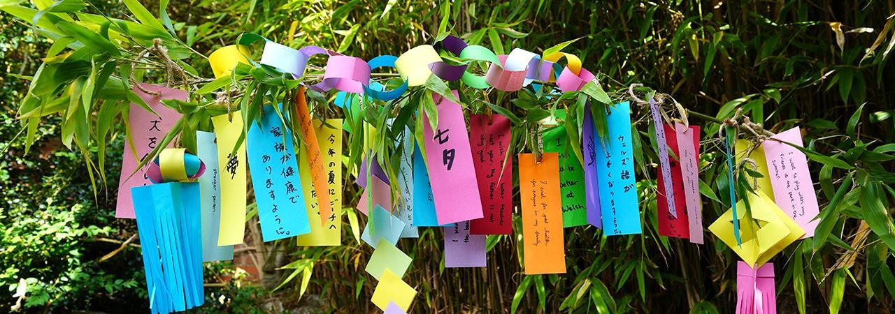
Figure 5 - The strips of paper with wishes for Tanabata

In Italy, on the contrary, there are many indigenous folktales with no clear origin other than explaining activities, like the use of lampara placed on a small boat that is stationed in the middle of the sea in the darkness to catch anchovies, as they are attracted by its bright light; once the anchovies have been attracted under the boat, they are surrounded with a net and fished. This is a traditional method of fishing still in use today in Italy that follows the phases of the moon, as the moonlight would interfere with the brightness of the lampara (Figure 6 below).
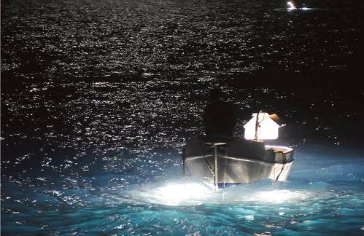
Figure 6 - Fishing anchovies with lampara

The problem with both the Japanese and Italian songs is that people from other cultures could not understand the meaning of the songs in relation to the myth, although nowadays there is an increased and renewed interest towards myths, especially as seen as a way to reconnect with nature. Fascinated by the colours and lights of the sky that tickle the imagination, people recognise the vastness of the sky so that they are able to ask questions and grasp answers, finding ways to understand themselves. It is a meditative practice to observe the sky and let the mind wander that day after day will connect with nature and with the instinct, as the sky accompanies humans through different phases, being night or day, or the changing seasons, as a companion in everyday life. It’s this sort of impermanence in the sky that oversees the different activities in life (‘We meet and we divide / The patterns made by human life’), yet humans can always look up and feel comforted by the constant presence of the sky, like the fisherman looks around full of hope for his future while he waits to catch the anchovies.

Theme two

Peculiarities of Tanabata include acts of kindness such as supporting the two stars and praying they can meet, as people would normally do for friends: many cities and towns in Japan host events where lanterns are lit and either let flow on a river or let fly in the sky, symbolising the stars in the Milky Way that light the way of Orihime and Hikoboshi - in the song this is not represented, however lanterns are present in the animated version at the moment of the chorus (’With a momentary flash of light tears run the night sky’), associating the tears to the stars and lanterns (reference Figure 7 below). It is also believed that on the evening of Tanabata it must not rain, otherwise Orihime and Hikoboshi would not be able to meet, so people create fabric dolls to ward off the rain, hanging them on the doors and windows of the house to scare the spirit of the rain.
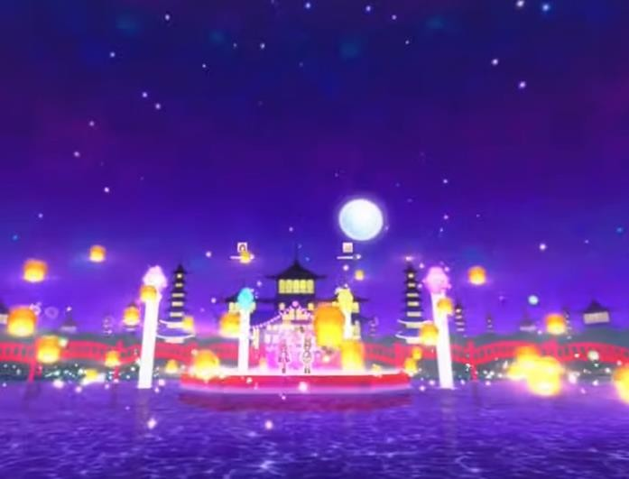
Figure 7 - Lanterns flown in the anime performance

A similar symbolism can be found in the myth of anchovies that, with their small silvery and sparkling appearance, mingle with the stars and in turn would like to return to the sky, as the fishermen's lamps lure them to the surface of the sea. There is a common theme that is the inescapability of one’s faith; as the two lovers already know they will be separated soon, anchovies are the protagonists of a hopeless journey and are victims of a cruel destiny that only allows them to choose the way they will die: either the fisherman captures them from above, deceiving them with the light of the lamps they are attracted to and under which they shine like the Engrauline stars of the legend, or the albacore devours them from below. The fisherman knows this game, and it is with a sense of guilt that he brings a bottle of spirit with him and holds it tight at the exact moment of the catch, hoping that a ‘sip of sweet liquor’ will free him from the evil actions that he made himself the author of, just like a prayer in which the Holy Spirit frees believers from the evil.
The journey of the small fishes is therefore hopeless, and is in strong contrast to the image of the female travellers who pass under the nets spread out in the sun to dry, as, unlike anchovies, the women do not let themselves be captured and in this sense the female figure

they evoke becomes the icastic form of fleeting love (‘And in the sea there is a fortune / Coming from the East / That everyone has seen it / And nobody takes it’).
It is instead a hymn to newfound freedom that of Goodrem: this time it is correct to say that the sky represents the hope of a better life and lasting happiness, just as the impossibility of contemplating it or the presence of clouds represent the desperate anguish of those who feel they have no way out, like Orihime and Hikoboshi on a raining Tanabata night. Therefore the sky is not only an element of the landscape, more or less picturesque, but it becomes the visible manifestation of the moods of the characters or, more rarely, of their opposite (‘I am brave but I am scared / I am lonely but I’m prepared’). As it was believed that the sky, without borders and placed above everything that happens in this world, was the natural home of the gods, from which they blessed or threatened human beings, it has always been seen as a goal to be reached in order to share the sense of infinity and omnipotence that it inspires, as a place of ideal perfection where all questions are answered and pain no longer exists (‘With everything my freedom’s worth / I’ll be a child of the universe’).

Theme three

The original Chinese legend for Tanabata originated from a very similar story set near the Hanshui River, where a skilled weaver lived, and she was the pride of her father, ruler of the region. She was given in marriage to a young shepherd and, like the legend of the two stars, the young couple also abandoned their activities and in the same way were cruelly separated. The legend that was born from this story was transposed into a celestial scenario thus giving life to the myth of Tanabata, the reason probably being the passion and mastery of the ancient Chinese with regards to the sky and celestial phenomena. On this occasion, it’s customary for the Japanese to address prayers to the two stars: especially young people ask for protection for their feelings (‘We’ll part under the summer night sky / But even in a new place, always be yourself, please…’) and help in order to improve their skills and study. Similarly, De André invites the listener to seize the moment, expressed in the title before the lyrics, where he chose precisely the collective gesture of protection that the anchovies make in an attempt to escape (they ‘’make the ball" – see Figure 8 below). Anchovies are found in schools, gathering in a vortex similar to a huge balloon, to defend from their natural hunter; it is at this point that the fisherman must be quick and cast his nets, before the albacore devours all the small fishes and he has nothing left. The sudden act of the fisherman, his personal carpe diem to capture the whole school, coincides with another action of the school itself: anchovies are already struggling with the attempt to escape and their making a ball is the answer to the first threat is fatal to them. Thus, the inexorable destiny of anchovies emerges and, in order to escape death by the albacore, they create the conditions for a second fate, equally sad, which is to die at the hands of the fisherman. The fisherman’s fate is inextricably connected to that of anchovies, as he has the uncontainable desire to seize the moment anyway before it finally escapes, while still in search of a way to redeem himself, of a ‘dream that comforts’, of a ‘mouth to fall in love with’, as if the anchovies making the ball meant ultimately the impossibility, basically, of being able to choose. This also happens in the myth, where their actions ultimately cause the fall to the sea and they become food, that would be sold in town to obtain ‘a great fortune’, so as much as the fisherman is fishing stars, everyone consuming anchovies would basically eat stars, bringing within themselves a piece of the sky.

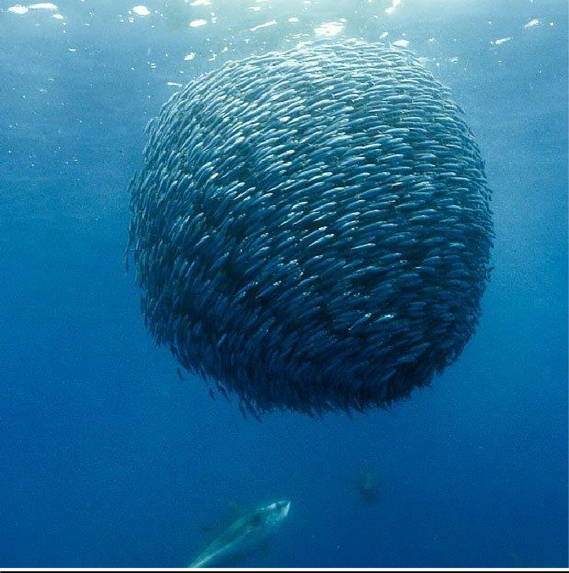
Figure 8 - Anchovies making the ball

The metaphor of being a child of the universe or the stars is somewhat true then, as scientists argue that the chemical composition of the human body is much more similar to what is found in space and therefore all humans carry within them stardust (“We are all connected without knowing / who we are”). Although this saying is related to New Ageism and is regarded by many as a state of mind or a set of beliefs, as Stefano Parisini from the INAF explains, intergalactic transhipment is a process that took place over a period of billions of years, fuelled by supernova explosions¹⁵. Simulations have in fact shown that supernova explosions eject copious quantities of gas from the galaxies within which they explode, producing powerful bursts of "galactic wind" that carries atoms from one galaxy to another. The astrophysicist concluded that almost half of the human body has a cosmic origin, being not only composed of native elements, but also of many atoms from distant galaxies.

Overall the three songs represent very different cultures, each with its own set of social rules and beliefs that appear clearly in the lyrics and create parallelism with the myths they reference. Apart from the contents, there are few differences in the way each song reflects its culture in approaching the myth, and that is the way emotions relate to the vision of the myth and the traditions associated with it. From Summer Tears Diary’s themes it appears how the journey is made starting from the inside, from inner emotions felt by the writer (and by extension by the Japanese) towards a relatable story that finds its positive resolution among the stars and to which they can somehow play a role in, carrying out the different activities of the festival to cheer for the happy ending. Le Acciughe Fanno il Pallone contrasts with this as the journey is made in the opposite way: the starting point is the sky myth, used to explain everyday life in a fantastical way, so that life itself looks less monotonous, indeed magical, despite the awareness of the fisherman to be part of a cruel reality is ever present. Child of the Universe is completely untied from traditional myths, as Goodrem reflects on her very own feelings (and she’s the only one of the three to do so in a

15 Stefano Parisini (2017). Siamo tutti un po’ migranti intergalattici. MediaINAF.

personal way), as she creates a duality where she feels little with regards to the universe, but also capable of realising her full potential thanks to her believing that the sky is a precious ally.

Conclusion
This essay analysed three songs from different cultures, comparing and contrasting the reason they were written, the contents with regards to the relative culture and myth, finding three main themes for each and assessing them against the literature review. It was found that, despite the diverse topics, the songs bear similarities in connecting humans to the sky through emotions, whether these are hope, freedom, resignation or ultimately solace, inviting the listener to seize a moment that will soon pass.
The differences lie in the socio-cultural environment of the stories they describe, as each culture has a specific approach to the myth, based on traditional and modern values that also appear to be shared by the writers themselves as they try to envelop the listener in that world through the use of suggestive and evocative music.

Bibliography
Barber, E. W., Barber, P. T. (2012). When they severed earth from sky: how the human mind shapes myth. Princeton University Press.

Clynes, F. (2011). The Enchanting Heavens. In Astronomy and Civilization in the New Enlightenment (pp. 61-67). Springer, Dordrecht.

Dolce, L. (2006). The worship of celestial bodies in Japan: politics, rituals and icons. na.

Heine, S. (2014). Japan and the Culture of the Four Seasons: Nature, Literature, and the Arts.

Iwaniszewski, S. (2011). Cultural Impacts of Astronomy. In Astronomy and Civilization in the New Enlightenment (pp. 123-128). Springer, Dordrecht.

Kilkelly, Daniel (2010). Delta Goodrem reveals new album plans. Digital Spy. https://www.digitalspy.com/music/a203954/delta-goodrem-reveals-new-album-plans/

Köchler, H. (2011). The relation between man and world. In Astronomy and Civilization in the New Enlightenment (pp. 37-46). Springer, Dordrecht.

AAVV, Fabrizio De André. Biografie Online. https://biografieonline.it/biografia-fabrizio-de- andre

Palmer, C. T., Begley, R. O., Coe, K., & Steadman, L. (2013). Moral elevation and traditions: Ancestral encouragement of altruism through ritual and myth. Journal of Ritual Studies, 83- 96.

Parisini, S. (2017). Siamo tutti un po’ migranti intergalattici. MediaINAF. https://www.media.inaf.it/2017/07/27/migranti-intergalattici/

Renshaw, S, Ihara, S. (1999). Archaeoastronomy and astronomy in culture in Japan, paving the way to interdisciplinary study. Archaeoastronomy, 14(1), 59-88.

Schrijver, K., Schrijver, I. (2015). Living with the Stars: How the Human Body is Connected to the Life Cycles of the Earth, the Planets, and the Stars. Oxford University Press, USA.

Stewart, T (2020). Tanabata: A Japanese Holiday of Love. Tokyo Weekender. https://www.tokyoweekender.com/2020/07/tanabata-a-japanese-holiday-of-love/

Vigliero Lami, M. (1998). La leggenda delle acciughe. http://www.vigliero.com/acci1.html

Songs live performances and interview

Aikatsu Stars! - Summer Tears Diary (https://www.youtube.com/watch?v=aUkk1tyuZHk) Fabrizio De André - Le acciughe fanno il pallone (https://www.youtube.com/watch?v=C_hgji7rFqA) Delta Goodrem - Child Of The Universe (https://www.youtube.com/watch?v=NL5Tky8dM5w
Delta Goodrem - Feline (Drum Break) / Child of the Universe (https://www.youtube.com/watch?v=7SVzrGpUi-4)
Delta Goodrem Track By Track - 'Child Of The Universe' (https://www.youtube.com/watch?v=8cCkJ1NcP1o)

Appendx

Summer tears diary

(Saori Kodama / Mito)
キラリ夜空 飛ばす涙
Kirari yozora tobasu namida
With a momentary flash of light tears run the night sky

秋の星座まで辿り着く前に もっと・・・
Aki no seiza made tadoritsuku mae ni motto...
Before the Autumn constellations finally arrive, a little more…

Don't cry 笑いあって ぎゅっと焼きつける
Don't cry, warai atte gyutto yakitsukeru
Don’t cry, your smile is etched tightly in my memory

Don't cry この夏を Don't cry, kono natsu wo Don’t cry, for this summer

あの時、時間が止まって
Ano toki jikan ga tomatte
That moment, the time stopped

ふたりは確かにお互いを見つけた
Futari wa tashika ni otagai wo mitsuketa And the two of us really found each other

今までの誰よりもトクベツな関係だよね
Ima made no dare yori mo tokubetsuna kankei dayo ne Now we have a relationship more special than anyone's

９月になれば 遠くはなれて
Kugatsu ni nareba tōku hanarete
When September comes, we’ll be far apart

違う制服を着てるの Chigau seifuku wo kiteru no Wearing different uniforms

ココロだけ何故 先回りしてKokoro dake naze sakimawari shite Why is my heart thinking about it

もう、切なさが溢れだす
Mou setsunasa ga afuredasu Sadness is already overflowing

キラリ夜空 飛ばす涙

Kirari yozora tobasu namida
With a momentary flash of light tears run the night sky

秋の星座まで辿り着く前にAh,
Aki no seiza made tadoritsuku mae ni ah
Before the Autumn constellations finally arrive ah

ふたり夜空 見送る夏
Futari yozora miokuru natsu
We’ll part under the summer night sky

新しい場所でもキミはキミらしく どうか・・・
Atarashī basho demo kimi wa kimi rashiku dōka...
But even in a new place, always be yourself, please…

Don't cry 笑いあって ちゃんと言えるように
Don't cry warai atte chanto ieru yō ni
Don’t cry, smile so you’ll be able to say it properly

Don't cry サヨナラって
Don't cry sayonaratte
Don’t cry, and say goodbye

いつかは思い出のなかでItsuka wa omoide no naka de At some point will be the day

キミを探しても気づけない日が来て
Kimi wo sagashite mo kizukenai hi ga kite
I suddenly won't search for you in my memories

すれ違う人の顔に少しずつぼやけちゃうのかな
Surechigau hito no kao ni sukoshi zutsu boyakechau no kana
I wonder if the faces of people I once meet fade a little at a time

オトナになれば時間も距離もOtona ni nareba jikan mo kyori mo Once you become an adult

カンタンに越えられるのに
Kantan ni koerareru no ni
You pass over on time and distance easily

きっとそれには間に合わないのKitto sore ni wa ma ni awanai no I’m sure one day it’ll be so for us

なんて・・・、のみ込むオモイが痛いNante..., nomikomu omoi ga itai Still…., I’m filled with painful emotions

チクリ胸に 刺さったまま

Chikuri mune ni sasatta mama
I feel as having thorns in my chest

癒えないでほしい 行かないでほしい ねえ
Ienaide hoshī ikanaide hoshī nē
I don’t want you to say it, I don’t want you to go

終わりかける 夏の傍でOwarikakeru natsu no soba de Near the end of summer

言葉にならない願いが揺れてる どうか・・・
Kotoba ni naranai negai ga yureteru dōka...
My wish that I'll never turn into words will be swaying, please…

いくつも流れ星を 追いかけてはキミの名を
Ikutsu mo nagareboshi wo oikakete wa kimi no na wo Chasing so many shooting stars I whisper your name

つぶやいてみるけど 最後まで言えないねTsubuyaite miru kedo saigo made ienai ne But look, I won’t be able to say it until the end

キラリ夜空 飛ばす涙
Kirari yozora tobasu namida
With a momentary flash of light tears run the night sky

秋の星座まで辿り着く前にAh,
Aki no seiza made tadori tsuku mae ni Ah, Before the Autumn constellation finally arrive ah

ふたり夜空 見送る夏
Futari yozora miokuru natsu
We’ll part under the summer night sky

新しい場所でもキミはキミらしく・・・いてAtarashī basho demo kimi wa kimi rashiku... ite But even in a new place, always be yourself…

チクリ胸に 刺さったまま
Chikuri mune ni sasatta mama
I feel as having thorns in my chest

癒えないでほしい 行かないでほしい ねえ
Ienaide hoshī ikanaide hoshī nē
I don’t want you to say it, I don’t want you to go

終わりかける 夏の傍でOwarikakeru natsu no soba de Near the end of summer

言葉にならない願いが揺れてる どうか・・・

Kotoba ni naranai negai ga yureteru dōka...
My wish that I'll never turn into words will be swaying, please…

Don't cry 笑いあって ぎゅっと焼きつける
Don't cry warai atte gyutto yakitsukeru
Don’t cry, your smile is etched tightly in my memory

きっとこの夏を ずっと忘れないKitto kono natsu wo zutto wasurenai I won’t forget this summer for sure

Don't cry 笑いあって ちゃんと言えるように
Don't cry warai atte chanto ieru yō ni
Don’t cry, smile so you’ll be able to say it properly Goodbye Dear my best friend

Le acciughe fanno il pallone

(Ivano Fossati / Fabrizio De Andre')

Le acciughe fanno il pallone Anchovies make the ball

Che sotto c'è l'alalunga
Because underneath is the albacore

Se non butti la rete
If you don't throw the net

Non te ne lascia una It won't leave you one

E alla riva sbarcherò
And at the shore I will disembark

Alla riva verrà la gente People will come to the shore

Questi pesci sorpresi These surprised fishes

Li venderò per niente
I will sell them for nothing

Se sbarcherò alla foce
If I land at the river’s mouth E alla foce non c'è nessuno

And there is no one at the river’s mouth

La faccia mi laverò I'll wash my face

Nell'acqua del torrente
In the water of the stream

Ogni tre ami Every three hooks

C'è una stella marina There is a starfish

Amo per amo Hook by hook

C'è una stella che trema There is a star that trembles

Ogni tre lacrime Every three tears

Batte la campana The bell resounds

Passano le villeggianti The vacationers pass by

Con gli occhi di vetro scuro With dark glass eyes

Passan sotto le reti
They pass under the nets

Che asciugano sul muro That dry on the wall

E in mare c'è una fortuna
And in the sea there is a fortune

Che viene dall'oriente Coming from the East

Che tutti l'hanno vista That everyone has seen it

E nessuno la prende And nobody takes it

Ogni tre ami Every three hooks

C'è una stella marina There is a starfish

Ogni tre stelle Every three stars

C'è un aereo che vola There is a plane flying

Ogni tre notti Every three nights

Un sogno che mi consola A dream that comforts me

Bottiglia legata stretta Bottle tied tight

Come un'esca da trascinare Like a bait to drag

Sorso di vena dolce Sip of sweet liquor

Che liberi dal male That frees from evil

Se prendo il pesce d'oro If I catch the gold fish

Ve la farò vedere I'll show you

Se prendo il pesce d'oro If I catch the gold fish

Mi sposerò all'altare
I will get married at the altar

Ogni tre ami Every three hooks

C'è una stella marina There is a starfish

Ogni tre stelle Every three stars

C'è un aereo che vola There is a plane flying

Ogni balcone
At every balcony

Una bocca che m'innamora A mouth to fall in love with

Ogni tre ami Every three hooks

C'è una stella marina There is a starfish

Ogni tre stelle Every three stars

C'è un aereo che vola There is a plane flying

Ogni balcone
At every balcony

Una bocca che m'innamora A mouth to fall in love with

Le acciughe fanno il pallone Anchovies make the ball

Che sotto c'è l'alalunga
Because underneath is the albacore

Se non butti la rete
If you don't throw the net

Non te ne resta una You won’t have one left

Non te ne lascia una It won't leave you one

Non te ne lascia
It won’t leave you any

Child of the universe

(Delta Goodrem / Gary Clark) I grew up to be myself
Still I feel there's something else
Look at all the satellites colliding in the sky We meet and we divide
The patterns made by human life
Look at all the stars tonight they're writing in the sky Together we are all alone

All trying to make it home, home In this world
If it's the only thing I've ever learned Is that everything you love can hurt
And the only thing you are is a child of the universe In this world
If it's the only thing I've ever learned Is that everything you love can hurt
And with everything my freedom's worth I'll be a child of the universe
I am brave but I am scared I am lonely
But I'm prepared
We are all connected without knowing Who we are
Together we are rolling stones All trying to make it home, home In this world
If it's the only thing I've ever learned Is that everything you love can hurt
And the only thing you are is a child of the universe In this world
If it's the only thing I've ever learned Is that everything you love can hurt
And with everything my freedom's worth I'll be a child of the universe
In this world
If it's the only thing I've ever learned Is that everything you love can hurt
And the only thing you are is a child of the universe In this world
If it's the only thing I've ever learned Is that everything you love can hurt
And with everything my freedom's worth I'll be a child of the universe
I'll be a child of the universe Child of the universe

