Process Improvement Methodologies

ACMA003 Level 4
Advanced Manufacturing Operations
Quality & Business Improvements

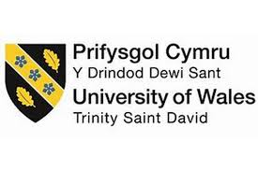

Darryl Thomas
2014853
Lecturer : Richard Morgan

Table of Contents
1. Introduction 3
2. Lean Principles 3
2.1 Identify Value 4
2.2 Map the value stream 4
2.3 Create Flow 4
2.4 Establish Pull 5
2.5 Seek Perfection 5
2.6 Implementation Benefits 5
2.7 Lean limitations 6
3. Six Sigma 6
3.1 DMAIC 7
3.2 DMADV 8
3.3 Implementation of Six Sigma 8
4. Lean Six Sigma 10
4.1 Lean Six Sigma Implementation success 11
4.2 Limitations of Lean 6 Sigma 11
5. Summary 11
6. References 12

Introduction

There have been many different Process Improvement methodologies that have been developed and implemented in business all over the world. These methodologies have been designed to look at waste in a process with the view to reduce or eliminate it. Through reduction or elimination of waste within a process, a company can then start to improve the efficiency and the quality of the product or service , then ultimately they will improve profits.
These methodologies can be used to look at the whole process over the company or for much larger and complex processes they can be used on more specific areas. In my current employer Tata Steel the process of making the final product of steel is so expansive that it would be too large a task to look at the process as one.
Lean and Six Sigma methodologies are used as part of a failure reduction process used in the Energy Department. The process is seen as so beneficial that some engineers are trained up to a Black belt standard and have a dedicated role looking at systems and trying to implement improvements. This process has become gradually more important over the last few years and the department has seen the rewards from increased importance of the Lean Six sigma Methodologies.

Lean Principles

Lean principles, although outlined for the automotive industry originally by Toyota in the 1960’s, have the underlying methodologies to transfer into other sectors. Womack et al (1990) predicted that ‘Lean production will supplement both mass production and the remaining outposts of craft production in all areas of industrial endeavour to become the standard global production system of the twenty-first century’, and undoubtably this has come true with the methodology being adopted in many different sectors including healthcare, civil service and other industries’.
Bicheno (2016) said ‘Lean is about moving ever closer to uninterrupted flow in the sequence of operations that deliver perfect quality’, this means that lean is a methodology that looks at the process to identify a clear flow looking at each component and process to ensure maximum efficiency and minimise of waste in the process. Lean has five main principles to the process with all five necessary for the process to work. As defined by Womack and Jones these 5 principles are:
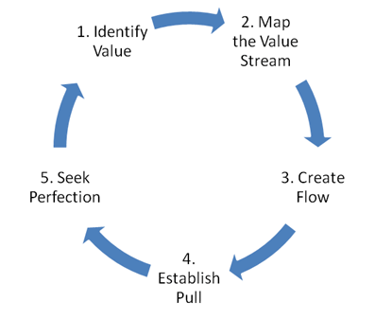
Fig. 1 Process flow for lean Principles. Lean.org (2020)

Identify Value

Value streams are looking at the process to define which aspects add value from the perspective of the customer. It is important that the product or service is looked at from customers perspective as they need to be willing to pay for it, although some processes, products or services require an element of waste.

Map the value stream

Mapping the process can produce a visual aid that identifies the value adding and non-value adding steps to the process. It is important waste is identified, although not all of this waste can be eliminated, some of the waste is necessary. The waste that is unnecessary is the part of the process that needs to be eliminated for the value to be added.
Lean defines waste as anything that uses time, resources or space. Identified by Ohno (1988) there were seven categories of waste. When Womack and Jones reported these in 1996 the added an eighth to the list. They were:

Overproduction | This is when production has continued when there is not enough demand. This will result in excess products and increased inventory.
Waiting | This is a result of an upstream activity not delivering on time, meaning that there is a period of in activity downstream.
Transport | This is the movement of materials from one operation to another. This results in time being added to the process which is non-value adding.
Extra Processing | This can be a result of overproduction where stored product will have to be reworked or re-handled as part of its storage.
Inventory | This is any inventory that is not required to produce the end product such as raw materials, or any product that has been produced and is not required by the end user. This will require extra handling and storage.
Motion | This is anything extra that the machinery or employees are required to undertake to accommodate the poor layout, defects or excess inventory.
Defects | This is when the end product does not meet the specification or expectation of the customer.
Under-utilisation | When Womack and Jones (1996) added this eighth waste, they explained that that there is an ‘underutilisation of people and in particular their ideas and creative input for improving the processes and practices’

Create Flow

After identifying and eliminating the waste from the process, a reconfiguration of the flow will be required to ensure the remaining parts of the process run without interruptions or delay. Some value adding steps might be added to the process for it to run more smoothly. A reconfiguration of the process might include, breaking down certain steps, levelling out the work loads or training employees to be multi-skilled.

Establish Pull

One of the biggest wastes of production is excess product. The goal is to achieve a pull-based system that limit the amount of product held or the amount of work in progress (WIP) whilst still having the essential materials available for a smooth work flow. A just in time (JIT) system allows the product to be created at the time they are needed and in the quantities required. Pull systems are created by looking at the needs of the customer.

Seek Perfection

It is important that the process is continually reviewed to identify any layers of waste. New innovative ideas or improvements should be implemented when possible to remove any non-value adding waste from the process.

Implementation Benefits

After all these steps have been undertaken, there are numerous results you can expect to see. If the persistence of overcoming the obstacles and if the process is adopted, the end product should be of a high quality and be produced in a quicker time. The best results require the customer to be fully engaged and the right questions being asked to steer the process in the right direction, relating to the price and product, as Womack et al (1996) said ‘value is defined by the customer’
Understanding the hold up in the process by completing a comprehensive Value Map stream should help to highlight if there are any ‘bottle necks’ in the production line. When possible the line of process should be changed to create a better flow, but not all processes take the same time on a production line. If the second process is taking longer than the first, this will slow down the next process and completion of the product and there will be the need to store the product whilst waiting, increasing costs. One way this can be rectified is by multi skilling the employees to move between lines when possible.
Implementing a just-in-time process will undoubtably benefit a company. This will keep the customer happy as the product is complete on time and will benefit the business by cutting the amount of raw materials held, tying up cash and space. It will also cut the amount of storage space needed for the finished product.
There are some impressive statistics that have been published to indicate the benefits of Lean methodologies being implemented. Davies (2017) quotes the Manufacturing Advisory Services for releasing statistics indicating that on average:
- Delivery targets met – up by 26%
- Increases in stock turnover – up by 33%
- Improved productivity – increased by 25%
- Reduction in scrap – reduced by 26%
- Space efficiency – improved by 33%

Lean limitations

If possible, when looking at implementing Lean principles, a company should always try to do so during the design stage. This will alleviate the need for a high amount of restructure later on in the process. If Lean is looked at later on when the machinery and tooling is already established this can lead to high implementation costs or not enough space to restructure. ‘The Lean philosophy, with its focus on minimizing waste and maximizing value, is therefore recommended to be applied as early as possible in a building process’ Skhmot (2015)
Tata Steel Port Talbot has been in operation for decades. Due to the new plant and new processes that have been installed and implemented in this time, the flow of the process is not as some newer purpose built steel works. New plant is required to be built when the old one is still running, this now causes a zig zag effect in the process with extra requirement for re-heating systems and longer train lines to move the product from one plant to another. This is all wasted time and energy in the process and as different departments feel very insular due to the distance. This can cause bottlenecks in the process forcing other departments to pull back on their part of the production line not knowing what detrimental effects this can cause in the process.

Six Sigma

Six Sigma is a methodology that aims to give the company the techniques to understand what is making the process slow down, how to eliminate the delays and how to improve the process. ‘The method uses a data-driven review to limit mistakes or defects in a corporate or business process’ Hayes (2020). The process was first developed by Bill Smith in the 1980’s whist working for Motorola.
He came up with this process with the aim of improving Motorola’s standards. ‘He recommended setting the goal at just 3.4 defects per million opportunities. This meant a quality level of 99.9997%.’ Swan (2018). He highlighted that understanding the customers’ needs is critical in the process and that the data that has been collected is vital in ensuring customers’ expectations are met.
‘Six Sigma is not achieved in a crash program. Moving to Six Sigma involves many factors, time, personnel, and funds. Moving toward Six Sigma from a four-sigma quality level requires a quality improvement at a rate of 78% annually to be achieved in 5 years. This requires improving monthly at 12% those areas needing improvement’ Gordon Jr (2002). This identifies that six sigma will not provide success over night, it is a process that needs to be set up correctly and only then will the company see the incremental results.
Six Sigma is based on two main strategies, DMAIC and DMADV. These are very similar in their steps but cannot be used together or they cannot be interchanged on a project. The main reason for this is that they fundamentally designed for different reasons. DMADV is used when new products or processes are being created whilst DMAIC is used for improving current processes.

DMAIC

1. Define
2. Measure
3. Analyse
4. Improve
5. Control
DMAIC

Step | Explanation | Tools include
Define | This will be done by assembling a team who will outline what the customers’ needs are, what issues are faced and what opportunities are available. | SIPOC,  A3,  Value stream map,
Measure | This is when a data collection plan is put in place and implemented to collect data from as many sources as possible. | Data Collection plan,  Check sheet,  Operational definitions
Analyse | The data collected should then be analysed to identify the root cause of the defects or any improvement opportunities. | Value stream map,  5 Whys, Pareto charts, Fishbourne Diagrams, Root cause analysis, Histograms
Improve | Develop a plan and implement the changes possibly using innovative or creative ideas to prevent or fix a problem. | Brainstorming, benchmarking, Value stream map, Implementation plan, PDCA/PDSA
Control | This is where improvements are maintained and process does not revert back to previous failings. This requires a monitoring plan which includes development and documentation to needed to sustain the gains made. | Gallery walks, Control plan, Documentation,

There is also sometimes a sixth step to the process, Transfer. This is when the organisation will transfer the findings and knowledge to other parts of the business. This is not an essential step to the process but it is a good way to maximise the benefits.

DMADV

1. Define
2. Measure
3. Analyse
4. Design
5. Verify
DMADV

DMADV is very similar in its steps as DMAIC with the first three steps being Define, Measure and Analyse. As DMADV is for a new process the design stage is next with its aim of using the information collected at the define, measure and analysing stages to now test the product or service against the customers wants and needs, this can be done using customer focus groups where they can provide valuable feedback. At this stage any adjustments to the final product or service should be made before it becomes widely available.
The last stage of the DMADV process is verify, this is a continuous process where the customer will provide feedback whilst the product or service is being released and some adjustments will be able to be made.

Implementation of Six Sigma

At Tata steel six sigma is implemented with several engineers being trained to black belts and above. The process is used to identify and improve any faults that have been found, and find out the root cause of the problem.
This has been used in the energy department on many different parts of plant as part of a failure reduction initiative. The data is stored on an A3 DMAIC tracker where many of the Six Sigma methodologies are used. Each problem area will be looked at individually using the different approaches such as the 5 Whys, a Fishbourne Diagram, or a scatter graphs, although not all of the methods add any insight or value to the process. These will then be rejected and another methodology might be used.
In the A3 tracker below identified the PRS spray pump number 3 as an issue in the process. There had been several incidents in which the pump had increased vibration and had failed, whilst in service. The 5 Whys is not on the A3 tracker, but would have been used as this is a standard to which we work to on any new topic. The process is to clearly define all aspects including operations and what the pumps should be doing.
Data for the pumps has been gathered this included the SAP notifications which highlights the amount of times an issue has been reported and vibration monitoring results which are done periodically to monitor any developing issues. Pumps specifications and control standards will also be compiled.
All the data will then be analysed to find the root cause of the issue so it can be rectified. This is a team effort and there will be input form the operations, electrical, mechanical and automation departments so that all areas can contribute to finding the solution.
All findings will then be used to improve the performance of that specific area and any findings are recorded. If any findings are relatable to other parts of plant which have a similar function, these will then be implemented periodically when plant conditions enable. Breaking down the issue into these categories ensures a thorough process is followed.
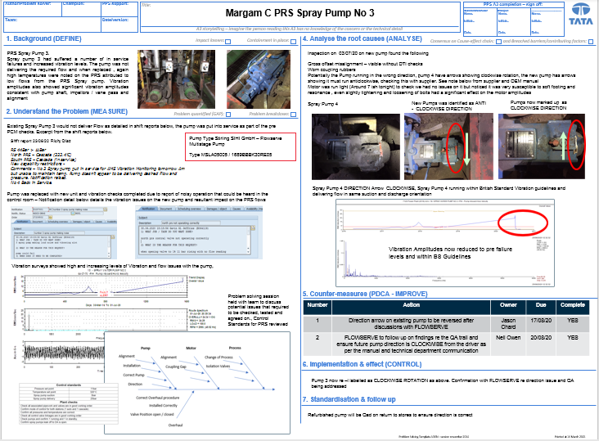

Fig. 2 Sample of an A3 DMAIC Tracker used in Tata steel Energy Department. Chard(2020)

Lean Six Sigma

Lean Six Sigma is a methodology that combines both the Six Sigma and Lean principles, with the aim of reducing or eliminating waste in the process. When a company adopts the methodologies of both the manufacturing techniques of lean and the streamlining of operations of six sigma then there is a benefit of an increase in value and a reduction in costs.
Lean helps the company make the product or in some cases provide the service faster by identifying and then reducing the waste, and six sigma will look at the reduction in defects and errors in the process. By combining both methodologies the company aim should be to look at the delivery of customer value from the view of the customer not the view of the organisation.
Lean Six Sigma focuses on issues like quality and efficiency, most processes and companies, no matter the size can be positively affected. It can be a tool for the health, finance, education, manufacturing, insurance, military or service industries to improve performance ,improve profits, lower costs, enhance employee development and most important improve customer satisfaction.
Lean Six Sigma engineers work on a belt colour system based on the six sigma methodology. Starting on a white belt higher belts are then obtained through study with the higher qualifications obtained via examinations requiring a significant amount of study. Bellow is a table of classifications taken from dvidshub(2020)

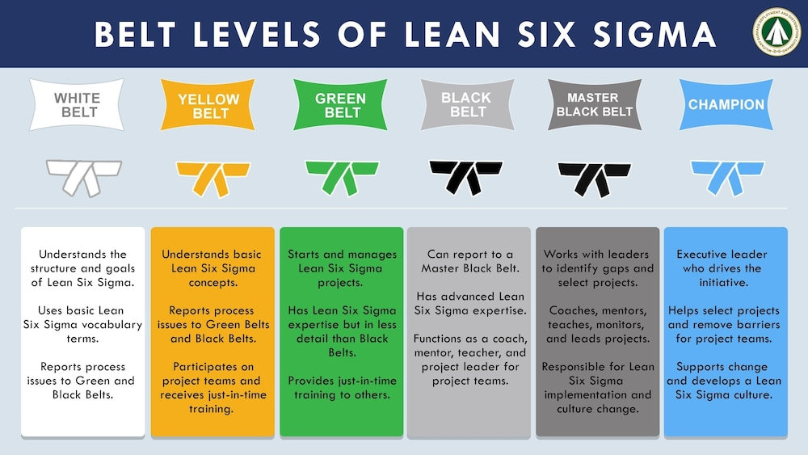

Fig. 3 Diagram taken from dvidshub.net(2020)

Lean Six Sigma Implementation success

There have many success stores with the implementation of lean six Sigma, throughout all mentioned industries and more. The Louisiana national guard was reported to have saved ‘over 500 man-hours and $370,000 in labour costs annually’ Dipuma (2018). This was done by looking at others in their sector and looked at ‘vehicle and installation maintenance’

Lean Six Sigma is not an overnight success and with the right level of training and dedication to the full implementation of these methodologies there can be some outstanding success. Due to a market crash and a substantial loss of income in Kern County, CA. They undertook a massive restructure of all departments aiming to train its 7,500 staff in the lean six sigma methodologies. Through this process ‘ Four years later, Kern County has trained over 1,000 employees who’ve gone onto complete over 185 projects, resulting in over $19 million and 100,000 hours saved.’ go lean six sigma (2020)

4.2 Limitations of Lean 6 Sigma

Lean Six Sigma is only as good as the company lets it be. There can be several failings to the process that would mean the full benefits will not be seen. Some of the reasons for the process failing could include:
- Lack of training
- Employee resistance
- Lack of planning
- Poor facilities
- Lack of resources (this can include money and people to dedicate their time to the process)
- Lack of information
- Lack of senior management involvement.

Summary

When a company is looking for business improvements in an ever increasing diverse and competitive market then the combination of the Two methodologies will only benefit the company. Whilst Lean looks at streamlining the operations Six sigma looks at ways to eliminate the errors and finding ways to improve the performance.
Through first-hand experience my department has seen the benefits of persistence in the pursuit of implementation of Lean Six Sigma, with the use of many of the methods that include Fishbourne diagrams, the 5 Why’s and the DMAIC techniques. We have become the first department in Port Talbot to be recognised by the business and awarded gold status in our failure reduction process, this is despite being one of the last departments to start using it. The energy department has bought into this process with all key personnel contributing to the success. If this process is not fully committed to, then there is always a possibility it could fail to be implemented correctly and efficiently.

References

- Womack, J., Jones, D. and Roos, D. (1990) The Machine That Changed the World., New York: Free Press

- Bicheno, J & Holweg, M (2016) The lean Tool Box 5th ed. Birmingham: Production and Inventory Control

- Womack, JP & Jones, DT (1996) Lean Thinking: Banish waste and create wealth in your corporation, London: Simon & Schuster

- Ohno, T (1988) The Toyota Production System, Portland, Productivity Press

- Lean Enterprise Institute (2016) Principles of Lean.
https://www.lean.org/whatslean/principles.cfm 18/03/2021 17:30

- Kilpatrick, J (2003) Utah Manufacturing Extension Partnership, academia.edu 18/03/2021 17:36

- Gordan Jr, MJ (2002), Six Sigma Quality for Business and Manufacture, Florida US, Gordon & Associates Palm Harbor

- Sgt. Dipuma, G L (2018) Louisiana National Guard identifies waste reducing strategies, Army https://www.army.mil/article/205522/louisiana_national_guard_identifies_waste_reducing_strategies 18/03/2021 15:56

- Davies, J (2017) 10 signs you should invest in lean manufacturing, Winman https://www.winman.com/blog/10-signs-you-should-invest-in-lean-manufacturing 18/03/2021 18:19

- Hayes, A (2020) Six Sigma Investopedia. https://www.investopedia.com/terms/s/six-sigma.asp#:~:text=Six%20Sigma%20is%20a%20quality,a%20corporate%20or%20business%20process. 18/03/2021 18:45

- Skhmot, N (2015) Applying Lean Thinking to the Design Process, Lean Construction Blog. https://leanconstructionblog.com/Applying-Lean-Thinking-to-the-Design-Process.html 18/03/21 19:55

- Swan, E (2020) Grand-Daddy of Quality: Bill Smith, Go Lean Six Sigma. https://goleansixsigma.com/bill-smith-grand-daddy-quality/#:~:text=Six%20Sigma%3A&text=Smith%20thought%20Motorola%20should%20hold,a%20quality%20level%20of%2099.9997%25.&text=Initially%20the%20method%20designed%20to,%2C%20Analyze%2C%20Improve%20and%20Control 18/03/2021. 18:57

- Chard, J (2020), A3 DMAIC Tracker PRS Spray pump Number 3, Tata Steel Port Talbot.

- Go Lean Six Sigma (2019) Lean Six Sigma Success Stories in the Government Industry https://goleansixsigma.com/lean-six-sigma-success-stories-in-the-government/ 18/03/21 19:33

- Dvidshub (2020) SDDC improves CPI program. https://www.dvidshub.net/image/6210592/sddc-improves-cpi-program 18/03/21 19:36

