Ordnance, Munitions and Explosives



Analysis of Electromagnetic Wave Propogation
Electromagnetic Radiation (ACDC5009)

Ewan Simpson

2115523
May 2025

Lecturer: Stalin Jacob Wilson Packia Dhas

Contents:
- Abstract (3)
- Introduction (3)
- Method (4)
- Results (6)
- Discussion (8)
- Conclusion (9)
- References (10)

Abstract:
This report explores the principles and practical applications of electromagnetic wave propagation using High Frequency Structure Simulator (HFSS) software. Two key simulations were carried out: the analysis of rectangular waveguides with Perfect Electric Conductor (PEC) walls filled with vacuum and Teflon, and the design of a half-wave dipole antenna. For the waveguides, cutoff frequencies for the first three modes were computed and compared between the two dielectric environments, demonstrating a significant reduction in cutoff frequencies when using Teflon due to its higher permittivity. The dipole antenna was designed based on a wavelength derived from the student ID, with theoretical and simulated operating frequencies compared to validate design accuracy. Electric and magnetic field distributions, as well as radiation patterns and S-parameters, were analysed to assess the behaviour and efficiency of the systems. The simulations confirmed theoretical expectations and provided insights into how material properties and structural dimensions influence electromagnetic behaviour.
Introduction:
Electromagnetic (EM) waves are waves of electric and magnetic fields that travel through space, carrying energy. They are a fundamental part of the electromagnetic spectrum, from radio waves to gamma rays. EM waves do not require a medium to travel, so they can move through the vacuum of space. EM waves are generated when an electric charge accelerates, such as electrons moving up and down an antenna to create radio waves, or vibrating electrons in atoms emitting visible light or other forms of EM radiation [1]. The oscillating electric fields generates a magnetic field, as well as the other way round. These fields propagate together, perpendicular to each other and to the direction the wave is moving. Electric and magnetic fields are perpendicular to each other. EM waves travel at the speed of light in a vacuum ($c=3×{10}^{8}$) and wavelength and frequency are inversely related ($c=λf$). EM waves have lots of applications such as communication, medical, astronomy and remote sensing and imaging.
A waveguide is a physical structure that guides electromagnetic waves from one point to another. It confines the wave within a specific geometry so that it propagates with minimal loss. It essentially acts as a pipe for electromagnetic waves to travel through, and channels EM energy [2]. Rectangular and circular waveguides are made of hollow metal tubes and are mostly used for microwave and millimetre-wave frequencies. Optical fibres are based on the principle of total internal reflection and are used for guiding infrared and visible light in communication systems. Dielectric slab waveguides are a core layer of dielectric material sandwiched between layers of lower refractive index and are used in integrated optics and photonics. In free space, EM waves can spread in all directions, whereas in waveguides, the boundaries force the wave to reflect and form standing wave patterns (modes) that can propagate along the guide. Each mode has a cutoff frequency, below which it cannot propagate. This is calculated with the formula $f_{c}=\frac{c}{2}\sqrt{{\left(\frac{m}{a}\right)}^{2}+{\left(\frac{n}{b}\right)}^{2}}$where ‘m’ and ‘n’ are the number of half-wavelength variations of the electric or magnetic field in the width and height of the waveguide, ‘a’ is the width and ‘b’ is the height of the waveguide, and ‘c’ is the velocity of light.
An antenna is a device that transmits and/or receives EM waves. It serves as the interface between electrical signals and EM waves in free space. In transmission, it converts electrical power into EM waves and in reception it converts EM waves back to electrical signals. Antennas work by accelerating electrons in a conductor, which generates time-varying electric and magnetic fields. These fields propagate as EM waves. The shape, size and structure of an antenna determines the frequencies it can handle and the pattern in which it radiates [3]. Key applications of antennas include telecommunications, broadcasting, navigation, radar systems, wireless sensors, remote sensing and space exploration.
For the simulations, a High Frequency Structure Simulator (HFSS) design was used with Ansys. This is a 3D electromagnetic simulation software developed by Ansys used primarily for simulating high-frequency electronic components. It uses the finite element method (FEM) to solve Maxwell’s equations and is commonly used in industries like aerospace, telecommunications, automotive, defence, and biomedical. HFSS allows engineers to design, simulate, and optimise components that interact with electromagnetic fields [4]. It provides accurate EM field distributions, reflection coefficients, impedance, radiation patterns, etc. Typical components analysed using HFSS include antennas, waveguides, RF and microwave circuits, resonators and filters, and more. Advantages of using HFSS include highly accurate 3D EM modelling, easy integration with other Ansys tools, being widely accepted in industry and academia, and it’s great for high-frequency and high-complexity systems.
Method:
The first task was split into two, with both requiring the same rectangular waveguide model design, just using a different material for the Perfect Electric Conductor (PEC) walls. The dimensions of the waveguide model were dependent on the identification numbers of each student, using the first two numbers for the width (a) and the third and fourth numbers divided by two for the height (b). This meant that for this waveguide model, the width would be 21mm, height would be 7.5mm, and the length was 50mm. For this design, a High-Frequency Structure Stimulator (HFSS) design was used in Ansys. A HFSS design is a powerful tool used for simulating high-frequency structures like antennas, waveguides, microwave circuits and radiofrequency components [4]. HFSS designs are useful as they are good for creating 3D models of antennas, waveguides, PCB components and radiofrequency circuits, with precise control over dimensions, shapes and materials. For complex 3D structures, they solve Maxwell’s equations accurately, in order to analyse electric and magnetic fields, scattering parameters and resonant modes. They are also able to handle a wide range of frequencies, from RF to millimetre-wave frequencies.
The design was then drawn up with the correct dimensions, individual to each student. Having done this, the boundaries required could be set, which meant assigning the PEC walls. This is done in order to assure the surface is a perfect conductor and reflects all incident electromagnetic waves, and no fields can penetrate it [5]. This means the tangential electric field on the surface is zero, the surface current density can be non-zero and the material has infinite conductivity. By doing this it enforces the correct transverse electric or transverse magnetic modes, ensuring fields reflect and form standing waves properly. This is critical when calculating cutoff frequencies, scatter (S) parameters or field distribution.
After setting the PEC boundaries, the two wave ports could be set at either end of the waveguide. These act as the entry and exit points for electromagnetic energy. The wave ports compute characteristic impedance, S parameters and mode fields, making them very important for the calculations and results. The number of modes was set as 3 and the full port impedance was set at 50 ohms. The port impedance is important for ensuring maximum power transfer from source to load, minimising reflections and accurate S parameter calculations. After completing this, the simulation can be completed.
For task 1b, the setup was exactly the same, however using a different material for the PEC walls. For this simulation, the rectangular waveguide would have PEC walls filled with Teflon compared to vacuum. In theory, this should reduce the cutoff frequency. This is because when the waveguide is filled with a dielectric such as Teflon, the electromagnetic properties of the medium inside change. This increases the permittivity, ε, which changes the phase velocity of waves in the guide. Once the simulations for both had been completed, the cutoff frequency for both models could be compared, along with the magnitude and vectors of the electric and magnetic fields for the modes.
Task 2 was to design a halfwave dipole antenna with a radius of 1mm, intended to radiate electromagnetic waves, with the wavelength dependent on the student ID number. For this design, the waves would have a wavelength of 211mm. Just as the first task was, the design for task 2 would be completed using the HFSS design tool on Ansys. The halfwave dipole antenna, like the rectangular waveguide, had PEC walls, which were filled with vacuum, and the excitation was applied through a lumped port with port impedance of 50 ohms. A lumped port is a simplified model of an excitation source used in EM simulation tools such as HFSS. It stimulates a voltage source with a defined impedance, which in this case is 50 ohms. It is located at a specific point or small region and stimulates connecting two conductors such as the two arms of the dipole. It is important for properly exciting the antenna, defining the reference impedance, and allowing radiation to be simulated [6].
After setting up the lumped port, an open region is created, and the operating frequency is set as default of 1GHz and the boundary as PML. This creates a rectangular open region with the antenna radiated within the open space. The next step is to create solution setup, with the frequency set close to the operating frequency (in this case it was set at 5GHz) and the maximum number of passes was set to 99. Once the frequency sweep was set, the simulation could be completed in order to give the operating frequency and S-parameter plot.
Results:
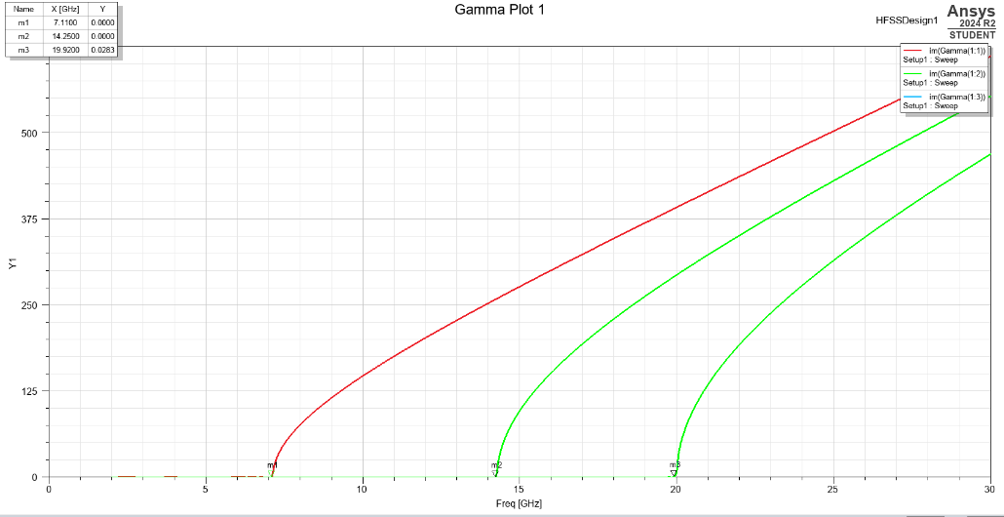

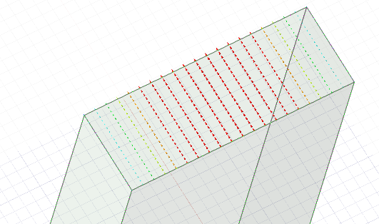
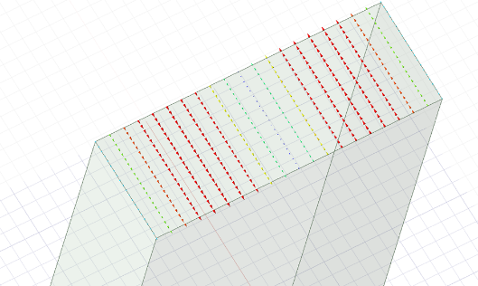
Figure 1 - Cutoff frequency for vacuum rectangular waveguide
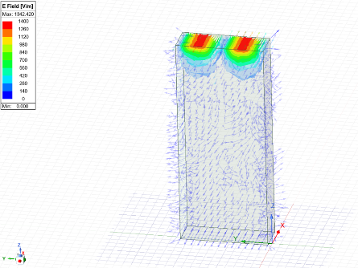
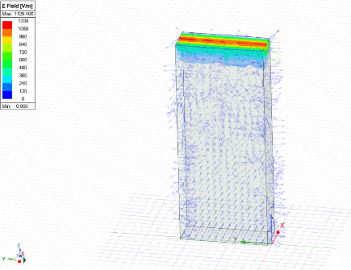
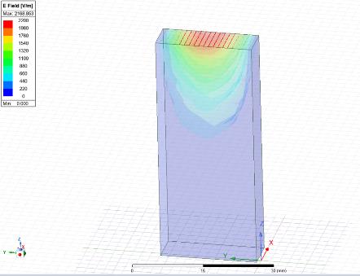
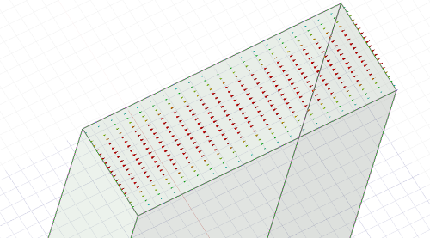
Figure 2 - EM Wave Modes
Figure 3 - Modes 1, 2 and 3 Magnitudes
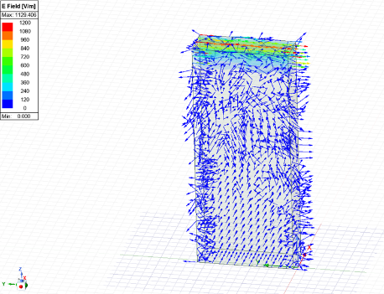
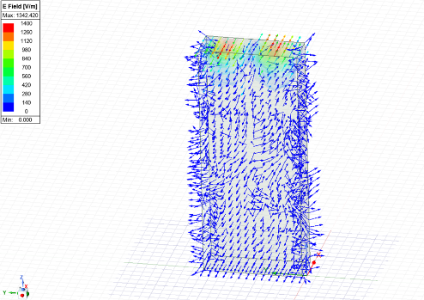
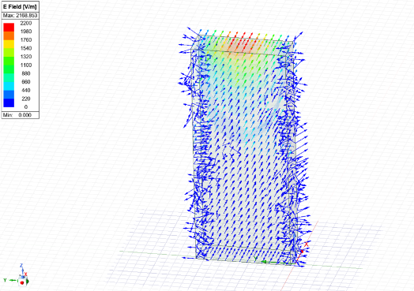
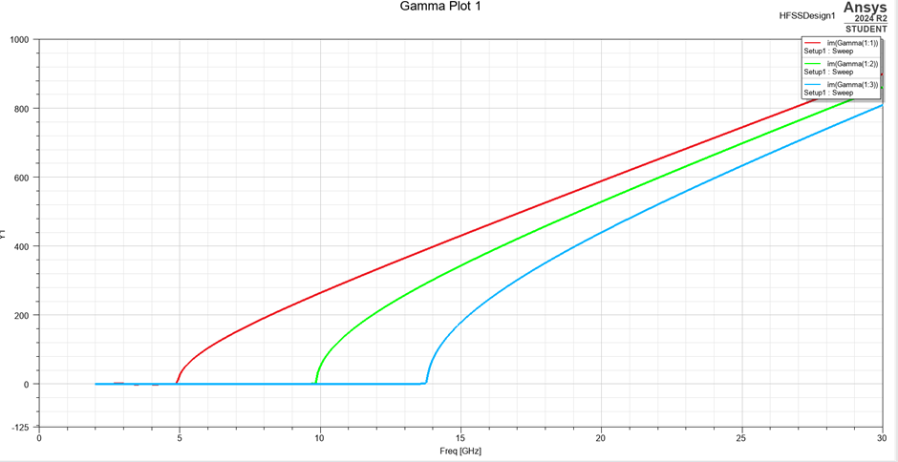
Figure 4 - Modes 1, 2 and 3 Vectors
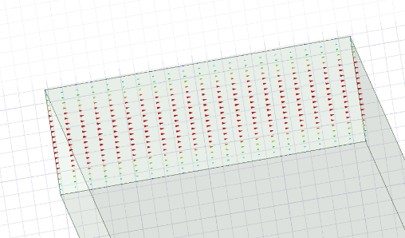
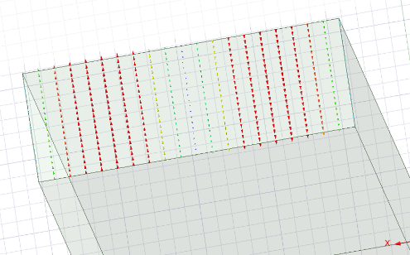
Figure 5 - Cutoff frequencies for Teflon rectangular waveguide
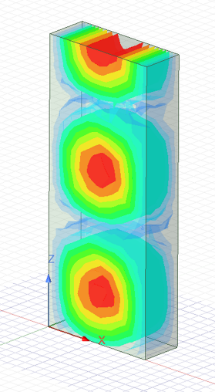
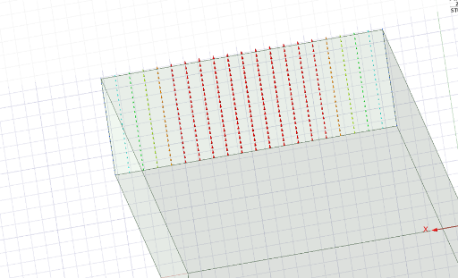
Figure 6 - EM Wave Modes
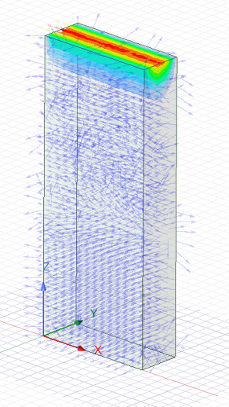
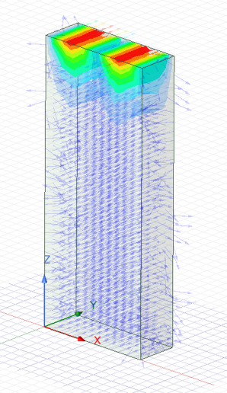

Figure 7 - Modes 1, 2 and 3 Magnitudes
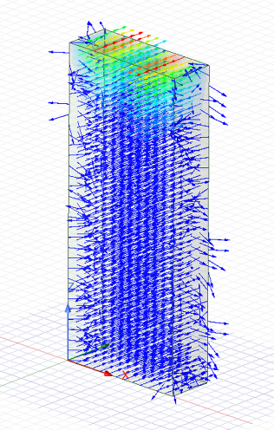
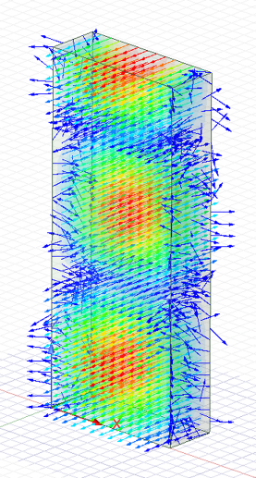
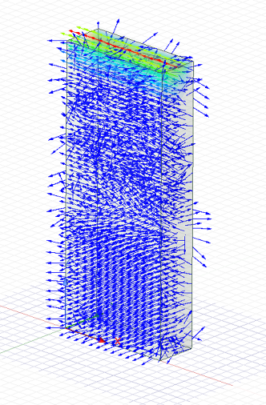

Figure 8 - Modes 1, 2 and 3 Vectors
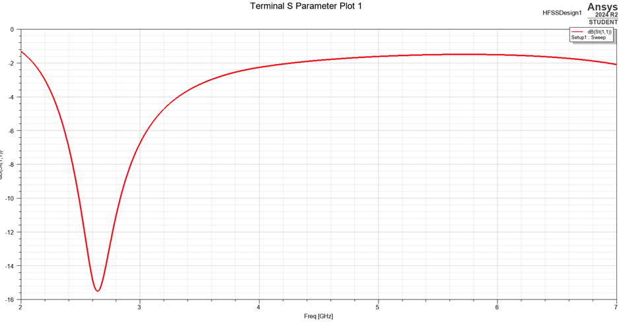
Figure 9 - S-Parameters and Operating Frequency for halfwave dipole antenna
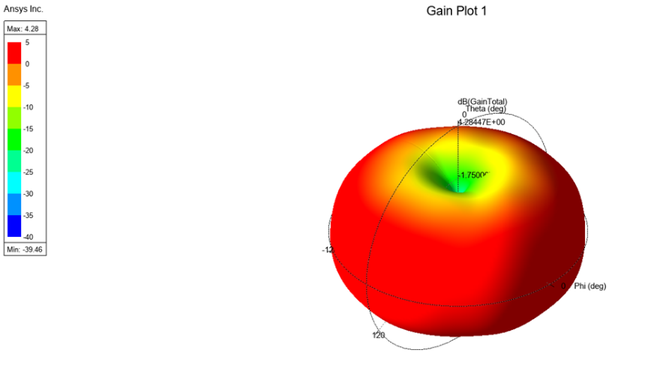
Figure 10 - Halfwave Dipole Antenna radiation pattern
Discussion:
Starting with task 1a, the first calculation was finding the dominant mode, which can be done simply by looking at the graph and identifying which mode has the lowest cutoff frequency. For the rectangular waveguide with PEC walls filled with vacuum, this was mode 1, or the TE₁₀ mode. For the cutoff frequency, this can be calculated using the theoretical formula $f_{c}=\frac{c}{2}\sqrt{{\left(\frac{m}{a}\right)}^{2}+{\left(\frac{n}{b}\right)}^{2}}$. Using this equation, the cutoff frequency for mode 1 is calculated as 7.143GHz, mode 2 is calculated as 14.286GHz, and mode 3’s cutoff frequency is calculated as 20GHz. Looking at the graph in figure 1, showing the cutoff frequencies, these calculations are reasonably accurate.
For task 1b, the design was the same, except with Teflon for the PEC walls, rather than vacuum. As with task 1a, the dominant mode for the Teflon PEC walls was also mode 1, or TE₁₀ mode. Using the same equation as before, the cutoff frequency for each mode can also be calculated. Before doing that, the velocity of light in the material needs to be calculated. For the vacuum, this was simply the speed of light, $3×{10}^{8}{ms}^{-1}$, but for Teflon, the permittivity is 2.1. Using the equation $c=\frac{1}{\sqrt{εμ}}$, and then multiplying by the standard value for speed of light, the velocity of light in Teflon is equal to $2.07×{10}^{8}{ms}^{-1}$. By putting the new value for ‘c’ into the equation, the cutoff frequency for mode 1 was 4.929GHz, for mode 2 it was 9.858GHz, and for mode 3 the cutoff frequency was calculated to be 13.801GHz. Comparing the values between the two rectangular waveguides, the cutoff frequency is lower in the Teflon-filled waveguide, compared to the vacuum-filled waveguide. This is due to Teflon’s higher relative permittivity which reduces the speed of electromagnetic waves inside the waveguide, therefore lowering the cutoff frequencies. The magnitude of difference aligns with the theoretical formula, $f_{c teflon}=\frac{f_{c vacuum}}{\sqrt{ε_{r}}}$, for example, the cutoff frequency in mode 1 of the Teflon-filled waveguide can be calculated by doing $\frac{7.143}{\sqrt{2.1}}$ to give 4.929GHz.
For task 2, the length of the halfwave dipole antenna can be calculated using theoretical formula, $L=\frac{λ}{2}=\frac{c}{2f}$. Using the wavelength 211mm, based off the first 3 digits of the student’s ID, this gives the length of the halfwave dipole antenna as 105.5mm. Using this length, the operating frequency would equal 1.422GHz.
The actual length used for the halfwave dipole antenna was 50mm. Therefore, using the same equation, the operating frequency should equal 3GHz. The equation $L=\frac{0.95.c}{2f}$ can be used to calculate a more practical and realistic value, which gives the operating frequency to equal 2.85GHz, which is closer to the value obtained in the simulations. The operating frequency shown in the S-parameter plot in figure 9 is approximately 2.625GHz. The radiation pattern of the antenna is shown in figure 10.
Conclusion:
The simulations conducted using Ansys HFSS successfully demonstrated the impact of material permittivity on electromagnetic wave propagation in rectangular waveguides, as well as the behaviour of a half-wave dipole antenna. The Teflon-filled waveguide exhibited lower cutoff frequencies compared to the vacuum-filled one, aligning with theoretical calculations that incorporate the relative permittivity of the medium. The antenna simulation validated the relationship between physical length and operating frequency, with results showing close agreement between theoretical and simulated values. These findings underline the importance of precise material and geometric configurations in high-frequency design and confirm the utility of HFSS as a robust tool for analysing and optimizing complex electromagnetic systems.

References

[1] | D. Pozar, Microwave Engineering, Hoboken, New Jersey, 2011.
[2] | D. F. J.D. Kraus, Electromagnetics with Applications, New York, 1999.
[3] | C. Balanis, Antenna Theory: Analysis and Design, Hoboken, New Jersey, 2016.
[4] | “Ansys HFSS: High Frequency Electromagnetic Field Simulation,” Ansys Inc, [Online]. Available: https://www.ansys.com/products/electronics/ansys-hfss. [Accessed 17 April 2025].
[5] | R. Collin, Foundations for Microwave Engineering, Hoboken, New Jersey, 2001.
[6] | R. Elliott, Antenna Theory and Design, Hoboken, New Jersey, 2003.

