

LEVEL/ LEfEL 5

SEMESTER 1

MODULE CODE/ Cod Y modIwl: M5X01050
NETWORK SERVICES
aSSESSMENT TYPE/ mATH O ASESU: aSSIGNMENT
Assessment/Component/ AsESIAD/CYDRAN: 1

COMPONENT WEIGHTING/ PWYSAU’R CYDRAN: 100 %

WORD COUNT (or WORD COUNT EQUIVALENT)/ NIFER Y GEIRIAU:
2500 WORDS/O EIRIAU

MODULE TUTOR / TIWTOR Y MODIWL: Seamus Hillen

SUBMISSION DETAILS/ MANYLION CYFLWYNO:

- Make sure that Your Name , Your Student P Number, Your Module Title, Assignment Title and Your Module Lecturer’s Name are clearly shown on the front page of your assignment
- All assignments must be submitted electronically to Turnitin unless indicated by the module lecturer here: …………………………………………...
- If lecturer additionally requires you to upload coding separately to Moodle it will be indicated here: ………….NO………..….
- If a paper submission is required then it will be indicated here: …NO……….
you will then be required to submit the assignment parts in a suitable report folder– not in poly-pockets - to the library. For paper submissions only this form (ALL PAGES) MUST be printed out, signed, attached to the front of your assignment and submitted to the library separately from your electronic assignment submission. Paper submission assignments will not be accepted without this form as it is a requirement that you sign the disclosure regarding the referencing convention.
- DO NOT put this form into Turnitin or it will match many similarities with other students’ submissions.

70/100
76/100

RESULT

School of Applied Computing ASSIGNMENT SPECIFICATION

Student name: | Gwyndaf Rees | Student P number: | 1603201
Programme: | HND Computing
Lecturer: | Seamus Hillen | Internal Verifier:
Assignment Title:
Hand Out Date: | Feb 2018 | Submission deadline: | 18th May 2018
Referencing: | In the main body of your submission you must give credit to authors on whose research your work is based. Append to your submission a reference list that indicates the books, articles, etc. that you have read or quoted in order to complete this assignment (e.g. for books: surname of author and initials, year of publication, title of book, edition, publisher: place of publication).
Disclosure: | I declare that this assignment is all my own work and that I have acknowledged all materials used from the published or unpublished works of other people. All references have been duly cited.
Student’s Signature: | Hardcopy assignments will not be accepted without a signature here | Date:
Late submission will result in a late penalty mark, as follows:
Up to one week late, maximum mark of 40% for first attempts. No late submission for resit work.
(Academic Quality Handbook 2016/17 7.5 (5))
Only the Extenuating Circumstances Committee may grant an extension.

Learning Outcomes tested
(from module syllabus)
Design and deploy critical network services and resources within optimised virtualisation based environments.

Demonstrate a systematic understanding of the concepts, principles and technologies within network service architectures.

TASK DESCRIPTION

Problem Specification:

This module is assessed, via a series of Assignment based Worksheets. The worksheets comprise a number of tasks that assess two skill areas, Practical Tasks and Observational Tasks.

The Practical Tasks are to be completed via ‘workshop sessions’ in scheduled/non-scheduled lab time. The Practical Tasks can be submitted based on work as pairs or small groups.

The Observational tasks involve the student undertaking their own reading/literature review into topics discussed. These tasks are to be completed, strictly on an individual basis, the laws of plagiarism, will apply the same here as with all other Assignments at this level of education.

Assignment Instructions:

You should complete the worksheets as instructed. The format for submission should be as follows:

- Use the worksheets from Moodle as discussed in the lecture/lab sessions.

- This document is the Assignment Front Sheet. All completed Worksheets (Practical and Observational Tasks) should be preceded by a title sheet indicating (i).Your Name and (ii).Title of the Worksheet.

- The completed worksheets should be appended to the front cover, and the final submission should be placed into a folder.

- Your documentation should contain a Table of Contents at the start of the submission, detailing all sections along with appropriate page No(s). Structure may be as follows:

Worksheets
p1 –10: Worksheet 1: Group Practical work for RRAS configuration.
Etc. to
PXX – XY: Worksheet 4: Name Resolution using the Domain Name Service (DNS)

Observation Tasks and Clustering Review Worksheet
pYY –YZ: Worksheet 1: Observation Tasks: Sheet.1
Etc. to
pZX – ZZ: Worksheet 5: Investigate Cluster Technologies

To summarise; Each student should submit the following:

- A copy of all the completed worksheets, along with the names of those you worked with in this task.
- A copy of individually completed ‘Observational Tasks’.

GUIDANCE FOR Students IN THE COMPLETION OF TASKS

Marks Breakdown:

There are five worksheets in total, when combined equal 100%. You must attempt all worksheets in order to achieve a pass since outcome literals for this module are distributed amongst the topics assessed in all worksheets.

Worksheet marks are weighted as follows:

Worksheet 1: IP Internetworking Platforms/Network Architectures and Routing and Remote Access Services.
[15 Marks].

Worksheet 2: Managing secure Network Access to services (TCP/ICMP/WWW) utilising Packet Filtering.
[20 Marks].

Worksheet 3: TCP/IP configuration using DHCP
[20 Marks].

Worksheet 4: Name Resolution using the Domain Name Service (DNS)
[25 Marks].

Worksheet 5: Investigate Clustering Technologies.
[20 Marks]

marking criteria and Student FEEDBACK
Common Assessment Criteria Applied | Marks available | Marks  awarded
1. Research-informed Literature
Extent of research and/or own reading, selection of credible sources, application of appropriate referencing conventions.
Inclusion of a wide range of research-informed literature, including sources retrieved independently.  Selection of relevant and credible sources. Very good use of referencing conventions, consistently applied | 10 | 6
2. Knowledge and Understanding of Subject
Extent of knowledge and understanding of concepts and underlying principles associated with the discipline.
Excellent knowledge and understanding of the main concepts and key theories. Clear awareness of challenges to established views and the limitations of the knowledge base. | 20 | 15
3. Analysis
Analysis, evaluation and synthesis; logic, argument and judgement; analytical reflection; organisation of ideas and evidence
Sound, logical, analytical thinking; synthesis and evaluation. Ability to devise and sustain persuasive arguments, and to review the reliability, validity & significance of evidence. Ability to communicate ideas and evidence accurately and convincingly.  Sound, convincing conclusions / recommendations. | 20 | 14
4. Practical Application and Deployment
Deployment of methods, materials, tools and techniques; application of concepts; formulation of innovative and creative solutions to solve problems.
An advanced application of a range of methods, materials, tools and/or techniques.  The context of the application is well considered, with extensive use of relevant examples.  Application and deployment extend beyond established conventions. Innovation and creativity evident throughout. | 40 | 31
5. Skills for Professional Practice
Attributes in professional practice: individual and collaborative working; deployment of appropriate media; presentation and organisation.
An adequate awareness and mostly appropriate application of well-established methods, materials, tools and/or techniques.  Basic appreciation of the context of the application. | 10 | 4

This section details the assessment criteria. The extent to which these are demonstrated by you determines your mark. The marks available for each criterion are shown. Lecturers will use the space provided to comment on the achievement of the task(s), including those areas in which you have performed well and areas that would benefit from development/improvement.

Assignment Mark (Assessment marks are subject to ratification at the Exam Board. These comments and marks are to give feedback on module work and are for guidance only until they are confirmed. ) | Late Submission Penalties (tick if appropriate) |  | 70%
 | Up to one week late |  | 70%
 | 1st/2nd/3rd attempt? | 1st | 70%

FdSc & HN COMMON ASSESSMENT AND MARKING CRITERIA

 | OUTRIGHT FAIL | UNSATISFACTORY | SATISFACTORY | GOOD | VERY GOOD | EXCELLENT | EXCEPTIONAL
Assessment Criteria | REFER (equivalent to 0-29% | REFER (equivalent to 30-39%* | PASS (equivalent to 40-49%) | PASS (equivalent to 50-59%) | MERIT (equivalent to 60-69% | DISTINCTION (equivalent to 70-79% | DISTINCTION (equivalent to 80-100%
1. Research-informed Literature  Extent of research and/or own reading, selection of credible sources, application of appropriate referencing conventions | Little or no evidence of reading.  Views and findings unsupported and non-authoritative.  Referencing conventions largely ignored. | Poor evidence of reading and/or of reliance on inappropriate sources, and/or indiscriminate use of sources.  Referencing conventions used inconsistently. | References to a limited range of mostly relevant sources. Some omissions and minor errors.  Referencing conventions evident though not always applied consistently. | Inclusion of a range of research-informed literature, including sources retrieved independently. Referencing conventions mostly consistently applied. | Inclusion of a wide range of research-informed literature, including sources retrieved independently.  Selection of relevant and credible sources. Very good use of referencing conventions, consistently applied. | A comprehensive range of research informed literature embedded in the work. Excellent selection of relevant and credible sources. High-level referencing skills, consistently applied. | Outstanding knowledge of research-informed literature embedded in the work. Outstanding selection of relevant and credible sources. High-level referencing skills consistently and professionally applied.
2. Knowledge and Understanding of Subject  Extent of knowledge and understanding of concepts and underlying principles associated with the discipline. | Major gaps in knowledge and understanding of material at this level. Substantial inaccuracies. | Gaps in knowledge, with only superficial understanding. Some significant inaccuracies. | Evidence of basic knowledge and understanding of the relevant concepts and underlying principles. | Knowledge is accurate with a good understanding of the field of study. | Knowledge is extensive. Exhibits understanding of the breadth and depth of established views. | Excellent knowledge and understanding of the main concepts and key theories. Clear awareness of challenges to established views and the limitations of the knowledge base. | Highly detailed knowledge and understanding of the main theories/concepts, and a critical awareness of the ambiguities and limitations of knowledge.
3. Analysis  Analysis, evaluation and synthesis; logic, argument and judgement; analytical reflection; organisation of ideas and evidence | Unsubstantiated generalisations, made without use of any credible evidence. Lack of logic, leading to unsupportable/ missing conclusions. Lack of any attempt to analyse, synthesise or evaluate. | Some evidence of analytical intellectual skills, but for the most part descriptive. Ideas/findings sometimes illogical and contradictory. Generalised statements made with scant evidence. Conclusions lack relevance. | Evidence of some logical, analytical thinking and some attempts to synthesise, albeit with some weaknesses.  Some evidence to support findings/ views, but evidence not consistently interpreted.  Some relevant conclusions and recommendations, where relevant | Evidence of some logical, analytical thinking and synthesis. Can analyse new and/or abstract data and situations without guidance.  An emerging awareness of different stances and ability to use evidence to support the argument.  Valid conclusions and recommendations, where relevant | Sound, logical, analytical thinking; synthesis and evaluation. Ability to devise and sustain persuasive arguments, and to review the reliability, validity & significance of evidence. Ability to communicate ideas and evidence accurately and convincingly.  Sound, convincing conclusions / recommendations. | Thoroughly logical work, supported by evaluated evidence. High quality analysis, developed independently or through effective collaboration.  Ability to investigate contradictory information and identify reasons for contradictions.  Strong, persuasive, conclusions, justifiable recommendations. | Exceptional work; judiciously selected and evaluated evidence. Very high quality analysis, developed independently or through effective collaboration.  Ability to investigate contradictory information and identify reasons for contradictions.  Highly persuasive conclusions
4. Practical Application and Deployment  Effective deployment of appropriate methods, materials, tools and techniques; extent of skill demonstrated in the application of concepts to a variety of processes and/or contexts; formulation of innovative and creative solutions to solve problems. | Limited or no use of methods, materials, tools and/or techniques.  Little or no appreciation of the context of the application. | Rudimentary application of methods, materials, tools and/or techniques but without consideration and competence. Flawed appreciation of the context of the application. | An adequate awareness and mostly appropriate application of well-established methods, materials, tools and/or techniques.  Basic appreciation of the context of the application. | A good and appropriate application of standard methods, materials, tools and/or techniques.  Good appreciation of the context of the application, with some use of examples, where relevant. | A very good application of a range of methods, materials, tools and/or techniques.  Very good consideration of the context of the application, with perceptive use of examples, where relevant.  Evidence of some innovation and creativity. | An advanced application of a range of methods, materials, tools and/or techniques.  The context of the application is well considered, with extensive use of relevant examples.  Application and deployment extend beyond established conventions. Innovation and creativity evident throughout. | Outstanding levels of application and deployment skills. Assimilation and development of cutting edge processes and techniques.
5. Skills for Professional Practice  Demonstrates attributes expected in professional practice including: individual initiative and collaborative working; deployment of appropriate media to communicate (including written and oral); clarity and effectiveness in presentation and organisation. | Communication media is inappropriate or misapplied.  Little or no evidence of autonomy in the completion of tasks.  Work is poorly structured and/or largely incoherent. | Media is poorly designed and/or not suitable for the audience.  Poor independent or collaborative initiative.  Work lacks structure, organisation, and/or coherence | Can communicate in a suitable format but with some room for improvement.  Can work as part of a team, but with limited involvement in group activities.  Work lacks coherence in places and could be better structured. | Can communicate effectively in a suitable format, but may have minor errors.  Can work effectively as part of a team, with clear contribution to group activities.  Mostly coherent work and is in a suitable structure. | Can communicate well, confidently and consistently in a suitable format.  Can work very well as part of a team, with very good contribution to group activities.  Work is coherent and fluent and is well structured and organised. | Can communicate professionally and, confidently in a suitable format.  Can work professionally within a team, showing leadership skills as appropriate, managing conflict and meeting obligations.  Work is coherent, very fluent and is presented professionally. | Can communicate with an exceptionally high level of professionalism.  Can work exceptionally well and professionally within a team, showing advanced leadership skills.  Work is exceptionally coherent, very fluent and is presented professionally.


Cyfadran Dylunio Cymhwysol a Pheirianneg
Faculty of Applied Design and Engineering

Taflen Cyflwyno Aseiniad
Assignment Hand in Sheet (for paper submissions only)

MANYLION Y MYFYRIWR
STUDENT’S DETAILS
ENW:  NAME: |  | RHIF  P Y MYFYRIWR:  STUDENT  P NUMBER: | P
CWRS:  COURSE: | Foundation Year/HNC/HND/FdSc/BEng/BSc/MEng/MComp/MSc * dileer fel y bo'n berthnasol / delete as appropriate |  | LEFEL Y CWRS:  LEVEL OF COURSE:
MODIWL:
MODULE:
TEITL YR ASEINIAD:
ASSIGNMENT
TITLE:
DARLITHIWR/WYR:  LECTURER/S: |  |  | DYDDIAD: DATE:
Staff Llyfrgell YN UNIG / Library Staff ONLY

Derbyniwyd gan / Accepted by: _______ Dyddiad Cyflwyno: Date Submitted: ________________________ Amser / Time: _____

----------------------------------------------------------------------------------------------------------------------------------------------------------

DERBYNNEB / RECEIPT
ENW / NAME: |  | RHIF  P Y MYFYRIWR: STUDENT  P NUMBER: |  | P
CWRS / COURSE: | Foundation Year/HNC/HND/FdSc/BEng/BSc/MEng/MComp/MSc * dileer fel y bo'n berthnasol / delete as appropriate |  | LEFEL Y CWRS / LEVEL OF COURSE:
MODIWL /
MODULE:
TEITL YR ASEINIAD/
ASSIGNMENT
TITLE:

DARLITHIWR/WYR:  LECTURER/S: |  |  | DYDDIAD /  DATE:
Staff Llyfrgell YN UNIG / Library Staff ONLY

Derbyniwyd gan / Accepted by: _______ Dyddiad Cyflwyno: Date Submitted: ________________________ Amser / Time: _____

Table of Contents

Worksheets including Observational Tasks and Reviews

Worksheet 1: IP Internetworking Platforms/Network Architectures and Routing and Remote Access Services Pgs 10 - 22

Worksheet 2: Managing secure Network Access to services (TCP/ICMP/WWW) utilising Packet Filtering. Pgs 23 - 46

Worksheet 3: TCP/IP configuration using DHCP Pgs 47 - 68

Worksheet 4: Name Resolution using the Domain Name Service (DNS) Pgs 69 - 102

Worksheet 5: Network Services Questions including Investigate Clustering Technologies Pgs 103 – 105

Questions and Answers Pgs 106 - 113


B.Sc. Level 5
WorkSheet 1:
Facilitating a Virtualised Remote Network Infrastructure utilising Type 1 Hypervisor software, and the RRAS (Routing and Remote Access Services).
Group Name: Ben McCarthy, Ben Archer, James Pugh, Gwyndaf Rees, Ryan Gallagher
Date:
Author(s): Gwyndaf Rees
Complete the following tasks:
Task 1: Verifying No Connection
VERY IMPORTANT:
You should provide screen shots and written narrative/observations where appropriate to record completion of these tasks.

You should already have setup, as a pre-requisite, a suitable environment consisting of:
- Installation of virtual machines in a type 1 hypervisor environment
- Creation of 2 Virtual servers, each with 3 network interfaces, a suitably renamed Backbone Connection and a LAN Switch connection.
- Creation of a Windows 7 client with 3 network interfaces, a suitably renamed Backbone Connection and a LAN Switch connection.
- Appropriate TCP/IP configuration for each of the 3 adapters in the two servers (e.g. 192.168.1, 192.168.10 and 192.168.11 networks)
Creation of suitable admin level user accounts
Here is the configuration of the Physical and virtual servers used during the task:
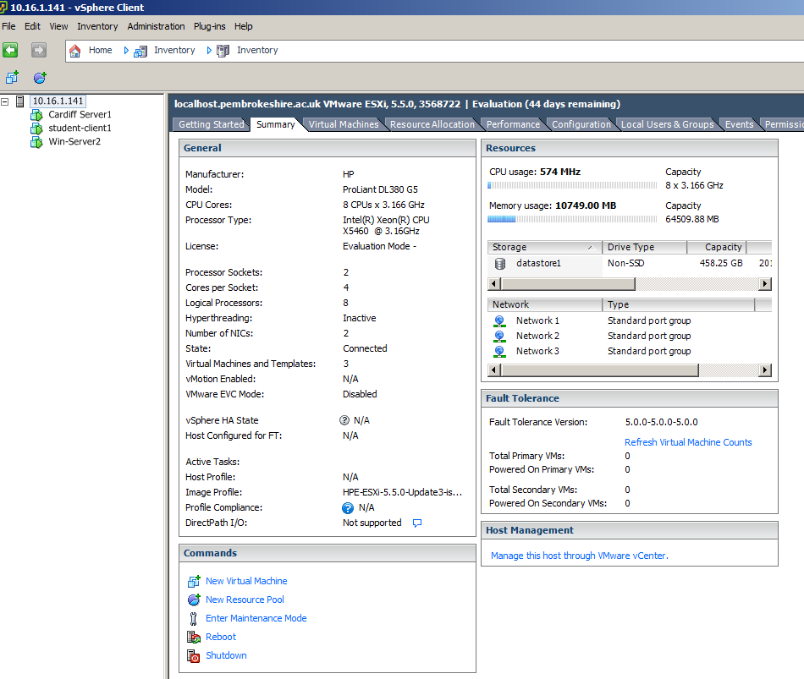

Here is the configuration of the virtual network used during the tasks:
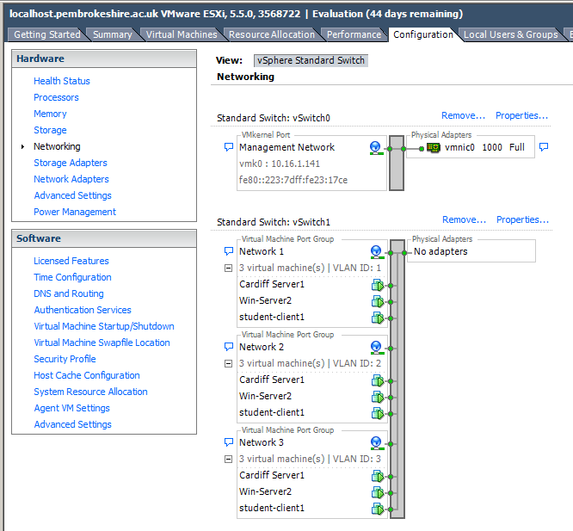

Note: The next activity is to disable the Network Interface on the Windows 7 client in the 10 and 11 networks. The only way for these computers to connect to the Backbone network (to access other subnets for example) is utilising each of the networks as a Router. This will be the context in each of our subnets.
192.168.0.1
192.168.0.3
Cardiff
Lab-01-01

192.168.10.1
192.168.10.2
Win-Server2

[Complete this task on the Windows 7 client]

- Log onto the server
- Right click the 0 network connection – then click Properties, click the TCP/IP protocol and click Properties.
- Select Use the Following IP Address. In the Default Gateway box type the IP Address of the 0 network connection of the Cardiff Server in the network.

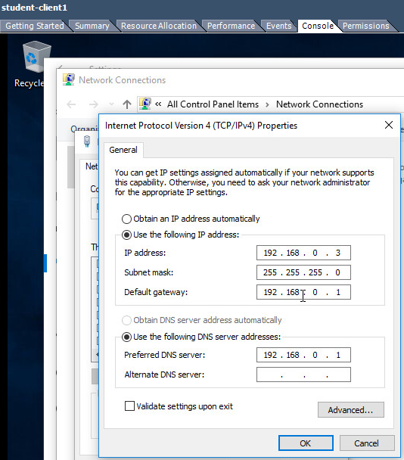

[Complete this task from Win-Server2]

- Set the default gateway of the 11 network to the IP address of the 11 network IP Address of the Cardiff server.
- Use the ping command to attempt to connect to the IP Address of the 11 network IP Address of the Cardiff server.
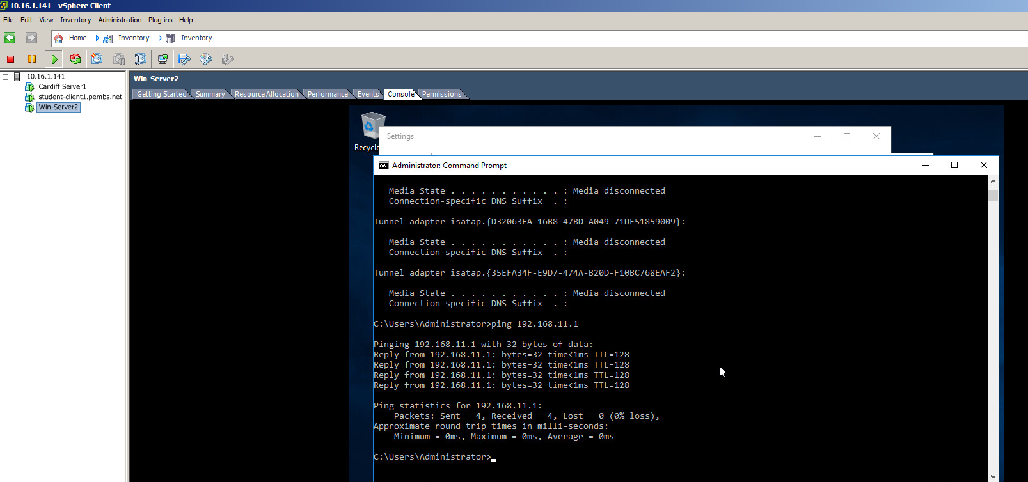

This screenshot shows the response received when attempting to ping the 192.168.11.1 IP address: the Cardiff server.

- Use ping to attempt to connect to the IP address of the 0 network IP Address of the Windows 7 client. You should not get any success at this stage.

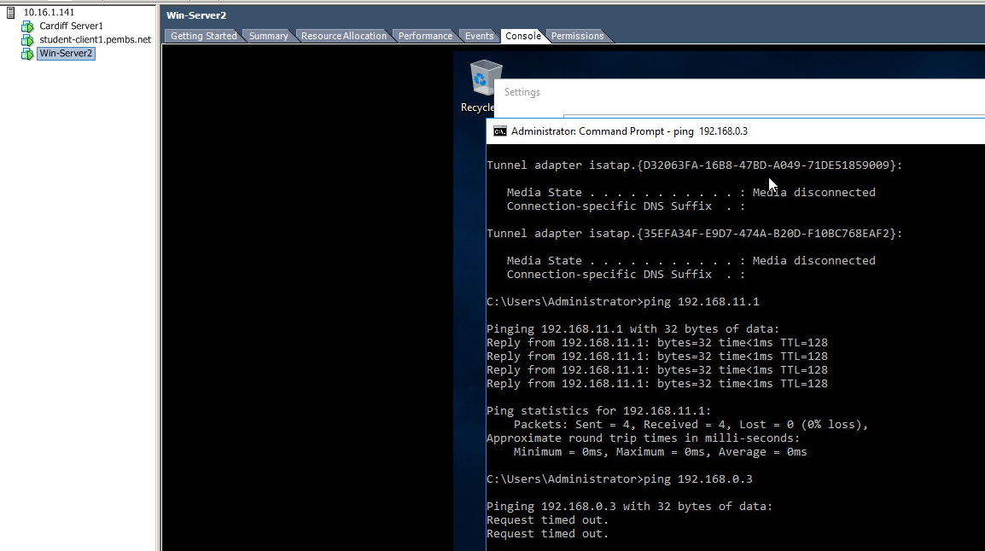

The above screenshot demonstrates an attempt to ping the client on 192.168.0.3 which return a Request Timed Out message.

Task 2: Enabling the Routing and Remote Access Service on a Server:
[Complete this task from the Win-Server2 server]

- Logon to the machine
- From the Server Manager dashboard choose Add Roles and Features
- Choose the Network Policy and Access Services
- Click Next at following page
- Check on Remote Access role.
- When configuring Remote Access, select “Routing”.
- Choose Next/Install.
- Upon completion of the install, choose Start Admin Tools – RRAS (Routing and Remote Access service.
- In the left hand side of the console window right click on your server and choose Configure and Enable Routing and Remote Access.
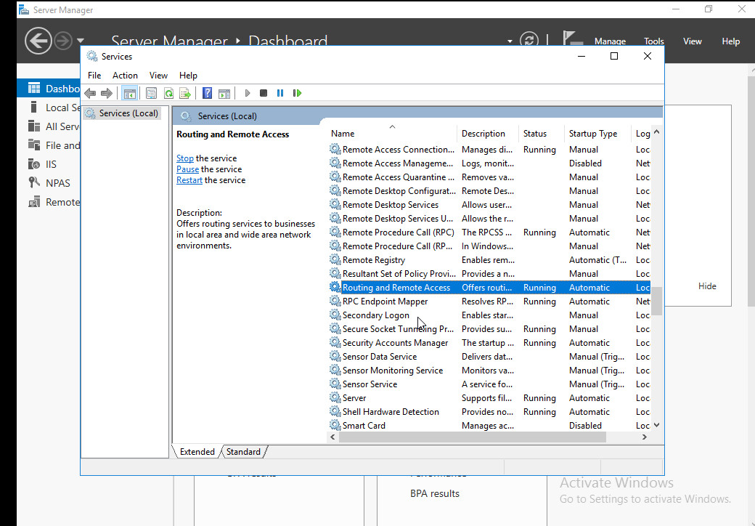
This screenshot shows the Routing and Remote Access service in the Services menu.
- Choose next
- Choose Custom Configuration
- Select the LAN Routing option, choose Next
- Click Finish.
- The service should be started (choose Yes if asked by the dialog window).

[Complete this task from the Windows 7 client]

Verify Routing to different computers:

- Use ping to attempt to connect to the 11 network IP address of the Win-Server2 server.
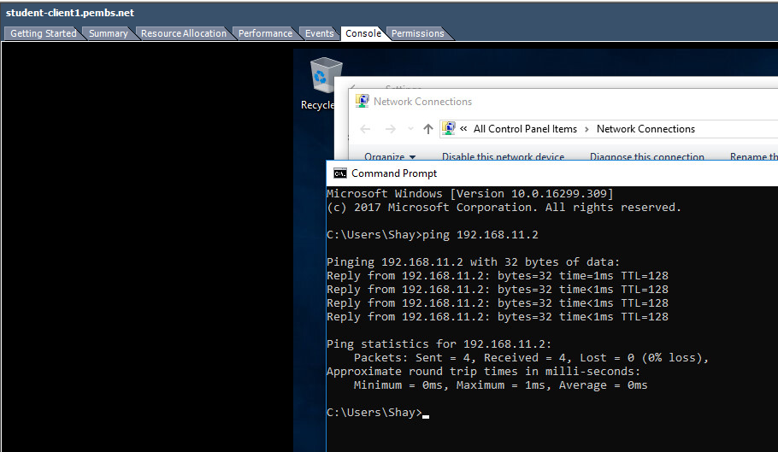
This screenshot shows a successful ping request to the Win-Server2 server on 192.168.11.2.

- Now try the Internet connection of the other server.
- Finally try to connect to and from the hosts in both of the LAN subnets (e.g. 192.168.0 and 192.168.11)
- You may find that the pings fail

Pinging the Cardiff server on 192.168.0.1, 192.168.10.1 and 192.168.11.1 fail.

This is because we do not yet know the routes to these other sub-networks. To accomplish this we need to either statically define these routes, or use dynamic routing via a Routing Protocol.

Task 3: Add Routing Protocols on the Server and Add Two Routing Interfaces to the Routing Protocol on the Server.
[Complete this task from Win-Server2]

- Start – All Programs – Administrative Tools – Routing and Remote Access.
- Expand the name of your Server– expand IP V4, right click General and then click New Routing Protocol.
- In the dialog box displayed – choose RIP Version 2 for Internet Protocol, now click Ok.
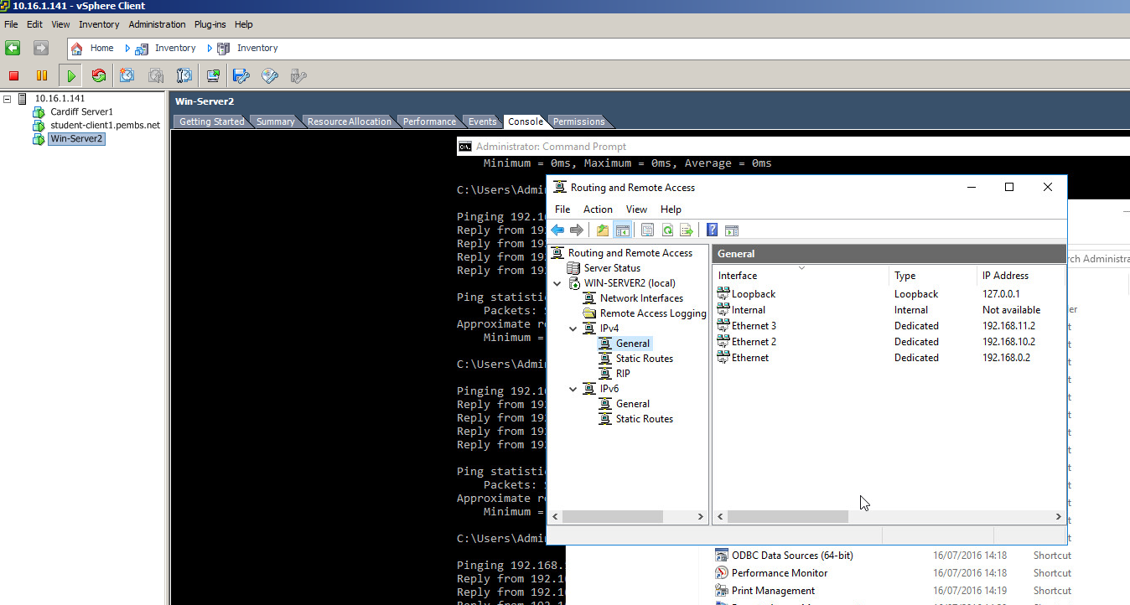
This screenshot depicts the Routing and Remote Access menu with general selected in the tree view, displaying all the interfaces within this category.

We will now see how to add two Routable Interfaces to the Routing Protocol that has been enabled as part of TCP/IP suite on our Server

The Routing Protocol will learn of the various Routes to other Networks (in our case Subnetworks), hopefully enabling us to be able to send packets directly to other machines on other networks.

- Right click on RIP then select New Interface.
- In the New Interface Dialog Box, select the 0 network – choose Ok
- Repeat the process but now add the 11 network as an additional RIP Interface.
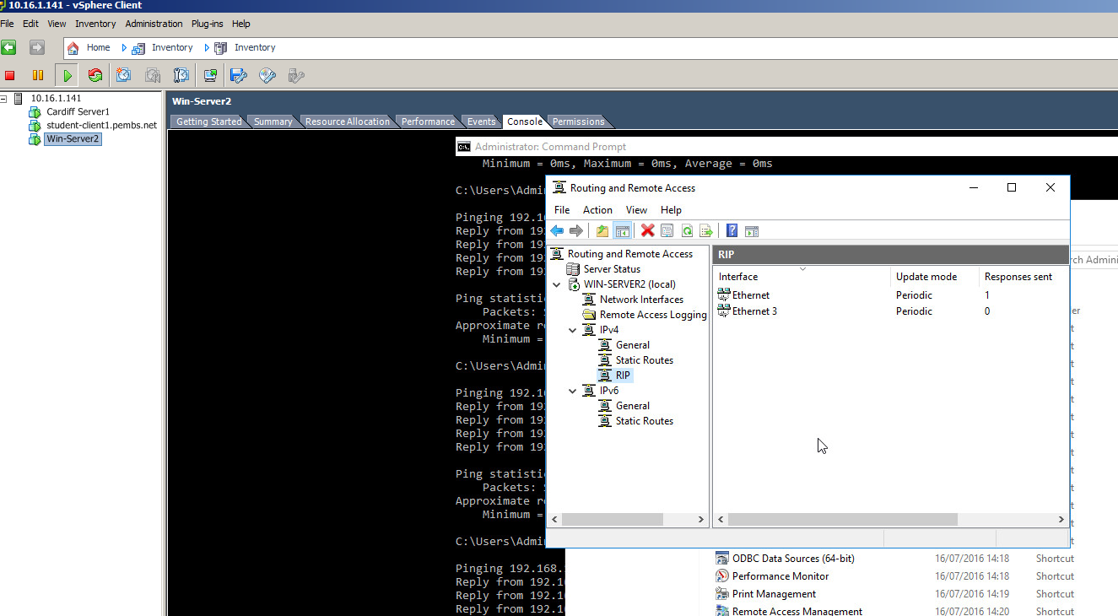
This screenshot displays the interfaces added to the RIP category.

For the last part of this task, look back at your notes and the ping Activities earlier.

You should find that you can now Ping Servers/Clients on other Subnets.
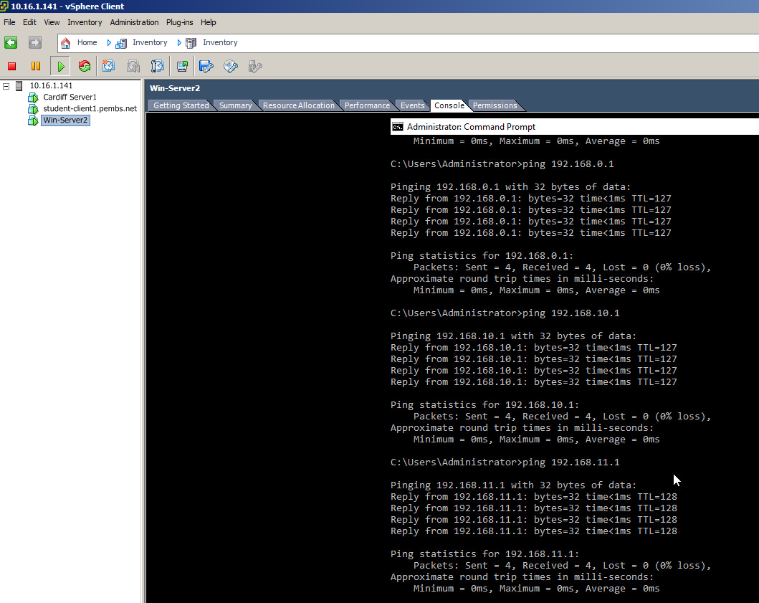

This screenshot shows that all subnets can now be successfully pinged.
Task 4: Learning about Local Area Network Routing
Question:
- Open up the command prompt, enter the following syntax: route print

What can you determine from the resulting Routing Table?

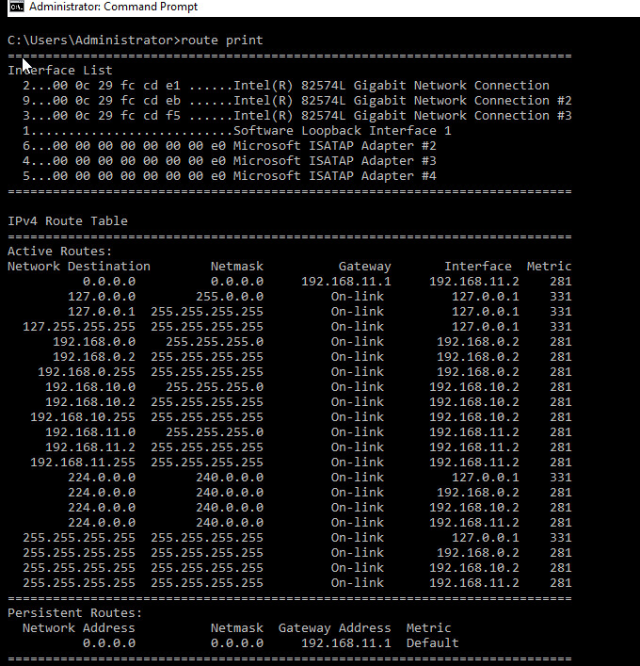
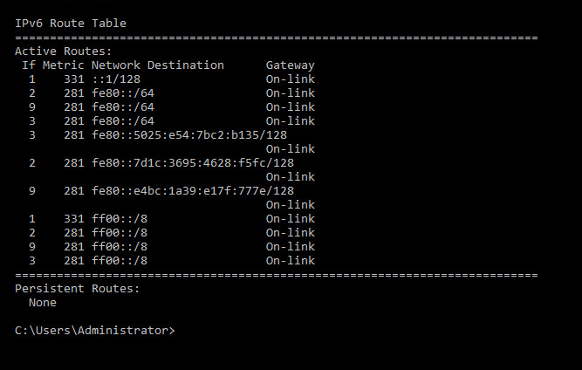
The above screenshots show the results of entering the route print command. The results contained an IPv4 route table, which shows a total of 21 active routes, and an IPv6 route table, but the IPv4 table is the important one in this scenario. These routes all have local IP addresses as their destination and include three with a localhost destination (0.0.0.0, 127.0.0.0, 127.0.0.1). The remaining destinations consist of nine with an IP address beginning with 192.168.x.x, four with an IP of 224.0.0.0, another four with an IP of 255.255.255.255 and one to 127.2555.2555.255.
All Routes use the On-link gateway except for the first (IP 0.0.0.0), which uses 192.168.11.1.
These routes all use one of four interfaces, 192.168.11.2, 192.168.10.2, 192.168.0.2 or 127.0.0.1. Those with an interface of 127.0.0.1 (localhost) have a metric of 331, the rest all have a metric of 281.

Task 5: Additional Observation Tasks:
Ensure these tasks are answered in appropriate detail and the sources and source materials are referenced using the IEEE Referencing system.
- Identify the benefits of Type 1 Hypervisor software services and briefly evaluate some suitable products.
The benefits of Type 1 Hypervisor software include the fast restoration of user machines when an installation becomes corrupt or unusable in any way, great performance due to the thin layer between software and hardware, remote wiping on loss or theft, the ability for multiple virtual machines with different permissions, and the abstraction of hardware on installation which allows for identical deployment on multiple specifications of machines.
Some of the primary services that offer Type 1 Hypervisor solutions are VMware with VMware ESX and ESXi, which offers advanced features and scalability but ESX must be licensed expensively, and ESXi is available as a free version with greatly reduced features or as one of five paid versions; Microsoft with its Hyper-V, which doesn’t offer many advanced features, but does offer a free version as well as four different paid options and works well with Windows Server; Citrix’ Xen Server comes as free software or as one of four commercial editions, as with the others, but offers very few advanced features.
- Define the role of Routers in the Network Architecture, what types can be used?
Routers are layer three devices that make decisions based on network addresses as to the best paths or routes to direct packets between networks and devices on those networks. There are two main types of routers: Hardware routers, which perform routing as a dedicated function; and Software routers, which is not dedicated to routing alone, performing other processes too.
- Identify and discuss the usage of common Routing Protocols, what are the associated benefits of using Routing Protocols?
For routers to calculate routes themselves, they must exchange information through Routing Protocols. A Routing Protocol is defined as a set of messages routers use to calculate appropriate paths to forward data. Routers use Dynamic Routing to inform each other of changes in a network, which uses these protocols to find and update the routing tables of the routers. The Routing Protocol determines the rules a router uses when sharing routing information with other routers and defines how routed protocols are routed. Current Routing Protocols include RIP (Routing Information Protocol), IGRP (Interior Gateway Routing Protocol), EIGRP (Enhanced Interior Gateway Routing Protocol), and OSPF (Open Shortest Path First). These allow for more effective automation of routing, less latency when performing dynamic requests and a higher likelihood of having data routed on the fastest route and less work for administrators as the routers are able to learn from each other.
- Define the role of Routing Tables, what are they. Breakdown and analyze the information a Routing Table provides us with.
Every router uses a routing table to store network addresses, network masks, router interfaces to reach a network and metric information. When a router receives a packet, the destination IP address is checked against the routing table. The network mask for each entry is used to recover the network address from the IP and is then compared with the address from the routing table. Once a match is found the packet is forwarded to the interface specified in the routing table. The metric information stored by in the routing table is used to determine whether one route should be used over another. It consists of information such as number of hops, speed of the path, packet loss, latency and bandwidth.
- What is the Subnet Mask, what is the significance of this in the Routing Table?
A Subnet Mask defines the range of IP addresses that can be used in a network. It is used to implement subnetworks on LANs. Subnets allow systems within it to communicate directly instead of through a router, allowing it to partition networks and limit traffic between them. The Subnet mask is required in a routing table entry to identify the network address from the IP address in order to determine the next hop on the route to the packet’s final destination.
13/15

B.Sc. Year 2
Network Services
Worksheet 2: Routing and Remote Access Services in Windows Server: ARP, Managing TCP/IP & ICMP Operations using Packet Filtering.
Group Name: Ben McCarthy, Ben Archer, James Pugh, Gwyndaf Rees, Ryan Gallagher
Date:
Author(s): Gwyndaf Rees
Complete the following tasks:
Note: you should take observations and screen captures when completing these tasks. It is also essential to produce an introduction to the scenario for this worksheet; you can only write this summary when you have finished all practical tasks.
Task 1: Using the ARP Protocol to obtain Physical/Logical Network Node information
You may need to disable Windows Firewall for part 3 of this worksheet.

[Complete this task from Cardiff]

The ARP table ‘maps’ logical IP (Internet Addresses) to Physical Addresses of Network Interfaces, this is how a packet is sent/received on a Network Interface, or if you like, how packets arrive at your machine over the Internet.

- Click Start – run – cmd
- At the command prompt type ARP -A
- The information you see displayed comprises of:

- The Interface (NIC’s) in your Machine.
- The Physical (MAC) Address of this NIC
- The Internet Address of this NIC.
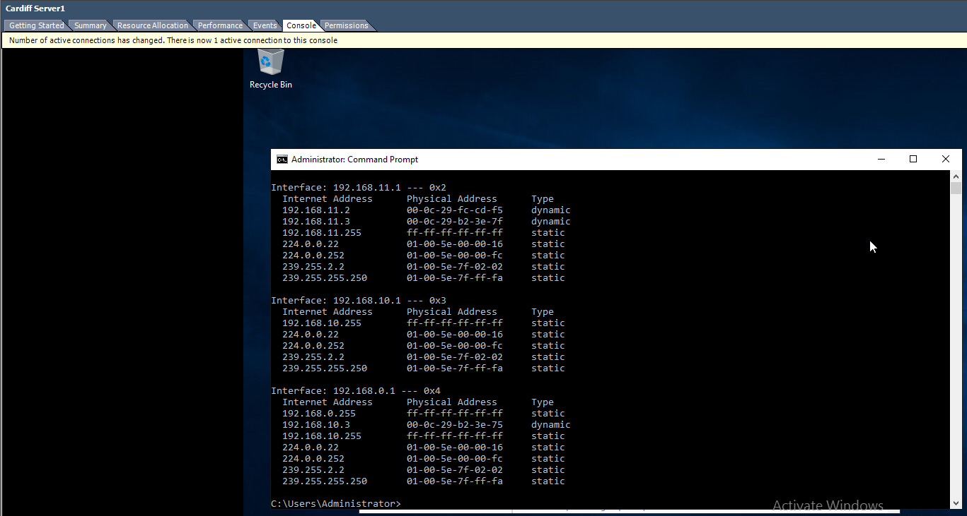
The above screenshot shows the use of the ARP –A command on the Cardiff server which returns the ARP table of IP addresses, MAC addresses and the type of IP allocated for every device connected through an interface.

You may not at present have any (or you may have very few entries). As you connect to, are connected to; other servers, this ARP Table (MAC Table) will be updated;

One common way to see this in practice, is by using an ICMP operation such as ‘PING’

- Attempt to ping other Servers in the network, note on successful attempts, check your ARP Table using the arp –A command, note the entries being updated as more servers connect/are connected to.

Task 2: Permitted TCP and ICMP Operations
[Using Routing and Remote Access Services for configuring IP packet filtering]

[Complete these tasks from Win-Server2]:

- Navigate to the Server Manager Dashboard.
- Add Roles
- In the list of Server Roles – check on the Web Server (IIS) – Choose Next.
- Choose Next at the Intro to web server (IIS) page.
- At the Select Role Services page, scroll down and check on FTP Service, click Next.
- Now install the service, and wait for the wizard to complete.
- Click Start – Administrative Tools - Computer Management
- Expand Local Users and Groups – Right Click on the Users Folder – New User

*VERY IMPORTANT*
Ensure that you Check off the ‘user must change password at next logon
setting’.

Name: ftpuser
Password: P@ssw0rd

- Start – Administrative Tools – Internet Information Services Manager.
- Expand the Computer Name – Right click on Sites – choose Add FTP Site
- In Site information type test
- Click on the browse button […] next to Content Directory/Physical Path
- Choose root drive (e.g. C:\Inetpub\ftproot) - next
- At the bindings and SSL settings page – choose No SSL
- Take note of the Port Number (20 & 21) can be used via the TCP protocol when using the FTP Service.
- Chose basic authentication as the preferred mode.
- Alongside the authentication textbox, click the drop down menu and choose Specified Users.
- Type in the name of your server (Win-Server2) followed by a backslash and the user account you created above (e.g. Win-Server2\ftpuser).
- Ensure you check on both the read\write options. Choose Finish.
- We can setup banners/welcome greetings as a way of knowing if we are connecting to the right server.
- To setup a banner, choose Start - Administrative Tools – IIS Manager.
- Expand the servername – Expand sites click on your ftp site you created earlier.
- Choose “FTP messages”.
- Here you can enter banners, welcome greetings and exit messages. Set ‘appropriate’ messages up here – you should indicate to the user that they’re connecting to the Win-Server2 server.
- Click Computer - Within the C:\Inetpub\ftproot directory, create a new text file, call it testftpdownload.txt
- We now have our FTP Server running on the Win-Server2 Server:
- We can upload files to or download files from the FTP server (using the appropriate windows authenticated account).

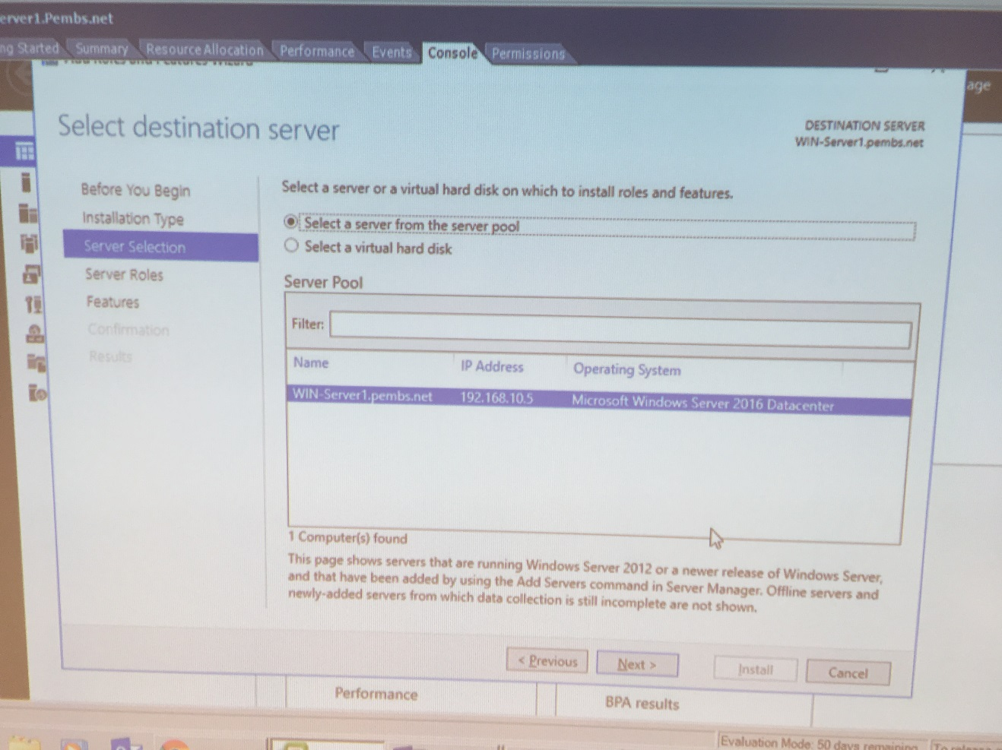
This image shows the selection of a destination server from the server pool.
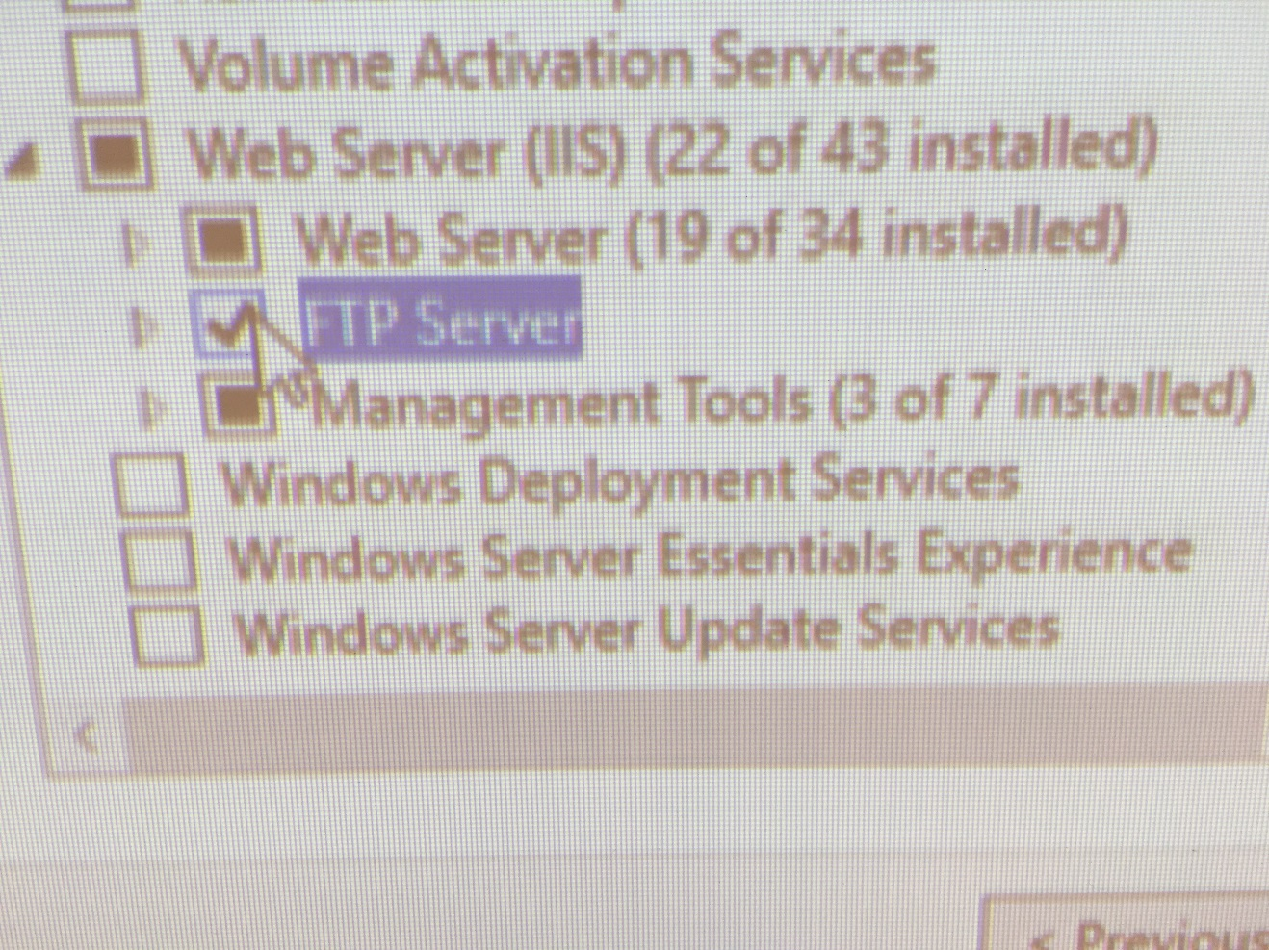
A photo of the FTP server role being selected from the tree view.
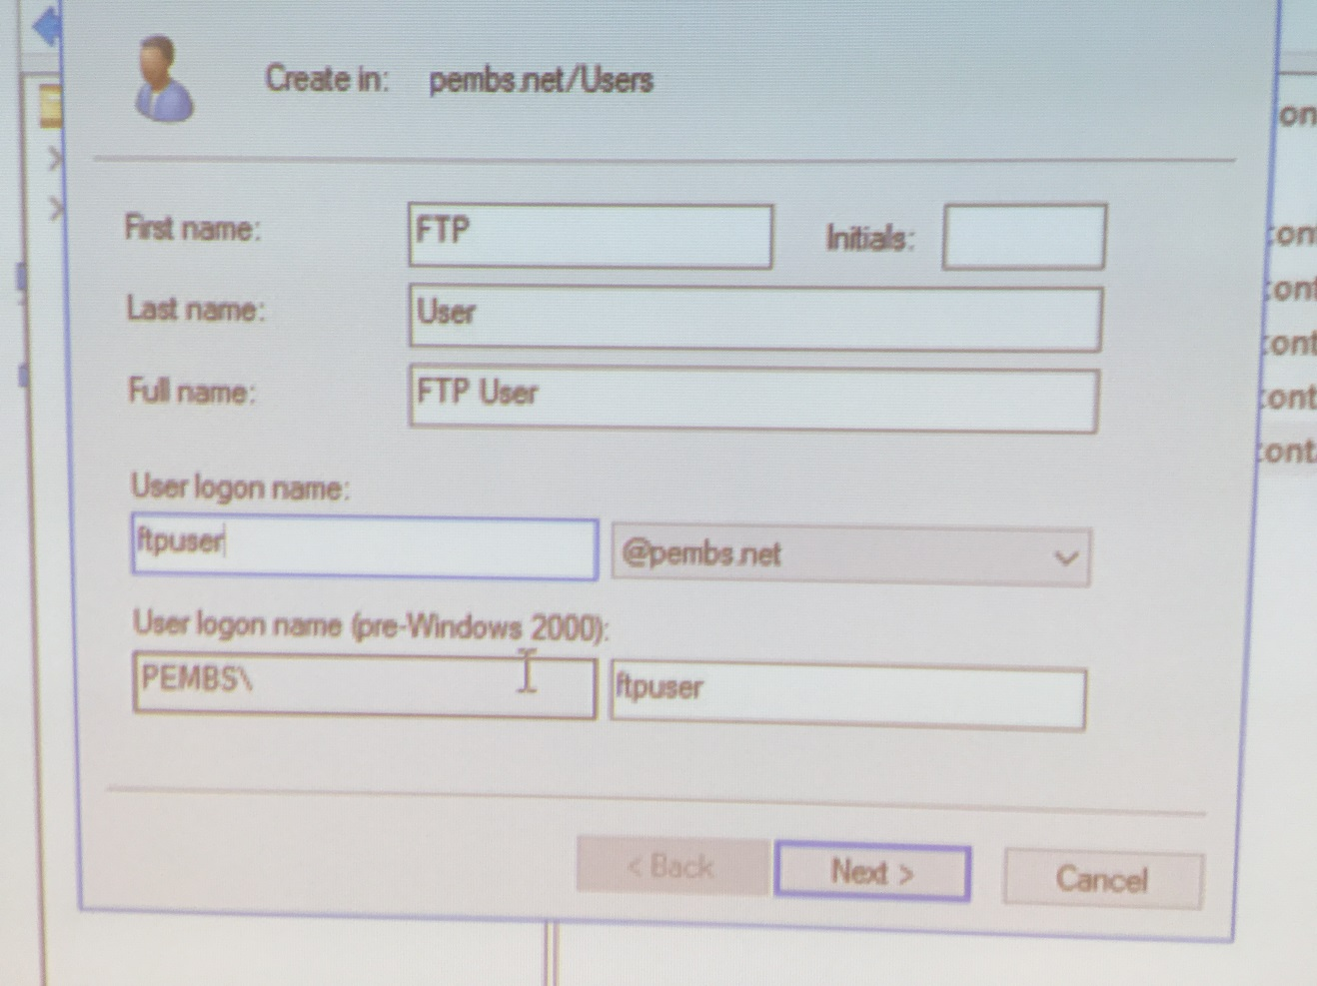
This image depicts the creation of an FTP user account for the server.

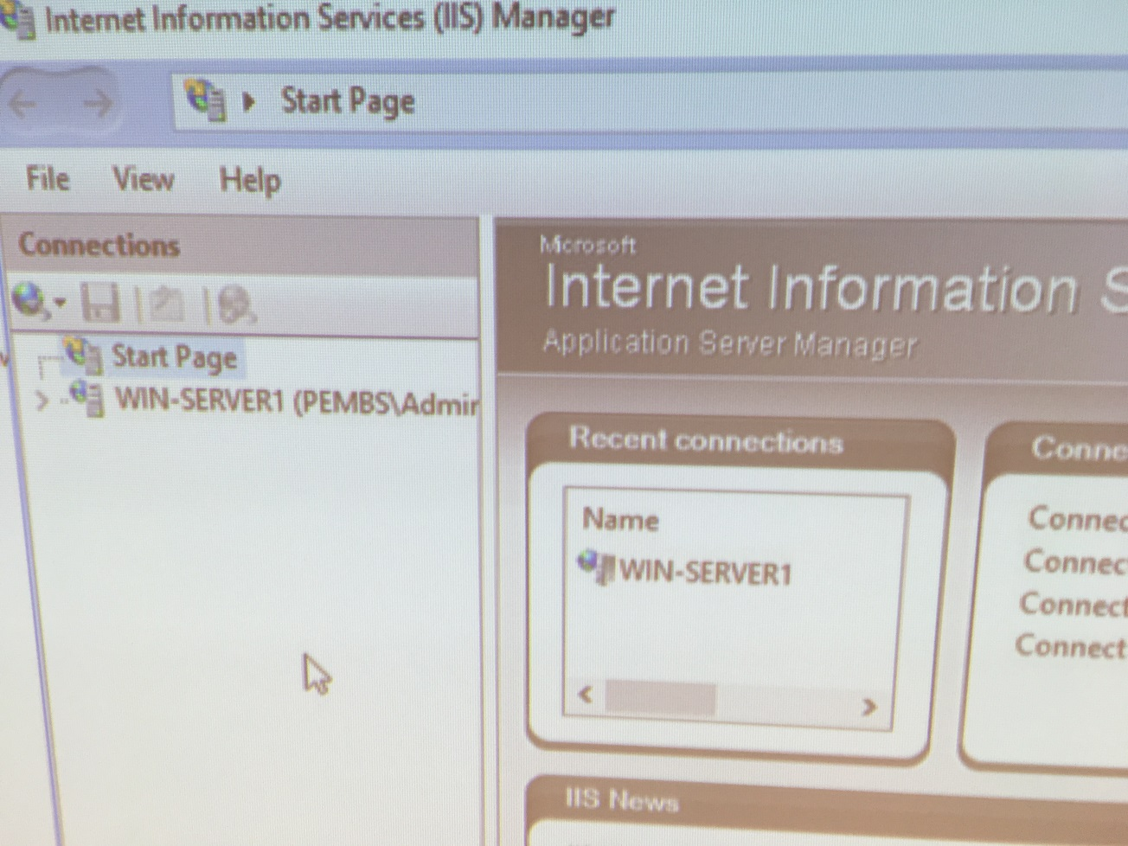
The above image shows IIS manager on the server, which allows for the management of different websites hosted on it and the server itself.

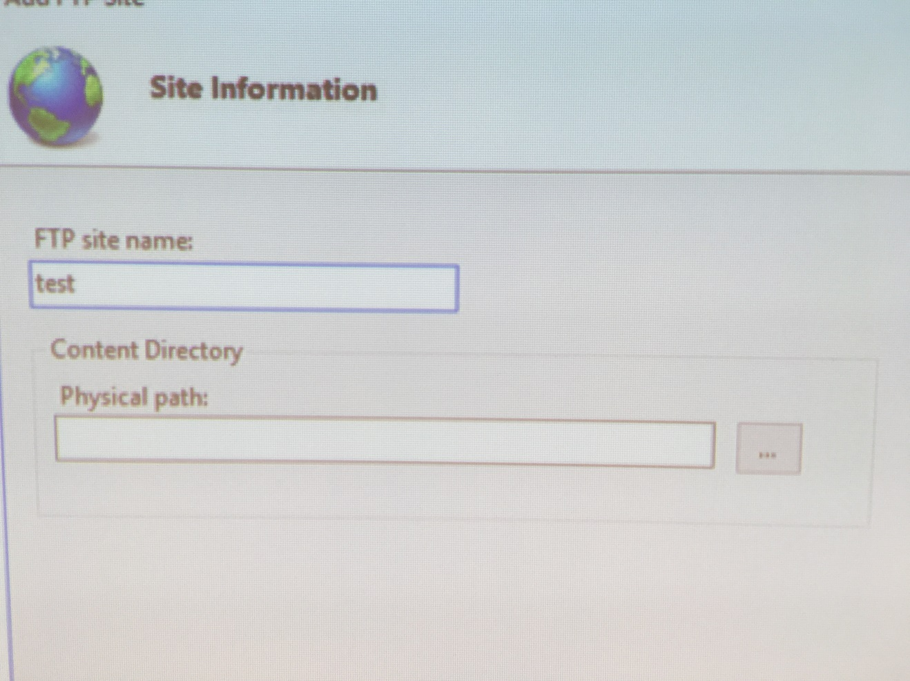
Add FTP site is chosen from the sidebar on the right. The window in the image above then prompts you to enter a site name and a path to the site on the server.
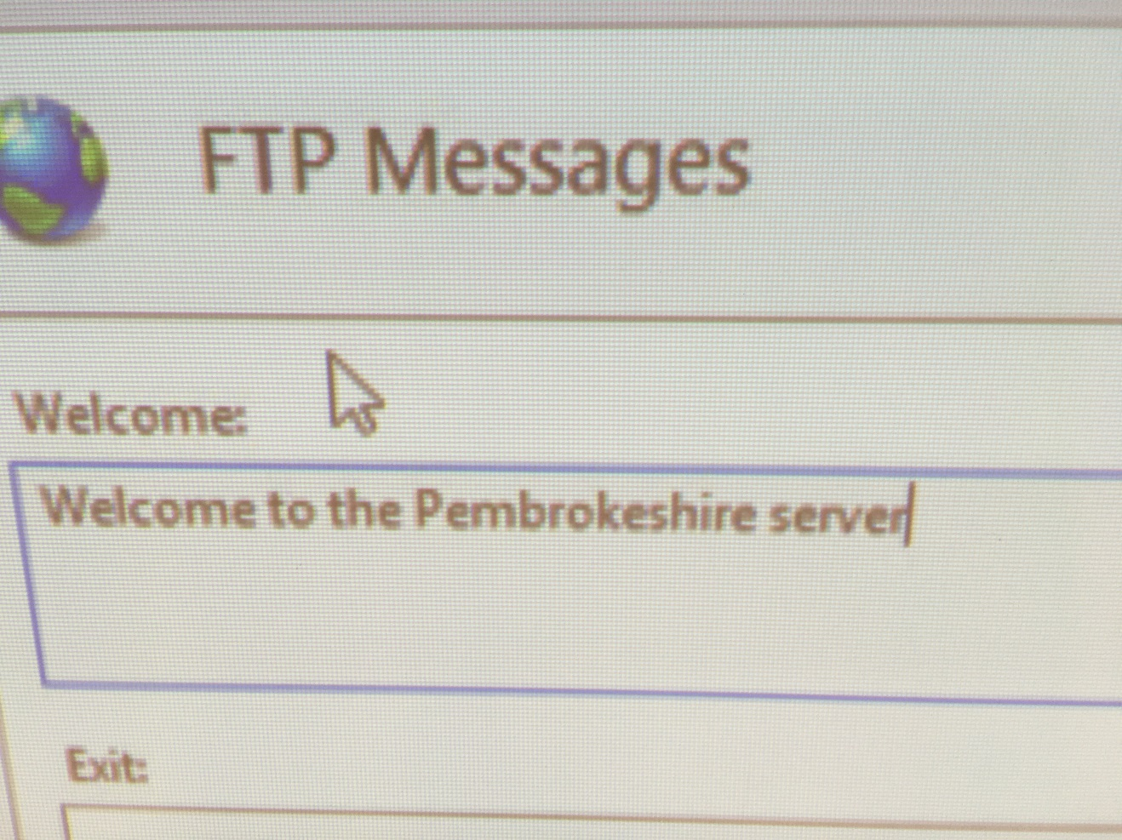
FTP messages can then be specified. The above image shows the welcome message being set to “Welcome to the Pembrokeshire server”.

We are now going to attempt an FTP operation from our Cardiff server (The Router) remember:

[Complete this task from the Cardiff]

Important Note: if at any stage your ftp session is ‘timed out’, type CTRL & C and/or type bye at the ftp> prompt;

We need a host directory to store the folder that is going to be ftp’d across from our FTP server.
- Click Start – My Computer – C: and create a new folder called ftpdownloads
- Click Start – Run – Type in cmd to launch the Command Prompt.
- We are now going to access the ftp service on the Win-Server2 – type the following command:

ftp IP of Win-Server2 Server
You may select any network interface from the Win-Server2 server.

- ftp service should be enabled,
- servername\ftpuser [don’t type in servername use your own servers name e.g.) User: Win-Server2\ftpuser.
- password P@ssw0rd.
- You are now logged into FTP server.
- Type dir to give you a list of what is stored in the Host Directory on the FTP Server. Note the file name testftpdownload.txt
- We need to change our Host Directory (done at this server not the ftp server) to specify where we want the FTP server to put the file to when it downloads.
- To do this we need the Local Directory Change Command, type lcd c:\ftpdownloads
- At the ftp prompt, type get testftpdownload.txt
- The ftp program should inform you that the process is complete.
- Go to My Computer, C:\ – create a folder called ftpfilesupload, within this folder create a new text file here call it testftpuploads.txt
- In the ftp prompt type the following
- lcd C:\ ftpfilesupload
- dir
- put testftpuploads.txt
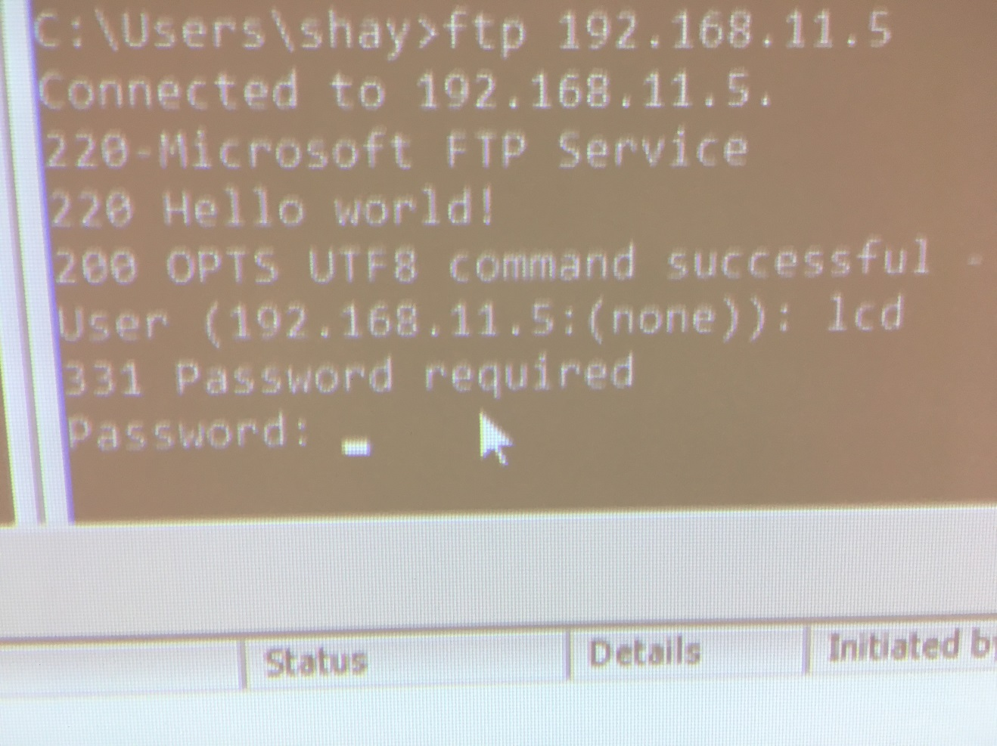
The image above demonstrates the process of connecting to the server through the command prompt. The server returns the message “Hello world!”, indicating that the setup of the FTP site was successful. The server then prompts the user for a password.
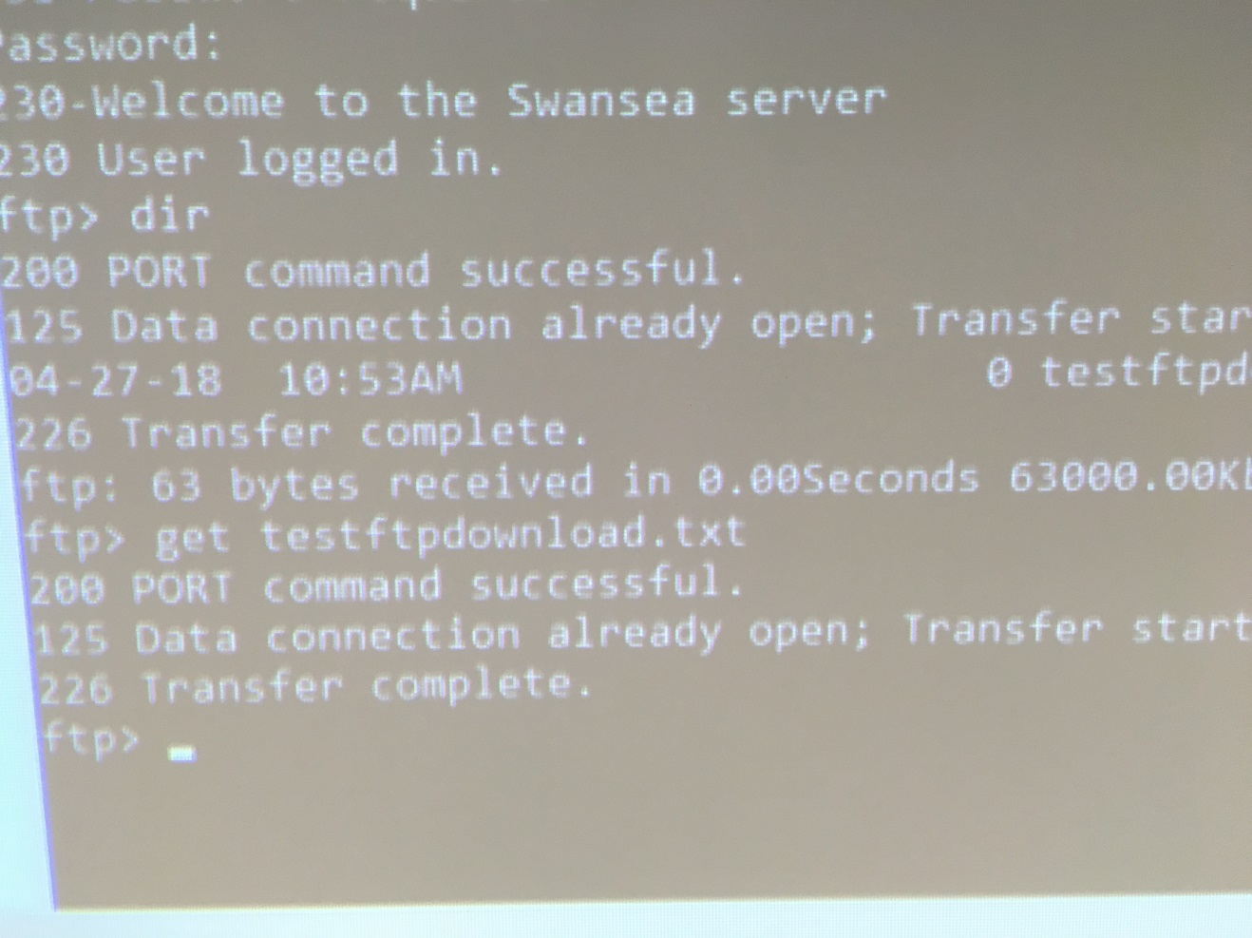
Once the correct password is entered, the server welcomes the user. This proves that the user account is working.

[Complete this task from Win-Server2]
- Go to the c:\inetpub\ftproot folder and verify that the file has been uploaded.

Task 3: Restricting ICMP Operations Using IP Packet Filtering with the Windows 2012 Server Routing and Remote Access Service

[Complete this task from Cardiff]

BEFORE BEGINNING, PLEASE CHECK THAT THE ROUTING AND REMOTE ACCESS SERVICE IS RUNNING ON YOUR MACHINE.

Configuring a Simple Inbound Filter (Remember filters are configured on the Router as traffic into our network arrives here first).

[Stopping the client from Pinging a Particular Network Host]

- Start – Administrative Tools – Routing and Remote Access Console
- Expand the Computer Name – Expand IP Routing – Then Click General
- In the details pane – right click the Partner Network Connection interface, click Properties.
- Click the General Tab – Inbound Filter (anything coming into the Router on this Partner Interface).
- Source IP Address This will be the IP address of the Client that you want to disallow. Set this to 192.168.0.3, and the subnet mask 255.255.255.255.
- Destination IP address: 192.168.0.2
- Destination Subnet Mask: 255.255.255.255 (This is because we know the exact Network/Host Address for the Destination).
- From the Protocol menu – Choose ICMP
- Note: you could also specify the port number here, if you do not specify a port the setting defaults to 255 meaning any type. Ok
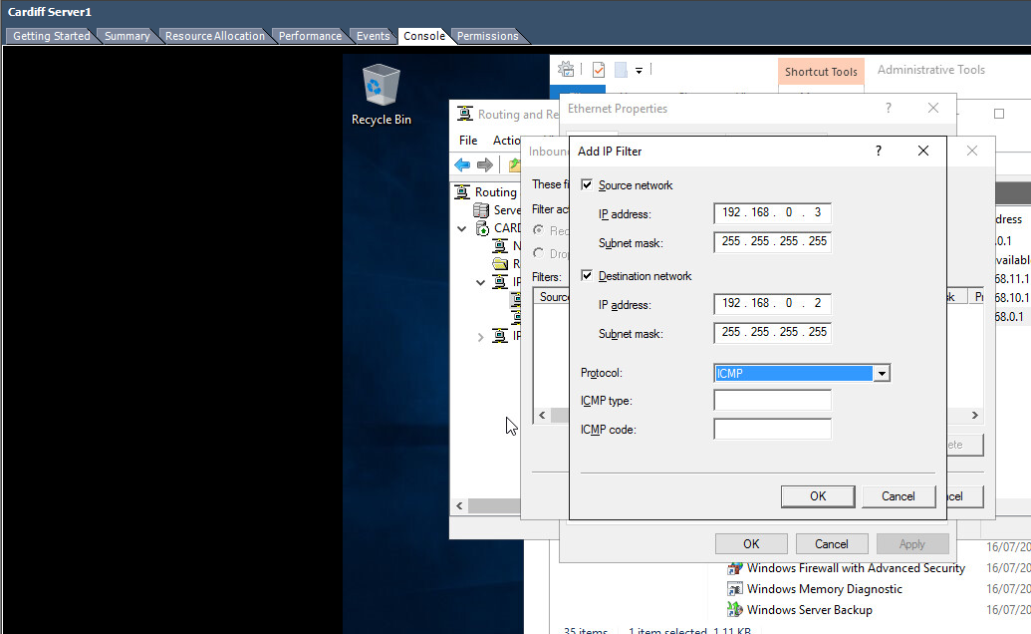
The image above shows the window displayed when adding an inbound IP filter. The ICMP protocol has been selected and the IP addresses of 192.169.0.3 for the source network, and 192.168.0.2 for the destination network have been used.
- From the Filters dialog select the Filter Action: Receive all Packets, except those that meet the criteria below

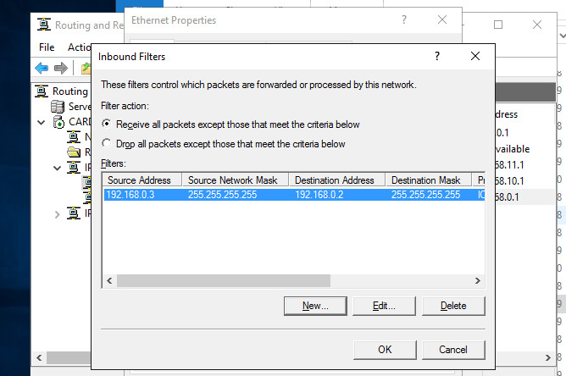
This image shows the inbound filters list with the newly added filter in it.

Rationale:

In this instance, we are creating a filter on a specific interface. You should still be able to ping the other network(s) on Win-Server2 from the client.

To confirm this:

[COMPLETE THIS TASK FROM THE CLIENT

- Attempt to PING Win-Server2 (192.168.0.2) you should NOT get any response from this IP address (you may get a reply from another bound IP telling you this host is unavailable).
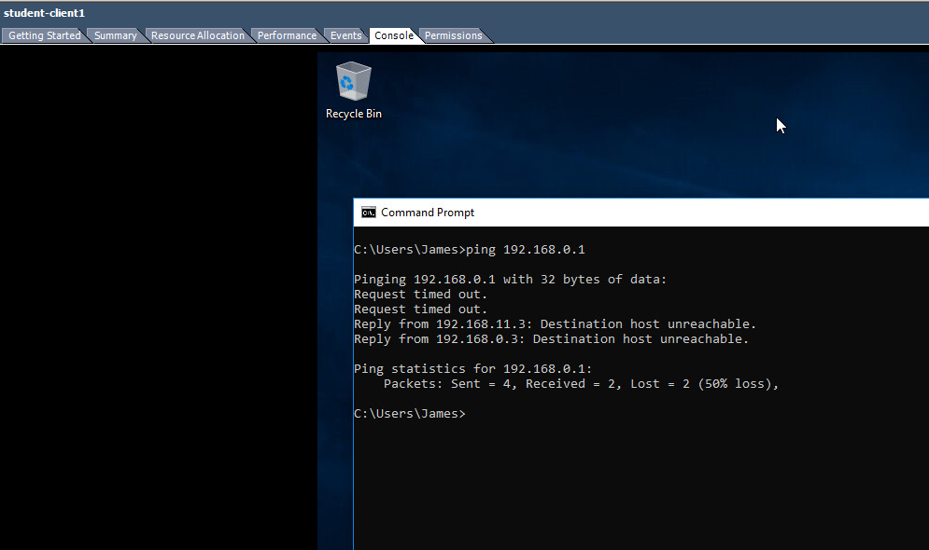
This image shows the attempt to ping the Win-Server2 server. 50% of the packets were lost. The two received packets were a reply from another IP stating that the “Destination host (is) unreachable”.
- Attempt to PING the other Private Network (e.g. 192.168.11.2) (This time you should find you receive a response)
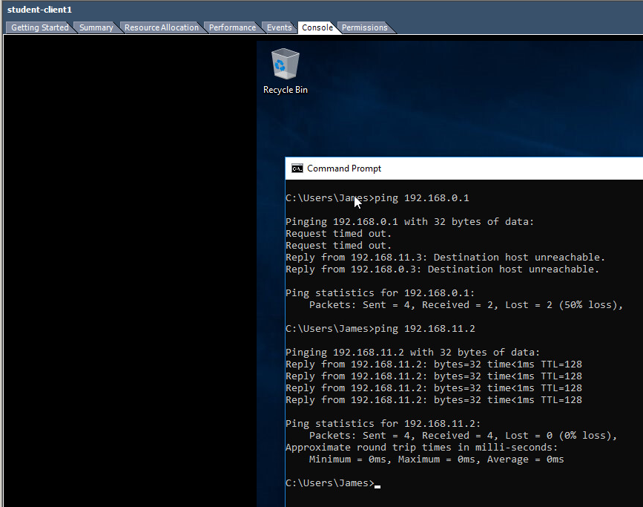
This image shows the attempt to ping the other private network which received a response for all packets.

Task 4: Restricting TCP Operations Using IP Packet Filtering with the Windows 2003 Server Routing and Remote Access Service.
[Complete this task from CARDIFF]

Configuring an Outbound Filter (packets travelling out of the Router).

First – remove the previous Inbound & Outbound Filters, this helps us avoid ‘Contradictory Filters’.

Earlier we performed FTP operations from the Win-Server2 Server, we needed to Connect to the FTP Service that was running on this server to complete the FTP operations.

Here we block all outbound traffic from the Router, in this instance we will block every body from accessing the FTP service that runs on the Win-Server2 Server in our Network.

- Start – Administrative Tools – Routing and Remote Access Console
- Expand the Computer Name – Expand IP Routing – Then Click General
- In the details pane – right click the Partner Network Connection interface, click Properties.
- Click the General Tab – Click Outbound Filter.
- Source and Destination IP Addresses these should be left Blank, as we intend to filter all packets that what to go out from the Router on this interface.
- Protocol: TCP (FTP Service is accessed using TCP port 20/21). You may need an identical rule for 20 and then 21
- Destination Port No: 21 (Note this value from earlier when we checked on default ftp site values). Choose OK.
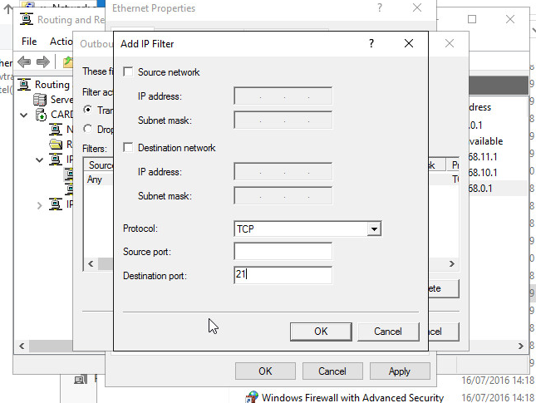
This image shows the ‘Add IP Filter’ window with source and destination network left blank and the destination port set to 21. This creates an outbound filter that allows all traffic through this port.
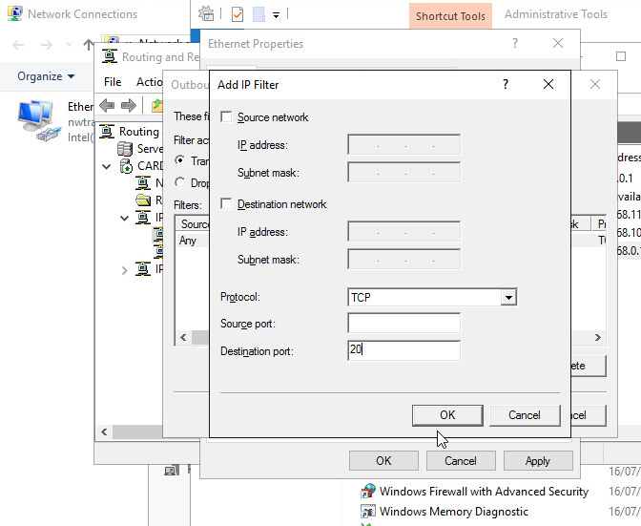
This image depicts the same process as above with the destination port set to 20.

From the Filters dialog select the Filter Action: Receive all Packets, except those that meet the criteria below
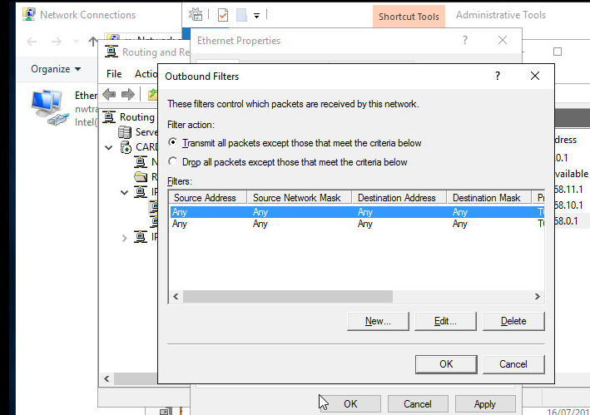
This image shows the outbound filters after creating two with ports 20 and 21 specified and no destination or source network specified.

[Complete this task from CARDIFF]

- Click Start – Run – cmd
- ftp (and then the IP Address of your Win-Server2 server e.g. the 0 or 11 address
- You should find that you get no reply, we cannot access the FTP service
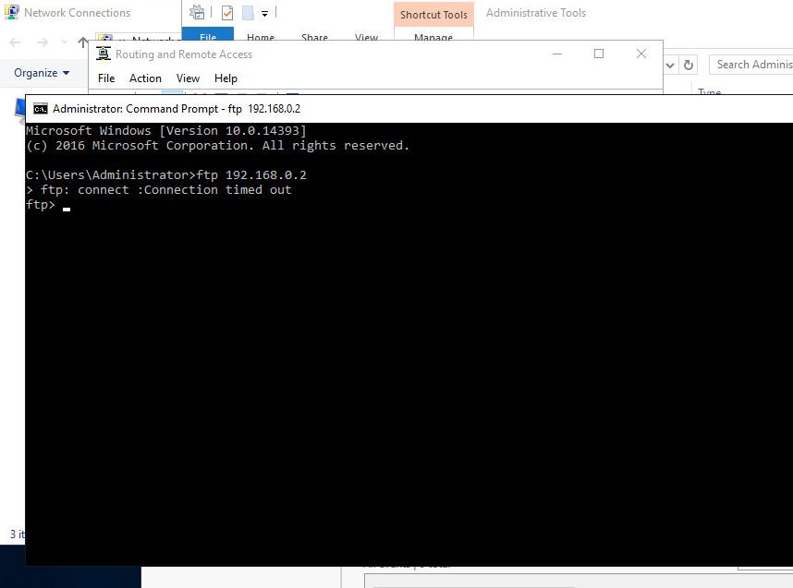
This image shows that no reply is received when attempting to connect to Win-Server2 server with the command prompt ‘ftp’ command.

Configuring an Outbound Filter.

[Complete this task from CARDIFF]

Here we will block access to the FTP Server for only our Router (Cardiff). All other Networks should be able to FTP into our FTP Server:

First – remove the previous Inbound & Outbound Filters, this helps us avoid ‘Contradictory Filters’.

- Start – Administrative Tools – Routing and Remote Access Console
- Expand the Computer Name – Expand IP Routing – Then Click General
- In the details pane – right click the Partner Network Connection interface, click Properties.
- Click the General Tab – Click Outbound Filter.
- In the Source IP Address enter the IP Address of the Partner Network Connection on the Router (or the Lower Number Server in your Group).
- Destination IP Address: is the IP address of the Partner Network Connection in the Win-server2 Server.
- Source Subnet Mask: 255.255.255.255
- Protocol: TCP
- Destination Port: 21
- From the Filters dialog select the Filter Action: Receive all Packets, except those that meet the criteria below.
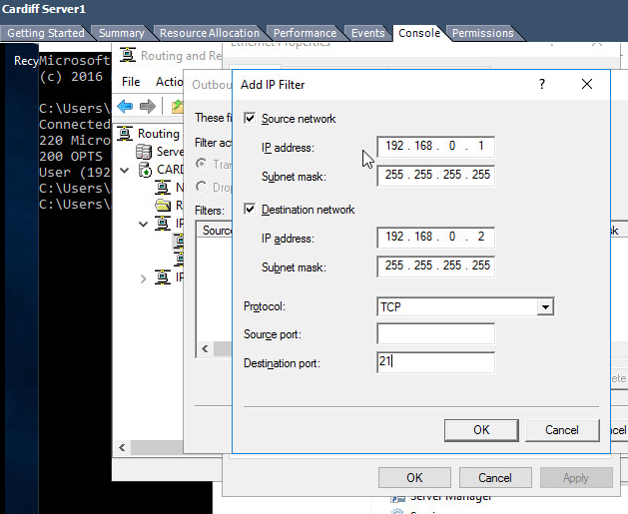
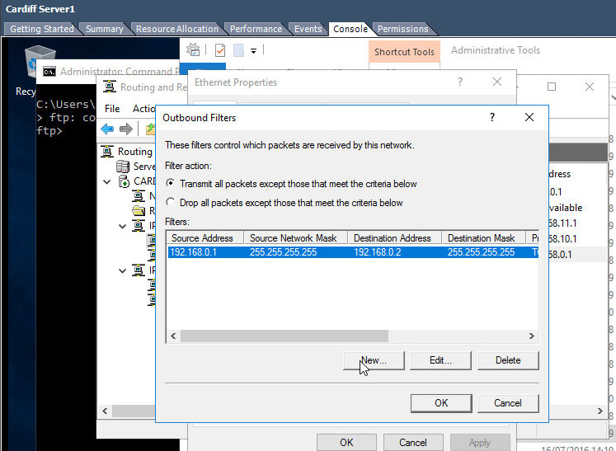

[Complete this task from CARDIFF]

- See if you can access your FTP server from your Router (remember you will need to access the FTP server using the Partner Network Connection).

Rationale:

Our Router will essentially stop itself from sending packets to the Partner Server, via the Partner Network Connection, the filter parameter is the source IP Address: which as specified is indeed the IP Address of the Partner Network Connection Interface on our Router.

No other filters are setup so the Router will forward all other requests from other networks.
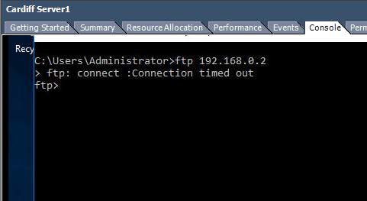

Task 5: Exercise
Here we want to only allow our Router to FTP. All other traffic from our Router and all other traffic from other networks (including PINGS) must be blocked.

Explain your method for achieving this:
On Win-Server2 create an outbound filter rule to drop all packets except for the defined FTP rule. A similar rule could also be done on the inbound filter as well.

Task 6: Observational Tasks
Observational Tasks:

Q1). Describe (using appropriate illustrations) how the ARP process operates in Networking Contexts?
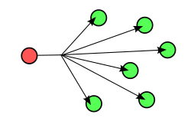
Each device on a network keeps an ARP lookup table which stores information about which IP addresses correspond with which MAC addresses. If the IP address is not present in the cached ARP table, the ARP protocol will be used to send a broadcast packet to a special MAC address which allows all machines on the network to receive it. A machine with a matching IP address will reply with an ARP packet containing its MAC address. The image on the right depicts the sending of a broadcast packet to all machines on a network and the image below illustrates the ARP process.
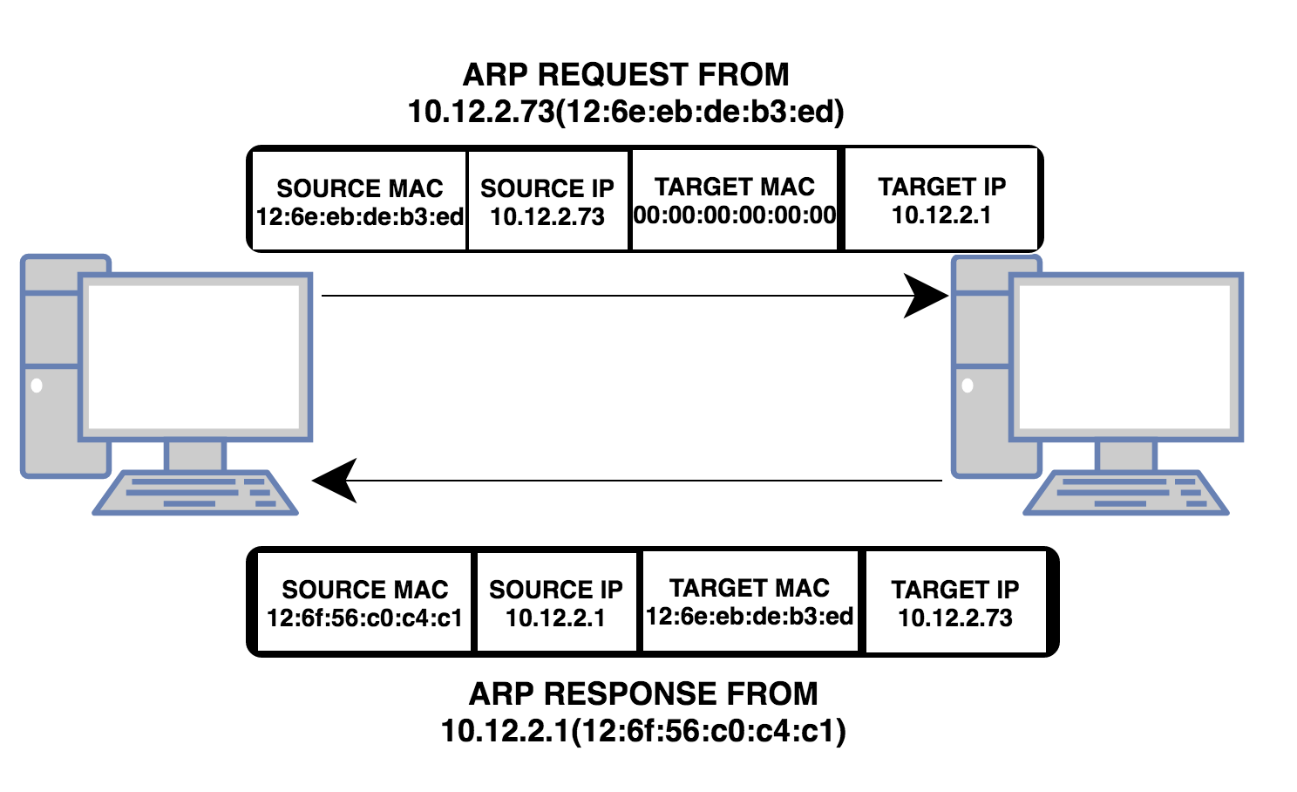
Q2). What is Packet Filtering? In our context, why is Packet Filtering termed ‘IP Packet’ Filtering? Why would you use Packet Filtering in your Network? What are the perceived benefits?
Packet filtering is a TCP/IP setting which dictates which packets can pass in or out of a router. In the context, the term IP packet filtering is used as the source IP address is the criteria for deciding which packets are discarded and which are accepted.
Packet filtering can be used prevent access from unauthorized users and stop access to certain resources providing benefits such as better security and improve performance by stopping unnecessary packets.
Q3). Why is it possible for contradictory filters to occur when you use packet filtering? Give an example of a Contradictory Filter:
Contradictory filters are possible when both inbound and outbound filters contradict each other. This is possible because traffic of a certain type may be useful to receive/send but traffic of the same type needs to be disabled when sent in the opposite direction for some reason, perhaps security or data protection. An example of this would be the inbound filter on one interface allows traffic in, but the output filter on the other blocks the outbound traffic. “The result is that the traffic is dropped and will not pass across the router.”
15/20
Q4). FTP Server is just one Role/Service we can configure our Server to provide? What other roles can the Server provide that would benefit our Infrastructure in both a local and remote context?
One possible role which would benefit the infrastructure is DHCP. A server with the DHCP (Dynamic Host Configuration Protocol) role allows a host to get its IP dynamically and efficiently. DHCP reduces workload with automatic TCP/IP configuration which involves automatically supplying clients with IP addresses, ensuring clients are always using correct settings which are updated automatically based on changes to the network structure, all of which help to eliminate network problems, making for a better remote user experience and easier local maintenance.
12/20

Question and Answers

Identify the benefits of Type 1 Hypervisor software services and briefly evaluate some suitable products:
The benefits of Type 1 Hypervisor software include the fast restoration of user machines when an installation becomes corrupt or unusable in any way, great performance due to the thin layer between software and hardware, remote wiping on loss or theft, the ability for multiple virtual machines with different permissions, and the abstraction of hardware on installation which allows for identical deployment on multiple specifications of machines.
Some of the primary services that offer Type 1 Hypervisor solutions are VMware with VMware ESX and ESXi, which offers advanced features and scalability but ESX must be licensed expensively, and ESXi is available as a free version with greatly reduced features or as one of five paid versions; Microsoft with its Hyper-V, which doesn’t offer many advanced features, but does offer a free version as well as four different paid options and works well with Windows Server; Citrix’ Xen Server comes as free software or as one of four commercial editions, as with the others, but offers very few advanced features.
Define the role of Routers in the Network Architecture, what types can be used?
Routers are layer three devices that make decisions based on network addresses as to the best paths or routes to direct packets between networks and devices on those networks. There are two main types of routers: Hardware routers, which perform routing as a dedicated function; and Software routers, which is not dedicated to routing alone, performing other processes too.
Identify and discuss the usage of common Routing Protocols, what are the associated benefits of using Routing Protocols?
For routers to calculate routes themselves, they must exchange information through Routing Protocols. A Routing Protocol is defined as a set of messages routers use to calculate appropriate paths to forward data. Routers use Dynamic Routing to inform each other of changes in a network, which uses these protocols to find and update the routing tables of the routers. The Routing Protocol determines the rules a router uses when sharing routing information with other routers and defines how routed protocols are routed. Current Routing Protocols include RIP (Routing Information Protocol), IGRP (Interior Gateway Routing Protocol), EIGRP (Enhanced Interior Gateway Routing Protocol), and OSPF (Open Shortest Path First). These allow for more effective automation of routing, less latency when performing dynamic requests and a higher likelihood of having data routed on the fastest route and less work for administrators as the routers are able to learn from each other.
Define the role of Routing Tables, what are they. Breakdown and analyze the information a Routing Table provides us with.
Every router uses a routing table to store network addresses, network masks, router interfaces to reach a network and metric information. When a router receives a packet, the destination IP address is checked against the routing table. The network mask for each entry is used to recover the network address from the IP and is then compared with the address from the routing table. Once a match is found the packet is forwarded to the interface specified in the routing table. The metric information stored by in the routing table is used to determine whether one route should be used over another. It consists of information such as number of hops, speed of the path, packet loss, latency and bandwidth.
What is the Subnet Mask, what is the significance of this in the Routing Table?
A Subnet Mask defines the range of IP addresses that can be used in a network. It is used to implement subnetworks on LANs. Subnets allow systems within it to communicate directly instead of through a router, allowing it to partition networks and limit traffic between them. The Subnet mask is required in a routing table entry to identify the network address from the IP address in order to determine the next hop on the route to the packet’s final destination.

Describe (using appropriate illustrations) how the ARP process operates in Networking Contexts?
Each device on a network keeps an ARP lookup table which stores information about which IP addresses correspond with which MAC addresses. If the IP address is not present in the cached ARP table, the ARP protocol will be used to send a broadcast packet to a special MAC address which allows all machines on the network to receive it. A machine with a matching IP address will reply with an ARP packet containing its MAC address. The image on the right depicts the sending of a broadcast packet to all machines on a network and the image below illustrates the ARP process.

What is Packet Filtering? In our context, why is Packet Filtering termed ‘IP Packet’ Filtering? Why would you use Packet Filtering in your Network? What are the perceived benefits?
Packet filtering is a TCP/IP setting which dictates which packets can pass in or out of a router. In the context, the term IP packet filtering is used as the source IP address is the criteria for deciding which packets are discarded and which are accepted.
Packet filtering can be used prevent access from unauthorized users and stop access to certain resources providing benefits such as better security and improve performance by stopping unnecessary packets.
Why is it possible for contradictory filters to occur when you use packet filtering? Give an example of a Contradictory Filter.
Contradictory filters are possible when both inbound and outbound filters contradict each other. This is possible because traffic of a certain type may be useful to receive/send but traffic of the same type needs to be disabled when sent in the opposite direction for some reason, perhaps security or data protection. An example of this would be the inbound filter on one interface allows traffic in, but the output filter on the other blocks the outbound traffic. “The result is that the traffic is dropped and will not pass across the router.”
FTP Server is just one Role/Service we can configure our Server to provide. What other roles can the Server provide that would benefit our Infrastructure in both a local and remote context?
One possible role which would benefit the infrastructure is DHCP. A server with the DHCP (Dynamic Host Configuration Protocol) role allows a host to get its IP dynamically and efficiently. DHCP reduces workload with automatic TCP/IP configuration which involves automatically supplying clients with IP addresses, ensuring clients are always using correct settings which are updated automatically based on changes to the network structure, all of which help to eliminate network problems, making for a better remote user experience and easier local maintenance.
Define the role of the DHCP Server in your Network?
The role of the DHCP server in the network is to automate the allocation of IP addresses to devices on the network with automatic TCP/IP configuration instead of allocating them manually, as would have to be done if some form of automation, like DHCP, is not implemented, which decreases workload and increases efficiency. The DHCP server is allocated a pool of IP addresses to use, the host then requests an IP address allocation and is given one from the pool. Network mask and DNS information, among others, can also be sent to the host in this transaction.
What happens when we have dynamically configured TCP/IP for our NIC, but then consequently cannot contact a DHCP server?
If the client already has an IP and is seeking to renew its lease but receives no response from the DHCP server, it will continue to resend DHCPREQUEST unicasts. After a certain length of time it will switch from unicast requests to broadcast requests, attempting to find another server available to serve the request. If this fails the IP address must be released by the client, and all connections using it, closed. At this point the client assigns itself an automatic private IP and must restart the process to get a public one.

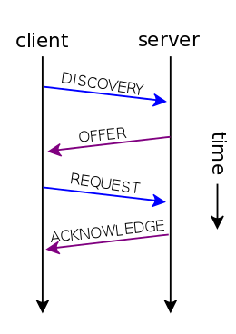
Illustrate (with illustrations) the four-stage process involved when DHCP clients look to obtain an IP address via DHCP?
The four-stage process consists of Discovery, a broadcast message sent with the 255.255.255.255 destination address; Offer, a DHCP server’s reply to a discover message containing an IP lease offer which includes the offered IP, the IP of the DHCP server, the client’s MAC address, the subnet mask and lease duration; Request, the clients reply to the server, requesting the IP the server offered. The client can receive offers from multiple servers but will only accept one; Acknowledgement, this is the final stage where the server acknowledges and accepts the request and sends the client the lease duration and any other information requested. The illustration on the right depicts this four-stage exchange between client and server.
Describe the advantages of using a relay agent. Explain (with descriptions and illustrations) how and why we would setup the Relay Agent on our Router?
Relay agents are devices configure to listen for DHCP client broadcasts and relay them to a DHCP server on a different subnet. This is required as routers don’t pass these packets across subnets. This essentially converts the broadcast packet into a unicast packet and then sends it to a server. This is important as it provides fault-tolerance and circumvents the alternative of creating a DHCP server for each subnet. The illustration on the next page demonstrates this concept.
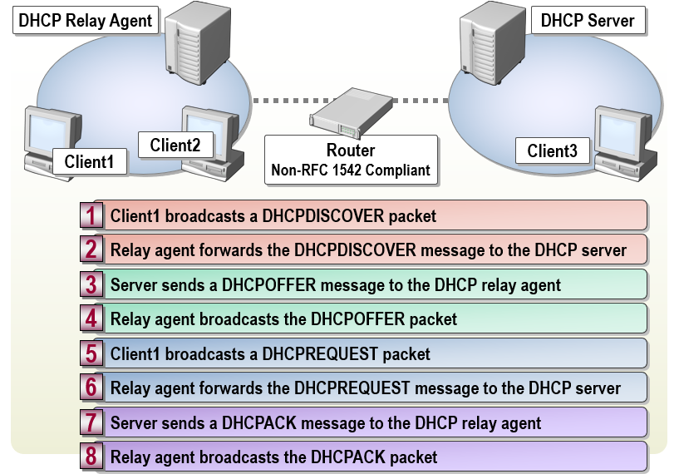
What steps does a client take (what is the process involved) when trying to resolve a Name to an IP address?
The process a client uses to resolve a name is called hostname resolution. Hostname resolution involves querying DNS server databases to find an IP that matches the hostname. This is hierarchical: queries are passed up the hierarchy until the hostname is resolved.
Describe how the Recursive Query and Iterative Query Processes resolve DNS Client Requests?
An iterative query is a DNS client query which queries a DNS server for the best possible match for a hostname without conferring with other DNS servers. The result often refers the client to another DNS server lower in the hierarchy. These requests are typically made between servers, not client and server.
A recursive query is made by a client to a DNS server, requesting a complete answer. This query cannot result in redirection to another DNS server and only returns an IP or an error message. The DNS server searches its cache for an IP matching the hostname. If no record is found it locates the authoritative DNS server for the zone. Once found, the authoritative server queries the DNS zone for a matching record. If not found, root hints are used to get the IP of the DNS root server. If the record still cannot be found, an error message is returned.
Explain the significance of root hints and how this process enables us to resolve names that are not managed (or kept in an authoritative DNS server in our network)?
Root hints are DNS server resource records that contain the IP addresses for DNS root servers maintained by InterNIC. These are significant in DNS hostname resolution as if no records of a name are found in a DNS server’s cache or in the DNS zone, they can be used to find the IP of the DNS root server.
Server1 is hosted in a subdomain called ‘subcontA’ with a root domain called nwtraders.msft, answer the following questions:
(1). What is the exact FQDN for this host?
The fully qualified domain name for this host would be “Server1.subcontA.nwtraders.msft”.

(2). Illustrate how the Domain Name System breaks up this FQDN into Host and
Domain Namespace?
The FQDN is broken into a hierarchy, as seen in the image below. The root domain isn’t required in this case as a null or full stop specifies the internet as the root domain. The top-level domain, in this scenario ‘msft’, represents an organisation or location. The second-level domain is ‘nwtraders’. This is the personalised part of the domain, assigned by the NIC, as is the subdomain, an extra domain, commonly used to specify individual sections of a website.
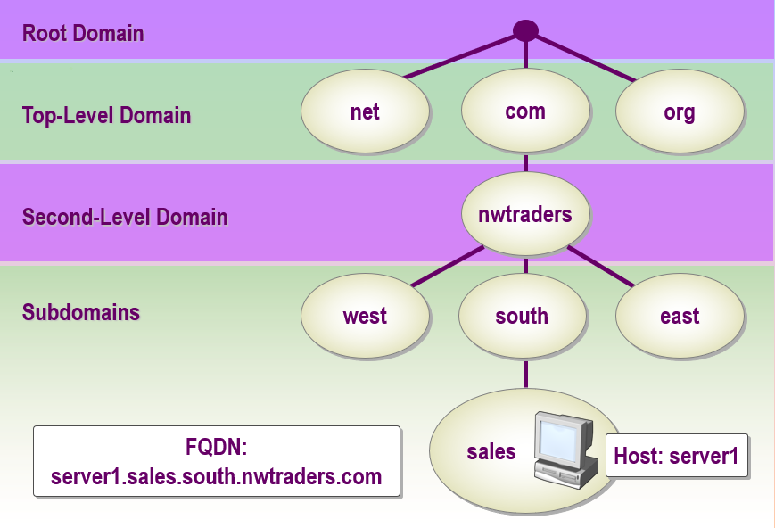
Explain how DNS Zones are used in DNS, give examples to illustrate the use of multiple zones and how these can be used to manage resource records of domains. What important factors/characteristics do we need to be aware of?
DNS Zones are a component of the domain space under the authority of a DNS server. Zones often have many domains and a server can have many zones. Each zone has resource records for the names under it, as well as files that define that zone. A common convention is to create zones on a regional basis to disseminate between distinct locations.
There are two types of zone, forward look up and reverse look up. Forward DNS lookup uses the hostname to find an IP, whereas reverse lookup uses the IP to find the hostname. For domains with multiple subdomains, a zone can be setup for every subdomain, allowing the configuration of zone types based on the subdomain. An example of this would be setting one subdomain for forward look up and another for reverse.
You are required to evaluate a suitable clustering strategy for hosting a ‘3-tier web development system. In this appraisal you should provide details of tools and technologies that are part of each type of cluster deployment. Any technical terms/components should be suitably discussed. You may use illustrations/narrative where possible to support your arguments. It is imperative that you use a suitable reference system when undertaking this task.
The three layers of a three-tier web application are data, application and presentation. The data tier consists of the database, its contents and the operations available for execution upon those contents. The next tier is application, which provides the functionality of the system, which includes displaying data from the data tier as well as entering input data into it and deleting records. The presentation tier “sends content to browsers”. It’s the design and aesthetic aspect, the user interface of the system that allows the user to operate the functionality developed in the previous two tiers.
Clusters are several servers operating as one unit. A server in a cluster is called a node and each node is physically connected to the other nodes. A clustering strategy may be deployed to improve data integrity; reduce the chance of system, application or site failure; or provide better application availability. The ability to handle failure “allows server clusters to meet requirements […] for user service access” and reduces frequency of unscheduled outages and contributes to the improved application availability that clustering can provide. The increased fault tolerance that clustering can offer only affects the application, not user data.
Server clusters have many failover designs that offer improved availability and reliability as well as providing good scalability useful for databases that continue to grow such as the those of the data tier as described in the three-tier system. A concept called ‘heartbeats’ is used to monitor a cluster’s nodes, updating fifty times a second. If a node is unaccounted for five heartbeats of 1.2 seconds each, it ‘regroups’ the nodes. The number of nodes allocated to a service depends on that service’s requirements. Most will be allocated one node but some, such as SQL server, require more.
Cluster often create groups of required components known as resource groups. These include IP addresses, services and network names. The number of resources that can be linked within a group is usually limited to 100.
One feature of server clustering is component load balancing which allows for dynamic load balancing. Dynamic load balancing divides traffic between nodes to improve the distribution of workloads across the cluster. Load balancing helps to optimise resource use and minimizes response time.
All tiers would benefit from the implementation of component load balancing as the multiple nodes assigned to the data tier would be able to perform requests more efficiently, and the subsequent reduction of response times would improve the performance of the application, thus allowing web requests from clients to be served quicker, improving the performance of the presentation tier.
Another form of load balancing that would improve the performance of the presentation tier is network load balancing which “distributes network traffic among multiple servers or virtual machines within a cluster to improve performance”. It manages incoming packets and distributes them between the nodes pertinent to their content which allows web requests to be served faster. Stress testing is required for both load balancing types to protect against failure. The image on the next page depicts an example of load balancing.
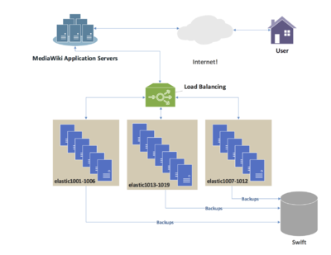

References

IBM. IP Packet Filter Firewall. https://www.ibm.com/support/knowledgecenter/en/ssw_i5_54/rzatj/packetff.htm. [Accessed: 05/05/2018]
Server Brain. How Packet Filters Are Applied. https://www.serverbrain.org/network-services-2003/how-packet-filters-are-applied-1.html [Accessed: 05/05/2018]  B.Sc. Year 2 Network Services Worksheet 3: TCP/IP Configuration using DHCP (Dynamic Host Control Protocol). Group Name: Ben McCarthy, Ben Archer, James Pugh, Gwyndaf Rees, Ryan Gallagher Date: Author(s): Gwyndaf Rees Complete the following tasks: abstract Task 1: Understanding Different TCP/IP Configurations We know that Computers use IP addresses to communicate over TCP/IP protocol. Windows 2012 provides three different ways to configure IP Addressing. Manually – Static IP addresses, usually assigned to Servers running Windows 2012 Server. All the servers on our 192.168.1.0 network are configured, at present with manual/static IP addresses Dynamically – If a DHCP server is installed IP addresses are assigned automatically on boot-up, DHCP is the default TCP/IP configuration and is in most cases automatically setup on Windows Workstations. Alternative - When you install Windows 2012 you are automatically configuring that Server to be a DHCP client. - Obtain an IP address automatically uses a DHCP server for dynamic IP addressing - Use the following IP address – Statically defines the IP address If you are a DHCP client, and you are unable to locate a DHCP server, you get your address from a range of IP addresses known as the APIPA (Automatic Private IP Addresses). An APIPA type address is a class B IP address. It is allocated from the range 169.254.0.1 to 169.254.255.255. It has a Subnet mask of 255.255.0.0. This is a private IP range; you would not find another computer attached to the public internet using any APIPA addresses. The DHCP client (if no host can be contacted) picks a random IP address from this range, and broadcasts it out on the network. If this address is in use the owner will send a packet informing the client it is already in use. If the IP address is not being used, the client ‘binds’ this IP address to the specific network adapter. The client will send out requests periodically to the DHCP server, until DHCP automatic IP address can be assigned. VERY IMPORTANT: BEFORE YOU UNDERTAKE THIS TASK MAKE A NOTE OF ALL STATICALLY DEFINED IP ADDRESSES; YOU WILL NEED THESE LATER ON. [Complete this task from Swanesa and the Windows 7 client] * Locate the Apipa setting only for the 0 Network interface * Set the networking to automatic private IP addressing on both servers (You will only need to complete this task on one of your networks). * Choose Start – run – cmd ipconfig/release (just to make sure our static address is completely erased. ipconfig /renew, it will take a few moments for our computer to realize that it cannot find a DHCP server on the network. - We will get an error message informing us the request is timed out (because a DHCP server could not be contacted). - We should now be able to obtain an APIPA, in the cmd prompt type ipconfig - We should now see for our Network Connection, that an Auto configuration IP address has been assigned, with a subnet mask of 255.255.0.0 - We see now that AutoConfiguration has been enabled, note no Default Gateway is assigned. This means that clients beyond the same switch or LAN that live on remotely separate networks cannot PING each other Try to ping the two other servers on the other network; record what happens. 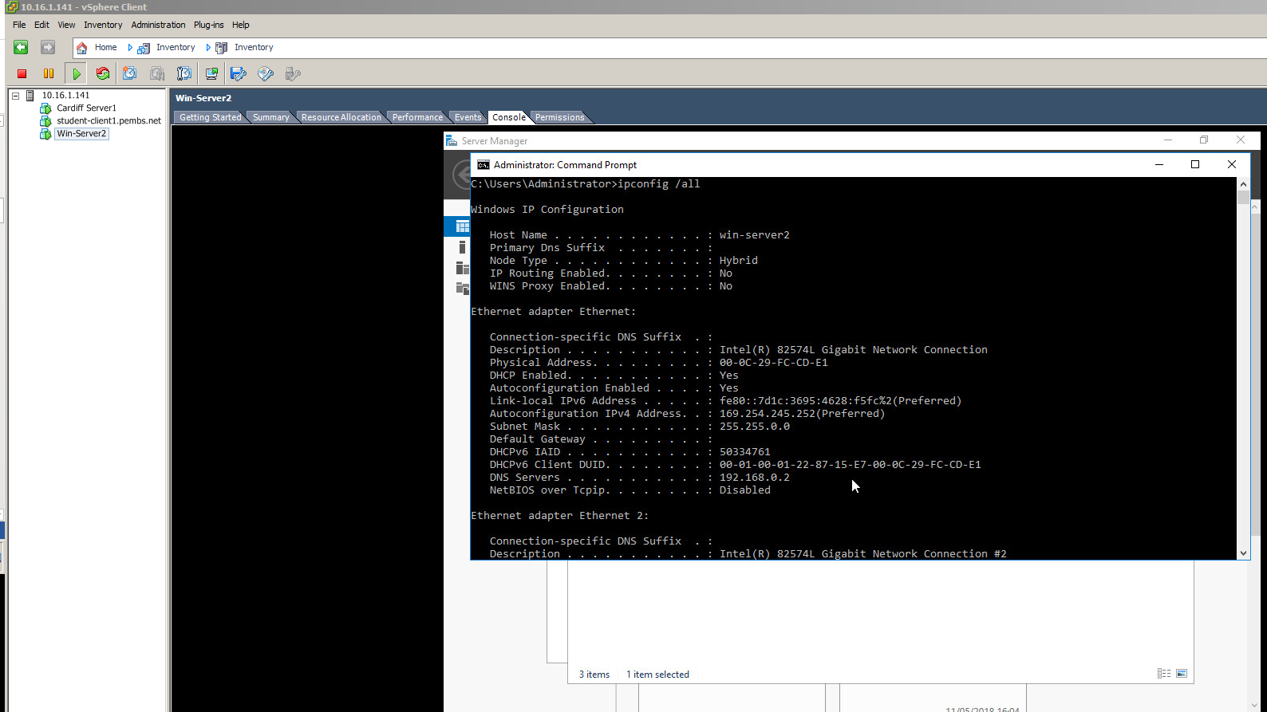 This image shows the result of the “ipconfig /all” command. Task 2: Installing the DHCP Server Installing the DHCP Server: Note: Before we do this task we need to reset our configuration back to the static IP addresses that were entered earlier, do this here. We’ve seen previously how to configure dynamic IP addresses on our Network Adapter. DHCP. DHCP gives us centralized control over IP addresses and TCP/IP default settings (subnets, default gateways). When we set up the DHCP server, we can rely on this server to supply the TCP/IP settings. DHCP lies at the application layer of the OSI model, it is one of the applications, that utilises the services of TCP/IP. Note at the moment; the Connection is configured with a Dynamic IP address (as a DHCP client). [Complete this task from Cardiff] - Add a role from the dashboard. - Choose next and the default screen - From the list of available services to install check on DHCP Server - . - Choose Next at the next notification page. Complete the dialog. - Access the DHCP Post-Install configuration wizard. - Select “Commit.” 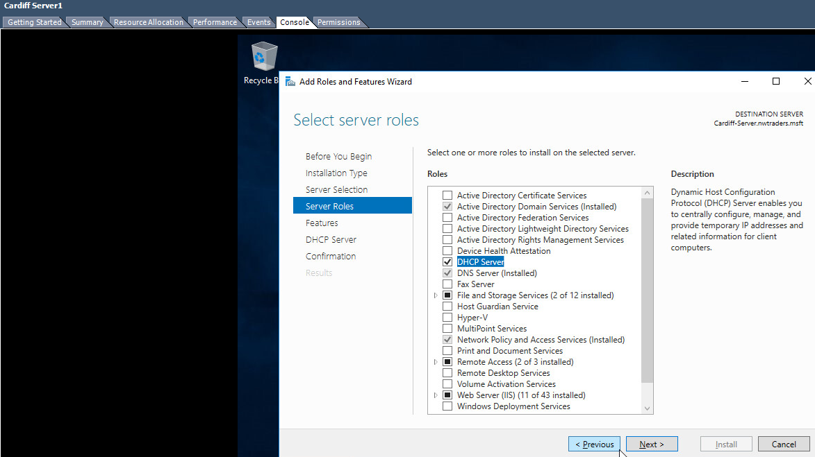 The screenshot above shows the server roles selection tree view with DHCP Server selected as part of the process of adding an new server role. 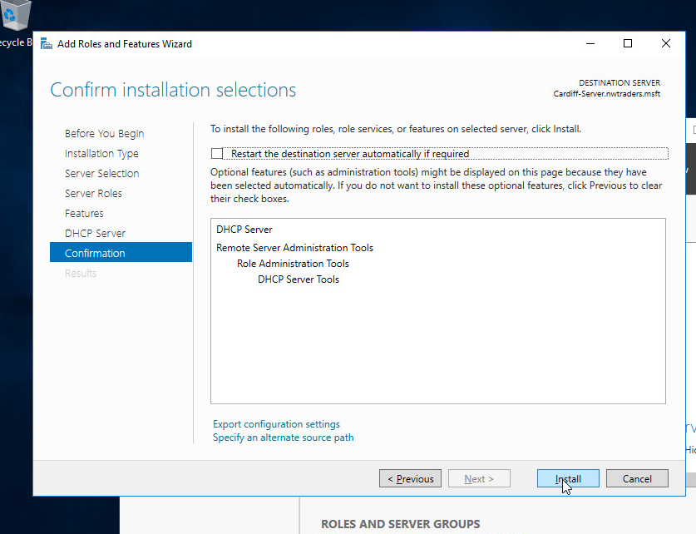 The image above shows the final step of the ‘Add Roles and Features Wizard’, detailing the features selected and offering the option to begin installation. Task 3: Authorising the DHCP Server YOU WON’T NEED TO DO THIS YET – THIS WILL BE NECESSARY ONLY ONCE WE CONFIGURE ACTIVE DIRECTORY, BUT COME BACK TO COMPLETE IT. WITHOUT COMPLETING THIS STEP, YOUR DHCP SERVER WILL NOT WORK AFTER INSTALLING ACTIVE DIRECTORY. Authorising the DHCP Server: One thing that Windows AD Domains protect against, is rogue DHCP servers or rather, the addition of them in our Network Infrastructure. DHCP clients are not really concerned which offer of an IP address they respond to (they just want an IP address). To avoid network communications problems, we must have a way of ensuring that our clients get a correct address from the right DHCP server in the right scope. In order for Domain clients to receive IP addresses from a DHCP server, the DHCP Servers must be authorised in Active Directory. To be an authorised the DHCP server must be: - Running DHCP console - A member server or a Domain Controller in the Active Directory domain. 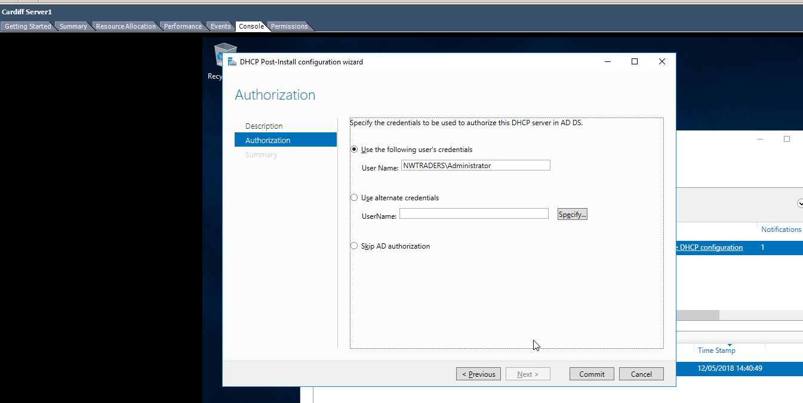 This image shows the DHCP Post-install configuration wizard with “NWTRADERS\Administrator” specified as the User Name. [Complete this task from Cardiff] - Start – Administrative Tools DHCP - In the Console Tree – Select the Server - On the Action Menu – click Authorise - Verify that the DHCP Service is authorised: in Console Tree, press F5 to refresh Confirm that DHCP Server now displays with a green arrow that points up - Close the DHCP console. Task 4: DHCP Scopes DHCP Scopes: When we have installed DHCP onto our Network, the next step is to create a scope. A scope is a range/pool of IP addresses (held within an IP address database), that are valid to be leased/assigned to DHCP clients within a particular NETWORK. Here we will create a scope for our Private Network. The scope must be configured before clients can use DHCP server for dynamic TCP/IP configuration. Each subnet is allowed a single DHCP scope that has a single continuous range of addresses. Specific addresses for applications (e.g. Web Servers, Print Servers) should be made exempt/excluded from the range that DHCP scope specifies (e.g. Reserved IP Addresses). Question. Why is it important to use Reservations when using DHCP? Tasks: Part A: [Creating a DHCP scope for initialization of ‘Leasing’ IP addresses to DHCP clients on the 0 network] [Complete this task from Cardiff] - Navigate to Start – Administrative Tools – DHCP. - Expand the server name, right click IPv4 and select “New Scope”. - Name it “0 Network DHCP Scope”. - Set the start IP address as 192.168.0.2 and the end address as 192.168.0.254. 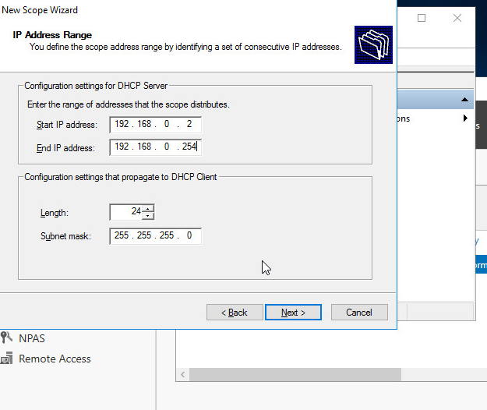 Above is a screenshot of the IP address range that has been specified for this new scope. - At the Select Network Connection Bindings screen choose an appropriate Network Connection adapter. - Do not add an exclusion. - An 8 day lease is fine, and normal for a wired connection. - Select “Yes” and continue. - Enter the IP address Cardiff on the relevant network and hit “Add”. 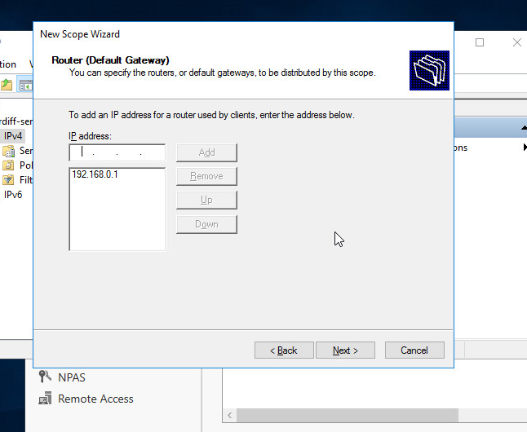 This shows another step of the ‘New Scope Wizard’ where the IP’s of routers or default gateways can be specified. - Immediately hit “Next” on the DNS and WINS options. - Select “Yes, I want to activate this scope now.” 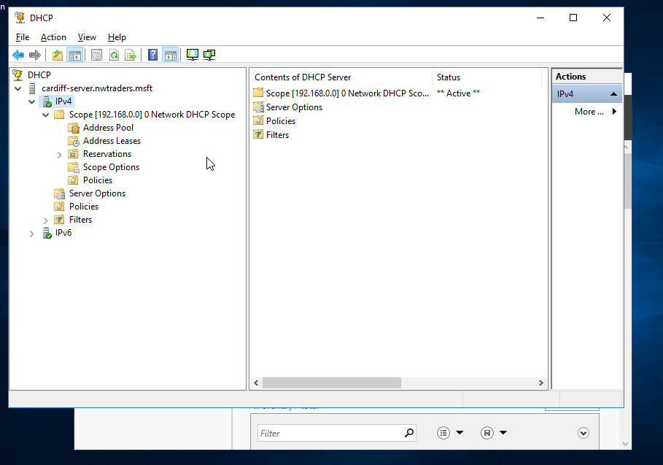 This image shows the new scope has been added. Part B: [DHCP Client obtains a leased IP address] [Complete this task from Win-Server2] - Login to the server if needed. - Choose Start – Control Panel – double click Network Connections.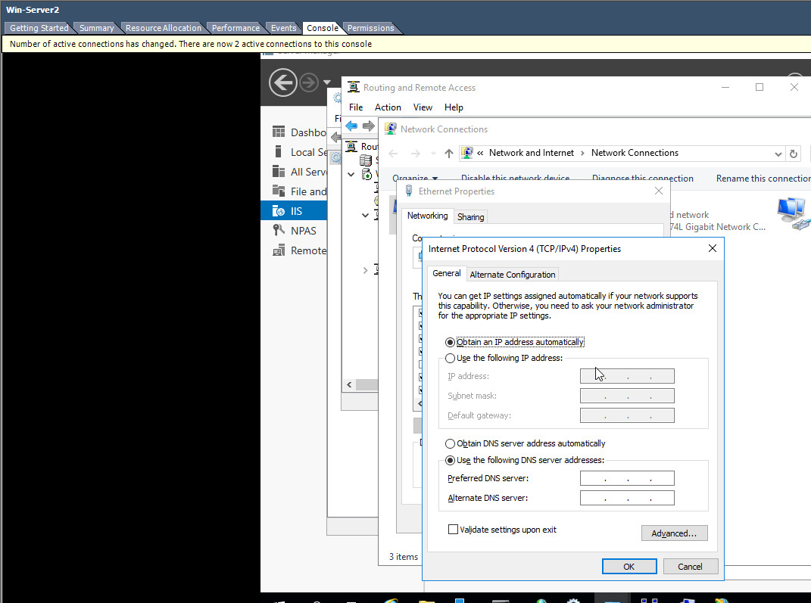 This image shows the IPv4 properties window where “Obtain an IP address automatically” has been selected. - Right click the Partner Network Connection - Choose Properties - Choose Internet Protocol (TCP/IP) click Properties. - Check on the Obtain IP address automatically option. - Check on the Obtain DNS Server address automatically option - Choose Ok – Close - Start – Run – cmd - Type: ipconfig /release 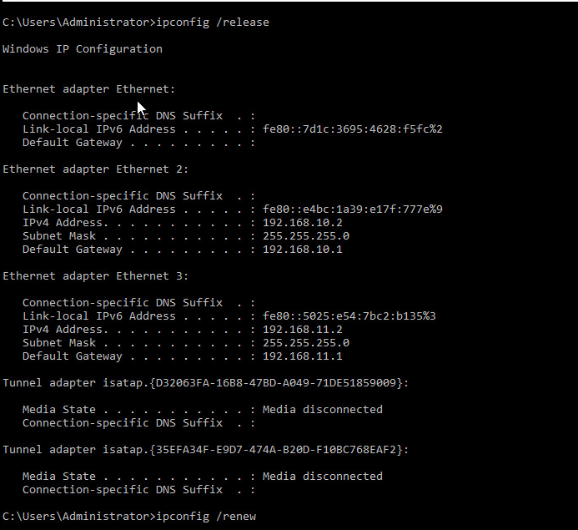 The above image shows the result of the ‘ipconfig /release’ command. - Type: ipconfig /renew (to obtain an IP address from DHCP Server) 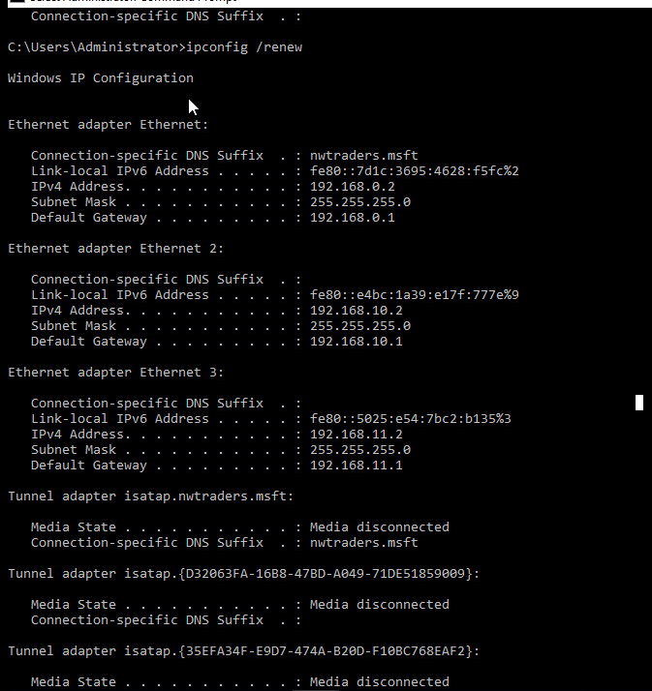 This image demonstrates the ‘ipconfig /renew’ command. - Type: ipconfig /all 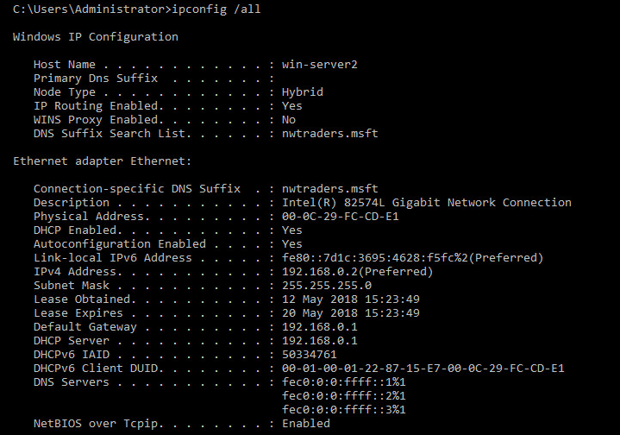 The image above shows the result of the ‘ipconfig /all’ command. Verify that the DHCP server IP Address for the Partner Network Connection, is the IP Address of Win-Server2 server. Win-Server2 has got the correct ip address as obtained by the Cardiff-Server DHCP [Complete this task from Cardiff] - Start – Administrative Tools – DHCP Console - In the console tree - Click Address Leases, verify that the Computer Name displayed is that of your Partners Computer. 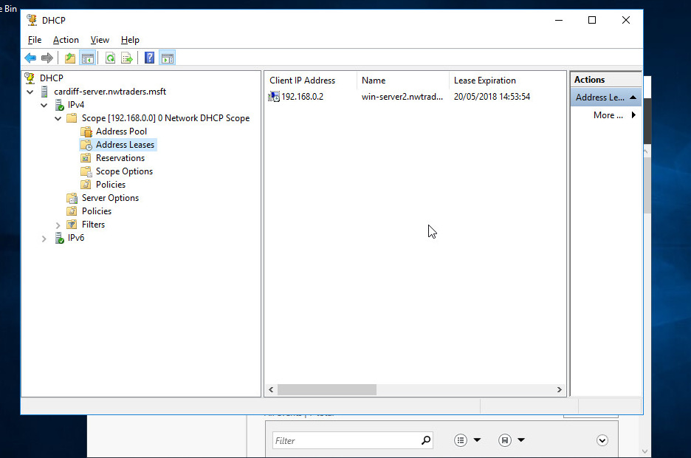 This image shows the IP the server has just leased. Task 5: Configuring DHCP reservations Configuring DHCP reservations. [Complete this task from Cardiff] - Navigate to Start – Administrative Tools – DHCP. - Expand the server name, then IPv4 and select “Address Leases”. - You should see a single lease: 192.168.0.2 – Win-Server2. We’ll convert this into a reservation. - Right click the reservation and select “Add to reservation”. This will convert the lease into a reservation. This is the easy way to create a reservation when a lease already exists. 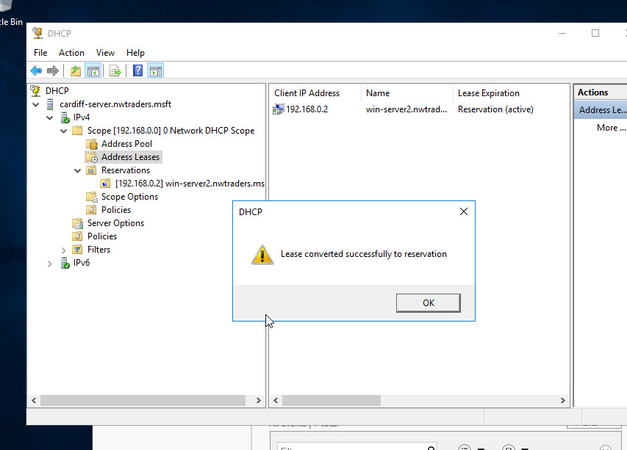 This image shows that the lease conversion to reservation was successful. We’ll now create a lease for a computer for which we do not have a lease. [Complete this task from the Windows 7 client] - Start – Computer – Right click Network and select “Properties”. - Change adapter settings. - Select the 0 network and choose “status”. - “Details”. - Copy (exactly) the “physical Address”. It should be in the format 00-00-00-00-00-00, e.g. 00-15-5D-86-03-3F. Close this. 192.168.0.3 – mac address: 00-0c-29-B2-3E-6B [Complete this task from Cardiff] - Navigate to Start – Administrative Tools – DHCP. - Expand the server name, then IPv4 and right click “Reservations” and select “New Reservation. - Set the reservation name to “Lab-01-01” and the IP address 192.168.0.5. - Set the MAC Address to the physical address noted above. This must be exact. - Select “Add”. [Complete this task from the Windows 7 client] - Start – cmd. - Type “ipconfig /release” 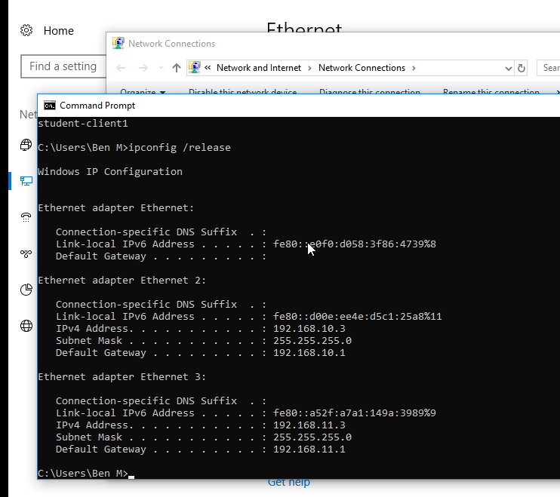 The above screenshot shows the results of the ‘ipconfig /release’ command. - Type “ipconfig /renew” 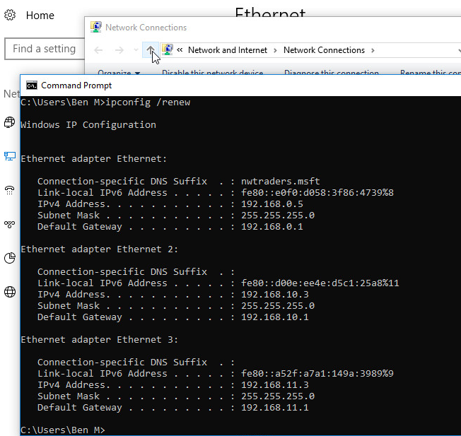 This screenshot shows the results of the ‘ipconfig /renew’ command. - Type “ipconfig” – what IP address has been obtained? 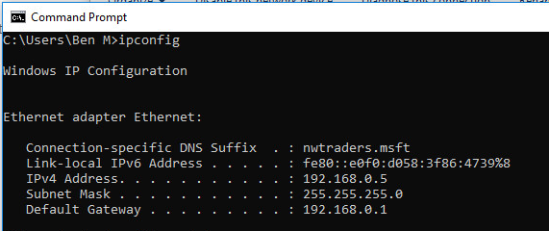 This image depicts the results of the ‘ipconfig’ command which shows that the 192.168.0.5 IP address has been obtained. [Complete this task from Cardiff] - Change the reservation for the Windows 7 client to give it the IP address 192.168.0.3. 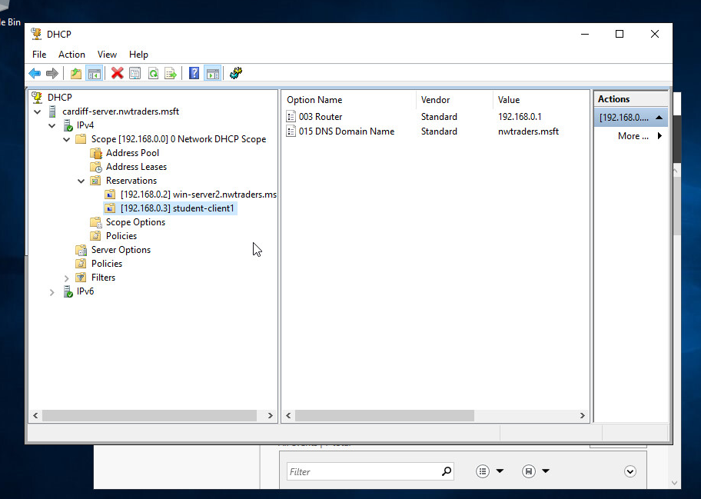 This image shows this reservation with the changed IP address of 192.168.0.3. [Complete this task from the Windows 7 client] - Start – cmd. - Type “ipconfig” – what IP address has been obtained? Has it changed? If not, why not? 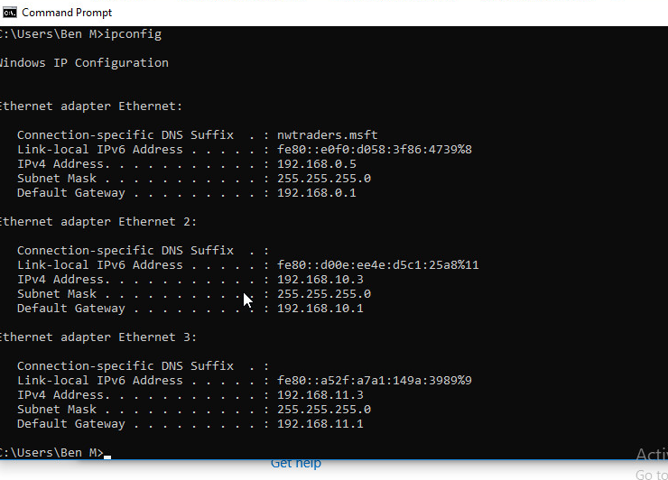 This image shows the result of this ‘ipconfig’. The IP address has not changed as the current address has been leased for 8 hours (the standard). If the server is restarted or the ‘ipconfig /release’ and ‘/renew’ commands are used then the IP would change. - Again, release and renew the IP address. Has it changed now? 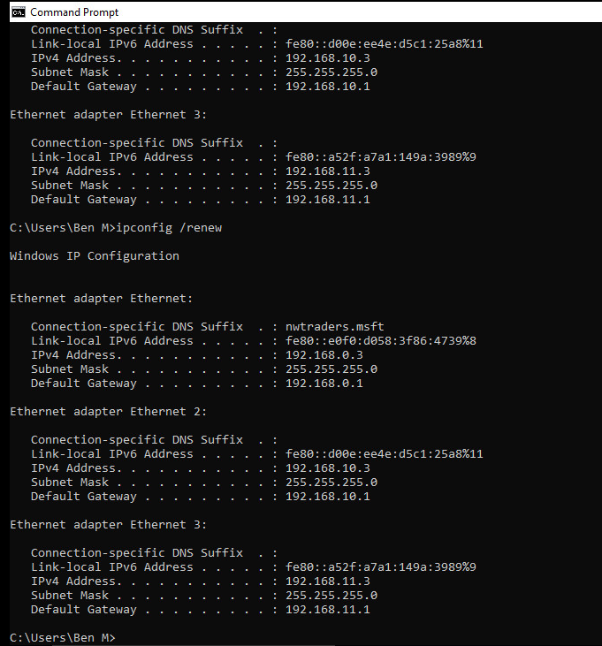 The above image shows that, on use of ‘ipconfig release’ and ‘renew’, the IP address has changed to 192.168.0.3. Task 6: Observational Tasks: Q). Define the role of the DHCP Server in your Network? The role of the DHCP server in the network is to automate the allocation of IP addresses to devices on the network with automatic TCP/IP configuration instead of allocating them manually, as would have to be done if some form of automation, like DHCP, is not implemented, which decreases workload and increases efficiency. The DHCP server is allocated a pool of IP addresses to use, the host then requests an IP address allocation and is given one from the pool. Network mask and DNS information, among others, can also be sent to the host in this transaction. Q). What happens when we have dynamically configured TCP/IP for our NIC, but then consequently cannot contact a DHCP server? If the client already has an IP and is seeking to renew its lease but receives no response from the DHCP server, it will continue to resend DHCPREQUEST unicasts. After a certain length of time it will switch from unicast requests to broadcast requests, attempting to find another server available to serve the request. If this fails the IP address must be released by the client, and all connections using it, closed. At this point the client assigns itself an automatic private IP and must restart the process to get a public one. Q). Illustrate (with illustrations!!) the 4 stage process involved when DHCP clients look to obtain an IP address via DHCP? The four-stage process consists of Discovery, a broadcast message sent with the 255.255.255.255 destination address; Offer, a DHCP server’s reply to a discover message containing an IP lease offer which includes the offered IP, the IP of the DHCP server, the client’s MAC address, the subnet mask and lease duration; Request, the clients reply to the server, requesting the IP the server offered. The client can receive offers from multiple servers but will only accept one; Acknowledgement, this is the final stage where the server acknowledges and accepts the request and sends the client the lease duration and any other information requested. The illustration on the right depicts this four-stage exchange between client and server. Q). Describe the advantages of using a relay agent. Explain (with descriptions and illustrations) how and why we would setup the Relay Agent on our Router? Relay agents are devices configure to listen for DHCP client broadcasts and relay them to a DHCP server on a different subnet. This is required as routers don’t pass these packets across subnets. This essentially converts the broadcast packet into a unicast packet and then sends it to a server. This is important as it provides fault-tolerance and circumvents the alternative of creating a DHCP server for each subnet. The illustration on the next page demonstrates this concept. B.Sc. Year 2 Network Services and Web Technology. WorkSheet 4: Name Resolution using the Domain Name Service (DNS) Group Name: Ben McCarthy, Ben Archer, James Pugh, Gwyndaf Rees, Ryan Gallagher Date: Author(s): Gwyndaf Rees Complete the following tasks: [Note you should read the worksheet information carefully as there are a number of written observation tasks. As always, take screen captures and written observations where appropriate]. Task 1: Understanding DNS operation; Planning and deploying DNS We need to install the Active Directory on the Cardiff server before deploying a secure DNS: [COMPLETE THIS TASK UPON THE CARDIFF SERVER] - Start – dashboard – All roles and features - Add the role “Active Directory Domain Services” - Once installed, select the flag with the yellow exclamation mark from the dashboard and select “promote this server to a domain controller”. - Active Directory wizard loads. - We are creating a new forest - The FQDN we are going to use is nwtraders.msft - Windows Server 2012 R2 is minimum platform we will support. Supply an appropriate restore password. - Accept defaults until the role installs. - The computer will restart. 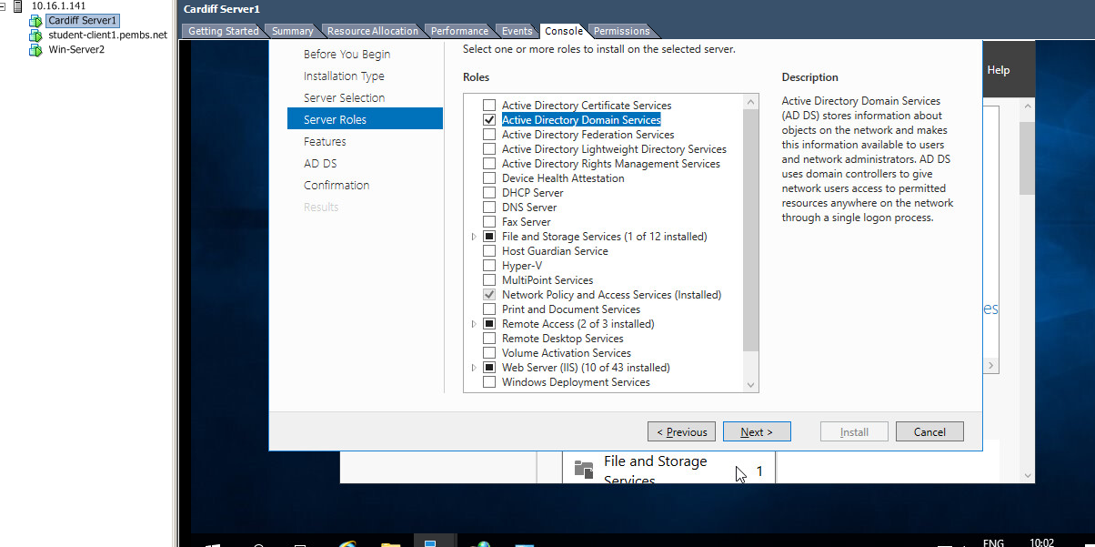 Above is an image showing the selection of the Active Directory Role in the Server Roles tree view. 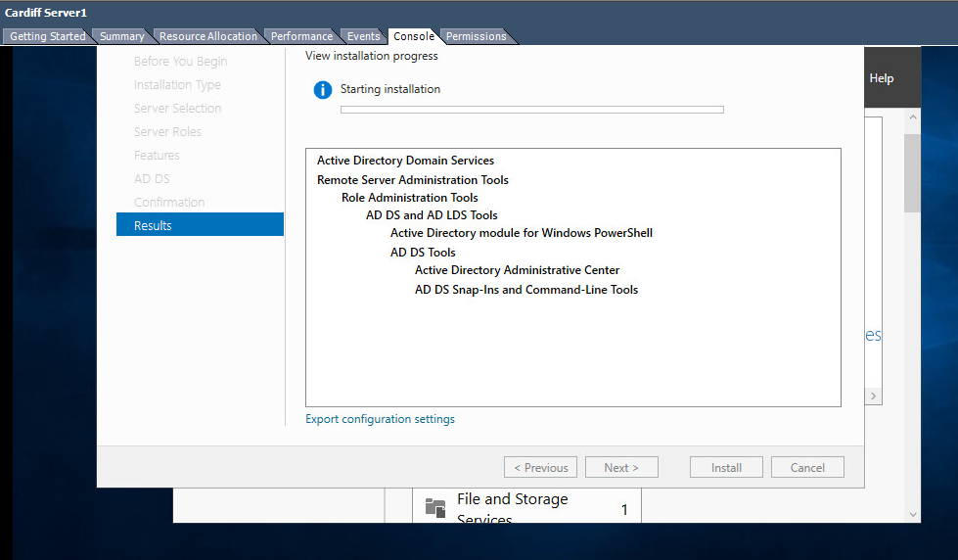 This image shows the installation of the Active Directory role. 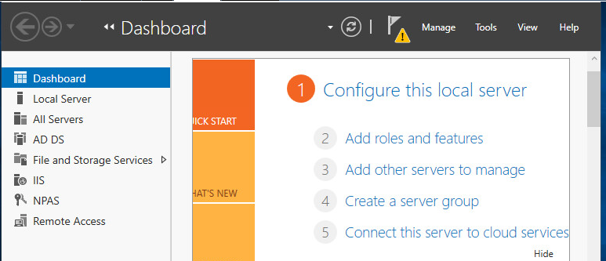 This image shows that the Active Directory “AD DS” Role has been installed. 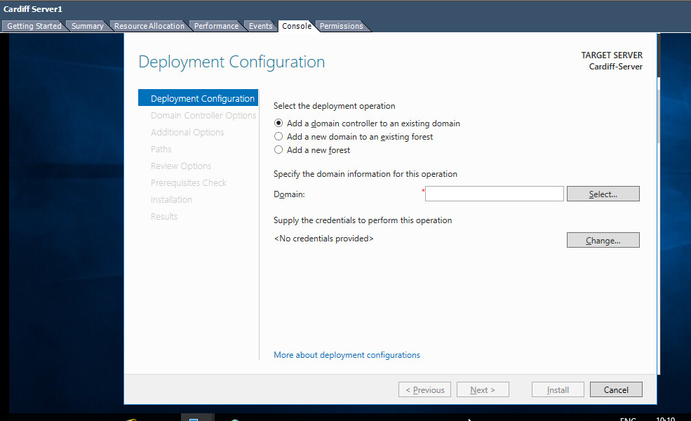 A demonstration of promoting the server to a Domain Controller process. 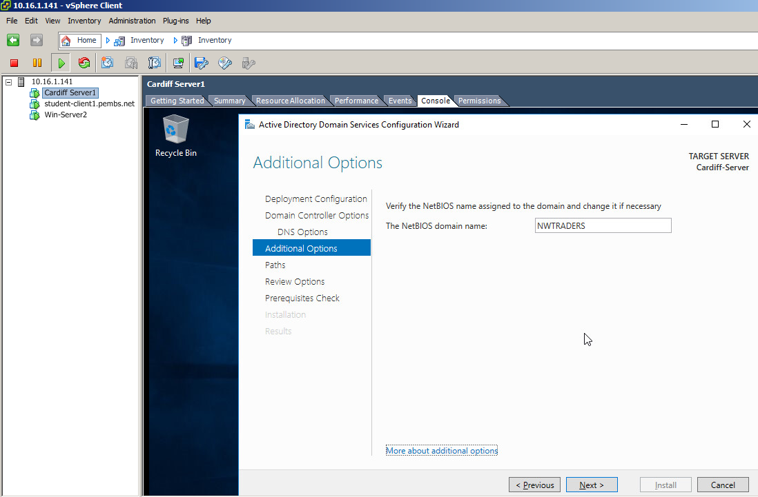 Shows the changing of the domain to NWTRADERS. 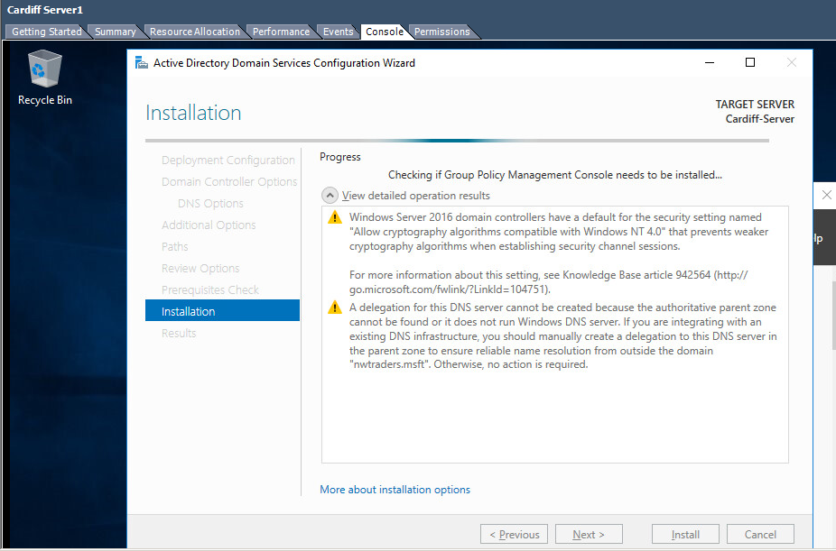 This image shows issues that have resulted from this process that will need addressing once the server is restarted. 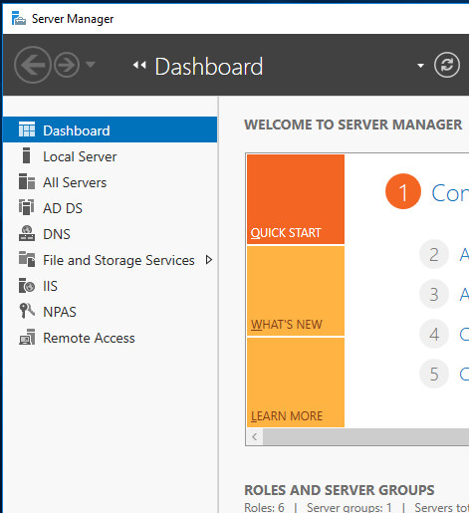 The image above shows that the DNS role has been installed. You will need to login with the administrative account you’ve been using at this point to make any changes in your newly created nwtraders.msft domain (e.g. to create users, install services etc). Remember: now this server is on a domain, its DHCP server will have to be authorised, otherwise DHCP will not work. Refer back to that tutorial if necessary. At this stage we will ensure that the other servers we have are added to the nwtraders.msft domain: To do this. - We’ll now add Win-Server2 and the Windows 7 client to the domain in turn. - At each VM in turn - right click on Computer – Properties – Advanced system settings - Click on the Computer name tab - Click change - Click the domain option and type in nwtraders.msft 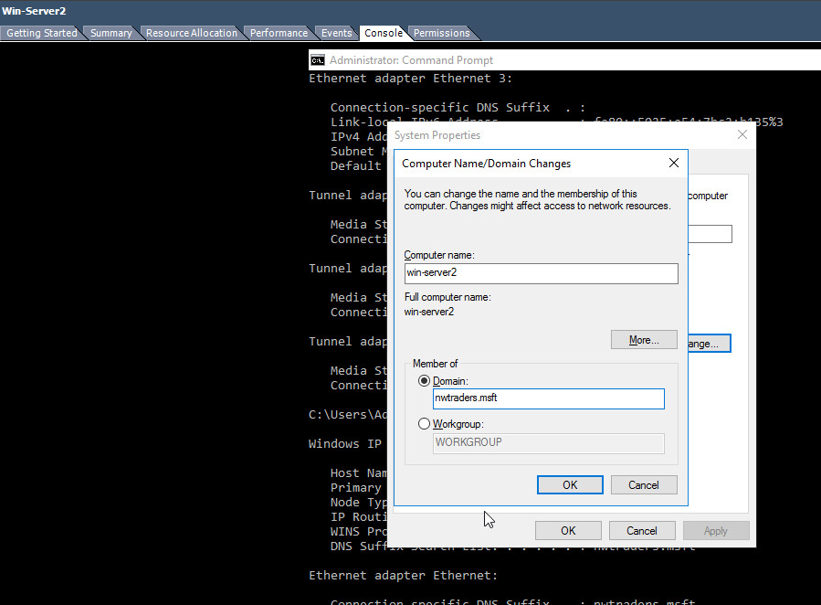 This image shows the domain change for the server. 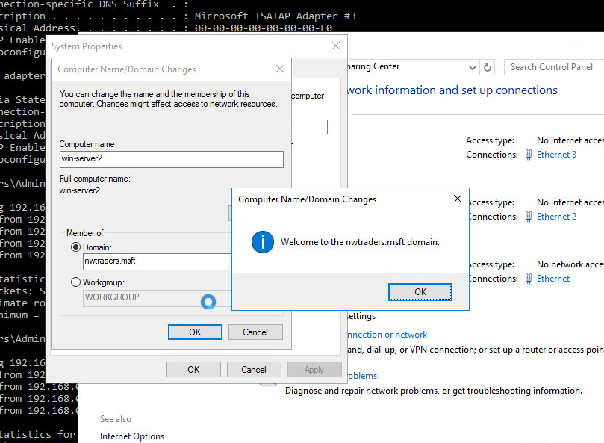 This image shows that Win-Server2 has successfully joined the nwtraders.msft domain. 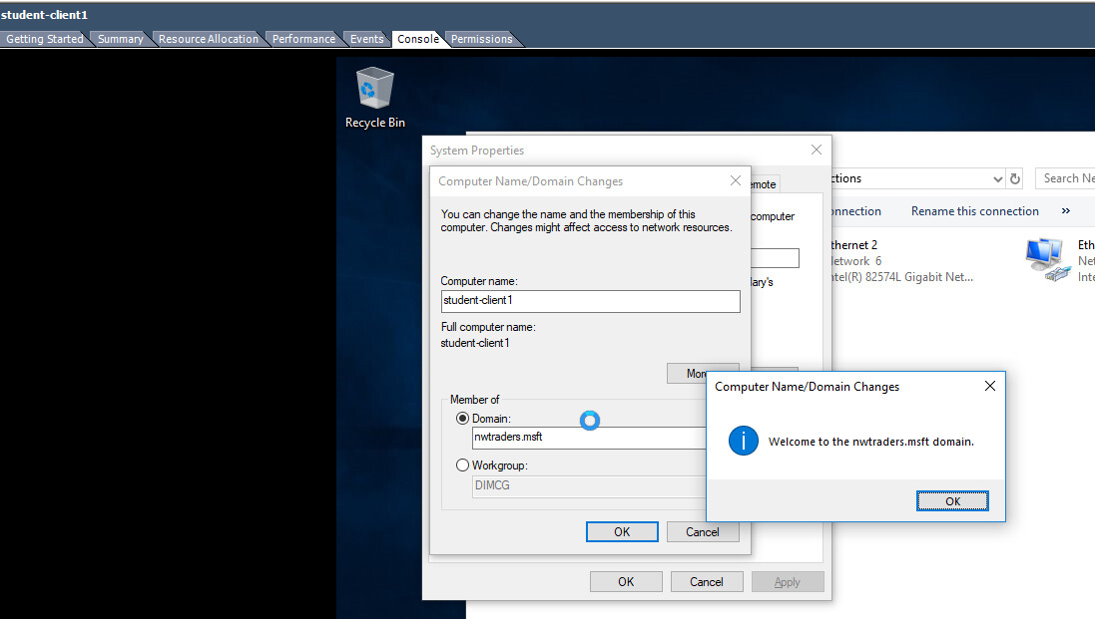 This image shows that the student-client1 could join the nwtraders.msft domain too. - When prompted for an account use the administrative account you specified during the Active Directory install. - When this is done, you should get a welcome message to the nwtraders.msft domain. - Restart the computer and logon using the active directory account you just used to add the PC to the domain. [COMPLETE THIS TASK ON Cardiff] - On Cardiff launch the Active Directory Users and Computers console – Start – Administrative Tools – Active Directory Users and Computers. - Expand the nwtraders.msft domain namespace in the left hand console view. - Click on the Computers Organisational Unit (it essentially resembles a folder). - You should see accounts for the Win-Server2 server and the Student Client you’ve just added to the nwtraders.msft domain 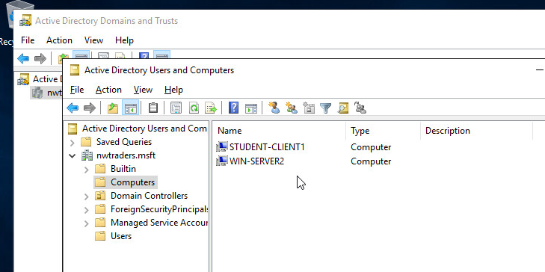 This image shows that the WIN-SERVER2 and STUDENT-CLIENT1 accounts are visible in the Active Directory Users and Computers menu. [COMPLETE THIS TASK ON CARDIFF] We saw previously that the Network Infrastructure needs to implement a Naming System (Host Names) which involves mapping IP addresses to names, as a form of alias. This is because it is very difficult for Humans to remember 32-bit number combinations (the format of logical IP addresses). You will remember that the DNS Namespace is used to refer to Computers or more specifically Network Cards (after all this is how our devices talk over the Network) as Hosts. Anything that binds an IP address to it is referred to as a Host in the DNS Namespace. DNS namespace is hierarchical, arranged into Parent and Child Domains, therefore Names can be reused. Understanding the DNS Namespace. DNS unlike the NetBIOS namespace is hierarchical; it uses a Parent – Child Domain Structure. This allows for scalability and reuse of names. Take the following example; Server1.leespace.com We reuse the domain space of leespace, as long as it’s unique within the Parent Level Domain Space of com. Can we have more than 1 Server named Server1,again the answer is yes as long as it’s unique within the Domain (no more Server1’s allowed in leespace domain), you could as part of leespace.com have a child domain called sales, therefore we could have Server1.sales.leespace.com The other important aspect to understand with DNS Namespace is within the Parent – Child (hierarchical space), we generate names for devices by giving them Fully Qualified Domain Names (FQDN). Example server1.leespace.msft Server1 identifies the host name and leespace identifies the Parent Domain that this host lives within. You don’t have to have the DNS Server Service installed to work in an everyday Windows 2012 Server environment; you could be part of a Workgroup or simply a Member Server in the domain. Choosing/Planning Domain Names using DNS. - You must use a unique domain, within the parent level domain space. - Once this is done, you need to select the Name Server that is authoritative for the Domain Space. (E.g. Is Server1 the authoritative Name Server for nwtraders.msft domain space?) In order to complete Worksheet 4, you will need two name servers in the network; one on Cardiff, one on Win-Server2. [Complete this task from both servers] Task (A). Check the Host Name and Fully Qualified Domain Name of your Server. To better visualize the concept of how the domain name system breaks down host names/fully qualified host names we have 2 methods available to us. You should record your results: To check the host name - Start – run – cmd - At command prompt, type hostname (Note the result) 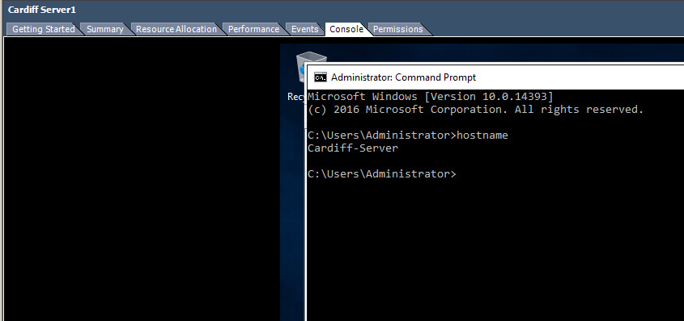 On the Cardiff server, the ‘hostname’ command returns “Cardiff-Server”. 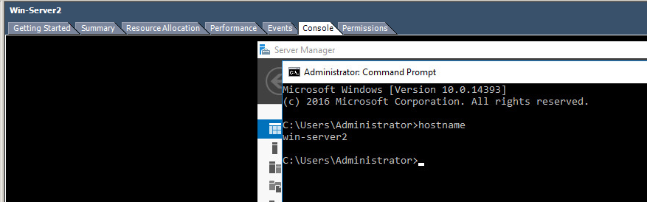 On Win-Server2, the hostname command returns ‘win-server2’. 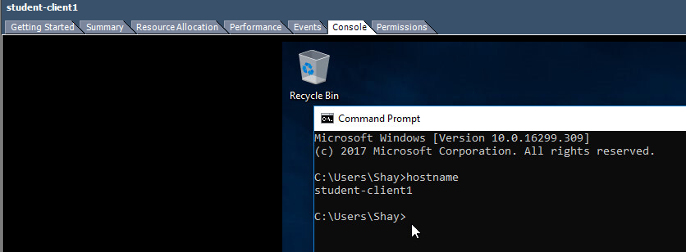 On the student client, the hostname command returns ‘student-client1’. To check the Fully Qualified Domain Name - Start – right click on My Computer – choose Properties - Click on the Computer Name tab - Note the full computer name provides the Fully Qualified Domain Name. 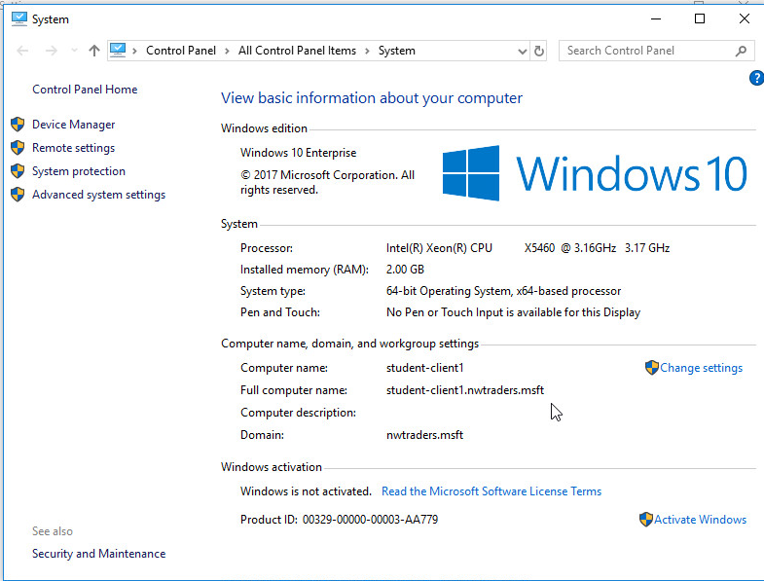 This image depicts the System information for the student client, with the full computer name showing as “student-client1.nwtraders.msft”, as expected. 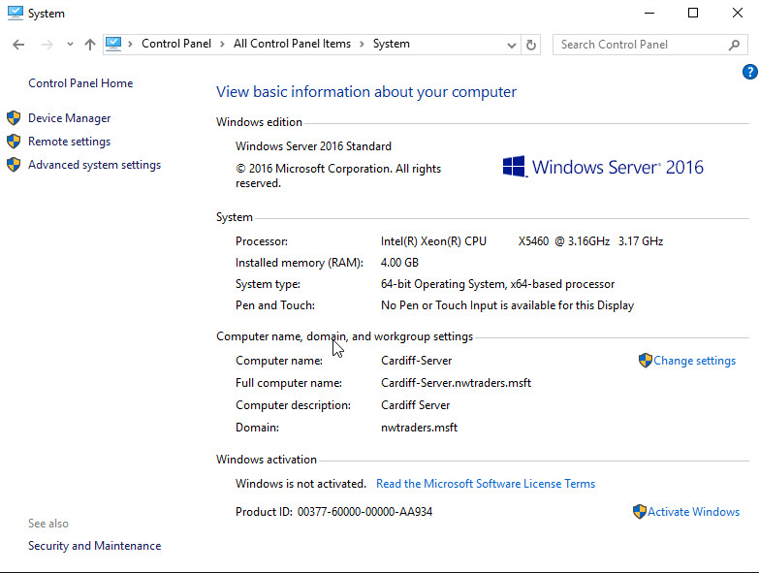 This image shows the system information for the Cardiff server with the full computer name set to “Cardiff-Server.nwtraders.msft”. 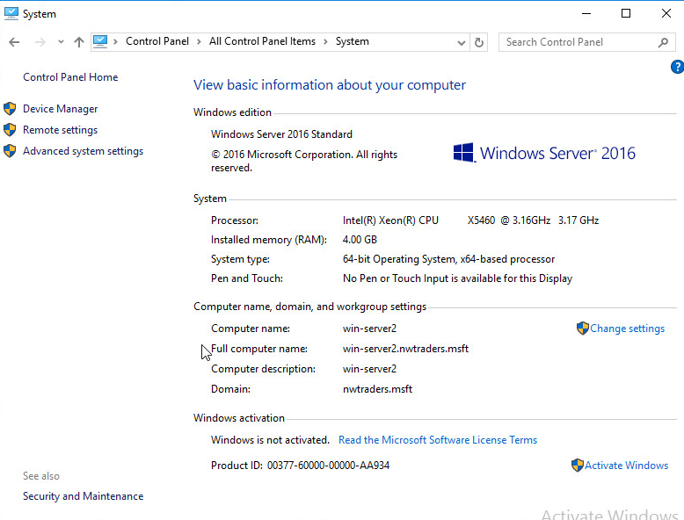 The above image shows the system information for win-server2. The full computer name is set to “win-server2.nwtraders.msft”. Task (B). Installing the DNS Server Service. [Complete this task from Win-Server2] Login using an administrative account; - Dashboard – add role - DNS Server - Wait for this to install. 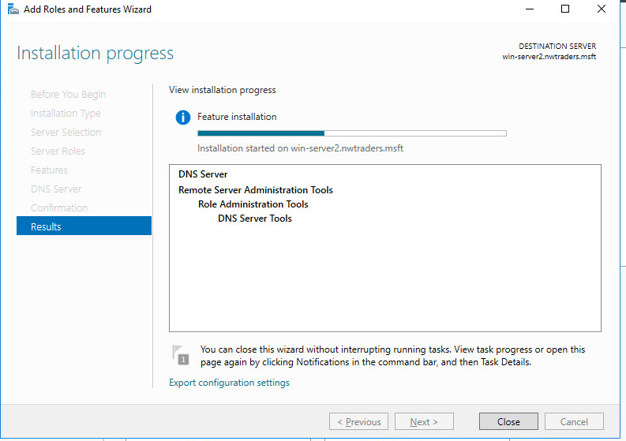 This image shows the DNS server role installing. - The DNS Console is now available by choosing Start – Administrative Tools – DNS. 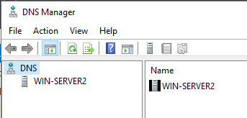 This screenshot shows the DNS manager. Authoritative and Non-Authoritative DNS Servers. Authoritative DNS Server – Is authoritative for the namespace of the query, if authoritative, the DNS Server hosts a primary/secondary copy of the query. When queried; the DNS Server will check the Cache then check the Zone and then return the requested address. If it cannot find the address the DNS Server responds to the client with an authoritative No. Non-Authoritative – Means the DNS Server is non-authoritative for the namespace of the query. The DNS Server will then either Forward the query to another server called a Forwarder, or addresses of multiple root servers to step up the DNS hierarchy to locate an answer for the query (also known as the Root Hints process). [Complete this task from Cardiff] Task (C). Configuring the Properties of the DNS Server Service. Q). We will not configure the DNS server at this time, although it is generally a good procedure to make the DNS Server, a Client of itself. In other words make our computer a DNS client, then this client will be a client of the DNS Server we are installing, why is it important do this? - Demonstrate how you would make this server a client of itself 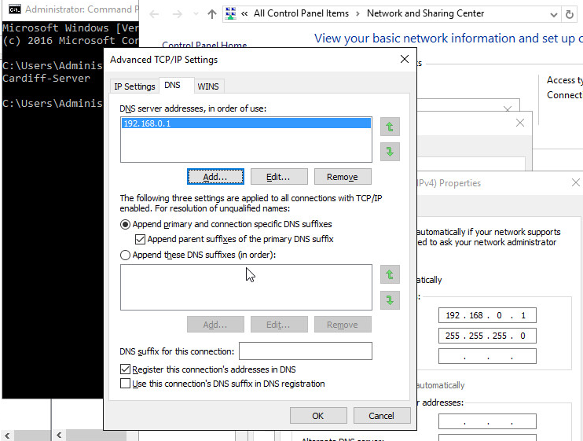 The server address has been added to the DNS setting on the IPv4 NIC advanced settings tab. 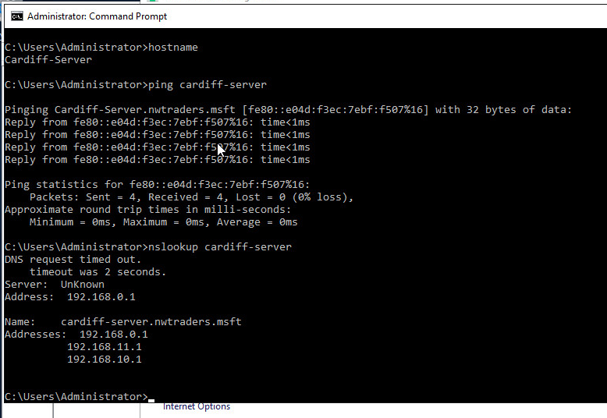 The above image shows the ping results from the Cardiff server to itself. There are Several elements to appreciate when configuring the properties of the DNS Server Service. When done ensure that you put these settings back to their original value(s). * DNS Solutions: Comprise the following elements: - DNS Server Service (The computer that runs DNS Service, resolves requests/queries that DNS Client – Resolve submits) - DNS Client – A computer that runs the DNS Client Service - DNS Resource Records – Information/records of host names to resources. * DNS Queries: A client takes several steps when trying to resolve a Name to an IP address, you will recall the process (from last week’s notes) but to refresh your memories the third step involves the client querying a DNS server. E.g. We are attempting to ping lees-server.com, in order for this action to be completed successfully we need to resolve the name to an IP address. To better appreciate the principle behind this, we first need to recall the DNS Namespace Hierarchy: Take the following FQDN (ftpserver.mainservers.sihe.org Root Level/Top Level Domain – Managed by Internet Controlled Servers (e.g. com, org, edu, ac). Secondary Level – Our registered domain name (e.g. uwtsd) Subdomain Level – Subdomain used in our hierarchy (e.g. mainservers) Host Level – the host name of our Machine (e.g. ftpserver1). The client (when attempting to resolve the IP address via the DNS service) will walkthrough the DNS Hierarchy of Servers with a series of Recursive and Iterative Queries. A query is the process involved when a DNS client resolver asks the DNS Server for the IP address of the supplied host name. The reason for the query is for the DNS solution to allow users to access resources by using alphanumeric names. 2 Types Recursive and Iterative; Keywords; Root Hints: These are resource records stored on a DNS Server that list IP addresses of DNS root Servers. Task (D). More DNS properties: DNS Forwarders, cache entries and root hints. This is a DNS Server that other internal DNS servers designate to handle/forward REQUESTS/QUERIES for resolving domain names that reside at external/offsite locations. Example: DNS Name Server receives a request so it attempts to locate this information in its own zone files. If this fails (e.g. because the Server is non-authoritative for the domain requested) the server must liaise with other servers to solve the request. This is the function of the Forwarder. In Wide Area Network contexts, the query may involve interaction with DNS servers across the WAN links. [Configuring a DNS Server to use a DNS Forwarder]. [Complete this Task from Win-Server2] - Ensure that DNS Console is open - Select the server in the console view - Choose Action – Properties - In the Selected Domains Forwarder IP address type any IP address of CARDIFF (DNS should be responding for CARDIFF on both): - Type 10 seconds into the ‘Number of Seconds before forward queries time out’ field. 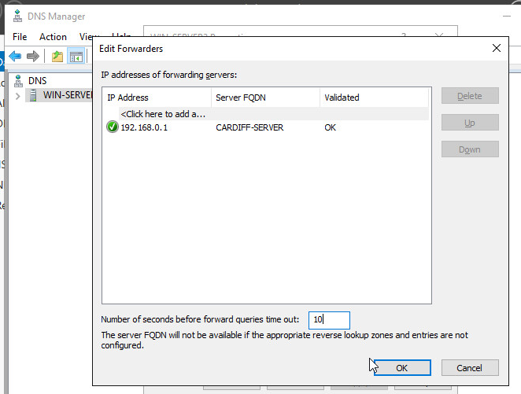 Setting the number of seconds before forward queries time out to 10 seconds. DNS Server Caching. We use Caching to temporarily store recently accessed information in a nearby memory location for the purposes of fast & efficient retrieval. DNS Server Caching provides fast responses and reduces DNS formulated network bandwidth. DNS Responses are cached for a certain period (TTL) so that future queries for this record can be resolved quickly from Cache. [Complete this Task from Cardiff] [Updating Root Hints]. - Open DNS Console - Select your Server. - From the Action Menu – select Properties - Select the Root Hints tab – click Add: enter the FQDN and 0 Network Connection IP Address of Win-Server2 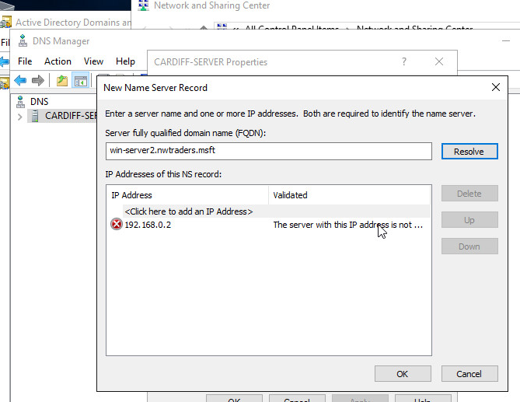 - Click Ok to close the properties dialog box and then close the DNS console. [Clearing the DNS Server cache using DNS Console]. - Ensure that DNS Console is open - Select the appropriate Server - Choose Action – Clear Cache Q). Why is it important to be able to control the DNS cache and in some cases clear the DNS cache entries? Task 2: Storing and Maintaining DNS Data. The Resource Record is a set database structure that contains information needed to process DNS queries. (E.g. Host Name: DNSClient1 IP Address: 192.168.10.100). The DNS Zones are the physical portion of the domain space, where Resource Records are kept. Let’s say for example we have the following Namespace structure Second Level Domain: nwtraders.msft And then within this structure we have two subdomains called Sales and Purchase. 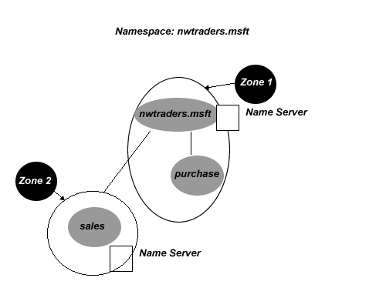 We could have a Zone (Zone 1) that can be Authoritative for both nwtraders.msft domain and the purchase.nwtraders.msft domains. If we have another Name Server on the Sales Domain, then on this server we have a Zone file. This zone file is authoritative for only a single portion of the DNS Namespace (hosts in the sales.nwtraders.msft domain). Zones are stored on Name Servers. The Zone file is the file stored on the Name (DNS) Server that contains configuration information for a zone and resource records contained within that Zone. A DNS Server is authoritative for a Zone, if it hosts resource records for the names and addresses that the clients request, in its Zone File. DNS Fault Tolerance - DNS Zone Types There are three different types of DNS Zones, Primary, Secondary and Stub Zone. It is generally good practice to configure a Primary DNS Zone on one server and configure a Secondary DNS Zone on another, this way if the primary zone fails we have fault tolerance in place. Primary Zone – The authoritative copy of DNS Zone information, resource records are created and managed here. We setup a Primary Server to host the zones for a domain or domains, this server is usually stored at an accessible location so that we can administer the zone file with any changes Secondary Zone – This zone contains a copy of the DNS Zone, but in read-only format. Records in the Zone file can only be changed at the Primary Zone. Stub Zones – A stub zone is a copy of a zone; that contains only the resource records that are needed to identify the authoritative DNS servers for that particular zone. The principle is like a bookmark or pointer that simply points to the DNS Server that is authoritative for a particular zone. Forward and Reverse Look-up Zones: Forward Lookup Zone – A query process where the display name for the DNS domain of a host computer is searched in order to find its IP address. Reverse Lookup Zone – A query that involves searching the IP address of a host computer, in order to establish its display name for the DNS Domain. Task (A): [Configuring DNS Zones] Here we will configure a DNS Zone by type and establish the Lookup Zone type: [Complete this Task from Win-Server2] - Open the DNS Console - In the DNS Console, right click on the DNS Server, click New Zone 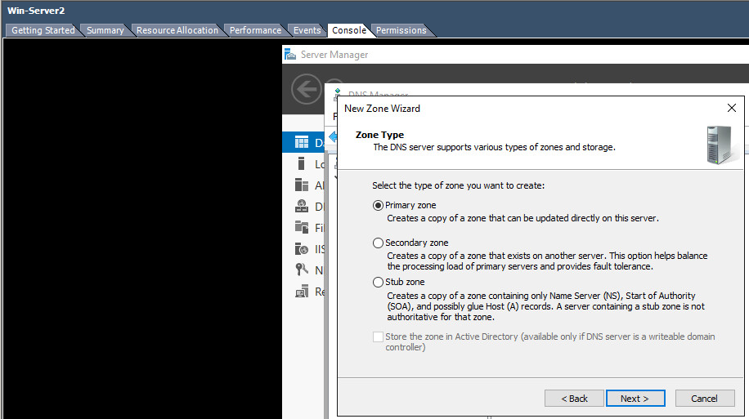 The image above shows the New Zone wizard. - At the Welcome Wizard Dialog page click Next - At the Zone Type page – choose Secondary Zone – choose Next. - In the Forward and Reverse Lookup Zone page, choose Forward Lookup Zone (if it is not already selected). Click Next - Zone Name: nwtraders.msft - Master DNS Server requires the IP address of the Master DNS Server: type the IP address of CARDIFF. (You will need to ensure that CARDIFF has allowed for zone updates) don’t worry about this now, we will configure it later. - Verify that the zone is loaded from the Master DNS Server: 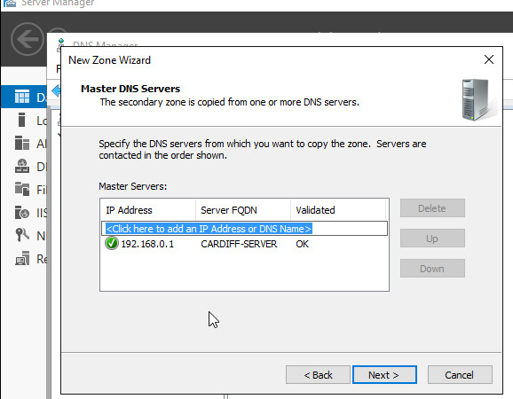 This image shows the master DNS server being set to the Cardiff server. 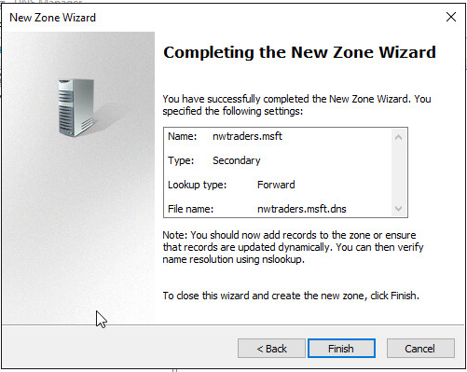 This wizard is finished. - We may have to ensure that zone transfers are allowed for this zone (security settings) to allow this to occur on our servers. Q). Identify how you enable zone transfers to allow this zone to store a secondary copy of the nwtraders.msft data. 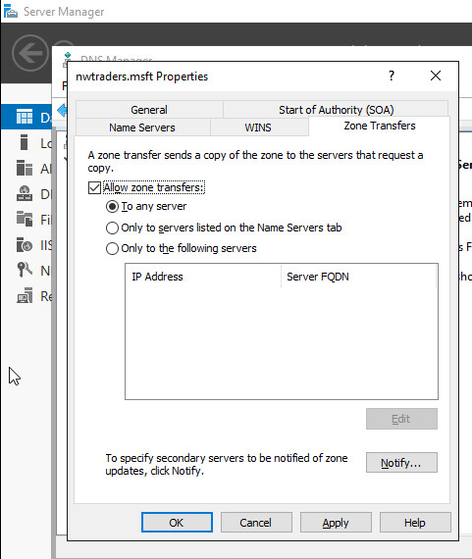 The Zone Transfers tab of the Properties menu. Allow zone transfers to any server has been set. - In the DNS Console select the Secondary Forward Lookup Zone we have just created – in the details pane, view the Resource Records to check that the zone has been loaded from the master server. 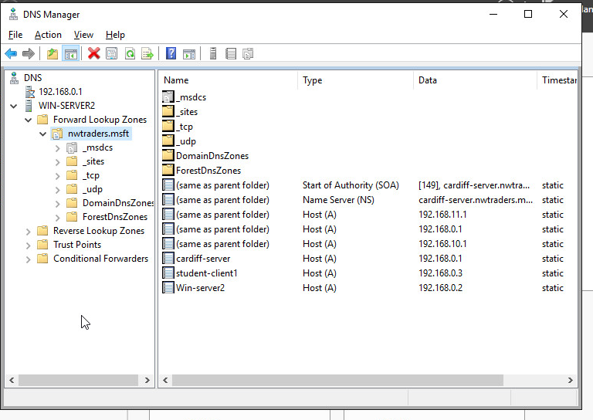 This screenshot shows the DNS manager with the new secondary forward lookup zone that was created selected in the tree view. [Here we will configure a Reverse Lookup Zone, each DNS Server in the lab will maintain both a forward lookup zone and a reverse lookup zone] [Complete this Task from Win-Server2] - Open the DNS Console - In the DNS Console, right click on the DNS Server, click New Zone - At the Welcome Wizard Dialog page click Next - At the Zone Type page – choose Secondary Zone – choose Next. 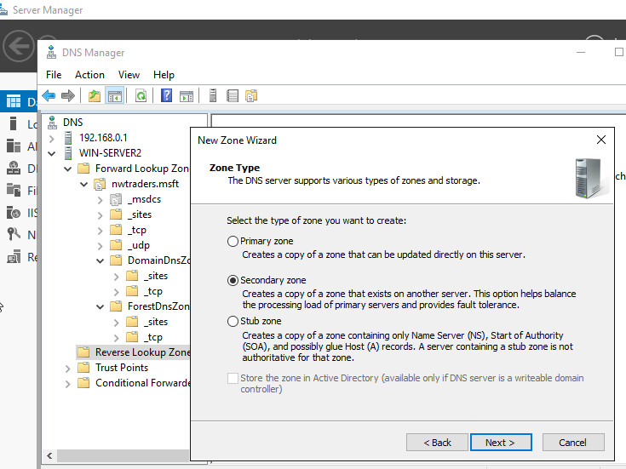 This image shows the new zone wizard on the zone type selection screen. - In the Forward and Reverse Lookup Zone page, choose Reverse Lookup Zone (if it is not already selected). Click Next. - In the Reverse Lookup Name page – in the Network ID field – type ONLY the Network ID Portion of the 0 Network IP address (E.G. 192.168.0) - On the Zone file page click Next to accept defaults. - At the Master DNS Servers page – type the IP address of the Master DNS Server the IP address of CARDIFF. - Click Finish at the Summary of Selections page. 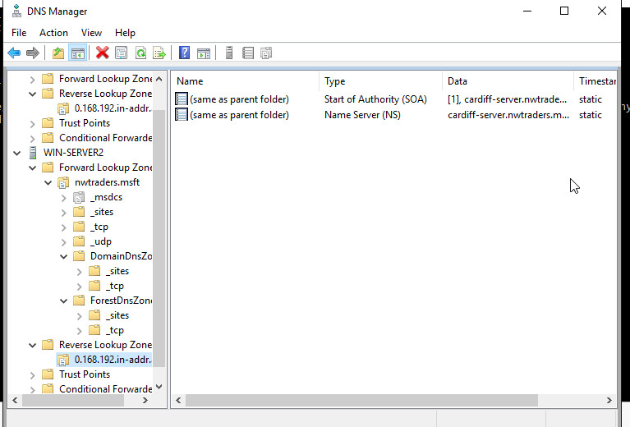 This screenshot shows that the new lookup has been created. - In the DNS Console select the Secondary Reverse Lookup Zone we have just created – in the details pane, view the Resource Records to check that the zone has been loaded from the master server. Here we will create a Forward Lookup Zone on a Primary Zone Type on our DNS Server. To achieve this we will need to create our own Primary Zone that will manage the resource records for just the client machine in our private network. [Complete this Task from Cardiff] - Open the DNS Console - In the DNS Console, right click on the DNS Server, click New Zone - At the Welcome Wizard Dialog page click Next - At the Zone Type page – choose Primary Zone – choose Next. - In the Forward and Reverse Lookup Zone page, choose Forward Lookup Zone (if it is not already selected). Click Next. - At the Zone Name page, we need to type the DNS Name of the Zone that this server will be authoritative for type the following: - Win-Server2server.nwtraders.msft - At Zone file page, choose Next to accept the Defaults. - At the Dynamic Update page (more on Dynamic Updates later on) choose the option; Allow both non-secure and secure dynamic updates. - On completion of the New Zone – choose Finish. 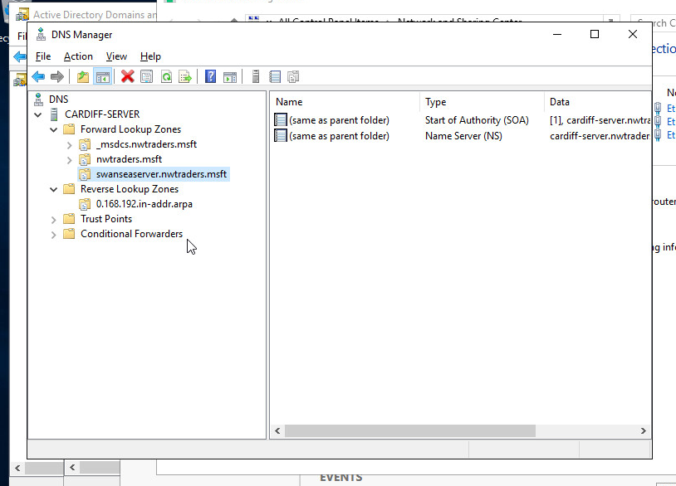 This image shows that the new zone has been added successfully. [READ THIS!!!] It is important to understand here that we have created an additional DNS Zone as well as the default nwtraders.msft zone that exists as part of our Active Directory. The idea here is to show how you can have a default zone which looks after maybe all servers, but a secondary layer of redundancy/load balancing by creating another zone. In our example, the zone we ve created only looks after the Win-Server2 DNS that the Cardiff server is directly connected to. In reality, this could well be another few hundred/thousand machines, in larger enterprise networks. Implementing Fault Tolerance via DNS Zone Transfers. A DNS Transfer is the transfer of all data in a particular zone, from the Primary DNS Server hosting the zone to a Secondary Server. The purpose of the Secondary Server is to host a copy of the Zone. Changes made to the Primary Server need to be reflected at the Secondary Server, thus should the Primary Server ever fail, the Secondary Server has an up to date copy of zone file (including all the resource records). We may have more than one Secondary Server, so it is important to replicate changes at the Primary Server to all these servers. This is done using DNS Zone Transfers. DNS Notify – This is the system by which, it is possible for the Primary Servers to notify Secondary Servers when changes to the zone occur. The purpose of DNS Notify is to enable Secondary Servers, (upon receiving notification that a change has occurred to the zone) to obtain these zone changes from the Master server. This ensures that the local replicas, on the Secondary Server, are up to date. [Configure DNS Transfers and DNS Notify] Here we are going to setup a zone transfer using DNS notify from our Primary – Forward Lookup zone (SRV-NWTRADERS.MSFT – in other words our server). We will set the Secondary Server (the Replica Server for our Zone to be the Cardiff Server. [Complete this Task from Cardiff] - Open DNS Console - Expand the Server and then Expand Forward Lookup Zones. - Select the Primary Zone you previously created. - Right click- choose Properties - Click the Zone Transfers tab – verify that Allow Zone Transfers option is enabled/selected. - Select the option Only to the servers listed on the Name Server tab. - Within the Zone Transfers category – select the Notify option. - In the Notify category – choose the option; Servers listed on the Name Servers tab. - On the Name Servers Tab, click Add. - In the new resource record dialog box in the Server fully qualified domain name (FQDN) field, type Win-Server2.nwtraders.msft and click “resolve”. - Click Ok. - On the Zone properties tab, click Ok. - Close the DNS Console. 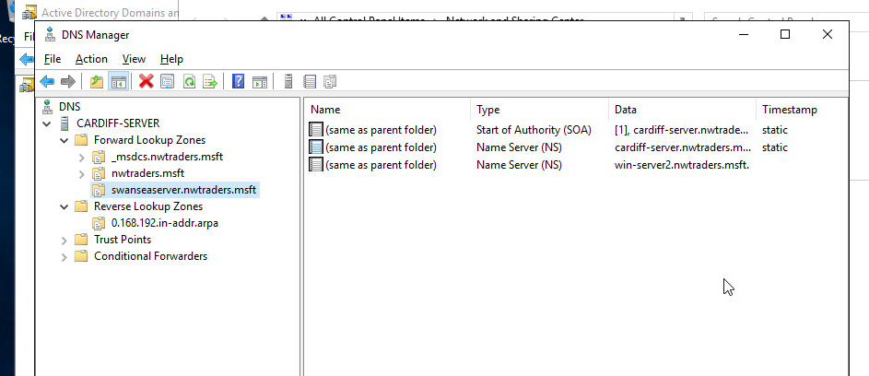 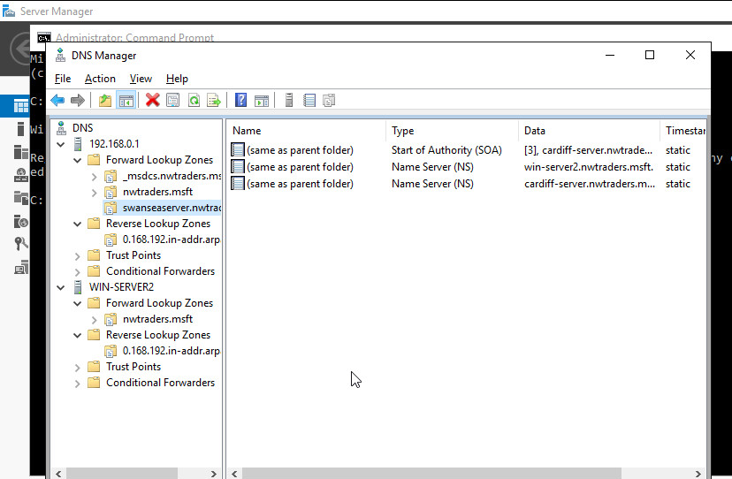 Finally after a few minutes, verify that the zone transfer has taken place on Win-Server2 . (See above steps on how to do this). Task 3: DNS Application Here we will begin the steps towards deploying a common network service that relies heavily upon the correct configuration of DNS, the web server service. Before we configure host settings in the zone file, we need to install and configure the web service. [Complete this task from Win-Server2] We should already have IIS installed from configuring the FTP server. If you have not yet done this, go back and do this first. [Creating a virtual directory] You may remember that a virtual directory is an alias for remote computers to access the files that are stored on one or more of our web servers ‘local disks’. By being local, these disks are not viewable by remote computers. The virtual directory makes this possible. - Start – Administrative Tools – IIS (Internet Information Services). - In the console view, expand the local computer, expand the web sites folder, right click on Default Web site and choose Add Virtual Directory. - Click Next on the Welcome screen - Give the virtual directory an Alias name. This name is what remote users will insert into their browsers to find the files that live locally on your machine. Ensure the name is relevant to the application you are hosting, e.g. “test”. - You will also need to point the alias to the local directory where you web site content will be stored. This is usually within the Inetpub/www directory within your local disk (e.g. C:\Inetpub\wwwroot). This is the default web folder for websites in Microsoft windows operating systems. Choose Next 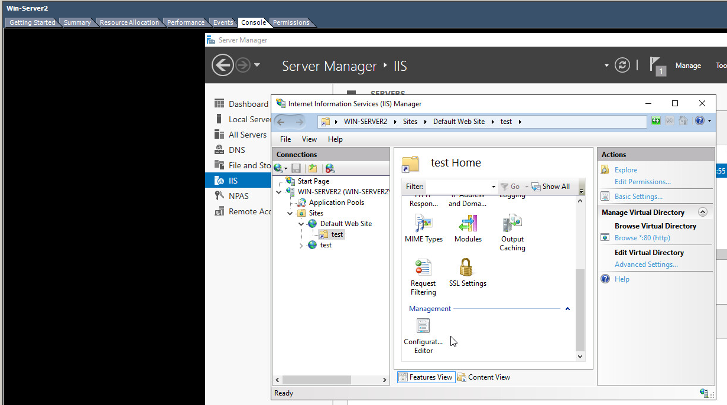 This screenshot shows IIS manager with the test site set as the default web site. - At the permissions page, ensure that your application has permissions to read files and run scripts. Choose Next and Finish to complete the wizard. - There are a few more steps to complete to ensure that content is visible from this directory. - Go into My Computer – C:\Inetpub and right click on the wwwroot folder, chose properties and on the Security Tab, ensure that the Internet Guest Account user has at least modify permissions. 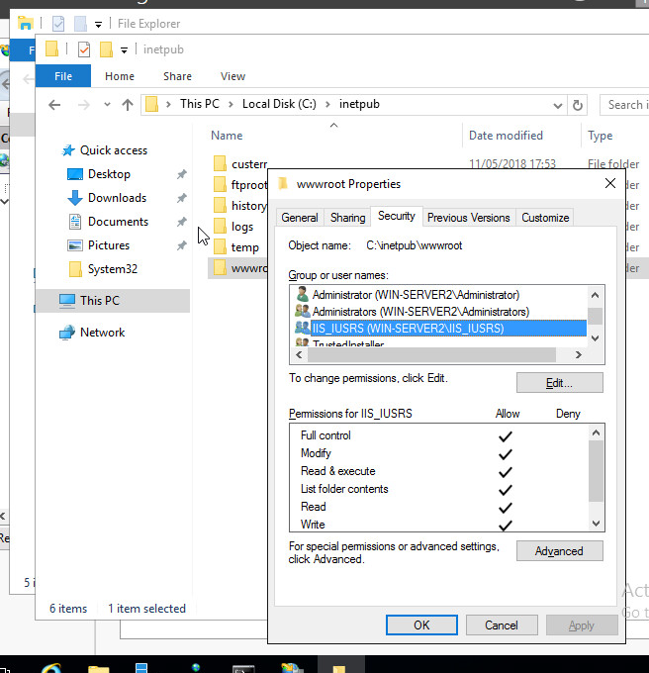 This screenshot shows that IIS_IUSRS has been granted full control to the files within the ‘wwwroot’ folder. - Finally go to Start – Administrative Tools – Internet Information Services Management. - Expand the server name and the default web site folder – right click on the Virtual Directory you have just created and choose properties. - Click on the documents tab – click Add – select the page you just created and ensure it is at the top of the list. This is the only way your page will be set as the default IIS page. Demonstrate locally how you would test this service is running (e.g. Just from this computer using the Alias you have just created). You will need to create some simple web content, e.g. a simple hello world html page within the C:\Inetpub\wwwroot folder to test the application is operational. [Test the website] We will now test whether we can access our website from other networks. [From the Windows 7 client] Ask a member of another network to launch an Internet Browser (e.g. Internet Explorer) * Using the convention: http://hostname.zonename/aliasname/yourwebpage.html For example, http://Win-Server2.nwtraders.msft/test/index.htm 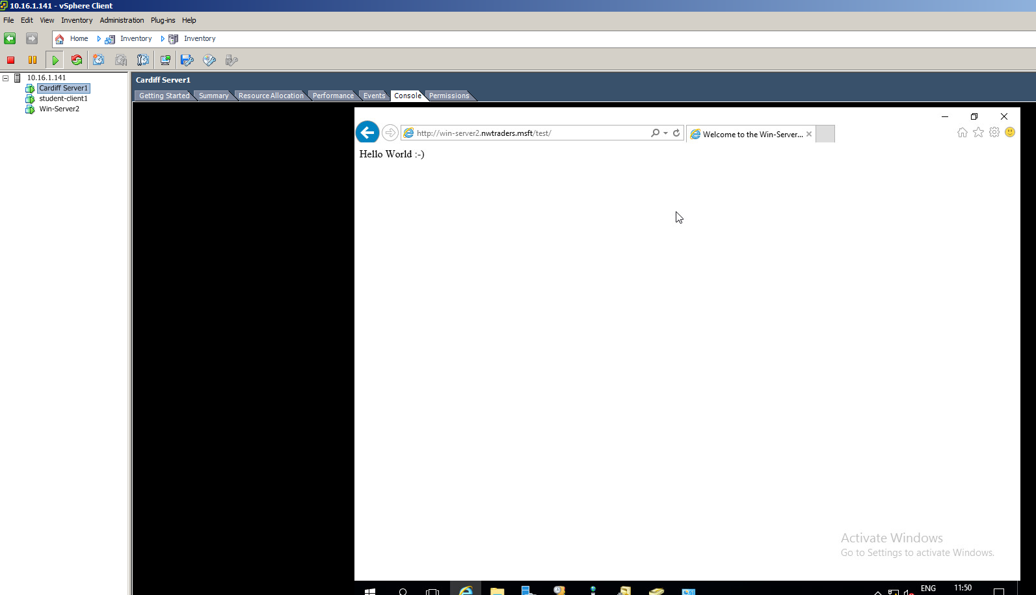 This shows that the test site is working and can be viewed in a browser with the URL win-server2.nwtraders.msft/test/. - Where hostname is the name of your server, aliasname is the name of your virtual directory (created in the previous worksheet) and yourwebpage.html is the name of your webpage, enter the address in the address field. Is your page returned successfully? If not consider the Primary DNS server address that your client is sending its requests to. Task 4: Observational Tasks Q). What steps does a client take (what is the process involved) when trying to resolve a Name to an IP address? The process a client uses to resolve a name is called hostname resolution. Hostname resolution involves querying DNS server databases to find an IP that matches the hostname. This is hierarchical: queries are passed up the hierarchy until the hostname is resolved. Q). Describe how the Recursive Query and Iterative Query Processes resolve DNS Client Requests? An iterative query is a DNS client query which queries a DNS server for the best possible match for a hostname without conferring with other DNS servers. The result often refers the client to another DNS server lower in the hierarchy. These requests are typically made between servers, not client and server. A recursive query is made by a client to a DNS server, requesting a complete answer. This query cannot result in redirection to another DNS server and only returns an IP or an error message. The DNS server searches its cache for an IP matching the hostname. If no record is found it locates the authoritative DNS server for the zone. Once found, the authoritative server queries the DNS zone for a matching record. If not found, root hints are used to get the IP of the DNS root server. If the record still cannot be found, an error message is returned. Q). Explain the significance of root hints and how this process enables us to resolve names that are not managed (or kept in an authoritative DNS server in our network)? Root hints are DNS server resource records that contain the IP addresses for DNS root servers maintained by InterNIC. These are significant in DNS hostname resolution as if no records of a name are found in a DNS server’s cache or in the DNS zone, they can be used to find the IP of the DNS root server. Q). We have a Server called Server1, this server will be hosted in a subdomain called ‘subcontA’ with a root domain called nwtraders.msft, answer the following questions: (1). What is the exact FQDN for this host. The fully qualified domain name for this host would be “Server1.subcontA.nwtraders.msft”. (2). Illustrate how the Domain Name System breaks up this FQDN into Host and Domain Namespace. The FQDN is broken into a hierarchy, as seen in the image below. The root domain isn’t required in this case as a null or full stop specifies the internet as the root domain. The top-level domain, in this scenario ‘msft’, represents an organisation or location. The second-level domain is ‘nwtraders’. This is the personalised part of the domain, assigned by the NIC, as is the subdomain, an extra domain, commonly used to specify individual sections of a website. Q). Explain how DNS Zones are used in DNS, give examples to illustrate the use of multiple zones and how these can be used to manage resource records of domains. What important factors/characteristics do we need to be aware of? DNS Zones are a component of the domain space under the authority of a DNS server. Zones often have many domains and a server can have many zones. Each zone has resource records for the names under it, as well as files that define that zone. A common convention is to create zones on a regional basis to disseminate between distinct locations. There are two types of zone, forward look up and reverse look up. Forward DNS lookup uses the hostname to find an IP, whereas reverse lookup uses the IP to find the hostname. For domains with multiple subdomains, a zone can be setup for every subdomain, allowing the configuration of zone types based on the subdomain. An example of this would be setting one subdomain for forward look up and another for reverse. B.Sc. Year 2 Network Services Worksheet 5: Evaluation of clustering strategies. Group Name: Ben McCarthy, Ben Archer, James Pugh, Gwyndaf Rees, Ryan Gallagher Date: Author(s): Gwyndaf Rees Task: You are required to evaluate a suitable clustering strategy for hosting a ‘3-tier web development system. In this appraisal you should provide details of tools and technologies that are part of each type of cluster deployment. Any technical terms/components should be suitably discussed. You may use illustrations/narrative where possible to support your arguments. It is imperative that you use a suitable reference system when undertaking this task. The three layers of a three-tier web application are data, application and presentation. The data tier consists of the database, its contents and the operations available for execution upon those contents. The next tier is application, which provides the functionality of the system, which includes displaying data from the data tier as well as entering input data into it and deleting records. The presentation tier “sends content to browsers”. It’s the design and aesthetic aspect, the user interface of the system that allows the user to operate the functionality developed in the previous two tiers. Clusters are several servers operating as one unit. A server in a cluster is called a node and each node is physically connected to the other nodes. A clustering strategy may be deployed to improve data integrity; reduce the chance of system, application or site failure; or provide better application availability. The ability to handle failure “allows server clusters to meet requirements […] for user service access” and reduces frequency of unscheduled outages and contributes to the improved application availability that clustering can provide. The increased fault tolerance that clustering can offer only affects the application, not user data. Server clusters have many failover designs that offer improved availability and reliability as well as providing good scalability useful for databases that continue to grow such as the those of the data tier as described in the three-tier system. A concept called ‘heartbeats’ is used to monitor a cluster’s nodes, updating fifty times a second. If a node is unaccounted for five heartbeats of 1.2 seconds each, it ‘regroups’ the nodes. The number of nodes allocated to a service depends on that service’s requirements. Most will be allocated one node but some, such as SQL server, require more. Cluster often create groups of required components known as resource groups. These include IP addresses, services and network names. The number of resources that can be linked within a group is usually limited to 100. One feature of server clustering is component load balancing which allows for dynamic load balancing. Dynamic load balancing divides traffic between nodes to improve the distribution of workloads across the cluster. Load balancing helps to optimise resource use and minimizes response time. All tiers would benefit from the implementation of component load balancing as the multiple nodes assigned to the data tier would be able to perform requests more efficiently, and the subsequent reduction of response times would improve the performance of the application, thus allowing web requests from clients to be served quicker, improving the performance of the presentation tier. Another form of load balancing that would improve the performance of the presentation tier is network load balancing which “distributes network traffic among multiple servers or virtual machines within a cluster to improve performance”. It manages incoming packets and distributes them between the nodes pertinent to their content which allows web requests to be served faster. Stress testing is required for both load balancing types to protect against failure. The image below depicts an example of load balancing.
IBM. IP Packet Filter Firewall. https://www.ibm.com/support/knowledgecenter/en/ssw_i5_54/rzatj/packetff.htm. [Accessed: 05/05/2018]
Server Brain. How Packet Filters Are Applied. https://www.serverbrain.org/network-services-2003/how-packet-filters-are-applied-1.html [Accessed: 05/05/2018]
Pepalis, B. 5 Benefits of a 3-Tier Architecture. (2017) https://www.izenda.com/blog/5-benefits-3-tier-architecture/. [Accessed: 10/05/2018]
Microsoft. What is a Server Cluster? https://technet.microsoft.com/pt-pt/library/cc785197(v=ws.10).aspx. [Accessed: 05/0/05/2018]
IBM. What is a Resource Group? https://www.ibm.com/support/knowledgecenter/en/SSRM2X_4.1.0/com.ibm.samp.doc_4.1/sampugdunresg.html. [Accessed: 05/05/2018]
IBM. Rules for Using Resource Groups. https://www.ibm.com/support/knowledgecenter/en/SSRM2X_4.1.0/com.ibm.samp.doc_4.1/sampugrulesresgrp.html. [Accessed: 05/05/2018]
Rouse. M. https://searchservervirtualization.techtarget.com/definition/Network-Load-Balancing-NLB. [Accessed: 05/05/2018]

