DS 1 Template

My Screenshots/Photos
- Please add 4–6 screenshots or photos of your digital life.
- You can use your phone or laptop.
- For each screenshot, write one or two sentences explaining what it shows.

Screenshot/Photo 1
[Insert Photo/Screenshot below]
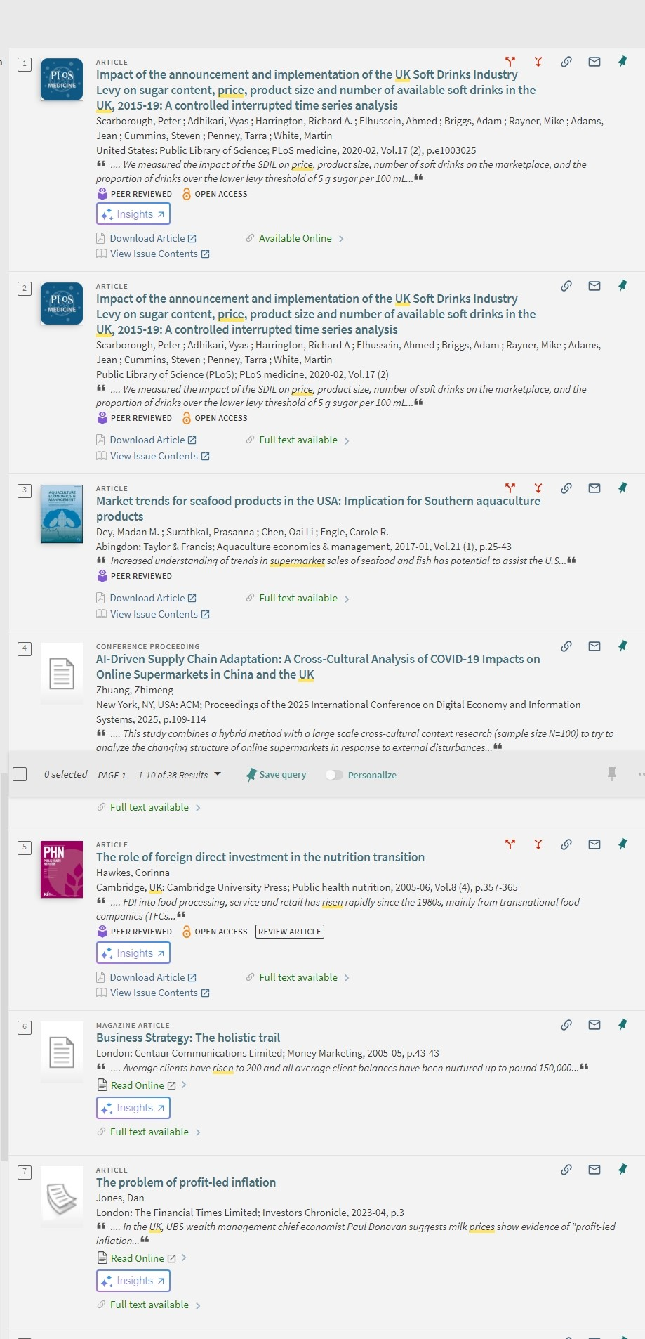
[Write what this shows of your digital life] This shows that I can do a screenshot from my laptop, name the file and uploaded it on to my one drive. What I did was use the snipping tool.

Screenshot/Photo 2
[Insert Photo/Screenshot below]
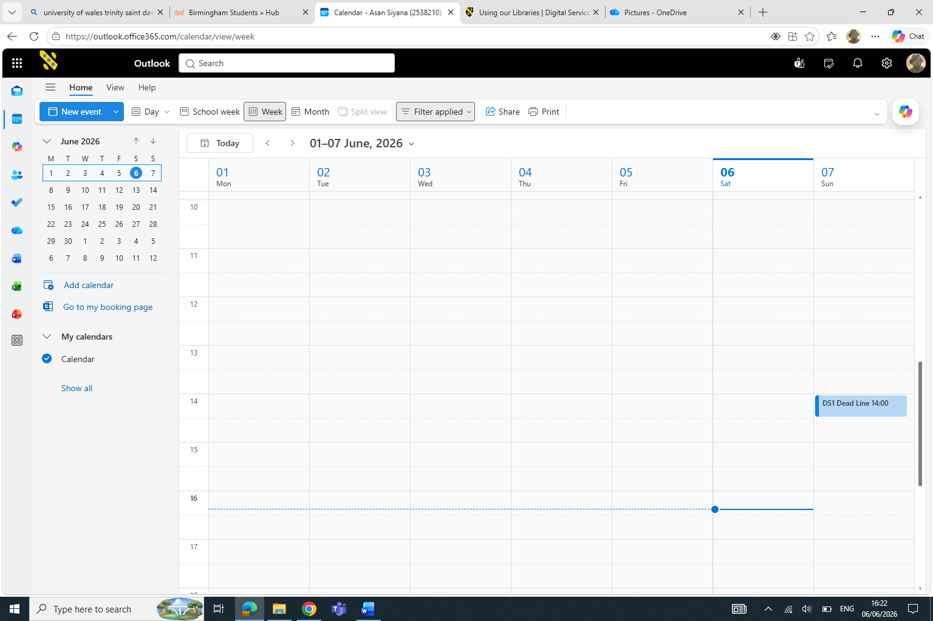
[Write what this shows of your digital life] just used my student deadline of my assignments to show how the importance of time and dates. So one can be in time and you don’t miss appointments.

Screenshot/Photo 3
[Insert Photo/Screenshot below]
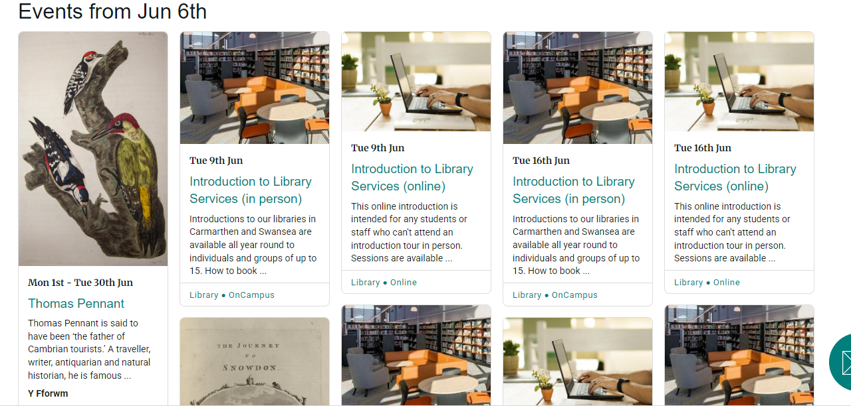
[Write what this shows of your digital life] I screen shot this from the university, because the university is more professional

Screenshot/Photo 4
[Insert Photo/Screenshot below]
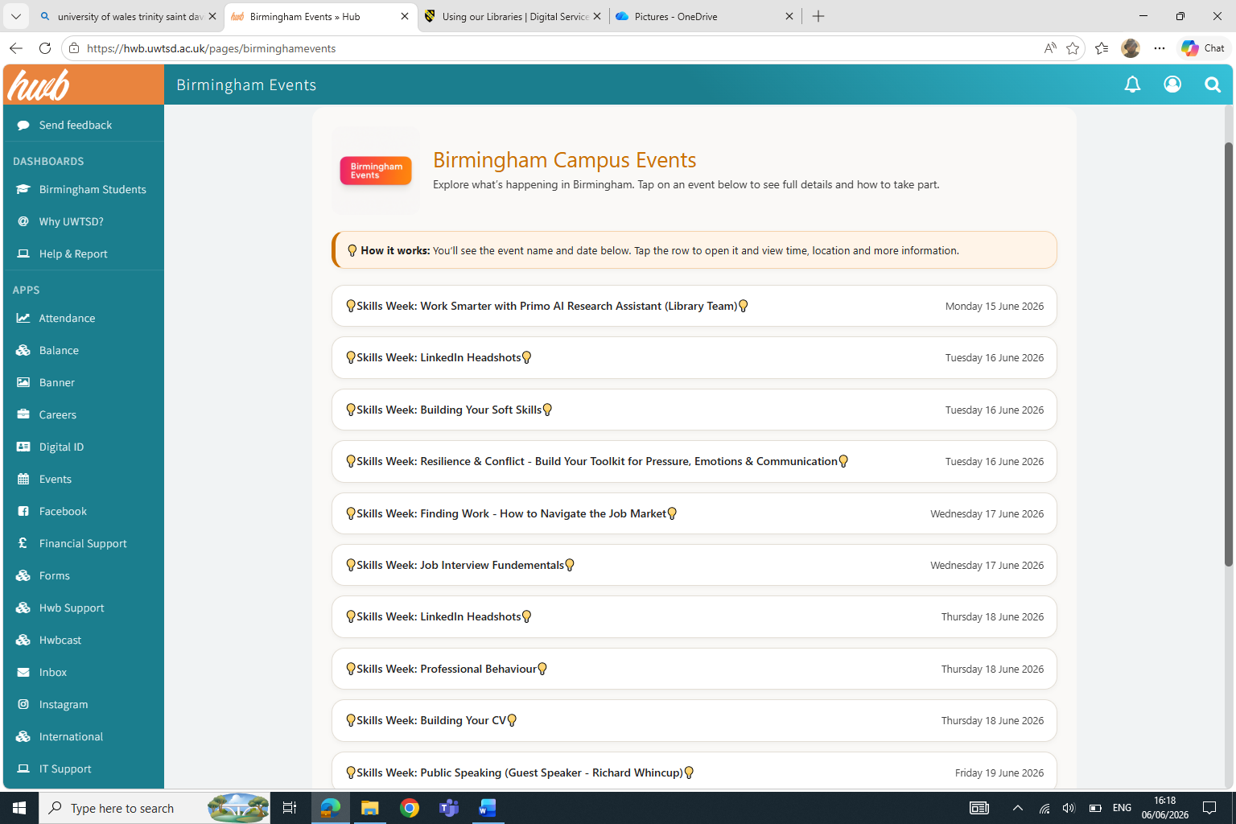
[Write what this shows of your digital life] this is a screenshot from the university

Screenshot/Photo 5
[Insert Photo/Screenshot below]
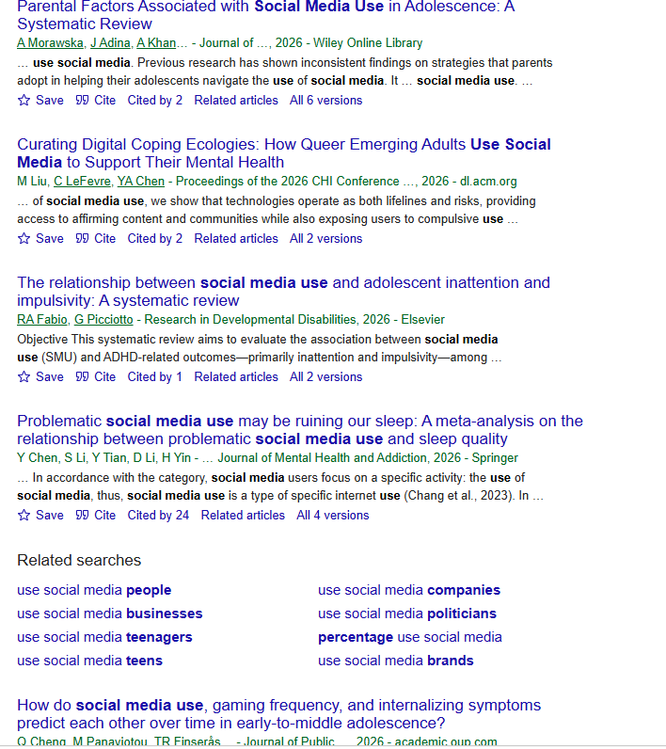
[Write what this shows of your digital life] it showed that I can screenshot and file the screenshot in photos, file or as a document.

Screenshot/Photo 6
[Insert Photo/Screenshot below] this is a screen shot form google scholar, I was just showing some of the things I have learnt on where to find information. I could have used AI but for now I only wanted to stick to simple things.
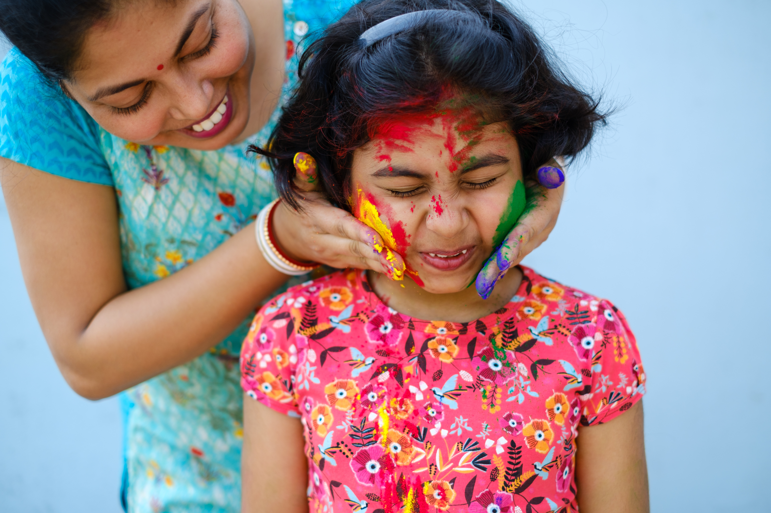
[Write what this shows of your digital life] I found the image on the university website, and I used copy and pest, this saves time because you don’t have to save it any file. The reason if you not that good in saving it leaves messy files and folders.

My Short Reflection
- Write 5–8 simple sentences about your digital life.
- You can use the sentence starters below if helpful.
- I use digital tools to … I used the snipping tool to take screenshot
- I feel confident when I … when it comes to hyperlink and search for information on other websites.
- I want to improve … I would like to improve on organising my messy folders, Zip and compressed folders.
- I often use these tools: … I use social media every day when I edit my text and images
- I sometimes feel nervous about … Planning projects and keeping up with appointments, one can easily forget but with digital calendar it makes everything easy.
- I hope this module will help me … On how to file and renaming of folders
- Digital skills are important for me because … everything nowadays is getting digital, with artificial intelligence

Sentence starters
- I use digital tools to …
- I feel confident when I …
- I want to improve …
- I often use these tools: …
- I sometimes feel nervous about …
- I hope this module will help me …
- Digital skills are important for me because …
You can write more if you want.is g

Submission Checklist
Before you submit, please check:
​​​ ☐ I added 4–6 screenshots
☐ I wrote short sentences for each screenshot
☐ I wrote my short reflection
☐ My work is my own
☐ My file opens correctly
​​☐ My file opens correctly

