Marketing Fundamentals Analysis and Evaluation on
Asda- a retail store

Student name: Alice Ana-Maria Casota(2117332)
Module code: LCBB4004
Module Coordinator/ Lecturer: Tushara Balendran
Assignment Title: Assessment 2
Blogging to communicate

Contents
Introduction 3
Various processes and stages of marketing 3
The role of the marketing environment and other situational analysis models 7
Segmentation, targeting positioning and marketing mix strategies of Asda 11
Conclusion 14
References 17

Introduction
The term, “Marketing” refers to an activity which is combined with various processes to create, deliver, communicate, exchange offerings. It has a value for the partners, clients, society and customers (Bartels, et, al., 2018). It is broadly known as a practice which helps an organization to maximize the brand awareness, influence the customer behavior for making a purchase through advertisements, pricing strategies, promotions and packaging. It has a vital role for selling a product or service. Without marketing no business could survive in the business market. Marketing has an essential role in the retail organizations because it ensures to enable various kinds of opportunities as well as assisting the marketing team for interacting with the customers to boost up the sales (Segal, et, al., 2019). The marketers create effective marketing strategies for leading an organization to increase the profit margin. As a marketing manager, the report is going to be made on Asda which is a well-known retail organization in the United Kingdom. Asda is a popular retail organization which offers home ware, grocery products, beauty products and many more at a reasonable price. Some marketing stages and processes, essential role of the marketing environment with situational analysis model, STP analysis as well as the marketing mix strategies of the organization will be briefly discussed.

Various processes and stages of marketing
Marketing is widely defined as a process that assists a firm in increasing brand recognition and influencing consumer behavior to make a buy through commercials, price tactics, promotions, and packaging. It is essential for marketing a product or service. No firm could succeed in the business market without marketing.
Marketing Process
Marketing process is a dynamic method which is required to measure regularly and evaluate the results of the plan so that an organization can bring success in their business. There are five steps which are present in the marketing process. For identifying and reaching the company goals, the steps have an essential role. By the marketing process and organization can enable a lot of opportunities for discovering the customers’ needs and demands towards a product. For the succession of the marketing process, the five elements are necessary. Such as,
- Mission
- Situation analysis
- Marketing strategy or planning
- Marketing mix
- Implementation and control.
These are briefly discussed below,
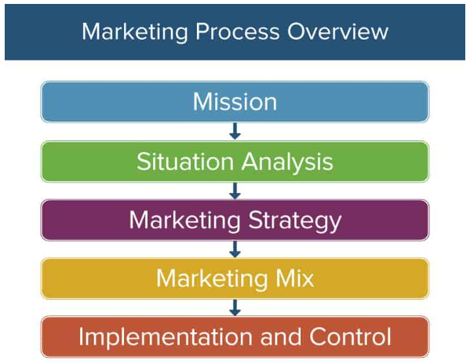
Figure: Marketing Process
Source: (Straková, et, al., 2018)
- Mission
A company firstly sets emission so that they can explain the business as well as identify that how it will be beneficial for the consumers. Mostly the mission statement is inspiring to the staff members for influencing the customers. Asda has a mission, “To be one of the best value retailers in the UK market.” Giving the highest priority to each and every customer is the main purpose for the organization. So the organization is highly concerned to offer the best quality products to the customers so that they can be a good competitor in the market for the survival of the business.
- Situation analysis
The situation analysis is the second step of the marketing process. In this segment the evaluation of the internal and external factors are held which has a great influence on the business as well as the market. Asda is highly influenced by either the internal resources or the external competition in the market. The situation analysis is giving clear objectives, status of the business, potential customers as well as the current industry trend to Asda for Identifying the present condition of the business. The internal factors, like, the SWOT analysis and the external factors, like, the PESTLE analysis is conducted in this stage for the market process. In the situation analysis segment Asda is identifying their strengths and turning it into their opportunities where as the organization is identifying their weaknesses and overcoming these before it becomes their threat (Jackson, et, al., 2018). Also the external factors are positively and negatively affecting the business operations in the UK market.
- Marketing strategy or planning
In the third step of the marketing process and effective marketing plan is created which helps Asda to identify various development opportunities. A marketing plan specifies the target customers so Asda can easily reach them. The marketing plan is always focused on forecasting the anticipated results. The marketing plan is supporting Asda to defining the targeted audiences, setting achievable goals, making a marketing budget etc.
- Marketing mix
In the fourth stage of the marketing process, the development of marketing mix decision is made. In the marketing mix they are 4ps, such as, promotion, product, place and price (Belohlavek, et. al., 2019). For the effective marketing process Asda is following the four segments of the marketing makes so that the organization can get proper guidance for understanding the value of the products to the customers. Also the competitive advantage of the product can be identified by the positioning segment. Asda is developing the marketing mix decisions by the marketing research so they can get their potential customers and understand the need of a product.
- Implementation and control
In this segment the plan is actually turned into an action. For introducing a product in the market the marketing process has the most important step which is implementation and control. In this part Asda gets the available resources for the marketing their products and organize the employees to the marketing activities. Asda manages all the details for each objective in this segment so that they create a schedule for keeping the marketing works on the track.
Marketing Stages
Marketing plays an important part in retail firms since it guarantees that various types of possibilities are available as well as supporting the marketing team in communicating with customers to increase sales (Bartels, et, al., 2018). Marketers design successful marketing techniques to help a firm boost its profit margins. There are four stages in marketing, such as,
- Production Orientation
- Product Orientation
- Sales Orientation
- Marketing Orientation
These are briefly discussed below,
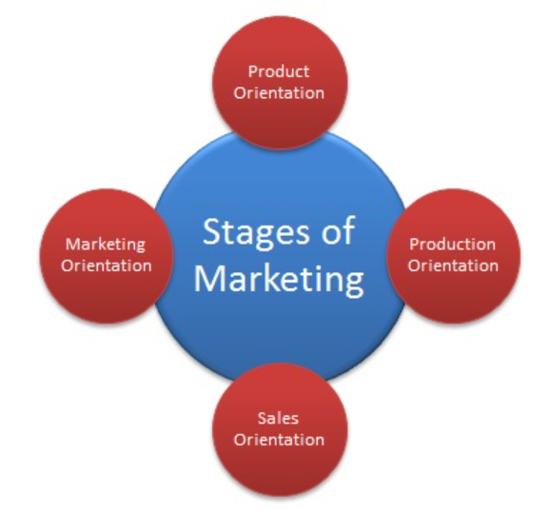
Figure: Marketing Stages
Source: (Segal, et, al., 2019)
- Production Orientation stage
In the product orientation stage Asda is highly concentrating on the maximum level of the production. The organization is giving their all efforts in the production process so that the high product efficiency can be held for meeting the customer demands. Asda is focusing on the mass production of the standard items. Asda is highly concentrating on controlling the costs by using a lot of strategies which are supporting them to minimize the extra costs. For doing so the organization is using mass production. By increasing the sales volume the organization is maximizing their profitability in the production orientation stage.
- Product orientation stage
In this orientation the organization gives their highest effort to produce the best quality products. So the organization is emphasizing on the designing and maintaining of the product quality. In this orientation the organization also controls the quality of the product for the improvement. As a result the customers get a good quality product which has a great impact on maximizing the sales volume. Most of the organizations are not concentrating on the philosophies of the product orientation so that they are facing downfall in the market. As the orientation is involved with delivering the best quality products, so that most of the customers are not willing to afford the super quality products
- Sales orientation stage
In this stage the organizations give their highest priority on the stock clearance. Asda tries to produce a lot of products so that they can influence the public to make a purchase which can impact on the high sales (Yousept, et, al., 2015). Asda is aggressive in increasing their sales so that they are promoting the company products through high advertisements. Quick selling technique is used in this orientation for maximizing the profit volume. Asda is doing great in following all the philosophies of the stage so that the organization is earning high profitability by quick sales.
- Marketing orientation stage
For meeting the customers demand the organizations are using this method for making effective decisions and planning. Because satisfying the customers is the main goal of every organization. So Asda follows the marketing orientation which involves everyone of the company to be customer oriented. Rather than prioritizing what the company wants, Asda is giving their highest priority in producing various products for fulfilling the wants of the customers. By following the marketing orientation stage Asda is ensuring that all customers are valued by the organization so that they can get the high quality products.

The role of the marketing environment and other situational analysis models
Marketing environment is analyzed by the PESTLE model and the situational analysis is analyzed by the SWOT analysis. These analyzes have a vital role in the marketing activity. Because of the Covid-19 situation, Asda is going through a lot of troubles. So the environmental factors are giving some opportunities and threats to the organization.
Marketing Environment
Marketing environment has a vital role in assisting and organization for identifying the customer needs as well as influencing the customers to make a decision for purchasing products. The marketing environment has six factors, which are influencing the business in both positive and negative ways. The marketing environment has two segments like, Micro Environment And The Macro Environment (Straková, et, al., 2018). In the micro environment they are task in environment and the internal environment. The suppliers, customers, competitors and intermediaries are contained in the task environment. The five environments of the external marketing environment are, political environment, economic environment, competitive environment, technological environment, social and cultural environment.
These are discussed below,
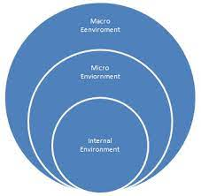
Figure: Marketing Environment
Source: (Jackson, et, al., 2018)
- Political environment
The political environment includes a lot of rules and regulations for conducting the business operations. The UK government has set some restrictions for protecting both businesses and the consumers so Asda is highly affected by the political environment of the country. The patent law is favoring the business but the advertisement restrictions are giving a threat to the organization. Asda is facing a lot of problems for following all the regulations of the country so that the marketing strategies of the business are highly affected.
- Economic environment
Because of the stable economic environment of UK, Asda is able to decline the unemployment rate. Also the income tax is low in the country so Asda is operating their business in the market by paint a minimum rate of tax. It is a good advantage for the organization (Bartels, et, al., 2018). The marketing products are available in the market because the customers are interested for buying it. As the economy of the country is stable so that the prices of the products are also stable. On the other hand, the organization is highly affected by the interest rate in the inflation time. The sales decline and all the promotional plans are hampered.
- Competitive environment
Organizations try to analyze the competitions of the market so that they can modify they are business process. Asda is monitoring the activities of the other competitors for enhancing the brand reputation and the substitute of the products. No organization wants to lose their shares so that Asda is trying to capture the share market for convincing more people to give it of competition to the other rivals. Already the market environment of UK is competitive because they are a lot of competitors who are giving a tough competition to Asda. Companies like, Marks and Spencer, ASOS, Tesco organizations are already popular in the market which are availing a lot of environmental advantages.
- Technological Environment
Because of the advancement of technology the market environment is becoming updated. So all the business organizations are interested to utilize the technology for enhancing their business operations. It not only helps an organization to enhance the production process but also helps an organization to increase the brand promotion. Asda is utilizing the updated technologies as well as adapting various strategies for enabling various opportunities which can give them a lot of benefits and reduce the tendency of threats.
- Social and Cultural environment
The marketers of Asda are highly concerned to stay updated for following the social and cultural factors. It is supporting the organization to be advanced and positively affect on the sales. The UK people are fond of various kinds of clothes so Asda is giving their high preferences for coping up with the social trend of the country (Moss, et, al., 2019). Also the culture of the country is getting high priority for offering the products of the organization. So Asda is trying hard to adjust with the environment of the country.
Situational Analysis Model
Situational analysis refers to a method for examining and organization as well as its competitors based on the company size and the market shares. It is also analyzed according to the sales history, profit, cost and customer types (Blackwell, et, al., 2016). For analyzing this, various approaches can be used. For analyzing the situation the sword analysis is the best. Because it capitalizes the company strengths, minimizes the bad effects of the company weaknesses, enables a lot of opportunities and reduces the impact of the threats. In the situation analysis segment Asda is identifying their strengths and turning it into their opportunities where as the organization is identifying their weaknesses and overcoming these before it becomes their threat (Jackson, et, al., 2018). Also the external factors are positively and negatively affecting the business operations in the UK market.
SWOT Analysis
In the SWOT analysis, it is observed that Asda is a popular organization in the UK market which is giving them the highest opportunities to operate their business. Because the country people are ever of the company products so that they consume more products from the organization which is increasing the sales and profitability of the organization (Yousept, et, al., 2015). Also the UK Government is supporting the retail businesses a lot which is a great opportunity for the business operations. The organization is paying a minimum rate of tax in the country which is an advantage of the business. On the other hand the operational cost is increasing in the market which is giving a threat to the business. They are various retail organizations which are already renowned and captured the market which is creating high competition for Asda.
5C Approach
Also the 5C approach can be used for analyzing the situation of a business. Under these approach the company, customer, climate, collaborators and the competitors get the highest priority (Siu, et, al., 2015). The company is connected with the evaluation process of the strategies, objectives and capabilities of Asda. The competitor analysis is evaluating the position of the business. It identifies the competitors and assesses the competitors for predicting the better future of the business. The customer analysis is based on the income level of the consumers and their ones and demons toward the retail, wholesale and online products. For increasing the business ideas Asda is collaborating with other businesses for achieving more opportunities. So the organization is building a good relationship with the suppliers and distributors. For analyzing the environment the organization is highly affected by the climate. The covid-19 situation is affecting very badly in the operation of the business (Sayyida, et, al., 2021). All the retail stores are closed because of the pandemic. So the business operations are greatly hampered. As a result the organization is facing a lot of difficulties in maximizing their profitability and revenue. The organization income is declining due to the fact.

Segmentation, targeting positioning and marketing mix strategies of Asda
STP analysis
The full form of STP analysis is segmentation, targeting and positioning which are a three step model for examining a product or service which communicates with the specific group of customers for offering various kinds of benefits. It supports an organization to measure the company position based on a product or service for the targeted groups of the customers in the most effective way (Dibb, et, al., 2021). The STP model is beneficial for Asda because it is supporting the organization to create the marketing communication plans as well as helping the marketers for identifying the business positions which are engaging the customers and developing the business. The market segmentation, market targeting as well as product positioning are present in the STP analysis which is significantly supporting Asda to operate their business in the UK market. These are briefly discussed below,
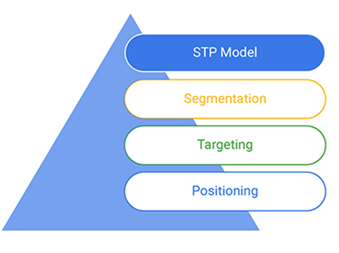
Figure: STP Analysis
Source: (Segal, et, al., 2019)
Market segmentation
When the customers are segmented based on their gender, education and occupation then the Demographic Segmentation is held. Whenever the country, state and region is the main focus for segmenting the market then it is called the Geographic Segmentation. Values, personality and lifestyle is focused on the Psychographic Segmentation and the customer's loyalty, various benefits and the uses of the product is the main focus in the Behavioral Segmentation.
Asda is a retail organization so that the organization is focusing on the Demographic and Geographic Segmentation. Under the demographic segmentation the organization is focusing on the personal attributes of the customers like, gender, occupation and the income level. The organization is ensuring that all level customers are able to purchase products from the company so they are following the demographic market segmentation strategy for operating their business.
Targeting the potential customers
For segmenting the market it is very important to identify the targeted groups of the customers. So that the largest return can be obtained by offering the desired products to the customers. It also positively affects the company's profitability. By targeting the customers and organization can identify their bottom line. Also the business size and the potential business growth can be measured by targeting the customers.
Asda is highly focused on the specific groups which have similar kinds of needs, wants and interests. By targeting the specific groups of customers, the organization ensures to influence the customers to make a purchase.
Positioning
The third stage of the STP analysis is positioning. By the customers’ acceptance of a product and organization can identify their position in the market. Basically, positioning is a method to analyze how an organization is increasing the brand awareness in the market. By Positioning, an organization assures to be market oriented, adjusts with the changes of the market, the customer expectations, promotes the brand loyalty, designs various promotional strategies as well as attracts different kinds of consumers.
Asda is positioning their offerings by creating a value proposition which is helping the organization to explain how the offerings will be fulfilling the customer requirements better than the other rival organizations. After that Asda developed a marketing campaign which represents the value proposition in the most significant way which is broadly accepted by the customers.
Marketing Mix
There are 7Ps in the marketing mix, such as, promotion, place, physical evidence, product, people, process, and pricing. Asda is following the seven stages for a successful marketing. It also supports the business to obtain precise assistance for recognizing the value of the items to the customers. Asda is generating marketing mix decisions based on marketing research in order to reach out to potential customers and identify the demand for a product.
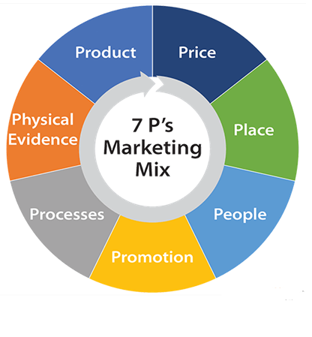
Figure: Marketing Mix
Source: (Valaskova, et, al., 2021)
- Product

Product is the main element of every business. Without offering products no business can run their operations. The organizations are highly concerned to offer a variety of products so that they can satisfy the customer demands. This is the technique for developing a product or service to gain a huge response from the customers. Asda is highly focused on developing their products so that they can meet the customer requirements and stay in the business market. The company takes a lot of initiative for identifying the customer requirements toward a product. After that, Asda starts their production process. Giving the highest priority to the customers for offering best quality products is the main motto of the organization.
- Price

Price is an important part for the selling of a product. Based on some factors the price is set. The current marketplace plays a significant role in setting the prices of the products. Asda is using the “Market Penetration Strategy” to offer their company products (Ivy, et, al., 2018). Under this strategy the products are offered at the cheapest rate but the products are of the best quality. So the organization is able to attract a lot of customers because of the low price. Also the current pricing structure of the United Kingdom is maintained by the organization for the selling activities.
- Promotion

Promotion can be held by advertisements in the social media or in the traditional method. By promoting the company products, Asda is ensuring the high promotion of their organization (Belohlavek, et. al., 2019). The customers get proper information about the company products and they are highly influenced to make a purchase. Because of the high promotion of the products the organization is leading a dramatic change in their results. Because it is not only enhancing the profitability but also supporting the business development.
- Place

The fourth segment of the marketing makes is the place. It has an essential role for boosting up the sales and profitability. Retail organizations are highly prioritizing the place where the company products are sold. So Asda is ensuring their high sales by giving the highest priority in different places. In every city the organization is trying to open their branches so that it will be easier for the customers to grab their desired products (Constantinides, et, al., 2021). Also the organization is making a joint venture with the famous organizations online for increasing the sales.
- Process

For manufacturing the company products most of the organizations are highly dependent on the technology process because it enhances the production process by delivering the quality goods. Asda is following the advanced technology for boosting up the production process so that they can ensure the high performance of their organization. Also the customers are getting products in the best quality. Meanwhile the organization is saving a lot of time and money.
- Physical Evidence

Packaging refers to a way of the product displayed from the outside. Packaging ensures to keep the quality of the products. A product is offered in attractive packages. Asda is packaging their products in various colors and materials so that it is influencing people to understand about the product quality which is positively impacting on the high sales. People are getting attracted by their first impression about the Asda products, so the customers want to buy it.
- People
People are the main concern of the business organizations so that Asda is identifying the customer preference before producing any kind of product. Forgiving the highest priority to the customers the organization is using various tactics (Straková, et, al., 2018). Every single policy and decision is made based on the customer's preferences. So the organization is recruiting highly skilled people to deliver the best results. The organization is assuring that the right people are doing the right kind of task in the organization so that they can keep the business reputation of offering the best products to the customers.

Conclusion
Marketing is widely understood as a method that assists a corporation in increasing brand recognition and influencing consumer behavior to make a buy through commercials, price tactics, promotions, and packaging. It plays an important part in the sale of a product or service. No firm could exist in the business market without marketing. Marketing is important in retail firms since it guarantees that various types of chances are available as well as supporting the marketing staff in communicating with customers to increase sales. Marketers develop successful marketing tactics to help a firm boost its profit margins.

References
Bartels, R., 2018. The general theory of marketing. Journal of marketing, 32(1), pp.29-33.
Belohlavek, P., 2019. Unicist marketing mix. Blue Eagle Group.
Blackwell, R. and Eppler, D., 2016. An approach to strategic situation analysis: Using models as analytical tools. Journal of Global Business management, 10(1), p.80.
Constantinides, E., 2021. The 4S web-marketing mix model. Electronic commerce research and applications, 1(1), pp.57-76.
Dibb, S. and Simkin, L., 2021. Targeting, segments and positioning. International Journal of Retail & Distribution Management.
Drummond, G., Ensor, J. and Ashford, R., 2017. Strategic marketing: planning and control. Routledge.
Ivy, J., 2018. A new higher education marketing mix: the 7Ps for MBA marketing. International Journal of educational management.
Jackson, T. and Shaw, D., 2018. Mastering fashion marketing. Macmillan International Higher Education.
Moss, M.K., 2019. Segmentation, Targeting, Positioning and CRM. Marketing: Real People, Real Decisions, p.212.
Sayyida, S., Hartini, S., Gunawan, S. and Husin, S.N., 2021. The impact of the COVID-19 pandemic on retail consumer behavior. Aptisi Transactions on Management (ATM), 5(1), pp.79-88.
Segal, M.N. and Giacobbe, R.W., 2019. Market segmentation and competitive analysis for supermarket retailing. International Journal of Retail & Distribution Management.
Siu, W.S. and Kirby, D.A., 2015. Approaches to small firm marketing: a critique. European journal of marketing.
Straková, J., Pártlová, P., Dobrovič, J. and Váchal, J., 2018. Situational analysis and its role in the process of strategic business management. Polish Journal of Management Studies, 18.
Valaskova, K., Durana, P. and Adamko, P., 2021. Changes in consumers’ purchase patterns as a consequence of the COVID-19 pandemic. Mathematics, 9(15), p.1788.
Yousept, I. and Li, F., 2015. Building an online grocery business: the case of asda. com. International Journal of Cases on Electronic Commerce (IJCEC), 1(2), pp.57-78.

