Workplace Culture and its impact on Organizational Efficiency

BMSW5105

Task 1 Individual Written Report
Student Name: Bianca Agripina Sztan
Student ID:2115858
Lecture Name:Richard Ashaye

Executive Summary
The study is focused on the organizational culture of EasyJet and its effect on organizational efficiency. EasyJet Plc has above 12000 skilled workers including above 7500 members of the cabin crew and 3300 pilots. The headquarters of EasyJet is situated in Luton in the UK. It is the leading Airline in the UK that operated above 1100 routes across 35+ countries with 300+ Airbus aircraft. The report analyzed and evaluated the environment of EasyJet it is essential to use the relevant organizational and environmental tools or techniques including SWOT analysis, PESTEL analysis, and Porter’s Five Forces Model. EasyJet always maintains a low-price structure. The GDP of the UK increased by 0.1% in the last quarter of 2022. Therefore EasyJet can get high profits in the aviation industry of the UK. in this assignment the nonfinancial and financial factors of the company quill also be discussed. This includes an understanding of the organizational culture and structure of the company. With their help of them, the financial and non-financial condition of the company can be analyzed. In a study, it can be observed how the company is maintaining its human resources department. The effects of different types of economic events will also be discussed in this report.

Table of Contents
Introduction 2
a) Briefly explain EasyJet airline 2
b) Relationship of organizational culture and structure of Easy jet impact on achieving financial and non-financial performance. 3
The organizational structure of Easyjet 3
Organizational culture of EasyJet 4
Relationship Between organizational culture and structure 4
c) SWOT, PESTLE, and Porter's Five Forces Model analysis of EasyJet Plc. 5
SWOT Analysis of EasyJet 6
PESTEL Analysis of EasyJet 7
d) Ethical approaches of EasyJet Plc's and the benefits. 8
e) Recommendations to EasyJet Plc 10
Recommendations to counter ethical challenges and improve performance: 10
Recommendations to counter environmental challenges and improve performance: 11
Conclusion 11
References 13

Introduction
The main objective of this assessment is to focus on the organizational culture of EasyJet and its effect on organizational efficiency. An effective organizational culture provides direction and consistency, guides decisions, develops the performances of employees and their well-being, and so on. Organizational culture can set expectations about the behavior of the people to inspire the workers to work together and function like a team. EasyJet’s organizational culture can be represented through innovative approaches to safety and performance to improve the operational activities of this company. The organizational culture of EasyJet Plc believes in giving their organization a human touch that leads to benefits for the workers. To explain the organizational behavior of EasyJet, the organizational structure and organizational culture of EasyJet, their border environment, their ethical approaches, and ethical challenges have to be analyzed. Based on the above factors some effective recommendations have to be provided to develop the business performance of EasyJet. The organizational culture of EasyJet Plc has valued accountability, quality, diversity, collaboration, leadership, integrity, and passion. The organizational culture of EasyJet Plc can ensure a high flow of information and leverage the skills, competencies, and knowledge of workers from diversified backgrounds. Moreover, the strong organizational culture and structure of EasyJet lead to inspiring and motivating the workers and therefore boost the performances of the employees of this company.

Briefly explain EasyJet airline
EasyJet Airline is considered one of the low-cost point-to-point airlines in Europe. The low-cost advantage, leading position, and operational efficiency can easily attract people (Rodrigues and Rocha, 2019). EasyJet Plc is a strong capital-based company with strong credit ratings among all airlines in the world. EasyJet Plc has above 12000 skilled workers including above 7500 members of the cabin crew and 3300 pilots. The headquarters of EasyJet is situated in Luton in the UK. It is the leading Airline in the UK that operated above 1100 routes across 35+ countries with 300+ Airbus aircraft (Routesonline, 2023). The company has a strong portfolio and filing rights across the AOCs and Europe in Austria, Switzerland, and the UK. EasyJet plc is aimed to be the largest data-driven airline in the world. The revenue of EasyJet has benefited from its data projects in various seat pricing (Easyjet, 2023). EasyJet has been considered the leading short-haul airline in Europe for the last 25 years. Moreover, EasyJet Airlines has provided affordable flight facilities, great consumer services, driving efficiency, online booking, paperless operations, point-to-point traveling offers, and so on that can help the company to be one of the renowned airlines in the UK (Daz, 2023).

Relationship of organizational culture and structure of Easy jet impact on achieving financial and non-financial performance.
The organizational structure and culture of easy Jet are discussed below.

The organizational structure of Easyjet
The organizational structure is all about the arrangement of the human resources of a company for maintaining the work performance of a company. In simpler terms, it can be said that maintaining organizational responsibility in different sectors is known as the organizational structure. Every company has to maintain an organizational structure for maintaining their work performance. Examples of organizational structures are flat organizational structure, heretical organizational structure, and other such models (Team, 2022).
In this assignment, the organizational structure of Eastjet will be discussed. In a study, it can be observed that the company is maintaining its human resources department in a functional organizational structure (Essay Biz Lab, 2023). In simpler terms, it can be said that Easyjet. plc is maintaining its human resources in a function-oriented organizational culture. The organizational structure of the company is given below.
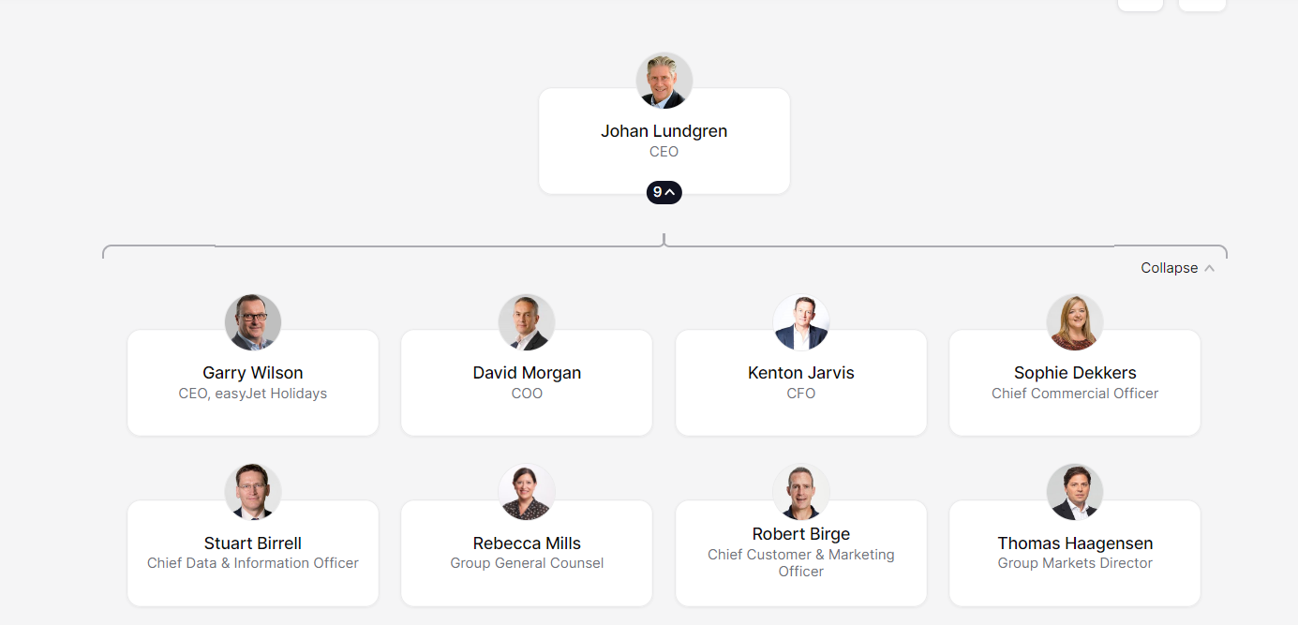
Figure 1: Organizational structure of Easyjet
(Source:- THE ORG, 2023)
In this given to figure it can be seen how the company is maintaining its organizational structure. From that, it can be said that the company is maintaining its structure in a function-based system. A function-based organizational structure is all about maintaining different types of departments in a single company. These departments are created depending on the function they are filling up, such as the accounting department, advertisement and accounting department, and other such departments (Team, 2022). Because of this, it can be said that the company is maintaining its human resources based on the functions that they are filling. The benefits that the company is getting for maintaining this structure are given below.
i) With the help of this structure Easyjet can create different specialized departments, which are based on different functions that they are filling. Because of this, the company can increase its productivity, which can improve its profitability in both financial and non-financial terms.
ii) The structure is also helpful for decreasing the cost of operations (Indeed, 2023).

Organizational culture of EasyJet
The aspect of the organizational culture is all about maintaining the values and techniques that are beneficial to the work environment of a company. In simpler terms, it can be said that the aspect of the organizational culture is all about maintaining the organizational values and other such methods for improving the work environment of a company. It includes how a company handles its workers and employees, authority given to the employees, and other such aspects. There are various types of organizational culture models that a company can follow, such as clan culture, market culture, and other such aspects.
In this scenario, Easyjet is maintaining its organizational culture by giving its employees authority for maintaining their unique ideas, and planning, it also includes the given authority for thinking differently and independently in their work environment (EasyJet, 2023). They are doing this to maintain a higher level of customer service than their competitors in the market. Their work culture excludes the heretical structures and other such aspects. Because of this, it can be said that the company is giving its employees enough space to improve their work environment. Because of these aspects, it can be said that the company is maintaining its organizational culture in an adhocracy style. This is because this style of model is also maintaining an innovative work culture in a work environment (Indeed, 2023). The benefits of this style are as follows.
i) The model of organizational culture encourages taking on new types of ideas, and other such aspects.
ii) The work culture of this model is relatively more flexible than the other types (Team, 2023).

Relationship Between organizational culture and structure
Organizational structure is the work performance of a company doing work in both external terms and internal terms. On the other hand, organizational culture is the internal and external communication methods of a company (Lefifi, 2023). Because of this reason, it can be said that both aspects are closely related to each other. The mismatch of this aspect can fail the projects and operations of a company.
The performance of Easyjet in its organizational culture and structure can be understood by its financial performance in recent years. This aspect is given below.
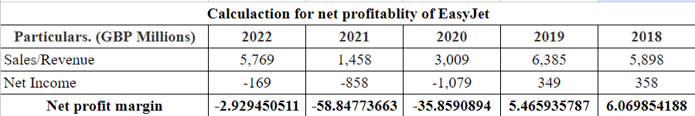
Figure 2: Financial performance of EasyJet
(Source: WSJ, 2023)
This aspect can better be understood by the below-given graph.
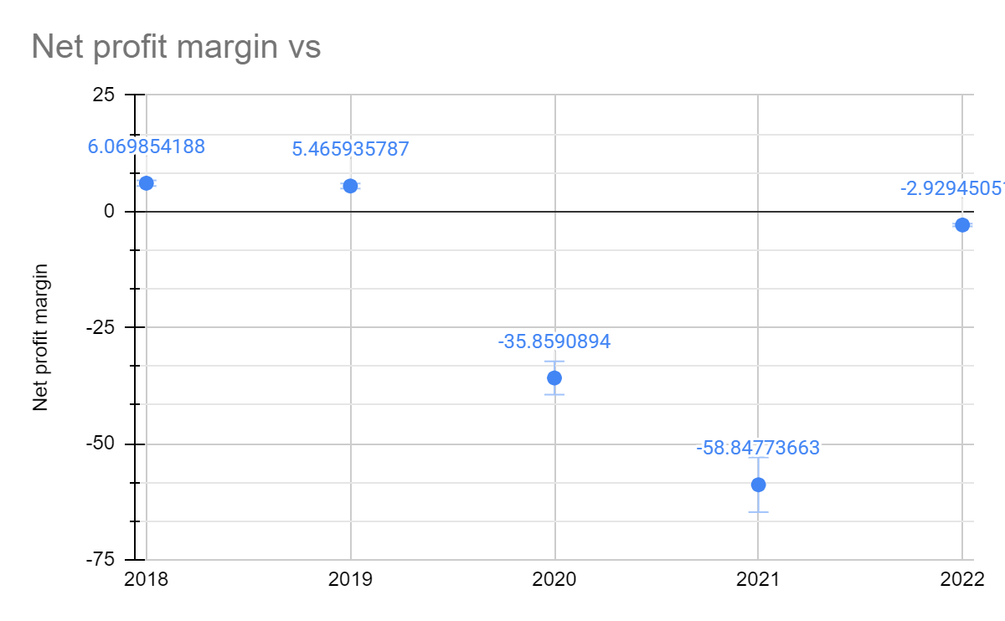
Figure 3: Financial performance of EasyJet
(Source: Self-made, 2023)
In this figure, it can be seen that financial performance has dropped in recent years, which can be due to different types of economic events.
As for the nonfinancial factors' performance, it can be said that the company had a total percentage of Load factor almost 85.5 percent, in 2022. It is higher than the previous year's record. The one-time performance of the company is 72% in 2022. It is lower than the previous year's records. The carbon emission is also lower than the previous year in the current year (EasyJet, 2023).
From that, it can be said that the organizational structure and culture are less effective during those economic events.

SWOT, PESTLE, and Porter's Five Forces Model analysis of EasyJet Plc.
To analyze and evaluate the wide environment of EasyJet it is essential to use the relevant organizational and environmental tools or techniques including SWOT analysis, PESTEL analysis, and Porter’s Five Forces Model. The SWOT analysis helps to identify the strengths, weaknesses, opportunities, and threats of an organization (Teoli et al. 2019). PESTEL analysis can analyze the political, economic, social, technological, environmental, and legal factors of an organization. The Five Forces Model of Porter can explain the market competition, the potentiality of the newcomers in the market, and the threat of the substitute items' bargaining power of suppliers and consumers (Sánchez-Cambronero et al, 2020).

SWOT Analysis of EasyJet
Strengths
- EasyJet always maintains a low price structure and great consumer facilities which leads to establishing a brand reputation for this company (David, 2023).
- The company has added more airplanes with advanced technology that can ensure the reliability and safety of passengers and reduce emissions (David, 2023).
- The management of EasyJet always targets a minimum ROCE. The minimum rate of return Strong cash generation and the balance sheet of EasyJet can easily exceed their cost of capital which leads to a better financial position for EasyJet (David, 2023).
- EasyJet has explained its corporate social responsibilities very clearly which helps to reduce the impact of EasyJet on the environment (David, 2023).
Weaknesses
- EasyJet does not offer service of free food for longer flights which makes the passengers disappointed (David, 2023).
- The low pricing strategy can make the power of the buyers relatively high which leads to the enhancement of the bargaining power of the consumers (David, 2023).
- The low-cost business model has not offered a similar range of premium services to their consumers as few of their competitors (David, 2023).
- The company has been criticized by some of its consumers for its long queues, strict policies for baggage, and delays (David, 2023).
Opportunities
- The easyJet airline has been expanding its route into new regional markets and catering to particular consumer segments (David, 2023).
- EasyJet can look for strategic partnerships for airports to expand their route system with more travel options for their consumers (David, 2023).
- EasyJet has great opportunities to invest in advanced technologies to enhance its efficiency and develop the experiences of its customers (David, 2023).
- The renowned company can expand its new market outside of Europe which can help the diversity of the airline and reduce the dependency of the company on the specific market (David, 2023).
Threats
- EasyJet has faced competition from both low-cost carriers and traditional airlines due to the highly competitive market of low-cost airlines (David, 2023).
- Political issues like Brexit can affect the financial performance and operational activities of EasyJet (David, 2023).
- Due to the pandemic, war, and other issues the travel industry has been facing increased apprehension that can be one of the threats to EasyJet (David, 2023).
- External risks like inflation, natural disasters, volatility of fuel prices, etc can affect the operational efficiency and profitability of EasyJet (David, 2023).

PESTEL Analysis of EasyJet
Political
One of the leading political issues of EasyJet is the ownership transfer from the UK AOC to the EU AOC due to the Brexit issue. The insatiable rate of interest, taxes, inflation, foreign exchange, currency, etc affects the business activities of the UK. The Irish and British have traveled freely with their employment benefits. As the UK has maintained good relationships with other countries, it helps EasyJet to continue its business (David, 2023).
Economic
The UK has ranked 6th position by the nominal GDP across the world. The GDP of the UK increased by 0.1% in the last quarter of 2022 (GOV.UK, 2023). Therefore it can be said that the market-based highly developed economy has played an integral role in the international trade of EasyJet. As the UK has been attracting millions of travelers every year, it is a golden opportunity for EasyJet to continue its activities successfully (David, 2023).
Social
The UK contains a big consumer market that tends to have a high demand for air travel. Therefore EasyJet is affected by the upward pressure on their labor cost. The social demand is increasing to maintain the sustainability of EasyJet and reduce wastage. In the Uk, the multi-ethnic market is increasing for EasyJet (David, 2023).
Technological
The UK is very advanced in modern technology. Therefore it creates opportunities for EasyJet to develop its electric aircraft. The innovations of EasyJet lead to sustainability and enhance the importance of the generation of profit through data analytics.
Environmental
As the UK has faced the challenges of climate, EasyJet often faces difficulties during their aviation services. EasyJet is committed to reducing carbon emissions by 50% with the government of the UK. This renowned company also follows the law to keep the environment of the UK pollution-free (Momin, 2022).
Legal
The Employee Act of 1996 has protected the rights of the employees of the UK. So the employees of EasyJet also have benefited from this law. The Equal Act of 2010 also prevents discrimination in the workplace of EasyJet and other companies in the UK (David, 2023).
Porter’s Five Force Model of EasyJet
Intensity of Rivalry
EasyJet has faced rivalry among its existing competitors including Ryanair, Wizz Air, Flybe, etc. due to reducing costs, low pricing strategy, etc of EasyJet. The company has operated in a very tough competitive market in the UK. The competitive environment can affect the long-term portability of EasyJet at any time by applying effective techniques, ideas, and strategies (Lorisangella, 2014).
Threats of New Entrance
EasyJet has faced the threats of newcomers in the industry. The market competition is going too high due to strong forces and unique and effective business ideas and strategies of the new companies in the industry. EasyJet has to control all these challenges regarding the barriers to the new entrance (Lorisangella, 2014).
Threats of substitutes
EasyJet contains a medium risk of a substitute. As a substitute for airlines, travelers can use other transportation like cars, trains, buses, boats, etc. Travelers also use other airlines with more opportunities in the same budgets (Lorisangella, 2014).
Bargaining Power of Buyers
Sometimes the buyers of EasyJet want to get service more by paying a minimum price that can pressure the profitability of the company. The large consumers of EasyJet seek offers and discounts. Therefore EasyJet always has to be concerned about its competitors and their policies (Lorisangella, 2014).
Bargaining Power of Suppliers
The suppliers of Easyjet have been concentrated in a particular region higher than their customers. There are few suppliers of aviation, therefore it is essential to meet their demands to keep consistency in their business (Lorisangella, 2014).

Ethical approaches of EasyJet Plc and the benefits.
Ethical approaches are the base for the organizational culture of a company. In simpler terms, a company can use different kinds of ethical approaches for improving the culture of work in their organization. An effective ethical approach is important for driving the motivation of the employees in a company (Redlands, 2021). Because of these reasons, it can be said that every business has to maintain ethical approaches in both internal aspects and external aspects of a business for maintaining the work environment.
It is also the same for EasyJet. They are also using ethical approaches to maintain their work environment and organizational culture. Some of the ethical approaches of the company are discussed below.
i) Prioritize safety
In this aspect of EasyJet, it is said that the company highly prioritizes the safety of its workers and customers (EasyJet., 2023). In simpler terms, it can be said that the company is maintaining its ethical approaches by prioritizing the safety of the workers and customers of the company. They are doing it by using different types of laws and regulations of the industry.
ii) Interest conflict avoiding
In this aspect, the company is maintaining its ethical approach by decreasing the possibility of conflict in the company, which is caused by taking personal interest priority in the work environment (EasyJet., 2023). In simpler terms, it can be said that the aspect is all about the company using its rules and regulations to stop the attempts of gaining personal benefits from the position of an employee in their organization.
iii) Fair business
This approach of the company is all about maintaining a fair business circle among its customers. In simpler terms, it can be said that EasyJet is maintaining zero tolerance against the act of bribery done by the employees of the company (EasyJet., 2023). It is also the same for the external affairs of the company. They are also maintaining legal activities against such actions. By doing so they are maintaining the interest of the employees of the company.
iv) Contribution to society.
The company is also using its business to make a positive impact on society. In simpler terms, it can be said that the company is using its business for making a positive impact on the overall society (EasyJet., 2023). They are doing it by investing in social activities, philanthropic, and other such activities. Because of these reasons, the company can motivate its employees to achieve a better society.
Benefits of the organizational culture
In the above-shown discussion, it can be seen the ethical approaches of the company. There are various kinds of benefits to these approaches. Some of them are discussed below.
i) Protection of tangible and intangible assets is one of the major benefits of maintaining the effective ethical approaches of a company. It means that the ethical values of a company can motivate employees of a company to maintain the integrity of the assets of a company. This aspect can also be seen in the case of EasyJet.
ii) Ethical approaches in the organizational culture are also increasing the team efforts of the employees of a company. In other words, effective ethical approaches can increase the team effectors amount the employees of a company (Ventimiglio, 2023). This aspect is also the same for EasyJet. They are using their ethical approaches for increasing efficiency and productivity. It also includes bullying a good public image and goodwill among its customers.

Recommendations to EasyJet Plc

Recommendations to counter ethical challenges and improve performance:
a.) To counter the ethical challenges of the company, the management should create a new Code Of Conduct that should apply to all. This will maintain equality between all members of the company and their involvement in the company will increase. This will lead to a better organizational culture and performance for EasyJet plc (Mayhew, 2017).
b.) Employees who show good ethics should be rewarded by the company. This reward can be some direct monetary rewards such as employee benefits or can be in the form of promotion in a job position too. This will surely make the employees perform more ethically and automatically their efficiency of work will increase. The company hence can incur better results both financially and non-financially (Mayhew, 2017).
c.) Leaders of a team should have better team-management skills so that they can keep all the employees engaged in the work for the company. They must be monitored now and then. This may lead to increased production for the company (Mayhew, 2017).
d.) Workers’ engagement must be increased by introducing various stakeholder programs. This will make the employees understand that they are important to the company and therefore their involvement towards the company will increase. They will try to act ethically. Improved ethical behavior is good for better productivity and organizational efficiency.
e.) The company should also arrange some programs to train ethical behaviors in their employees. Roleplay, experiential learning, etc. techniques can be used to train employees to behave ethically in the workplace of EasyJet. This will stop certain organizational issues like misuse of the company’s funds, improper relationship at the workplace, regulatory issues, etc (Mayhew, 2017).

Recommendations to counter environmental challenges and improve performance:
As for the recommendations for solving the environmental challenges faced by the company, various steps can be taken for resolving them. Some of them are given below.
a.) For solving the problems caused by the environmental problems in a company they can analyze the total amount of carbon emissions and categorize them. By doing so they can understand how much the unnecessary amount of carbon emissions by that company (Clément Fournier., 2020). It is also the same for EasyJet.plc. They can analyze their unnecessary percentage of carbon footprint for decreasing them. By doing so they can decrease the consumption of carbon-based energy, which is the best way to deal with environment-related challenges.
b.) The company can also update its ground equipment with newer ones, which can operate in renewable energy. The company is currently working with zero-carbon flight systems. However, they can also use renewable energy for other ground operational work purposes. By doing so they can lower their consumption of carbon in every sector. Because of this reason, this step can also be helpful for EasyJet in solving their environment-related challenges.
c.) Noise pollution is also one of the active challenges for this industry. In impeller terms, it can be said that noise pollution created by this industry is one of the biggest environmental challenges. This is also the same for EasyJet. As for solving this matter, the company can use different types of programs, and methods for reducing the noise created during flight activities. With the help of this, they can reduce the noise pollution challenge (Conserve Energy Future, 2022).

Conclusion
This assignment concludes that the organizational structure and culture of the Easyjet company are discussed in this assignment. With the help of that is understood the organizational culture and structure of the company. As for the culture of the company, it can be seen that the company is maintaining its organizational culture based on encouraging the employees of the company. From the organizational structure of the company, it can be seen that the company is maintaining its human resources in a function-oriented style. With the help of this, they can effectively work with different types of departments. However, in recent years the company has failed to collect enough revenue for covering its expenditures. It is due to different types of economic events, which occurred in recent years. The discussion about SWOT analysis and PESTEL analysis of the company is done in this assignment. From that, it can be seen that the company has different kinds of weaknesses in its organizational structure. The problem caused by economic events is also a part of this. This aspect includes the conflict, pandemic, Brexit, and other such aspects. The results of them can be observed in the financial statement of the company. The ethical approaches taken by the company for improving its organizational structure are also discussed in this assignment. The recommendation for resolving ethical and environmental issues in the company is also discussed in this report.

References
Clément Fournier., Y. (2020) 10 actions to be implemented in the company for the climate, Youmatter. Available at: https://youmatter.world/en/actions-companies-climate-change-environment-sustainability/ (Accessed: April 3, 2023).
Conserve Energy Future. (2022) Effects and solutions to reduce the impact of air travel on the environment, Conserve Energy Future. Available at: https://www.conserve-energy-future.com/effects-solutions-air-travel-environment.php (Accessed: April 3, 2023).
David, J. (2023) Pestel analysis of the UK (country profile), www.howandwhat.net. Available at: https://www.howandwhat.net/pestel-analysis-uk/ (Accessed: April 3, 2023).
David, J. (2023) SWOT analysis of EasyJet (a strategic analysis), www.howandwhat.net. Available at: https://www.howandwhat.net/swot-analysis-easyjet/ (Accessed: April 3, 2023).
Daz, R.L. (2023) EasyJet mini-case study - name: Ma. Rosela L. Daz year/course: BSBA FM- subject code: CBMEC 2 /, Studocu. Available at: https://www.studocu.com/ph/document/samar-college/business-administration/easyjet-mini-case-study/32564664 (Accessed: April 3, 2023).
Easyjet, (2023) What we do, – easyJet plc. Available at: https://corporate.easyjet.com/about/what-we-do#:~:text=We%20are%20a%20low%2Dcost,warmest%20welcome%20in%20the%20sky. (Accessed: April 3, 2023).
EasyJet. (2023) 2022, 2022 – easyJet plc. Available at: https://corporate.easyjet.com/investors/reports-and-presentations/2022 (Accessed: April 3, 2023).
EasyJet. (2023) EasyJet - code of Business Ethics. Available at: https://corporate.easyjet.com/~/media/Files/E/Easyjet/attachments/code-of-business-ethics.pdf (Accessed: April 3, 2023).
EasyJet. (2023) EasyJet careers, easyJet Careers. Available at: https://careers.easyjet.com/why-easyjet/our-culture/#:~:text=We're%20an%20optimistic%20bunch,our%20colleagues%2C%20and%20each%20other. (Accessed: April 3, 2023).
Essay Biz Lab. (2023) EasyJet airline company information: Business Essay Example, EssayBizLab. Available at: https://essaybizlab.com/easyjet-airline-company-information/ (Accessed: April 3, 2023).
GOV.UK, (2023) Gross domestic product (GDP), Gross Domestic Product (GDP) - Office for National Statistics. Available at: https://www.ons.gov.uk/economy/grossdomesticproductgdp (Accessed: April 3, 2023).
Indeed. (2023) Functional structure: Advantages and disadvantages | indeed.com. Available at: https://www.indeed.com/career-advice/career-development/functional-structure (Accessed: April 3, 2023).
Indeed. (2023) Organizational culture: Definition and why it's important. Available at: https://www.indeed.com/career-advice/career-development/organizational-culture (Accessed: April 3, 2023).
Lefifi, K. (2023) The relationship between organizational culture, Structure and performance, LinkedIn. Available at: https://www.linkedin.com/pulse/relationship-between-organizational-culture-structure-kabelo (Accessed: April 3, 2023).
Lorisangella, P. (2014) Porter's five forces of the airline industry, Easyjet & Ryanair. Available at: https://easyjetryanairbrandaudit.wordpress.com/2014/12/07/porters-five-forces-of-the-airline-industry/ (Accessed: April 3, 2023).
Mayhew, R. (2017) How to create a harassment-free workplace, Small Business - Chron.com. Chron.com. Available at: https://smallbusiness.chron.com/create-harassmentfree-workplace-10269.html (Accessed: April 3, 2023).
Momin, A. (2022) EasyJet pestle analysis 2021: Lots of hits and misses, PESTLE Analysis. Available at: https://pestleanalysis.com/easyjet-pestle-analysis/ (Accessed: April 3, 2023).
Redlands. (2021) 3 reasons why business ethics is important: University of Redlands, Redlands. Available at: https://www.redlands.edu/study/schools-and-centers/business/sbblog/2019/may-2019/3-reasons-why-business-ethics-important/#:~:text=Business%20ethics%20enhances%20the%20law,become%20common%2C%20the%20quality%20varies. (Accessed: April 3, 2023).
Rodrigues, M. and Rocha, V., (2019). Easyjet-airline: low-cost carriers take over Europe (Doctoral dissertation).
Routesonline, (2023) EasyJet, Routes. Available at: https://www.routesonline.com/airlines/3452/easyjet/#:~:text=We%20are%20Europe's%20leading%20airline,positions%20in%20key%20markets%3A%20No. (Accessed: April 3, 2023).
Sánchez-Cambronero, A., González-Cancelas, N. and Serrano, B.M., (2020). Analysis of port sustainability using the PPSC methodology (PESTEL, Porter, SWOT, CAME). World Scientific News, (146), pp.121-138.
Team, W. (2022) Organizational structure, WallStreetMojo. Available at: https://www.wallstreetmojo.com/organizational-structure/ (Accessed: April 3, 2023).
Teoli, D., Sanvictores, T. and An, J., (2019). SWOT analysis.
THE ORG. (2023) EasyJet - org chart, teams, Culture & Jobs, THE ORG. Available at: https://theorg.com/org/easyjet (Accessed: April 3, 2023).
The team, W.E. (2023) 9 types of organizational cultures in 2023, Workhuman. Available at: https://www.workhuman.com/types-of-organizational-cultures/ (Accessed: April 3, 2023).
Ventimiglio, L. (2023) The benefits & importance of ethics in the Workplace, LinkedIn. Available at: https://www.linkedin.com/pulse/benefits-importance-ethics-workplace-larry-ventimiglio (Accessed: April 3, 2023).
WSJ. (2023) The Wall Street Journal. Dow Jones & Company. Available at: https://www.wsj.com/market-data/quotes/UK/EZJ/financials/annual/income-statement (Accessed: April 3, 2023).

