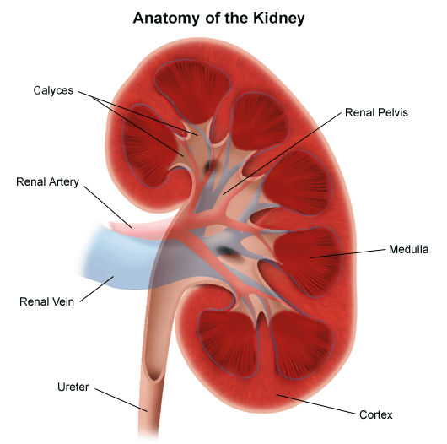
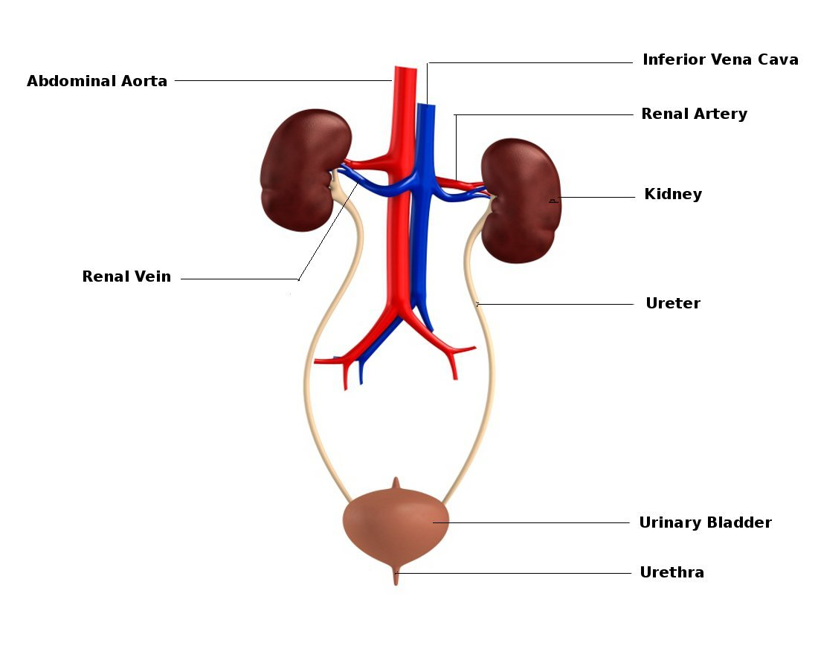
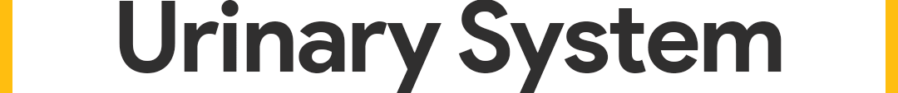
Kidney

Functions of the kidneys involves various processes such as excretion, which is the procedure of urea and other toxins made in the body are metabolised and removed from the blood and incorporated into the urine. Another function of the kidneys is to control osmotic potential of the blood and this is when surplus water is removed from the blood and incorporated into urine. The pH levels are controlled in the blood by the kidneys and this takes place when surplus hydrogen ions are neutralised or removed from the blood. The kidneys role is to the regulation and production of erythropoietin, that controls red blood cells production in the bone marrow (Dirks et al., 2006).

Physiology of reabsorption and excretion

Reabsorption takes place in various stages in the kidneys. The proximal convoluted tubule (PCT) is part of the reabsorption site, where a tubular structure that is based in the nephron of the kidney. The PCT will reabsorb up to 80% of filtered sodium (Na) and h20. During this process the PCT will absorb almost all of amino acids and glucose for protein synthesis and energy. The glucose is absorbed by the Na-Glucose cotransporter and also reabsorbs some bicarbonactes, potassium, phosphate and calcium. PCT is connects to the Bowman’s capsule, which is essential for the reabsorption of water and other solutes in the nephron. Filtrate enters the PCT due to sodium and potassium in the epidethal cell in the membrane. Waste is prevented from passing through the cells by the PCT that has epidethal cells that ate tightly compressed to it, therefore causing difficulty for waste to pass though (Palmer and Schnermann, 2015).

The PCT then leads on to the loop on Henley, which carries out the function to increase salt content in the tissues of the medulla. This allows for the reabsorption of water to take place from ultrafiltration in the second coiled tubules and collecting duct. The loop of Henley is allocated between the PCT and the Distal convoluted tubule (DCT) in the nephron. This is a juxtamedullary nephron because of its long loop of Henley and because it is formed in a stricter where there is a deep dip in the medulla. The structure is essential in increasing the concentration levels of urine in the kidneys. The concentration of filtrate has an osmolality of 300 m0sm/L , the same and the surrounding tissue fluids, meaning the filtrate is isosmotic with interstitial fluid. This differs from the loop of Henley as the thick ascending limb releases a lot of Na+ ions and negative ions such as chloride follow, which creates a concentrated salt region within the medulla (Molnar and Gair, 2020). Therefore water (H20) eaves the thin descending limb of the loop of Henley because of the surrounding salty environment. As the H20 leaves the descending limb, the filtrate becomes significantly more concentrated. Due to the sodium ions being pumped out in the thicker ascending limb it causes the osmosis to decrease (Koeppen and Stanton, 2015).

The Distal convoluted tubule (DCT) is the third main site of when reabsorption takes place and its where highly selective molecules are reabsorbed back into the blood. The descending limb will lave low permeability to ions but will have high permeability to water. The filtrate moves up to the ascending limb and the ions are reabsorbed. The salts are being actives pumps from the filters and back to the blood where water does no do this. Therefore osmosis does not take place in the DCT (Koeppen and Stanton, 2015).

Urinary system

The basic components to the urinary tract included the kidneys, Ureters, bladder, Sphincter and urethra.
The body creates energy through the breakdown of food and collects the necessary components. Waste products are then transported to the bowel and in the blood (Saladin and Porth, 2010).

The Urinary system and kidneys main function is to remove urea (liquid waste) and to filter chemicals such as sodium, potassium and water for energy and homeostasis. The production of urea is formed when foods containing protein are broken down into the body and then carried through the bloodstream to the kidneys (Saladin and Porth, 2010).

Summary Functions of Urinary Organs Summary
Urinary System | - Stores and removes liquid waste.  - The organs in the Urinary system include; the kidneys, ureters, bladder and urethra.
Kidneys | - Removes liquid waste  - Balance the body’s fluids  - Release hormones to regulate blood pressure
Ureters | - Carries urine from the kidneys into the urinary bladder
Urinary bladder | - Storage of the urine.  - Contains nerves to alert the body when it needs to excrete the urine.
Urethra | - Carries the urine from the bladder to outside the body
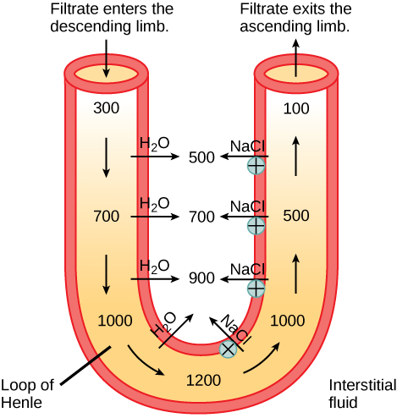
Urea is removed from the kidneys through nephrons (small filtering units). Nephrons consist of a ball formed from capillaries known as glomerulus and a small tube known as a renal tubule. The removal of urea, water and waste together forms urine as it is passed through the nephrons and down the renal tubules of the kidney (Palmer and Schnermann, 2015).

Ureters are narrow like tubes that transport urine from the kidney and into the bladder. Ureters contrain muscles that contract forcing to exit away from the kidneys. It is then exited through the hylam and runs down to the urinary bladder. However, if urine is backed up, there runs the risk of a urine infection.

The urinary bladder functions as storage for urine. Therefore it is hollow and triangular in shape located in the lower abdomen. The bladder is held in to position by ligaments that are attached to other organs and the pelvic bones. The walls of the bladder expand and relax to store and expel urine via the urethra (McGrath and Porrett, 2005).

Within the structure of the bladder contains two circular sphincter muscles that function to keep the urine from leaking. This process involves closing tightly around the opening of the bladder like a rubber band (Bar-Yoseph and Polsky, 2014).

The bladder also contains nerves that holds a purpose to alert the body when it is time to empty the bladder and urinate (McGrath and Porrett, 2005).

The excretion of process of urine is passed through a tube like structure called the Urethra. The brain signals the bladders muscles to constrict in the attempt to excrete the urine, and at the same time, signals sphincter muscles to relax allowing the urine to exit the bladder via the urethra (Jones, Hard and Mohr, 2013).

References

Bar-Yoseph, G. and Polsky, A. (2014). Stimulation of the Urinary System. U.S. Patent No. 8,923,970. Washington, DC: U.S. Patent and Trademark Office.

Dirks, J., Remuzzi, G., Horton, S., Schieppati, A. and Rizvi, S. A. H. (2006). Diseases of the kidney and the urinary system. Disease control priorities in developing countries, 2, 695-706.

Jones, T. C., Hard, G. C. and Mohr, U. (2013). Urinary system. Springer Science & Business Media.

kidney.org.uk, 2020. How Your Kidneys Work. [online] National Kidney Foundation. Available at: <https://www.kidney.org/kidneydisease/howkidneyswrk> [Accessed 6 November 2020].

Koeppen, B. M. and Stanton, B. A. (2009). Berne & Levy Physiology, Updated Edition E-Book. Elsevier Health Sciences.

McGrath, A. and Porrett, T. (2005). Anatomy and physiology of the bowel and urinary systems. Stoma Care. Wiley-Blackwell, Chichester.

Molnar, C. and Gair, J., 2020. 22.2. The Kidneys And Osmoregulatory Organs. [online] Opentextbc.ca. Available at: <https://opentextbc.ca/biology/chapter/22-2-the-kidneys-and-osmoregulatory-organs/> [Accessed 6 November 2020].

Palmer. J. and Schnermann. J. (2015). Integrated Control of NA Transport along the Nephron. American Society of Nephrology. 10 (4). Pp. 676-68.

Saladin, K. S. and Porth, C. (2010). Anatomy & physiology: the unity of form and function (Vol. 5). New York: McGraw-Hill.

Kidney.org.uk (2020)

Student Name: James Sahonta
Student number: 1715427
Lecturer: Mumtaz Goolam
Course Module: Introduction of Physiology
Course Code: BMHP5003_BIRM
Word Count: 1000

