Research proposal

Research methods and professional development
Module: ACFA7004

University of Wales Trinity Saint David
(MADE Project)



The missing 11%: Utilising robotics to fill the gaps of labour shortages and attendance inconsistency.

By
Darren Bright (2134166)
19/12/2022

Wales Institute of Science and Art
Graham Howe

 Research proposal Executive summary 

At Tubex we extrude tree shelters that protect saplings during the critical years of growth. £8 Million Tubes leave the Aberdare plan each year with a large majority being made from sustainable plastic. The shelters are produced from raw material in pellet for being extruded through dies to create the correct profile for the customer’s needs. There are critical parts to the current process that have to remain but with the possibility of introducing robotics into the plant, this will drastically change the conversion process on the manufacturing lines. An overview of the process is:
- Raw material stored in bag/day bins or silos is automatically transferred to material blenders
- The material mix set within the blenders to ensure colour, additives and reprocess material is added at the relevant rates.
- The correct mix of raw material enters the extruders where its heater to make it Moulton before Archimedes screws in the extruder fed the material into the die’s.
- The product is cooled so it solidifies.
- The product is cut to size. From here, this is where the product enters the conversion process.
- A flared end is pressed into the product (which protects the tree sapling) and from here the extrusion will automatically index to the operator for holes and ties to be put into the Tubex before the product is stacked (nested in our terms) into wooden crates called tee chests. This is the part of the process that is labour intensive and part of the process we envisage automating. Due to labour inefficiency, attracting labour and retention very difficult we see 89% average attendance against the plan hence the project title being the missing 11%.

- The below parts of the process is what the research proposal will be based on to provide the solution in the points below.

- The tube will be securely gripped and accurately rotated into the required orientation using an overhead vision system, which will detect the tube’s strengthening seams.

- Punches or laser systems will cut the holes. Where the tube requires two pairs of holes, two such systems will automatically index to their required positions, allowing the two pairs of holes to be cut simultaneously. Extraction of gas and debris from this process will be essential.

- Tie wraps will be automatically inserted into the cut holes. Where the tube requires two tie wraps two automatic tie wrap inserting heads will need to automatically index to their required positions, allowing the two tie wraps to be inserted simultaneously.

- Tie wraps will be individually orientated and fed to the auto inserting heads from such devices as a bowl feeder or reel feeder. The system has to retain Tubex’s existing release-able tie wrap design.

- The tube will be preheated and flared at one end using a similar solution to what already in place.

- The tube will be released from the orientation clamp and picked by a robot equipped with a suitable end-of-arm tool and placed directly into the tee chest. At the extrusion line producing the largest diameter tube, the robot will place the tube directly into an aligning device contained within the stillage. At the extrusion lines producing the smaller four diameters, the robot will nest each tube within its larger diameter brother/sister. Each stillage will have capacity to hold 60 tube nests, each nest containing five tube diameters.

- This will be the end of the process as far as my research proposal goes but future research may entail further Robots in the form of potential AVG’s to move the Stillage’s containing a complete set of 60 tube nests to a packing station. Here the tube nests will be automatically unloaded by robot into a banding machine where they will be automatically banded into bundles. Bundles of Standard Range tubes with lengths 400mm, 500mm, 600mm, and 750mm will additionally be automatically bagged and their bags automatically banded.

- Introduction…………………………………………………………………………………………………………….4

- Research aim……………………………………………………………………………………………………………5

- Robotics background……………………………………………………………………………………………….6
  - History………………………………………………………………………………………………………………6

- Research………………………………………………………………………………………………………………..10
4.1- Advantages……………………………………………………………………………………………………..10
4.2- Auto Tie solution…………………………………………………………………………………………….11
4.3- Hole solution…………………………………………………………………………………………………..11
4.4- Nesting…………………………………………………………………………………………………………..12

- Challenges………………………………………………………………………………………………………….….13
5.1-Ethics……………………………………………………………………………………………………………….13
5.2-Bespoke technology…………………………………………………………………………………………13
5.3- Cost…………………………………………………………………………………………………………………13
- Current conclusion……………………………………………………………………………………………...…14

- References……………………………………………………………………………………………………………..16

- Appendices……………………………………………………………………………………………………………..17

1-Introduction
The use of Robots in manufacturing is not a new idea but the idea has spread greatly with the development of industry 4.0. Even smaller companies now have the ability to look into Robotics as an automation solution. The need for companies to become more efficient within production and manufacturing areas has led to new a lot of companies now offering affordable Robotic solutions. For many years, Automation was seen as the technological solution to either speed up manufacturing lines or make them more efficient. A lot of the time this automation did not involve robots but actuators and mechanical Automation controlled by PLC’s or relay logic.
Industrial applications of Robotics gained a paramount importance in the last century. The beginning of Industrial Robotics as we currently define it, can be dated back to the 1950’s, although some kinds of automation in industry started to appear since the times of the Industrial Revolution. The evolution of industrial robots can be subdivided in four categories, as in (Zamalloa, 2017) , the first three covering the timespan from the 1950’s to the end of the 1990’s. The robots of the fourth generation which ranges from 2000 to nowadays, that are characterized by high-level “intelligent” features such as the capability of performing advanced computations, logical reasoning, deep learning, complex strategies and collaborative behaviour are likely to be the generation to provide solutions to my issues today.
Within a manufacturing line that is very labour intensive due to the dextrous nature of the task questions have been asked for many years if Robots can be used to support staff. Within the plastics industry, automation and Robotics have not been the obvious choice but with labour recruitment and retention becoming increasingly difficult, the only way to move forward is to evolve. Week on week labour fulfilment percentages are not getting better than 89% so how do we find the missing 11%? Is Robotics the answer?
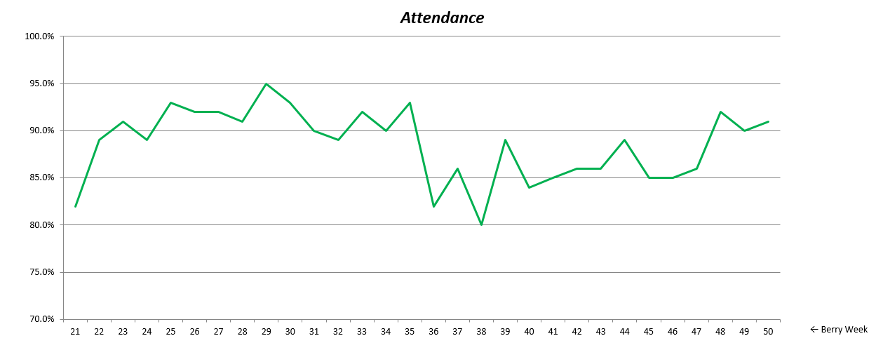

2-Research aim
The aim of this research article is to explore if modern day Robotics can work in tandem with humans as part of a manufacturing process. Key components of the research will be:
- Do robots have the ability to hit line speeds?
- Are robots dexterous enough to carry out the specific task?
- Are Robots currently carrying out similar processes where they work in tandem with employees?
- How reliable are Robots?
- What Data can be provided to support manufacturing?
Along with above components an essential part of the research will be cost and if the cost is justified. As with most corporate business, the shareholders and board of directors ultimately have the final say on innovation projects and that generally comes down to payback. Capex rules stipulate that a as rule of thumb the ideal payback on investment of any project is to not exceed five years.
Key Facts (FY22):
- 2574 tons sold
- 21 M tubes
- 102,493 Direct Labour hours
- 77,225 FTE / 77,314 Agency
- Line capacity: 47,144 hrs (85%) shutdowns removed 96%
- Labour intensive process (1 tube every ~10sec)
- Labour limitation for line output
- High seasonality
- Ranges from 15 to 45 temps
- Difficulty to hire, churn rate = 3/1
- Inventory build-up needed
- Impact on lead time & sales during season

3-Robotics Background--International Federation of Robotics (ifr.org)
3.1History
After carrying out literature research using journal articles, google and engineering magazines I found substantial information on the history of robots and their application. The message from all the research clearly identified key generational changes in Robotics through the decades. Many articles were aligned in their messages two of which have based my background data on (Gasparetto, 2019) (robotics, 2021).
Although Robotics had some purpose pre 1950 it wasn’t until 1959 where the development of the first industrial robot by George Devol and Joseph Engelberger was established. It weighed two tons and was controlled by a program on a magnetic drum. They used hydraulic actuators and were programmed in joint coordinates, i.e. the angles of the various joints were stored during a teaching phase and replayed in operation. They were accurate to within 1/10,000 of an inch.
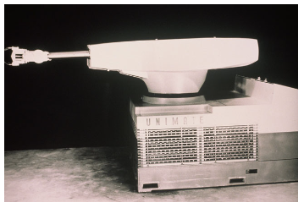
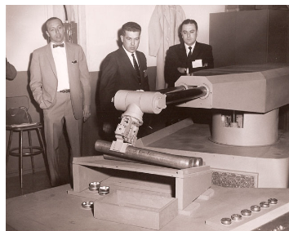
In 1961 Unimation installed the first industrial robot at GM The world's first industrial was robot used on a production line at the GM Ternstedt plant in Trenton, NJ, which made door and window handles, gearshift knobs, light fixtures and other hardware for automotive interiors. Obeying step-by-step commands stored on a magnetic drum, the Unimate robot's 4,000 pound arm sequenced and stacked hot pieces of diecast metal. The robot cost US$ 65,000 to make but Unimation sold it for US $18,000. Towards the end of the decade in 1967 The first industrial robot in Europe was installed at Metallverken, Uppsland Väsby, Sweden followed by at The octopus-like Tentacle Arm was developed by Marvin Minsky and in 1969 GM installed the first spot-welding robots at its Lordstown assembly plant. The Unimation robots boosted productivity and allowed more than 90 percent of body welding operations to be automated vs only 20 percent to 40 percent at traditional plants, where welding was a manual, dirty and dangerous task dominated by large jigs and fixtures
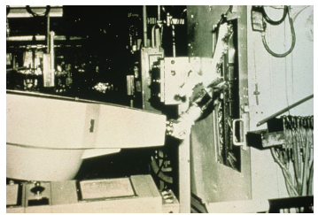
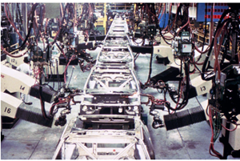

Once the Automotive industry were on board with Robotics in the 1970’s the use of Robots really took off. More robots manufacturers were starting to evolve and big names in the automotive industry such as GM and Fords were on board and considering where robots could impact their operation. During the same time Japanese manufacturers had started to get on board with Robots and developed the Kawasaki-Unimate 2000, the first industrial robot ever built in Japan with the manufacturer and county to become one of the leading manufacturers in the world. It was in Japan that the first national robotic association in the world was founded in 1971, namely JIRA (Japanese Robotics Association).
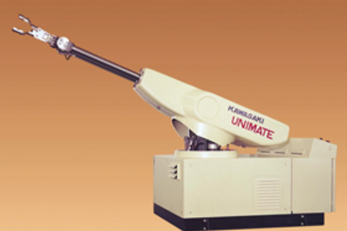
Within the 1970,s the industrial robots of the second generation (conventionally ranging from 1968 to 1977) were basic programmable machines with limited possibilities of self-adaptive behaviour and elementary capabilities to recognize the external environment (Zamalloa, 2017). These robots used servo-controllers, which enabled them to perform both point-to-point motion, and continuous paths as well. Their control system consisted of microprocessors or of Programmable Logic Controllers (PLC), and they could be also programmed by an operator by means of a teach box. Tech boxes and software was bespoke to each manufacturer and not very user friendly. Specialised integrators and manufactures were relied on to programme and fault find on what were at time extremely expensive part of a process. This fact meant that the robots were very task specific. Within this era of robots hydraulic actuators started to be replace with electric motors, sensors, actuators and basic electronic control. In 1975 ABB developed an industrial robot with a payload up to 60 kg which met the demand of the automotive industry for more payload, more flexibility. The robot, called the IRB60, was first delivered to Saab in Sweden for welding car bodies and in 1979 Nachi, Japan, developed the first motor-driven robots The spot-welding robots ushered in a new era of electric driven robots, replacing the previous era of hydraulic drive
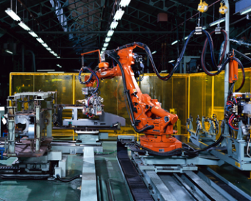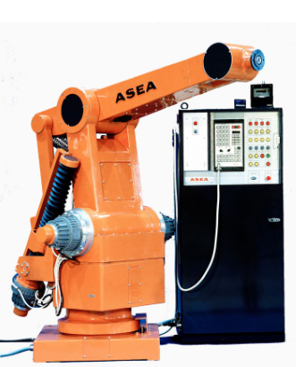

The industrial robots of the third generation (conventionally ranging from 1978 to 1999) were characterized by a larger extent of interaction with both the operator and the environment, through some kind of complex interfaces such as vision or voice and has some kind of self programming. The robot of this generation were smarter and continued to get smarter. With the use of servo controls they could move from point to pint more accurately and more linear paths, Programming was achieve by the use of PLC’s or micro processors and some even evolved to be interfaced with a data base or computer automated design.
The intelligence of these robots allowed some self diagnostic and failure indication. Another relevant technical improvement in industrial robotics was the appearance of direct drive actuated robot. The first prototype of this kind was the CMU Direct Drive Arm (Asada & Kanade, 1983) , developed in 1981 by Kanade and Asaka at Carnegie Mellon University (Pittsburgh, USA). This kind of robot featured higher accuracy and faster operations because the motors connected directly to the arms eliminating the need for intermediate gear or chain systems. ABB, Sweden produced the fastest assembly robot (IRB 1000) which was equipped with a vertical arm or a sort of hanging pendulum robot. The robot could work quickly across a large area without the need to traverse. It was as much as 50% faster than conventional arm robots.
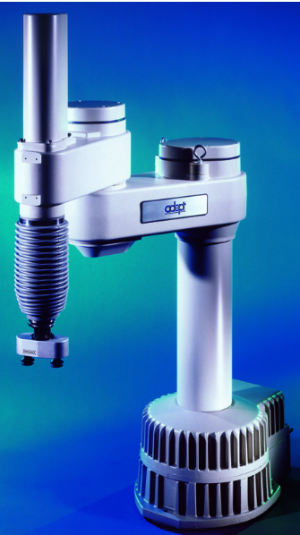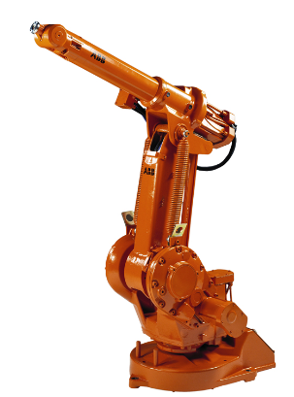

Development in the 1980’s was fast and although more technical it wasn’t until the 1900’s arrived that Robotics took a bigger step forward with high speed and lighter weight Robotics being developed. Serial and parallel robots were being developed running at such speeds the brought about pick and place manufacturing lines. In 1992 Demaurex, Switzerland, sold its first Delta robot packaging application to Roland with the pick and place robots packing pretzels into trays followed in 1998 by ABB and its flex picker running at 10m/min and packing 120 objects a min. In 1999 KUKA robotics ahd developed remote diagnostic through the internet and Regis robots were using laser guides on its robotic arms.
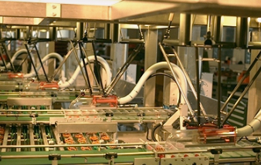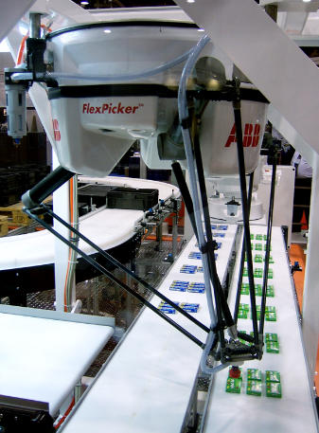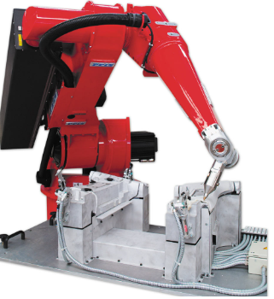

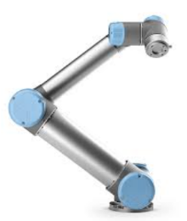
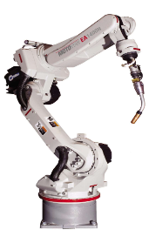
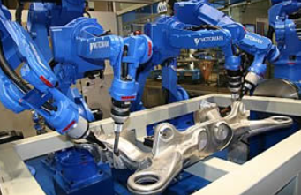
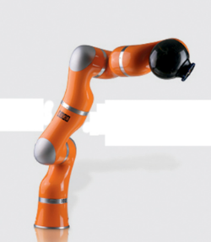
Beginning from the year 2000 the robotics sector entered the 4th generation of robots. Such robots feature high-level “intelligent” capabilities such as performing advanced computations, logical reasoning, deep learning, complex strategies, collaborative behaviour. In 2004 Motoman, Japan, introduced the improved robot control system 〈NX100〉 which provided the synchronized control of four robots, up to 38 axis using a pendant control and Windows operating system. KUKA developed the lightweight robot in 2006 which was highly sensitive thanks to its smart sensors and weighed just 16kgs whilst Motoman Japan launched a super fast arc welding robot which had 40% axis movement. Many Robot manufactures were now established and investing in innovation. Fanuc, Universal, ABB and Yasakawa were all offering smart, reliable and relatively low cost Robots that suited many industries. End effectors and manipulators along with tooling capabilities of robots now seemed endless with multiple option available and new integrators of automation solutions now Turing top robots as oppose to collation devices.

4.Research- Robots to close the missing 11%
4.1-In recent years we have invested in the production line as most companies have. With the cost of automation, dropping and industry 4.0 technology coming on board we have been able to accurately, measure line performance using real time machine feedback. An initiative we ran called standardise 17 allowed us to standardise all nine manufacturing lines to use the same instrumentation and control alongside the introduction of Total productive maintenance (TPM). So how does this fit into the missing 11%.
The turning point in the industrial sector over recent times has been with the arrival of big data, artificial intelligence and machine learning, all technologies that determine the autonomy of the machine in carrying out the work, without the need for human intervention. The With real time data it allowed us to see that machine uptime was very high, in excess of 98% but out targeted output was being missed. After drilling down through the data we established that due to staff shortages line leaders were slowing manufacturing lines down to speed to match the labour and not the operating plan. The lines were being dictated by the amount of employees on site as oppose to fully staffing the lines to match the plan. For many months we looks we worked with recruiters to get a stable workforce but the realisation was that a technological change is required.
There are considerable advantages in the implementation of automated robotic processes and certainly, they must be identified in productivity, consistency and efficiency and staff can spend more time on activities that have a greater impact on the business. The movement of particularly heavy or toxic objects or materials and repetitive mundane tasks can be entrusted to robots and automated processes.
At other Berry sites robots are placed in cold warehouses carrying out repetitive task such as box loading or unloading and in one site the robots dip non-woven fabric into hazardous dye which would be a problem for a human without the relevant PPE. Another advantage that has been seen on a recent Robot installation at our Tarragona plant is a reduction in risk and a reduction in errors. Repetitive activities are done the same way, every day when loading or packing activities are carried out and although our process is different, the repetitiveness is similar.
You can be sure when processes, tests, updates and workflows will take place, how long they will last, and how consistent the results will be. Business productivity is increased thanks to the constant and tireless use of robotic automation. (ARCOS, n.d.)

4.2- Robots to take part of a human’s task or robot and Human Corporation are now more interactive and more personalised than ever. We see in news broadcast and articles that Robots support the NHS in theatres, manufacturing and even in transportation. In these applications, robots are desired to have the capabilities of handling tasks autonomously in different environments and interact with human safely. A key enabler to these applications is to design a system with reasoning and learning ability. That said the process we are looking to use Robotics as a solution requires a cable tie to be inserted through a hole at high speed and looped by around into itself. Although the task is easily performed by a human it is dexterous and the Human hand is perfectly developed to carry out the task, Can this dexterity be achieved using a Robot. To look at solutions for this aspect further research will need to take place with integrators to look at robot options but Justas important end effector options. How to portray the movement of the human hand may be very expensive leading to the end effector being a critical part of the process. Cable tie insertion guns exist as a concept but in an automated way controlled by a robot will not be an off the shelf solution.
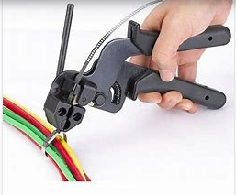

4.3- Creating a hole in the plastic extrusion is an essential part of the process currently but if the hole isn’t clean cut it doesn’t cause to much of an issue for the employee. For an automated application that will not be the case and the hole will need to be clean cut every time else the robot end effector will not be able to get the tie inserted. When you think of how to put holes in plastic, the obvious choice would be to drill or punch. Neither of these solutions will work in our extrusion as it moving as part of the process. This is due to the product moving at speed and also the extrusion being weak enough that any pressure applied causes it to fold in on itself. I’ve researched this many times including reading papers from the polymer academy and speaking to experts at city of Wolverhampton college which is the polymer training centre. The obvious answer that processing plastic always comes back to is use hot pins to melt through extrusion. This usually has to be an off line conversion process so can be quite slow but still a tangible solution. The other solution is to use lasers but again the question comes down to speed and cost. Both will require further research and will need to be assessed from a HSE perspective. Early research provided:
- Cutting holes with lasers eliminates the maintenance costs associated with a mechanical punch tool. Including maintenance and adjustment of the mechanism and sharpening of the tool itself.
- Cutting holes with lasers provides the flexibility to cut different shapes and sizes of holes, should these be required in future tube designs. It also allows for varying hole positions, either relative to one another and/or the tube’s reinforcement seams. A mechanical punch solution would require costly re-tooling.
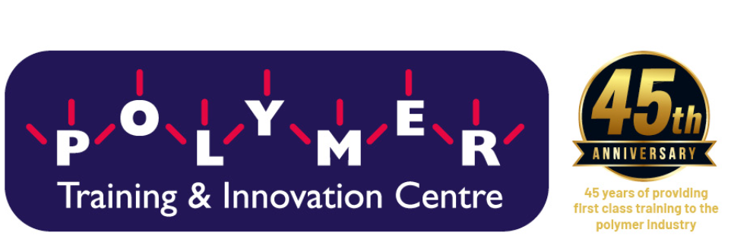

4.4- Nesting a tube involves placing different diameter extruded product into each other so you end up with a nest of product much like a Russian doll. This application is very much suited for Robotic application. Again the design of the end effector will be critical but this application is a pick and place operation. Handling of the product to ensure no damage is caused will need some R and D with various trials of the best option of end effectors with some options shown below.
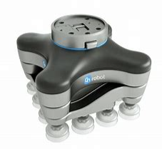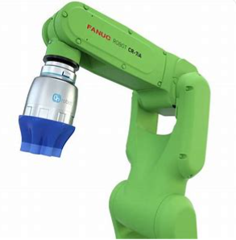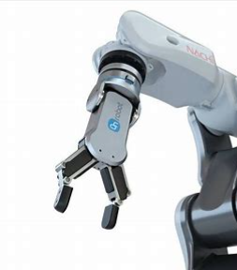

5- Challenges
At this point, in the research there are some obvious challenges that are listed below but I have reached out to our Tarragona plant who recently installed KUKA robots and have started correspondence with the UK representative. Prior to any site visit KUKA understood, that any investment in Robotics would come at a cost and has to match the business needs whilst providing payback. The International Federation of Robotics reports in September 2020 that there are 2.7 million robots in factories globally, an increase of 12% on 2018. UK robot sales dipped in 2019 while they rose elsewhere, including Ireland (KUKA, 2020). The will be many challenges relating to the type of Robot for our process and choosing the right technology but the challenges I’m focussing on at this time is more aligned with the site challenges.
5.1-morals and Ethics- A key statement in this project charter is that ethically we don’t want Robots to replace employees. There is a place for both in our company but the balance has to be right. The main driver of the research is to ensure that we can fill the 11% gap without the reliance of temporary labour. Morally if we were to look at replace the majority of employees with Robots in an area of South Wales where unemployment is high then we would be doing the wrong thing. Ultimately if we could fill out vacancies 100% of the time and maximise line through put then a proposal such a s this wouldn’t exist. With improved benefits and wages being offered and still no improvement in the missing 11% we have been forced to look at the only remaining option of turning to technology. There will obviously be some vacancies lost to the robots but installing Robots will also create other jobs for more highly skilled employees that have to work with and maintain the robots.
5.2-Bespoke technology is what we have always struggled with as with many plastics companies. Within our plastics industry there is no off the shelf solution for our process when it comes to conversion. Extruders, material handling systems and water baths are all off the shelf equipment but the conversion side is totally bespoke.

5.3- Cost- Brexit and stronger economies in Eastern Europe are removing our access to low-cost labour; for many businesses, this is a serious problem. Robots can help future-proof an operation from the vagaries of labour supply. It is often said that robot investment is a net job creator, rather than destroyer, as more high-skilled jobs are created (KUKA, 2020). Labour cost are also on the rise and the gap between skilled and unskilled labour is closing along side companies now having to offer more in terms of benefits and pension payments. The only thing constant is change. Labour challenges and the need to negate rising labour costs mean that automation will remain a top priority for lots of companies.
As a labour intensive company and following suit with other manufacturing or production facilities the majority of direct labour will be involved in repetitive tasks. The fact that 80% of labour is attributed as direct labour means that there will almost certainly be payback with investment into Robotics but the cost of implementation is also likely to be high.

6- Current conclusion
Current debates around robotics are dominated by concerns over the threat to employment, amid widely varying estimates of potential job losses. Countries are expected to fare differently, but there is little comparative research that goes beyond analysing industry and occupational structures. (Payne, 2019). Much like a lot of organisations outside of the aviation or automation industry we have been slow with the uptake of Robotics with the message from the directors being the availability of cheap flexible labour out weighs the investment into technology. This may have worked in the past when the business was flat but post Covid-19 the business has grown 40%+ causing flexible worker number to increase and become unreliable. This alone highlights that the estimated cost of Automation will fall within 5 year payback based upon additional overtime hours having to be paid and lost production volumes from the missing 11%.
There will be risks relative to improving technology and recent studies referrer to a shortages of skills in relation to a small group of specialists, such as engineers at the interface with IT, programmers and those involved in development and implementation of Robotics systems. The bespoke process required to introduce these technologies into the workplace was said to depend on individualised solutions developed between technology suppliers and the purchasing organisation (Payne, 2019).
Identifying the right integrator and Robot manufacturer will be key to the success to any project of this scale along with training. Training will need to be in place for both skilled and unskilled labour before any improvements are installed. No longer will an SOP be sufficient on its own but will need backing up with specialist training and training that’s regular. This should then have a positive impact on the change culture which can be difficult in the south wales valley. The management of change process is critical and a project like this will impact almost all employees even up to director level. Change programmes often fail because of poor management: poor planning, monitoring and control, lack of resources and know-how, and incompatible corporate policies and practices (Gill, 2003). With the leadership team and key directors bought into the project the buy in at the Gemba will be positively accepted as long as the management of change is delivered correctly at all levels.

7-Bibliography
ARCOS, n.d. [Online] Available at: https://www.arcossrl.com/en/industrial-robotic-automation-what-it-is-and-what-are-the-benefits-for-industries

Gasparetto, A. a. S. L., 2019. A Brief History of Industrial Robotics in the 20th Century. [Online]
Available at: https://www.scirp.org/journal/paperinformation.aspx?paperid=90517

Gill, R., 2003. Change management — or change leadership. p. 13.

KUKA, 2020. Stronger, faster, more productive automation for the new normal. [Online]
Available at: https://www.kuka.com/-/media/kuka-corporate/countries/united-kingdom/documents/kuka-weareorange.pdf?rev=d717964b6025484697be0998bd4c6177&hash=BAB7D1E24E8CB7760868E6AA0623B278

Payne, C. L. a. J., 2019. [Online] Available at:https://orca.cardiff.ac.uk/id/eprint/125500
robotics, I. f., 2021. [Online]

International federation of robotics (2021) Available at: https://ifr.org/robot-history

8-Appendicies


