

Module: Population Health and Digital Health Promotion
Module code: LCHS7007
Student Name: Carlene Campbell
Student ID:1908537
Lecturer Name: Diola Bijlhout

Table of Contents

BLOG 1 Smartphone Apps to Self-Manage Diabetes 3
Diabetes a Concern to Public Health 3
Statistics 3
MyDiabetes App……………………………………………………………………………………………………………………4
Advantages………………………………………………………………………………………………………………………..4
Dis-Advantages……………………………………………………………………………………………………………5
Recommendations………………………………………………………………………………………………….5
Blog 2 Modified e-Health Technology 6
Allergies in the UK 6
Zapallergy 7
How to use Zapallergy…………………………………………………………………………………………………………..7
Advantages……………………………………………………………………………………………………………………….8
Dis-Advantages…………………………………………………………………………………………………………8
Recommendations………………………………………………………………………………………………8
Poster – Digital Health Technology for Diabetes……………………………………………………………………………9
References…………………………………………………………………………………………………………………………………..10

Blog 1

Smartphone Apps to Self-manage Diabetes
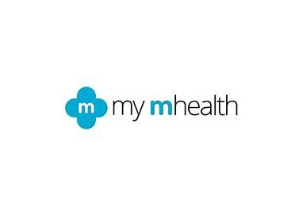

Source: ability today.com
Source: diabetes-education-km.co.uk
Diabetes as a concern to public health
Diabetes comes in two basic forms: type 1 diabetes and type 2 diabetes. Type 2 diabetes occurs quite frequently than type 1. In the UK, type 2 diabetes affects over 90% of all individuals.
In the UK, diabetes is a rapidly expanding disease. Nearly a third of the people 3.9 million live with diabetes in the UK now as there were in 1996, when there were just 1.4 million. In the UK, 5 million individuals are predicted to have diabetes by 2025. (NHS Medway and NHS Foundation Trust, 2023).
Statistics
According to Diabetes UK, (2023) diabetes costs the NHS more than £1.5 million every hour, or 10% of the overall NHS expenditure for England and Wales. Over £25,000 is spent on diabetes every minute. Approximately £14 billion is spent annually on treating diabetes and related consequences, with the expense of treating comorbidities being significantly greater. By 2025, 4 million people are predicted to have diabetes.
MyDiabetes App
With a user-friendly digital programme that provides simple access to information on smart phones, tablets, and laptops from anywhere, at any time, the myDiabetes app has been created to empower patients to undertake personal diabetes self-management. By making the most vital medical information more easily accessible, this will immediately enhance patient care. Additionally, the in-app material is specially designed to allow patients to track HbA1C, blood sugar, and other risk indicators, and access to a professional training programme enables them to acquire knowledge about diabetes with the aim of lowering the risk of major long-term problems (My Mhealth, 2023).

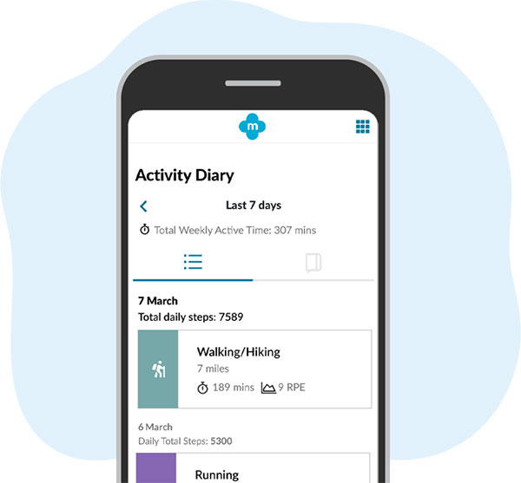

Advantages
MyDiabetes is a fully functional, NICE-aligned App that offers professional assistance, organised education, dietary recommendations, and fitness programmes. Helps people manage glucose level using blood glucose monitors connected via Bluetooth and the option to create a unique set of goals. With unparalleled access to remote treatment, patient management, reports, and monitoring tools, clinicians can provide patients with care that is quicker, simpler, more affordable, and ultimately more satisfying (My Mhealth, 2023).
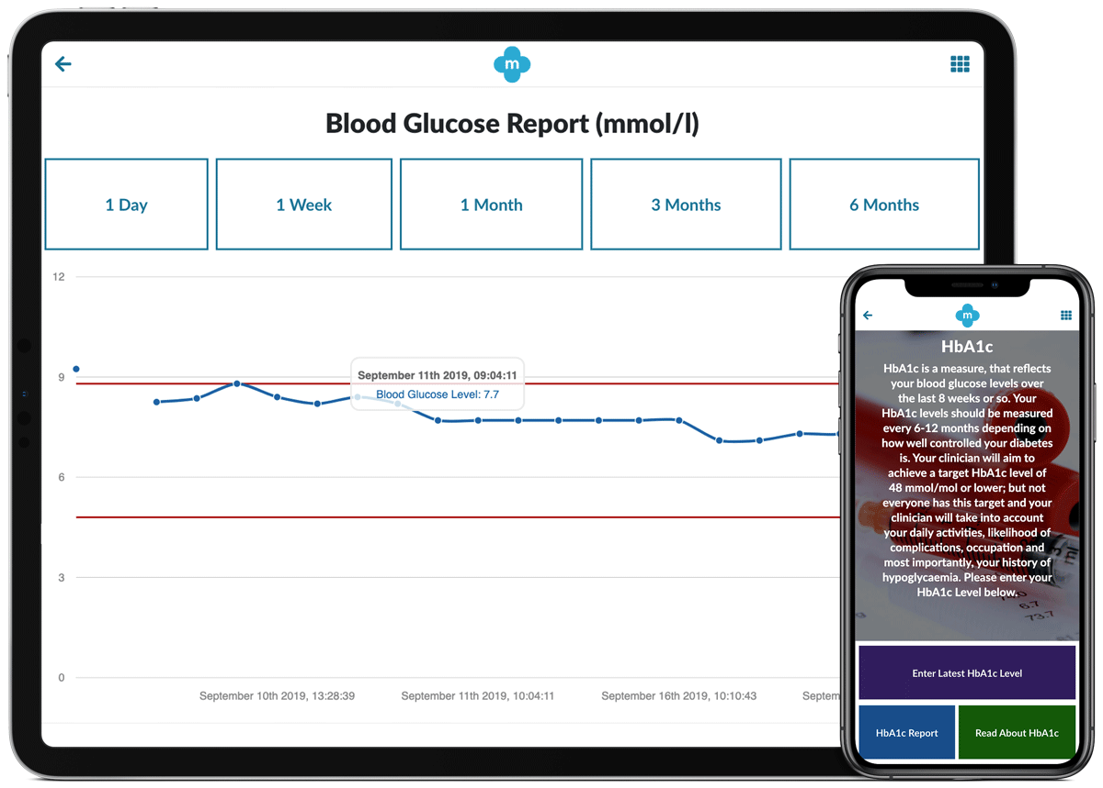

Disadvantages
Some of the disadvantages of the Mydiabetes app is if individuals have no Wi-Fi access such as some elderly people. It can encourage isolation and loneliness for individuals who have regular GP visits. If individuals do not have access to smart phones, then they will not be able to use the app.

Recommendations
Introduce virtual GP appointments via the app for those who are immobile, and this will also help to eliminate loneliness for those who prefer to see the GP. Modify the app to also be an electronic device so people without smart phones will have access to the service.
Tags: https://mymhealth.com/mydiabetes, https://abilitytoday.com/diabetes-digital-platform-successfully-rolled-out-in-kent-and-medway-med-tech-innovation/.

Blog 2

Modified e-Health technology used to monitor Allergies

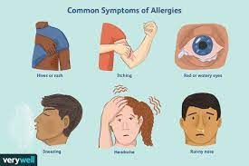

Allergies in the UK
Approximately 40 million people in the UK suffer from at least one allergic condition (Allergy UK, 2022). Thus, creating a requirement for electronic health remedies as antihistamines and steroids all have side effects and can be costly. The use of these technologies has increased significantly recently due to the various benefits of eHealth, including cost savings and the replacement of in person healthcare encounters and communications (Steven et al, 2019).
In the UK, allergic rhinitis impairs quality of life, attendance at work and school, and is a risk element for developing asthma. It affects 10-15% of kids as well as 26% of adults. According to estimates, allergies and associated illnesses cost the UK NHS around £1 billion annually (Allergy UK, 2021).

Zapallergy - Modified Digital Technology
Bionette has been modified to Zapallergy to treat or aid in preventing allergy problems like hay fever, asthma, food allergies or eczema. To become a once-a-day treatment where optimal progress will be seen within two weeks. Zapallergy works as a stand-alone treatment whereas Bionette is taken alongside antihistamines. Zapallergy is designed with settings that the user selects based on the type of allergy that they are experiencing. For example, a red light is selected for hayfever, green for food allergies, blue for asthma and yellow for eczema.
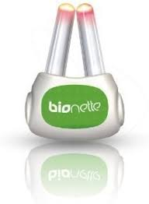
Zapallergy is an innovative and unorthodox remedy. This gizmo zaps your nose with different light treatments. This lightweight, compact pocket pollen head is ideal for use when travelling because it is only 38mm x 52mm and weighs less than 20g. Sneezing, itchy skin, breathlessness, blocked noses, and watery eyes can all be treated by this drug-free, no side-effect gadget employing minimal narrow-band light technology (Mirror, 2023).

How to use Zapallergy
The best aspect is that it is not going to keep you up at night or make you feel tired throughout the day. When allergy symptoms start to occur, you just place the gadget in the nostrils for 3 minutes, once per day. Within two weeks, improvement will be noticeable. Zapallergy can be taken daily throughout the year or only during certain seasons depending on the allergy (Bionette.co.uk)
Avoid looking straight at the source of light. Do not stick cracked or broken rods up your nose. Don't submerge the gadget in water. Don't put in the dishwasher (Bionette UK).
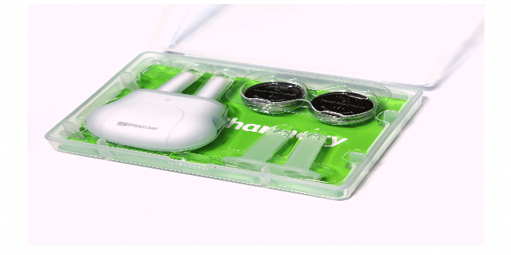
Advantages
Zapallergy costs about the same as the typical cost of drugs for hay fever season, asthma inhalers, antihistamines, and steroids for eczema. Buying Zapallergy only once will provide you years of use. Zapallergy is a long-term, drug-free, and side-effect-free treatment. Children above the age of six can also use it safely (Bionette.co.uk).
Dis-advantages
Because of the size and weight of Zapallery, it can be easily misplaced. Children must be supervised when using Zapallergy as it cannot be submerged into liquid. Individuals might experience some discomfort when using Zapallergy, as it is inserted up in the nostrils and some people have phobias of inserting objects in their nostrils.
Recommendations
Colour code the device so it can be easily seen. Improvement on the design where it can be waterproof. The probe that is inserted in the nostril can be made from a softer material such as silicone.

Tags: www.allergyuk.org/wp-content/upload/2022/12/impact-report-2022-2.pdf/, www.boinette.co.uk/using/bionette/device/

Poster

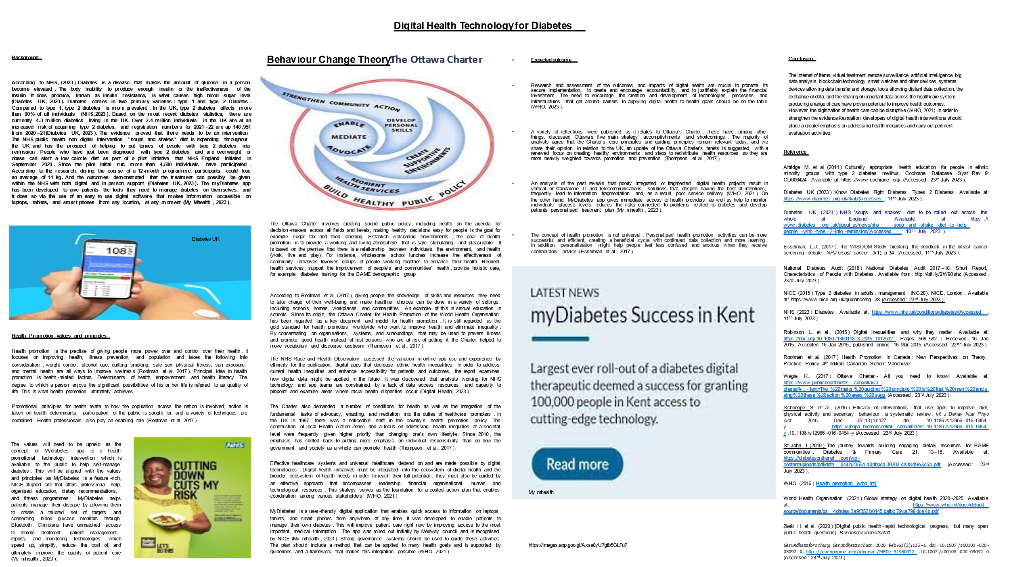

Reference
Allergy UK, (2022) Survey Impact Report. Available at: https://www.allergyuk.org/wp-content/upload/2022/12/impact-report-2022-2.pdf/ (Accessed: 19th July 2023).
Allergy UK, (2021) The British Allergy Foundation Trustees’ Annual Report. Available at: https://www.allergyuk.org/wp-content/upload/2022/12/impact-report-2022-2.pdf- annual-review=2020-2021.pdf/(Accessed: 19th July 2023).

Attridge M. et al (2014) Culturally appropriate health education for people in ethnic minority groups with type 2 diabetes mellitus. Cochrane Database Syst Rev 9: CD006424. Available at: https://www.cochrane.org/ (Accessed: 23rd July 2023).
Bionette (2023) Allergy Relief Device. Available at: https://www.boinette.co.uk/using/bionette/device/ (Accessed: 4th July 2023).
Diabetes App to the Community of Kent. Available at: https://mymhealth.com/news/mymhealth-roll-out-my-diabetes-in-kent/ (Accessed: 03 July 2023).
Diabetes.co.uk (2023) Cost of Diabetes. Available at: https://www.diabetes.co.uk/cost-of-diabetes.html/(Accessed: 3rd July 2023).
Diabetes Digital Platform (2023) Diabetes digital platform successfully rolled out in Kent and Medway. Available at:
https://abilitytoday.com/diabetes-digital-platform-successfully-rolled-out-in-kent-and-medway-med-tech-innovation/(Accessed: 3rd July 2023).
Diabetes UK (2023) Know Diabetes Fight Diabetes. Types 2 Diabetes. Available at: https://www.diabetes.org.uk/diab/(Accesses: 11th July 2023).
Diabetes UK, (2023) NHS 'soups and shakes' diet to be rolled out across the whole of England. Available at: https:// www.diabetes.org.uk/about_us/news/nhs-soup-and-shake-diet-to-help-people-with-type-2-into-remission/(Accessed: 10th July 2023).
Digital Healthcare and Medtech News (2023) Successful roll-out of NHS-Approved
Local Support – Diabetes Education Kent and Medway https://www.diabetes-education-km.co.uk/local-diabetes-support/(Accessed: 03 July 2023).
Esserman, L.J., (2017). The WISDOM Study: breaking the deadlock in the breast cancer screening debate. NPJ breast cancer, 3(1), p.34. (Accessed: 11th July 2023).
Mirror (2023) Hay fever sufferers could find huge allergy relief with futuristic tech this summer. Available at: Best hayfever remedies 2022 - Mirror Online(Accessed: 4th July 2023)
MyDiabetes (2023) The diabetes app that helps you take control. Available at: https://mymhealth.com/mydiabetes/ (Accessed: 3rd July 2023).

National Diabetes Audit (2018) National Diabetes Audit 2017–18: Short Report, Characteristics of People with Diabetes. Available from: http://bit.ly/2W90shz (Accessed: 23rd July 2023).
NHS (2021) NHS Hay fever. Available at: www.nhs.uk/conditions/hay-fever (Accessed: 4th July 2023)
NHS Kent and Medway Clinical commissioning group (2023) Diabetes Education. Available at: Book a course - Diabetes Education Kent and Medway (diabetes-education-km.co.uk) (Accessed: 03 July 2023).
NHS Kent and Medway Diabetes (2023). https://www.kentandmedway.icb.nhs.uk/your-health/local-services/diabetes(Accessed: 03 July 2023).
NHS Medway NHS Foundation Trust (2023) Best of Care best of People. Diabetes. Available at: Diabetes (medway.nhs.uk) (Accessed: 03 July 2023).
Stevens et al, (2019) eHealth apps replacing or complementing health care contacts: scoping review on adverse effects. J Med Internet Res 2019; 21: e10736. https://journals.sagepub.com/(Accessed: 4th July 2023)
NHS (2023) Diabetes. Available at: https://www.nhs.uk/conditions/diabetes/(Accessed: 11th July 2023).

NICE (2015) Type 2 diabetes in adults: management (NG28). NICE, London. Available at: https://www.nice.org.uk/guidance/ng28 (Accessed: 23rd July 2023).
Robinson L. et al., (2015) Digital inequalities and why they matter. Available at: https://doi.org/10.1080/1369118X.2015.1012532. Pages 569-582 | Received 16 Jan 2015, Accepted 16 Jan 2015, published online: 16 Mar 2015 (Accessed: 22nd July 2023).
Rootman et al. (2017) Health Promotion in Canada: New Perspectives on Theory, Practice, Policy, 4th edition Canadian Scholr: Vancouver

Wagle K., (2017) Ottawa Charter- All you need to know! Available at: https://www.publichealthnotes.com/ottawa-charter/#:~:text=The%20major%20guiding%20principle%20is%20that%20men%20and,using%20these%20action%20areas%20sugg (Accessed: 23rd July 2023).

Schoeppe S. et al., (2016) Efficacy of interventions that use apps to improve diet, physical activity and sedentary behaviour: a systematic review. Int J Behav Nutr Phys Act. 2016 Dec 07;13(1):127. doi: 10.1186/s12966-016-0454-y. https://ijbnpa.biomedcentral.com/articles/10.1186/s12966-016-0454-y .10.1186/s12966-016-0454-y (Accessed: 23rd July 2023)

St John J (2019) The journey towards building engaging dietary resources for BAME communities. Diabetes & Primary Care 21: 13–16. Available at: https://diabetesonthenet.com/wp-content/uploads/pdf/dotn044b23554a0dbbcb39203ce38d9e3c5b.pdf (Accessed: 23rd July 2023).
WHO, (2016) Health promotion (who.int)
World Health Organisation (2021) Global strategy on digital health 2020-2025. Available at: https://www.who.int/docs/default-source/documents/gs4dhdaa2a9f352b0445bafbc79ca799dce4d.pdf

Zeeb H. et al, (2020) [Digital public health-rapid technological progress, but many open public health questions] Bundesgesundheitsblatt Gesundheitsforschung Gesundheitsschutz. 2020 Feb;63(2):135–6. doi: 10.1007/s00103-020-03092-0. http://europepmc.org/abstract/MED/31960072 .10.1007/s00103-020-03092-0 (Accessed: 23rd July 2023).

https://www.verywellhealth.com/are-allergies-hereditary-5198808
https://www.digitalhealth.net/2023/01/nhs-digital-apps-data-could-reduce-health-inequalities/

