Sustainability within the hotel industry

Hotel placement (BMIH4006)

Lecturer:
Ffion Cumberpatch

Student Name:
Hani Rosteenmehr
Student ID number:
2118863

In this journal discuss what the sustainability in the hotel is and describe that why sustainability play significant role in hotel industries, and why we need have a sustainability to keep update the hotel and do best service for the guests in hotel industries.
(Premier Inn web, 2022) In the Cardiff Premier Inn central, with email that customers show booking conformation can be correct and can be emend but price of booking can be change according to date, can be less and more and hotel should inform the guests. When hotel wants to check in a lone guest ask the surname and hotel try to allocate them near lift in each floor. I believe that sustainability is sessional in all parts of hotel industry. Premier Inn every 2 or3 years update CABA system which is data base of controlling the hotel.
(visitBritain web,2022) now a days sustainability it means hotels try to reduce pollution, a side of that assist to update customer services, customer experience and support local business area of hotel. Premier Inn Cardiff central there is a tables that department of front office provide table of charity for hospital.
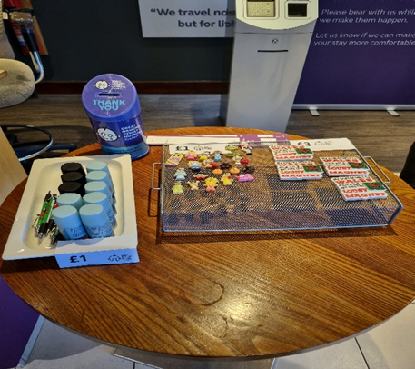
In sustainability hotels try to update to attract more people to come to the hotel. Other issue is avoid to have waste food, so they can save more money with this strategy.
(UCF web, 2022) stand out is one the main result of sustainability in hotel industries. Hotels and other businesses more concentrate on sustainability and customers culturally, socially and environmentally tend to buy their products as well and reaction to sustainability is positive. For instance Premier Inn in Cardiff central update a rooms every year and use update policy in rooms. Also they already started to renovation kitchen area and restaurant and bar.
(Reymond, 2022) Sustainability helps hotels and industries running better and of curse environmentally can better welcoming the guests. In Premier Inn guests understand that sustainability in kitchen area brings new atmosphere of seating and dining area. So they accept despite of shortcomings facilities of food area which continue with complimentary breakfast in front hall of hotel until end of December. One the other main outcome of sustainability is that establish a fanatical health to hotel as a part of business industries.
(Conet, 2021) The way that companies and hotels try to reduce waste water and food consumption is sustainability. In Premier Inn mostly in housekeeping area sustainability more tangible, like bathrooms are updated.
(Post, 2021) By sustainability hotels and brands can be beneficial for business and customer needs and demand and also play crucial role to improve industry according environment. So most of the hotels and hospitality industry start to renew the houses and restaurant and dining area because culture of customer needs have been changed and customers feedback mostly related to how hotels sustainable and can solve the issues.
(Premier Inn web, 2022) Premier Inn as largest hotel chain in UK has an aim to responsible to staff and employee and to respond to work communities by the responsibility and sustainability. I believe that in Premier Inn Cardiff central sustainability has a good speed mostly renovation of kitchen area and free complimentary breakfast is a good idea to support loyalty customers which is a part of sustainability and respond to customer needs and CABA system support suitability by connecting housekeeping area with administrative section and front office.

Reference:
Conte, D (2021), Sustainability in the Hospitality Industry: Challenges and Opportunities, available at: https://business.cornell.edu/hub/2021/10/06/sustainability-in-the-hospitality-industry-challenges-and-opportunities/
Post. G,(2021), Achieving Sustainability in the Hotel Industry, available at: https://asksuite.com/blog/sustainability-in-hotel-industry/
Premier Inn hotel Cardiff central (2022), premier Inn & restaurants skills matrix, Cardiff central administrative section

Premier Inn web,(2022), available at: https://www.premierinn.com/gb/en/home.html?ef_id=d877faae45241cbf60d099f21e24d9c6:G:s&s_kwcid=AL!9693!10!75729028422653!75729255902847&cid=KNC_Brn_B_UK_UK_Eng_PureBrand_Null_Null&mckv=_dc|pcrid|75729028422653|kword|premier%20inn|match|be|plid||pgrid|1211662306687668|ptaid|kwd-75729255902847:loc-188|&s_kwcid=AL!9693!10!75729028422653!75729255902847&msclkid=d877faae45241cbf60d099f21e24d9c6
Reymond. N. (2022), Hotel Sustainability: How Can Hotels Get Started?, available at: https://hospitalityinsights.ehl.edu/hotel-sustainability
Visitbritain web, 2022, Make your business sustainable, available at: https://www.visitbritain.org/business-advice/make-your-business-sustainable?utm_source=bing&utm_medium=paidsearch&utm_content=na_general_na_na_link_adcopy_na&utm_campaign=hubcampaign22_b2b_sep22&gclid=5313e7aae5e41f90ead484f168a36967&gclsrc=3p.ds&
UCF WEB (2022), Sustainability in hospitality: why it is important and how industry leaders can help, available at: https://www.ucf.edu/online/hospitality/news/sustainability-in-hospitality-why-it-is-important-and-how-industry-leaders-can-help/#:~:text=Sustainability%20%E2%80%94%20the%20mindful%20use%20of%20a%20resource,visit%20their%20destinations.%20Not%20doing%20so%20has%20consequences.

