

Course Title: BEng Electrical/Electronic Engineering
Module: ACDA6002
Assignment Number : 2
Assignment Title: Marine Weather Monitor / Logger
Student Name: Carys Williams
Student Number: 1708572
Hand in Date: 30/12/2021
Lecturer Name: Dr. Gary Jones

Contents
Contents 2
1 Introduction 1
2 Marine Weather Monitor / Logger 2
2.1 Type 1 2
2.2 Type 2 2
2.3 Type 3 3
2.4 Type 4 3
3 Comparison of Marine weather monitors 4
4 Sensors 5
4.1 Temperature Comparison 5
4.2 Humidity Comparison 5
4.3 Temperature and Humidity Selection 6
4.4 Wave Hight 6
4.4.1 Comparison 6
4.4.2 Selection 7
4.5 Wind speed Comparison 7
4.6 Wind Direction Comparison 8
4.7 Wind Speed and Direction Selection 8
4.6 Sunlight Brightness 9
4.6.1 Comparison 9
4.6.2 Selection 9
4.7 GPS Position 10
4.7.1 Comparison 10
4.7.2 Selection 10
5 LED Selection 11
6 Data 11
6.1 RS232 11
6.2 Non-Volatile memory 11
6.3 SD card Selection 12
6.4 Logging Rates 12
7 Microcontroller 12
7.1 Resolution Calculations 12
7.2 Specification 12
7.3 Selection 13
8 Battery 13
8.1 Specification 13
8.2 Comparison 14
8.3 Selection 14
9 Connectors 15
9.1 Comparison and selection 15
10 Casing 15
11 Pricing Table 16
12 Proteus Design 17
12.1 Full Design 17
12.2 Signal Conditioning 17
12.3 Temperature and Humidity 18
12.4 Wave Hight 18
12.5 Wind Speed and Direction 18
12.6 Sunlight Brightness 19
12.7 GPS Position 19
12.8 USB 19
12.9 SD Card 20
12.10 LED 20
12.11 Battery 20
12.12 Microcontroller 21
13 Easy-PC Design 22
13.1 Full Design Schematic 22
13.2 Full design PCB 23
13.3 Front Facing 3D view 24
13.4 3D view of layers and bottom 24
14 PCB Quote 25
15 Flow Chart 26
16 Block Diagram 27
17 Improvements 28
18 Reference 29
19 Bibliography 31

1 Introduction

Marine weather-based data logger, that takes measurements and logs data over a 7-day period, is what this report is based on. It must be portable and adaptable for any number of potential vessels.
The following data will be acquired during the 7day cycle: -
- Temperature
- Humidity
- Wave height
- Wind speed
- Wind direction
- Sunlight brightness
- GPS position
This design does not require a display except for a LED which flashes once every 10 secs for 1 sec.

2 Marine Weather Monitor / Logger
Weather monitor/ logger are data acquisition systems. They take the different conditions and translate it into data that can easily be compared to other data. There are many varieties of weather monitor that can be purchased on the market. However, they all have differences. Below will show a selection that are available to buy. Table 1 will show the comparisons of the selected weather monitors/ loggers.

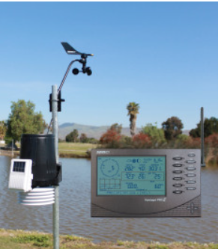
2.1 Type 1
This is a ‘Pro2’ which offers an accurate and trustworthy data with self-contained sensor suite, which is simple to install. Large Robust console with an easy-to-read display. It displays: Time and date, moon phase, weather forecast, indoor and outdoor temperature, outdoor humidity, atmosphere pressure, rainfall, wind speed, wind direction, dew pint, sunrise/sunset, weather alarm/trends. [1]

2.2 Type 2
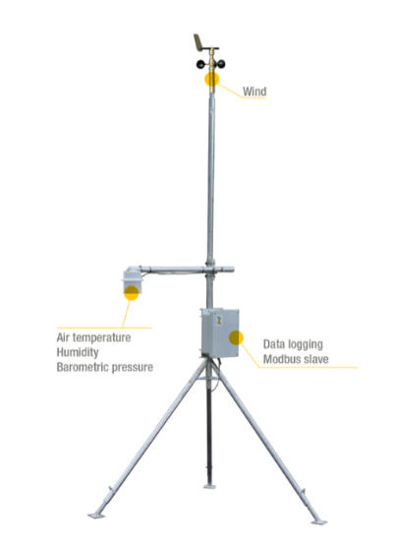
This is a Dyacon MS-120. It is a cable-connect weather station. Wind, temperature, pressure, humidity is a few of the sensors that come with it however, an upgrade is possible. The options include rain gauge, solar sensor, or soil moisture sensor. A wireless connection can be possible; however, it will need to be upgraded again.[2]

2.3 Type 3
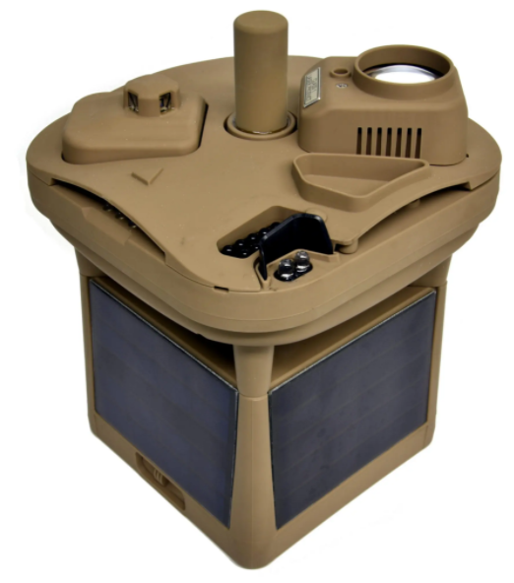
The MWS-M625, can weight up to three and a half pounds and adds a micro lidar components for cloud hight measurements. It becomes the most ruggedized, lightweight, and low-cost solution for weather sensing with cloud height measurements. [3]

2.4 Type 4
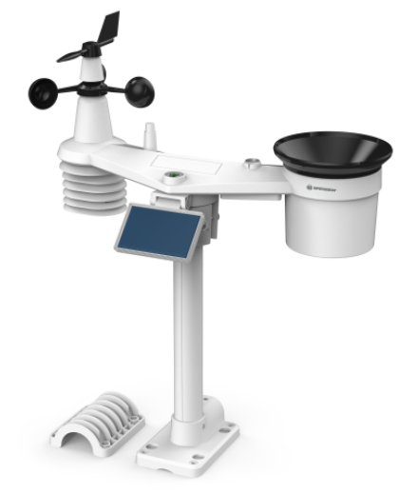
This is a Bresser 7-in-1 solar 6-day 4 CAST PRO WI-FI Weather centre. It is a solar-powered weather station that measures temperature, humidity, precipitation, wind speed, wind direction etc. it shows a 6-day weather forecast via WI-FI on a display. [4]

3 Comparison of Marine weather monitors
Here is a table that shows the comparison of the 4 types of weather monitors seleted.
Name | Wireless Vantage Pro2 Bundle | MS-120 | MWS-M625 | Bresser 4CAST PRO WLAN
Images | 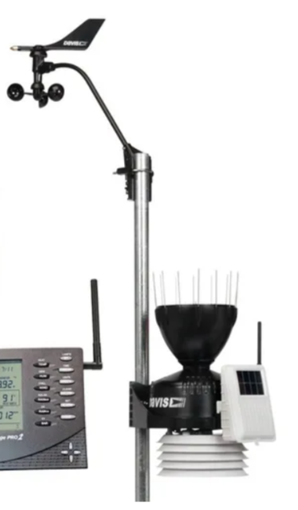 |  |  | 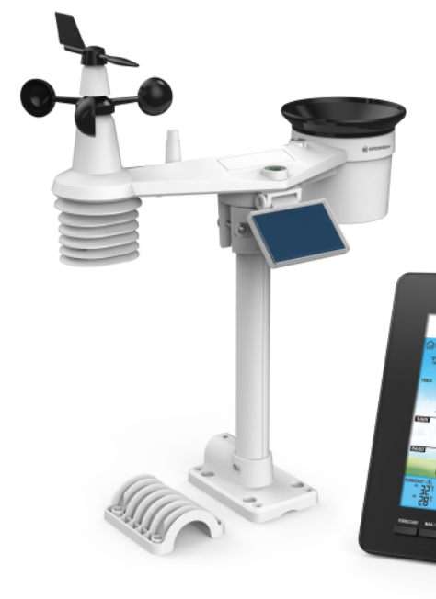
Product  Code | Vantage-pro2-bundle | MS-120 | MWS-M625 | 7003210
Voltage Supply | Solar Powered, 12VDC | 12-24V | Solar power  Nickel cadmium batteries | 5V  Solar panel
Wind Speed | Yes | Yes | Yes | Yes
Wind Direction | Yes | Yes | Yes | Yes
Temperature | Yes | Yes | Yes | Yes
Humidity | Yes | Yes | Yes | Yes
Pressure | No | Yes | Yes | Yes
Other Features? | - Rainfall  - Windchill  - Dew point  - heat calculated. | - Real-Time Gust Detection | - Precipitation  - Cloud Ceiling  - Angular tilt  - Dust Accumulation  - Lightning Distance  - 360 Imaging sensor | - Moon Phase  - Precipitation  - Time and Date  - Rainfall  - UV level and light
Upgrades available? | N0 | Yes | Yes | Yes
Data | Wireless, anemometer (12m away max), app | Cable, on bored Modbus RTU (RS-485) port. | USB cable  Transmitted data satellite | Wi-Fi, USB
Dimension | 350 x 220 x 360 mm | 420mm x 120mm | 19 x 14 x 14 cm | Sensor: 390 x 174 x 465mm  Base: 215 x 27 x 176.5mm
Price | £865.00 | +$2,493.00 | $7,300 - $27,000 | £264.00
Reference | [1] | [2] | [3] | [4]

4 Sensors
Selecting the correct sensors are essential to develop a Weather data logger. The following section will consist of comparing and selecting sensors.

4.1 Temperature Comparison
Type | Thermistor | Thermocouple | Temperature and Humidity
Image | 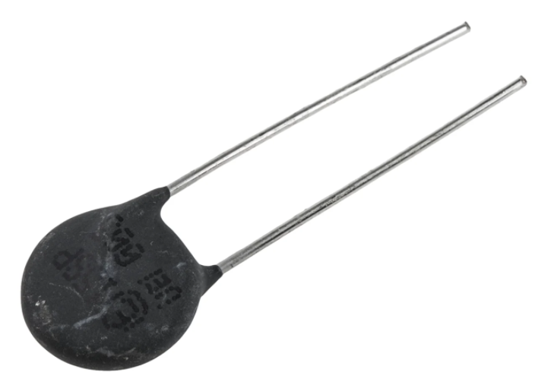 | 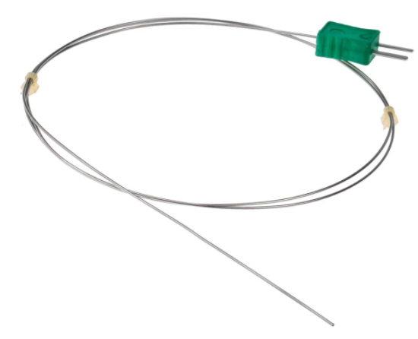 | 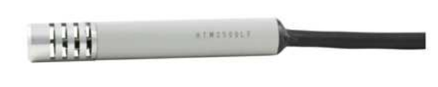
Robustness | Good | Good | Very good
Connection | Simple | Simple | Simple
Price | Cheap | Cheap | Expensive
IP rating | Low | High | High
Dual reading | n/a | n/a | Yes
Reference | [5] | [6] | [7]

4.2 Humidity Comparison
Type | Thermistor | Thermocouple | Temperature and Humidity
Image | 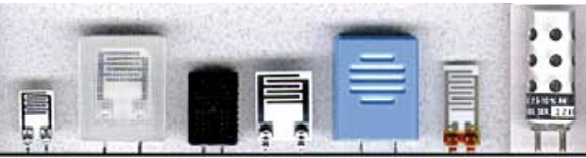 | 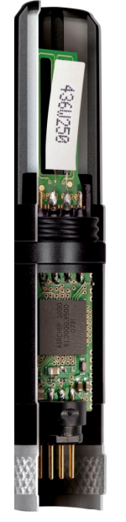
Robustness | Good | Good | Very good
Connection | Simple | Simple | Simple
Price | Cheap | Cheap | Expensive
IP rating | Low | Mid-range | High
Dual reading | n/a | n/a | Yes
Reference | [8] | [9] | [7]

4.3 Temperature and Humidity Selection
Name | HTM2500LF | T9602 – 5 - A | HX94B
Images |  | 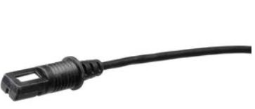 | 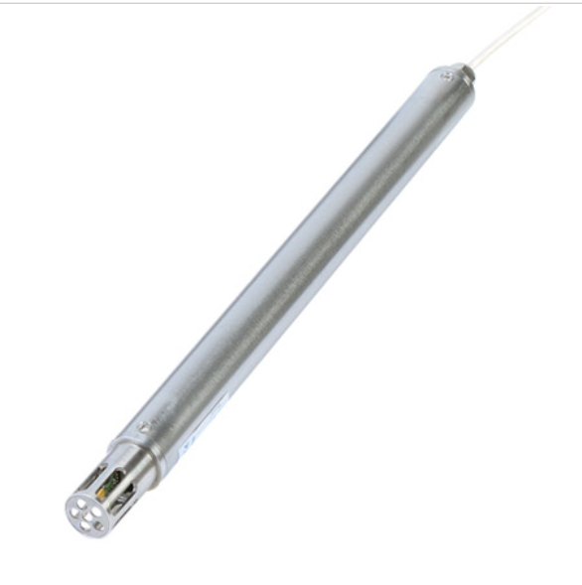
Mfr. Number | HPP809A031 | T9602-5-A | HX94B
Voltage Supply | 4.75V – 5.25V | 5Vdc | 9 Vdc – 30Vdc
Output | 1 – 4Vdc | 0 – 5V (750uA) | 0 – 10Vdc
Range  (temperature °C) | -40°C – 85°C | -20°C – 70°C | 0°C – 100 °C
Range (Humidity%) | 1 – 99 % | 0 – 95% | 0% - 100%
Connection | 5 wires | 4 Wires | 4 wires
Analogue or Digital | A | A | D
IP rating | IP65 | IP67 | IP68
Dimension | 11.6mm x 76.3mm | 41.5mm x 10.5mm | 258mm x 19mm
Price | £69.38 | £52.14 | £304.80
Reference | [10] | [11] | [12]

4.4 Wave Hight

4.4.1 Comparison
Name | Pressure | Retro - Reflective | Ultrasonic
Images | 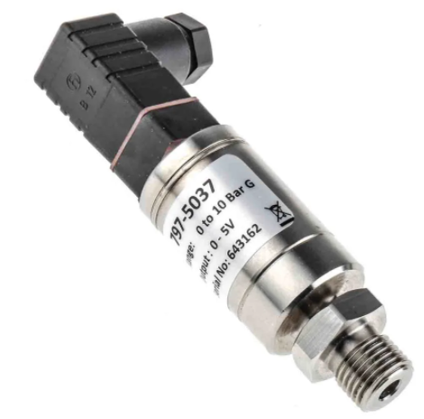 | 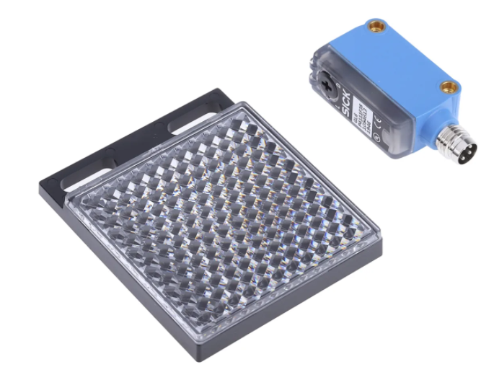 | 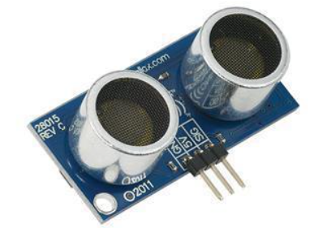
IP rating | Low - Mid | Low - Mid | Low - Mid
Price | Mid-range | Mid-range | Cheap
Accurate | Yes | Weather dependant | Yes
connection | Complex | Complex | Simple
Reference | [13] | [14] | [15]

4.4.2 Selection
Name | 28015 | 166-9496 or 166-9497 | Sick M30 x 1.5
Images |  | 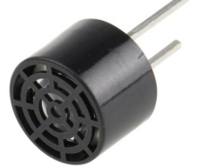 | 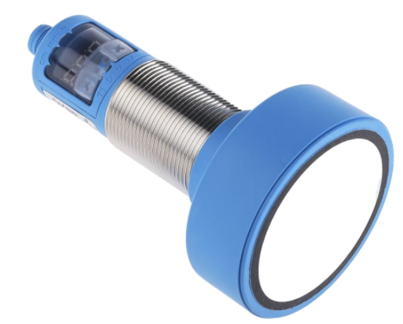
Mfr. Number | 28015 | 166-9496  166-9497 | UM30-215113
Receiver or transmitter? | Both | Order 1 Transmitter  Order 1 Receiver | n/a
Supply | +5VDC | 20V | 15V – 30V
Output | 0V – 5V (35mA max) | 0V – 20V
Range | 0.02m – 3M | 0.2 – 4M | 600 – 6000mm (0.6 – 6M)
Frequency | 40KHz | 40KHz | 80KHz
Connection | 3 pins | 2 pins | 5 pin M12 Connector
Analogue or Digital | A | A | A
Dimension | 22mm x 46mmm x 16mm | 7.1mm x 9.9mm | 105mm x 65mm
Price | £25.18 | £13.02 each | £580.09
Reference | [15] | [16] | [17]

For the wave height it was decided that it would consist of 2 plastic pipes that are in the water. One will have a large whole at the bottom, as for the other will have littles holes to allow a small flow of water to enter. This it will be able to show the height of the wave without connected another object to the seabed.

4.5 Wind speed Comparison
Name | Doppler Radar | Laser-Based LIDAR | Anemometer Ultrasonic  (Wind Speed/Direction)
Images | 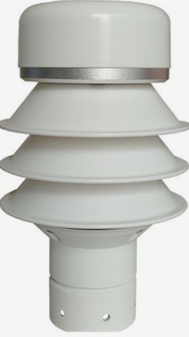 | 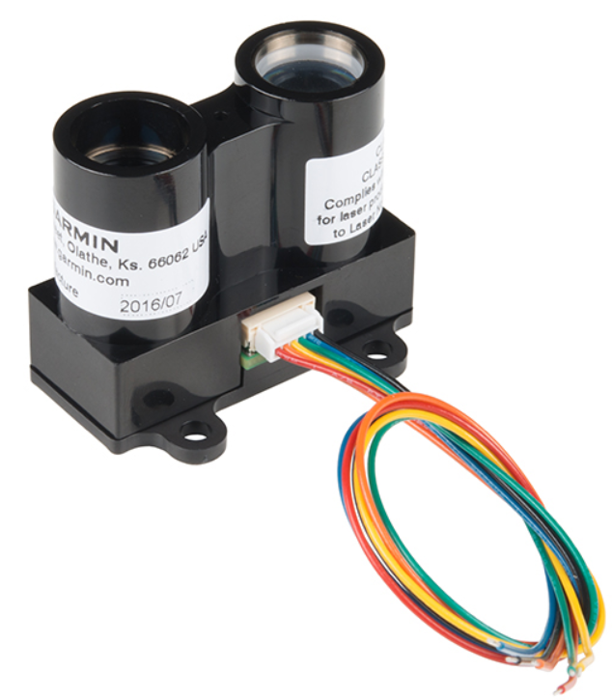 | 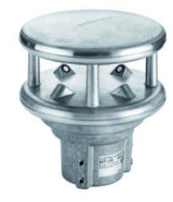
Accuracy | Good | Good | Very Good
Price | Mid-range | Cheap (large scale) | Expensive
Connection | Simple | Simple | Simple
Dual reading | N/A | N/A | Yes
IP rating | High | High | High
Reference | [18] | [19] | [20]

4.6 Wind Direction Comparison
Name | Weathervane | Anemometer Ultrasonic  (Wind Speed/Direction)
Images | 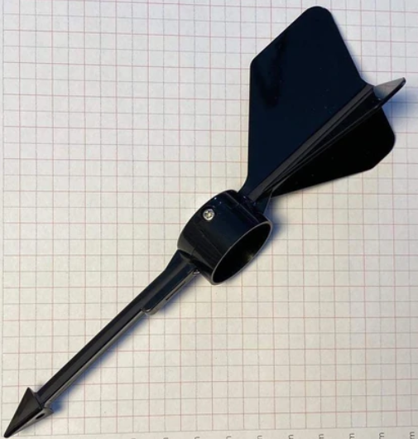
Accuracy | Bad | Very Good
Price | Cheap | Expensive
Connection | Simple | Simple
Durable | Bad (moving part) | Good
Dual reading | N/A | Yes
Reference | [21] | [20]

4.7 Wind Speed and Direction Selection
Name | Wind Sonic | Wind Observer | WMS-23
Images | 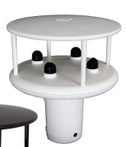 | 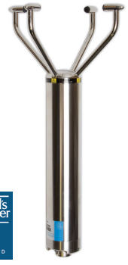 | 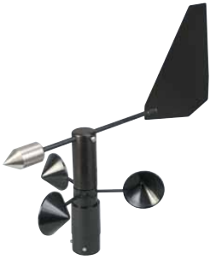
Mfr. Number | 1405-PK-021 | 1390-70-B-142 | WMS-23
Voltage | 5VDC – 30VDC | 9VDC – 30VDC | 8VDC – 30VDC
Output | 12V | 0-5V | 4 – 20 mA
Accuracy | +/- 2% | +/- 2% | +/- 1%
Response Time | 0.25 s | n/a | 0.8 mph
Wind Direction | 0° - 359° | 0° - 359° | 0°–360°  (every 2 – 5 = 355)
Wind Speed | 0 – 60 m/s | 0 – 70 m/s | 0 – 100mph
Pins | 4 wires | 4 wires | 5 wires
Analogue or Digital | RS232 | RS422/RS485 | Both
Dimension | 142mm x 163mm | 389mm x 213mm | 114mm x 216mm
Reference | [22] | [23] | [24]

4.6 Sunlight Brightness

4.6.1 Comparison
Name | Phototransistor | LDR | Photodiode
Images | 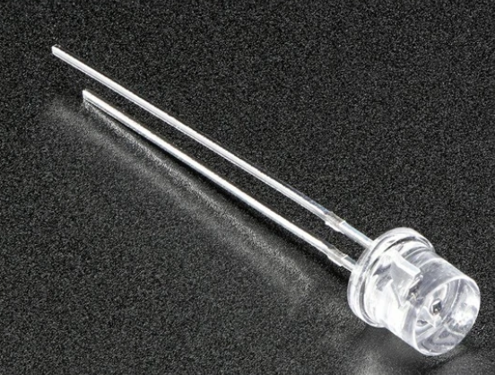 | 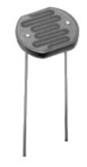 | 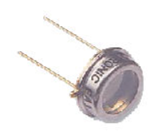
Price | Cheap | Cheap | Cheap
Durability | Fragile | Fragile | Very Fragile
Connection | Simple | Simple | Simple
Temperature range | limited | Very high | Sesnitive
Response time | Very Fast | Fast | Fast
Contaminated lens | Yes | Yes | Yes
Negative | - surges  - spikes  - EM energy |  | - High Voltage
Reference | [25] | [25] | [25]

4.6.2 Selection
Name | NORPS-12
Images | 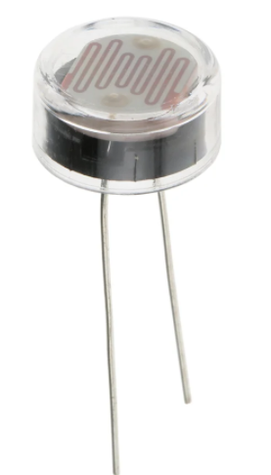 | 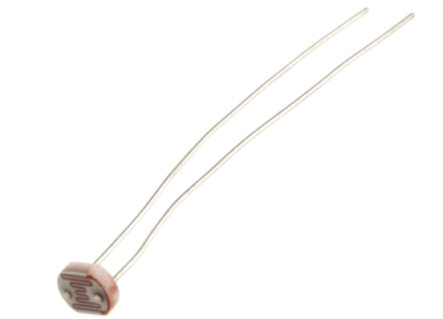
Mfr. Number | NORPS-12 | NSL-19M51
Voltage | +250V | +100V
No Pins | 2 pins | 2 pins
Resistance range | 5.4KΩ – 12.6KΩ | 20kΩ -100KΩ
Temperature range | -60°C - +75°C | -60°C - +75°C
Mounting | Through Hole | Through Hole
Dimension | 14.35mm x 38mm | 4.1mm x 37.8mm
Price | £2.91 (pack of 4) | £0.78
Reference | [26] | [27]

4.7 GPS Position

4.7.1 Comparison
Name | GPS | N/A
Images | 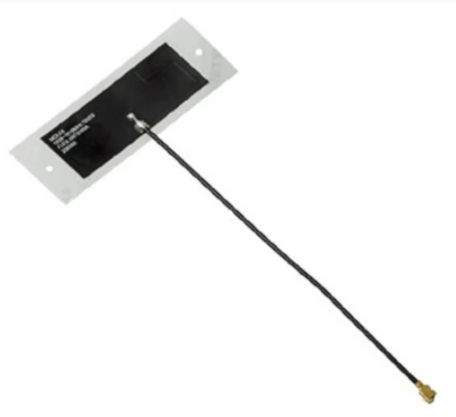
Positive | - Worldwide  - Accurate  - Cheap  - Works in all weathers
Negative | - May need backup map direction
Reference | [28]

4.7.2 Selection
Name | NEO6M | ADAFRUIT INDUSTRIES | Tiny GPS Module
Images | 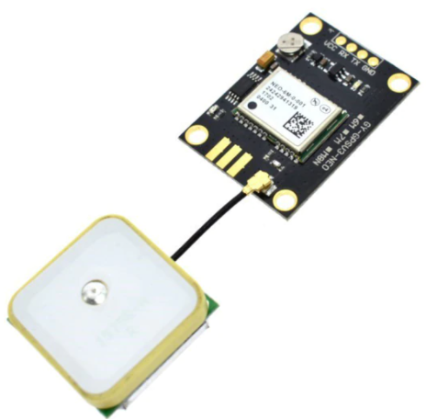 | 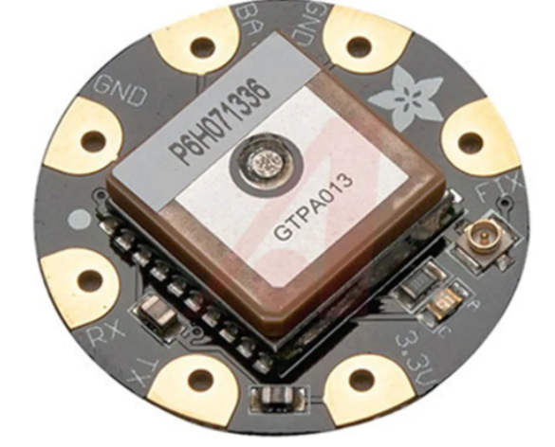 | 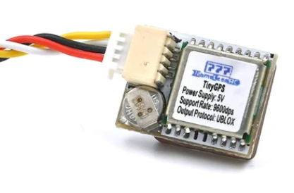
Mfr. Number | GYGPSV5-NEO | 1059 | KQP_Nameless_GPS
Voltage | 3V – 5V | 3V – 4.3V | 5V
Support rate | 9600dps | 9600dps | 9600dps
Connection | 4 Pins | 4 pins | 4 pins
Analogue or Digital | RS232 | RS232 | RS232
Dimension | 23mm x 30mm / 12mm x 12mm | 15mm x 15mm x 4mm | 12mm x 16mm x 6mm
Price | £3.60 | £38.48 | £8.99
Reference | [29] | [30] | [31]

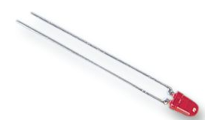
5 LED Selection
An LED is required to be fitted that will flash every 10 seconds for 1 second. A correct sized resistor will need to be in series with the LED. It will be connected as normal to the PIC. For the timer it is possible to add it to the program. [32]
An LED Pipe will be added to prevent water contamination [33]

The calculation is as followed:
$$R=\frac{\left(Battery V-LED V\right)}{Desired LED Current}= R= \frac{Vres}{If}$$
$$R= \frac{(5V-1.9v)}{20mA}= \frac{3.1V}{0.02}$$
$$R=155Ω$$

6 Data

6.1 RS232
RS232 ports are required for this system. There is one available on the PIC. Running a full RS232 will use 15V, this is not advised. A TTL would be better as it runs on 0V – 5V. This can then be connected to a PC via a USB.

6.2 Non-Volatile memory
For this design a non-volatile memory will be required. Below shows the calculations taken for the required memory storage for the duration needed.
Measurements | Logging | Calculation | Total bytes
Temperature and Humidity | 1s | 60*60*24*7 | 604,800
Wave hight | 0.5s | 60*60*24*7*2 | 1,209,600
Wind Speed and Direction | 0.1s | 60*60*24*7*10 | 6,048,000
Sunlight brightness | 1s | 60*60*24*7 | 604,800
GPS | 1s | 60*60*24*7 | 604,800
Total memory |  |  | 9,072,000

$$MB= \frac{9,072,000}{1,000,000}= = 9.072 MB$$
For a 7 day test a total of 10MB memory is required.

6.3 SD card Selection
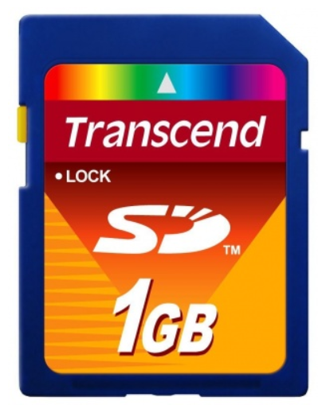
1GB SD memory card was selected. This is cheaper than a lower memory at £7.29. Also, there is room if any alterations are needed. [34]

6.4 Logging Rates
Time | Wind Speed & Direction | Wave Height | Temperature & Humidity | Sunlight | GPS
0s | Wind Speed & Direction | Wave Height | Temperature & Humidity | Sunlight | GPS
0.1s | Wind Speed & Direction
0.2s | Wind Speed & Direction
 | Wind Speed & Direction
0.5s | Wind Speed & Direction | Wave Height
1s | Wind Speed & Direction | Wave Height | Temperature & Humidity | Sunlight | GPS
1s | Wind Speed & Direction | Wave Height | Temperature & Humidity | Sunlight | GPS

7 Microcontroller

7.1 Resolution Calculations

Temperature
-20°C – 70°C range = 90 steps
Measure every 0.5
90/0.5 = 180 = 8 bits

Humidity
0% – 95% range = 95 steps
Measure every 0.5
95/0.5 = 190 = 8 bits

Wave Hight
20mm – 3000mm = 2980 steps
Measure every 20mm
2980/20 = 149 = 8 bits

7.2 Specification
Name | Analogue or Digital | Pins | Resolution | Sample Time
Temperature & Humidity | Analogue | 2 | 8 Bits | 1s
Wave height | Digital | 2 | 8 Bits | 0.5s
Wind speed & Direction | Digital | 2 | RS232 | 0.1s
Sun Brightness | Analogue | 1 | 8 Bits | 1s
GPS | Digital | 2 | RS232 | 1s
SD Card | Digital | 3
USB | D+/D- | 2
RS232 | Digital | 2
LED | Digital | 1
Switch | Digital | 1
With the resolution all components need to run on the same. It has been decided to run at 8 bits.
 | Pins
Data Storage | 3 (SPI)
Power | 2 or 4 (depending on chip)
Digital Pins (plus interrupt) | 6
Analogue Pins | 4 (8 bits)
USB | 2
RS232 Debug | 2
LED | 1
Total | 22
For this design a 40-pin chip will be selected. This is to ensure Improvement can be added and there are enough pins available.

The following needs to be considered when selecting a Microcontroller
Pins Required | 22
Memory | 9.072MB

7.3 Selection
Mfr. number | PIC18F45K50-IP | PIC18F45K50-I/MV | PIC18LF45K50-I/P
Images | 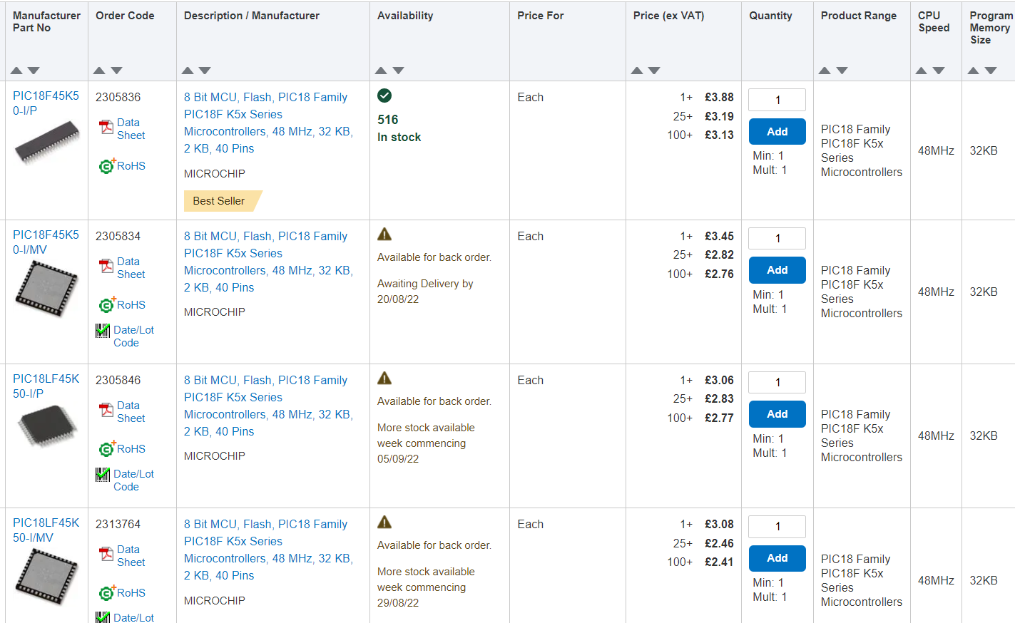
CPU Speed | 48MHz | 48MHz | 48MHz
SPI | Yes | Yes | Yes
Program Memory | 32KB | 32KB | 32KB
Max Voltage | 5.5V | 5.5V | 3.6V
Min Voltage | 2.3V | 2.3V | 1.8V
RAM Memory | 2KB | 2KB | 2KB
Price (1 ex VAT) | £3.88 | £3.45 | £3.06
Reference | [35] | [36] | [37]

8 Battery

8.1 Specification
To calculate the size of the battery required. The maximum Current for each component must be taken.
Components | Max Current
Temperature and Humidity | 750uA
Wind Speed and Direction | 44mA
Wave Height | 35mA (x2)
Sunlight | 10mA
GPS | 40mA
LED | 30mA
SD Card | 10uA
Total | 194.76mA

$$Capacity \left(Amp Hourly\right)=Total Current \left(Amps\right)× Time \left(hour\right)$$
$$Capacity \left(Amps in a day\right)=0.185Ah ×24 \left(Hours\right)$$
$$Capacity \left(Amps a week\right)=4.68Ah ×7 \left(days\right)$$
$$Total Capacity needed for a week=32.76Ah$$
To ensure the battery can last long enough the total capacity will be rounded to 50Ah.

8.2 Comparison
Battery | Nickel Metal Hydride (NiMH) | Lithium-ion | Lead Acid
Images | 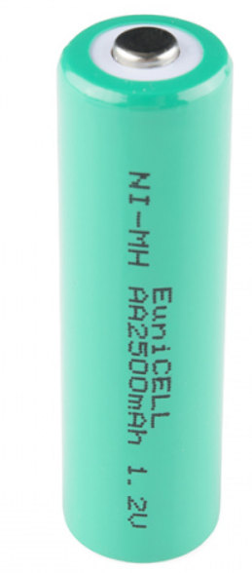 | 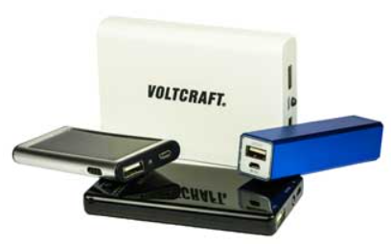 | 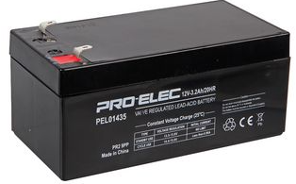
Pros | - High power density  - ‘Standard’ sizing  - Rechargeable | - High energy density  - Self-discharge  - Low maintenance  - Variety | - Cheap  - powerful  - High power capacity  - Rechargeable
Cons | - Low Density to LiPo  - Self-discharges quickly  - Limit discharge current  - Heat loss when charging | - Protection  - Ageing  - Cost | - Heavy  - Low power density
Reference | [38] | [39] | [40]

8.3 Selection
Manufacturer | QTshine | TOOSPON | MAXOAK
Images | 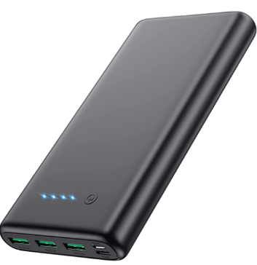 | 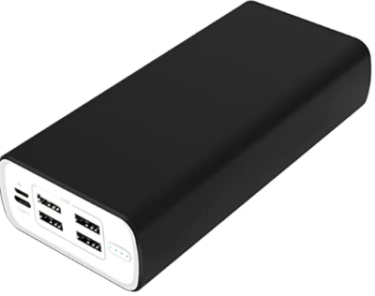 | 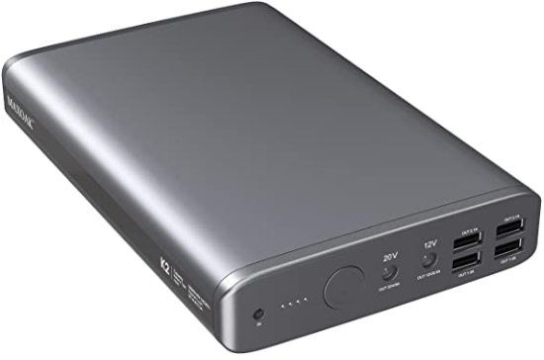
Mfr. Number | HX200Q6 | APD101 | K”-50000mAh
Voltage | 5V | 5V | 3.7V
Amp Hourly | 26800 (2 required) | 50000mAh | 50000mAh
Dimension | 155mm x 79mm x 22mm | 178mm x 84mm x 39mm | 206mm x 135mm x 33mm
Price | £23.95 | £49.99 | £169.99
Reference | [41] | [42] | [43]

9 Connectors

9.1 Comparison and selection
Manufacture | LEMO | LEMO | XLR
Images | 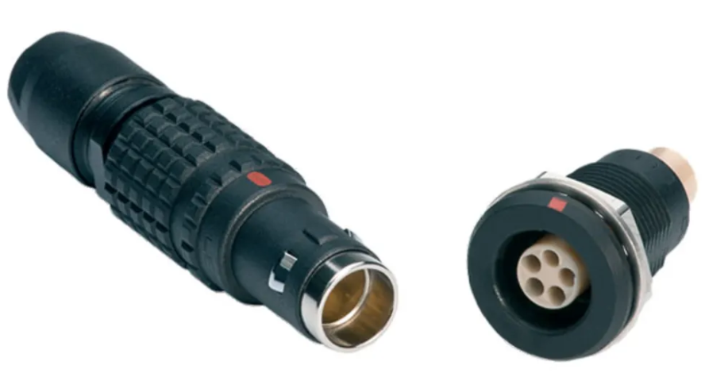 | 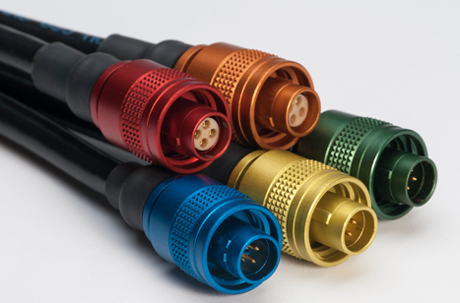 | 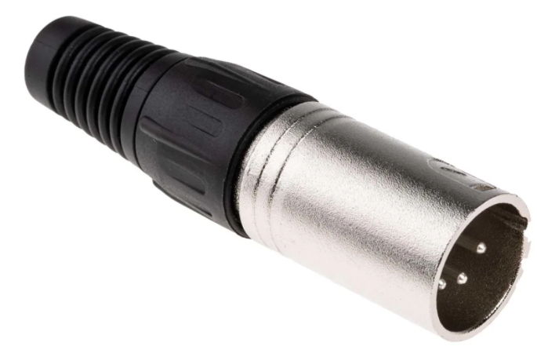
Mfr. Number male | EGG.TT.304.CLL | FMP.0M.305.LLCJ | 457-908
Mfr. Number female | FGG.TT.304.CLAC31Z | PMP.0M.305.LLMJ | 457-885
Plating | Gold | Gold | Silver
Price (Male) | £35.46 | £73.47 | £2.88
Price (Female) | £40.91 | £88.92 | £2.91
Quality | Medium | Medium | Medium
Protection | Good | Good | Low
Positive | - Medium quality  - Good protection | - Medium quality  - Multicolour  - Good Protection | - Medium quality  - cheap
IP | IP68 | IP68 | Not stated
Reference | [44], [45] | [46], [47] | [48], [49]

10 Casing
Name | MAX300 | Hurricane | Storm case
Images | 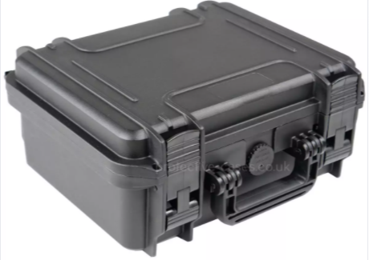 | 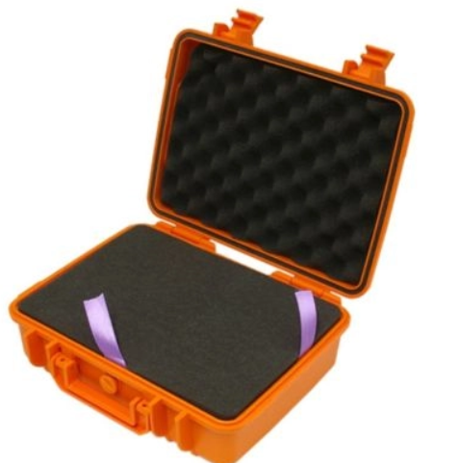 | 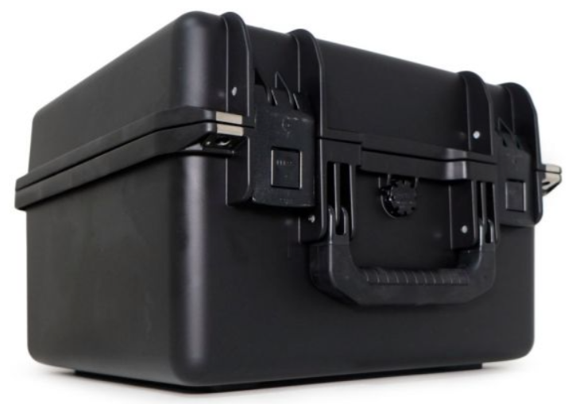
Mfr. Number | MAX300 | EN-EC-37-1-OR | iM2275
Positive | - Foam interior  - Good protection | - Foam interior  - Very good protection | - Foam interior  - Good Protection
Negative | - No Wheels | - No Wheels | - No wheels
Dimension | 300mm x 225mm x 132mm | 275mm x 203mm x 95.4mm | 359mm x 335mm x 241mm
IP rating | IP67 | IP67 / IK08 | IP67
Price | £48.42 | £23.44 | £232.80
Reference | [50] | [51] | [52]

11 Pricing Table
Items | Mfr. Number | Supplier | Qty. | Cost | Total Cost | Reference
Temp & humidity sensor | T9602-5-A | Farnell | 1 | £52.14 | £52.14 | [11]
Wave height Sensor | 28015 | Farnell | 2 | £25.18 | £50.36 | [15]
Sunlight Sensor | NORPS | RS-Online | 1 | £2.91 (4) | £2.91 | [26]
Wind speed & Direction sensor | 1405-PK-021 | Gill Instruments | 1 | £640.46 | £640.46 | [22]
GPS sensor | GYGPSV5-NEO | AliExpress | 1 | £3.60 | £3.60 | [29]
LED | HLMP-1301 | Farnell | 1 | £0.51 (+5) | £0.102 | [32]
LED Pipe | 1316.2001 | Farnell | 1 | £2.89 | £2.89 | [33]
SD Card | TS1GSDC | PicStop | 1 | £7.29 | £7.29 | [34]
Battery | APD101 | Amazon | 1 | £49.99 | £49.99 | [42]
Case | EN-EC-37-1-OR | Cases-and-enclosures | 1 | £23.44 | £23.44 | [51]
PCB Bored | Weather Logger 2 | JLCPCB | 1 | $9.23 (roughly £6.30) | $9.23 (roughly £6.30) | [53]
Microcontroller | PIC18F25K50-I/SO | Farnell | 1 | £3.12 | £3.12 | [36]
Connector Male | FMP.0M.305.LLCJ | Lemo | 2 | £73.47 | £146.94 | [46]
Connector Female | PMP.0M.305.LLMJ | Lemo | 2 | £88.92 | £177.84 | [47]
Total |  |  |  |  | £1,167.38

12 Proteus Design

12.1 Full Design
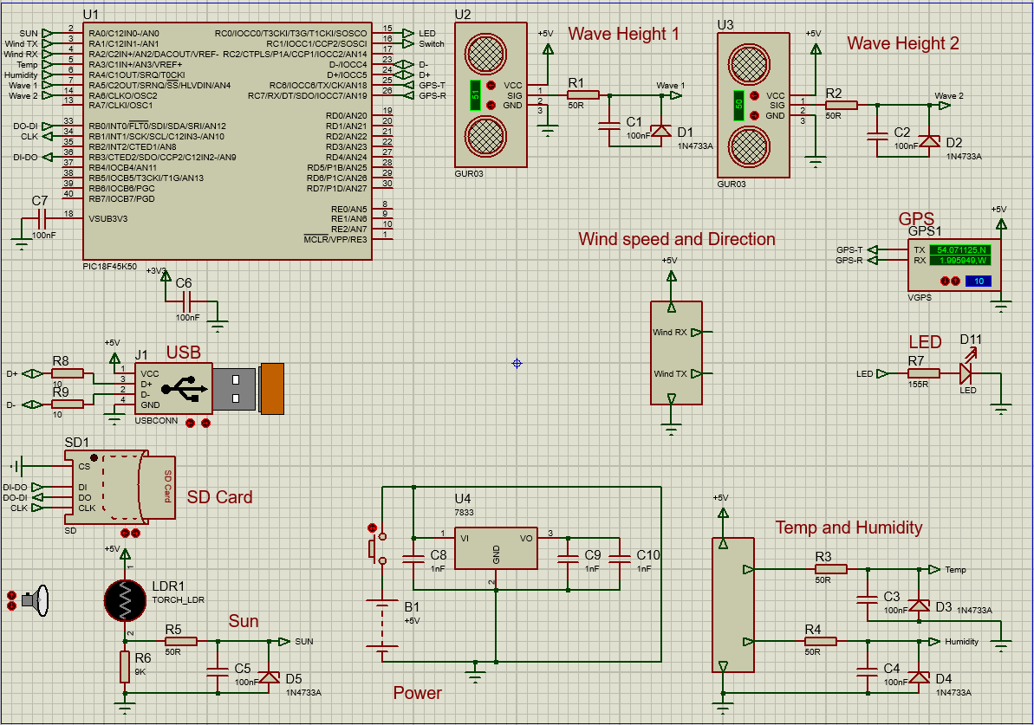

12.2 Signal Conditioning
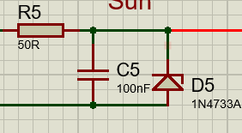
Here is a design of a clamp. This must be present on some sensors to limit the voltage to +5V for the microcontroller

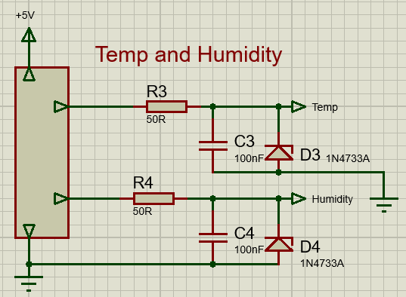
12.3 Temperature and Humidity

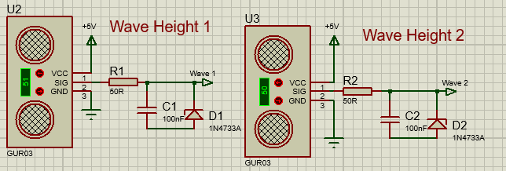
12.4 Wave Hight

12.5 Wind Speed and Direction
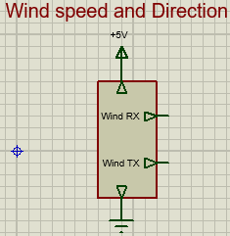

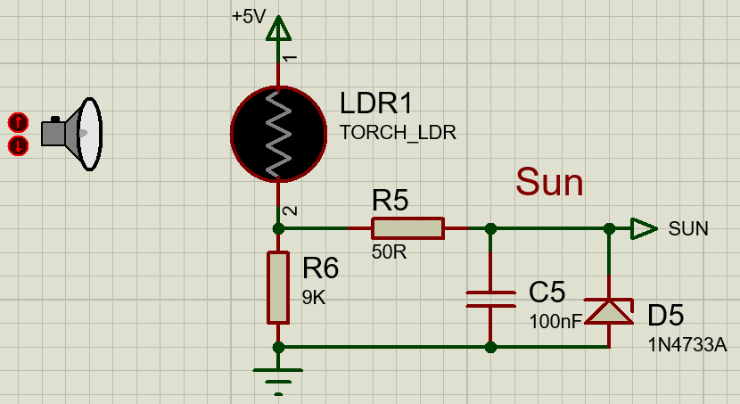
12.6 Sunlight Brightness

12.7 GPS Position
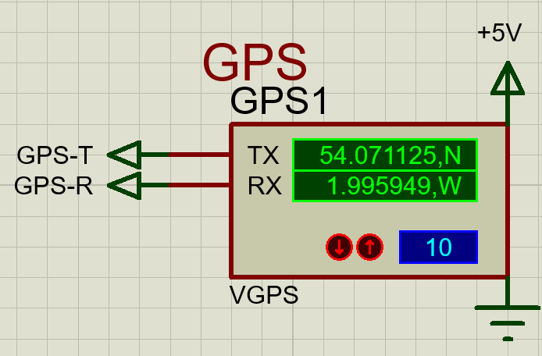

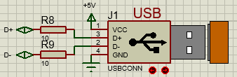
12.8 USB

12.9 SD Card
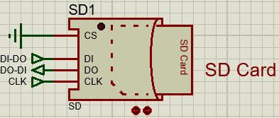

12.10 LED
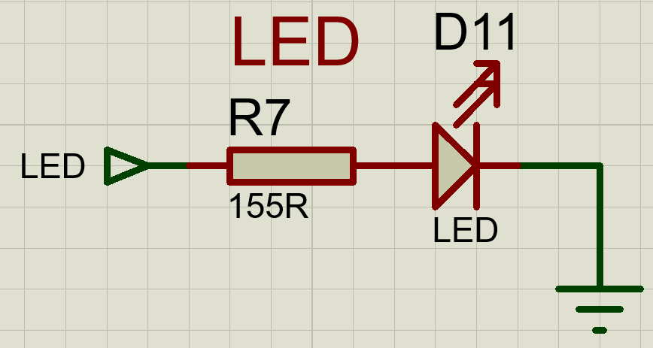

12.11 Battery

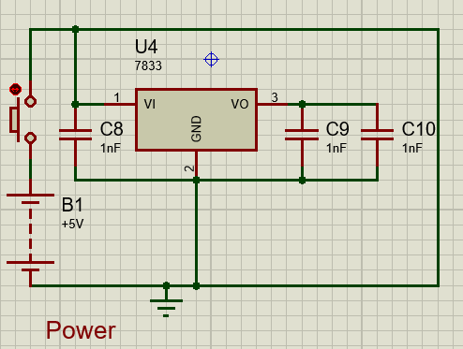

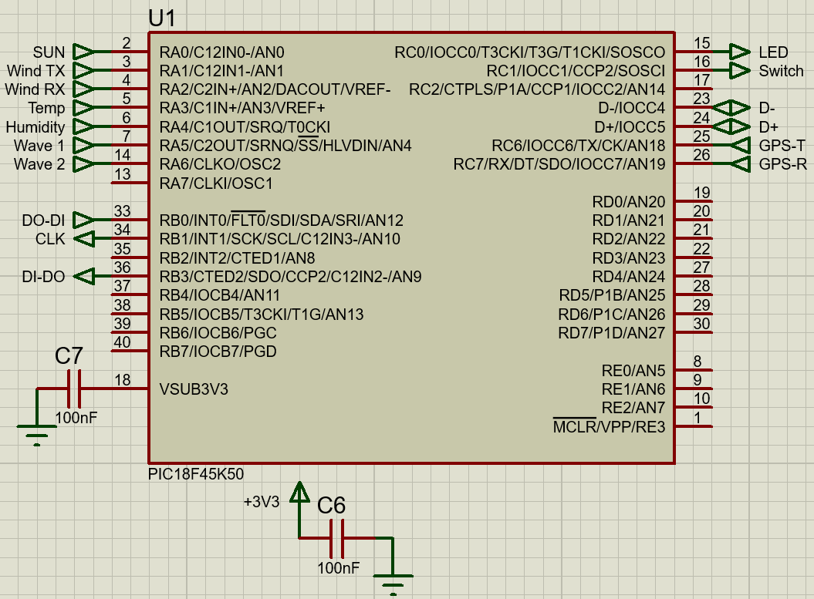
12.12 Microcontroller

13 Easy-PC Design

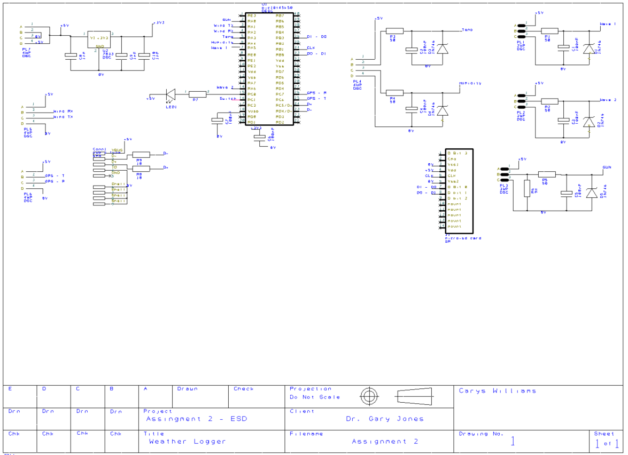
13.1 Full Design Schematic

13.2 Full design PCB
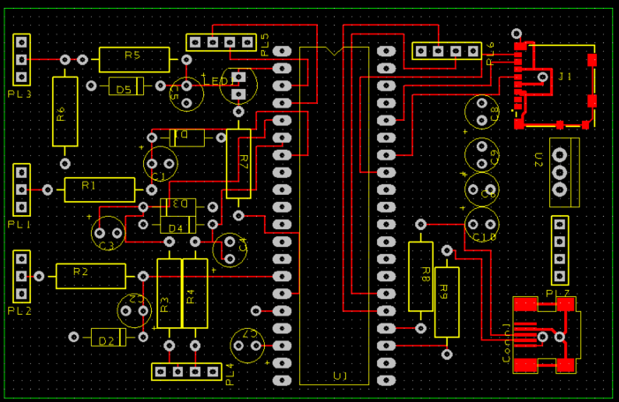

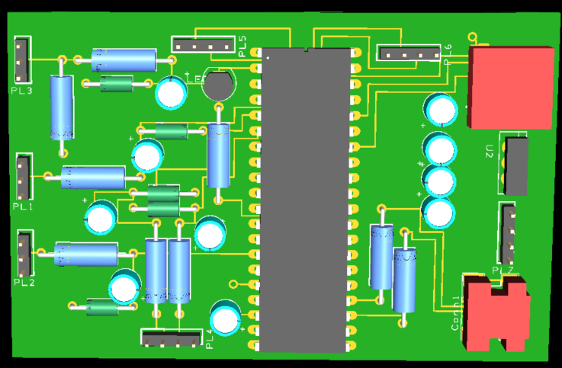
13.3 Front Facing 3D view

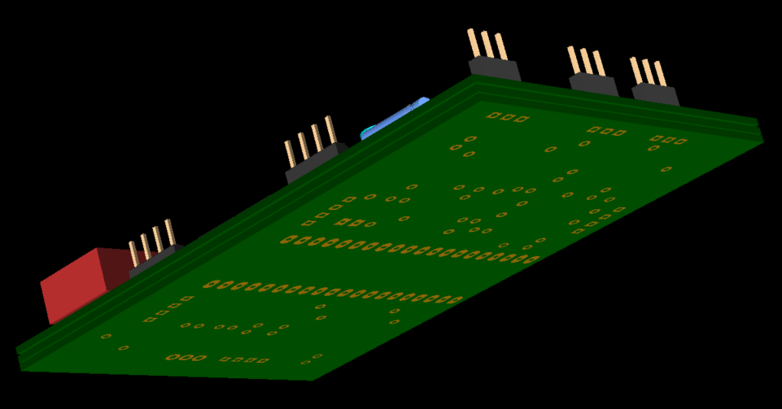
13.4 3D view of layers and bottom

14 PCB Quote
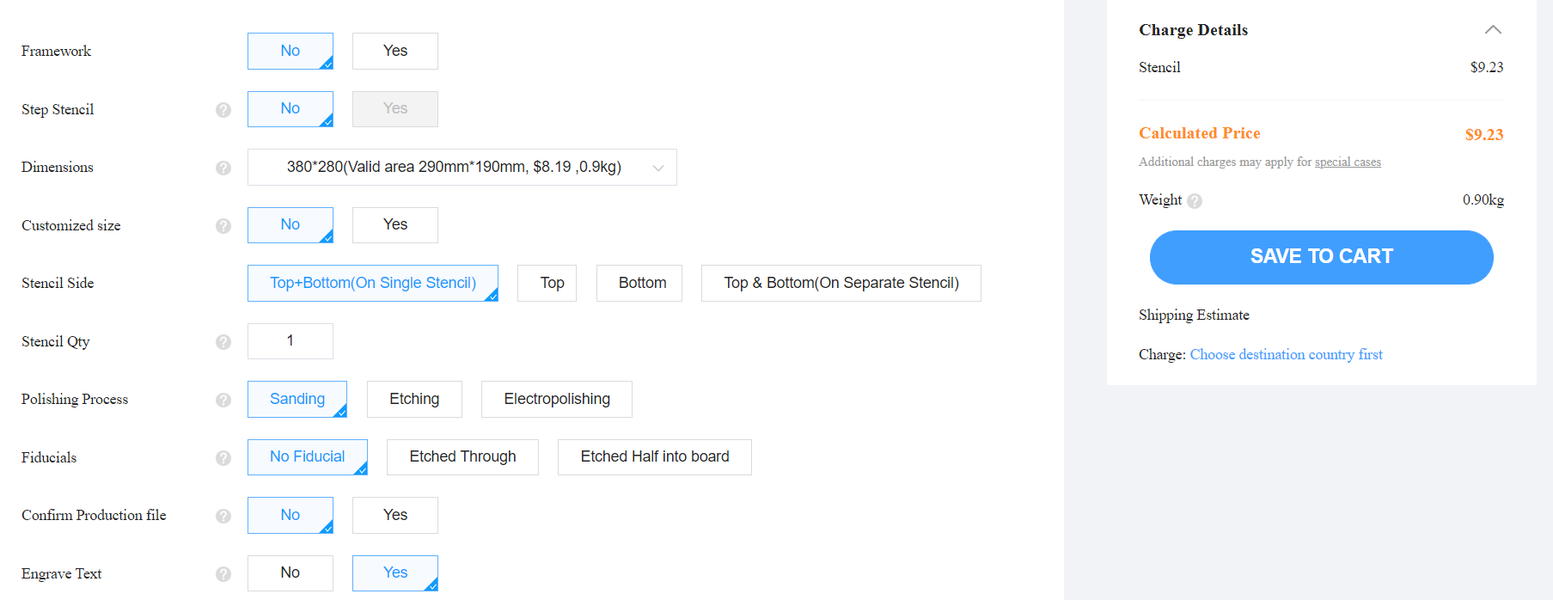
Here is an image showing the price of the PCB when using reference [53].

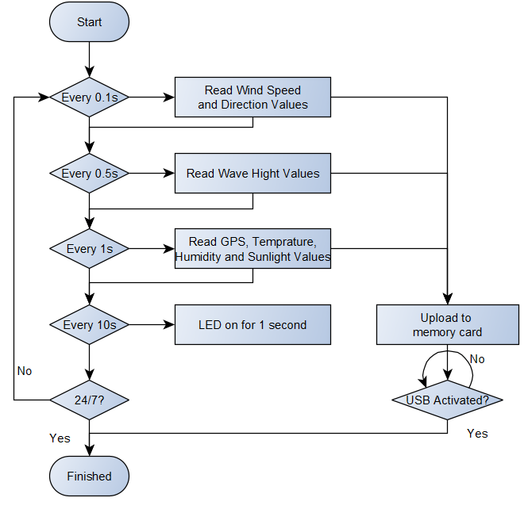
15 Flow Chart

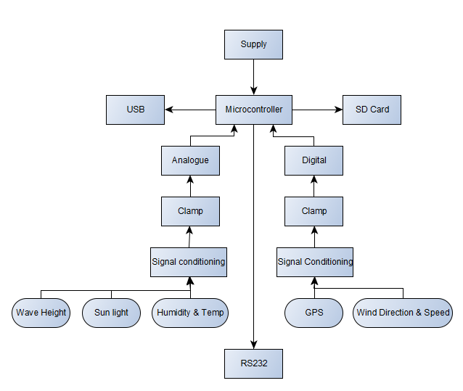
16 Block Diagram

17 Improvements

On the Completion of the marine weather monitor, a few improvements could be done. They are as followed: -
Firstly, for the battery, solar panels could be used instead. This would be more environmentally friendly as well as improve the power efficiency of the system. This would make it possible to record for a longer period.
Secondly, adding other sensors to measure other circumstances would improve the weather monitor. Such as rain fall, or wind strength. These would be more helpful to calculate the conditions for sailors.
Connectors could have been chosen differently if there was a price cap. However, there wasn’t so the connectors are of high quality and good protection. This would help with the overall price of the device.
Another improvement that should be considered is sensors. Some sensors need better protection or a higher IP rating like the ultrasonic sensors. However, this is down to personal preference of how to measure wave height.

18 Reference
[1] “www.weather-station-products.co.uk”, 2019. [Online]. Available: Wireless Vantage Pro2 Bundle (weather-station-products.co.uk) . [Accessed 1/12/2021].
[2] “www.weathershop.co.uk”, 2021. [Online]. Available: Davis Vantage Pro2 Wireless Weather Station & WeatherLink Live Bundle 6122 UK | Weather Shop ® UK . [Accessed 1/12/2021].
[3] “www.dycon.com”, 2019. [Online]. Available: MS-120 - Dyacon . [Accessed 1/12/2021].
[4] “intellisenseinc.com”, 2021. [Online]. Available: The All-in-One Weather Station with Cloud Height - The MWS-M625 (intellisenseinc.com) . [Accessed 1/12/2021].
[5] “electricalterminology.com”, 2021. [Online]. Available: Advantages and disadvantages of thermistor | 27 benefits and drawbacks (electricalterminology.com) . [Accessed 5/12/2021].
[6] “Sciencing.com”, 2019. [Online]. Available: Advantages and Disadvantages of Using Thermocouples (sciencing.com). [Accessed 5/12/2021].
[7] “rs-online.com”, 2021. [Online]. Available: HPC169_C HTM2500LF data sheet (rs-online.com). [Accessed 5/12/2021].
[8] “rotronic.com”, 2019. [Online]. Available: Webinar 2 v4 - Pros & Cons of Humidity Measurement Technologies - 9-17 (rotronic.com). [Accessed 5/12/2021].
[9] “rotronic.com”, 2019. [Online]. Available: Webinar 2 v4 - Pros & Cons of Humidity Measurement Technologies - 9-17 (rotronic.com). [Accessed 5/12/2021].
[10] “rs-online.com”, 2021. [Online]. Available: HPC169_C HTM2500LF data sheet (rs-online.com). [Accessed 5/12/2021].
[11] “uk.arnell.com”, 2021. [Online]. Available: Telaire T9602 Humidity & Temperature Sensor (farnell.com). [Accessed 5/12/2021].
[12] “omega.co.uk”, 2021. [Online]. Available: Humidity & Temperature Transmitters:Relative Humidity/Ambient Temperature Transmitters - HX94BV2W (omega.co.uk). [Accessed 5/12/2021].
[13] “rs-online.com”, 2021. [Online]. Available: RS PRO Relative Pressure Sensor for Air, Gas, Hydraulic Fluid, Liquid, Water, 10bar Max Pressure Reading, Voltage | RS Components (rs-online.com). [Accessed 7/12/2021].
[14] “rs-online”, 2021. [Online]. Available: RS PRO Retroreflective Photoelectric Sensor Block Sensor, 5 m Detection Range | RS Components (rs-online.com). [Accessed 7/12/2021].
[15] “uk.farnell.com”, 2021. [Online]. Available: 28015 Parallax, Sensing Range Min:2cm | Farnell. [Accessed 7/12/2021].
[16] “rs-online.com”, 2021. [Online]. Available: RS Pro Ultrasonic Sensor Barrel, 0.2 → 4 m, PCB | RS Components (rs-online.com). [Accessed 8/12/2021].
[17] “rs-online.com”, 2021. [Online]. Available: UM30-215113 | Sick M30 x 1.5 Ultrasonic Proximity Sensor - Barrel, Analogue Output, 600 → 6000 mm Detection, IP67 | RS Components (rs-online.com). [Accessed 8/12/2021].
[18] “lidarradar.com”, 2021. [Online]. Available: Advantages and Disadvantages of Doppler Radar – LiDAR and RADAR Information (lidarradar.com) . [Accessed 10/12/2021].
[19] “lidarradar.com”, 2021. [Online]. Available: Advantages and Disadvantages of LiDAR – LiDAR and RADAR Information (lidarradar.com). [Accessed 10/12/2021].
[20] “windpowerengineering.com”, 2021. [Online]. Available: Ultrasonic wind sensors or cup anemometers? (windpowerengineering.com). [Accessed 10/12/2021].
[21] “weatherspares.co.uk-”, 2021. [Online]. Available: https://weatherspares.co.uk/products/garni-940-wind-vane-940v?variant=32255807127648&currency=GBP&utm_medium=product_sync&utm_source=google&utm_content=sag_organic&utm_campaign=sag_organic. [Accessed 11/12/2021].
[22] “gillinstruments.com”, 2021. [Online]. Available: windsonic-1405-027-iss7.pdf (gillinstruments.com).[Accessed 11/12/2021].
[23] “gillinstruments.com”, 2021. [Online]. Available: 1390-0033 Iss 6 WindObserver70 plus OPTIONS.pdf (gillinstruments.com). [Accessed 11/12/2021].
[24] “uk.farnell.com”, 2019. [Online]. Available: WMS-23 Omega, ENV MONITORS, WEATHER STATION | Farnell. [Accessed 11/12/2021].
[25] “ecstuff4u.com”, 2020. [Online]. Available: ECSTUFF4U for Electronics Engineer: light sensor advantages and disadvantages. [Accessed 11/12/2021].
[26] “rs-online.com”, 2021. [Online]. Available: Luna Optoelectronics, 250 V Through Hole LDR (Light Dependent Resistor) 5.4 kΩ Light, 1MΩ Dark, 2-Pin TO-18 NORPS-12 | RS Components (rs-online.com). [Accessed 13/12/2021].
[27] “rs-online.com”, 2021. [Online]. Available: Luna Optoelectronics, 100 V Through Hole LDR (Light Dependent Resistor) 20 kΩ Light, 20MΩ Dark, 2-Pin TO-18 NSL-19M51 | RS Components (rs-online.com). [Accessed 13/12/2021].
[28] “geeksforgeeks.org”, 2020. [Online]. Available: Advantages and disadvantages of GPS - GeeksforGeeks .[Accessed 16/12/2021].
[29] “www.aliexpress.com”, 2021. [Online]. Available: WAVGAT APM2.5 NEO 6M NEO M8N NEO M7N 0 000 GPS Module GYGPSV1 8M 3 5V GYGPSV5 NEO for Pixhawk APM|Integrated Circuits| - AliExpress. [Accessed 16/12/2021].
[30] “rs-online.com”, 2021. [Online]. Available: ADAFRUIT INDUSTRIES 1059 GPS Module | RS Components (rs-online.com). [Accessed 16/12/2021].
[31] “kingquad.shop”, 2021. [Online]. Available: NameLessRC Tiny GPS Module 5V 9600dps UBLOX (kingquad.shop) .[Accessed 16/12/2021].
[32] “uk.farnell.com”, 2021. [Online]. Available: HLMP-1301 Broadcom, LED, Red, Through Hole | Farnell. [Accessed 17/12/2021].
[33] “uk.farnell.com”, 2021. [Online]. Available: LL_11_1_Products_03_42_v4_cs3.indd (farnell.com). [Accessed 17/12/2021].
[34] “picstop.co.uk”, 2021. [Online]. Available: Transcend Secure Digital Card 1GB (picstop.co.uk). [Accessed 17/12/2021].
[35] “uk.farnell.com”, 2021. [Online]. Available: PIC18F45K50-I/P Microchip, 8 Bit MCU, Flash, PIC18 Family PIC18F K5x Series Microcontrollers | Farnell [Accessed 18/12/2021].
[36] “uk.farnell.com”, 2021. [Online]. Available: PIC18F45K50-I/MV Microchip, 8 Bit MCU, Flash, PIC18 Family PIC18F K5x Series Microcontrollers | Farnell. [Accessed 18/12/2021].
[37] “rs-online.com”, 2021. [Online]. Available: PIC18LF45K50-I/P Microchip, 8 Bit MCU, Flash, PIC18 Family PIC18F K5x Series Microcontrollers | Farnell [Accessed 18/12/2021].
[38] “www.large.net”, 2021. [Online]. Available: NiMH or Lithium Batteries-Pros and Cons-battery-knowledge | Large Power [Accessed 20/12/2021].
[39] “www.electronics-notes.com”, 2021. [Online]. Available: Li-Ion Battery Advantages / Disadvantages: Lithium Ion » Electronics Notes (electronics-notes.com) . [Accessed 20/12/2021].
[40] “www.rfwireless-world.com”, 2020. [Online]. Available: Advantages of Lead Acid Battery,disadvantages of Lead Acid Battery (rfwireless-world.com) . [Accessed 20/12/2021].
[41] “Amazon.co.uk”, 2021. [Online]. Available: QTshine Power Bank,【26800 mAh High Capacity】Portable Charger Fast Charge with 3 Outputs & Type-C Input External Battery Pack with 4 LED Lights Ultra Compact for Smart Phone, Tablet - Classic Black : Amazon.co.uk: Electronics & Photo. [Accessed 21/12/2021].
[42] “Amazon.co.uk”, 2021. [Online]. Available: Portable Charger 50000mAh Portable Charger Simple Stylish and Compact Design Quick Charge Smart Phones Tablet Camera etc (Black): Amazon.co.uk: Electronics & Photo. [Accessed 21/12/2021].
[43] “Amazon.co.uk”, 2021. [Online]. Available: MAXOAK 50000mAh 6 Port (5V/12V/ 20V) Portable Battery Charger External Battery Power Bank for Laptop & Notebook (not for Apple Laptop) : Amazon.co.uk: Computers & Accessories. [Accessed 21/12/2021].
[44] “rs-online.com”, 2021. [Online]. Available: EGG.TT.304.CLL | Lemo Panel Mount Circular Connector, 4 Contacts, M7 Connector | RS Components (rs-online.com) [Accessed 22/12/2021].
[45] “rs-online.com”, 2021. [Online]. Available: FGG.TT.304.CLAC31Z | Lemo Cable Mount Circular Connector, 4 Contacts | RS Components (rs-online.com) [Accessed 22/12/2021].
[46] “www.mouser.co.uk”, 2021. [Online]. Available: FMN.0M.304.ILCT LEMO | Mouser United Kingdom [Accessed 22/12/2021].
[47] “www.mouser.co.uk”, 2021. [Online]. Available: HEN.0M.304.ILNP LEMO | Mouser United Kingdom [Accessed 22/12/2021].
[48] “rs-online.com”, 2021. [Online]. Available: RS PRO Cable Mount XLR Connector, Male, 250 V ac, 4 Way, Silver Plating | RS Components (rs-online.com) [Accessed 22/12/2021].
[49] “rs-online.com”, 2021. [Online]. Available: RS PRO Cable Mount XLR Connector, Female, 250 V ac, 4 Way, Silver Plating | RS Components (rs-online.com) [Accessed 22/12/2021].
[50] “www.thecaseshop.co.uk”, 2021. [Online]. Available: Max Case MAX300 - Case Empty - Black | The Case Shop [Accessed 26/12/2021].
[51] “www.cases-and-enclosures.co.uk”, 2021. [Online]. Available: Hurricane Waterproof and Shockproof Hard Equipment Case - Orange (L275xW203xH95.4mm) | cases-and-enclosures.co.uk Suppliers of Aluminium Flight Cases, Sealed Plastic Enclosures, Hurricane Equipment Cases, Custom Foam [Accessed 26/12/2021].
[52] “www.peliproducts.co.uk”, 2021. [Online]. Available: Peli iM2275 Storm Case - Equipment Hard Case - Peli UK (peliproducts.co.uk). [Accessed 26/12/2021].
[53] “cart.jlcpcb.com”, 2022. [Online]. Available: PCB Order & Online PCB Quote & SMT Assembly Quote - JLCPCB. [Accessed 1/01/2022].

19 Bibliography

Horowitz.P and Hill.W(1990) ‘The Art of Electronics’,2nd edition. Cambridge: Press Syndicate.
Microprossesor and interfacing programming and hardware by douglas V. Hall 1986

[1] “www.weather-station-products.co.uk”, 2019. [Online]. Available: Wireless Vantage Pro2 Bundle (weather-station-products.co.uk) . [Accessed 1/12/2021].
[2] “www.weathershop.co.uk”, 2021. [Online]. Available: Davis Vantage Pro2 Wireless Weather Station & WeatherLink Live Bundle 6122 UK | Weather Shop ® UK . [Accessed 1/12/2021].
[3] “www.dycon.com”, 2019. [Online]. Available: MS-120 - Dyacon . [Accessed 1/12/2021].
[4] “intellisenseinc.com”, 2021. [Online]. Available: The All-in-One Weather Station with Cloud Height - The MWS-M625 (intellisenseinc.com) . [Accessed 1/12/2021].
[5] “electricalterminology.com”, 2021. [Online]. Available: Advantages and disadvantages of thermistor | 27 benefits and drawbacks (electricalterminology.com) . [Accessed 5/12/2021].
[6] “Sciencing.com”, 2019. [Online]. Available: Advantages and Disadvantages of Using Thermocouples (sciencing.com). [Accessed 5/12/2021].
[7] “rs-online.com”, 2021. [Online]. Available: HPC169_C HTM2500LF data sheet (rs-online.com). [Accessed 5/12/2021].
[8] “rotronic.com”, 2019. [Online]. Available: Webinar 2 v4 - Pros & Cons of Humidity Measurement Technologies - 9-17 (rotronic.com). [Accessed 5/12/2021].
[9] “rotronic.com”, 2019. [Online]. Available: Webinar 2 v4 - Pros & Cons of Humidity Measurement Technologies - 9-17 (rotronic.com). [Accessed 5/12/2021].
[10] “rs-online.com”, 2021. [Online]. Available: HPC169_C HTM2500LF data sheet (rs-online.com). [Accessed 5/12/2021].
[11] “uk.arnell.com”, 2021. [Online]. Available: Telaire T9602 Humidity & Temperature Sensor (farnell.com). [Accessed 5/12/2021].
[12] “omega.co.uk”, 2021. [Online]. Available: Humidity & Temperature Transmitters:Relative Humidity/Ambient Temperature Transmitters - HX94BV2W (omega.co.uk). [Accessed 5/12/2021].
[13] “rs-online.com”, 2021. [Online]. Available: RS PRO Relative Pressure Sensor for Air, Gas, Hydraulic Fluid, Liquid, Water, 10bar Max Pressure Reading, Voltage | RS Components (rs-online.com). [Accessed 7/12/2021].
[14] “rs-online”, 2021. [Online]. Available: RS PRO Retroreflective Photoelectric Sensor Block Sensor, 5 m Detection Range | RS Components (rs-online.com). [Accessed 7/12/2021].
[15] “uk.farnell.com”, 2021. [Online]. Available: 28015 Parallax, Sensing Range Min:2cm | Farnell. [Accessed 7/12/2021].
[16] “rs-online.com”, 2021. [Online]. Available: RS Pro Ultrasonic Sensor Barrel, 0.2 → 4 m, PCB | RS Components (rs-online.com). [Accessed 8/12/2021].
[17] “rs-online.com”, 2021. [Online]. Available: UM30-215113 | Sick M30 x 1.5 Ultrasonic Proximity Sensor - Barrel, Analogue Output, 600 → 6000 mm Detection, IP67 | RS Components (rs-online.com). [Accessed 8/12/2021].
[18] “lidarradar.com”, 2021. [Online]. Available: Advantages and Disadvantages of Doppler Radar – LiDAR and RADAR Information (lidarradar.com) . [Accessed 10/12/2021].
[19] “lidarradar.com”, 2021. [Online]. Available: Advantages and Disadvantages of LiDAR – LiDAR and RADAR Information (lidarradar.com). [Accessed 10/12/2021].
[20] “windpowerengineering.com”, 2021. [Online]. Available: Ultrasonic wind sensors or cup anemometers? (windpowerengineering.com). [Accessed 10/12/2021].
[21] “weatherspares.co.uk-”, 2021. [Online]. Available: https://weatherspares.co.uk/products/garni-940-wind-vane-940v?variant=32255807127648&currency=GBP&utm_medium=product_sync&utm_source=google&utm_content=sag_organic&utm_campaign=sag_organic. [Accessed 11/12/2021].
[22] “gillinstruments.com”, 2021. [Online]. Available: windsonic-1405-027-iss7.pdf (gillinstruments.com).[Accessed 11/12/2021].
[23] “gillinstruments.com”, 2021. [Online]. Available: 1390-0033 Iss 6 WindObserver70 plus OPTIONS.pdf (gillinstruments.com). [Accessed 11/12/2021].
[24] “uk.farnell.com”, 2019. [Online]. Available: WMS-23 Omega, ENV MONITORS, WEATHER STATION | Farnell. [Accessed 11/12/2021].
[25] “ecstuff4u.com”, 2020. [Online]. Available: ECSTUFF4U for Electronics Engineer: light sensor advantages and disadvantages. [Accessed 11/12/2021].
[26] “rs-online.com”, 2021. [Online]. Available: Luna Optoelectronics, 250 V Through Hole LDR (Light Dependent Resistor) 5.4 kΩ Light, 1MΩ Dark, 2-Pin TO-18 NORPS-12 | RS Components (rs-online.com). [Accessed 13/12/2021].
[27] “rs-online.com”, 2021. [Online]. Available: Luna Optoelectronics, 100 V Through Hole LDR (Light Dependent Resistor) 20 kΩ Light, 20MΩ Dark, 2-Pin TO-18 NSL-19M51 | RS Components (rs-online.com). [Accessed 13/12/2021].
[28] “geeksforgeeks.org”, 2020. [Online]. Available: Advantages and disadvantages of GPS - GeeksforGeeks .[Accessed 16/12/2021].
[29] “www.aliexpress.com”, 2021. [Online]. Available: WAVGAT APM2.5 NEO 6M NEO M8N NEO M7N 0 000 GPS Module GYGPSV1 8M 3 5V GYGPSV5 NEO for Pixhawk APM|Integrated Circuits| - AliExpress. [Accessed 16/12/2021].
[30] “rs-online.com”, 2021. [Online]. Available: ADAFRUIT INDUSTRIES 1059 GPS Module | RS Components (rs-online.com). [Accessed 16/12/2021].
[31] “kingquad.shop”, 2021. [Online]. Available: NameLessRC Tiny GPS Module 5V 9600dps UBLOX (kingquad.shop) .[Accessed 16/12/2021].
[32] “uk.farnell.com”, 2021. [Online]. Available: HLMP-1301 Broadcom, LED, Red, Through Hole | Farnell. [Accessed 17/12/2021].
[33] “uk.farnell.com”, 2021. [Online]. Available: LL_11_1_Products_03_42_v4_cs3.indd (farnell.com). [Accessed 17/12/2021].
[34] “picstop.co.uk”, 2021. [Online]. Available: Transcend Secure Digital Card 1GB (picstop.co.uk). [Accessed 17/12/2021].
[35] “uk.farnell.com”, 2021. [Online]. Available: PIC18F25K50-I/SO Microchip, 8 Bit MCU, Flash, PIC18 Family PIC18F K5x Series Microcontrollers | Farnell. [Accessed 18/12/2021].
[36] “uk.farnell.com”, 2021. [Online]. Available: PIC18F25K42-I/SP Microchip, 8 Bit MCU, PIC18 Family PIC18F K4x Series Microcontrollers, 64 MHz | Farnell. [Accessed 18/12/2021].
[37] “rs-online.com”, 2021. [Online]. Available: Microchip PIC18F252-I/SO, 8bit PIC Microcontroller, PIC18F, 40MHz, 32 kB Flash, 28-Pin SOIC | RS Components (rs-online.com). [Accessed 18/12/2021].
[38] “www.large.net”, 2021. [Online]. Available: NiMH or Lithium Batteries-Pros and Cons-battery-knowledge | Large Power [Accessed 20/12/2021].
[39] “www.electronics-notes.com”, 2021. [Online]. Available: Li-Ion Battery Advantages / Disadvantages: Lithium Ion » Electronics Notes (electronics-notes.com) . [Accessed 20/12/2021].
[40] “www.rfwireless-world.com”, 2020. [Online]. Available: Advantages of Lead Acid Battery,disadvantages of Lead Acid Battery (rfwireless-world.com) . [Accessed 20/12/2021].
[41] “Amazon.co.uk”, 2021. [Online]. Available: QTshine Power Bank,【26800 mAh High Capacity】Portable Charger Fast Charge with 3 Outputs & Type-C Input External Battery Pack with 4 LED Lights Ultra Compact for Smart Phone, Tablet - Classic Black : Amazon.co.uk: Electronics & Photo. [Accessed 21/12/2021].
[42] “Amazon.co.uk”, 2021. [Online]. Available: Portable Charger 50000mAh Portable Charger Simple Stylish and Compact Design Quick Charge Smart Phones Tablet Camera etc (Black): Amazon.co.uk: Electronics & Photo. [Accessed 21/12/2021].
[43] “Amazon.co.uk”, 2021. [Online]. Available: MAXOAK 50000mAh 6 Port (5V/12V/ 20V) Portable Battery Charger External Battery Power Bank for Laptop & Notebook (not for Apple Laptop) : Amazon.co.uk: Computers & Accessories. [Accessed 21/12/2021].
[44] “rs-online.com”, 2021. [Online]. Available: EGG.TT.304.CLL | Lemo Panel Mount Circular Connector, 4 Contacts, M7 Connector | RS Components (rs-online.com) [Accessed 22/12/2021].
[45] “rs-online.com”, 2021. [Online]. Available: FGG.TT.304.CLAC31Z | Lemo Cable Mount Circular Connector, 4 Contacts | RS Components (rs-online.com) [Accessed 22/12/2021].
[46] “www.mouser.co.uk”, 2021. [Online]. Available: FMN.0M.304.ILCT LEMO | Mouser United Kingdom [Accessed 22/12/2021].
[47] “www.mouser.co.uk”, 2021. [Online]. Available: HEN.0M.304.ILNP LEMO | Mouser United Kingdom [Accessed 22/12/2021].
[48] “rs-online.com”, 2021. [Online]. Available: RS PRO Cable Mount XLR Connector, Male, 250 V ac, 4 Way, Silver Plating | RS Components (rs-online.com) [Accessed 22/12/2021].
[49] “rs-online.com”, 2021. [Online]. Available: RS PRO Cable Mount XLR Connector, Female, 250 V ac, 4 Way, Silver Plating | RS Components (rs-online.com) [Accessed 22/12/2021].
[50] “www.thecaseshop.co.uk”, 2021. [Online]. Available: Max Case MAX300 - Case Empty - Black | The Case Shop [Accessed 26/12/2021].

Wireless Vantage Pro2 Bundle (weather-station-products.co.uk)
MS-120 - Dyacon
The All-in-One Weather Station with Cloud Height - The MWS-M625 (intellisenseinc.com)
Bresser UK | BRESSER 4CAST PRO WLAN | Call 01342 837 098 for advice and sales.
Davis Vantage Pro2 Wireless Weather Station & WeatherLink Live Bundle 6122 UK | Weather Shop ® UK
MS-120 - Dyacon
The All-in-One Weather Station with Cloud Height - The MWS-M625 (intellisenseinc.com)
Bresser UK | BRESSER 4CAST PRO WLAN | Call 01342 837 098 for advice and sales.
RS PRO Thermistor 5Ω, 15 x 6mm | RS Components (rs-online.com)
RS PRO Type K Thermocouple 1m Length, 1mm Diameter → +800°C | RS Components (rs-online.com)
HPC169_C HTM2500LF data sheet (rs-online.com)
RS PRO Thermistor 5Ω, 15 x 6mm | RS Components (rs-online.com)
RS PRO Type K Thermocouple 1m Length, 1mm Diameter → +800°C | RS Components (rs-online.com)
HPC169_C HTM2500LF data sheet (rs-online.com)
HPC169_C HTM2500LF data sheet (rs-online.com)
T9602-5-A. Amphenol Advanced Sensors, HUMIDITY/TEMP SENSOR, 0-100% RH, IP67 | Farnell
Humidity & Temperature Transmitters:Relative Humidity/Ambient Temperature Transmitters - HX94BV2W (omega.co.uk)
RS PRO Relative Pressure Sensor for Air, Gas, Hydraulic Fluid, Liquid, Water, 10bar Max Pressure Reading, Voltage | RS Components (rs-online.com)
RS PRO Retroreflective Photoelectric Sensor Block Sensor, 5 m Detection Range | RS Components (rs-online.com)
28015 Parallax, Sensing Range Min:2cm | Farnell
28015 Parallax, Sensing Range Min:2cm | Farnell
PowerPoint Presentation (rs-online.com)
UM30-215113 | Sick M30 x 1.5 Ultrasonic Proximity Sensor - Barrel, Analogue Output, 600 → 6000 mm Detection, IP67 | RS Components (rs-online.com)
https://www.pinterest.co.uk/pin/655344183250909634/
LIDAR-Lite v3 - SEN-14032 - SparkFun Electronics
What are the Advantages of Ultrasonic Wind Sensors? | Lufft Blog
https://weatherspares.co.uk/products/garni-940-wind-vane-940v?variant=32255807127648&currency=GBP&utm_medium=product_sync&utm_source=google&utm_content=sag_organic&utm_campaign=sag_organic
What are the Advantages of Ultrasonic Wind Sensors? | Lufft Blog
windsonic-1405-027-iss7.pdf (gillinstruments.com)
1390-0033 Iss 6 WindObserver70 plus OPTIONS.pdf (gillinstruments.com)
WMS-23 Omega, ENV MONITORS, WEATHER STATION | Farnell
Photo Transistor Light Sensor– The Pi Hut
Light Sensor including Photocell and LDR Sensor (electronics-tutorials.ws)
Light Sensor including Photocell and LDR Sensor (electronics-tutorials.ws)
Luna Optoelectronics, 250 V Through Hole LDR (Light Dependent Resistor) 5.4 kΩ Light, 1MΩ Dark, 2-Pin TO-18 NORPS-12 | RS Components (rs-online.com)
Luna Optoelectronics, 100 V Through Hole LDR (Light Dependent Resistor) 20 kΩ Light, 20MΩ Dark, 2-Pin TO-18 NSL-19M51 | RS Components (rs-online.com)
Molex 206560-0050 Square Omnidirectional GSM & GPRS Antenna, GPS | RS Components (rs-online.com)
WAVGAT APM2.5 NEO 6M NEO M8N NEO M7N 0 000 GPS Module GYGPSV1 8M 3 5V GYGPSV5 NEO for Pixhawk APM|Integrated Circuits| - AliExpress
ADAFRUIT INDUSTRIES 1059 GPS Module | RS Components (rs-online.com)
NameLessRC Tiny GPS Module 5V 9600dps UBLOX (kingquad.shop)
HLMP-1301 Broadcom, LED, Red, Through Hole | Farnell
Transcend Secure Digital Card 1GB (picstop.co.uk)
PIC18F45K50-I/P Microchip, 8 Bit MCU, Flash, PIC18 Family PIC18F K5x Series Microcontrollers | Farnell
PIC18F45K50-I/MV Microchip, 8 Bit MCU, Flash, PIC18 Family PIC18F K5x Series Microcontrollers | Farnell
PIC18LF45K50-I/P Microchip, 8 Bit MCU, Flash, PIC18 Family PIC18F K5x Series Microcontrollers | Farnell
NiMH or Lithium Batteries-Pros and Cons-battery-knowledge | Large Power
Li-Ion Battery Advantages / Disadvantages: Lithium Ion » Electronics Notes (electronics-notes.com)
Advantages of Lead Acid Battery,disadvantages of Lead Acid Battery (rfwireless-world.com)
QTshine Power Bank,【26800 mAh High Capacity】Portable Charger Fast Charge with 3 Outputs & Type-C Input External Battery Pack with 4 LED Lights Ultra Compact for Smart Phone, Tablet - Classic Black : Amazon.co.uk: Electronics & Photo
Portable Charger 50000mAh Portable Charger Simple Stylish and Compact Design Quick Charge Smart Phones Tablet Camera etc (Black): Amazon.co.uk: Electronics & Photo
MAXOAK 50000mAh 6 Port (5V/12V/ 20V) Portable Battery Charger External Battery Power Bank for Laptop & Notebook (not for Apple Laptop) : Amazon.co.uk: Computers & Accessories
EGG.TT.304.CLL | Lemo Panel Mount Circular Connector, 4 Contacts, M7 Connector | RS Components (rs-online.com)
M Connector | LEMO Connectors | Push-Pull, Circular Connectors | Cables
RS PRO Cable Mount XLR Connector, Male, 250 V ac, 4 Way, Silver Plating | RS Components (rs-online.com)
⁣Max Case MAX300 - Case Empty - Black | The Case Shop
Hurricane Waterproof and Shockproof Hard Equipment Case - Orange (L275xW203xH95.4mm) | cases-and-enclosures.co.uk Suppliers of Aluminium Flight Cases, Sealed Plastic Enclosures, Hurricane Equipment Cases, Custom Foam
Peli iM2275 Storm Case - Equipment Hard Case - Peli UK (peliproducts.co.uk)
PCB Order & Online PCB Quote & SMT Assembly Quote - JLCPCB

